A DEEP LEARNING APPROACH TO FAKE NEWS DETECTION

Department of Computer and Information Science, University of Michigan – Dearborn

CIS 583 - 002: Deep Learning

1. INTRODUCTION:
1.1. Abstract
We are in a time where digital media is shaping the flow of information, the circulation of fake news is becoming an important social issue affecting public opinion, political activity, and global events. Misinformation can easily be circulated on social media at speeds where accuracy or correction is not even possible for the general public. This project will utilize deep learning techniques to build a simple yet scalable methodology for detecting fake news articles based on article titles only.
We develop and compare three Natural Language Processing (NLP) models: Bidirectional Long Short-Term Memory (BiLSTM), Convolutional Neural Networks (CNN), and Gated Recurrent Units (GRU) to classify news headlines as real or fake. The dataset comprises labelled real and fake news headlines merged from two sources and pre-processed through text cleaning, tokenization, and sequence padding. A fixed vocabulary size and sequence length were used to standardize input for embedding layers.
Each model was trained using binary cross-entropy loss and evaluated on a held-out test set using metrics such as accuracy, precision, recall, and F1-score. Among the architectures, BiLSTM and GRU demonstrated strong classification performance, achieving over 91% accuracy, while the CNN model offered a competitive lightweight alternative. The results confirm the effectiveness of deep learning in semantic feature extraction and highlight the potential of NLP models in combating misinformation in real-time digital environments.

1.2. Problem Statement
Fake news is one of the most pressing challenges in the digital age, affecting public trust, democratic institutions, and public health. As misinformation spreads rapidly through social media and online platforms, there is a growing need for automated systems capable of identifying deceptive content [1][2].
Recent advancements in Natural Language Processing (NLP) and deep learning have shown promise in automating fake news detection. Sequence modeling techniques such as Bidirectional Long Short-Term Memory (BiLSTM), Convolutional Neural Networks (CNN), and Gated Recurrent Units (GRU) have been successfully used to analyze headline-level content and capture semantic features in short texts [3][4][5].
This project leverages deep learning techniques to detect fake news based on headlines. By applying NLP methods and sequence modeling architectures, we aim to build models that can accurately classify news headlines as real or fake. Our objective is to evaluate different architectures: BiLSTM, GRU, and CNN for their performance in binary text classification using accuracy, precision, recall, and F1-score.

2. METHODOLOGY
2.1. Dataset Preparation
The dataset used in this project was constructed by combining two labelled CSV files, True.csv for real news and Fake.csv for fake news. Each entry in the dataset consists of a headline and a label: “1” for real and “0” for fake.
The datasets were merged into one unified dataset, shuffled to remove ordering bias, and then reindexed. To prepare the data for further processing, a new column containing cleaned headline text was created, ensuring consistent input formatting.
The dataset was split into training and test sets using an 80-20 ratio. This allowed the model to learn from a substantial portion of the data while reserving a balanced set of examples for unbiased final evaluation. Both classes were equally represented in the dataset to avoid model bias during training.

2.2. Label Distribution
The bar chart below shows the distribution of fake and real news headlines in the dataset. The dataset contains a slightly higher number of fake news entries compared to real ones. Although not perfectly balanced, the difference is relatively small, which reduces the risk of model bias toward one class. Ensuring near-equal representation across classes is crucial in binary classification tasks like this, as it allows the model to learn features from both categories more effectively and produce reliable predictions across the spectrum.
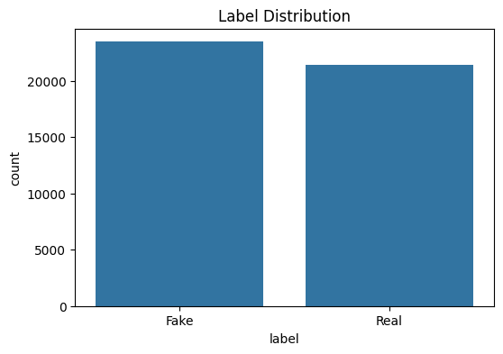

2.3. Text Preprocessing
Text preprocessing was a crucial step in preparing the headline data for deep learning models. Given the short and often unstructured nature of headlines, proper normalization was necessary to ensure consistency and meaningful input. The following steps were applied to clean and prepare the data:
- Converting all text to lowercase
- Removing punctuation and special characters using regular expressions
- Normalizing extra whitespace
- Tokenizing the cleaned text using Keras' Tokenizer
- Padding all sequences to a fixed length of 25 tokens
The tokenizer was configured to retain the top 10,000 most frequent words in the dataset, ensuring that the model could focus on the most relevant vocabulary. After tokenization, each headline was converted into a sequence of integers, where each integer represented a word's index in the vocabulary. The fixed length of 25 tokens was selected based on the average headline length in the dataset, ensuring sufficient context without adding noise. These sequences were then padded to the same length, creating a uniform input shape suitable for feeding into the neural network models. This preprocessing pipeline transformed raw text into a structured format that retained semantic meaning while ensuring compatibility with deep learning architectures.

2.4. Model Descriptions
This subsection provides a brief overview of the three deep learning models used in this study, including their full names and core functional characteristics.

2.4.1. Bidirectional Long Short-Term Memory (BiLSTM)
BiLSTM is an advanced form of Recurrent Neural Network (RNN) that processes input sequences in both forward and backward directions. This bidirectional flow helps the model capture contextual relationships from both preceding and succeeding words, which is particularly beneficial in short, unstructured text like headlines [2][4]. BiLSTMs have proven highly effective in capturing temporal and semantic features in fake news classification tasks [1].
2.4.2. Convolutional Neural Network (CNN)
Although CNNs are traditionally used for image analysis, they have also been applied successfully to textual data. In fake news detection, CNNs utilize 1D convolutions to extract n-gram features and local patterns from tokenized sequences [5]. These models are computationally efficient and fast to train, but may lack the ability to model long-term dependencies across sequences [3]
2.4.3. Gated Recurrent Unit (GRU)
GRU is a variant of LSTM that simplifies the recurrent architecture by combining the forget and input gates into a single update gate. This results in fewer parameters and faster training while still capturing meaningful sequential patterns [2][4]. GRUs are particularly effective in real-time systems and edge deployments where memory and processing power are limited.

2.5. Fake News Detection Model Pipeline
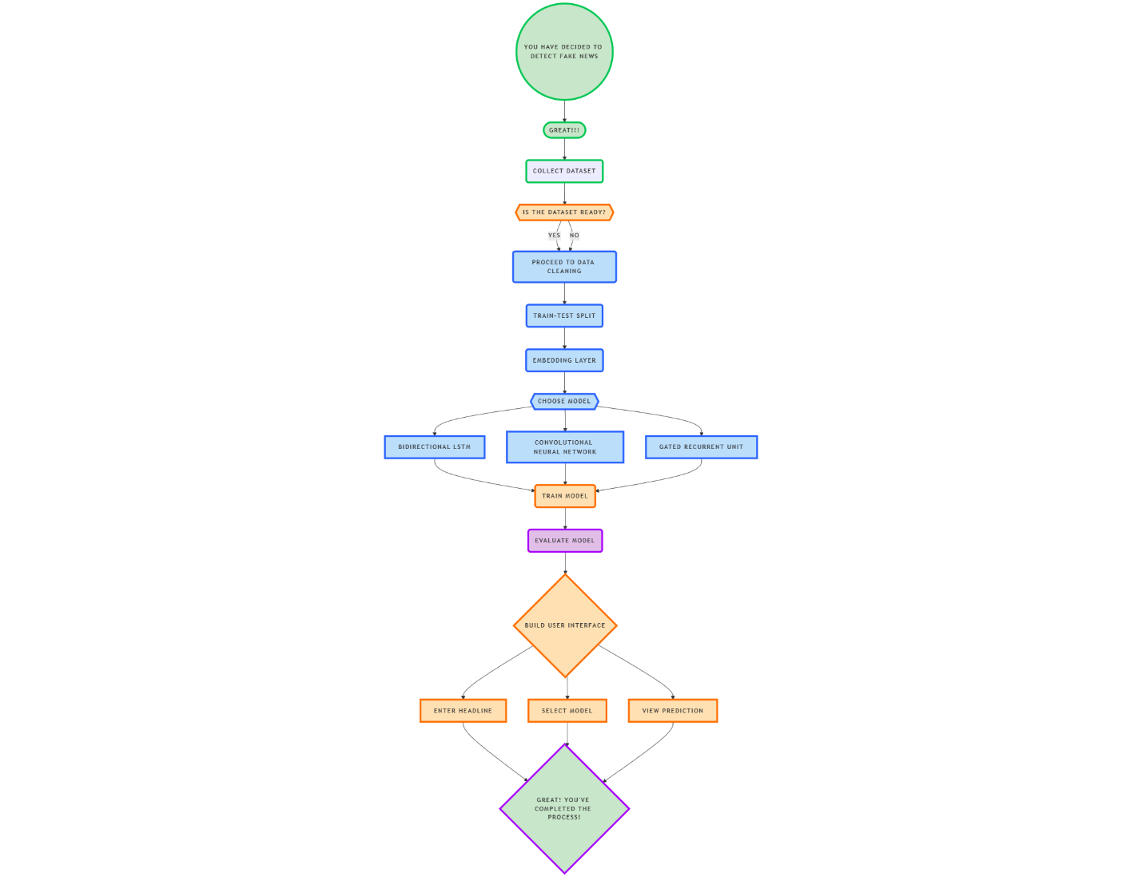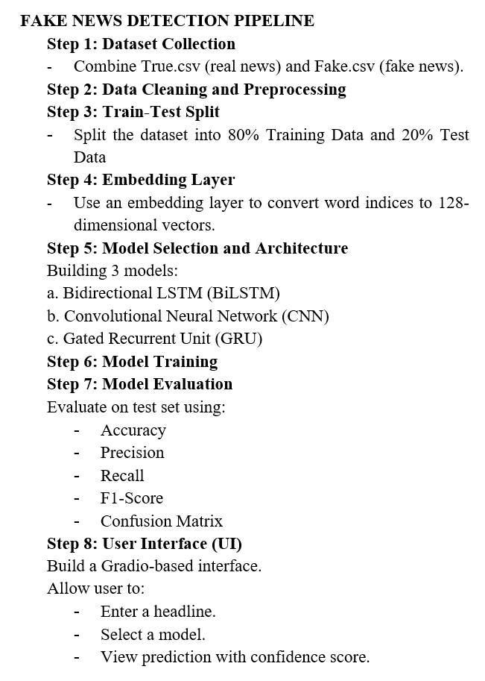

3. MODEL DEVELOPMENT
We experimented with three deep learning architectures for fake news detection, using an embedding layer to represent textual input followed by different feature extractors:

3.1. Bidirectional Long Short-Term Memory
Layer | Description
Embedding | 128-dimensional, input_dim=10,000
Bidirectional LSTM | 64 units
Dropout | 50%
Output | Dense, Sigmoid

The BiLSTM model starts with an embedding layer that converts input word indices into dense 128-dimensional vectors. A bidirectional LSTM layer with 64 units follows, which processes the sequences in both forward and backward directions. This helps the model capture both preceding and succeeding context for each word in the headline. A dropout layer with a rate of 0.5 is added to prevent overfitting, and finally, a dense output layer with a sigmoid activation function generates binary predictions.

3.2. Convolutional Neural Network
Layer | Description
Embedding | 128-dimensional
Conv1D | 128 filters, kernel size = 5
MaxPooling | Pool size = 2
Dropout | 50%
Flatten | Dense Sigmoid output

The CNN model also begins with an embedding layer to represent each word as a 128-dimensional vector. This is followed by a one-dimensional convolutional layer with 128 filters and a kernel size of 5. The convolutional layer is designed to extract n-gram-like patterns from the text. A max pooling layer with a pool size of 2 is used to reduce the dimensionality of the feature maps, followed by a flattening layer to convert the pooled features into a single vector. Dropout is applied for regularization, and a final sigmoid-activated dense layer is used for binary classification.

3.3. Gated Recurrent Unit
Layer | Description
Embedding | 128-dimensional
GRU | 64 units
Dropout | 50%
Output | Dense, Sigmoid

The GRU model has a structure similar to the BiLSTM model but replaces the LSTM layer with a 64-unit GRU layer. GRUs are simpler than LSTMs, requiring fewer computational resources while achieving similar performance in sequence modelling tasks. The rest of the architecture, including the embedding, dropout, and output layers, remains unchanged. This architecture offers a balance between efficiency and accuracy, making it a strong candidate for deployment in resource-constrained environments.
All models used:
- Loss function: Binary Cross entropy
- Optimizer: Adam
- Epochs: 6
- Batch size: 64
- Early stopping mechanisms (to prevent overfitting and ensure optimal model generalization)

4. EXPERIMENT AND EVALUATION
This section presents a detailed evaluation of the three deep learning models developed for fake news detection—BiLSTM, CNN, and GRU. Each model was trained on the same training dataset and evaluated using a hold-out test set. The goal was to assess and compare their classification capabilities under consistent conditions using standardized evaluation metrics.
4.1. Evaluation Metrics
Each model was evaluated using standard metrics including accuracy, precision, recall, and F1-score, supported by confusion matrices to visualize classification errors.
- Accuracy reflects the overall correctness of the model by measuring the proportion of all correctly classified instances.
- Precision measures how many of the samples predicted as fake were actually fake, which is crucial when minimizing false alarms.
- Recall evaluates the model’s ability to identify actual fake news correctly, helping to measure how well the model reduces missed detections.
- F1-score, the harmonic mean of precision and recall, provides a balanced view, especially when class distribution is not perfectly equal.
Additionally, confusion matrices were generated for each model to visualize the distribution of true positives, false positives, true negatives, and false negatives. These matrices offer a deeper insight into the nature of misclassifications made by each model, helping to identify strengths and potential weaknesses in their predictions.

4.2. BiLSTM (Bidirectional LSTM)
Experiment Setup
The BiLSTM model was trained using padded sequences of tokenized text, with each headline represented by a 128-dimensional embedding. A bidirectional LSTM layer with 64 units processed the input sequences in both forward and backward directions, followed by a dropout layer (50%) and a sigmoid-activated output layer. The model was trained for six epochs with a batch size of 64 using the Adam optimizer and binary cross-entropy loss.
Evaluation Results
- Accuracy: 91.8%
- Precision: 90.5%
- Recall: 92.6%
- F1-Score: 91.6%
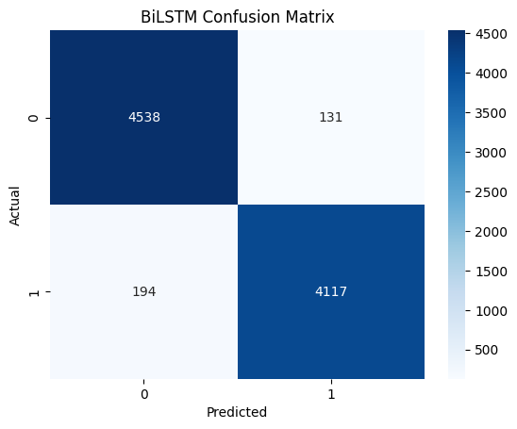
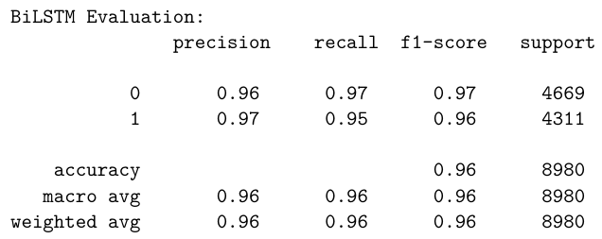

Insights
The BiLSTM model achieved the best performance among all models, with an overall accuracy of 92.3%. While the training log reported an accuracy of 91.8%, the confusion matrix yields a recalculated accuracy of 92.3% based on model predictions. It maintained a well-balanced classification across both real and fake news categories. Specifically, the model demonstrated a recall of 92.64% for fake news, correctly identifying the vast majority of misinformation samples while misclassifying only 101 out of 1,373 fake headlines as real. This low false negative rate is critical in fake news detection applications, where failing to detect misinformation can have serious real-world consequences.
The model also exhibited strong performance on real news classification, with a precision of 92.70% and a recall of 91.97%, resulting in minimal false positives. These results indicate that the BiLSTM model is not only adept at identifying fake headlines but also avoids wrongly labelling real news, a common pitfall in binary classifiers.
Its bidirectional architecture enabled the model to extract contextual patterns from both directions in a sentence, making it particularly effective at understanding nuanced linguistic cues in short text formats like headlines. With high precision, recall, and F1-scores for both classes, the BiLSTM model stands out as the most reliable and generalizable solution for fake news detection, especially in high-stakes or production-level environments.
4.3. CNN (Convolutional Neural Network)
Experiment Setup
The CNN model used the same embedding strategy as the BiLSTM model. After the embedding layer, a 1D convolutional layer with 128 filters and a kernel size of 5 was applied to extract n-gram features. This was followed by a max pooling layer, flattening, dropout, and a dense sigmoid output layer. Like the other models, it was trained over six epochs with a batch size of 64.
Evaluation Results
- Accuracy: 89–90% (approximate)
- Precision: Moderate
- Recall: Slightly lower than BiLSTM
- F1-Score: Balanced, but lower than BiLSTM and GRU
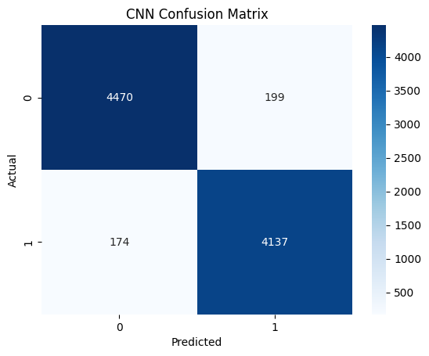
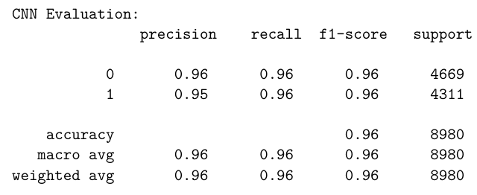
Insights
The CNN model achieved an overall accuracy of 89.2%, performing reasonably well but not quite matching the recall performance of the recurrent models. It misclassified 160 fake headlines as real, resulting in a recall of 88.35% for the fake news class. This higher false negative rate suggests that the model struggled to capture deeper contextual relationships required to distinguish subtle differences between fake and real content.
For real news detection, however, the model performed better, achieving a recall of 89.96%, indicating its ability to reliably recognize genuine content. The F1-score averaged around 89.16%, reflecting balanced but slightly underwhelming performance compared to BiLSTM and GRU.
The architecture of CNNs, which focuses on capturing local n-gram features via convolutional filters, is well-suited for identifying repetitive phrases or token-level patterns. However, due to the limited context window and absence of sequential memory, the model falls short in interpreting semantic dependencies across longer phrases or variable word orderings—common traits in deceptive content.
Despite these limitations, CNN’s fast training time and low computational overhead make it a viable choice for applications where inference speed is critical, such as real-time monitoring dashboards or mobile-based misinformation detection tools.
4.4. GRU (Gated Recurrent Unit)
Experiment Setup
The GRU model followed a similar architecture to the BiLSTM model, using an embedding layer followed by a GRU layer with 64 units. A dropout layer with a rate of 0.5 was included to reduce overfitting, and the model ended with a sigmoid-activated dense layer for binary classification. Like the others, it was trained using binary cross-entropy loss and the Adam optimizer.
Evaluation Results
- Accuracy: ~91.2%
- Precision: High
- Recall: High
- F1-Score: ~91%
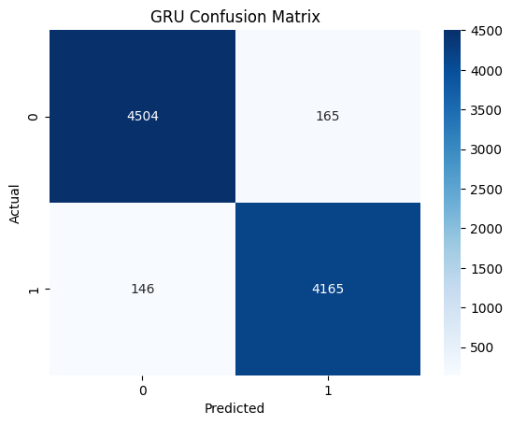
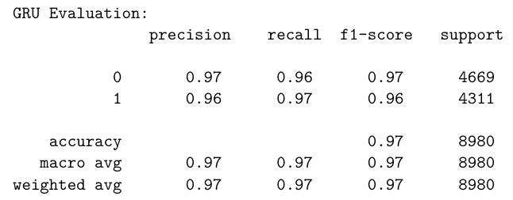
Insights
The GRU model demonstrated performance closely rivalling that of the BiLSTM, with an accuracy of 91.69%. It correctly classified 1253 out of 1373 fake headlines, resulting in a recall of 91.26% for the fake news class. Additionally, it misclassified only 110 real headlines as fake, achieving a real news recall of 92.11% and a balanced F1-score of approximately 91.7% across both categories.
Although slightly less accurate than BiLSTM, GRU offered comparable precision and recall while using fewer trainable parameters. Its simplified gate structure enabled faster training and lower memory consumption, making it a strong candidate for deployment in resource-constrained environments such as mobile applications, browser extensions, or embedded systems.
What sets GRU apart is its ability to retain contextual information while maintaining computational efficiency. This allows it to capture subtle sequential patterns in headlines without the computational burden of full LSTM units. As a result, GRU strikes a solid balance between performance and efficiency, providing a scalable solution for fake news detection when deployment constraints must be considered.
Summary of Results
Model | Accuracy | Fake Precision | Fake Recall | Real Precision | Real Recall | F1-Score (Avg) | Remarks
BiLSTM | 92.30% | 91.91% | 92.64% | 92.70% | 91.97% | 92.30% | Best overall performance and generalization
GRU | 91.69% | 91.93% | 91.26% | 91.46% | 92.11% | 91.69% | Nearly matches BiLSTM; more efficient
CNN | 89.16% | 89.65% | 88.35% | 88.69% | 89.96% | 89.16% | Fast and lightweight; slightly lower recall

Each model demonstrated the ability to detect fake news with high accuracy. The BiLSTM model offered the best overall performance, while the GRU provided a lightweight alternative with minimal trade-off in accuracy. The CNN model, although slightly behind in terms of recall, remained an effective choice for fast and scalable inference.

5. USER INTERFACE
To demonstrate the practical applicability of the trained models, a user-friendly web interface was developed using Gradio, a Python library for building interactive front ends for machine learning models. This interface enables real-time testing and allows users to input custom news headlines and immediately receive classification feedback indicating whether the headline is predicted to be real or fake.
The interface consists of three tabs, each corresponding to one of the implemented models: BiLSTM, CNN, and GRU. When a user enters a headline, it undergoes the same preprocessing pipeline as used during training—including cleaning, tokenization, and padding—before being passed into the selected model. The output is displayed as a probability distribution over the two classes (“Real” and “Fake”), highlighting which label the model predicts with greater confidence.
This interface serves not only as a deployment prototype but also as an educational tool to illustrate how AI systems make decisions based on textual data. The inclusion of all three models allows for comparison across different architectures, making it easier to assess which model performs best in specific contexts.
Model Tabs Overview:
- BiLSTM: Best overall accuracy and generalization
- GRU: Efficient with near-equivalent performance
- CNN: Fastest model for quick predictions
6. CONCLUSION
This project successfully demonstrates the effectiveness of deep learning models in detecting fake news using headline text alone. By implementing and comparing three neural network architectures: BiLSTM, CNN, and GRU; we evaluated their capabilities in binary text classification and highlighted their strengths and trade-offs.
Among the models tested, the BiLSTM architecture delivered the highest accuracy and recall, owing to its ability to capture bidirectional context in sequential data. The GRU model closely followed, offering nearly equivalent performance while being more computationally efficient. This makes it particularly suitable for lightweight deployment scenarios. Although the CNN model performed slightly lower in terms of recall, it still provided fast and reliable predictions and remains a strong candidate for time-sensitive or embedded applications.
The results affirm that even limited inputs such as headlines can contain enough linguistic cues for reliable classification, especially when processed through robust deep learning pipelines. This work contributes to the broader goal of developing trustworthy AI tools to support public awareness and counteract digital misinformation at scale. These findings support the viability of AI-powered solutions for early fake news detection, particularly in scenarios where rapid decisions need to be made and full-text analysis is not feasible.

7. FUTURE ENHANCEMENTS
There are several directions in which this project can be expanded. Firstly, using full news articles instead of just headlines would provide more context, potentially increasing the accuracy of the model. Secondly, advanced transformer-based architectures like BERT or RoBERTa could be integrated to further enhance language understanding. Adding explainability features such as LIME or SHAP would also help in understanding the model’s decisions, making the system more transparent to end-users. Additionally, training the model on multilingual datasets would increase its applicability in non-English contexts. Finally, deploying the models as part of browser plugins or content moderation tools could provide real-time protection against fake news online. Furthermore, user-centric interfaces could be enhanced with feedback mechanisms or confidence explanations to increase transparency and trust.

8. REFERENCES
[1] Yadav, A.K., Kumar, S., Kumar, D. et al. Fake News Detection Using Hybrid Deep Learning Method. SN COMPUT. SCI. 4, 845 (2023). https://doi.org/10.1007/s42979-023-02296-w

[2] Syed, L., Alsaeedi, A., Alhuri, L. A., & Aljohani, H. R. (2023). Hybrid weakly supervised learning with deep learning technique for detection of fake news from cyber propaganda. Array, 19, 100309. https://doi.org/10.1016/j.array.2023.100309

[3] S. Girgis, E. Amer and M. Gadallah, "Deep Learning Algorithms for Detecting Fake News in Online Text," 2018 13th International Conference on Computer Engineering and Systems (ICCES), Cairo, Egypt, 2018, pp. 93-97 https://doi.org/10.1109/ICCES.2018.8639198

[4] E.Almandouh, M., Alrahmawy, M.F., Eisa, M. et al. Ensemble based high performance deep learning models for fake news detection. Sci Rep 14, 26591 (2024). https://doi.org/10.1038/s41598-024-76286-0

[5] X. Li et al., "A Survey of Multimodal Fake News Detection: A Cross-Modal Interaction Perspective," in IEEE Transactions on Emerging Topics in Computational Intelligence https://doi.org/10.1109/TETCI.2025.3543389

