Inventory Demand Forecasting: Business Report
Built with AI assistance. The sales data is simulated (one store, 30 products, 156 weeks, 2023 to 2025) because no real store file was available. The results describe the simulation, not a real store.

1. The problem
Too little stock loses sales. Too much ties up cash in unsold goods and can leave products outdated. For each product, the question is how many units to reorder for next week, given what is already on hand and on order.

2. The data
The raw file has one row per product per week: units sold, price, promotion and festival flags, stock on hand, stock on order, and the store's own order quantities. Next-week rows hold the planned price, promotion and festival flag, with no sales yet.
Cleaning fixed: 706 category labels with extra spaces or capitals, 60 dates in a second format, 25 duplicate product-weeks, 12 negative sales, 40 missing prices and 30 missing festival flags. The result is 4,680 product-weeks with no missing values or duplicates.
Stockouts occur in 30% of product-weeks. When a product runs out, recorded sales show only what was on the shelf, so they understate demand.

3. What the data shows
- Beverages peak in summer (about 1.3 times their normal level in June) and dip in winter. Personal Care peaks in December.
- Snacks and Dairy stay within about 10% of their normal level all year.
- Promotions lift sales by a median of 1.35 times, but the lift varies a lot by product.
- Median price elasticity is -1.42: a 10% price cut lifts units by roughly 14%.
- Last week's sales is a weak signal (week-to-week correlation -0.22), because stock arrives in waves and sales follow replenishment.

4. Method
Each forecast uses only information known before the forecast week: recent sales, rolling averages, the same week last year, next week's planned price and promotion, the festival flag and week of year. Stock on hand is left out on purpose, since low stock lowers recorded sales.
The notebook also prints how strongly each input moves with next week's sales. The 4-week and 8-week averages are the strongest, at about 0.76 and 0.77 correlation.
The data is split by time. Models train on weeks 52 to 141 and are tested on the last 13 weeks. The best model is chosen on a validation window inside the training weeks (weeks 130 to 141), so the test weeks are not used for the choice.
Six methods were compared: two baselines (last week's sales and the 4-week average) and five models (ridge regression, random forest, gradient boosting, LightGBM and XGBoost).
Each tree model was tried with a small set of settings (22 combinations in total), scored on the validation weeks only. The settings that won are in the notebook and in outputs/tuning_results.csv. The gap between settings is under 2 points of validation error for each model, so tuning is a check, not a big gain.
Reorder quantity = three weeks of forecast demand + safety stock − (stock on hand + stock on order), never below zero. Safety stock is set from each product's typical forecast miss on the validation weeks.

5. Results

Choosing the model (validation weeks)
Method | Validation error
Random forest | 23.1%
Gradient boosting | 23.3%
LightGBM | 23.3%
XGBoost | 23.4%
Ridge regression | 25.5%
4-week average | 29.0%
Last week's sales | 40.2%

Random forest had the lowest validation error, so the forecast and reorder table use it.

Accuracy on the test weeks
Method | Error (WAPE) | MAE (units) | RMSE (units) | Better than last week
Last week's sales | 50.5% | 36.5 | 54.6 | 0%
4-week average | 34.8% | 25.2 | 35.9 | 31%
Ridge regression | 29.2% | 21.2 | 30.1 | 42%
Random forest | 27.8% | 20.1 | 28.9 | 45%
Gradient boosting | 27.7% | 20.0 | 28.6 | 45%
LightGBM | 27.9% | 20.2 | 29.2 | 45%
XGBoost | 28.2% | 20.4 | 29.0 | 44%

The best model cuts error by about 20% against the 4-week average on recorded sales. Recorded sales understate demand in stockout weeks, so this is a floor on the real gap.
The four tree-based models are within about half a point of each other on the test weeks. None of them clearly beats the others, so the choice between them doesn't change the conclusion.
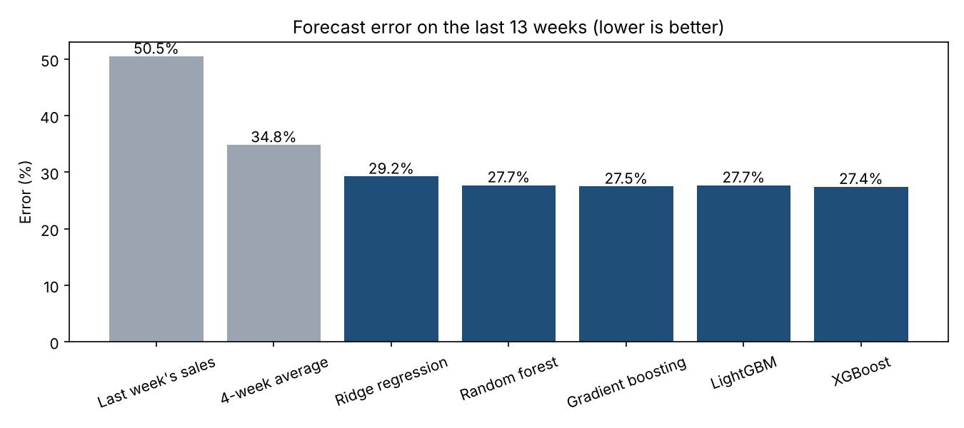

Reorder cost (simulation, test weeks)
Cost is lost margin on short units plus carrying cost on extra units. The 30% margin and 25% carrying cost are assumptions. Replace them with real figures before using the buffer results.
Policy | Total cost, 95% safety stock (INR) | Total cost, cost-optimal safety stock (INR)
Store's recorded orders | 1,148,196 | 1,148,196
Last week's sales | 1,790,231 | 1,271,866
4-week average | 1,227,291 | 735,248
Ridge regression | 1,167,132 | 955,580
Random forest | 1,113,754 | 818,113
Gradient boosting | 1,085,174 | 786,832
LightGBM | 1,098,265 | 797,190
XGBoost | 1,117,203 | 813,847

- At the 95% safety stock, gradient boosting is the cheapest model, with random forest about 3% higher. The model was chosen on validation error, not cost, so the forecast still uses random forest.
- At the cost-optimal safety stock, the simple 4-week average is cheapest.
- The store's recorded orders look cheap at the 95% level, but they have stockouts in 78% of weeks. The cost measure uses recorded sales as demand, so it favours lean stock levels. Treat these cost comparisons as unreliable until stockouts are fixed.

6. Which products need attention
Likely to run out next week, in order of expected shortfall:
Product | Category | Forecast next week | On hand | On order | Expected short (units) | Reorder (units)
P09 | Beverages | 83.1 | 0.0 | 39.9 | 43.2 | 316
P11 | Beverages | 70.5 | 0.0 | 38.9 | 31.6 | 245
P10 | Beverages | 53.9 | 29.9 | 2.2 | 21.8 | 208
P19 | Dairy | 72.4 | 11.4 | 51.4 | 9.6 | 207
P06 | Snacks | 96.1 | 0.0 | 86.7 | 9.4 | 294
P18 | Dairy | 40.7 | 13.6 | 20.0 | 7.1 | 149
P29 | Personal Care | 40.9 | 40.2 | 0.0 | 0.7 | 107

Overstock: 0 products. No product holds more than about 2 weeks of forecast demand, and the overstock flag is set at 4 weeks. The real risk in this data is running out, not holding too much.
Hardest to forecast (highest test error for the chosen model): P16 (49.2%), P12 (46.2%), P02 (39.3%), P09 (37.1%), P07 (36.7%). These products also run out of stock often, which hides their demand.
Total recommended reorder for next week: 5,372 units across 30 products. P29 is borderline: its expected shortfall is under 1 unit.

7. Answers to the business questions
- Which products are most difficult to forecast? P16, P12, P02, all with frequent stockouts and large week-to-week swings.
- Does the model improve on the simple baseline? Yes on accuracy: 20% less error than the 4-week average and 45% less than last week's sales. On cost, the answer depends on the safety stock level and is not settled until stockouts are handled.
- Which products are likely to run out next week? P09, P11, P10, P19, P06, P18, and P29 (borderline).
- Which products appear overstocked? None.
- How could the inventory team use this? Check the at-risk list before each order, use the recommended quantity as a starting point, and adjust for promotions and supplier delays.

8. Limitations
- The data is simulated. The method carries over to real data; the numbers do not.
- Stockouts hide demand. The model learns from sales capped by stock, and the reorder test treats recorded sales as demand. Safety stock is probably too small, and the cost comparison favours lean stock.
- Costs are assumptions. The margin and carrying-cost figures decide which buffer level looks best.
- One 13-week test window is a small sample. The top tree models are close enough that a different window could change the ranking. The tuning also used one validation window.
- Safety stock uses 13 validation weeks per product, which is a small sample for estimating spread.

9. Next steps
- Get a real sales extract with stockout flags and at least a year of weekly history.
- Fix censored demand: flag stockout weeks and either exclude them from training or model demand with a censored-data method.
- Get real margin, carrying cost and lead time, then rerun the cost comparison.
- Test the models across several different test windows to see which ranking holds.
- Run the notebook each week to refresh the forecast, the at-risk list and the reorder table.

