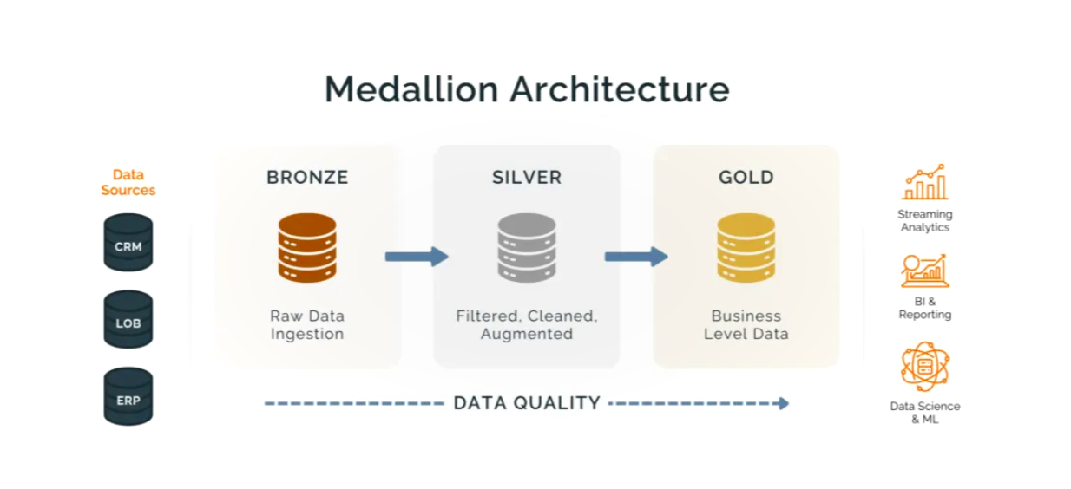

FLOW
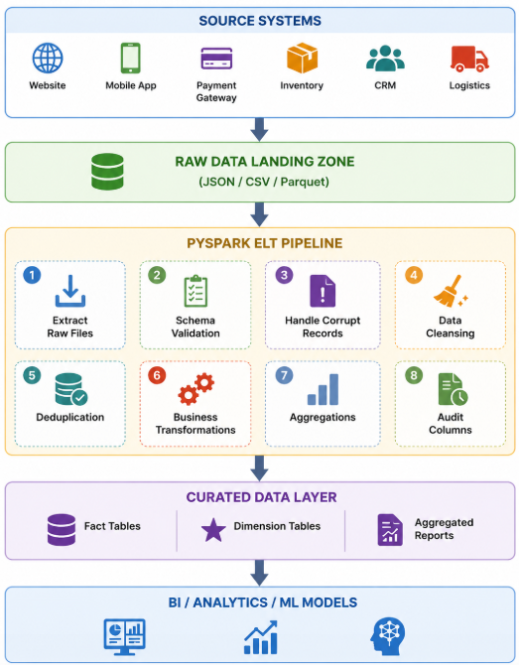

The company wants to build a scalable ELT (Extract, Load, Transform) pipeline using PySpark to:
- Ingest raw data from multiple systems
- Load raw data into a data lake
- Clean and transform the data
- Handle bad records
- Deduplicate transactions
- Join customer and product information
- Generate business KPIs
- Store curated analytics-ready data

Corruptions Included
- Invalid IDs (BAD_ID, INVALID)
- Null customer IDs
- Invalid prices (BAD_PRICE)
- Invalid quantities (TEN)
- Malformed dates (32-13-2025)
- Missing fields
- Duplicate transactions
- Unknown statuses
- Incorrect emails/phones

