1)

# CODE:

import React from 'react';

function App() { return (

<div>

<h1>Welcome to the first session of React</h1>

</div>

);

}

export default App;

# OUTPUT:

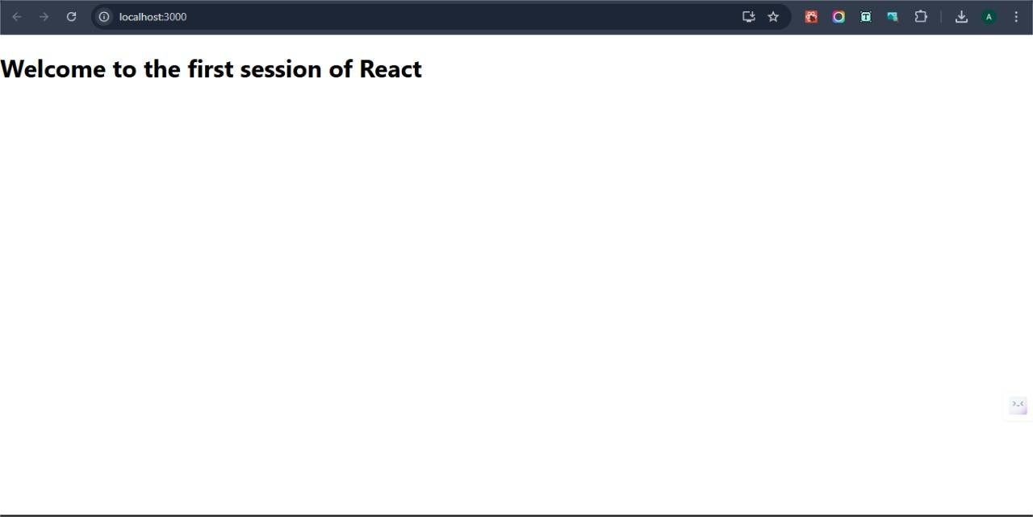

2)

# CODE:

import React, { Component } from 'react';

class Home extends Component { render() {

return (

<div>

<h2>Welcome to the Home page of Student Management Portal</h2>

</div>

);

}

}

export default Home;

import React, { Component } from 'react';

class Contact extends Component { render() {

return (

<div>

<h2>Welcome to the Contact page of the Student Management Portal</h2>

</div>

);

}

}

export default Contact;

import React, { Component } from 'react';

class About extends Component { render() {

return (

<div>

<h2>Welcome to the About page of the Student Management Portal</h2>

</div>

);

}

}

export default About;

# OUTPUT:

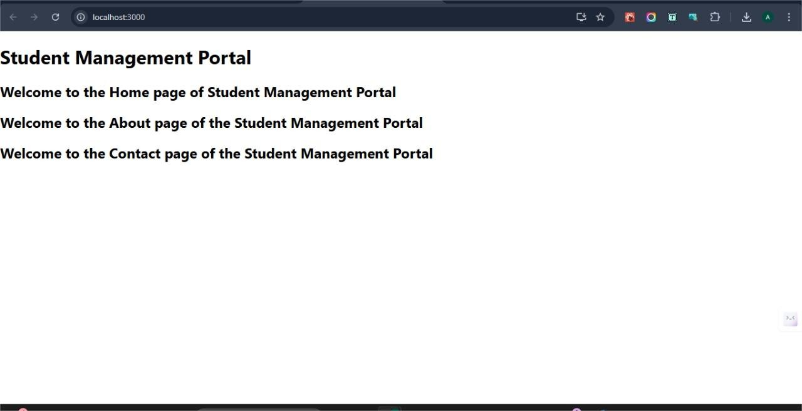

3)

# CODE:

import React from 'react';

import '../Stylesheets/mystyle.css';

function CalculateScore(props) {

const { name, school, total, goal } = props; const average = total / goal;

return (

<div className="score-card">

<h2>Student Score Report</h2>

<p><strong>Name:</strong> {name}</p>

<p><strong>School:</strong> {school}</p>

<p><strong>Total Score:</strong> {total}</p>

<p><strong>Goal (Subjects):</strong> {goal}</p>

<p><strong>Average Score:</strong> {average.toFixed(2)}</p>

</div>

);

}

export default CalculateScore;

# CSS:

.score-card {

border: 2px solid #4CAF50; padding: 20px;

margin: 20px; border-radius: 10px;

background-color: #f0fdf4;

box-shadow: 2px 2px 8px rgba(0, 0, 0, 0.1);

}

.score-card h2 { color: #388e3c;

}

.score-card p { font-size: 16px; line-height: 1.6;

}

import React from 'react'; import './App.css';

import CalculateScore from './Components/CalculateScore';

function App() { return (

<div className="App">

<h1>Score Calculator App</h1>

<CalculateScore name="ABCD" school="XYZ SCHOOL" total={465}

goal={6}

/>

</div>

); } export default App;

# OUTPUT:

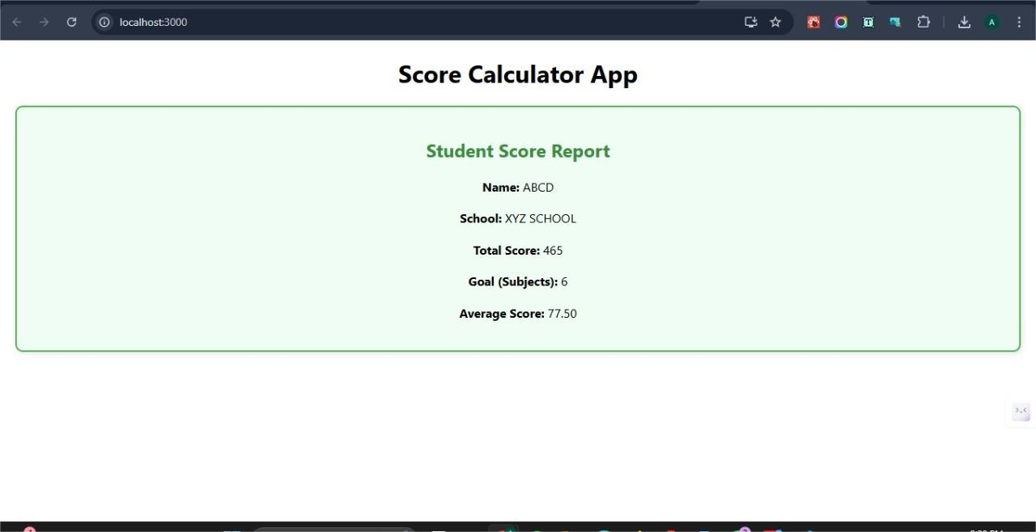

4)

# Code

// src/Post.js

import React from 'react';

class Post extends React.Component { render() {

const { title, body } = this.props; return (

<div style={{ border: '1px solid #ccc', padding: '10px', marginBottom: '10px' }}>

<h3>{title}</h3>

<p>{body}</p>

</div>

);

}

}

export default Post;

// src/Posts.js

import React from 'react'; import Post from './Post';

class Posts extends React.Component { constructor(props) {

super(props); this.state = { posts: [], hasError: false,

errorMessage: ''

};

}

// 4. Method to load posts using Fetch API loadPosts = async () => {

try {

const response = await fetch('https://jsonplaceholder.typicode.com/posts'); const data = await response.json();

this.setState({ posts: data });

} catch (error) {

this.setState({ hasError: true, errorMessage: error.message });

}

};

// 5. componentDidMount to call loadPosts componentDidMount() {

this.loadPosts();

}

// 6. componentDidCatch to catch errors componentDidCatch(error, info) {

this.setState({ hasError: true, errorMessage: error.toString() }); alert(`Error caught in component: ${error}`);

}

// 7. render method render() {

if (this.state.hasError) {

return <h2>Something went wrong: {this.state.errorMessage}</h2>;

}

return (

<div>

<h1>Blog Posts</h1>

{this.state.posts.map(post => (

<Post key={post.id} title={post.title} body={post.body} />

))}

</div>

);

}

}

export default Posts;

// src/App.js

import React from 'react'; import './App.css';

import Posts from './Posts';

function App() { return (

<div className="App">

<Posts />

</div>

);

}

export default App;

# OUTPUT:

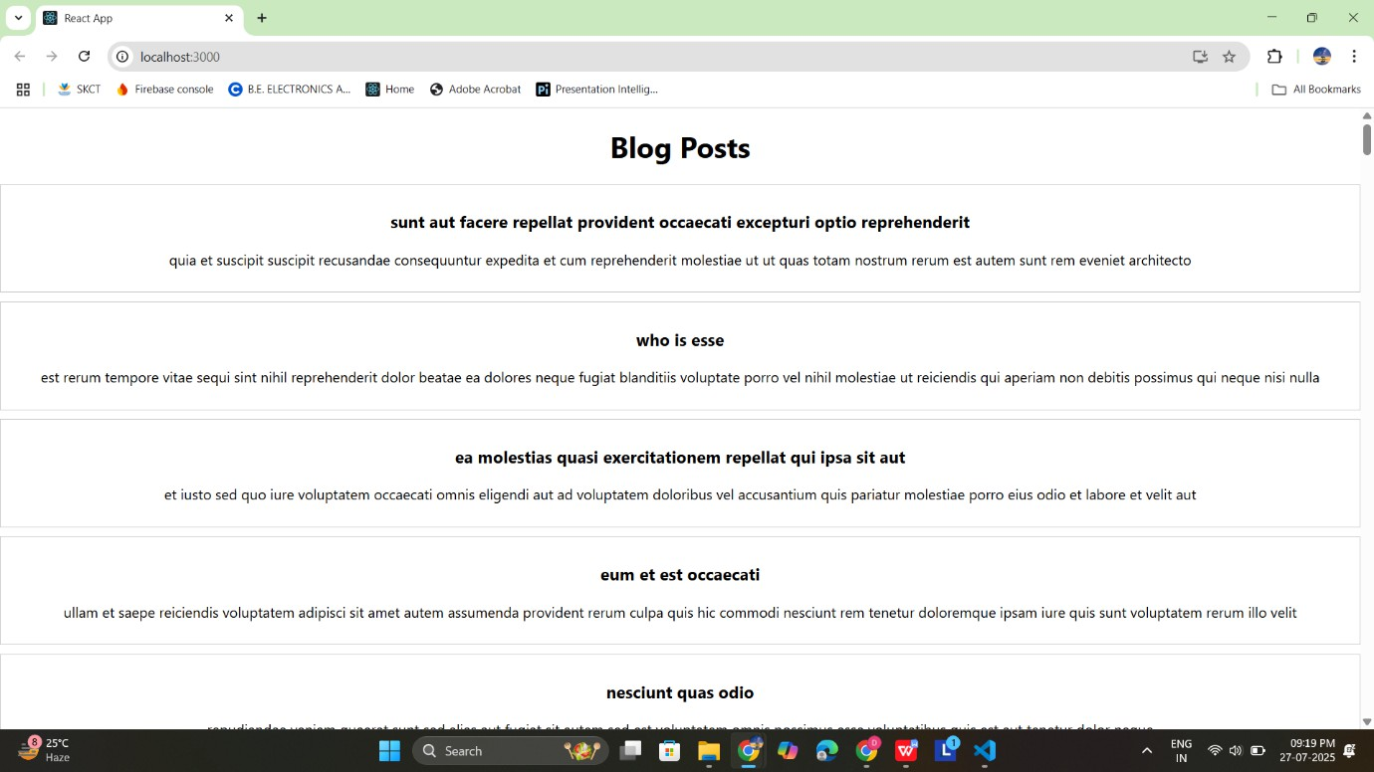

5)

# CODE:

**CohortDetails.js**

import React from 'react';

import styles from './CohortDetails.module.css';

function CohortDetails({ cohort }) {

const isOngoing = cohort.currentStatus.toLowerCase() === 'ongoing';

const titleStyle = {

color: isOngoing ? 'green' : 'blue', fontWeight: 'bold',

};

return (

<div className={styles.box}>

<h3 style={titleStyle}>

{cohort.cohortCode} - {cohort.technology}

</h3>

<dl>

<dt>Started On</dt>

<dd>{cohort.startDate}</dd>

<dt>Current Status</dt>

<dd>{cohort.currentStatus}</dd>

<dt>Coach</dt>

<dd>{cohort.coachName}</dd>

<dt>Trainer</dt>

<dd>{cohort.trainerName}</dd>

</dl>

</div>

);

}

export default CohortDetails;

# CSS:

.box {

width: 300px; display: inline-block; vertical-align: top; margin: 10px; padding: 10px 20px;

border: 1px solid #ccc; border-radius: 10px;

box-shadow: 0 1px 3px rgba(0, 0, 0, 0.1);

}

dt {

font-weight: 500; margin-top: 10px;

}

dd {

margin: 0 0 10px 0;

}

# App.js

import React from 'react';

import CohortDetails from './CohortDetails'; import { CohortsData } from './CohortData';

function App() { return (

<div>

<h2 style={{ paddingLeft: '10px' }}>Cohorts Details</h2>

<div style={{ display: 'flex', flexWrap: 'wrap', gap: '10px', padding: '10px' }}>

{CohortsData.map((cohort, index) => (

<CohortDetails key={index} cohort={cohort} />

))}

</div>

</div>

);

}

export default App;

**OUTPUT:**

