Product Inventory Management System - Project Documentation
1. Introduction:
Project Title: Product Inventory Management System
Team Leader: Deepadharshini V - gunaldharshini2006@gmail.com
Team Members:
1. Gopika S - gobikaselvaraj2007@gmail.com
2.Gayathri M - gayathrinkrcs@gmail.com
3. Neha Varshini S - nehavarshininkr@gmail.com

2. Project Overview:
Purpose: Product Inventory Management System is a web application designed to manage and track products in a store or warehouse. It allows users to add, update, delete, and monitor stock efficiently.
Features:
• Add new products to inventory
• Update product details
• Delete products
• View product list
• Track stock quantity
• User login system
3. Architecture:
Frontend: HTML, CSS, JavaScript / React.js
Backend: Node.js with Express.js
Database: MongoDB
4. Setup Instructions:
Prerequisites: Node.js, MongoDB, Git, Visual Studio Code
Installation Steps:
git clone <repository-link>
cd client
npm install
cd ../server
npm install
5. Folder Structure:
InventorySystem/
|-- client/
| |-- components/
| |-- pages/
|-- server/
| |-- routes/
| |-- models/
| |-- controllers/
6. Running the Application:
Frontend: cd client → npm start
Backend: cd server → npm start
Access: http://localhost:3000
7. API Documentation:
User APIs: POST /api/user/register , POST /api/user/login
Product APIs: GET /api/products , POST /api/products/add , PUT /api/products/update/:id , DELETE /api/products/delete/:id
8. Authentication: JWT (JSON Web Token) is used for secure login and to protect private routes.
9. User Interface: Login Page, Dashboard, Add Product Page, Product List Page, Update Product Page
10. Testing: Manual testing during development. Tools: Postman, Chrome DevTools, Jest
11. Screenshots or Demo:
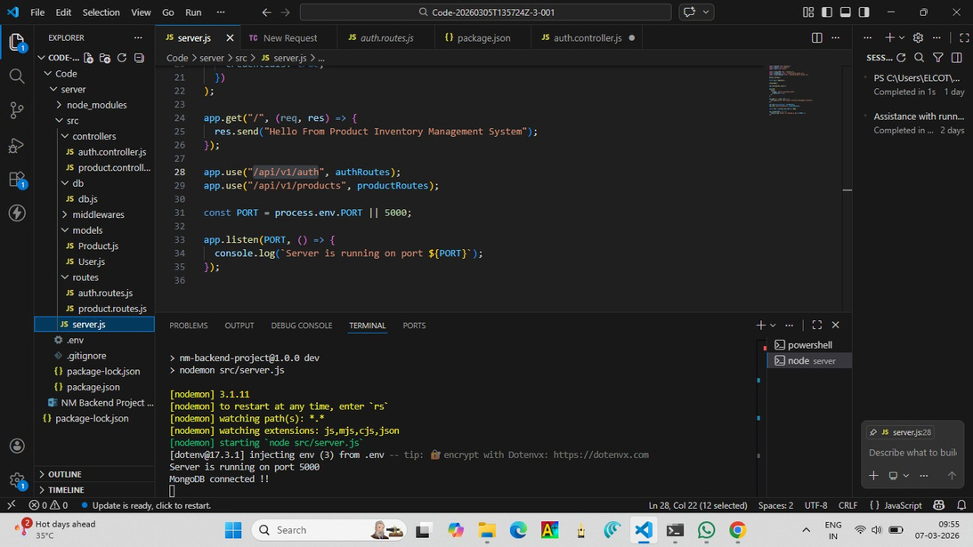
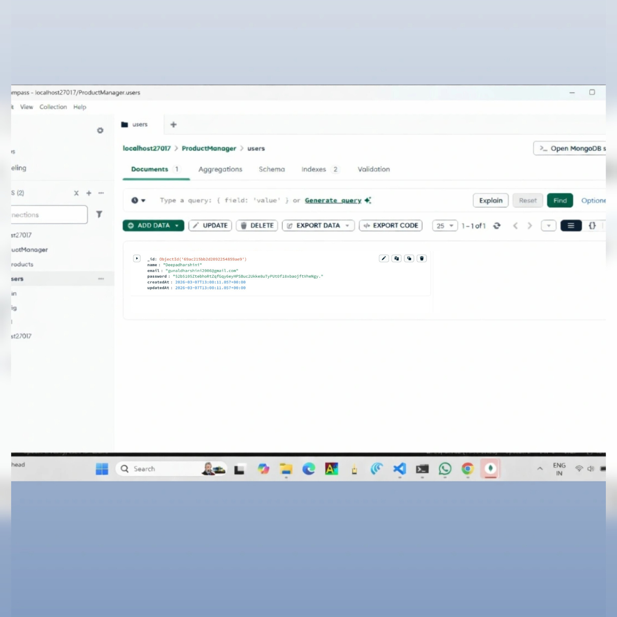
12. Known Issues: Slow loading when many products exist. No barcode scanning feature.
13. Future Enhancements: Barcode scanning for products, AI-based stock prediction, Mobile application support, Cloud database integration
Sample Backend Code (Node.js + Express):
const express = require("express");
const app = express();
app.use(express.json());
let products = [];
app.get("/products", (req, res) => {
res.json(products);
});
app.post("/products", (req, res) => {
const product = req.body;
products.push(product);
res.json({message: "Product added successfully"});
});
app.put("/products/:id", (req, res) => {
const id = req.params.id;
products[id] = req.body;
res.json({message: "Product updated"});
});
app.delete("/products/:id", (req, res) => {
const id = req.params.id;
products.splice(id,1);
res.json({message: "Product deleted"});
});
app.listen(3000, () => {
console.log("Server running on port 3000");
});

