**SOFTWARE TESTING CC-1**

**QUESTION 1:**

**CODE:**

package CC1test;

import org.openqa.selenium.By;

import org.openqa.selenium.WebDriver;

import org.openqa.selenium.chrome.ChromeDriver;

import org.openqa.selenium.chrome.ChromeOptions;

import io.github.bonigarcia.wdm.WebDriverManager;

public class Question_1 {

public static void main(String[] args) throws InterruptedException {

// TODO Auto-generated method stub

ChromeOptions co=new ChromeOptions();

co.addArguments ("--remote-allow-origins=*");

WebDriverManager.chromedriver().setup ();

WebDriver driver=new ChromeDriver();

driver.get ("https://www.saucedemo.com/");

driver.manage().window().maximize();

Thread.sleep(3000);

driver.findElement(By.xpath("//*[@id=\"user-name\"]")).sendKeys("standard_user");

driver.findElement(By.xpath("//*[@id=\"password\"]")).sendKeys("secret_sauce");

driver.findElement(By.xpath("//*[@id=\"login-button\"]")).click();

driver.findElement(By.xpath("//*[@id=\"add-to-cart-sauce-labs-backpack\"]")).click();

String initial = driver.findElement(By.xpath("//*[@id=\"item_4_title_link\"]/div")).getText();

driver.findElement(By.xpath("//*[@id=\"shopping_cart_container\"]/a")).click();

String cart = driver.findElement(By.xpath("//*[@id=\"item_4_title_link\"]/div")).getText();

if(cart.equals(initial)) {

System.out.println("Product is added successfully");

}

else {

System.out.println("Something went worng!!!");

}

String check_cart = driver.findElement(By.xpath("//*[@id=\"continue-shopping\"]")).getText();

System.out.println(check_cart);

if(check_cart.equals("Continue Shopping")) {

System.out.println("Contents of the cart is viewed successfully!!!");

}

else {

System.out.println("Something went wrong!!!");

}

driver.findElement(By.xpath("//*[@id=\"checkout\"]")).click();

String checkout = driver.findElement(By.xpath("//*[@id=\"header_container\"]/div[2]/span")).getText();

if(checkout.equals("Checkout: Your Information")) {

System.out.println("My information is displayed successfully");

}

else {

System.out.println("Something went wrong!!!");

}

driver.findElement(By.xpath("//*[@id=\"first-name\"]")).sendKeys("vaish");

driver.findElement(By.xpath("//*[@id=\"last-name\"]")).sendKeys("p");

driver.findElement(By.xpath("//*[@id=\"postal-code\"]")).sendKeys("641008");

driver.findElement(By.xpath("//*[@id=\"continue\"]")).click();

String product_name = driver.findElement(By.xpath("//*[@id=\"item_4_title_link\"]/div")).getText();

String product_price = driver.findElement(By.xpath("//*[@id=\"checkout_summary_container\"]/div/div[1]/div[3]/div[2]/div[2]/div")).getText();

if(product_name.equals(cart)) {

System.out.println("Product overview is displayed");

System.out.println("product Name : "+product_name);

System.out.println("product price : "+product_price);

}

else {

System.out.println(cart);

System.out.println(product_name);

}

String title = driver.getTitle();

if(title.equals("Swag Labs")) {

System.out.println("Title matched");

}

else {

System.out.println("Title mismatched");

}

if(driver.getCurrentUrl().equals("https://www.saucedemo.com/checkout-step-two.html")) {

System.out.println("URL matched");

}

else {

System.out.println("URL mismatched");

}

driver.close();

}

}

**OUTPUT:**

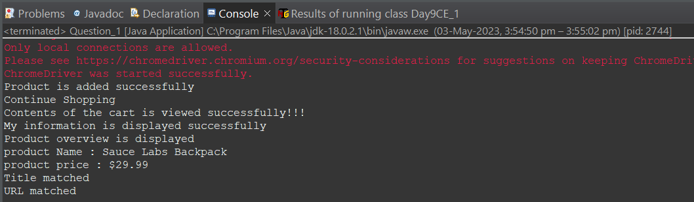

**QUESTION: 2**

**CODE:**

package CC1test;

import org.openqa.selenium.By;

import org.openqa.selenium.WebDriver;

import org.openqa.selenium.WebElement;

import org.openqa.selenium.chrome.ChromeDriver;

import org.openqa.selenium.chrome.ChromeOptions;

import io.github.bonigarcia.wdm.WebDriverManager;

public class Question_2 {

public static void main(String[] args) throws InterruptedException {

// TODO Auto-generated method stub

ChromeOptions co=new ChromeOptions();

co.addArguments ("--remote-allow-origins=*");

WebDriverManager.chromedriver().setup ();

WebDriver driver=new ChromeDriver(co);

driver.get ("https://www.saucedemo.com/");

driver.manage().window().maximize() ;

WebElement txtBoxl=driver.findElement(By.xpath("//*[@id=\"user-name\"]"));

txtBoxl.sendKeys("standard_user");

WebElement txtBox2=driver.findElement(By.xpath("//*[@id=\"password\"]"));

txtBox2.sendKeys("secret_sauce");

driver.findElement(By.xpath("//*[@id=\"login-button\"]")).click();

String txt1=driver.findElement(By.xpath("//*[@id=\"item_4_title_link\"]/div")).getText();

System.out.println(txt1);

System.out.println("Filter (A-Z) is used successfully!!!");

driver.findElement(By.xpath("//*[@id=\"header_container\"]/div[2]/div/span/select")).click();

driver.findElement(By.xpath("//*[@id=\"header_container\"]/div[2]/div/span/select/option[2]")).click();

String txt2=driver.findElement(By.xpath("//*[@id=\"item_3_title_link\"]/div")).getText();

System.out.println(txt2);

System.out.println("Filter (Z-A) is used successfully!!!");

driver.findElement(By.xpath("//*[@id=\"header_container\"]/div[2]/div/span/select")).click();

driver.findElement(By.xpath("//*[@id=\"header_container\"]/div[2]/div/span/select/option[3]")).click();

String txt3=driver.findElement(By.xpath("//*[@id=\"inventory_container\"]/div/div[1]/div[2]/div[2]/div")).getText();

System.out.println(txt3);

System.out.println("Filter (low price - high price) is used successfully!!!");

driver.findElement(By.xpath("//*[@id=\"header_container\"]/div[2]/div/span/select")).click();

driver.findElement(By.xpath("//*[@id=\"header_container\"]/div[2]/div/span/select/option[4]")).click();

String txt4=driver.findElement(By.xpath("//*[@id=\"inventory_container\"]/div/div[1]/div[2]/div[2]/div")).getText();

System.out.println(txt4);

System.out.println("Filter (high price - low price) is used successfully!!!");

driver.close();

}

}

**OUTPUT:**

