**KONGU COLLEGE OF ARTS AND SCIENCE KARUR**

**DEPARTMENT OF MATHEMATICS**

**NAAN MUDHALVAN PROJECT REPORT**

**Project partner: Smart internz Project by: Data literacy with tableau**

**Class: III B.Sc (MATHEMATICS) Team ID:NM2023TMID04614**

**INDIA’S AGRICULTURAL CROP PRODUCTION ANALYSIS (1997-2021)**

INTRODUCTION

OVERVIEW:

This report delves into the captivating realm of India’s agricultural cultivation, providing a comprehensive visual exploration of key aspects and trends in the agricultural sector. Through the visual representations, readers can gain valuable insights into crop production, seasonal variations, regional distribution, and overall production trends. These visualizations enable intuitive analysis, allowing stakeholders to uncover patterns, identify areas of growth or concern, and make data-driven decisions.

PURPOSE:

Agriculture in India is important for the development of the industrial sector and for trading purposes. Agricultural products like tea, coffee, etc. are some of the most edible, and textiles of India contribute to many parts of the total export from the country.

**PROBLEM DEFINITION AND DESIGN THINKING**

EMPATHY MAP:

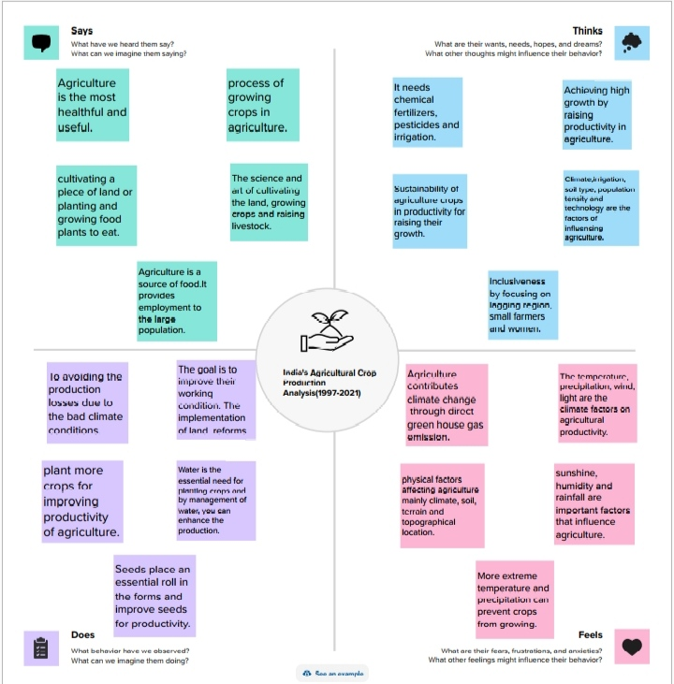

BRAINSTROMING MAP:

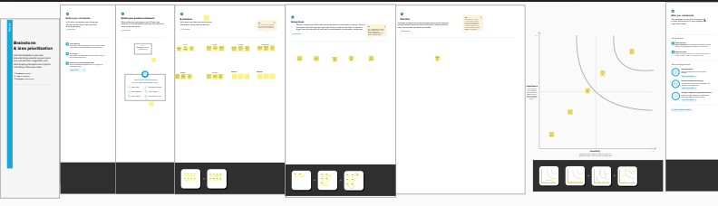

**RESULT**

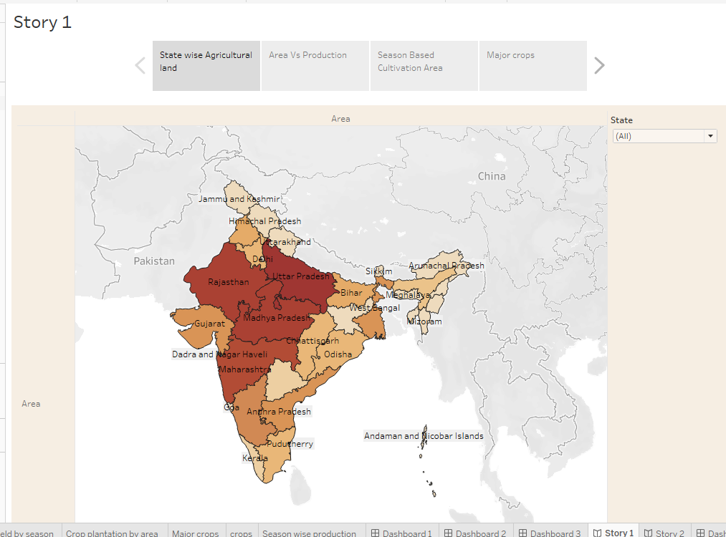

In this project, we conclude that the statewise agricultural land, area vs production, season based cultivation area, and major crops.

**ADVANTAGES**  
 Agriculture supplies raw material to various agro-based industries like sugar, jute, cotton textile and vanaspati industries.  
 Food processing industries are similarly dependent on agriculture. The development of these industries entirely is dependent on agriculture.  
 Agriculture is the backbone of the indian economy and it plays a crucial role in the ensuring food security for the population.

**DISADVANTAGES**  
 The type of farming is conducted on a large scale, it can lead a several environmental issues such as deforestation, soil degradation, water pollution and bio diversity loss. Food safety concerns.  
 Agriculture can lead to the depletion of natural resources such as water and soil.   
 It can lead to land degradation and desertification. Possibility of poor quality food production. It is risk to human health.

**CONCLUSION**  
 The Agriculture sector is of vital importance for the region. Agriculture has given so much to society but it has its own pros and cons that we can’t over look.

It is under going a process of transition to a market economy , with substantial changes in the social, legal, structural, productive and supply set-ups, as in the case with all other sector of the economy.

India’s Agriculture sector is still very important to the indian economy, although its share of the economy has decreased over the past 50 years.

**FUTURE SCOPE**

There will be more of vertical and urban farming and there will also be efforts in long term to find new areas for production like barren deserts and seawater. Hydroponic farming, which is a soil-less, water-based farming operation, that may even be done in a tiny space is going to pick up the pace.

**APPENDIX**

SOURCE CODE:

https://public.tableau.com/app/profile/dharani.p5674/vizzes