Assignment 2


학 과 | 디지털헬스학과
교수님 | 신수용 교수님
학 번 | 2021710781
이 름 | 금나현
제출일 | 2021.03.18



- What happens if you implement only parts of a GRU, e.g., with only a reset gate or only an update gate?
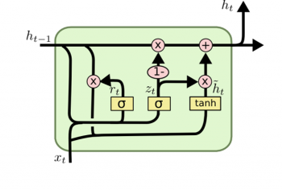
We can select how much data we want to pass through by reset gate.
And the update gate determines the weight between $h_{t-1}$ and $\tilde{h}t$.
However, the existence of only reset gate can lead to vanishing gradient problems that can be observed in vanilla RNN, because it cannot specify the weight of the currently entered data $x_{t}$ and previously derived data $h_{t-1}$.
In addition, if only update gate exists, we can only determine the weight between $\tilde{h}t$ ,that is temporary output data calculated as a tanh function on the current input $x_{t}$, and $h_{t-1}$ . we cannot select for the values of $h_{t-1}$. That is the same effect as the recent input data may have increased importance.

- Compare the computational cost for GRUs, LSTMs, and regular RNNs for a given hidden dimension. Pay special attention to the training and inference cost.
GRU > LSTM > RNN .
GRU has less learning weight than LSTM. This will shorten the learning time and can be learned with less data.
Also, when processing sequential data such as time series, text data, as well as audio data such as sound, the input remembers the previous information longer even if it is longer. In short, LSTM is a more advanced form of circular neural network than RNN.

