Assignment 5


학 과 | 디지털헬스학과
교수님 | 신수용 교수님
학 번 | 2021710781
이 름 | 금나현
제출일 | 2021.04.08



- Assume that you want to balance a (real) ball on a (real) saddle.
  - Why is this hard?
A saddle point is a point on the surface of the graph of a function where the slopes in orthogonal directions are all zero (a critical point), but which is not a local extremum of the function. When we try to make it stand still at this point, a little disturbance will get it out of the saddle point.
  - Can you exploit this effect also for optimization algorithms?
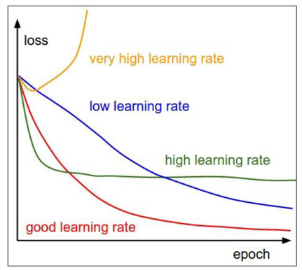
As shown in this figure, it can be set to high learning rate at the beginning and then found to the point where the loss function is minimal while reducing the learning rate at the end.

- What changes when we perform SGD with momentum? What happens when we use minibatch SGD with momentum?
Adding momentum literally speeds up the movement by adding inertia.
It can also be expected that using the momentum method will have the effect of exiting the local minima.
A similar effect will be shown in minibatch SGD.

https://en.wikipedia.org/wiki/Saddle_point

