Assignment 6


학 과 | 디지털헬스학과
교수님 | 신수용 교수님
학 번 | 2021710781
이 름 | 금나현
제출일 | 2021.04.15



- We learned optimizer such asSGD, Adagrad, RMSProp, Adadelta, and Adam. Research the other two state-of-the- art optimizers and explain their feature.
  - AdaMod
AdaMod is a stochastic optimizer that restricts adaptive learning rates with adaptive and momental upper bounds. The dynamic learning rate bounds are based on the exponential moving averages of the adaptive learning rates themselves, which smooth out unexpected large learning rates and stabilize the training of deep neural networks.
The weight updates are performed as:
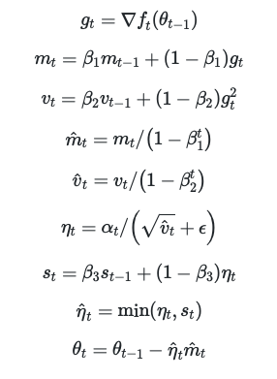
<AMSGrad>
AMSGrad is a stochastic optimization method that seeks to fix a convergence issue with Adam based optimizers. AMSGrad uses the maximum of past squared gradients vt rather than the exponential average to update the parameters:
