- AdamW
AdamW is a stochastic optimization method that modifies the typical implementation of weight decay in Adam, by decoupling weight decay from the gradient update. To see this, L2 regularization in Adam is usually implemented with the below modification where Wt is the rate of the weight decay at time t:
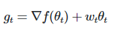
while AdamW adjusts the weight decay term to appear in the gradient update:
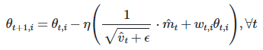
AdamW yields better training loss and that the models generalize much better than models trained with Adam allowing the new version to compete with stochastic gradient descent with momentum.
- AdaBound
AdaBound is a variant of the Adam stochastic optimizer which is designed to be more robust to extreme learning rates. Dynamic bounds are employed on learning rates, where the lower and upper bound are initialized as zero and infinity respectively, and they both smoothly converge to a constant final step size. AdaBound can be regarded as an adaptive method at the beginning of training, and thereafter it gradually and smoothly transforms to SGD (or with momentum) as the time step increases.
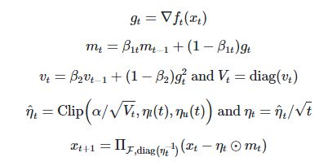
Where α is the initial step size, and η_{l} and η_{u} are the lower and upper bound functions respectively.
Motivated by the strong generalization ability of SGD, they design a strategy to constrain the learning rates of ADAM and AMSGRAD to avoid a violent oscillation. The proposed algorithms, AdaBound and which employ dynamic bounds on their learning rates, achieve a smooth transition to SGD. They show the great efficacy on several standard benchmarks while maintaining advantageous properties of adaptive methods such as rapid initial progress and hyperparameter insensitivity.

