Assignment#3
- Can you design a learnable positional encoding method?
The positional encoding allows a model to easily learn to attend by relative positions. The characteristic of sinusoidal positional encoding is that it allows the model to attend relative positions effortlessly.
Proposed Method:
Let t be the desired position in an input sentence, p_{t}∈R^{d} be its corresponding encoding, and d be the encoding dimension (where d≡2 0) Then f: N→R^{d} will be the function that produces the output vector P_{t} and it is defined as follows:
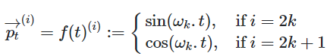[1]
Where
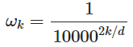 [1]
You can also imagine the positional embedding P_{t} as a vector containing pairs of sines and cosines for each frequency (Note that d is divisible by 2):
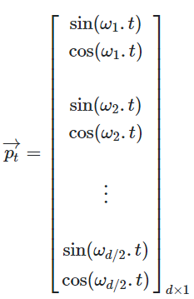 [1]
Earlier in this post, it mentioned that positional embeddings are used to equip the input words with their positional information. In fact, the original paper added the positional encoding on top of the actual embeddings. That is for every word ωt in a sentence [ω1,... ωn], alculating the correspondent embedding which is fed to the model is as follows:
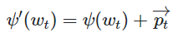「1」
To make this summation possible, we keep the positional embedding’s dimension equal to the word embeddings’ dimension i.e. dword embedding=dpostional embedding
For every sine-cosine pair corresponding to frequency ω_{k}, there is a linear transformation M∈R^{2×2} (independent of t) where the following equation holds:
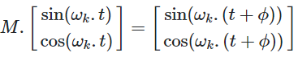[1]
Proof:
Let M be a 2×2 matrix, we want to find u1, v1, u2 and v2 so that:
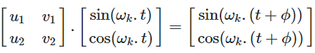[1]
By applying the addition theorem, we can expand the right-hand side as follows:
[1]
Which result in the following two equations:
[1]
By solving above equations, we get:
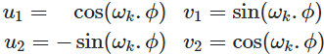 [1]
So, the final transformation matrix M is:
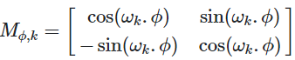 [1]
As you can see, the final transformation does not depend on t. Note that one can find the matrix M very similar to the rotation matrix.
Similarly, we can find M for other sine-cosine pairs, which eventually allows us to represent P_{t+ϕ} as a linear function of P_{t} for any fixed offset ϕ. This property, makes it easy for the model to learn to attend by relative positions.
So, the positional encoding can easily learn to attend by relative positions.
2. What can be challenges to Transformers if input sequences are very long? Why?
Extending Transformer to even larger context windows runs into limitations. Because the power of Transformer comes from attention, the process by which it considers all possible pairs of words within the context window to understand the connections between them. So, in the case of a text of 100K words, this would require assessment of 100K x 100K word pairs, or 10 billion pairs for each step, which is impractical.
Another challenge is with the standard practice of storing the output of each model layer. For applications using large context windows, the memory requirement for storing the output of multiple model layers quickly becomes prohibitively large (from gigabytes with a few layers to terabytes in models with thousands of layers). This means that realistic Transformer models, using numerous layers, can only be used on a few paragraphs of text.

Reference:
- Kazemnejad, A. Transformer Architecture: The Positional Encoding. 2019.

