- Is it efficient to use matrix multiplication to implement convolution operations?
Why?
Yes, it is efficient to use matrix multiplication to implement convolution operations.
As we known, a more realistic implementation will only be further complicated by parameters like stride, dilation, padding, etc. We could continue using the basic conv as a working example but, as you will see, extracting maximum performance out of the computer requires many tricks – carefully fine-tuning at multiple levels & exploiting very specific knowledge of the computer architecture at hand. In other words, this is going to be a formidable task if we are hoping to address all of the complexities.
However, Matrix multiplication can be easier to solve some problems.
Matrix multiplication, or Generalized Matrix Multiplication (GEMM), is at the heart of deep learning. It is used in fully-connected layers, RNNs, etc., and can be used to implement convolutions too.
Conv is, after all, a dot-product of the filter with input patches. If we lay out the filter into a 2-D matrix and the input patches in another, then the multiplying these 2 matrices would compute the same dot product. And matrix multiplication – unlike CNNs – has been heavily studied and optimized over several decades, being a critical problem in many scientific domains.
The above laying out of the image patches into a matrix is called im2col, for image to column. We rearrange the image into columns of a matrix, so that each column corresponds to one patch where the conv filter is applied.
Consider this normal, direct 3x3 convolution:
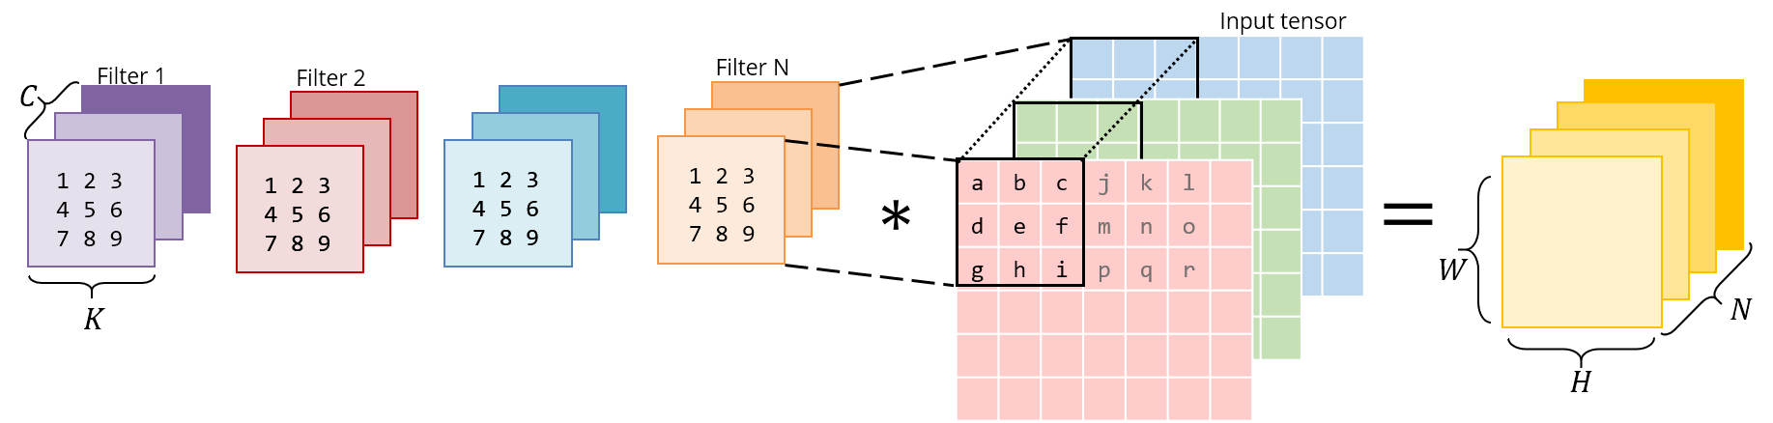
Below is the same operation implemented as a matrix multiplication. The right matrix is the result of im2col – it has to be constructed by copying pixels from the original image. The left matrix has the conv weights, which are already stored this way in memory.
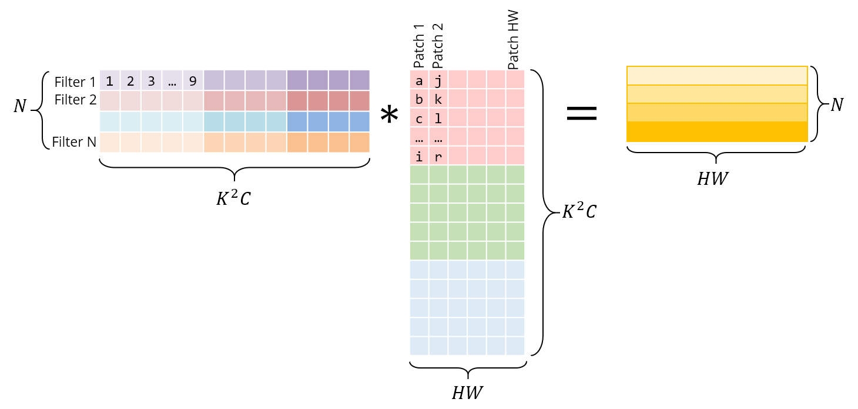

Note that the matrix product gives us the conv output directly – there is no need for an extra “conversion” to the original form.
It has shown each patch as independent here for visual clarity. However, in reality, there usually is some overlap between different image patches, and hence im2col incurs some memory duplication. The time taken to generate this im2col buffer and the inflated memory, will have to be offset by the speedup we achieve via GEMM.
With im2col, we have now transformed the convolution operation into a matrix multiplication. We can now plug in more general-purpose & popular linear algebra libraries like OpenBLAS, Eigen, etc. to take care of efficiently computing this matrix multiplication, riding on the back of decades of optimizations & careful fine-tuning.
That is the reason that it is efficient to use matrix multiplication to implement convolution operations.

Reference:
- Sahni. M. Anatomy of a High-Speed Convolution. (2019)

