- Adamax is a variant of Adam based on the infinity norm. In Adam update rule scales the gradient inversely proportionally to the 𝔩₂ norm of the past gradients (vₜ-₁) and the current gradient term(|gₜ|²) instead of this we can generalize the update to the 𝔩ₚ norm.
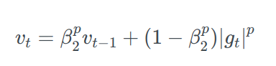
putting p →∞ ,
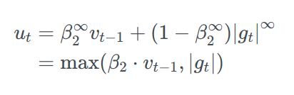
Finally, we can now put this uₜ in the Adam update equation by replacing with √^vₜ + ϵ :
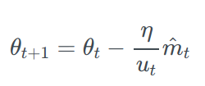
Note that as uₜ relies on the max operation, it is not as suggestible to bias towards zero as mₜ and vₜ in Adam, which is why we do not need to compute a bias correction for uₜ. Good default values are again η=0.002, β₁=0.9 and β₂=0.999 .

AMSGrad uses the maximum of past squared gradients vₜ rather than the exponential average to update the parameters.
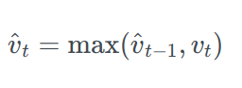
The full AMSGrad update is :
