SAVEETHA INSTITUTE OF MEDICAL AND TECHNICAL SCIENCES (SIMATS ENGINEERING)
DEPARTMENT OF COMPUTER SCIENCE AND ENGINEERING
CO1 – AT1
Scalability Audit of an E-Commerce Platform (“ShopSphere”)
CSA06 – Design and Analysis of Algorithms
Assessment Tool 1: IT Application-Based Problem Solving
Course Outcome CO1: Determine algorithm efficiency using asymptotic notations and mathematical techniques including the Master Theorem and substitution method.
Mode: Individual Duration: 3 days
Student name: K DHEEPAK
Student Reg. No.: 192411108

0. Overview, Assumptions and Method
This report audits five back-end modules (M1–M5) of the ShopSphere platform. For each module the basic operation is identified, the operation count is derived step by step, the asymptotic result is stated, and its meaning for the platform is interpreted. Every closed form derived by hand was also verified by executing a program (Source_Code/): the instrumented code counts the basic operation directly, the recurrences are evaluated numerically and compared with the closed forms, and 12 unit tests pass.
Assumptions.
- Server speed. The question states “10 basic operations per second”, but the exponent did not survive in the text supplied (the superscript is missing). This report uses the common value $R={10}^{8}$ basic operations per second as the primary figure and repeats the final table for $R={10}^{9}$ so that the conclusion can be checked for either value. (Replace $R$ with the value printed in your question paper if it differs; time $=\text{operations}/R$.)
- All logarithms are base 2. For the recurrences $n$ is a power of 2 (the standard simplification; floors/ceilings do not change the asymptotic class).
- Constants in the recurrences are taken as written: $T\left(1\right)=1$ and the non-recursive work is exactly the stated term ($n$, $1$ or $nlogn$).
- The nightly window is 10 minutes = 600 s, i.e. a budget of $6×{10}^{10}$ operations at $R={10}^{8}$.
Symbol | Meaning
$$n$$ | catalogue size: 100,000 today, 1,000,000 expected within a year
$$R$$ | server speed, basic operations per second
$$L$$ | $$\log_{2}n$$

(a) Understand the Problem – input size and basic operation (Rubric: Understanding of Problem Context)
Module | Input size $n$ | Basic operation | Where it occurs | Expected growth of its execution count
M1 Duplicate detector | number of products | the IF test comparing title and seller of two products | innermost loop body, executed once for every pair $\left(i,j\right)$ with $i<j$ | one execution per pair of products: quadratic in $n$ (doubling $n$ makes it about 4 times larger)
M2 API rate limiter | upper limit $n$ of the audited window (number of requests) | Audit(Request[j]) (marked in the code) | body of the inner FOR, run $i$ times for each doubling value $i$ | the window sizes $1,2,4,…$ form a geometric series that is dominated by its last term, so the count grows only linearly in $n$
M3 Product search | number of entries in the catalogue / index | comparison of the search key with a stored product key | S1: body of the sequential scan; S2: the comparison with the middle entry in each halving step | S1 grows linearly with $n$; S2 grows with $logn$ (one extra comparison each time $n$ doubles)
M4 Recommendation engine | size of the customer–product data | the element-processing step of the linear-time merge, executed in every recursive call | the non-recursive term $n$ in $T\left(n\right)=aT\left(n/2\right)+n$ | each level of the recursion does about $n$ units of merge work when $a=2$; when $a=4$ level $i$ has $4^{i}$ sub-problems of merge work $n/2^{i}$ each, so the work per level doubles going down and is dominated by the deepest level – the total is quadratic for $a=4$ and $nlogn$ for $a=2$
M5 Sales analytics (and report generator) | number of sales records | a comparison made while sorting the records of a sub-problem; for $f\left(n\right)=3n^{2}+10nlogn+50$ the dominating operation is the one that is executed $3n^{2}$ times | the $nlogn$ term at every level of the recursion; the quadratic term of the report generator | $nlogn$ work at each of $logn$ levels, giving a little more than $nlogn$ in total; the report generator grows quadratically
Justification. In every module the chosen operation lies on the innermost path of the algorithm, is executed more often than any other statement, and every other statement is executed at most a constant number of times for each execution of it; hence the total running time is proportional to the number of times it executes.

(b) Analyse the Iterative Modules

M1 – Duplicate-Listing Detector
Derivation. For a fixed value of $i$ the inner loop runs for $j=i+1,…,n-1$, i.e. $n-1-i$ times, and each iteration executes one comparison. The outer loop has $i=0,1,…,n-2$:
$$C_{M1}\left(n\right)=\sum_{i=0}^{n-2}{\left(n-1-i\right)}=\left(n-1\right)+\left(n-2\right)+…+2+1=\frac{\left(n-1\right) n}{2}=\frac{n^{2}-n}{2}.$$
There is no early exit and no data-dependent branch around the comparison, so best, average and worst case are all equal to $\frac{n\left(n-1\right)}{2}$.
Complexity. Time: $\frac{n^{2}}{2}-\frac{n}{2}∈Θ\left(n^{2}\right)$. Space: only the loop counters $i,j$ are used besides the input, so auxiliary space is $Θ\left(1\right)$ (the input array itself needs $Θ\left(n\right)$).
Check by execution (verify.py): the counted number of comparisons equals $n\left(n-1\right)/2$ for $n=2,5,10,100,500,1000,2000$ (e.g. 1,999,000 for $n=2000$). Measured running time grows by a factor of about 4 each time $n$ doubles (ratios 4.00 and 4.77), as $Θ\left(n^{2}\right)$ predicts.
Meaning for the platform. $n=100,000$: $4,999,950,000≈5.0×{10}^{9}$ comparisons ($≈50$ s at $R={10}^{8}$). $n=1,000,000$: $499,999,500,000≈5.0×{10}^{11}$ comparisons – 100 times more for a catalogue that is only 10 times larger ($≈5,000$ s $=83$ min at $R={10}^{8}$).

M2 – API Rate Limiter
Derivation. The values taken by $i$ are $1,2,4,…$, i.e. $i=2^{t}$ for $t=0,1,2,…$ The WHILE condition $i<n$ holds as long as $2^{t}<n$, i.e. for $t=0,1,…,⌈\log_{2}n⌉-1$. So the outer loop executes $m=⌈\log_{2}n⌉$ times. In the iteration with $i=2^{t}$ the inner loop executes Audit exactly $i=2^{t}$ times. Hence
$$A\left(n\right)=\sum_{t=0}^{m-1}{2^{t}}=2^{m}-1=2^{⌈\log_{2}n⌉}-1.$$
(geometric series with ratio 2: $1+2+4+…+2^{m-1}=2^{m}-1$.)
Tight bound. Because $n≤2^{⌈\log_{2}n⌉}<2n$, we get $n-1≤A\left(n\right)<2n-1$, hence $A\left(n\right)∈Θ\left(n\right)$ with constants $c_{1}=1/2, c_{2}=2$ (for $n≥2$).
Is the team member’s claim $Θ\left(nlogn\right)$ correct? No. The reasoning “outer loop $≈logn$ times $×$ inner loop up to $n$ times” gives only an upper bound: the inner loop does not run $n$ times in every outer iteration. Its length doubles with each outer iteration (1, 2, 4, …), so only the very last iteration is of size about $n/2$ to $n$; the earlier ones are $n/2, n/4, n/8,…$ and together are no bigger than the last one. The sum is a geometric series dominated by its largest term, which yields $Θ\left(n\right)$ instead of $Θ\left(nlogn\right)$. The statement “$A\left(n\right)∈O\left(nlogn\right)$” is true but not tight, and “$A\left(n\right)∈Θ\left(nlogn\right)$” is false because $A\left(n\right)/\left(n\log_{2}n\right)<2/\log_{2}n→0$. Tight bound: $Θ\left(n\right)$.
Verification for $n=1,024$. $⌈\log_{2}1024⌉=10$, so the outer loop runs 10 times with $i=1,2,4,8,16,32,64,128,256,512$. Audits: $1+2+4+…+512=2^{10}-1=1023=n-1$. (The team member’s formula would predict about $n\log_{2}n=10,240$, ten times too many.) The program output confirms 1023 audit operations and 10 outer iterations for $n=1024$.
Complexity. Time $Θ\left(n\right)$, auxiliary space $Θ\left(1\right)$.
$$n$$ | outer iterations | exact Audit count $2^{⌈\log_{2}n⌉}-1$ | counted by program | $$n\log_{2}n$$
1,024 | 10 | 1,023 | 1,023 | 10,240
100,000 | 17 | 131,071 | 131,071 | 1,660,964
1,000,000 | 20 | 1,048,575 | 1,048,575 | 19,931,569
Meaning for the platform. About ${10}^{6}$ operations at $n={10}^{6}$ ($≈0.01$ s at $R={10}^{8}$): the rate limiter scales linearly and is not a scalability risk; the team member’s claim overestimates its cost by a factor of about $logn≈20$.
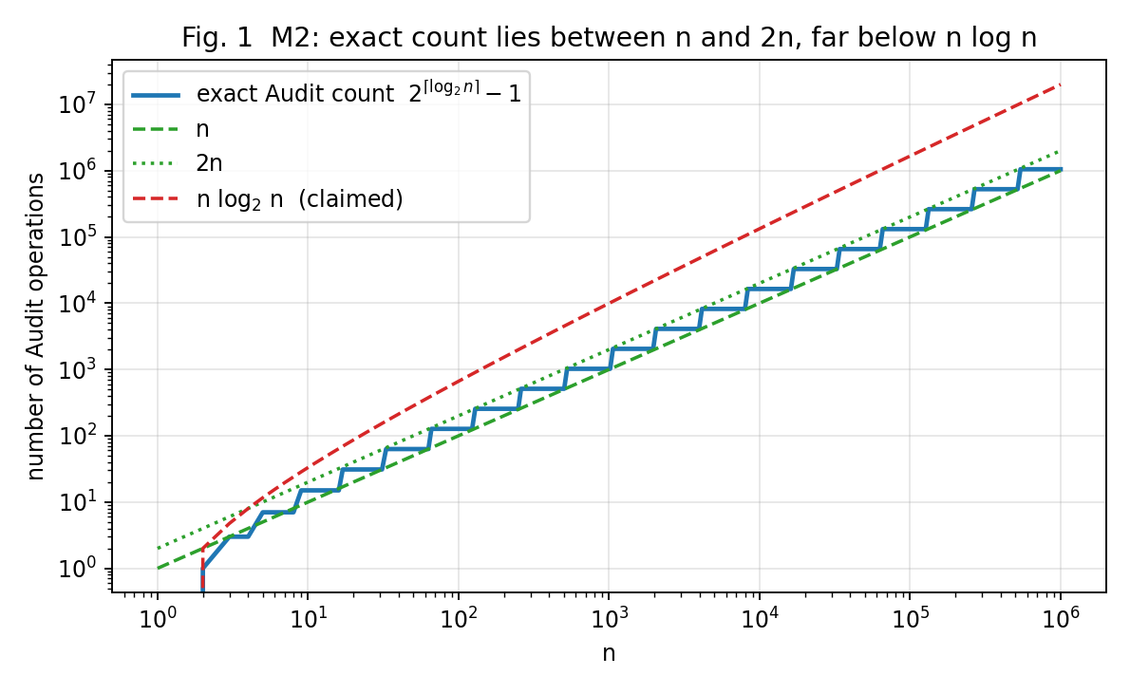

(c) Solve a Recurrence by Substitution – Search version S2
Recurrence: $T\left(n\right)=T\left(n/2\right)+1, T\left(1\right)=1$ (assume $n=2^{k}$).
Backward substitution, step by step.
$$\begin{matrix}T\left(n\right) & =T\left(n/2\right)+1 \\ & =\left[T\left(n/4\right)+1\right]+1=T\left(n/2^{2}\right)+2 \\ & =\left[T\left(n/8\right)+1\right]+2=T\left(n/2^{3}\right)+3 \\ & ⋮ \\ & =T\left(n/2^{k}\right)+k \left(\text{general pattern after }k\text{ substitutions}\right).\end{matrix}$$
The recursion stops when the argument reaches the base case: $n/2^{k}=1⇒k=\log_{2}n$. Substituting $T\left(1\right)=1$:
$$\boxed{T\left(n\right)=\log_{2}n+1} \left(\text{for general }n: ⌊\log_{2}n⌋+1\right).$$
Proof of the closed form by induction. Base: $T\left(1\right)=\log_{2}1+1=1$ ✓. Step: assume $T\left(n/2\right)=\log_{2}\left(n/2\right)+1$; then $T\left(n\right)=T\left(n/2\right)+1=\log_{2}n-1+1+1=\log_{2}n+1$ ✓.
Time complexity: $T\left(n\right)=\log_{2}n+1∈Θ\left(logn\right)$. For $n={10}^{6}$: $⌊\log_{2}{10}^{6}⌋+1=20$ comparisons.
Implementation | Time | Space | Reason
Iterative | $$Θ\left(logn\right)$$ | $$Θ\left(1\right)$$ | only low, high, mid are kept; the loop runs $\log_{2}n+1$ times
Recursive | $$Θ\left(logn\right)$$ | $$Θ\left(logn\right)$$ | each of the $\log_{2}n+1$ nested calls keeps one stack frame of constant size; the maximum recursion depth is $T\left(n\right)$ (20 frames for $n={10}^{6}$)
The program confirms the closed form: the recurrence value, the formula $\log_{2}n+1$, the measured worst-case comparisons of the iterative version, and the measured maximum recursion depth of the recursive version agree for $n=1,2,16,1024,131072,1048576$ (output: 1, 2, 5, 11, 18, 21). Meaning: doubling the catalogue costs S2 only one more comparison.

(d) Apply the Master Theorem
For $T\left(n\right)=aT\left(n/b\right)+f\left(n\right)$ compare $f\left(n\right)$ with $n^{\log_{b}a}$: Case 1 if $f\left(n\right)=O\left(n^{\log_{b}a-ε}\right)$ → $Θ\left(n^{\log_{b}a}\right)$; Case 2 if $f\left(n\right)=Θ\left(n^{\log_{b}a}\right)$ → $Θ\left(n^{\log_{b}a}logn\right)$; Case 3 if $f\left(n\right)=Ω\left(n^{\log_{b}a+ε}\right)$ and the regularity condition holds → $Θ\left(f\left(n\right)\right)$.

M4 – current design: $T\left(n\right)=4T\left(n/2\right)+n$
$a=4, b=2, f\left(n\right)=n, n^{\log_{b}a}=n^{\log_{2}4}=n^{2}$. Since $f\left(n\right)=n=O\left(n^{2-ε}\right)$ with $ε=1$, Case 1 applies:
$$T\left(n\right)=Θ\left(n^{2}\right).$$

M4 – proposed redesign: $T\left(n\right)=2T\left(n/2\right)+n$
$a=2, b=2, f\left(n\right)=n, n^{\log_{b}a}=n^{\log_{2}2}=n^{1}$. Since $f\left(n\right)=Θ\left(n\right)=Θ\left(n^{\log_{b}a}\right)$, Case 2 applies:
$$T\left(n\right)=Θ\left(nlogn\right).$$
Exact solutions (with $T\left(1\right)=1$, $n=2^{k}$; verified by the program): current $T\left(n\right)=2n^{2}-n$; redesign $T\left(n\right)=n\log_{2}n+n$.
What happens when the data doubles?
$$\frac{T\left(2n\right)}{T\left(n\right)} → 4 \text{(current, quadratic)}, \frac{T\left(2n\right)}{T\left(n\right)}=\frac{2\left(L+2\right)}{L+1} → 2 \text{(redesign)}.$$
$$n$$ | current $T\left(2n\right)/T\left(n\right)$ | redesign $T\left(2n\right)/T\left(n\right)$
1,024 | 4.001 | 2.182
16,384 | 4.000 | 2.133
262,144 | 4.000 | 2.105
So with the current design every doubling of the data quadruples the running time; with the redesign it only slightly more than doubles it. At $n={10}^{6}$ the current design needs $≈2.0×{10}^{12}$ operations and the redesign $≈2.09×{10}^{7}$ – about 95,000 times fewer. The cause is replication: four sub-problems of half size ($a=4$) means more total work at the leaves ($n^{2}$ leaves) than the merge work can ever “pay for”, so the recursion is leaf-dominated; with two sub-problems the work is spread evenly over $logn$ levels.

M5 – $T\left(n\right)=2T\left(n/2\right)+nlogn$
$a=2, b=2, n^{\log_{b}a}=n$, $f\left(n\right)=nlogn$.
- Case 1 needs $f\left(n\right)=O\left(n^{1-ε}\right)$: false, $f$ is larger than $n$.
- Case 2 needs $f\left(n\right)=Θ\left(n\right)$: false, $f\left(n\right)/n=logn→∞$.
- Case 3 needs $f\left(n\right)=Ω\left(n^{1+ε}\right)$ for some $ε>0$: false, because $\frac{nlogn}{n^{1+ε}}=\frac{logn}{n^{ε}}→0$.
So none of the three standard cases applies ($f$ lies in the gap between Case 2 and Case 3: larger than $n$ but only by a polylog factor).
Extended Master Theorem. If $f\left(n\right)=Θ​\left(n^{\log_{b}a}\log^{k}n\right)$ with $k≥0$ then $T\left(n\right)=Θ​\left(n^{\log_{b}a}\log^{k+1}n\right)$. Here $k=1$, so
$$T\left(n\right)=Θ\left(n\log^{2}n\right).$$
Recursion tree (independent derivation). At level $i=0,1,…,L-1$ there are $2^{i}$ sub-problems of size $n/2^{i}$, each costing $\frac{n}{2^{i}}log\frac{n}{2^{i}}=\frac{n}{2^{i}}\left(L-i\right)$. The cost of level $i$ is therefore $n\left(L-i\right)$. Summing the levels and adding the $n$ leaves of cost $T\left(1\right)=1$:
$$T\left(n\right)=\sum_{i=0}^{L-1}{n}\left(L-i\right)+n=n⋅\frac{L\left(L+1\right)}{2}+n=\frac{n\log_{2}n \left(\log_{2}n+1\right)}{2}+n∈Θ\left(n\log^{2}n\right).$$
The program evaluates the recurrence directly and confirms this closed form for $n=2^{1},2^{4},…,2^{20}$ (e.g. $T\left(2^{20}\right)=221,249,536$). The doubling ratio $T\left(2n\right)/T\left(n\right)$ tends to 2 slowly from above (2.39, 2.28, 2.22 at $n=2^{10},2^{14},2^{18}$), the signature of an $n\log^{2}n$ function. Meaning: M5 costs only about $2.1×{10}^{8}$ operations at $n={10}^{6}$ – an order of magnitude more than $nlogn$ but still small.
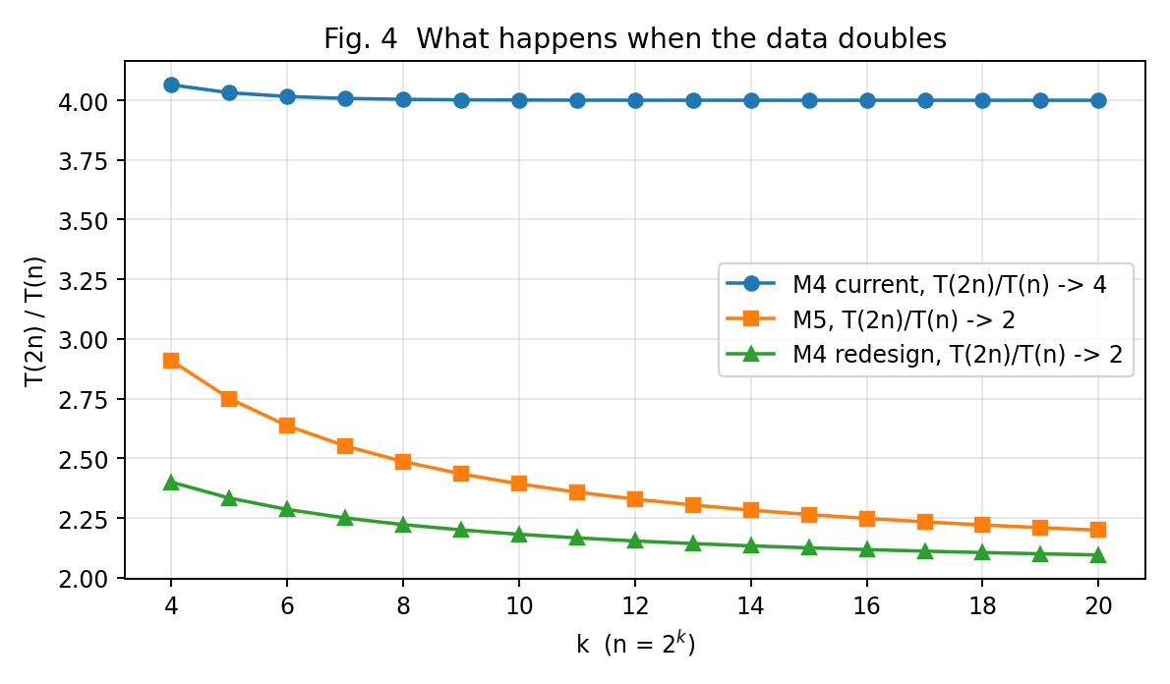

(e) Best, Average and Worst Cases – S1 and S2
 | Best case | Average case | Worst case
S1 sequential (unsorted) | the key is the first product: 1 comparison | key present and equally likely at any position: $\frac{n+1}{2}$ | the key is the last product or is absent: $n$ comparisons
S2 binary (sorted index) | the key equals the middle entry: 1 comparison | key present: $≈\log_{2}n-1$ (exactly $\log_{2}\left(n+1\right)-1+\frac{\log_{2}\left(n+1\right)}{n}$); absent: $≈\log_{2}n$ | the key is at the deepest level of the search tree or absent: $⌊\log_{2}n⌋+1$ (20 for $n={10}^{6}$)
Why these cases occur. S1 has no information about the location of the key, so it must look at every product that precedes it: the position of the key is the number of comparisons, and an absent key forces a full scan. S2 halves the candidate range at every comparison, so the number of comparisons is the depth of the key in the implicit binary search tree; half of all keys lie at the deepest level, which is why the average is only about one comparison below the worst case.
Average case of S1 with success probability $p$. With probability $p$ the product exists and, being at position $i$ with probability $\frac{1}{n}$, costs $i$ comparisons; with probability $1-p$ it is absent and costs $n$:
$$A_{S1}\left(n,p\right)=p\sum_{i=1}^{n}{\frac{i}{n}}+\left(1-p\right) n=p⋅\frac{n+1}{2}+\left(1-p\right) n.$$
For $n=1,000,000$ and $p=0.5$:
$$A_{S1}=0.5×\frac{1,000,001}{2}+0.5×1,000,000=250,000.25+500,000=750,000.25 \text{comparisons}.$$
At $R={10}^{8}$ this is $7.5$ ms per search, against $20$ comparisons ($0.2 μs$) for S2. Program check ($n=1000$, $p=0.5$, 200,000 simulated searches): simulated average $749.81$ vs formula $750.25$; S2 measured average $8.987$ vs formula $8.977$.

(f) Prove an Asymptotic Bound – $f\left(n\right)=3n^{2}+10nlogn+50∈Θ\left(n^{2}\right)$
Definition. $f\left(n\right)∈Θ\left(n^{2}\right)$ iff there are constants $c_{1},c_{2}>0$ and $n_{0}$ with $c_{1}n^{2}≤f\left(n\right)≤c_{2}n^{2}$ for all $n≥n_{0}$.
Lower bound. All terms are non-negative for $n≥1$, so $f\left(n\right)≥3n^{2}$. Take $c_{1}=3$.
Upper bound. For $n≥1$: $\log_{2}n≤n$, hence $10nlogn≤10n^{2}$; and $50≤50n^{2}$. Therefore
$$f\left(n\right)=3n^{2}+10nlogn+50≤3n^{2}+10n^{2}+50n^{2}=63n^{2}.$$
Take $c_{2}=63$.
Result. With $c_{1}=3, c_{2}=63, n_{0}=1$: $3n^{2}≤f\left(n\right)≤63n^{2}$ for all $n≥1$, so $f\left(n\right)∈Θ\left(n^{2}\right)$. (Check at $n_{0}=1$: $f\left(1\right)=53$, and $3≤53≤63$ ✓. The program verified the inequality for every $n=1,…,200,000$ and for $n={10}^{6},{10}^{7}$ with no violation.)
$f\left(n\right)$ is not $O\left(n\right)$. Suppose, for contradiction, that there exist $c>0$ and $n_{1}$ with $f\left(n\right)≤cn$ for all $n≥n_{1}$. Since $f\left(n\right)≥3n^{2}$, we would have $3n^{2}≤cn$, i.e. $n≤c/3$, for every $n≥n_{1}$ – false for any $n>max\left(n_{1},c/3\right)$. Hence no such constants exist and $f\left(n\right)∉O\left(n\right)$. (Numerically $f\left(n\right)/n=3.0×{10}^{6}$ at $n={10}^{6}$ and keeps growing.)
Meaning. The nightly report generator is a quadratic algorithm: ten times more products means 100 times more work.

(g) Scalability Decision
Estimated operations and running time. $L=\log_{2}n$. The window is 10 min $=600$ s; the budget is $6×{10}^{10}$ operations at $R={10}^{8}$ ($6×{10}^{11}$ at $R={10}^{9}$).
Module (formula) | operations, $n={10}^{6}$ | time, $R={10}^{8}$ | meets 10 min? | time, $R={10}^{9}$ | meets 10 min?
M1: $n\left(n-1\right)/2$ | $$5.0×{10}^{11}$$ | 5,000 s (83.3 min) | No | 500 s | yes, but 83 % of the window
M2: $2^{⌈\log_{2}n⌉}-1$ | $$1.05×{10}^{6}$$ | 0.0105 s | yes | 0.001 s | yes
S2: $⌊\log_{2}n⌋+1$ (one search) | 20 | $2×{10}^{-7}$ s | yes | $2×{10}^{-8}$ s | yes
M4 current: $2n^{2}-n$ | $$2.0×{10}^{12}$$ | 20,000 s (5.6 h) | No | 2,000 s (33 min) | No
M4 redesign: $n\log_{2}n+n$ | $$2.09×{10}^{7}$$ | 0.21 s | yes | 0.02 s | yes
M5: $\frac{nL\left(L+1\right)}{2}+n$ | $$2.10×{10}^{8}$$ | 2.1 s | yes | 0.21 s | yes
Report generator: $3n^{2}+10nlogn+50$ | $$3.0×{10}^{12}$$ | 30,002 s (8.3 h) | No | 3,000 s (50 min) | No
For comparison, today ($n={10}^{5}$) the quadratic modules need $5.0×{10}^{9}$ (M1), $2.0×{10}^{10}$ (M4 current) and $3.0×{10}^{10}$ (report generator) operations, i.e. 50 s, 200 s and 300 s at $R={10}^{8}$ – all inside the window. The catalogue grows 10 times and the quadratic modules become 100 times slower, which is exactly why they break the window next year.
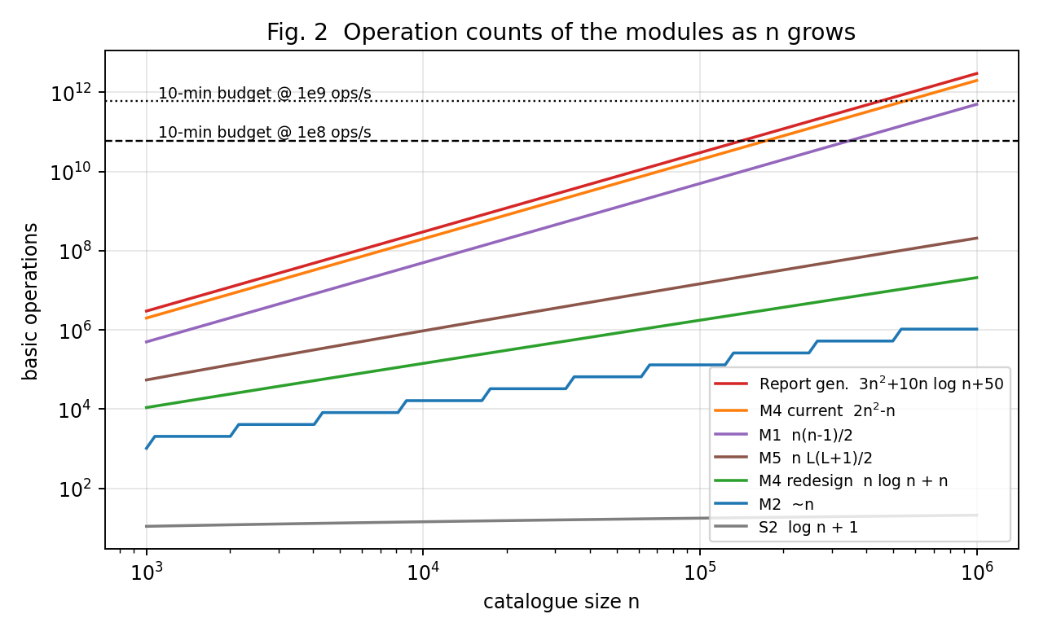
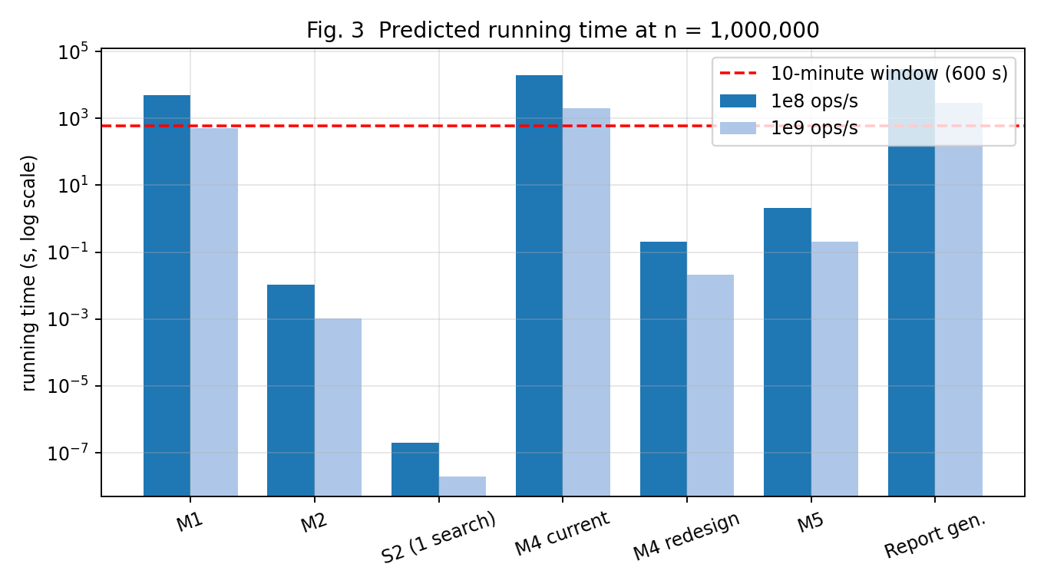
Modules that fail the 10-minute window (at $R={10}^{8}$): M1, M4 (current design) and the nightly report generator. At $R={10}^{9}$ the M4 current design and the report generator still fail, and M1 passes with only 17 % headroom; because its cost is quadratic it fails at about $n≈1.1×{10}^{6}$ ($n^{2}/2=6×{10}^{11}$), i.e. practically at the expected size. M1 should therefore be redesigned under either assumption.
Recommendations.
Module | Decision | How, and the justification
M1 | Redesign | Replace the all-pairs comparison by hashing: insert the key (title, seller) of each product in a hash set and flag a product whose key is already present: one pass, expected $Θ\left(n\right)$ ($≈{10}^{6}$ operations, 0.01 s) – about 500,000 times fewer operations. Alternative without hashing: sort by (title, seller) in $Θ\left(nlogn\right)≈2×{10}^{7}$ operations and compare neighbours. Better still, check each new listing at upload time against the index.
M4 | Redesign – adopt the proposed design | Removing the replication changes $a$ from 4 to 2, so $Θ\left(n^{2}\right)$ becomes $Θ\left(nlogn\right)$: $2.0×{10}^{12}→2.1×{10}^{7}$ operations (about 95,000 times fewer), 0.2 s instead of 5.6 h.
Report generator | Redesign | $3n^{2}$ indicates a nested pass over the data. Replace it with a sort/aggregate or hash-join based single pass ($Θ\left(nlogn\right)$ or $Θ\left(n\right)$ expected), or with incrementally maintained aggregates. At $n={10}^{6}$ this is about $2×{10}^{7}$ operations instead of $3×{10}^{12}$.
M2 | Keep | $Θ\left(n\right)$, about ${10}^{6}$ operations; the claim that it is $Θ\left(nlogn\right)$ is wrong and no redesign is needed.
M3 | Keep S2 for frequent searches | S2 needs 20 comparisons ($Θ\left(logn\right)$) versus 750,000 on average for S1 ($p=0.5$); S1 is acceptable only for rare, one-off look-ups. Keep the index sorted (or use a hash index) and update it in batches.
M5 | Keep (optional tuning) | $Θ\left(n\log^{2}n\right)≈2.1×{10}^{8}$ operations (2.1 s); well inside the window. It can be reduced to $Θ\left(nlogn\right)$ by merging already-sorted halves instead of re-sorting at every level, but this is not required.

Implementation, Test Cases and Evidence

Source files (Source_Code/)
File | Purpose
shopsphere.py | instrumented implementations of M1, M2, S1, S2 (iterative and recursive), the recurrences of S2, M4 (both designs) and M5, the closed forms and $f\left(n\right)$
verify.py | executes the verification of parts (b)–(g) and prints all tables used above (writes results.json)
test_shopsphere.py | 12 unit tests (counts, edge cases, closed forms, bounds)
charts.py | produces the graphs in Report/Graphs/
render_screenshots.py | renders the images in this section from the real source files and console logs

Test cases
# | Test | Result
1 | M1 comparisons $=n\left(n-1\right)/2$ for $n=2..59$ | pass
2 | M1 really detects duplicates (same title and seller only) | pass
3 | M1 with empty list and single product | pass
4 | M2 count $=2^{⌈\log_{2}n⌉}-1$ for every $n=2..2999$ | pass
5 | M2 for $n=1024$ gives (1023 audits, 10 iterations) | pass
6 | M2 count $<2n$ for every $n$ (linear, not $nlogn$) | pass
7 | S2 worst case $=⌊\log_{2}n⌋+1$ for $n=1,2,7,8,100,1023,1024$ | pass
8 | S2 iterative and recursive give the same answers | pass
9 | S1 best/worst: 1, $n$, $n$ (absent) | pass
10 | Recurrences equal the closed forms for $n=2^{0}.{.2}^{14}$ | pass
11 | S1 average with $p=0.5$, $n={10}^{6}$ equals 750,000.25 | pass
12 | $3n^{2}≤f\left(n\right)≤63n^{2}$ for $n=1..4999$ | pass

Screenshots of the source code and output
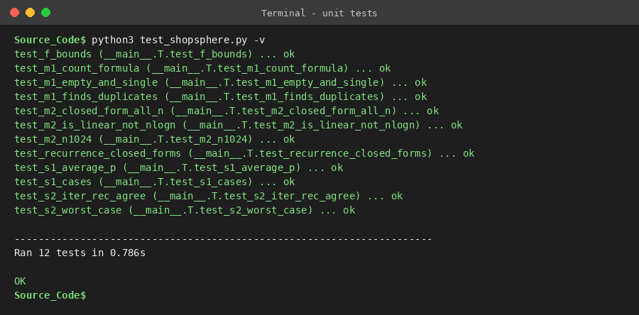
Output – unit tests (12 tests, all pass)
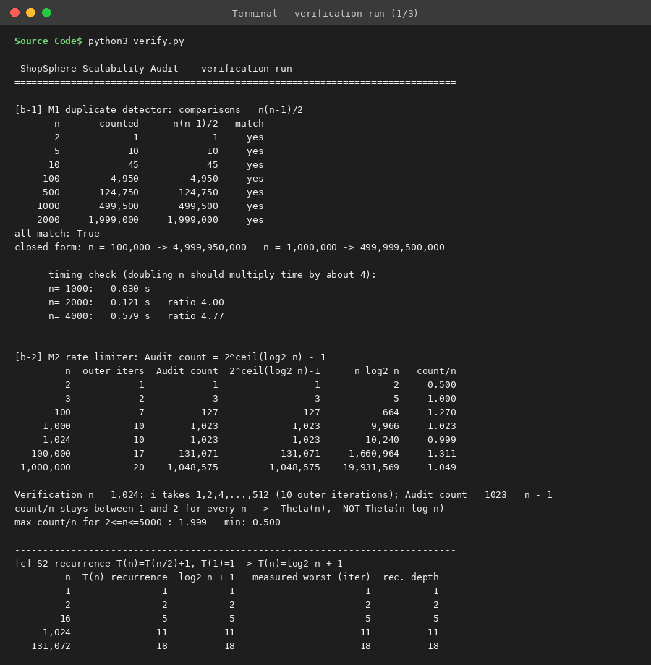
Output – verification run (1/3)
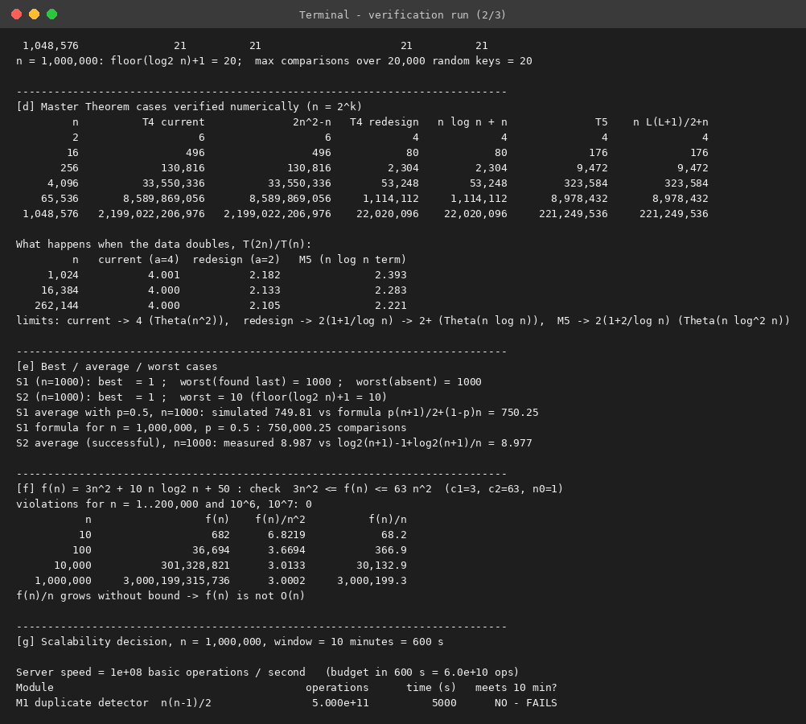
Output – verification run (2/3)
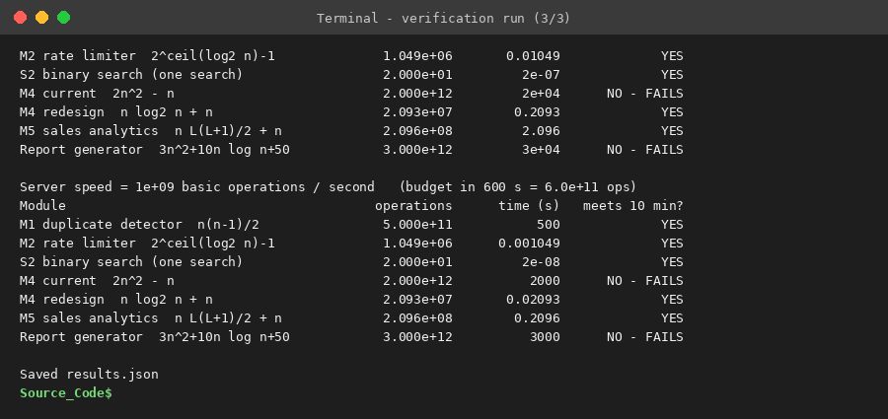
Output – verification run (3/3)
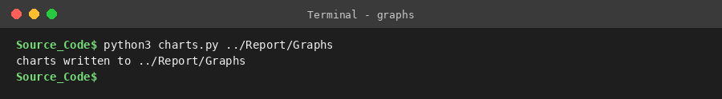
Output – graph generation
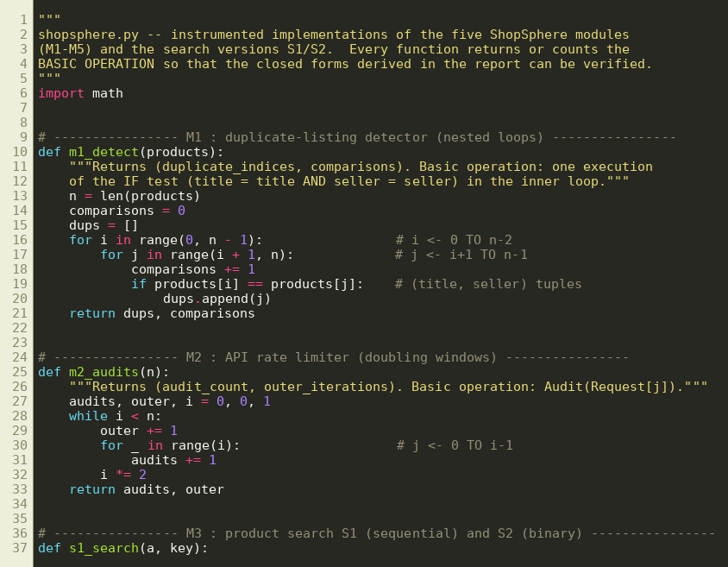
Source code – shopsphere.py (part 1)
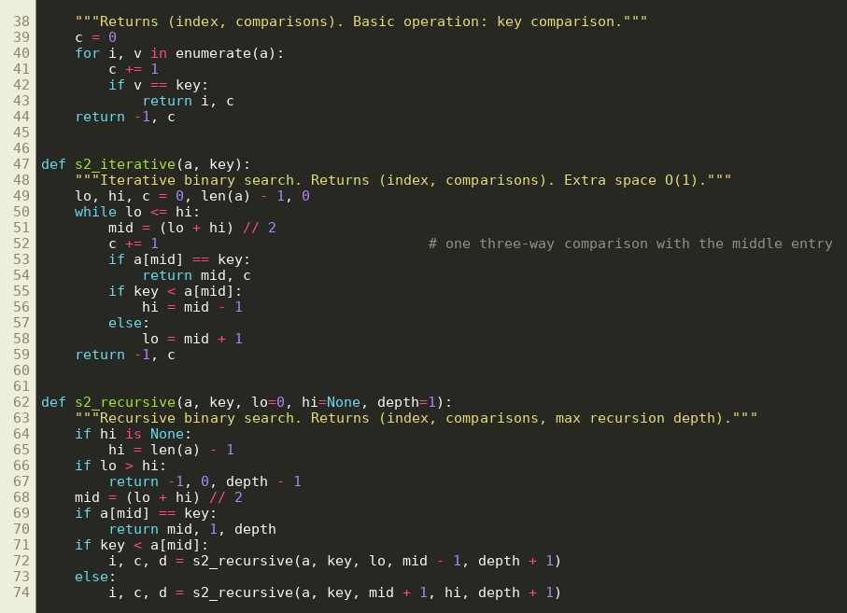
Source code – shopsphere.py (part 2)
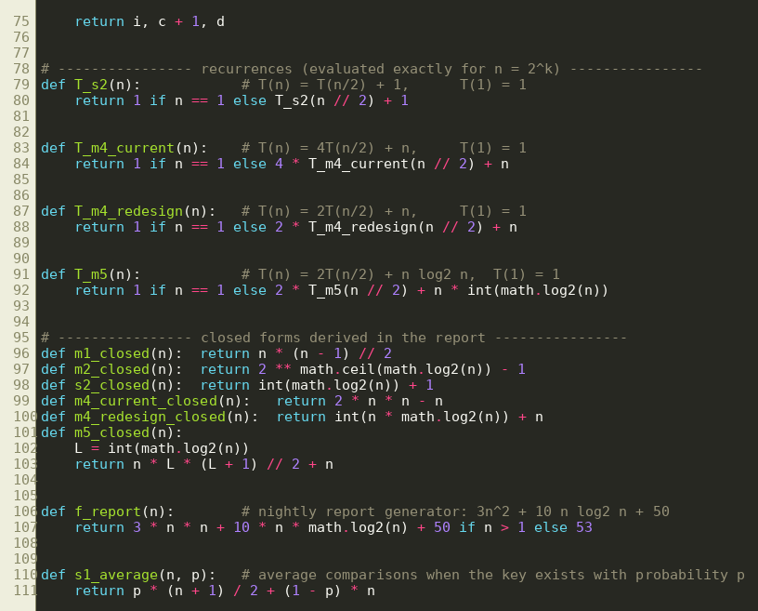
Source code – shopsphere.py (part 3)
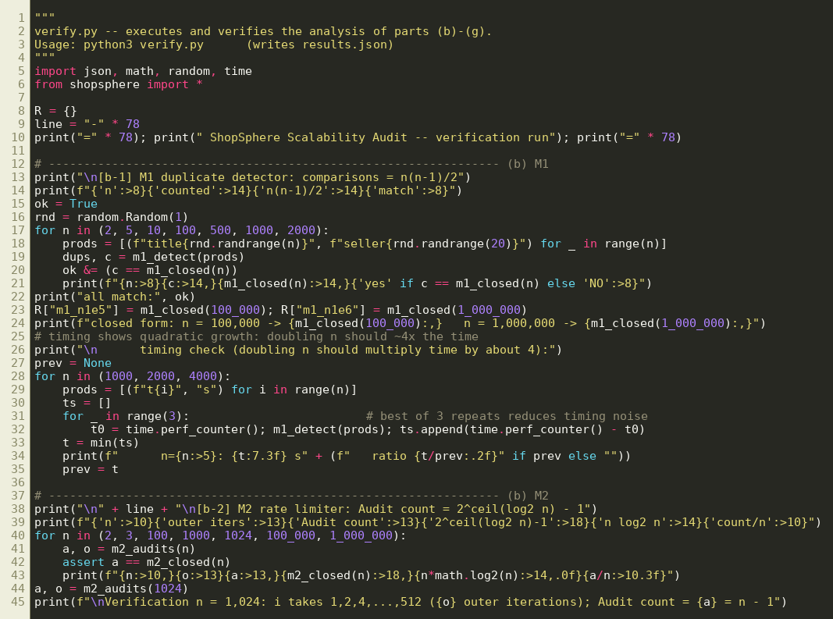
Source code – verify.py (part 1)
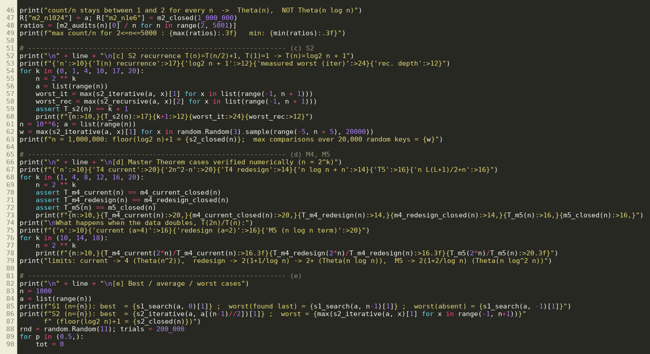
Source code – verify.py (part 2)
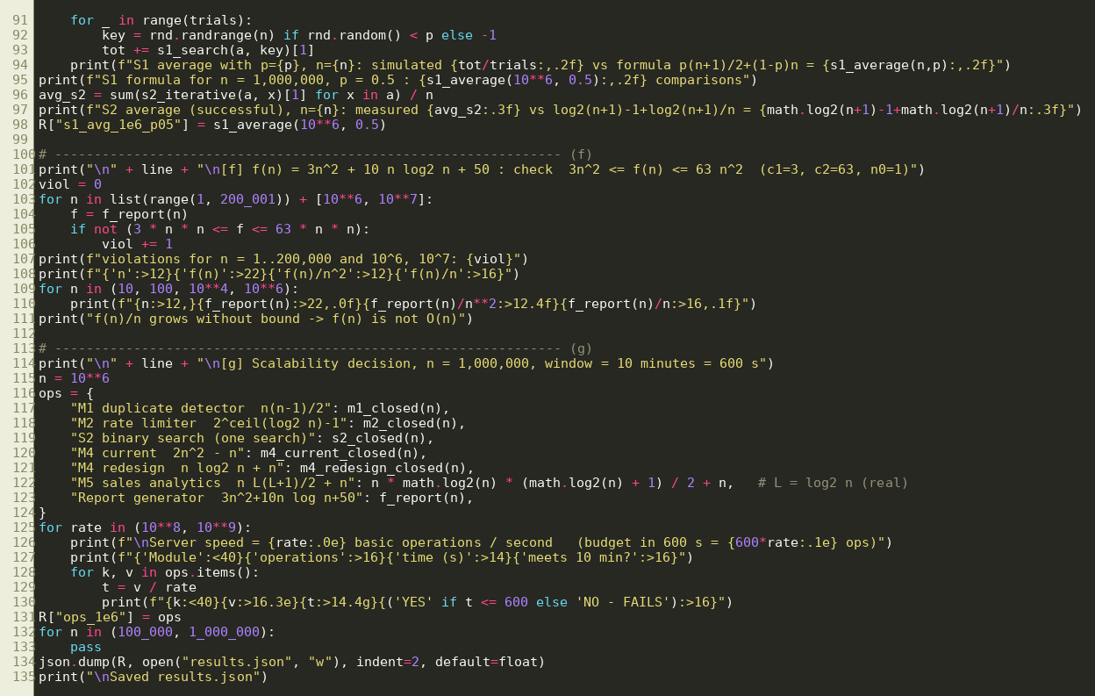
Source code – verify.py (part 3)
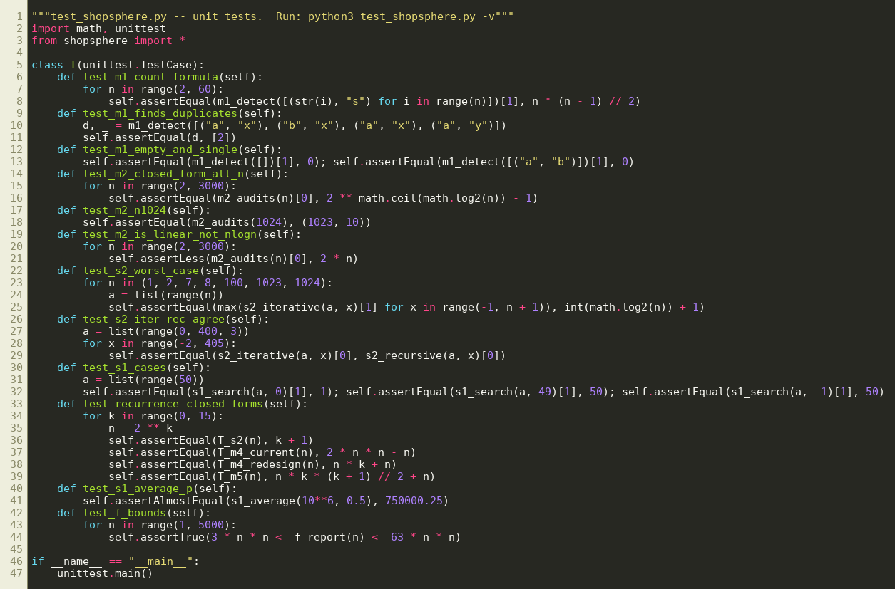
Source code – test_shopsphere.py

Conclusion
M2 is linear and healthy (the $Θ\left(nlogn\right)$ claim is wrong); S2 is logarithmic; M5 is $Θ\left(n\log^{2}n\right)$ and acceptable. The quadratic modules – the duplicate detector M1, the current recommendation engine M4 ($Θ\left(n^{2}\right)$ because $a=4$) and the nightly report generator ($3n^{2}$) – will exceed the 10-minute window when the catalogue grows from 100,000 to 1,000,000 products and must be redesigned: hashing for M1, the replication-free design ($Θ\left(nlogn\right)$) for M4, and a single-pass aggregate for the report generator.

Code of Conduct – I K DHEEPAK (192411108) (Name / Reg. No.) certify that this submission is my original work and that I have adhered to the guidelines specified for this assessment.
Signature of the Student: K DHEEEPAK Date: 19th October

