SAVEETHA INSTITUTE OF MEDICAL AND TECHNICAL SCIENCES (SIMATS ENGINEERING)
DEPARTMENT OF COMPUTER SCIENCE AND ENGINEERING
CSA06 – Design and Analysis of Algorithms
Assignment 1 – CO1
Design, Analyse and Validate an Efficient Search Strategy for a Large-Scale Student Record System
Course Outcome CO1: Determine algorithm efficiency using asymptotic notations and mathematical techniques including the Master Theorem and substitution method.
Total marks: 50
Student name: Dheepak K
Register number: 192411108
Section / Batch: 2024-2028

Contents
- Introduction and Methodology
- Task 1 – Design the Algorithm
- Task 2 – Identify the Basic Operation
- Task 3 – Derive the Time-Complexity Function
- Task 4 – Best-, Average- and Worst-Case Behaviour
- Task 5 – Asymptotic Analysis
- Task 6 – Formulate the Recurrence Relation
- Task 7 – Solve the Recurrence Relation
- Task 8 – Implement and Test the Algorithms
- Task 9 – Record Experimental Performance
- Task 10 – Compare Theory with Experimental Behaviour
- Task 11 – Recommend and Defend the Final Design
- Task 12 – Day-4 Design Challenge
- Conclusion
- Appendix – Repository structure and how to reproduce

1. Introduction and Methodology

1.1 Problem statement
A university stores a very large database of student records. Each record is identified by a unique, 9-digit Registration Number, and staff repeatedly need to decide whether a given registration number exists and to retrieve the associated record. The database may grow through $1,000→10,000→100,000→1,000,000+$ records. This report designs three structurally different search strategies, analyses them mathematically (basic operation, time-complexity function, best/average/worst cases, asymptotic notation, recurrence), implements and measures them on datasets of the four sizes, compares theory with experiment, recommends a final design, and finally re-evaluates the design for the changed requirement of 50,000 searches per hour on 1,000,000 records with new records added once per day.

1.2 Notation and conventions
- $n$ = number of student records (the input size). $q$ = number of searches performed.
- The basic operation of each algorithm is defined in Task 2 (a key comparison).
- $C_{best}\left(n\right)$, $C_{avg}\left(n\right)$, $C_{worst}\left(n\right)$ denote the number of basic operations in the best, average and worst case of a single search.
- Logarithms are to base 2 unless written otherwise.

1.3 Experimental set-up (summary)
Item | Value
Language / platform | Python 3.12 (CPython), single thread, one machine, no other heavy processes
Registration numbers | unique random 9-digit integers (random.Random(42+n)), stored in random arrival order
Dataset sizes | 1,000; 10,000; 100,000; 1,000,000 records
Query sets | Successful: keys drawn at random from the data (average case). Unsuccessful: random 9-digit keys not in the data (worst case). Best: first element (linear) / middle element (binary)
Queries per measurement | 10,000 (binary, hash); 1,000 / 1,000 / 200 / 60 for linear at the four sizes (linear is $O\left(n\right)$ per query)
Timing | time.perf_counter(), mean per query of the un-instrumented code; preprocessing = median of 3 runs
Operation counts | instrumented copies of the same algorithms count key comparisons
Correctness | every answer verified against Python set membership; the three algorithms must agree
All source code is in Task_8_Implementation_Testing/Source_Code/ and the experiments are fully reproducible (Section 9).

2. Task 1 – Design the Algorithm (5 marks)
Three meaningfully different design strategies were selected. They differ in the design paradigm, in the preprocessing they demand and in the cost model they follow – they are not three implementations of the same idea.
 | Approach A | Approach B | Approach C
Name | Linear (sequential) search | Binary search on sorted records | Hash table with separate chaining
Design strategy | Brute force | Decrease-and-conquer (decrease by a factor of 2) | Transform-and-conquer / space–time trade-off (hashing)
Style | Iterative | Recursive | Iterative (chain scan)
Preprocessing | None | Sort the records by registration number (and keep an index to the original record) | Build the hash table: insert every record
Extra memory | $$O\left(1\right)$$ | $O\left(n\right)$ for the sorted index | $O\left(n\right)$ for buckets/chains

2.1 Approach A – Linear search (iterative, brute force)
Basic idea. Scan the records one by one from the first to the last and compare each registration number with the target; stop at the first match or when the records are exhausted.
Pseudocode
ALGORITHM LinearSearch(A[0..n-1], target)
// A holds the registration numbers in arrival order
for i <- 0 to n-1 do
if A[i] = target then // basic operation
return i
return -1 // not found
Preprocessing: none – works directly on unsorted data and needs no maintenance when records are added.
Why selected. It is the natural baseline: simplest to write and verify, zero preprocessing, and the reference against which the benefit of the other two approaches (and the cost of their preprocessing) can be measured. For very small databases it can be perfectly adequate.

2.2 Approach B – Binary search (recursive, decrease-and-conquer)
Basic idea. If the records are sorted by registration number, one comparison with the middle record tells us in which half the target must lie, so half of the remaining records can be discarded at every step. The problem size is decreased by a constant factor (2) each time.
Preprocessing: sort the registration numbers (carrying along the position of each record so the payload can be retrieved): $Θ\left(nlogn\right)$ with a comparison sort such as merge sort / Timsort.
Pseudocode
ALGORITHM BuildSortedIndex(A[0..n-1])
order <- indices 0..n-1 sorted by A[index] // Theta(n log n)
S <- [ A[order[j]] for j <- 0 to n-1 ]
return S, order
ALGORITHM BinarySearch(S[0..n-1], target, low, high) // initial call: low=0, high=n-1
if low > high then return -1 // base case: empty range
mid <- floor((low + high) / 2)
if S[mid] = target then return mid // basic operation
if target < S[mid] then
return BinarySearch(S, target, low, mid - 1) // left half
else
return BinarySearch(S, target, mid + 1, high) // right half
Why selected. Registration numbers are naturally ordered keys, so the logarithmic behaviour of binary search is available if the one-time sorting cost is accepted. It is the classic recursive strategy, its recurrence is derived directly from the code (Tasks 6–7), and a sorted array also supports ordered queries (ranges, prefixes such as a batch/department code).

2.3 Approach C – Hash table with separate chaining (hashing, space–time trade-off)
Basic idea. Use the registration number itself to compute where the record is stored. A hash function $h\left(k\right)=k mod m$ (with $m$ a prime near $n/0.75$) maps a key to one of $m$ buckets; keys that collide are kept in a short chain inside the bucket. A search computes $h\left(k\right)$ and examines only that one chain.
Preprocessing: build the table by inserting all $n$ records – expected $Θ\left(n\right)$.
Pseudocode
ALGORITHM BuildHash(A[0..n-1])
m <- smallest prime >= n / 0.75 + 1 // load factor alpha ~ 0.75
T[0..m-1] <- empty chains
for i <- 0 to n-1 do
append (A[i], i) to chain T[ A[i] mod m ] // expected O(1) each
return T
ALGORITHM HashSearch(T, m, target)
b <- target mod m // one hash computation
for each (key, pos) in chain T[b] do
if key = target then return pos // basic operation
return -1
Why selected. It trades memory for speed and is the strategy used by real database indexes for exact-match lookups. Its expected cost is independent of $n$, so it shows the opposite extreme to linear search while avoiding the sort. It is also very cheap to update (insert one record at the end of one chain), which matters for Task 12.

2.4 Other strategies considered
Interpolation search (needs near-uniform keys), balanced binary search trees / B-trees (good for dynamic data and disk, but heavier to implement and with the same $Θ\left(logn\right)$ search as B) and jump search ($Θ\left(\sqrt{n}\right)$) were considered. They were not selected because they either duplicate the behaviour of one of the chosen approaches or add implementation complexity without adding a new kind of cost behaviour to the study.

3. Task 2 – Identify the Basic Operation (2 marks)
The basic operation is the operation that lies in the innermost part of the algorithm, is executed most often, and therefore dominates running time. In all three approaches it is a comparison of the target registration number with a stored registration number; what differs is where it occurs and how its count depends on $n$.
Algorithm | Basic operation | Where it occurs | How the count changes with $n$
A – Linear search | A[i] = target | In the body of the single for loop, once per examined record | Grows in direct proportion to $n$: between 1 and $n$ executions (about $n/2$ on average)
B – Binary search | S[mid] = target (a three-way comparison with the middle element) | Once per recursive call | Each call halves the range, so the count grows only with $\log_{2}n$: at most $⌊\log_{2}n⌋+1$
C – Hash search | key = target against a chain element | Inside the loop that scans the single bucket chain | Depends on the chain length (the load factor $α=n/m$), not on $n$: about $1+α/2$ on a hit, $α$ on a miss

3.1 Why this operation is appropriate
- It is on the critical path. Every other statement (index increment, mid computation, recursion bookkeeping, computing $k mod m$) executes a constant number of times for each comparison, so the total time is $T\left(n\right)≈c⋅C\left(n\right)$ for a machine-dependent constant $c$. Counting comparisons therefore captures the growth rate of the running time and is independent of the processor, language and cache behaviour.
- It is the only operation that depends on the data. Loop control or arithmetic would not reveal the best/average/worst-case differences; the number of comparisons does.
- It is directly measurable. The instrumented versions in algorithms.py count exactly this operation, so theoretical counts can be compared with measured counts in Task 10.

3.2 Convention for binary search
A three-way comparison (<, =, >) with S[mid] is counted as one basic operation per recursive call. (If the two Python tests == and < were counted separately the count would be at most doubled, which changes only the constant, never the growth rate.)

3.3 Basic operations of the preprocessing
- Sorting (B): the comparison of two registration numbers; a comparison sort needs $Θ\left(nlogn\right)$ of them.
- Hash build (C): the insertion of one record into its chain (one hash computation $k mod m$ and one append); $n$ insertions in total.

4. Task 3 – Derive the Time-Complexity Function Mathematically (6 marks)
Input size. $n$ = number of records in the database (equivalently, the length of the array that is searched). The number of searches is $q$. For a single search, $C\left(n\right)$ denotes the number of executions of the basic operation.

4.1 Approach A – Linear search
Operation count. If the target is at position $i$ ($1≤i≤n$) the loop executes the comparison exactly $i$ times. If the target is absent the loop runs to the end: $n$ comparisons.
Best case (target is the first record): $C_{best}\left(n\right)=1$. Worst case (target is last, or absent): $C_{worst}\left(n\right)=n$.
Average case. Let $p$ be the probability that the target is present, and assume that a present target is equally likely to be at any of the $n$ positions (probability $p/n$ each):
$$C_{avg}\left(n\right)=\sum_{i=1}^{n}{i}⋅\frac{p}{n}+n \left(1-p\right)=\frac{p}{n}⋅\frac{n\left(n+1\right)}{2}+n\left(1-p\right)=\frac{p \left(n+1\right)}{2}+n\left(1-p\right).$$
For a successful search ($p=1$): $C_{avg}\left(n\right)=\frac{n+1}{2}$; for an unsuccessful search ($p=0$): $C_{avg}\left(n\right)=n$.
Preprocessing: none, $P_{A}\left(n\right)=0$.
Total cost for $q$ searches (successful):
$$T_{A}\left(n,q\right)=q⋅\frac{n+1}{2}∈Θ\left(qn\right).$$

4.2 Approach B – Binary search on sorted records
Operation count (derived from the recursion). Let $C\left(n\right)$ be the number of comparisons for a range of $n$ elements. One comparison is made with S[mid]; if the target is not there, the search continues in a sub-range of at most $⌊n/2⌋$ elements, so
$$C_{worst}\left(n\right)=C_{worst}\left(⌊n/2⌋\right)+1, C_{worst}\left(0\right)=0, C_{worst}\left(1\right)=1.$$
Unrolling $k$ times gives $C_{worst}\left(n\right)=k+C_{worst}\left(⌊n/2^{k}⌋\right)$. The range becomes empty when $2^{k}>n$, hence
$$C_{worst}\left(n\right)=⌊\log_{2}n⌋+1.$$
(The full solution is given in Task 7.)
Best case: the target is the middle element of the original array: $C_{best}\left(n\right)=1$.
Average case (successful search). Take $n=2^{k}-1$ so that the comparison tree is a complete binary tree with $k$ levels. Level $i$ contains $2^{i-1}$ records and each of them needs exactly $i$ comparisons. Hence the total number of comparisons over all $n$ equally likely targets is
$$\sum_{i=1}^{k}{i}⋅2^{i-1}=\left(k-1\right)2^{k}+1,$$
and the average is
$$C_{avg}\left(n\right)=\frac{\left(k-1\right)2^{k}+1}{2^{k}-1}=\left(k-1\right)+\frac{k}{2^{k}-1}=\log_{2}\left(n+1\right)-1+\frac{\log_{2}\left(n+1\right)}{n} ≈ \log_{2}n-1.$$
For an unsuccessful search the number of comparisons is $≈\log_{2}\left(n+1\right)$, i.e. essentially the worst case.
Preprocessing. Sorting $n$ keys with a comparison sort costs $P_{B}\left(n\right)∈Θ\left(nlogn\right)$. (For merge sort the recurrence $S\left(n\right)=2S\left(n/2\right)+n-1$ gives at most $n\log_{2}n-n+1$ comparisons; see Task 7.) No comparison-based method can do better than $Ω\left(nlogn\right)$ in the worst case.
Total cost for $q$ searches:
$$T_{B}\left(n,q\right)=\underset{\text{sort}}{\underset{⏟}{Θ\left(nlogn\right)}}+q \log_{2}n.$$

4.3 Approach C – Hash table with separate chaining
Model. $n$ keys are stored in $m$ buckets; the load factor is $α=n/m≈0.75$. Assume simple uniform hashing: each key is equally likely to fall in any bucket.
Unsuccessful search. The chain of the bucket must be scanned completely. A given chain has expected length $n/m=α$, so
$$C_{fail}\left(n\right)=α.$$
Successful search. Suppose the target is the $i$-th key inserted. When it was inserted there were $i-1$ keys in the table, each of which is in the same bucket with probability $1/m$, so the expected number of keys before it in its chain is $\left(i-1\right)/m$. It therefore needs $1+\left(i-1\right)/m$ comparisons. Averaging over the $n$ equally likely targets:
$$C_{succ}\left(n\right)=\frac{1}{n}\sum_{i=1}^{n}{\left(1+\frac{i-1}{m}\right)}=1+\frac{n-1}{2m}=1+\frac{α}{2}-\frac{α}{2n} ≈ 1.375\text{ for }α=0.75.$$
Because $α$ is a constant (the table size grows with $n$), this is $Θ\left(1\right)$, independent of $n$.
Best case: the target is the first element of its chain: $C_{best}=1$. Worst case: all $n$ keys fall into one bucket and the target is last in the chain: $C_{worst}\left(n\right)=n$ (extremely unlikely with a prime $m$ and well-spread keys; the longest chain observed in the experiments was 8 records at $n={10}^{6}$).
Preprocessing. Each of the $n$ insertions computes one hash and appends to a chain: $O\left(1\right)$ expected, so $P_{C}\left(n\right)∈Θ\left(n\right)$ expected (plus allocating $m=Θ\left(n\right)$ buckets).
Total cost for $q$ searches:
$$T_{C}\left(n,q\right)=Θ\left(n\right)+q \left(1+\frac{α}{2}\right)∈Θ\left(n+q\right).$$

4.4 Overall cost – preprocessing and searching together
Approach | Preprocessing | One search (average, successful) | Total for $q$ searches | $n={10}^{6}, q=5×{10}^{4}$ (basic operations)
A – Linear | $$0$$ | $$\frac{n+1}{2}$$ | $$q \frac{n+1}{2}$$ | $$≈2.5×{10}^{10}$$
B – Binary | $$≈n\log_{2}n$$ | $$\log_{2}n-1$$ | $$n\log_{2}n+q\left(\log_{2}n-1\right)$$ | $$≈2.0×{10}^{7}+0.95×{10}^{6}≈2.1×{10}^{7}$$
C – Hash | $≈n$ inserts | $$1+α/2$$ | $$n+1.375 q$$ | $$≈1.0×{10}^{6}+0.07×{10}^{6}≈1.1×{10}^{6}$$
Break-even. Preprocessing is worthwhile once the saved search time exceeds its cost. For binary search against linear search: $n\log_{2}n+q\log_{2}n<q {n+1}/2$ gives
$$q^{*}≈\frac{n\log_{2}n}{\left(n+1\right)/2-\log_{2}n}≈2\log_{2}n ≈ 40\text{ searches for }n={10}^{6}.$$
The sort pays for itself after only a few dozen searches – a fact that is confirmed experimentally in Task 12.

5. Task 4 – Best-, Average- and Worst-Case Behaviour (4 marks)

5.1 Linear search
- Best case – the target is the first record. The very first comparison succeeds and the loop exits: 1 comparison, independent of $n$. This is rare (probability $1/n$) but defines the lower bound $Ω\left(1\right)$.
- Average case – the target is present at a uniformly random position. On average half of the records are inspected before the match: $\left(n+1\right)/2$ comparisons. The linear dependence arises because the algorithm has no information about where the key is, so it cannot skip any record. If the target is not guaranteed to be present, the average rises towards $n$ as the miss probability grows ($C_{avg}=p\frac{n+1}{2}+n\left(1-p\right)$).
- Worst case – the target is the last record or is absent. Every record is compared: $n$ comparisons. An unsuccessful search is always a worst-case input, and in a student database a mistyped registration number is a realistic input.

5.2 Binary search (on sorted data)
- Best case – the target is the middle record of the sorted array. The first comparison hits: 1 comparison.
- Average case – the target is present and uniformly distributed. Half of all records lie in the deepest level of the comparison tree and another quarter in the level above, so most searches end near the bottom of the tree: $≈\log_{2}n-1$ comparisons (derived in Task 3).
- Worst case – the target is at the deepest level of the comparison tree or absent. The range is halved until it is empty: $⌊\log_{2}n⌋+1$ comparisons. The difference between best and worst case is small in absolute terms (1 vs. 20 at $n={10}^{6}$) because the number of levels is only $\log_{2}n$. The behaviour does not depend on the arrangement of the original data, because the sort has normalised it; this is a major advantage over linear search.

5.3 Hash table
- Best case – the target is the first (or only) key in its bucket. One comparison.
- Average case – keys spread uniformly over the buckets. The chain length equals the load factor, giving $1+α/2≈1.375$ comparisons for a hit and $α=0.75$ for a miss. These values do not change with $n$ because the table is sized in proportion to $n$.
- Worst case – every key hashes to the same bucket (or the target is at the end of a long chain). The table degenerates into one linked list and the search becomes linear: $n$ comparisons. It occurs only for pathological key sets or a poor hash function; with $h\left(k\right)=k mod m$, $m$ prime, the longest chain observed was only 4, 6, 8 and 8 records for $n={10}^{3},{10}^{4},{10}^{5},{10}^{6}$.

5.4 Measured behaviour of the cases
The table gives the number of comparisons observed (best = constructed input, average = random present keys, worst = maximum over all measured queries including absent keys).
n | Linear (best / avg / worst) | Binary (best / avg / worst) | Hash (best / avg / worst)
1,000 | 1 / 490.38 / 1,000 | 1 / 9.01 / 10 | 1 / 1.33 / 4
10,000 | 1 / 5,125.85 / 10,000 | 1 / 12.37 / 14 | 1 / 1.40 / 6
100,000 | 1 / 54,464.78 / 100,000 | 1 / 15.73 / 17 | 1 / 1.38 / 8
1,000,000 | 1 / 547,933.25 / 1,000,000 | 1 / 19.02 / 20 | 1 / 1.37 / 5
The experiments agree with the analysis: for linear search the average is about half the worst case at every size, while binary search shows a gap of about one comparison between average and worst, and hash search shows an almost constant count at every size.

6. Task 5 – Asymptotic Analysis (3 marks)

6.1 Asymptotic classification
Algorithm | Best case | Average case | Worst case | Overall statement
A – Linear search | $$Ω\left(1\right)$$ | $$Θ\left(n\right)$$ | $$Θ\left(n\right)$$ | $T\left(n\right)∈O\left(n\right)$ and $Ω\left(1\right)$; no single $Θ$ for all inputs
B – Binary search (search only) | $$Ω\left(1\right)$$ | $$Θ\left(logn\right)$$ | $$Θ\left(logn\right)$$ | $$T\left(n\right)∈O\left(logn\right)$$
B – Preprocessing (sort) | $Ω\left(n\right)$ (already sorted input) | $$Θ\left(nlogn\right)$$ | $$Θ\left(nlogn\right)$$ | $$O\left(nlogn\right)$$
C – Hash search | $$Ω\left(1\right)$$ | $Θ\left(1\right)$ (expected) | $$Θ\left(n\right)$$ | $T\left(n\right)∈O\left(n\right)$ worst, $Θ\left(1\right)$ expected
C – Preprocessing (build) | – | $Θ\left(n\right)$ expected | $O\left(n^{2}\right)$ (all keys collide, no resizing) | $Θ\left(n\right)$ expected
Justification of the notation. For linear search the average count $\left(n+1\right)/2≥n/2$ for $n≥1$ and $≤n$, so $C_{avg}∈Θ\left(n\right)$; the worst case $n$ is also $Θ\left(n\right)$, while the best case is a constant, so only the weaker statement $O\left(n\right)$ / $Ω\left(1\right)$ covers all inputs. For binary search, $⌊\log_{2}n⌋+1≤2\log_{2}n$ for $n≥2$ and $≥\log_{2}n$, so the worst case is $Θ\left(logn\right)$. For hashing, $1+α/2≤1.375$ is bounded by a constant, hence $Θ\left(1\right)$ in expectation; the $Θ\left(n\right)$ worst case is a property of the input, not of typical operation.

6.2 Growth-rate hierarchy
$$Θ\left(1\right) ≺ Θ\left(logn\right) ≺ Θ\left(n\right) ≺ Θ\left(nlogn\right) ≺ Θ\left(n^{2}\right)$$
Hash search ($Θ\left(1\right)$) grows slower than binary search ($Θ\left(logn\right)$), which grows far slower than linear search ($Θ\left(n\right)$). Formally, $logn∈o\left(n\right)$ and $1∈o\left(logn\right)$, so the ratio of the costs of linear to binary search, $\frac{n}{2\log_{2}n}$, itself tends to infinity.

6.3 What this means for the university database (1,000 → 1,000,000+ records)
Multiplying the database size by 1,000 has the following predicted and observed effect on one successful search:
 | Predicted effect of $n×1000$ | Comparisons observed (1,000 → 1,000,000) | Time observed (1,000 → 1,000,000)
A – Linear | $$×1000$$ | 490.4 → 547,933 | 8.937 µs → 13,128 µs (×1,469)
B – Binary | $+\log_{2}1000≈+10$ comparisons | 9.01 → 19.02 | 0.985 µs → 6.405 µs (×6.5)
C – Hash | unchanged | 1.33 → 1.37 | 0.140 µs → 1.286 µs (×9.2)
Interpretation. A linear-search system that answers in a few microseconds for 1,000 students needs about 13 milliseconds per search at one million students – slow, and every additional record makes it slower in proportion. Binary search needs only about ten additional comparisons for a thousand-fold larger database, so it scales almost for free. Hash search needs the same number of comparisons for any size; its time still rises by a small factor because larger tables no longer fit in the processor cache (discussed in Task 10). For an application that must stay practical “for both small and very large datasets”, only B and C have an acceptable growth rate; A is acceptable only for very small databases or very rare searches.

7. Task 6 – Formulate the Recurrence Relation (3 marks)
The recursive approach is Approach B, binary search (BinarySearch(S, target, low, high)). The recurrence is read directly from the code in Task 1.

7.1 Identification of the components
Component | Identification from the algorithm
Input size of the original problem | $n=high-low+1$, the number of records in the current range
Size of the recursive sub-problem | The call discards S[mid] and one half. With $mid=⌊\left(low+high\right)/2⌋$ the left range has $⌊\left(n-1\right)/2⌋$ elements and the right range has $⌈\left(n-1\right)/2⌉=⌊n/2⌋$ elements. In the worst case the larger one is searched: size $⌊n/2⌋$
Number of recursive calls | Exactly one per invocation – either the left call or the right call is executed, never both (the if … else selects one)
Work outside the recursive call | Computing mid and one comparison with S[mid] (plus the low > high test): a constant, $Θ\left(1\right)$; counted as 1 basic operation
Base case | low > high (empty range, $n=0$): the function returns $-1$ with no comparison, so $C\left(0\right)=0$. A range with one element performs one comparison before reaching the empty range: $C\left(1\right)=1$

7.2 Resulting recurrence
For the number of basic operations (worst case):
$$C\left(n\right)=C\left(⌊n/2⌋\right)+1 \left(n≥1\right), C\left(0\right)=0 \left(\text{so }C\left(1\right)=1\right).$$
For the running time:
$$T\left(n\right)=T\left(⌊n/2⌋\right)+Θ\left(1\right) \left(n>1\right), T\left(1\right)=Θ\left(1\right).$$
This is of the form $T\left(n\right)=aT\left(n/b\right)+f\left(n\right)$ with $a=1$ sub-problem, each of size $n/b$ with $b=2$, and $f\left(n\right)=Θ\left(1\right)$.

7.3 Check against the implementation
For $n=7$: $C\left(7\right)=C\left(3\right)+1=C\left(1\right)+1+1=C\left(0\right)+1+1+1=3=⌊\log_{2}7⌋+1$. The instrumented function binary_search_counted returned at most $⌊\log_{2}n⌋+1$ comparisons for every key at every size (unit test test_14), in agreement with the recurrence.

8. Task 7 – Solve the Recurrence Relation (4 marks)
Recurrence: $C\left(n\right)=C\left(⌊n/2⌋\right)+1, C\left(1\right)=1$ (and $T\left(n\right)=T\left(n/2\right)+Θ\left(1\right)$).

8.1 Why these methods are applicable
- The recurrence has a single sub-problem of size $n/2$ and a constant additive term, which is exactly the shape handled by iteration (back-substitution); restricting to $n=2^{k}$ removes the floor function without changing the growth rate (the function is eventually non-decreasing and $log$ is smooth).
- It also fits the template $T\left(n\right)=aT\left(n/b\right)+f\left(n\right)$, so the Master Theorem applies directly.
- The substitution method is used to prove the result rigorously for all $n$.

8.2 Method 1 – Iteration (back-substitution)
Let $n=2^{k}$ ($k=\log_{2}n$):
$$\begin{matrix}C\left(2^{k}\right) & =C\left(2^{k-1}\right)+1 \\ & =C\left(2^{k-2}\right)+1+1=C\left(2^{k-2}\right)+2 \\ & =C\left(2^{k-3}\right)+3 \\ & ⋮ \\ & =C\left(2^{k-i}\right)+i \\ & =C\left(2^{0}\right)+k \left(i=k\right) \\ & =1+\log_{2}n.\end{matrix}$$
The pattern after $i$ steps is $C\left(2^{k-i}\right)+i$; the recursion stops when $2^{k-i}=1$, i.e. $i=k=\log_{2}n$, and $C\left(1\right)=1$. Hence $C\left(n\right)=\log_{2}n+1∈Θ\left(logn\right)$. For general $n$ the same argument gives $C\left(n\right)=⌊\log_{2}n⌋+1$.

8.3 Method 2 – Master Theorem
Here $a=1$, $b=2$, $f\left(n\right)=Θ\left(1\right)$. Compute $n^{\log_{b}a}=n^{\log_{2}1}=n^{0}=1$. Since $f\left(n\right)=Θ\left(1\right)=Θ\left(n^{\log_{b}a}\right)$, Case 2 of the Master Theorem applies:
$$T\left(n\right)=Θ\left(n^{\log_{b}a}logn\right)=Θ\left(logn\right).$$

8.4 Method 3 – Substitution (proof by induction)
Claim: $C\left(n\right)≤2\log_{2}n$ for all $n≥2$.
- Base case $n=2$: $C\left(2\right)=C\left(1\right)+1=2≤2\log_{2}2=2$. ✓
- Inductive step. Assume the claim for all $m$ with $2≤m<n$. Then
$$C\left(n\right)=C\left(⌊n/2⌋\right)+1≤2\log_{2}⌊n/2⌋+1≤2\log_{2}\left(n/2\right)+1=2\log_{2}n-2+1=2\log_{2}n-1≤2\log_{2}n. ✓$$
So $C\left(n\right)∈O\left(logn\right)$. The matching lower bound $C\left(n\right)≥\log_{2}n$ follows in the same way (assume $C\left(m\right)≥\log_{2}m$; then $C\left(n\right)≥\log_{2}⌊n/2⌋+1≥\log_{2}n-1+1$ up to rounding), so $C\left(n\right)∈Θ\left(logn\right)$.

8.5 Result and interpretation
$$C\left(n\right)=⌊\log_{2}n⌋+1∈Θ\left(logn\right).$$
$$n$$ | 1,000 | 10,000 | 100,000 | 1,000,000 | 10,000,000
Worst-case comparisons $⌊\log_{2}n⌋+1$ | 10 | 14 | 17 | 20 | 24
Every time the database is made 1,000 times larger the search needs only about 10 more comparisons: the recursion depth is tiny (20 recursive calls for a million records), so there is no risk of stack overflow, and the search cost is essentially insensitive to growth.

8.6 Bonus – the preprocessing recurrence (merge sort)
Sorting the records (the preprocessing of approach B) with merge sort satisfies $S\left(n\right)=2S\left(n/2\right)+Θ\left(n\right)$ – two sub-problems of half size and linear merging work. Here $a=2, b=2, f\left(n\right)=Θ\left(n\right)=Θ\left(n^{\log_{2}2}\right)$, so Case 2 of the Master Theorem gives $S\left(n\right)=Θ\left(nlogn\right)$. This is the preprocessing cost used in Task 3.

9. Task 8 – Implement and Test the Algorithms (4 marks)

9.1 Implementation summary
File | Purpose
algorithms.py | The three algorithms, each as a plain version (timing) and an instrumented version (comparison counting): linear_search, binary_search (+ build_sorted_index), HashIndex / build_hash_index
test_algorithms.py | 14 unit tests (correctness, edge cases, collisions, count bounds)
benchmark.py | Experiments for $n={10}^{3},{10}^{4},{10}^{5},{10}^{6}$; writes results.json
day4_challenge.py | Task 12 experiment (50,000 searches/hour on ${10}^{6}$ records; daily update cost)
make_charts.py | Produces all graphs and CSV tables
render_screenshots.py | Renders source-code and console-output images for this report from the real files/logs
The implementation corresponds exactly to the pseudocode analysed in Tasks 1–7: the same loop for linear search, the same low/high/mid recursion for binary search, and the same $k mod m$ chained table (load factor 0.75, prime $m$) for hashing. Each search returns the position of the record, from which the record itself is retrieved in $O\left(1\right)$.

9.2 Test cases
# | Test case | Purpose | Result
1 | Empty database | boundary: $n=0$ | All three return “not found” – pass
2 | One record, present | boundary: $n=1$ | pass
3 | One record, absent | boundary | pass
4 | Target is the first record (arrival order) | linear best case | pass
5 | Target is the last record | linear worst case | pass
6 | Target is a middle record | general case | pass
7 | Absent, smaller than every key | binary-search left edge | pass
8 | Absent, larger than every key | binary-search right edge | pass
9 | Absent, between two keys | unsuccessful search | pass
10 | 200 keys forced into the same hash bucket | collision handling | pass
11 | Random agreement test: $n∈\{1,2,3,10,100,1000,5000\}$, 200 present + 200 absent keys each | all three agree with set membership | pass
12 | Instrumented versions vs plain versions | counting code does not change results | pass
13 | Linear comparison counts 1 / $n$ / $n$ | validates best/worst-case analysis | pass
14 | Binary comparisons $≤⌊\log_{2}n⌋+1$ for every key of $n=1023$ | validates Task 7 result | pass
All 14 tests pass (screenshot below). In addition, benchmark.py re-verifies correctness at every dataset size (4,000 binary/hash queries and 40–400 linear queries per size against Python’s set membership) before timing starts; the line “correctness check: PASSED” appears for each size.

9.3 Reproducible testing procedure
- Same dataset for all three algorithms at each size (unique random 9-digit numbers, fixed seeds 42+n), in random arrival order; the binary-search structure is built from the same data.
- Same query sets for all algorithms (random present keys for the average case, random absent keys for unsuccessful searches).
- Timing uses the un-instrumented functions only; operation counts use the instrumented functions.
- Preprocessing is timed separately (median of 3 runs) and reported separately from search time.
- Run: cd Task_8_Implementation_Testing/Source_Code && python3 test_algorithms.py -v && python3 benchmark.py && python3 day4_challenge.py && python3 make_charts.py ../Tables_and_Graphs.

9.4 Source code and output screenshots
The following figures show the source code and the console output of the runs used in this report. The images are generated from the actual files and the captured console logs (Report/Documentation/log_*.txt).
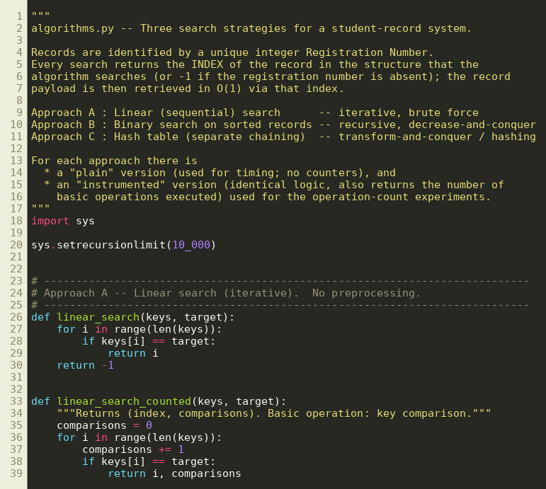
Source code – algorithms.py (part 1)
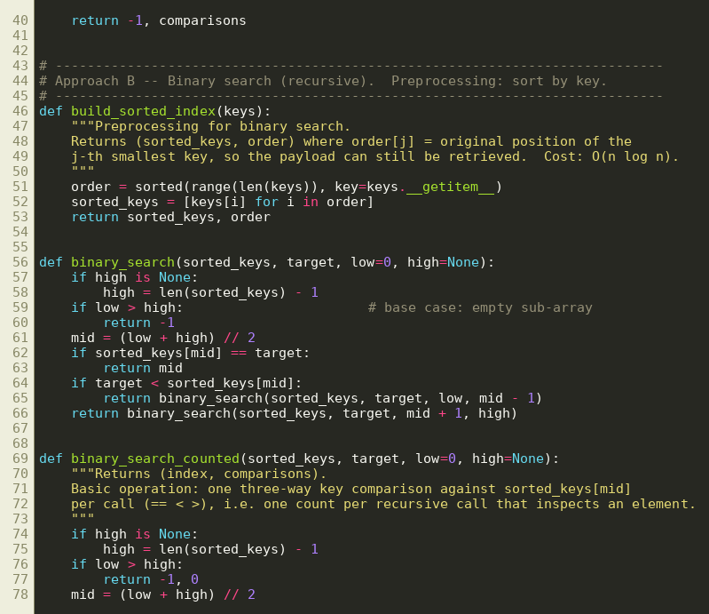
Source code – algorithms.py (part 2)
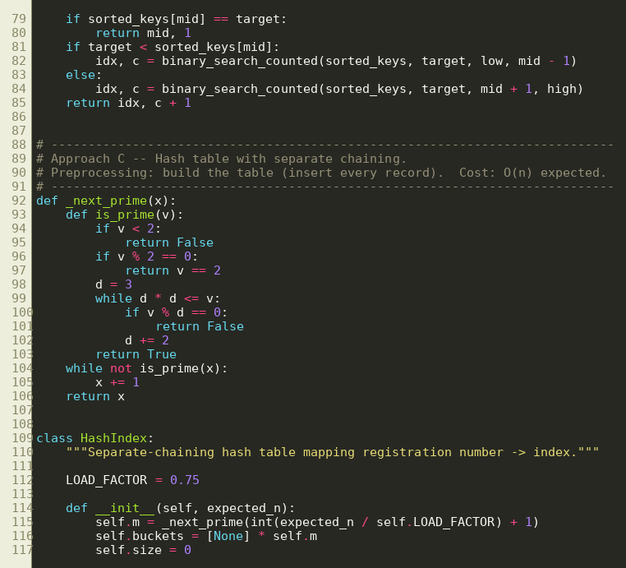
Source code – algorithms.py (part 3)
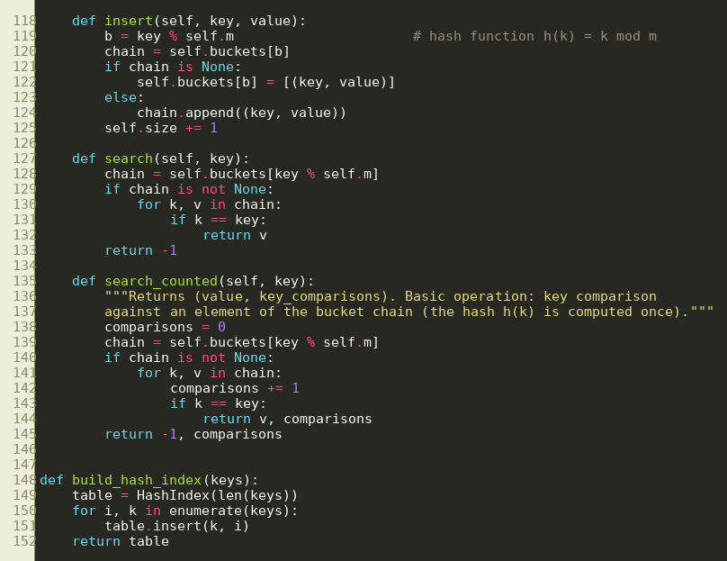
Source code – algorithms.py (part 4)
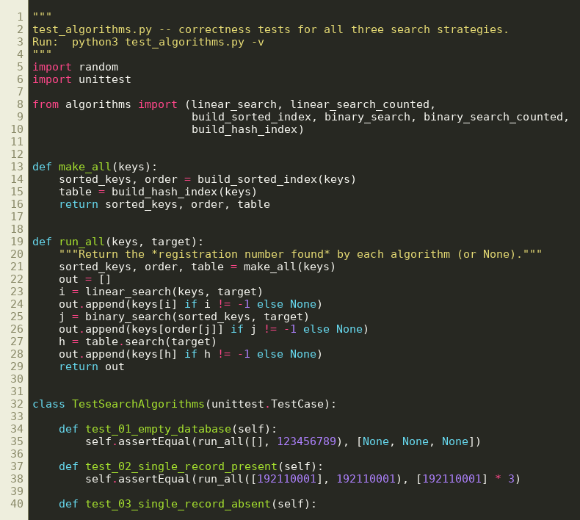
Source code – test_algorithms.py (part 1)
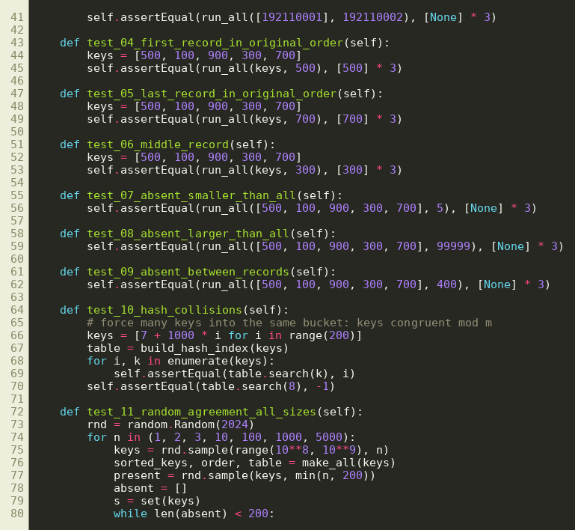
Source code – test_algorithms.py (part 2)
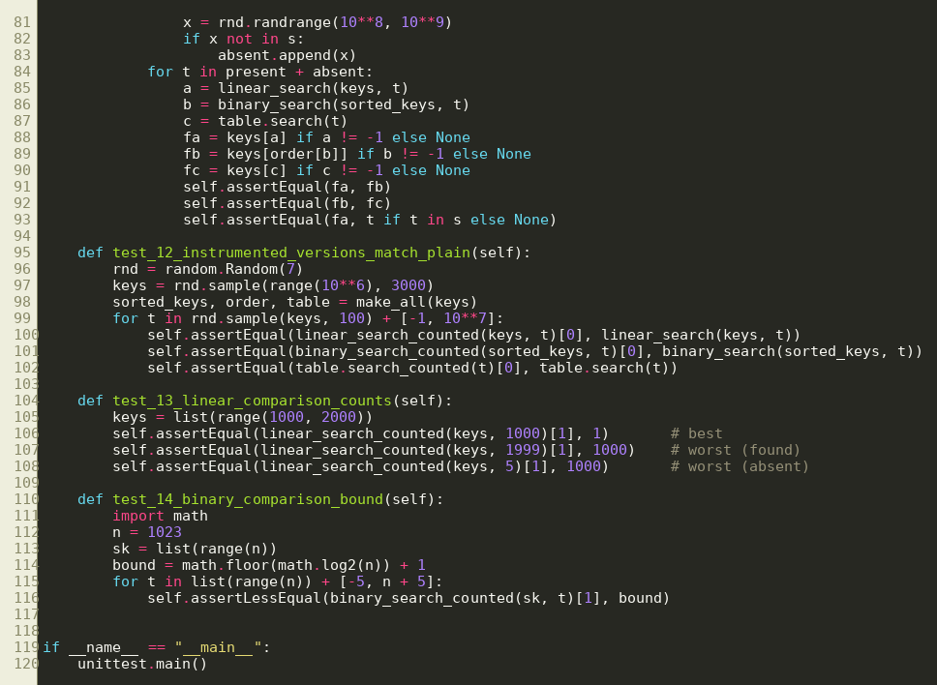
Source code – test_algorithms.py (part 3)
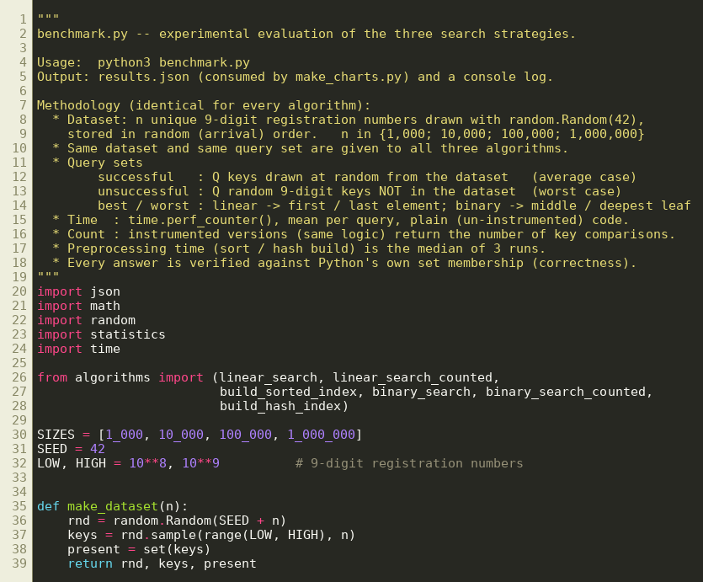
Source code – benchmark.py (part 1)
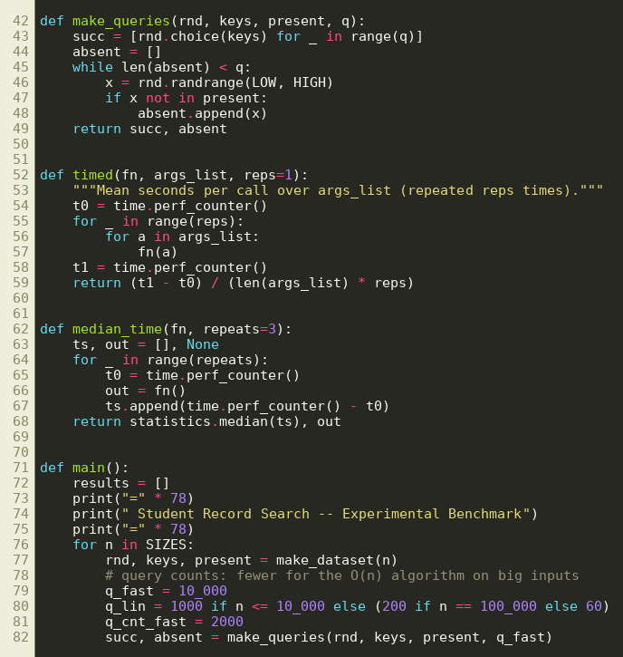
Source code – benchmark.py (part 2)
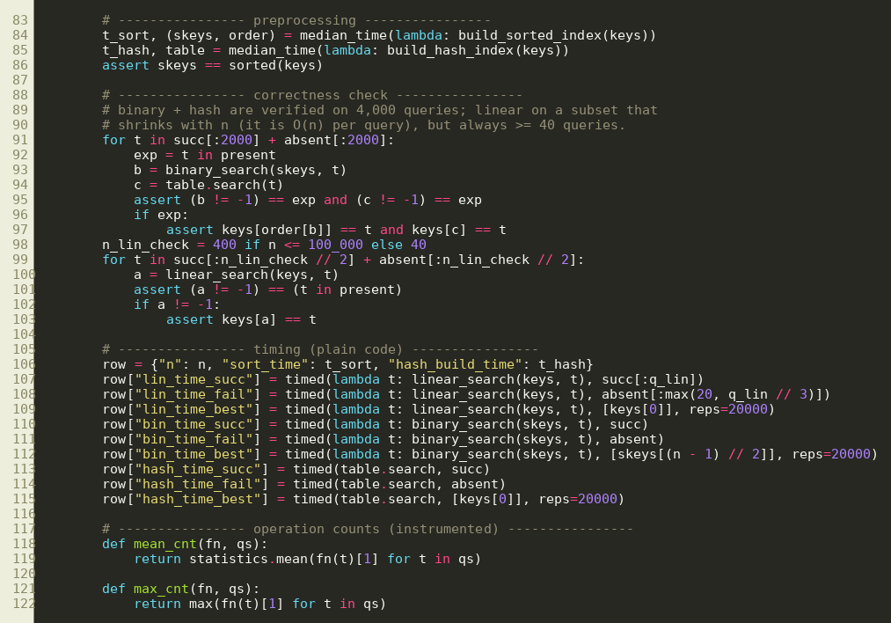
Source code – benchmark.py (part 3)
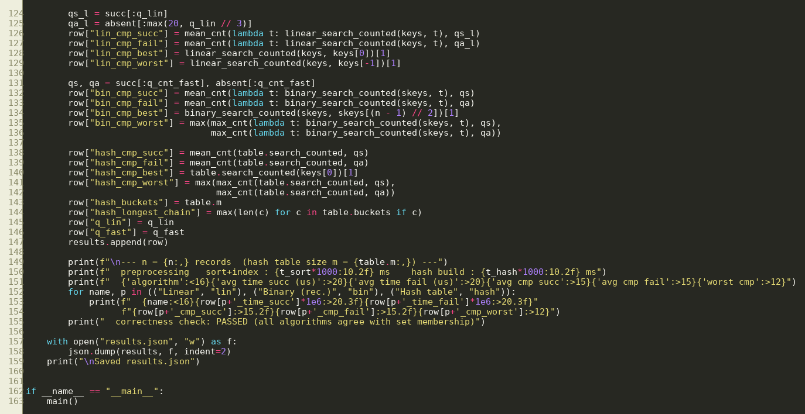
Source code – benchmark.py (part 4)
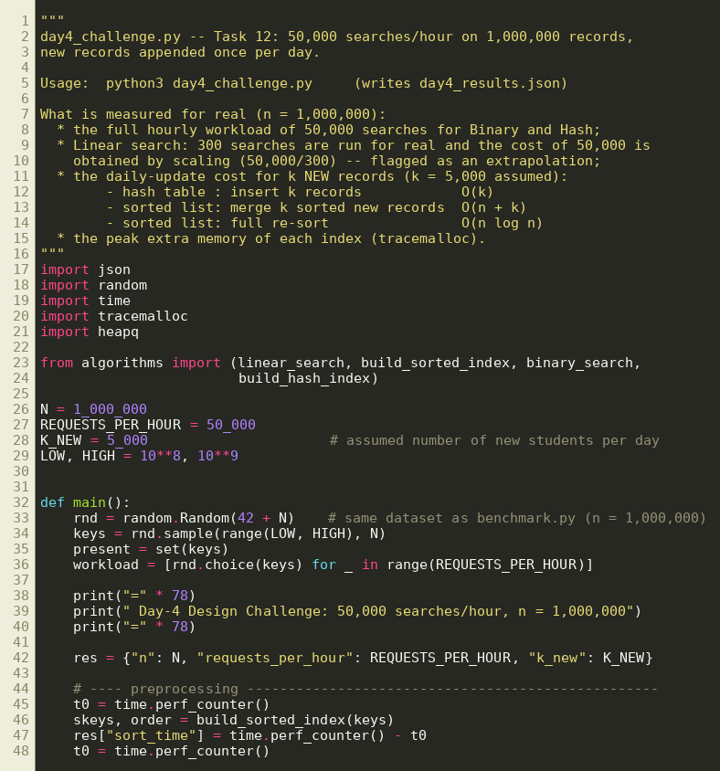
Source code – day4_challenge.py (part 1)
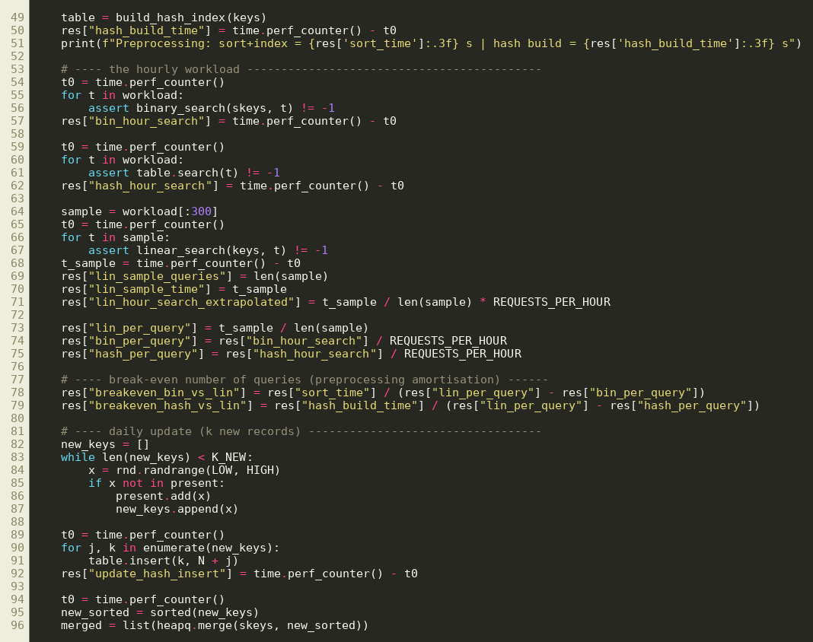
Source code – day4_challenge.py (part 2)
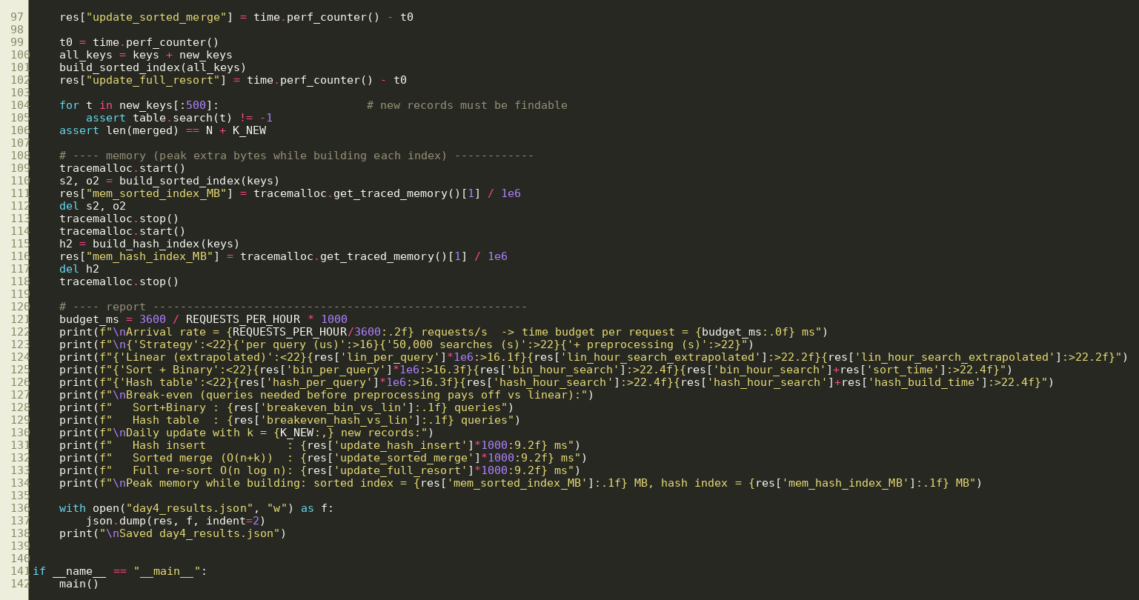
Source code – day4_challenge.py (part 3)
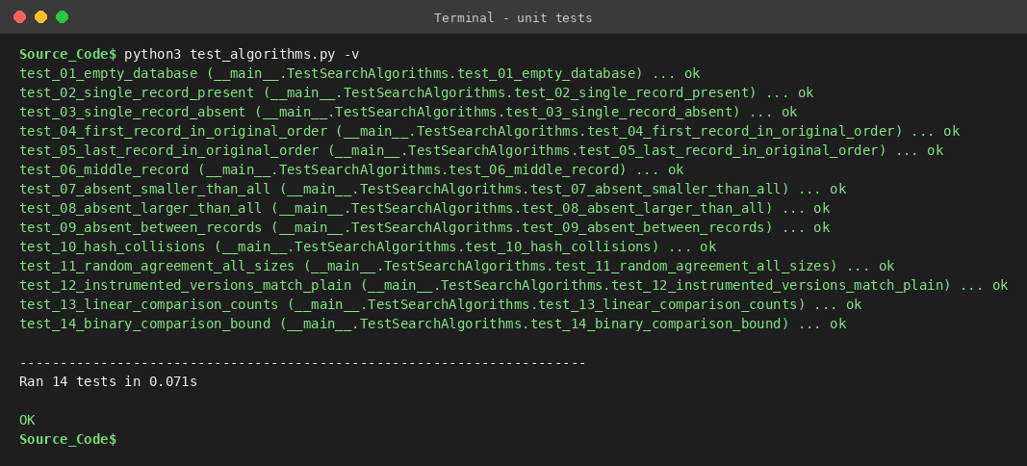
Output – unit tests (14 tests, all pass)
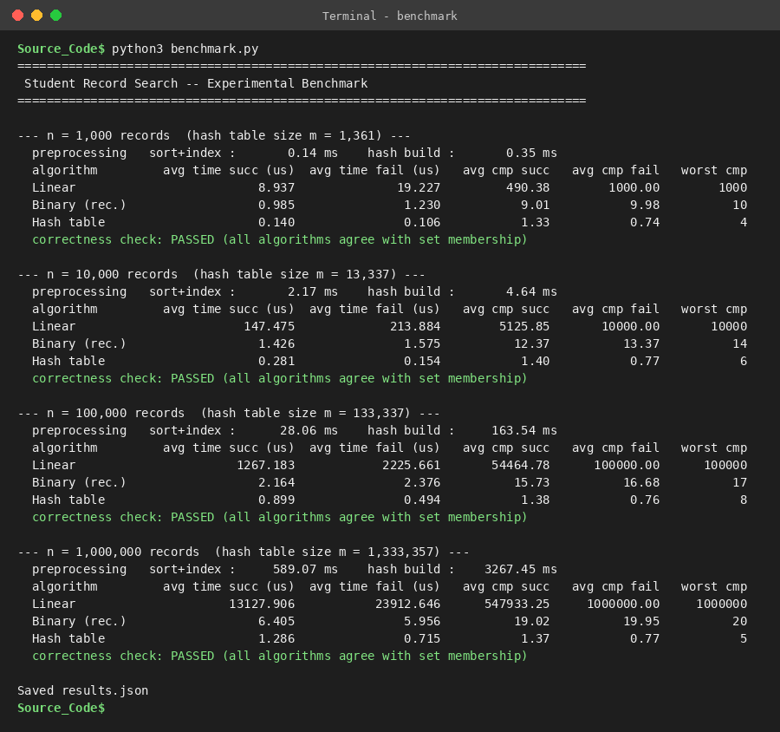
Output – benchmark run for the four dataset sizes

10. Task 9 – Record Experimental Performance (3 marks)

10.1 Mean time per search (microseconds)
Successful = random present key (average case); unsuccessful = random absent key (worst case for linear and binary search).
n | Linear succ. | Linear unsucc. | Binary succ. | Binary unsucc. | Hash succ. | Hash unsucc.
1,000 | 8.937 | 19.227 | 0.985 | 1.230 | 0.140 | 0.106
10,000 | 147.475 | 213.884 | 1.426 | 1.575 | 0.281 | 0.154
100,000 | 1,267.183 | 2,225.661 | 2.164 | 2.376 | 0.899 | 0.494
1,000,000 | 13,127.906 | 23,912.646 | 6.405 | 5.956 | 1.286 | 0.715

10.2 Mean number of key comparisons per search
n | Linear succ. | Linear unsucc. | Binary succ. | Binary unsucc. | Hash succ. | Hash unsucc.
1,000 | 490.38 | 1,000.00 | 9.01 | 9.98 | 1.33 | 0.74
10,000 | 5,125.85 | 10,000.00 | 12.37 | 13.37 | 1.40 | 0.77
100,000 | 54,464.78 | 100,000.00 | 15.73 | 16.68 | 1.38 | 0.76
1,000,000 | 547,933.25 | 1,000,000.00 | 19.02 | 19.95 | 1.37 | 0.77

10.3 Preprocessing cost (one-time)
n | Sort + index (B), ms | Hash build (C), ms | Hash / sort
1,000 | 0.14 | 0.35 | 2.4
10,000 | 2.17 | 4.64 | 2.1
100,000 | 28.06 | 163.54 | 5.8
1,000,000 | 589.07 | 3,267.45 | 5.5

10.4 Best-case times (microseconds per search)
n | Linear (first record) | Binary (middle record) | Hash
1,000 | 0.161 | 0.158 | 0.128
10,000 | 0.164 | 0.163 | 0.116
100,000 | 0.177 | 0.163 | 0.125
1,000,000 | 0.189 | 0.163 | 0.117

10.5 Graphs
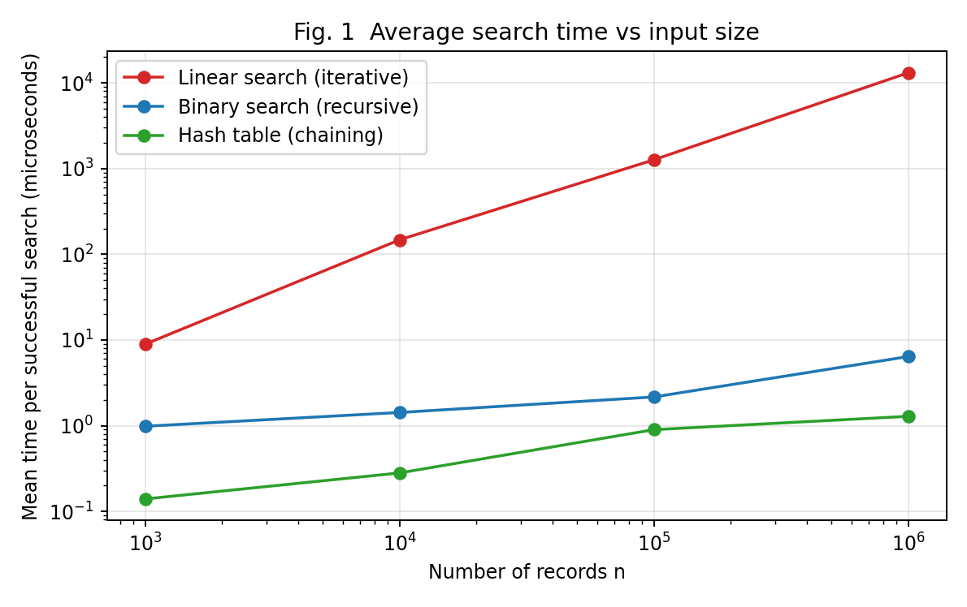
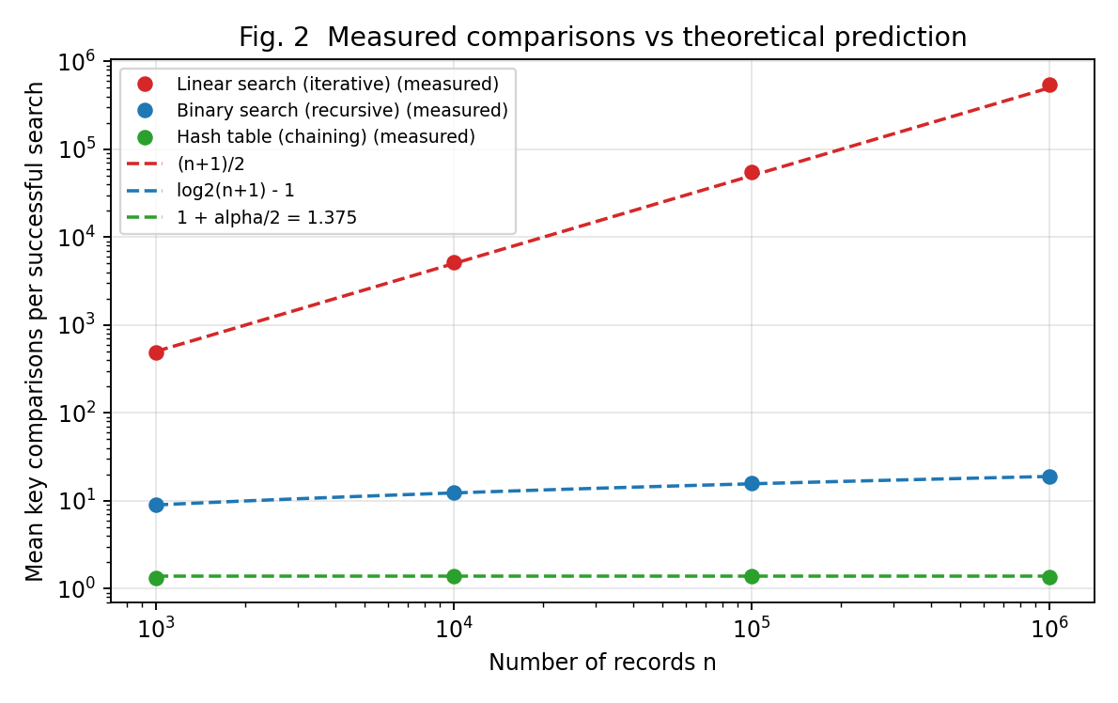
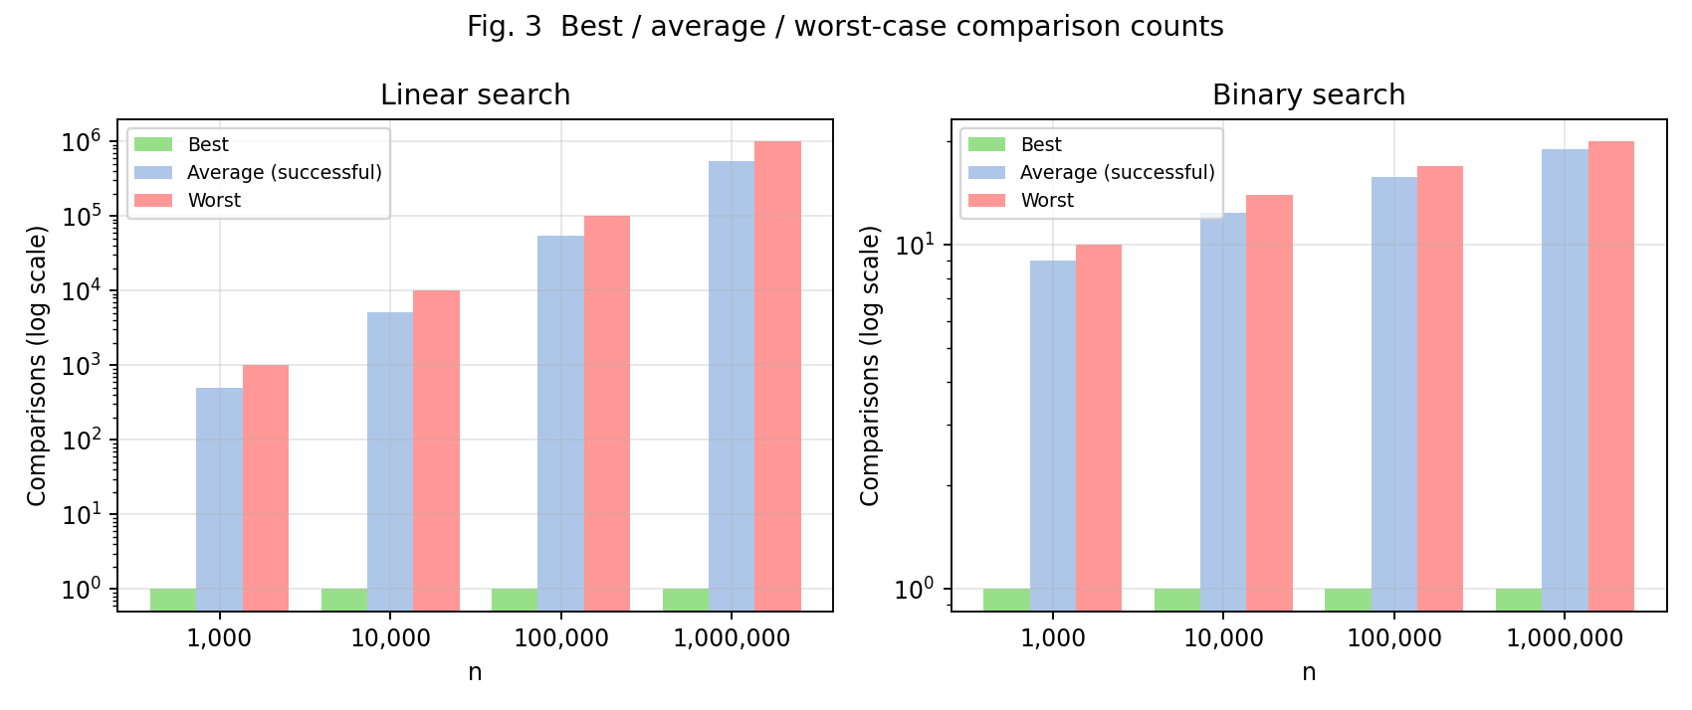
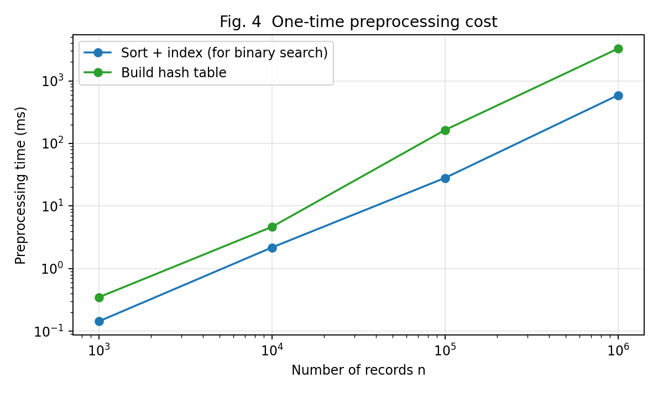
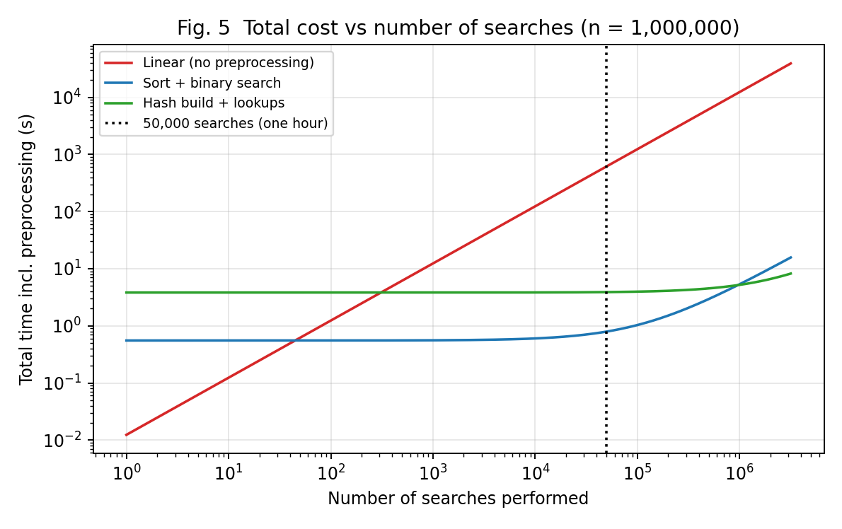
Reading the graphs. On the log–log axes of Fig. 1 and Fig. 2 an $O\left(n\right)$ algorithm appears as a straight line of slope 1, an $O\left(logn\right)$ algorithm as an almost flat, slowly rising curve and an $O\left(1\right)$ algorithm as a horizontal line. Linear search is clearly a steep line; binary search rises slowly; the hash table is the lowest curve. Fig. 5 shows that the preprocessing of both B and C is repaid after only tens to hundreds of searches.

10.6 Output screenshots
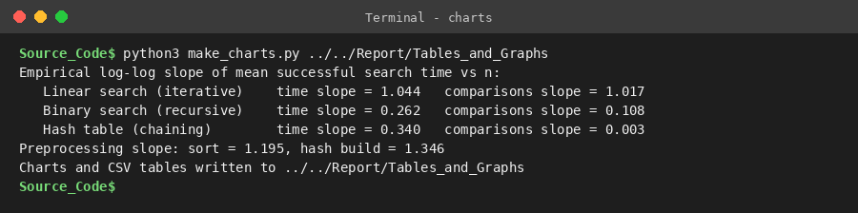
Output – generation of graphs and growth exponents

11. Task 10 – Compare Theory with Experimental Behaviour (4 marks)

11.1 Operation counts: prediction vs. measurement
n | Quantity (formula) | Predicted | Measured | Difference
1,000 | Linear, successful: $\left(n+1\right)/2$ | 500.5 | 490.4 | -2.0 %
 | Binary, successful: $\log_{2}\left(n+1\right)-1+\log_{2}\left(n+1\right)/n$ | 8.98 | 9.01 | +0.4 %
 | Binary, worst: $⌊\log_{2}n⌋+1$ | 10 | 10 | bound respected
 | Hash, successful: $1+\left(n-1\right)/2m$ ($α$=0.735) | 1.367 | 1.328 | -2.9 %
 | Hash, unsuccessful: $α$ | 0.735 | 0.738 | +0.4 %
10,000 | Linear, successful: $\left(n+1\right)/2$ | 5,000.5 | 5,125.9 | +2.5 %
 | Binary, successful: $\log_{2}\left(n+1\right)-1+\log_{2}\left(n+1\right)/n$ | 12.29 | 12.37 | +0.6 %
 | Binary, worst: $⌊\log_{2}n⌋+1$ | 14 | 14 | bound respected
 | Hash, successful: $1+\left(n-1\right)/2m$ ($α$=0.750) | 1.375 | 1.405 | +2.2 %
 | Hash, unsuccessful: $α$ | 0.750 | 0.765 | +2.1 %
100,000 | Linear, successful: $\left(n+1\right)/2$ | 50,000.5 | 54,464.8 | +8.9 %
 | Binary, successful: $\log_{2}\left(n+1\right)-1+\log_{2}\left(n+1\right)/n$ | 15.61 | 15.73 | +0.8 %
 | Binary, worst: $⌊\log_{2}n⌋+1$ | 17 | 17 | bound respected
 | Hash, successful: $1+\left(n-1\right)/2m$ ($α$=0.750) | 1.375 | 1.382 | +0.5 %
 | Hash, unsuccessful: $α$ | 0.750 | 0.758 | +1.1 %
1,000,000 | Linear, successful: $\left(n+1\right)/2$ | 500,000.5 | 547,933.2 | +9.6 %
 | Binary, successful: $\log_{2}\left(n+1\right)-1+\log_{2}\left(n+1\right)/n$ | 18.93 | 19.02 | +0.5 %
 | Binary, worst: $⌊\log_{2}n⌋+1$ | 20 | 20 | bound respected
 | Hash, successful: $1+\left(n-1\right)/2m$ ($α$=0.750) | 1.375 | 1.367 | -0.5 %
 | Hash, unsuccessful: $α$ | 0.750 | 0.770 | +2.7 %
The measured comparison counts agree closely with the derived formulas: binary search and hashing match within about 1 % of the prediction. The linear-search average at $n={10}^{6}$ is about 10 % above $\left(n+1\right)/2$ only because the average is taken over a small random sample (60 queries at that size, since each linear query costs ~13 ms); the standard deviation of a uniformly distributed position over 60 samples is roughly $\frac{n}{\sqrt{12⋅60}}≈0.037n$, so a deviation of this size (about 1.3 standard deviations) is ordinary sampling noise. As a check, the mean position of all 10,000 queries generated for that dataset is 503,364, within 0.7 % of $\left(n+1\right)/2$, which shows the dataset and query generator are unbiased. The bounds are respected exactly: no binary search ever exceeded $⌊\log_{2}n⌋+1$ comparisons, and linear search used exactly $n$ comparisons in the worst case.

11.2 Growth rates: empirical vs theoretical exponents
The slope of $log\left(\text{value}\right)$ against $logn$ measures the empirical growth exponent ($\text{value}∝n^{s}$):
Quantity | Empirical exponent $s$ | Theory
Linear: comparisons | 1.02 | 1 ($Θ\left(n\right)$)
Linear: time | 1.04 | 1
Binary: comparisons | 0.11 | $logn$ (≈0.1 over this range)
Binary: time | 0.26 | $logn$ (≈0.1)
Hash: comparisons | 0.00 | 0 ($Θ\left(1\right)$)
Hash: time | 0.34 | 0
Preprocessing: sort + index | 1.19 | $nlogn$ (slightly above 1)
Preprocessing: hash build | 1.35 | 1 ($Θ\left(n\right)$)
- Linear search: slope $≈1$ for both comparisons and time – experiment confirms $Θ\left(n\right)$ (the time slope of 1.04 is slightly above 1, see below).
- Binary search: a $logn$ curve looks like a small power on a log–log plot ($\log_{2}n$ from 10 to 20 over three decades gives slope $≈0.1$); the measured comparison slope 0.11 matches. The time slope (0.26) is higher than the comparison slope for the reason given below.
- Hash table: comparisons are constant (slope $≈0.00$), confirming $Θ\left(1\right)$ search. The time slope of 0.34 is above zero for the reason given below.

11.3 Which algorithm scales better?
The hash table scales best, binary search second and linear search worst. At $n={10}^{6}$ a binary search is about 2,050 times faster than a linear search and a hash lookup is about 10,208 times faster than a linear search (successful searches); the gap widens as $n$ grows, exactly as $n$ versus $logn$ versus $1$ predicts.

11.4 Differences between theory and experiment, and their reasons
- Time grows faster than the operation count for B and C. Comparisons for hashing stay constant, yet the time per lookup rises from about 0.140 µs to 1.286 µs. The reason is memory hierarchy: the 1,000-record structures fit in the CPU cache, whereas the million-record table (over 100 MB in Python) does not, so every probe incurs a cache miss. The RAM model used in the asymptotic analysis assumes every access costs the same; real machines do not. The same effect explains binary search’s time slope being larger than its comparison slope: the first levels of the search are cached, the last ones are not.
- Linear search is slightly worse than $Θ\left(n\right)$ (time slope 1.04, ratio ×1,469 for a ×1000 increase in $n$). Again this is cache and memory-bandwidth behaviour for larger arrays, plus sampling noise.
- Preprocessing grows faster than predicted. The sort slope is about 1.2 (theory: $nlogn$, i.e. a slope slightly above 1 – as observed) but the hash build slope is 1.35, although it is $Θ\left(n\right)$ in theory. In CPython building the table creates a million tuples and chain lists, which causes memory allocation, garbage-collection and cache-miss overhead that grow with $n$. Also, sorted() runs in C while the hash table is built by Python-level code, so the hash build appears about 5–6 times slower than the sort at $n={10}^{6}$ even though it has the better asymptotic cost – a constant-factor effect that Big-O hides.
- Constant factors at small $n$. At $n=1000$ the recursive binary search is only ~9 times faster than linear search although the comparison count is ~50 times smaller, because every recursive call in Python carries function-call overhead. Asymptotic analysis is about growth, not about the constant $c$ in $T\left(n\right)=c C\left(n\right)$.
- Timing noise. Wall-clock timings on a shared machine fluctuate by a few percent; operation counts are exactly reproducible and therefore the primary evidence for the complexity class, with timings as supporting evidence.
Conclusion of the comparison. The experiments confirm the theoretical complexity classes ($Θ\left(n\right)$, $Θ\left(logn\right)$, $Θ\left(1\right)$ expected) and the ranking of the algorithms. The deviations are explained by hardware and language-implementation effects which asymptotic analysis deliberately ignores.

12. Task 11 – Recommend and Defend the Final Design (4 marks)

12.1 Recommendation
Recommended design: sort the records once by registration number and use recursive binary search (Approach B), storing a position index so the full record is retrieved in $O\left(1\right)$.
(For the changed operating conditions of Task 12 this recommendation is modified – see Section 13.)

12.2 Why it is more appropriate than the alternatives
Criterion | A – Linear | B – Binary (recommended) | C – Hash
Search cost (average) | $$Θ\left(n\right)$$ | $$Θ\left(logn\right)$$ | $Θ\left(1\right)$ expected
Worst-case guarantee | $$n$$ | $⌊\log_{2}n⌋+1$ – deterministic | $Θ\left(n\right)$ if keys collide (rare)
Preprocessing | none | $Θ\left(nlogn\right)$, 589 ms at $n={10}^{6}$ | $Θ\left(n\right)$ expected, but 3,267 ms at $n={10}^{6}$ in this implementation
Memory overhead | none | 56 MB peak for the index | 153 MB peak
Ordered / range queries (e.g. all registration numbers of one batch) | no | yes | no
Break-even vs. linear search | – | after 45 searches | after 310 searches
Simplicity / verifiability | simplest | simple | more complex (hash function, collisions, resizing)

12.3 Evidence
- Theoretical efficiency. $Θ\left(logn\right)$ per search, i.e. $⌊\log_{2}n⌋+1$ comparisons in the worst case (Tasks 3, 7). Together with sorting: $Θ\left(nlogn\right)+qlogn$.
- Experimental performance. At $n={10}^{6}$ the average successful search takes 6.405 µs and needs 19.02 comparisons, versus 13,128 µs and 547,933 comparisons for linear search (about 2,050 times faster). Going from 1,000 to 1,000,000 records increased the comparisons only from 9.01 to 19.02.
- Preprocessing cost. Sorting 10^6 records took 589 ms, repaid after only 45 searches.
- Not just the lowest Big-O. Hashing has the lowest asymptotic search cost, but in the experiments its build took about 5–6 times longer than the sort and needed about 2.7 times the memory; its advantage in search time ($≈$ 3.5 times faster than binary search) matters only when searches are very frequent (see Task 12). With no information about the search frequency, binary search gives the best balance of cost, guaranteed worst case, memory and functionality.

12.4 Trade-offs and limitations
- The sort must be redone (or the new records merged in) when records are added; inserting a single record into a sorted array costs $O\left(n\right)$. This is acceptable only if updates are infrequent or batched.
- Binary search requires random access (an array) and a total order on keys – both true for registration numbers.
- If searches were extremely frequent or the database were many orders of magnitude larger, the constant factor of the hash table would start to pay off.

12.5 Practicality as the database grows
The worst-case count grows by only one comparison per doubling of the database ($⌊\log_{2}n⌋+1$ = 24 even for 10 million records), the recursion depth is negligible, and preprocessing is a one-time $nlogn$ cost. Hence the solution remains practical well beyond 1,000,000 records, up to the limit of available memory.

13. Task 12 – Day-4 Design Challenge (8 marks)
Changed requirement: 50,000 search requests per hour on a database of 1,000,000 records; new records are added once per day.

13.1 A. Impact analysis (2 marks)
What has changed. The original problem asked for an efficient search strategy as the database grows; the number of searches was unspecified. It is now fixed and large: 50,000 per hour $=13.9$ requests per second, i.e. a time budget of about 72 ms per request if processed serially, on a database of fixed size $n={10}^{6}$ that is almost static.
Assumptions affected.
- “Preprocessing is an extra cost.” In the original analysis preprocessing (sorting or building a table) was a cost to be charged against a possibly small number of searches. With $q$ now very large it is amortised over a huge number of searches.
- “Insertion cost must be low.” The original design implicitly allowed for continuous growth. Records are now added only once per day, so the structure can be rebuilt or updated in a batch – a slow update costs almost nothing.
- “All three approaches are comparable.” They are not once the workload is known: the total cost of a strategy is $P\left(n\right)+q⋅s\left(n\right)$, and the dominant term changes from $P\left(n\right)$ (few searches) to $q⋅s\left(n\right)$ (many searches).
Why the search frequency now matters. The total time is preprocessing plus $q$ times the cost of one search. Linear search is $q⋅n/2$ comparisons – at $q=50,000$ and $n={10}^{6}$ that is $2.5×{10}^{10}$ comparisons per hour, repeated every hour. An $O\left(logn\right)$ or $O\left(1\right)$ search turns this into $≈{10}^{6}$ comparisons.
Why infrequent updates influence the design. The main drawback of sorted arrays and (to a lesser degree) hash tables is the cost of keeping the structure up to date. If updates are rare, this drawback almost disappears and all the time can be spent on making search fast: it is worth paying preprocessing once per day to save time on roughly $24×50,000=1.2$ million searches per day.

13.2 B. Evaluation of the original design (2 marks)
Original recommendation: sort once + binary search. Measured at $n={10}^{6}$ with the real workload of 50,000 searches (day4_challenge.py):
Strategy ($n={10}^{6}$) | Per search | 50,000 searches (1 hour) | One-time preprocessing | Hour incl. preprocessing
A – Linear (extrapolated from 300 real searches) | 12,375.6 µs | 618.78 s | none | 618.78 s
B – Sort + binary search | 4.798 µs | 0.2399 s | 0.554 s | 0.794 s
C – Hash table | 1.389 µs | 0.0695 s | 3.830 s | 3.899 s
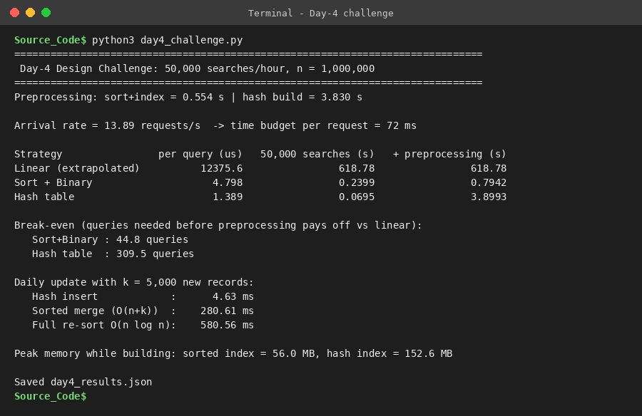
Output – Day-4 challenge run (real 50,000-search workload at n = 1,000,000)
Expected behaviour under 50,000 searches/hour. The original design needs about 0.24 s of CPU time for the whole hour (of 3,600 s) – far below the 72 ms/request budget (it answers in about 4.8 µs). It remains fully adequate.
Is its preprocessing cost acceptable? The sort takes 0.55 s once; even if the data were re-sorted every hour, this is only 0.015 % of the hour. A daily re-sort costs 581 ms for 5,000 new records (assumed number – the assignment does not state it); merging the sorted new records into the sorted array costs 281 ms ($O\left(n+k\right)$). Acceptable.
Could another approach give better overall performance? Yes. The hash table answers a search in 1.39 µs, about 3.5 times faster than binary search, and a daily update of 5,000 new records costs only 4.6 ms (inserting $k$ records is $O\left(k\right)$, versus 281 ms for a sorted merge). Its one-time build (3.83 s) is amortised after 310 searches – i.e. in under a minute of the first hour – and the high memory cost (153 MB versus 56 MB) is acceptable on a server. Linear search, although it would technically fit on one core (619 s of CPU per hour, 17 % of a core) leaves no headroom, scales linearly with the load and is therefore rejected.
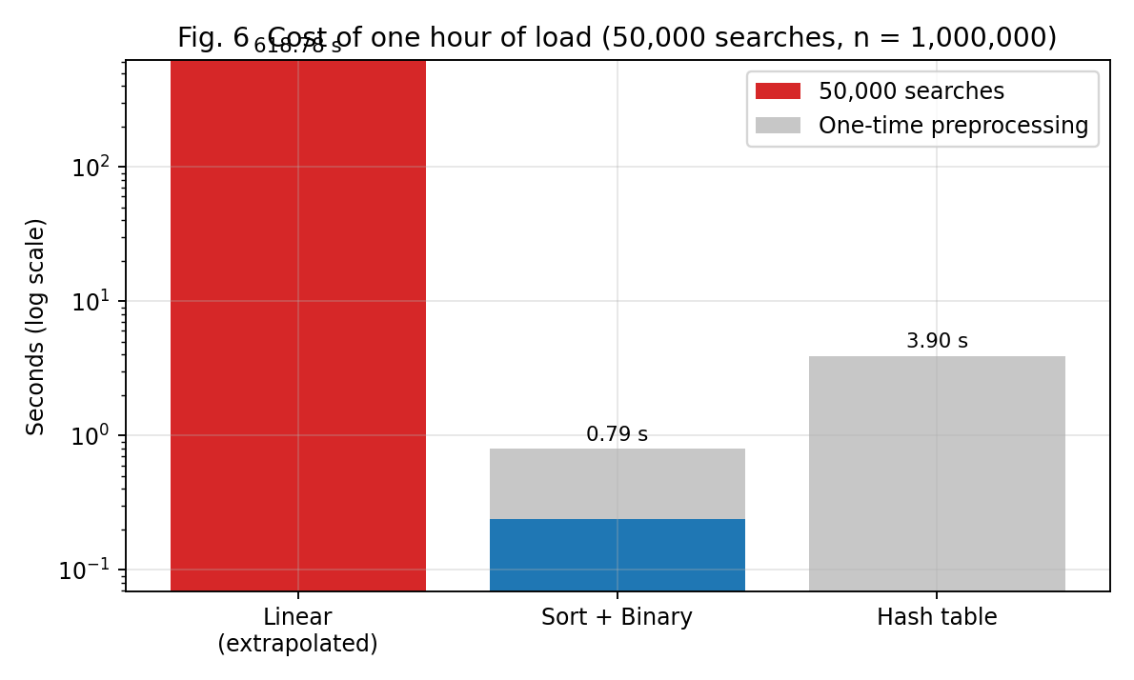

13.3 C. Adaptation or redesign (2 marks)
Decision: MODIFY. The philosophy of the original design is retained (preprocess once, then answer many searches quickly), but the index structure is modified from a sorted array to a hash table keyed on registration number.
Revised strategy.
- Build the hash table once from the 1,000,000 records (load factor 0.75, prime table size) – $Θ\left(n\right)$.
- Answer each of the 50,000 hourly searches with HashSearch – expected $Θ\left(1\right)$.
- Daily batch update: insert the day’s new records into the table – $Θ\left(k\right)$ for $k$ new records – (and, if the load factor exceeds a threshold, rebuild with a larger $m$ once, $Θ\left(n\right)$).
- Optional: retain the sorted array as a secondary index only if the university also needs range or prefix queries (these are not possible with a hash table).
What has changed. Only the data structure that answers searches; the correctness argument, key and record layout are unchanged.
Effect on computational complexity.
 | Original (sorted + binary) | Modified (hash)
Search | $Θ\left(logn\right)$ — 20 comparisons | $Θ\left(1\right)$ expected — 1.37 comparisons
Initial preprocessing | $$Θ\left(nlogn\right)$$ | $Θ\left(n\right)$ expected
Daily update (k new) | $Θ\left(n+k\right)$ merge | $$Θ\left(k\right)$$
Cost of $q=50,000$ searches/hour | $50,000×\log_{2}n≈{10}^{6}$ comparisons | $50,000×1.375≈7×{10}^{4}$ comparisons
Memory | $Θ\left(n\right)$ ( 56 MB ) | $Θ\left(n\right)$ ( 153 MB )
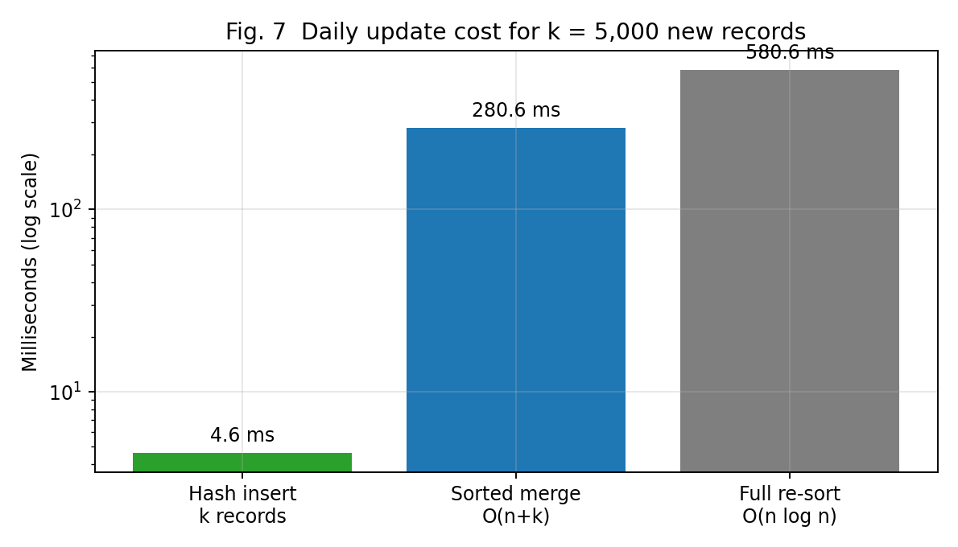

13.4 D. Evidence-based defence (2 marks)
Total cost of a day of operation (24 hours at 50,000 searches/hour = 1.2 million searches, one daily update of 5,000 records; hash: incremental inserts, binary: sorted merge), from the measurements:
Strategy | 1.2 M searches / day | Daily update (5,000 new records) | Total per day | Share of 24 h
A – Linear (extrapolated) | 14,851 s | none (append) | 14,851 s (= 4.1 h) | 17.2 %
B – Sorted + binary | 5.76 s | 0.281 s (merge) | 6.04 s | 0.0070 %
C – Hash table | 1.67 s | 0.0046 s (insert) | 1.67 s | 0.0019 %
- Mathematical complexity. Total cost $P\left(n\right)+q s\left(n\right)$: linear $q n/2$ ($≈6×{10}^{11}$ comparisons per day), binary $nlogn+qlogn$, hash $n+1.375q$. With $q=1.2×{10}^{6}$ per day the search term dominates and the lowest per-search cost wins.
- Experiments. Hash search: 1.39 µs per search versus 4.8 µs for binary search and 12,376 µs for linear search; the real 50,000-search workload took 0.07 s with the hash table, 0.24 s with binary search and an extrapolated 619 s with linear search.
- Search frequency. At 13.9 requests/s the arrival rate is low enough that both binary search and hashing meet the requirement by a very large margin; the justification for changing is not necessity but efficiency and headroom (peak loads, several concurrent services, growth well beyond ${10}^{6}$).
- Preprocessing cost. The hash build (3.83 s) is the highest one-time cost but happens once, and it is repaid after 310 searches (less than one minute at the stated rate). Daily maintenance is cheaper than for the sorted array (4.6 ms against 281 ms).
- Dataset size. At $n={10}^{6}$ the hash table needs about 153 MB in this Python implementation (56 MB for the sorted index) – small for a server.
- Trade-offs. The hash table gives up ordered queries, has a theoretical $Θ\left(n\right)$ worst case for adversarial keys (observed longest chain: 8) and needs more memory. If ordered/range queries are required, retain binary search (it too is entirely adequate for 50,000 searches per hour).
Final decision. Modify the original design: use a hash index, rebuilt or incrementally updated once per day, because it minimises the total cost for a read-heavy, rarely updated database. The decision follows from the evidence: per-search cost, amortised preprocessing, update cost and memory. It does not rely on the Big-O notation alone.

14. Conclusion
Three distinct strategies – linear search (iterative brute force), binary search (recursive decrease-and-conquer) and hashing (space–time trade-off) – were designed, analysed and measured for the student-record search problem. The analysis showed $Θ\left(n\right)$, $Θ\left(logn\right)$ and expected $Θ\left(1\right)$ search costs, with preprocessing costs of $0$, $Θ\left(nlogn\right)$ and $Θ\left(n\right)$. The recurrence $C\left(n\right)=C\left(⌊n/2⌋\right)+1$ was formulated from the code and solved by iteration, the Master Theorem and substitution to $⌊\log_{2}n⌋+1$. Experiments on 1,000 to 1,000,000 records confirmed the operation counts closely and the growth rates qualitatively; deviations in timings were explained by cache and implementation effects. With no assumption about search frequency, sorted records with binary search are the most balanced choice; for the workload of 50,000 searches per hour on a rarely updated database of one million records the design is modified to a hash index.

Limitations of this study
- Timings were measured in CPython on one machine; absolute values will differ on another machine, but operation counts and growth trends should not.
- The linear-search averages at the largest sizes are based on few queries (60 at $n={10}^{6}$) because each query is slow; its comparison count therefore has noticeable sampling error.
- The number of new records per day (5,000) and a constant request rate over 24 hours are assumptions made for the Day-4 analysis.
- Keys are random integers; real registration numbers are structured (year, department, serial) and a hash function should be re-validated against real data.

15. Appendix – Repository Structure and Reproduction
CO1_Assignment
|-- Task_1_Algorithm_Design/ (task write-ups, one .md per task)
|-- Task_2_Basic_Operation/
|-- Task_3_Mathematical_Complexity/
|-- Task_4_Case_Analysis/
|-- Task_5_Asymptotic_Analysis/
|-- Task_6_Recurrence_Formulation/
|-- Task_7_Recurrence_Solution/
|-- Task_8_Implementation_Testing/
| `-- Source_Code/ (algorithms.py, tests, benchmark, results.json)
|-- Task_9_Experimental_Performance/
|-- Task_10_Theory_vs_Experiment/
|-- Task_11_Final_Recommendation/
|-- Task_12_Design_Challenge/
|-- Report/
| |-- CO1_Assignment_Report.docx (this report)
| |-- Source_Code_Screenshots/
| |-- Output_Screenshots/
| |-- Analysis/
| |-- Tables_and_Graphs/
| `-- Documentation/ (raw console logs, report builder)
`-- README.md
To reproduce every number in this report (Python 3.10+, matplotlib, numpy, Pillow, pygments):
cd Task_8_Implementation_Testing/Source_Code
python3 test_algorithms.py -v
python3 benchmark.py
python3 day4_challenge.py
python3 make_charts.py ../Tables_and_Graphs
Timings will differ slightly from machine to machine; operation counts and growth trends should match.

