SAVEETHA INSTITUTE OF MEDICAL AND TECHNICAL SCIENCES (SIMATS ENGINEERING)
DEPARTMENT OF COMPUTER SCIENCE AND ENGINEERING
CSA06 – Design and Analysis of Algorithms
Assignment 2 – CO2
Brute-Force and Exhaustive-Search Techniques: Predict → Design → Implement → Measure → Analyse → Evaluate → Diagnose → Redesign → Validate
Course Outcome CO2: Apply Brute Force technique to solve sorting, searching, Closest-Pair and Convex-Hull problems.
Total marks: 50
Student name: Dheepak K
Register number: 192411108
Section / Batch: 2024-2028

GitHub repository: CO2_Assignment/ (structure in Appendix A)

Contents
1. Introduction, Methodology and System Architecture
2. Q1 – Sorting Under Different Data Conditions (6)
3. Q2 – When Is Sequential Search an Appropriate Engineering Choice? (4)
4. Q3 – Engineer the Behaviour of Brute-Force String Matching (6)
5. Q4 – Closest Pair and the Cost of Examining Every Possibility (6)
6. Q5 – Derive a Convex Hull Algorithm from a Geometric Principle (7)
7. Q6 – Exhaustive Search and Combinatorial Growth (8)
8. Q7 – Day-4 Design Challenge: Diagnose, Redesign and Validate (13)
9. Overall Conclusion
10. Appendix A – Repository structure and how to reproduce
11. Appendix B – Mark-scheme coverage map

1. Introduction, Methodology and System Architecture

1.1 Purpose
This report answers the seven tasks of CSA06 Assignment 2. Each of Q1–Q6 follows the same cycle demanded by the assignment: a prediction with an algorithmic reason is written first; test data is designed to expose behaviour; the algorithm is implemented with counters; observed counts are compared with the prediction; and a decision is defended. Q7 then selects one of the earlier solutions (Q6), diagnoses its bottleneck from the Q6 evidence, redesigns it, predicts the effect, validates it experimentally against the original and critically evaluates the result.

1.2 Measurement policy
- Primary evidence = operation counts (key comparisons, moves, character comparisons, pairs examined, distance calculations, side tests, candidate subsets, tree nodes). Counts are deterministic for fixed seeds and machine-independent.
- Execution time is reported as secondary evidence only (Python 3, CPython, single thread; one machine; Python function-call and loop overhead is included in the times).
- Every algorithm is cross-checked by an independent verifier (Python's sorted(), a dynamic-programming knapsack solver, Andrew's monotone-chain hull) used only for verification, never as the solution.
- All random data comes from seeded random.Random instances, so every table in this report can be regenerated exactly (raw JSON/CSV and the console output of each run are stored in each question's raw_data/ folder).

1.3 System architecture
Figure 1 shows how test-data design, instrumented algorithms, measurement and evidence generation connect, ending in this report. Figures 2–8 are flowcharts of the algorithm for each question and are repeated next to its pseudocode in the repository.
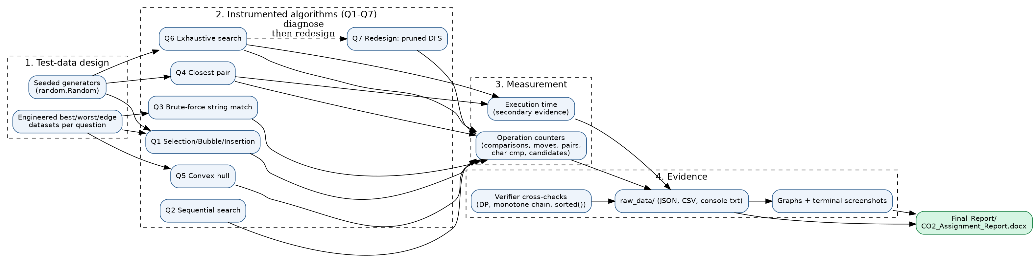
Figure 1 – Experimental architecture of the CO2 assignment

1.4 Notation
n = input size; m = pattern length; W = payload limit; log is base 2. C(n) = number of basic operations. Θ, O, Ω have their usual asymptotic meanings.

2. Q1 – Sorting Under Different Data Conditions

2.1 Problem and approach
A fulfilment centre sorts orders by dispatch priority score. The question is whether one of Selection, Bubble or Insertion sort should always be preferred, or whether the best choice depends on the arrangement of the incoming data. Basic operation: one key comparison; second measure: moves (a swap counts as one move; an insertion-sort shift counts as one move).

2.2 Predictions before implementation
Algorithm | Prediction (n elements) | Algorithmic reason
Selection | Comparisons = n(n-1)/2 for every input; moves ≤ n-1 | The inner loop always scans the entire unsorted suffix to find the minimum; it has no way to notice that the data is already in order. Only one swap per pass.
Bubble (with early-exit flag) | ≈ n²/2 comparisons on random and reversed data; n-1 on sorted data. Moves = number of inversions. On 'nearly sorted' data I predicted it would behave like Insertion sort. | A pass without a swap proves order, so sorted input needs one pass. Each swap removes exactly one inversion. Bubble moves a small element left by only ONE position per pass (to be tested on D6).
Insertion | ≈ n²/4 comparisons on random, n-1 on sorted, n²/2 on reversed. Comparisons ≈ (n-1) + inversions. | Each element shifts left past exactly the larger elements before it; it stops at the first smaller one, so the cost adapts to the number of inversions.
Table 1 – Predictions for Q1

2.3 Test-data design
ID | Dataset (n = 1000) | Purpose
D1 | Random permutation | Average-case reference
D2 | Already sorted | Contrasting dataset 1 – best case for adaptive sorts
D3 | Reverse sorted | Contrasting dataset 2 – worst case for all three
D4 | Nearly sorted: 20 adjacent pairs swapped (2%) | Small, local disorder
D5 | Edge case (my own): only 5 distinct priority values | Many duplicates – tests how comparisons/moves behave with ties and stability
D6 | Fulfilment scenario: 950 ordered orders + 50 new random orders appended at the end (95% / 5%) | Exactly the situation reported by the fulfilment centre
Table 2 – Q1 datasets

2.4 Algorithm design
Pseudocode (also in Q1_Sorting_Algorithms/Pseudocode/):
Q1 - SORTING UNDER DIFFERENT DATA CONDITIONS
Basic operation: key comparison A[j] vs A[i]. Second measure: moves (swap = 1 move, insertion shift = 1 move).

SelectionSort(A[0..n-1])
for i <- 0 to n-2: // grow a sorted prefix one position at a time
m <- i
for j <- i+1 to n-1:
comparisons++ // ALWAYS executed -> n(n-1)/2 in total
if A[j] < A[m]: m <- j // remember index of smallest remaining key
if m != i: swap(A[i], A[m]); moves++ // at most one swap per outer pass

BubbleSort(A[0..n-1]) // with early-exit flag
for i <- 0 to n-2:
swapped <- false
for j <- 0 to n-2-i:
comparisons++
if A[j] > A[j+1]: swap; moves++; swapped <- true
if not swapped: stop // a pass with no swap proves the array is sorted

InsertionSort(A[0..n-1])
for i <- 1 to n-1:
v <- A[i]; j <- i-1
while j >= 0:
comparisons++
if A[j] > v: A[j+1] <- A[j]; moves++; j <- j-1 // shift larger element right
else: break
A[j+1] <- v // drop v into its gap

Experiment driver
datasets: D1 random, D2 sorted, D3 reversed, D4 nearly sorted, D5 five distinct values,
D6 95% ordered + 5% new batch appended
predict(formulae) -> run each algorithm on a COPY -> verify output == sorted -> store counts -> compare with prediction

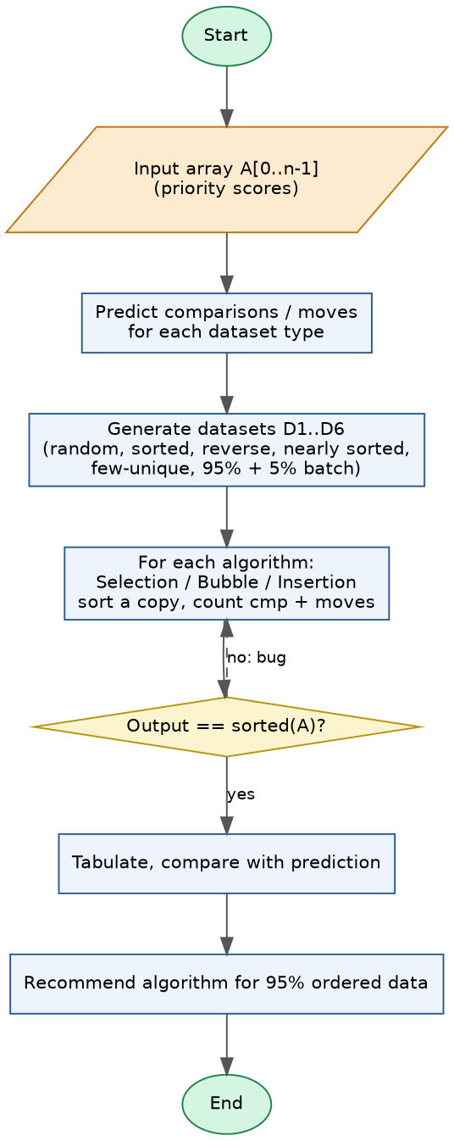
Figure 2 – Q1 experiment flowchart

2.5 Results
Dataset | Selection cmp / moves | Bubble cmp / moves | Insertion cmp / moves
D1 Random | 499,500 / 994 | 498,759 / 257,782 | 258,771 / 257,782
D2 Already sorted | 499,500 / 0 | 999 / 0 | 999 / 0
D3 Reverse sorted | 499,500 / 500 | 499,500 / 499,500 | 499,500 / 499,500
D4 Nearly sorted (2% adjacent swaps) | 499,500 / 20 | 1,997 / 20 | 1,019 / 20
D5 Edge: only 5 distinct priorities | 499,500 / 798 | 478,997 / 193,990 | 194,988 / 193,990
D6 Fulfilment: 95% ordered + 5% new batch | 499,500 / 991 | 499,364 / 25,214 | 26,212 / 25,214
Table 3 – Measured comparisons / moves, n = 1000 (n(n-1)/2 = 499,500)
Dataset | Selection ms | Bubble ms | Insertion ms
D1 Random | 20.876 | 48.571 | 22.569
D2 Already sorted | 21.597 | 0.092 | 0.077
D3 Reverse sorted | 22.392 | 68.797 | 53.466
D4 Nearly sorted (2% adjacent swaps) | 20.527 | 0.101 | 0.082
D5 Edge: only 5 distinct priorities | 19.900 | 40.494 | 18.032
D6 Fulfilment: 95% ordered + 5% new batch | 19.652 | 24.532 | 2.134
Table 4 – Execution time (secondary evidence)
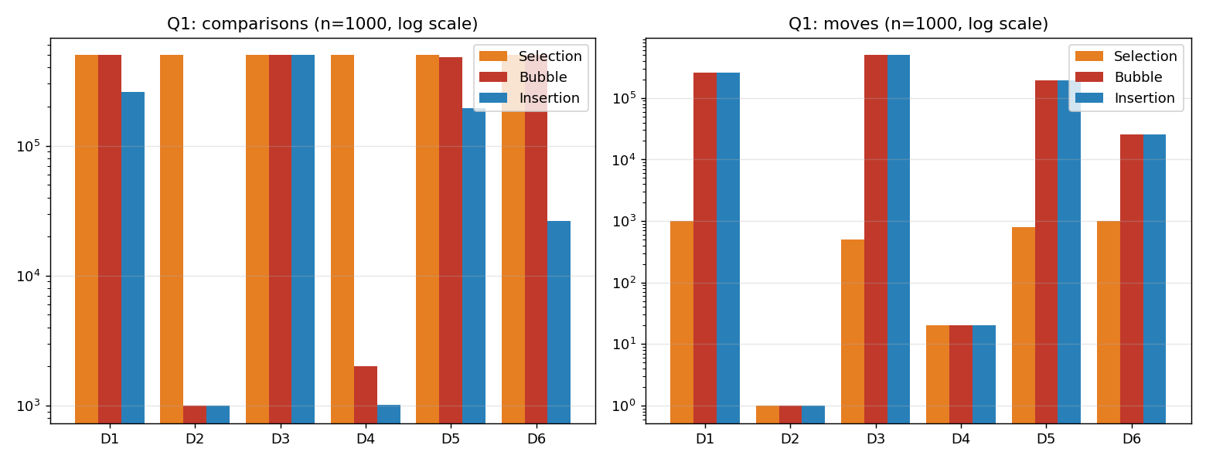
Figure 3 – Comparisons and moves per dataset (log scale)
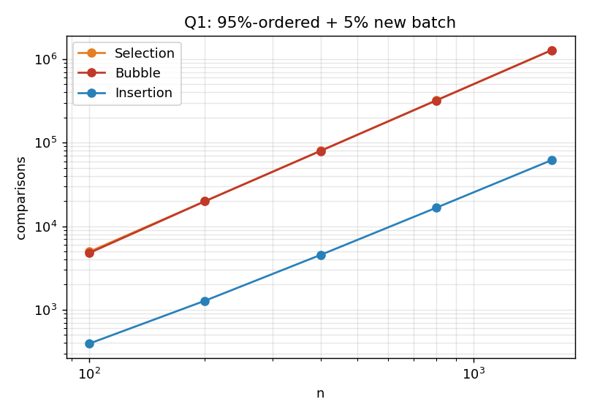
Figure 4 – Growth with n on the 95%-ordered + 5%-batch dataset
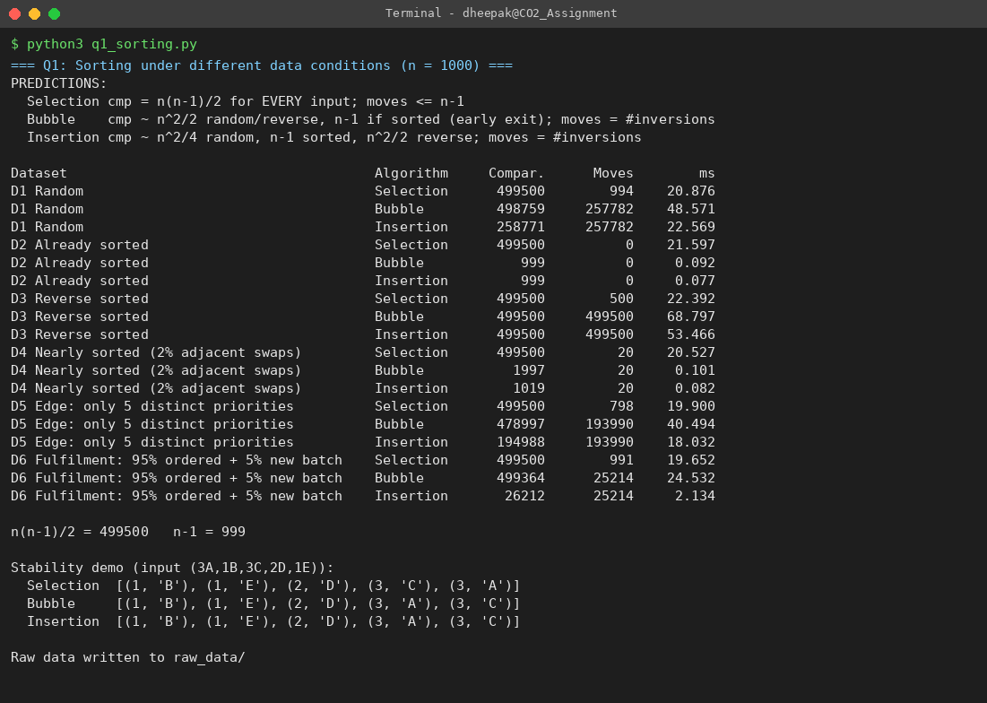
Screenshot 1 – Q1 program output (screen 1 of 1)

2.6 Prediction versus observation
- Selection – confirmed. 499,500 comparisons on every dataset (= n(n-1)/2). Moves never exceeded n-1 (max 994). It is completely insensitive to input order, so it can never benefit from existing order.
- Insertion – confirmed. 258,771 comparisons on random data (≈ n²/4 = 250,000), 999 on sorted (n-1), 499,500 on reversed (n²/2). On D6 it needed only 26,212 comparisons; moves (25,214) equal the number of inversions.
- Bubble – partly confirmed, partly refuted. Sorted (999) and locally disordered D4 (1,997) behaved as predicted. My prediction that Bubble would also be near-linear on D6 was wrong: it needed 499,364 comparisons – almost as many as Selection. Reason: the 50 new orders sit at the END, and a small element travels left by only one slot per pass, so the number of passes equals the largest leftward displacement (hundreds of passes), each pass scanning almost the whole array. Moves (25,214) still equal the inversions, so Bubble and Insertion perform the SAME number of data movements – Bubble simply pays about 19× more comparisons to discover where to stop.
- Edge case D5 (duplicates). Insertion and Bubble use strict comparison (>), so equal keys are never moved past each other; both are stable. Selection's long-distance swap breaks stability (stability demo in the console output: orders 3A and 3C come out as 3C, 3A with Selection).

2.7 Design decision for the fulfilment centre
Recommendation: Insertion sort. With ~95% of orders already in priority order and only small batches appended, Insertion sort's cost is (n-1) + inversions. On D6 it used 26,212 comparisons against 499,500 (Selection) and 499,364 (Bubble) – a 19× reduction – and 2.1 ms against 19.7 ms and 24.5 ms. Selection cannot exploit the order at all; Bubble can exploit local disorder but not displaced batches. Insertion is also stable, which preserves arrival order between orders with equal priority, and needs O(1) extra memory.
Answer to the challenge: no algorithm should *always* be preferred. Selection is only attractive when moves are extremely expensive (≤ n-1 swaps). Insertion is the best of the three whenever the data is nearly ordered. If the batch becomes large (say 30%+ of the data) its cost grows as batch×n and the brute-force family stops being appropriate – the batch should then be sorted separately and merged. That extension is beyond CO2 but follows directly from the measured inversion count.

3. Q2 – When Is Sequential Search an Appropriate Engineering Choice?

3.1 Problem and approach
The tool-tracking system answers “Who currently has Tool T-184?” by scanning a temporary list of records (Tool ID | Technician ID | Issue Time | Work Bay). Basic operation: comparison of the Tool ID of a record with the key. The list is small and changes continuously (issue and return), which is the typical situation in which sequential search is considered.

3.2 Predictions and algorithm
- Successful search at position i costs exactly i comparisons: first = 1, middle ≈ n/2, last = n. With a uniformly random target the average is (n+1)/2.
- An unsuccessful search must examine every record: exactly n comparisons – the worst case.
- Cost grows linearly with n, so doubling the list doubles the work; there is no sub-linear shortcut because the list is unordered.
Q2 - SEQUENTIAL SEARCH FOR TOOL T-184
SequentialSearch(L[0..n-1], key)
comparisons <- 0
for i <- 0 to n-1:
comparisons++
if L[i].tool_id = key: return (i, comparisons) // successful search
return (-1, comparisons) // unsuccessful: exactly n comparisons

Experiment driver
for n in {50,...,100000}:
build n records (Tool ID, Technician ID, Issue Time, Bay)
successful search for first / middle / last record -> record comparisons
unsuccessful search (key not present) -> record comparisons
2000 random successful searches -> average comparisons vs (n+1)/2
timing: sequential vs hash index (dictionary tool_id -> record)
boundary: n_max = (acceptable time per lookup) / (cost per comparison) * 2
scenarios: compare q*(n+1)/2 (sequential) with n + q (build index once, 1 probe per lookup)

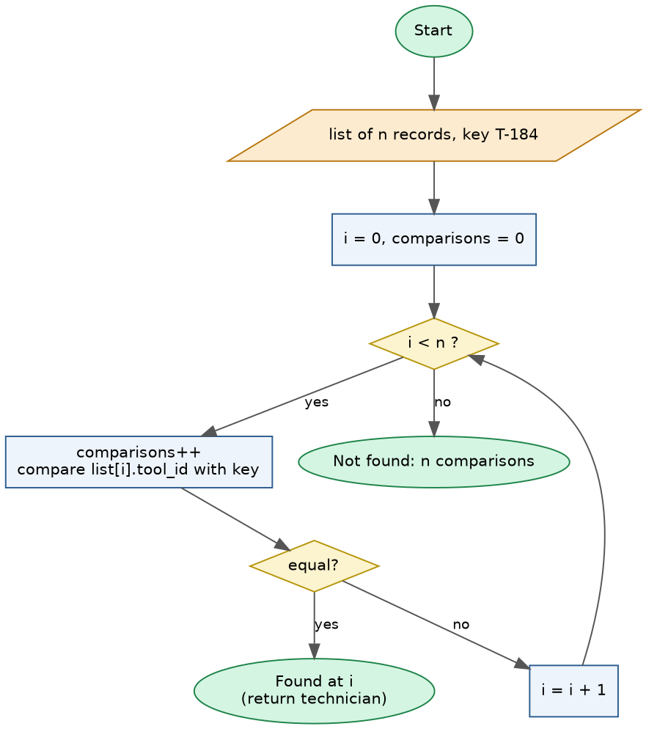
Figure 5 – Sequential search flowchart

3.3 Experiments and results
n | First | Middle | Last | Unsuccessful | Avg. successful (2000 random) | (n+1)/2
50 | 1 | 26 | 50 | 50 | 26.0 | 25.5
100 | 1 | 51 | 100 | 100 | 51.4 | 50.5
500 | 1 | 251 | 500 | 500 | 250.5 | 250.5
1,000 | 1 | 501 | 1,000 | 1,000 | 504.2 | 500.5
5,000 | 1 | 2,501 | 5,000 | 5,000 | 2511.9 | 2500.5
10,000 | 1 | 5,001 | 10,000 | 10,000 | 5028.7 | 5000.5
50,000 | 1 | 25,001 | 50,000 | 50,000 | 25428.6 | 25000.5
100,000 | 1 | 50,001 | 100,000 | 100,000 | 50041.7 | 50000.5
Table 5 – Comparisons for successful (different positions), unsuccessful and average searches
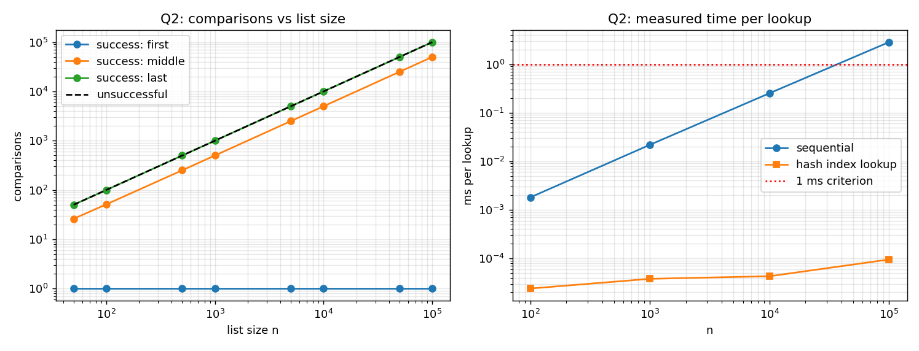
Figure 6 – Comparisons vs list size (left); measured time per lookup, sequential vs hash index (right)
n | Sequential ms/lookup | Hash-index ms/lookup | Hash build ms
100 | 0.00181 | 0.000024 | 0.010
1,000 | 0.02187 | 0.000038 | 0.070
10,000 | 0.25207 | 0.000043 | 0.692
100,000 | 2.84488 | 0.000095 | 15.375
Table 6 – Measured time (secondary evidence)
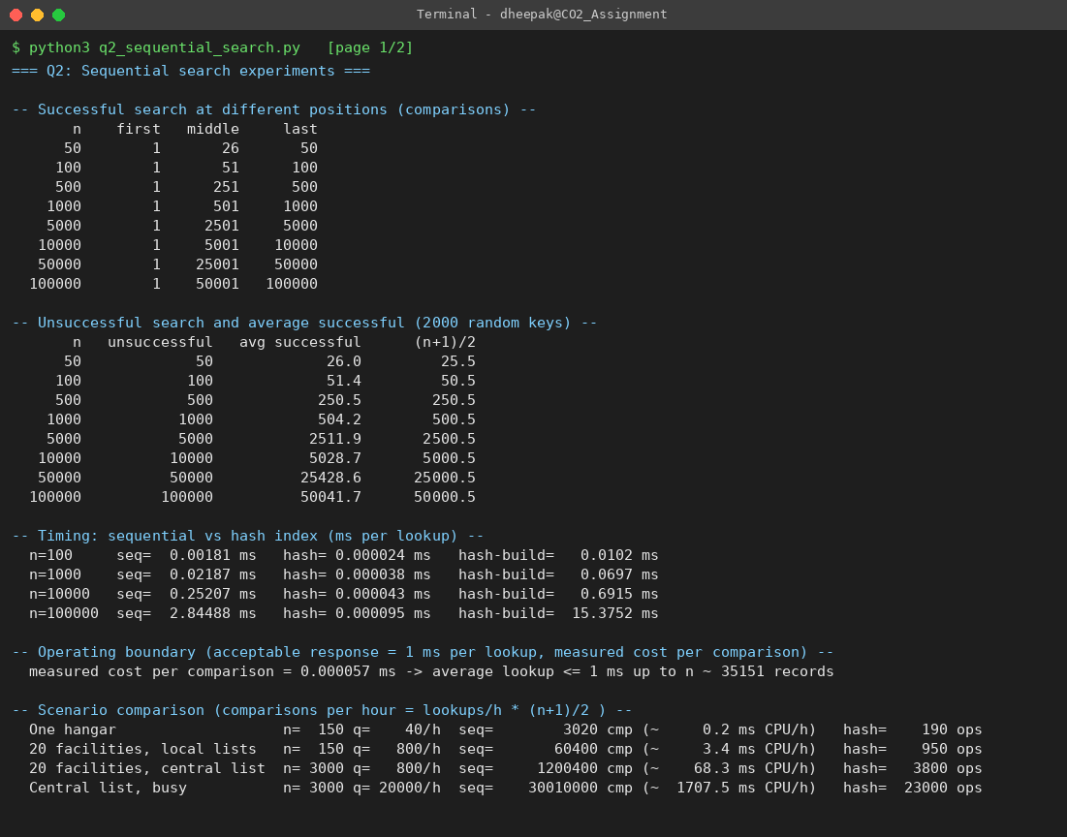
Screenshot 2 – Q2 program output (screen 1 of 2)
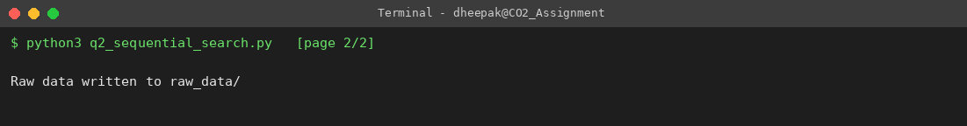
Screenshot 2 – Q2 program output (screen 2 of 2)

3.4 Observations
All predictions were confirmed exactly: first/middle/last cost 1, ⌈n/2⌉ and n comparisons; unsuccessful searches cost n at every size; the empirical average of 2000 random successful searches matches (n+1)/2 within sampling error (e.g. 50042 vs 50000.5 at n = 100,000). The graph is a straight line of slope 1 on log-log axes: cost is Θ(n) per search.

3.5 Operating boundary
Acceptability criterion. A lookup is acceptable if its average response is ≤ 1 ms on this machine (a technician at a counter perceives this as instant; even 10× this would be fine, but 1 ms leaves headroom for the rest of the system). Measured cost is 57 ns per comparison (Python), so the average successful lookup stays under 1 ms up to n ≈ 35,151 records; an unsuccessful lookup (worst case) reaches 1 ms at about half of that.
Frequency. Total work is q·(n+1)/2 comparisons for q lookups. A hash index costs n to build plus 1 probe per lookup (plus O(1) per issue/return). Sequential search is therefore reasonable when n is small (hundreds to a few thousand) and/or lookups are infrequent; I would stop recommending it when either (a) n exceeds ≈ 35,151 (latency criterion) or (b) lookup load q·n/2·57 ns exceeds about 1% of a CPU core (≈ 36 s of comparisons per hour), i.e. q·n > 1,265,443,885 per hour.

3.6 Changed condition – 20 maintenance facilities
Scenario (assumed) | Active records n | Lookups / hour | Sequential comparisons / hour | ≈ CPU time / hour | Hash-index operations / hour
One hangar | 150 | 40 | 3,020 | 0.2 ms | 190
20 facilities, local lists | 150 | 800 | 60,400 | 3.4 ms | 950
20 facilities, central list | 3,000 | 800 | 1,200,400 | 68.3 ms | 3,800
Central list, busy | 3,000 | 20,000 | 30,010,000 | 1707.5 ms | 23,000
Table 7 – Re-evaluation (the 20× growth in records and lookups is my assumption: 150 records / 40 lookups per hour per hangar)
Re-evaluation. If each facility keeps its own list, nothing changes: each list is still ~150 records and ≈ 20 comparisons per lookup on average, so sequential search remains an acceptable engineering choice (it is simple, needs no index maintenance and cannot become inconsistent). If the 20 facilities are merged into one central service (n ≈ 3,000, 800 lookups/hour), the arithmetic still permits sequential search (≈ 68 ms of comparisons per hour), but the margin to the boundary has shrunk to about 12× in n and the system now has concurrency, bursts of requests and audit scans that the measured averages hide. My revised recommendation: keep sequential search for the per-hangar lists; for the central service use a hash index keyed by Tool ID – its 3,800 operations/hour and O(1) update on issue/return are negligible, and it removes the dependency on n. The decision flips unambiguously to an index when n approaches ≈ 35,151 records or the combined lookup rate reaches the q·n limit above.

4. Q3 – Engineer the Behaviour of Brute-Force String Matching

4.1 Problem and approach
A security operations centre scans text logs for signatures. Brute-force matching tries every alignment i = 0 … n-m of the pattern under the text and compares characters left to right until a mismatch. Basic operation: one character comparison T[i+j] = P[j]. There are n-m+1 alignments, so the work lies between n-m+1 (every alignment fails immediately) and m(n-m+1) (every alignment fails at the last character).
Q3 - BRUTE-FORCE STRING MATCHING
BruteForceMatch(T[0..n-1], P[0..m-1])
cmp <- 0; matches <- []
for i <- 0 to n-m: // every alignment of P under T : n-m+1 alignments
j <- 0
while j < m:
cmp++ // basic operation: one character comparison
if T[i+j] != P[j]: break // mismatch: shift pattern by ONE and restart (no memory of j)
j <- j+1
if j = m: matches.append(i)
return matches, cmp

Predictions made before execution
T1 text A^n, pattern B^m : mismatch at j=0 each time -> n-m+1
T2 text A^n, pattern A^(m-1)B : mismatch at j=m-1 each time -> m(n-m+1)
T3 log text + real signature : varied characters, early misses -> about 1.0-1.1 per alignment
T4 random binary text : P(prefix of length j matches)=2^-j -> about 2 per alignment
T5 B^m only at end of A..AB..B : one comparison per alignment, then m at the end -> about n

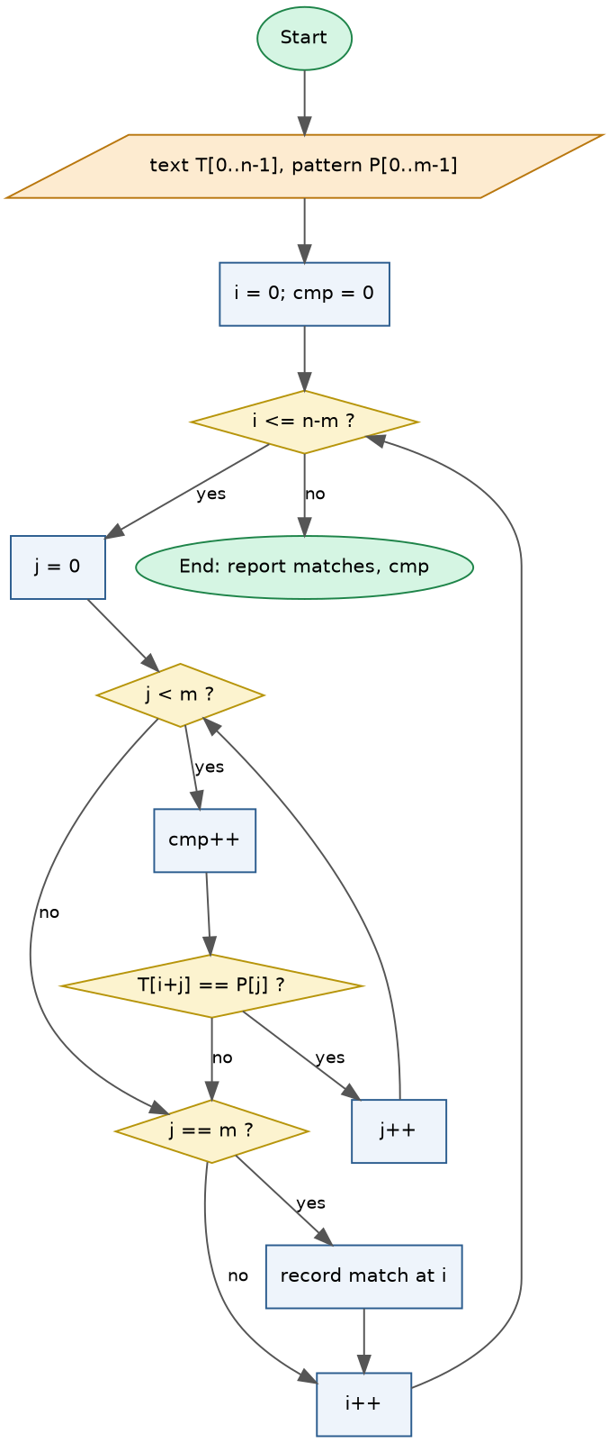
Figure 7 – Brute-force string matching flowchart

4.2 Test design, predictions (made before executing) and observations
Test | Text / pattern | Prediction and reason | Predicted | Observed
T1 (little work) | A^10000 / B^8 | Every alignment fails on the 1st comparison because the pattern's first character does not occur in the text. | n-m+1 = 9,993 | 9,993
T2 (engineered worst case) | A^10000 / A^7 B | Every alignment matches 7 characters, fails on the 8th, and the shift of 1 forgets everything learned. | m(n-m+1) = 79,944 | 79,944
T3 (own test: realistic log) | 400 generated log lines (14,106 chars) / “ERROR user299 port scan” | Varied text: most alignments fail at the first or second character (log lines share a few leading letters). | ≈ 1.0–1.1 per alignment | 15,283 (1.085 per alignment)
T4 (own test: small alphabet) | random binary text 10000 / 0000000 1 | Small alphabet: P(first j characters match) = 2^-j, so expected comparisons per alignment = 1 + 1/2 + 1/4 + … ≈ 2. | ≈ 2 per alignment (~19,990) | 20,188 (2.020 per alignment)
T5 (own test: late match) | A^9992 B^8 / B^8 | 1 comparison per alignment until the final one, which costs m. | ≈ n = 10,000 | 10,000
Table 8 – Q3 tests: prediction before execution, and result (T1 and T2 matched their formulas exactly; the program asserts it)
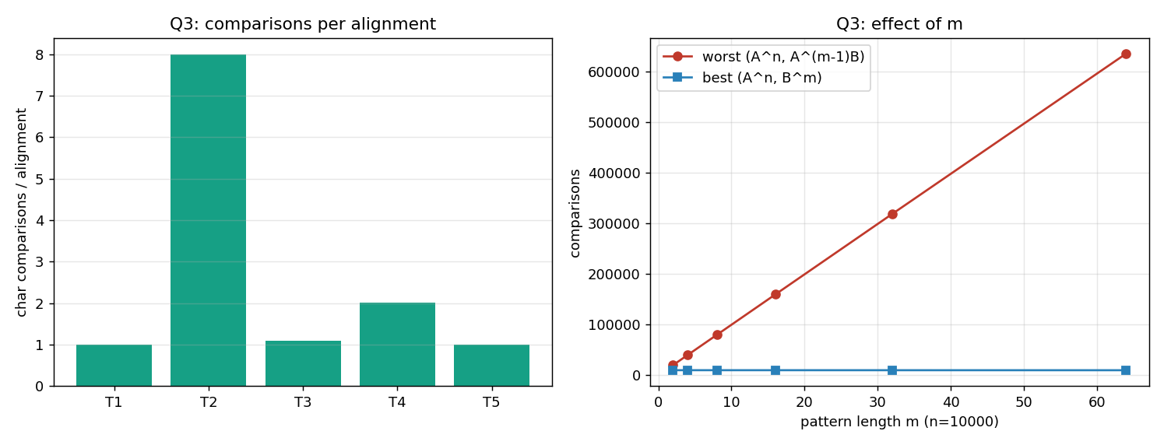
Figure 8 – Comparisons per alignment (left); effect of pattern length on best and worst case at n = 10,000 (right)
m | Best (A^n, B^m) | Worst (A^n, A^(m-1)B) | Worst / best
2 | 9,999 | 19,998 | 2.0
4 | 9,997 | 39,988 | 4.0
8 | 9,993 | 79,944 | 8.0
16 | 9,985 | 159,760 | 16.0
32 | 9,969 | 319,008 | 32.0
64 | 9,937 | 635,968 | 64.0
Table 9 – Pattern-length sweep: the worst/best ratio equals m
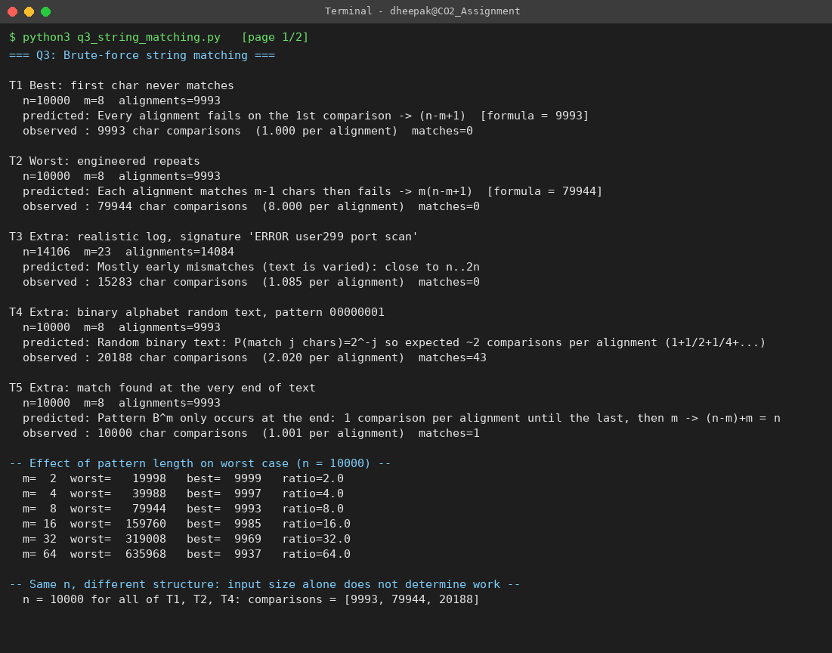
Screenshot 3 – Q3 program output (screen 1 of 2)
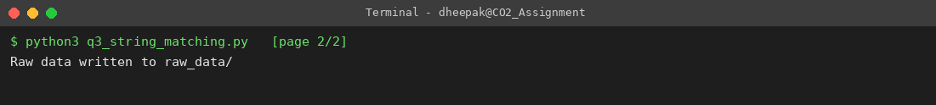
Screenshot 3 – Q3 program output (screen 2 of 2)

4.3 Inquiry
- Why one input needs far more work. T1 and T2 have identical n = 10,000 and m = 8 yet cost 9,993 vs 79,944 comparisons – 8× more. In T2 each alignment survives m-1 comparisons before failing; in T1 none survives the first.
- Characteristics that create repeated comparisons. (1) A pattern whose prefix is highly self-similar to the text (long runs of one repeated character) so that long partial matches occur at many alignments; (2) the mismatch located late in the pattern (…AB); (3) a small alphabet (T4), where chance matches of prefixes are common: 2 comparisons per alignment on average versus ≈ 1.08 for the varied English-like log (T3). The brute-force algorithm re-reads text characters it has already compared, because after a mismatch it shifts by one and restarts with j = 0.
- What this reveals about evaluating an algorithm by input size alone. n and m do not determine the cost: the same (n, m) gave 9,993 and 79,944 comparisons. Complexity statements need the case (best Θ(n), worst Θ(nm), average ≈ Θ(n) for varied text) and the data structure of the input, not just its length. A log-screening system must be sized for the adversarial or repetitive worst case (e.g. long runs of padding characters) and not for the average log.

5. Q4 – Closest Pair and the Cost of Examining Every Possibility

5.1 Design
- Candidate pairs. Every unordered pair {Di, Dj} with i ≠ j must be examined because any two drones might be the closest.
- Avoiding duplicates. d(Di,Dj) = d(Dj,Di), so only pairs with i < j are generated (the inner loop starts at i+1), which also excludes self-pairs.
- Counting. Drone 0 pairs with n-1 others, drone 1 with n-2 further ones, … drone n-2 with 1: (n-1)+(n-2)+…+1 = n(n-1)/2 = C(n,2) ∈ Θ(n²). Doubling n multiplies the pairs by ≈ 4.
- Distance. Squared distance (xi-xj)²+(yi-yj)² is compared instead of the square root, since √ is monotonic; this removes a costly operation without changing which pair wins. The square root is taken only once for the final answer.
Q4 - BRUTE-FORCE CLOSEST PAIR
Candidate pairs: unordered pairs {i,j}, i != j. Using i < j removes duplicates (d(i,j)=d(j,i)) and self pairs.
Count = sum_{i=0}^{n-2} (n-1-i) = (n-1)+(n-2)+...+1 = n(n-1)/2 = C(n,2)

ClosestPair(D[0..n-1])
best <- +infinity; pair <- none; pairs <- 0
for i <- 0 to n-2:
for j <- i+1 to n-1:
pairs++
d2 <- (xi - xj)^2 + (yi - yj)^2 // squared distance: sqrt is monotone, so ordering is unchanged
if d2 < best: best <- d2; pair <- (i,j)
return pair, sqrt(best), pairs

Scalability procedure
measure time for n = 50..4000; fit t = k * n(n-1)/2 (least squares); acceptable = 1 second
n_max = largest n with k*n(n-1)/2 <= 1 s -> solve n^2 - n - 2/k = 0

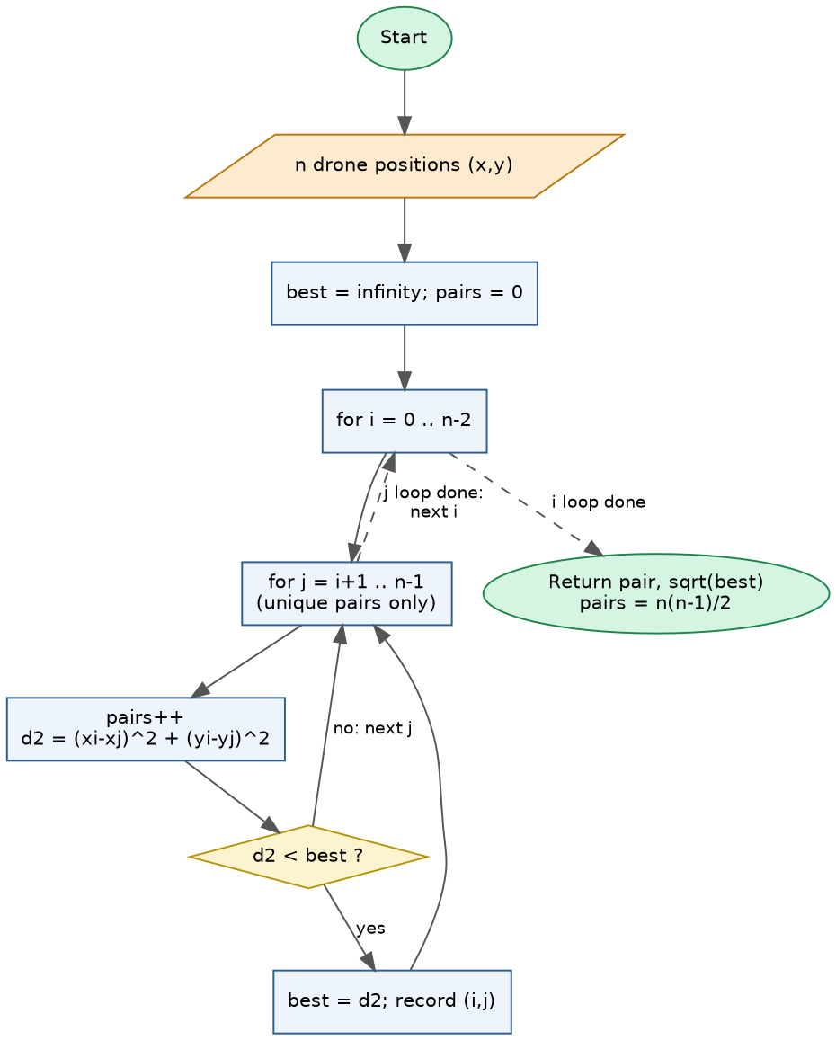
Figure 9 – Brute-force closest-pair flowchart

5.2 Results
n | Pairs examined | n(n-1)/2 | Distance calculations | Time (s)
50 | 1,225 | 1,225 | 1,225 | 0.0005
100 | 4,950 | 4,950 | 4,950 | 0.0016
250 | 31,125 | 31,125 | 31,125 | 0.0098
500 | 124,750 | 124,750 | 124,750 | 0.0394
1,000 | 499,500 | 499,500 | 499,500 | 0.1368
2,000 | 1,999,000 | 1,999,000 | 1,999,000 | 0.3929
3,000 | 4,498,500 | 4,498,500 | 4,498,500 | 0.7727
4,000 | 7,998,000 | 7,998,000 | 7,998,000 | 1.3356
Table 10 – Experimental growth (8 input sizes; pairs examined equal the derived formula at every size)
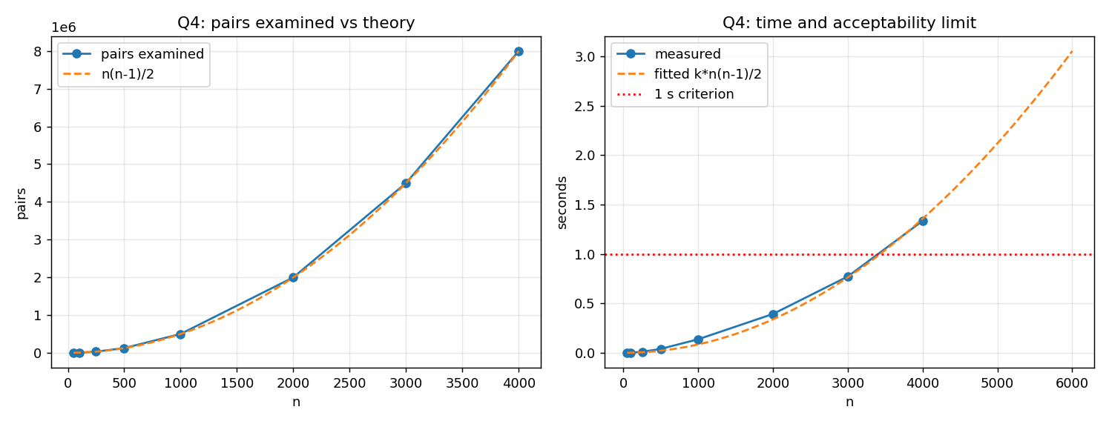
Figure 10 – Pairs examined vs theory (left); time and the 1-second acceptability limit (right)
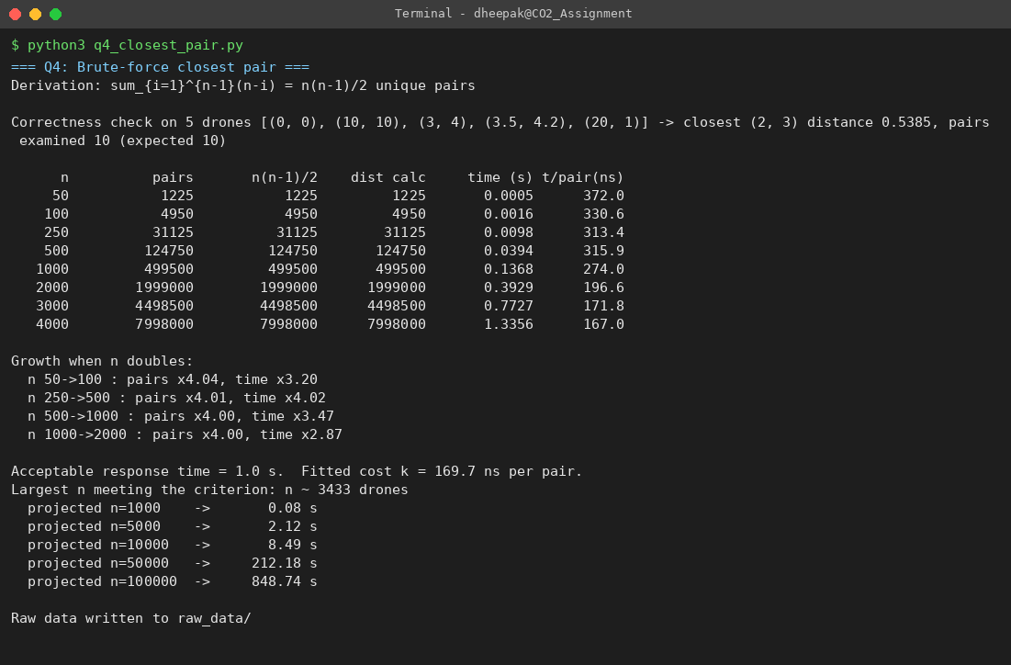
Screenshot 4 – Q4 program output (screen 1 of 1)

5.3 Theory versus experiment
Pairs examined matched n(n-1)/2 exactly for all sizes, and the distance-calculation count equals the pair count (one per pair). When n doubles, the pair count grows by 4.00× (e.g. 1000 → 2000: 499,500 → 1,999,000) and the measured time by 2.9–4.0×, confirming quadratic growth; the time per pair is almost constant (≈ 170 ns).

5.4 Scalability inquiry
Acceptable response time: 1 second per monitoring snapshot in this environment (a collision-risk display refreshed about once per second). A least-squares fit of t = k·n(n-1)/2 gives k = 170 ns per pair. Solving k·n(n-1)/2 ≤ 1 s gives n ≈ 3,433 drones. Measured: n = 3,000 took 0.77 s and n = 4,000 took 1.34 s. The approach becomes impractical between roughly 3,000 and 4,000 drones; projected times are 2.1 s at 5,000, 8.5 s at 10,000 and 849 s at 100,000 drones.
Source of the inefficiency. The effort is in examining pairs whose distance is obviously large: for a fleet spread over a wide area, most of the n(n-1)/2 pairs involve drones that are far apart and can never be the closest pair, yet each is still computed. The algorithm has no notion of spatial locality – it uses no information about *where* the drones are, so it cannot discard any candidate without evaluating it. A redesigned strategy must (i) avoid comparing pairs that are provably too far apart (for example by ordering or partitioning the drones by position so that only neighbours in space are compared), and (ii) reuse the best distance found so far as a shrinking search radius. Such a strategy needs a pre-processing step (sorting or gridding) in exchange for examining only a small fraction of the pairs; it is not implemented here as the question permits.

6. Q5 – Derive a Convex Hull Algorithm from a Geometric Principle

6.1 From the principle to a procedure
Given principle: *a line joining two candidate points may form part of the boundary if all remaining points lie on an appropriate single side of that line.* I converted it into five decisions:
Question | My derivation
How do two points define a line? | For p = (x1,y1) and q = (x2,y2): a·x + b·y = c with a = y2 − y1, b = x1 − x2, c = x1·y2 − y1·x2. (Substituting p or q gives 0, so both lie on it.)
How is the side of another point found? | s(r) = a·xr + b·yr − c. The expression is positive on one side of the line, negative on the other and zero on it – no division or angle is needed, so integer inputs give exact results.
How are the remaining points examined? | Every point r ≠ p, q is tested, with an early exit as soon as both signs have been seen.
What condition identifies a hull edge? | pq is an edge iff all s(r) ≥ 0 or all s(r) ≤ 0 (no points strictly on both sides) AND every r with s(r) = 0 lies inside the segment pq. The second clause is my own refinement for collinear points: if a collinear point lies beyond p or q, then p or q is not an extreme point and pq must be rejected.
How is the boundary constructed? | Accepted edges are chained: from the lowest-leftmost vertex repeatedly move to the neighbouring endpoint that is not the previous vertex (each hull vertex has exactly two incident edges).
Table 11 – Derivation of the decision rule
Q5 - BRUTE-FORCE CONVEX HULL (derived from the half-plane principle)
Step 1 Two points p=(x1,y1), q=(x2,y2) define the line a*x + b*y = c with
a = y2-y1, b = x1-x2, c = x1*y2 - y1*x2
Step 2 Side of another point r: s(r) = a*xr + b*yr - c. s>0 : one open half-plane, s<0 : the other, s=0 : on the line.
Step 3 Edge rule: pq is a hull edge <=> no two other points lie strictly on opposite sides
(i.e. all s(r) >= 0 or all s(r) <= 0), and every point with s=0 lies inside segment pq.
Step 4 Chain accepted edges into a polygon.

ConvexHull(P)
P <- distinct points; edges <- []
for each pair (p,q) with p before q:
pos <- false; neg <- false; ok <- true
for each other point r:
s <- side(p,q,r)
if s > 0: pos <- true
elif s < 0: neg <- true
elif r not between p and q: ok <- false; break // collinear but beyond an endpoint => p or q is not extreme
if pos and neg: ok <- false; break // points on both sides => line cuts the set
if ok: edges.append((p,q))
hull <- walk adjacency of edges from the lowest-leftmost point
return hull
Work: pairs n(n-1)/2, each tests up to n-2 points -> O(n^3) worst case.

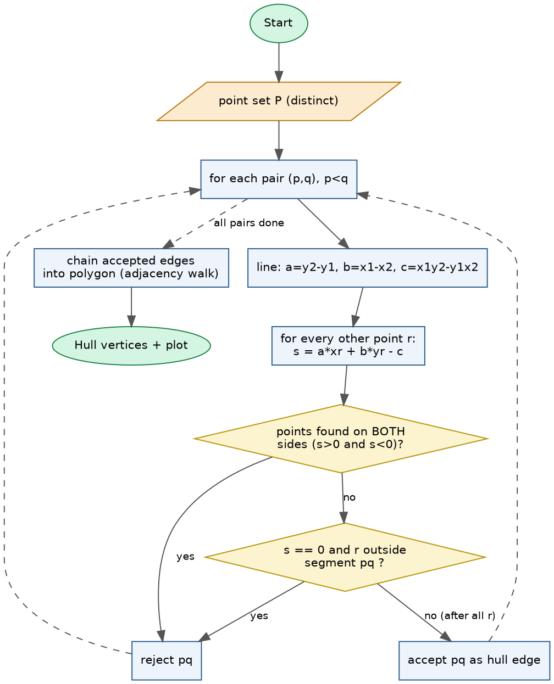
Figure 11 – Brute-force convex-hull flowchart

6.2 Tests
Test | Distinct points | Accepted edges | Side tests | Hull vertices | Matches monotone-chain verifier
A: random + 4 corner anchors | 34 | 4 | 5,692 | 4 | Yes
B: challenge (collinear boundary, duplicate, outside diag.) | 15 | 5 | 554 | 5 | Yes
C: all points collinear | 8 | 1 | 48 | 2 | Yes
D: 5x5 grid (many collinear edges) | 25 | 4 | 2,368 | 4 | Yes
Table 12 – Hull tests
Test A is a point set with boundary and interior points (30 random points plus four corner anchors; only the four corners form the hull). Test B is my challenge set: collinear points on the boundary edges (e.g. (4,0) listed twice and (8,4)), points inside, a point (10,10) beyond the diagonal and an outlier (−2,3). It checks duplicates, collinear boundary points and a non-rectangular hull. Tests C (all collinear) and D (5×5 grid, every side has five collinear points) are degenerate stress cases; the hull degenerates to a segment in C and to the four corners in D.
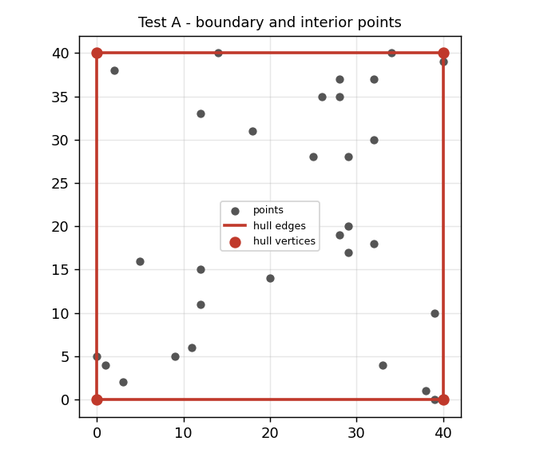
Figure 12 – Test A: boundary vs interior points
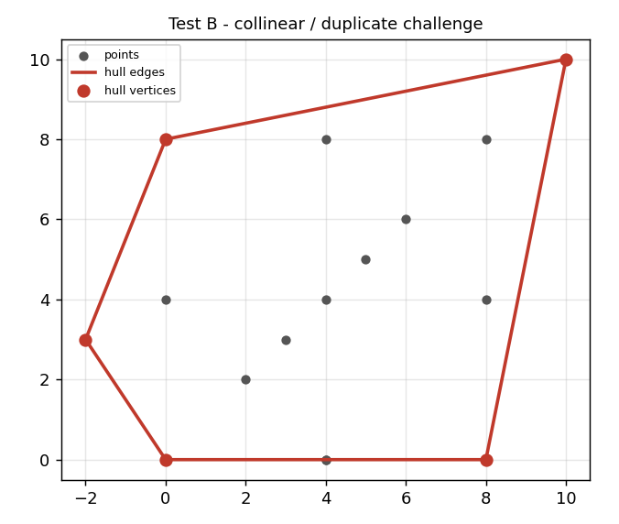
Figure 13 – Test B: collinear / duplicate challenge
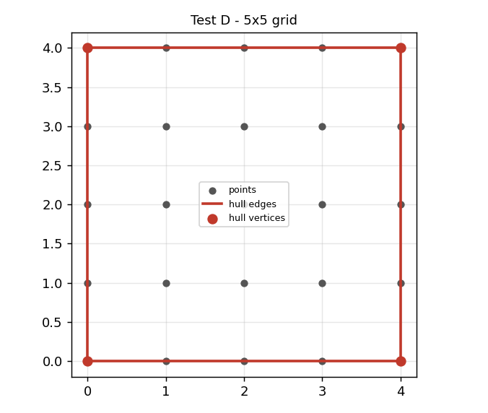
Figure 14 – Test D: 5×5 grid
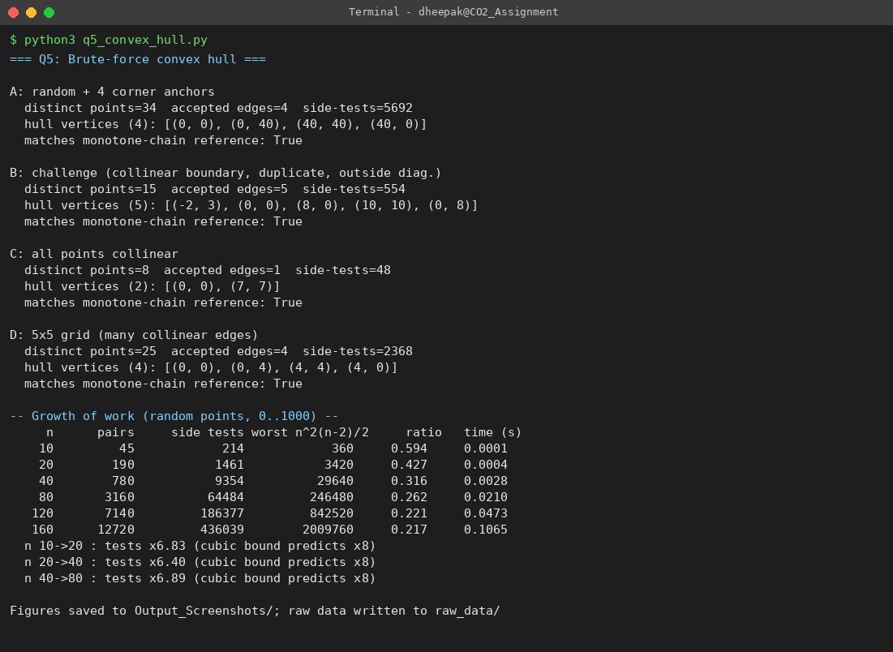
Screenshot 5 – Q5 program output (screen 1 of 1)

6.3 Computational analysis
n | Pairs | Side tests | Worst bound n(n-1)(n-2)/2 | Time (s)
10 | 45 | 214 | 360 | 0.0001
20 | 190 | 1,461 | 3,420 | 0.0004
40 | 780 | 9,354 | 29,640 | 0.0028
80 | 3,160 | 64,484 | 246,480 | 0.0210
120 | 7,140 | 186,377 | 842,520 | 0.0473
160 | 12,720 | 436,039 | 2,009,760 | 0.1065
Table 13 – Growth of work on random points
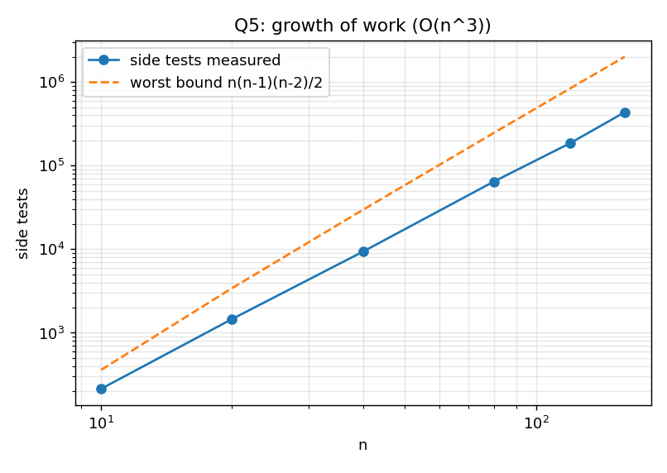
Figure 15 – Side tests vs the cubic bound
There are n(n-1)/2 candidate lines and each needs up to n-2 side tests, so the worst case is n(n-1)(n-2)/2 ∈ Θ(n³). Measured tests stay below this bound (22–59% of it) because most lines are rejected after only a few points – the early exit when both signs appear. The ratio of tests when n doubles is 6.4–6.9, approaching but below the cubic prediction of 8. The algorithm is simple and exact, but cubic: 160 points already require 436,039 tests.

6.4 Correctness inquiry – why an accepted edge belongs to the boundary
Let H be the convex hull of the point set S, i.e. the smallest convex set containing S. Suppose all points of S lie in a closed half-plane h bounded by the line L through p and q. Because h is convex and contains S, it contains H (H is the smallest such set). Hence H lies entirely on one side of L, and p, q ∈ S ⊂ H lie on L itself. Because H is convex, the whole segment pq lies in H, and on L. A point of the segment cannot be an interior point of H: every neighbourhood of it contains points on the forbidden side of L, which are outside h and therefore outside H. So each point of the segment pq is a boundary point of H – pq is part of the outer boundary (L is a *supporting line* of the set).
The rejection rule is justified by the converse: if r1 and r2 lie strictly on opposite sides of L, then the segment pq has points of H on both sides of it, so the interior of segment pq (which is on L) lies inside a triangle/quadrilateral of H and cannot be a boundary edge, so L is not a supporting line. Finally every hull edge has a supporting line through its two endpoints, so no edge is missed. For collinear points: if r on L is beyond q, then p, r are farther apart than p, q, and q is not extreme; the pair (p, r) will be tested instead. This argument is geometric and holds for any input, independently of the program output (which was additionally verified against the monotone-chain algorithm in all four tests).

7. Q6 – Exhaustive Search and Combinatorial Growth

7.1 Design of the exhaustive strategy
Design question | Answer
Representation of a candidate | An n-bit mask m ∈ [0, 2ⁿ): bit i = 1 means package i is loaded.
Generation | Binary counting from 0 to 2ⁿ−1 visits every subset exactly once, with no recursion or library help.
Feasibility check | Decode the mask, sum the weights, feasible iff total weight ≤ payload.
Evaluation | Sum the values of the loaded packages.
Retention of best | Keep (best value, best mask); replace only on a strictly higher value.
Table 14 – Exhaustive-search design
Q6 - EXHAUSTIVE SEARCH FOR THE AIRLIFT LOAD
Representation : a candidate load is an n-bit mask m; bit i = 1 means package i is loaded. 2^n masks = whole solution space.
Generation : iterate m from 0 to 2^n - 1 (binary counting visits every subset exactly once).
Feasibility : weight(m) = sum of W[i] over set bits; feasible iff weight(m) <= payload.
Evaluation : value(m) = sum of V[i] over set bits.
Retention : keep (best_value, best_mask); replace only on strictly higher value.

Airlift(W[0..n-1], V[0..n-1], cap)
best <- -1; bestmask <- 0
for m <- 0 to 2^n - 1:
w <- 0; v <- 0
for i <- 0 to n-1:
if bit i of m is 1: w <- w + W[i]; v <- v + V[i]
if w <= cap and v > best: best <- v; bestmask <- m
return best, bestmask
Prediction: candidates = 2^n ; adding one package doubles the work; adding k packages multiplies it by 2^k.
Verification: n=5 instance - all 32 subsets listed by hand/script; an independent DP solver must give the same optimum.

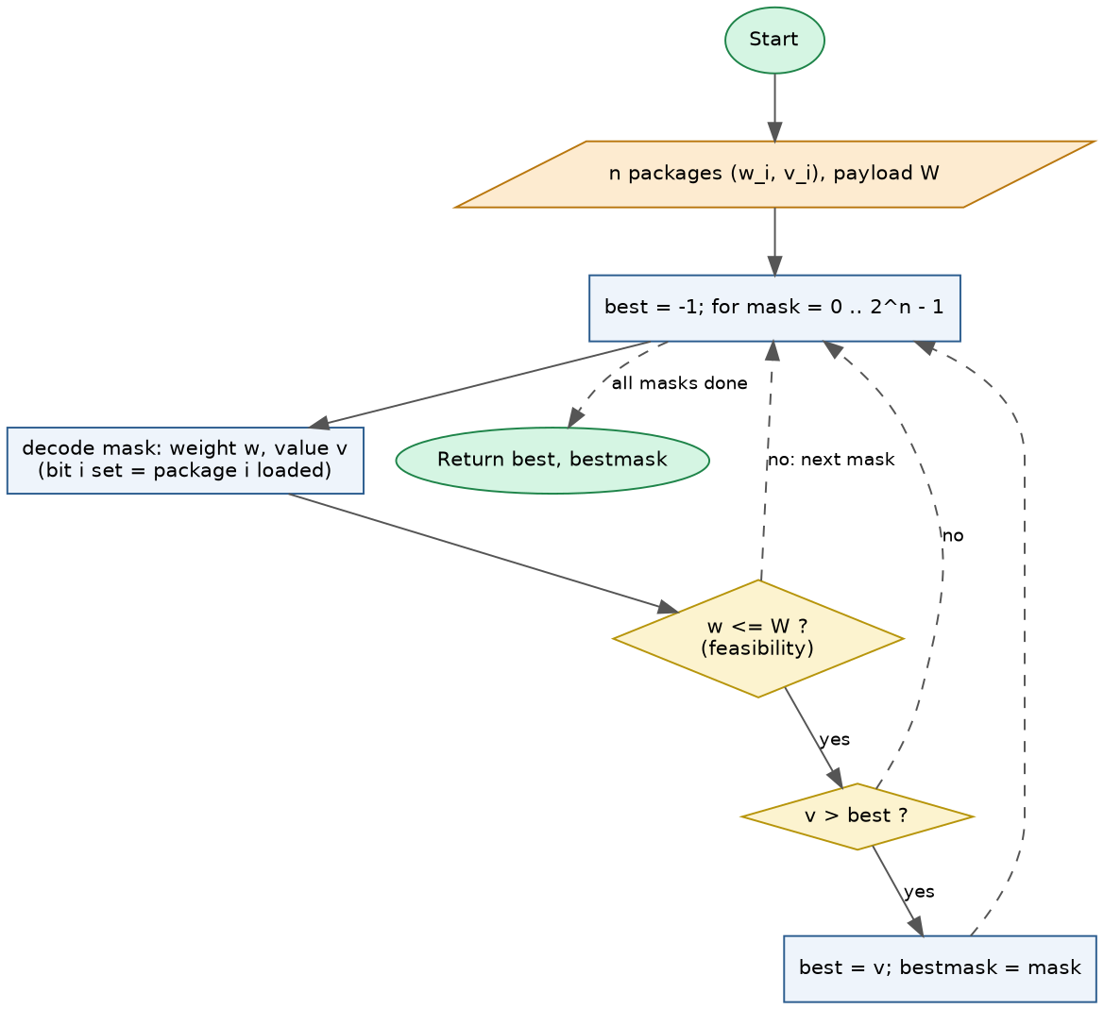
Figure 16 – Exhaustive search flowchart

7.2 Correctness check on a verifiable instance
Instance: P1 Water (w 7, v 9), P2 Medicine (w 3, v 10), P3 Food (w 6, v 7), P4 Blankets (w 5, v 4), P5 Radios (w 4, v 6); payload limit 12. There are 2⁵ = 32 subsets, all listed by the program; 16 are feasible. Best feasible loads:
Mask (P5..P1) | Packages | Weight | Value
11010 | P2+P4+P5 | 12 | 20
00011 | P1+P2 | 10 | 19
00110 | P2+P3 | 9 | 17
10010 | P2+P5 | 7 | 16
10001 | P1+P5 | 11 | 15
01010 | P2+P4 | 8 | 14
Table 15 – Top feasible combinations (from the full 32-subset table in raw_data/q6_small_table.json)
Independent check: the best load is P2+P4+P5 (weight 12, value 20); no other feasible subset reaches 20. The algorithm returned value 20 with 32 candidates checked and 16 feasible, and an independent dynamic-programming verifier also gives 20 – the algorithm is correct on this instance.

7.3 Growth investigation
Prediction (before experimenting). Every package doubles the number of subsets: candidates(n) = 2ⁿ, so the number of candidates is multiplied by 2ᵏ when k packages are added, and the running time (≈ n·2ⁿ elementary steps) should roughly quadruple for every +2 packages. Adding 10 packages should make the search ≈ 1000× longer.
n | Predicted 2ⁿ | Candidates examined | Feasible | Time (s)
10 | 1,024 | 1,024 | 280 | 0.001
14 | 16,384 | 16,384 | 4,180 | 0.014
16 | 65,536 | 65,536 | 15,526 | 0.060
18 | 262,144 | 262,144 | 60,328 | 0.265
20 | 1,048,576 | 1,048,576 | 208,967 | 1.550
22 | 4,194,304 | 4,194,304 | 819,957 | 5.769
Table 16 – Experimental validation (6 problem sizes; every run verified against the DP solver)
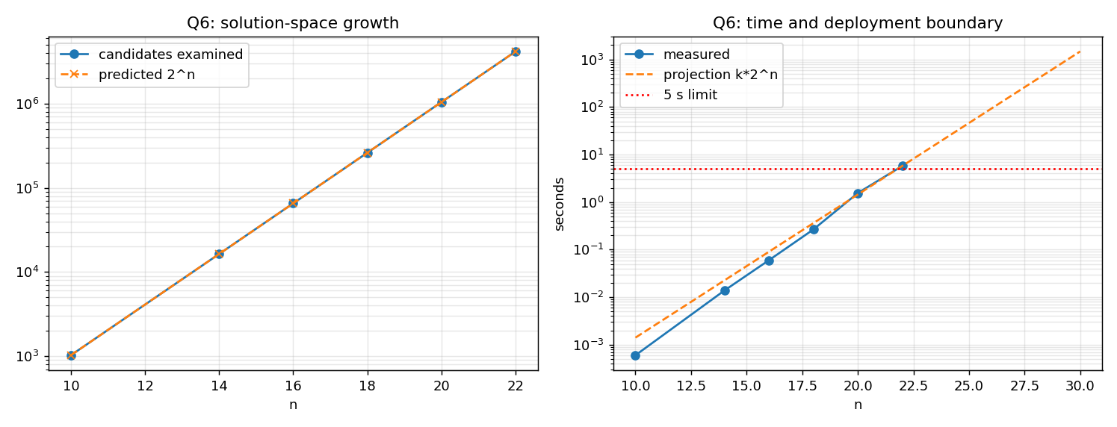
Figure 17 – Candidate growth (left); running time and deployment boundary (right)
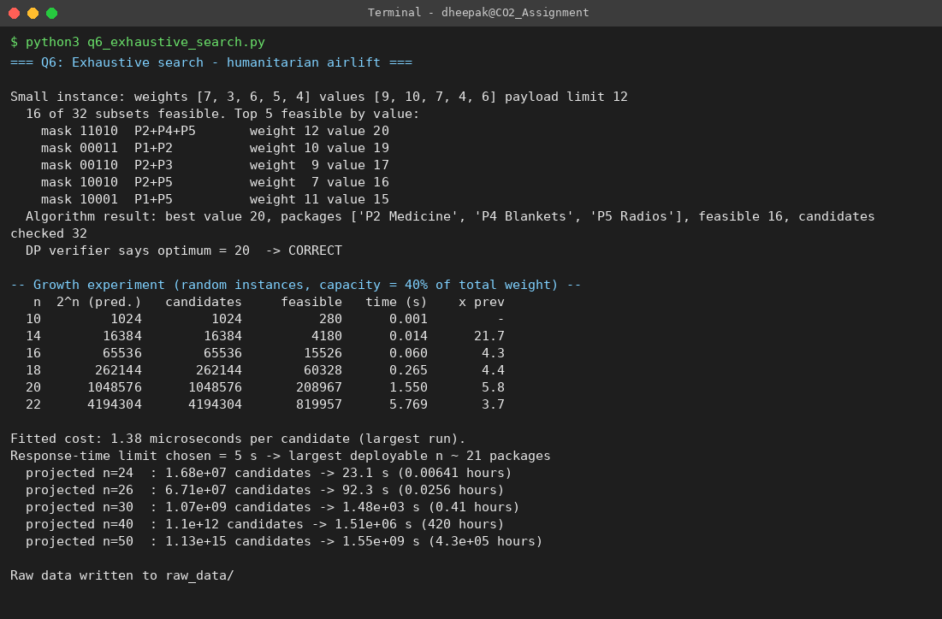
Screenshot 6 – Q6 program output (screen 1 of 1)
The count of candidates equals 2ⁿ at every size, so the prediction on solution-space growth is exactly confirmed. Time grew by 3.7–5.8× per +2 packages from n = 14 onward (prediction ≈ 4×; the spread is timing noise plus the extra decode cost per candidate at larger n).

7.4 Inquiry – why a few extra packages cause a dramatic increase
The effort is proportional to the size of the solution space, 2ⁿ, not to n. Each additional package gives every existing candidate a second form (with or without the new package), so the space doubles; ten extra packages multiply it by 1,024 and thirty by over a billion. The input grows by a few bytes while the number of candidates grows geometrically, so the steady, linear intuition (“5% more packages = 5% more work”) fails: 22 → 24 packages costs 4× as much, and 22 → 32 about 1,000×. Moreover the cost per candidate also grows with n (the decoding loop), so the time curve is slightly steeper than 2ⁿ.

7.5 Deployment decision
Response-time limit chosen: 5 seconds – an airlift planner must refresh a loading decision while the crew waits, and anything longer interrupts the dispatch process. With the measured 1.38 µs per candidate, 5 s allows 2ⁿ ≤ 3,634,957 candidates, i.e. n ≈ 21 packages (n = 22 took 5.8 s in the experiment). Projections: n = 24 ≈ 23 s, n = 30 ≈ 25 minutes, n = 40 ≈ 420 hours. I would deploy the exhaustive version only for loads of up to 21 packages; beyond that the redesign in Q7 is required.

8. Q7 – Day-4 Design Challenge: Diagnose, Redesign and Validate
Selected solution: the Q6 exhaustive search for the airlift. Of the six solutions, Q6 shows the most dramatic limitation: its work doubles with every added package and the evidence in Q6 already shows it leaving the 5-second budget at n ≈ 22. (Q4 and Q5 are polynomial, Q1–Q3 linear/quadratic with a modest constant.)

A. Diagnose the computational bottleneck (2 marks)
Question | Diagnosis from my own evidence
Where is most effort spent? | In the generate-and-test loop: n·2ⁿ elementary steps (Q6 Table 16 – 4,194,304 candidates and 5.2 s at n = 22). Almost all time is spent generating, decoding and weighing candidate subsets.
Which operation grows significantly? | The number of candidate subsets examined, exactly 2ⁿ, doubling with every package. The decode step multiplies this by n.
Is work unnecessarily repeated? | Yes. At n = 22 only 819,957 of 4,194,304 candidates (19.5%) were feasible, so about 80% of the examined candidates are infeasible. If a partial load already exceeds the payload, every superset (all combinations of the remaining packages) is also infeasible, but the algorithm generates and rejects each of them separately. In addition, each candidate's weight/value is recomputed from scratch with an n-step loop instead of being derived from its parent.
Which characteristic of the algorithm causes it? | It is oblivious: candidates are produced in a fixed numerical order, independent of the payload and the values, and nothing already learned (an infeasible prefix, the best value found so far) is used to avoid future candidates.
Table 17 – Diagnosis

B. Design objective (2 marks)
- O1 – Avoid examining candidates that cannot be feasible: never extend a partial load beyond the payload.
- O2 – Avoid examining candidates that cannot beat the best solution found so far.
- O3 – Reuse information: carry the partial weight/value down the decision sequence instead of recomputing it (removes the factor n per candidate).
- Measurable targets: (i) ≥ 100× fewer candidates/nodes examined than 2ⁿ at n = 20 on random instances; (ii) exactly the same optimal value as the exhaustive search on every test instance; (iii) the search must remain correct (no optimum lost).

C. Revised computational strategy (4 marks)
What changed. Instead of enumerating complete masks, the load is built package by package as a depth-first decision tree (include / exclude package i). Each node carries its running weight and value (O3). Two cuts are applied at each node:
- Feasibility pruning (O1): the “include” branch is only taken if running weight + w_i ≤ payload. This removes every subtree whose root is infeasible, because adding packages never reduces weight.
- Bound pruning (O2): an optimistic estimate of the best value reachable below the node is computed; if it is ≤ the best value already found, the whole subtree is cut. The estimate is the *fractional relaxation*: fill the remaining room with the remaining packages in decreasing value/weight order, taking a fraction of the first package that does not fit. It can never underestimate the real optimum below the node, so no optimal solution is lost.
Information exploited: the monotonicity of weight (infeasible prefix ⇒ infeasible supersets) and the value density of packages (value per kilogram). Operations avoided: generation, decoding and testing of all candidates in cut subtrees. Preprocessing: one sort of the packages by value/weight (O(n log n)) and suffix sums. Memory: O(n) – the recursion depth and two arrays (the exhaustive version needed O(1)). New trade-offs: the bound itself costs O(n) per node; the effectiveness depends on the data, and in the worst case none of the cuts fire (investigated in F).
Q7 - REDESIGN OF THE EXHAUSTIVE AIRLIFT SEARCH (target: Q6)
Diagnosis : every one of 2^n subsets is generated blindly. ~80% of them are infeasible at n=22, and an infeasible
prefix is re-expanded into all its supersets. Work is repeated for the same bad decisions.
Objective : examine far fewer candidates (target: >=100x fewer nodes at n=20 on random instances) with the SAME optimum.
Idea : build the load package by package (decision tree). Cut a subtree as soon as
(a) partial weight > payload -> every superset is infeasible
(b) optimistic value of what is still possible <= best value already found -> cannot improve

PreProcess: order <- packages sorted by value/weight descending; suffixValue[i] <- sum of values of packages i..n-1

Bound(i, usedWeight, curValue) // optimistic value, fractional relaxation
room <- cap - usedWeight; u <- curValue
for k <- i to n-1:
if w[k] <= room: room <- room - w[k]; u <- u + v[k]
else: u <- u + v[k]*room/w[k]; break // take a fraction of the next package
return u

Go(i, usedWeight, curValue)
nodes++
best <- max(best, curValue)
if i = n: return
if Bound(i, usedWeight, curValue) <= best: return // bound prune
if usedWeight + w[i] <= cap: Go(i+1, usedWeight + w[i], curValue + v[i]) // include (feasibility prune otherwise)
Go(i+1, usedWeight, curValue) // exclude

Trade-offs: needs preprocessing O(n log n) + O(n) memory (recursion depth n); worst case still exponential
(shown by the adversarial subset-sum instances where the bound never fires).

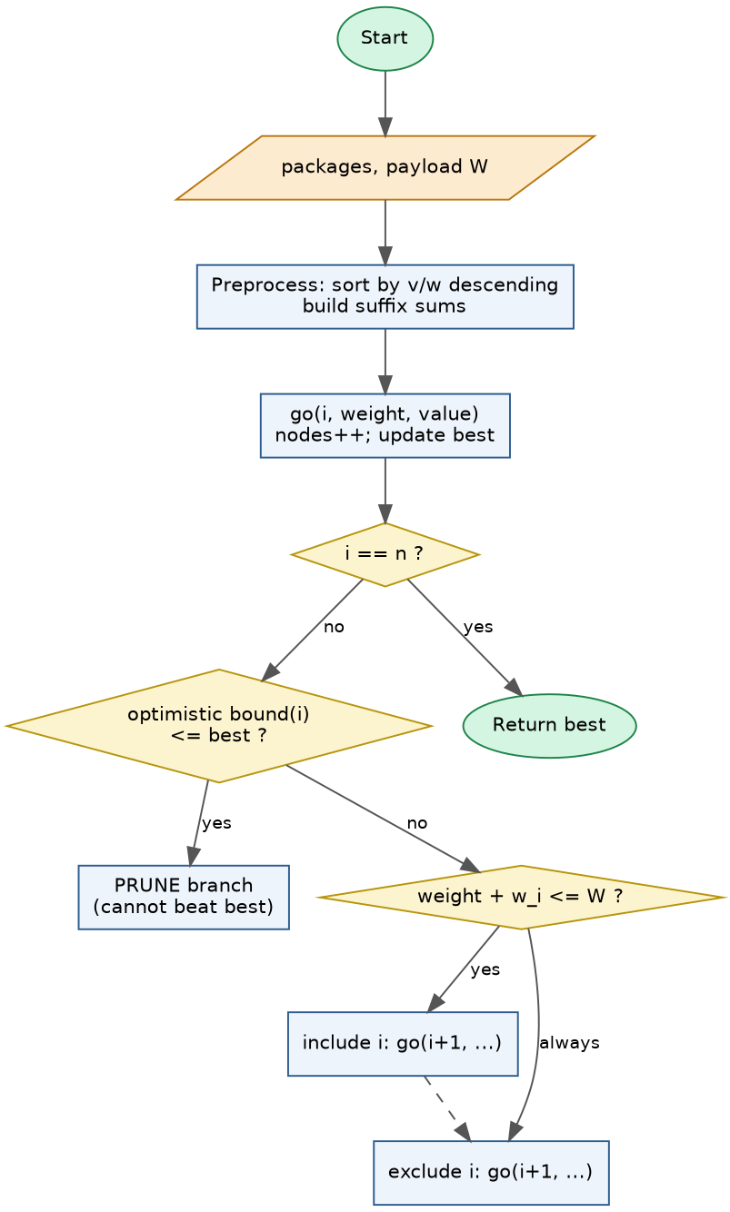
Figure 18 – Redesigned pruned-search flowchart

D. Prediction before implementation (1 mark)
Prediction. (1) The number of nodes examined will fall from 2ⁿ to a small fraction on random instances; the performance measure expected to improve is candidate/node count, and then execution time. (2) Feasibility pruning alone removes only ≈ 25–50% of the candidates (since about 80% of the final candidates are infeasible but they sit mostly at the leaves, below few cuts), whereas the bound should give orders of magnitude, because for random data the density-greedy solution is very close to optimal and the fractional bound is tight. (3) The improvement will not be guaranteed: on instances where value equals weight (subset-sum structure) every package has the same density, the fractional bound equals the remaining capacity and almost never lets us cut, so I expect only a small constant-factor gain there and the growth to remain exponential.

E. Implementation and validation (2 marks)
The redesigned search (q7_redesign.py) is compared with the original on identical instances (three seeds averaged per size). The program asserts that the optimal value of the original, the feasibility-only variant, the value-sum-bound variant and the fractional-bound variant are identical on every instance. Random instances: weights 5–40, values 10–100, payload = 40% of total weight. Adversarial (“subset-sum”) instances: value = weight, all weights even, payload odd – so the bound can never be tight.
n | Original candidates (2ⁿ) | Feasibility pruning only | + value-sum bound | + fractional bound (final) | Reduction | Time orig (s) | Time new (s)
10 | 1,024 | 857 | 180 | 17 | 61x | 0.001 | 0.00003
14 | 16,384 | 12,027 | 1,818 | 73 | 223x | 0.029 | 0.00009
16 | 65,536 | 44,485 | 2,378 | 26 | 2,489x | 0.077 | 0.00003
18 | 262,144 | 174,078 | 10,356 | 53 | 4,977x | 0.373 | 0.00005
20 | 1,048,576 | 611,441 | 18,968 | 79 | 13,273x | 1.642 | 0.00007
22 | 4,194,304 | 2,338,758 | 25,306 | 42 | 100,663x | 7.103 | 0.00006
Table 18 – Random instances (averages of 3 seeds; time is the total for the 3 instances)
n | Original candidates (2ⁿ) | Feasibility pruning only | + value-sum bound | + fractional bound | Reduction | Time orig (s) | Time new (s)
10 | 1,024 | 797 | 504 | 504 | 2.0x | 0.001 | 0.000
14 | 16,384 | 11,103 | 7,126 | 7,126 | 2.3x | 0.016 | 0.003
16 | 65,536 | 41,638 | 26,787 | 26,787 | 2.4x | 0.071 | 0.010
18 | 262,144 | 151,746 | 83,687 | 83,687 | 3.1x | 0.315 | 0.032
20 | 1,048,576 | 579,604 | 365,060 | 365,060 | 2.9x | 1.518 | 0.178
Table 19 – Adversarial subset-sum instances
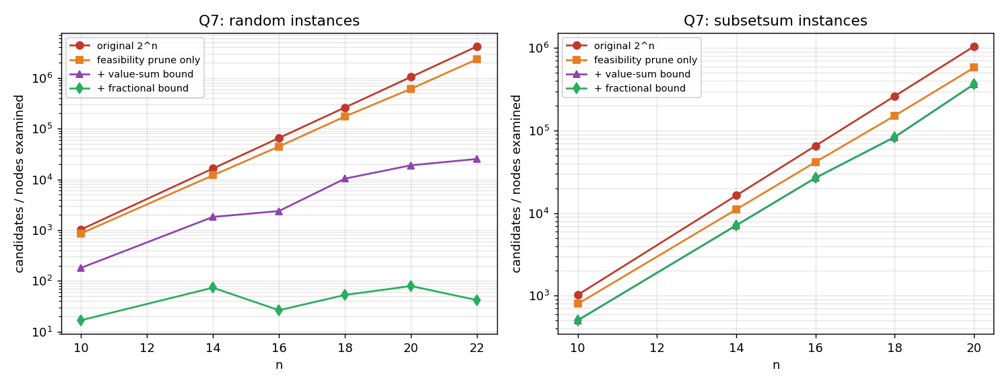
Figure 19 – Candidates/nodes examined: original vs redesign variants (log scale)
n | Redesign nodes (random) | 2ⁿ | Time (s)
26 | 95 | 6.71e+07 | 0.0001
30 | 79 | 1.07e+09 | 0.0001
40 | 169 | 1.10e+12 | 0.0001
50 | 131 | 1.13e+15 | 0.0001
60 | 228 | 1.15e+18 | 0.0002
Table 20 – Redesign alone at sizes the original cannot solve in the 5 s budget (n up to 60)
n | Nodes (subset-sum, redesign) | 2ⁿ | Nodes / 2ⁿ | Time (s)
14 | 9,495 | 16,384 | 0.58 | 0.003
18 | 107,641 | 262,144 | 0.41 | 0.047
20 | 525,899 | 1,048,576 | 0.50 | 0.263
22 | 1,146,303 | 4,194,304 | 0.27 | 0.441
Table 21 – Limitation probe: adversarial instances
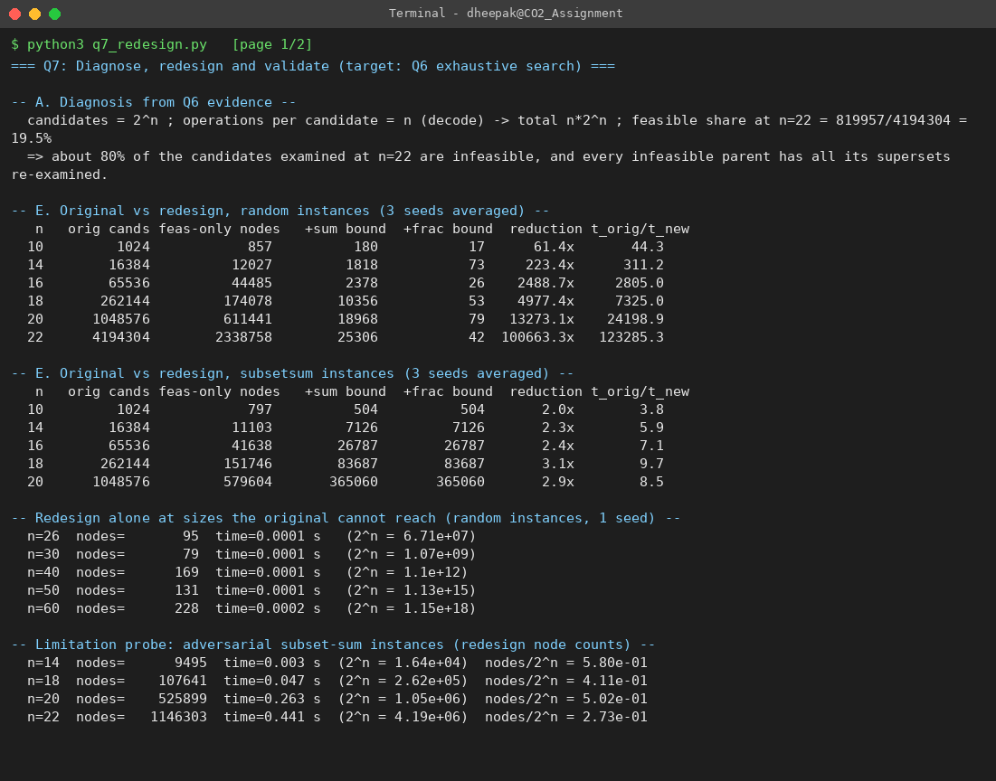
Screenshot 7 – Q7 program output (screen 1 of 2)
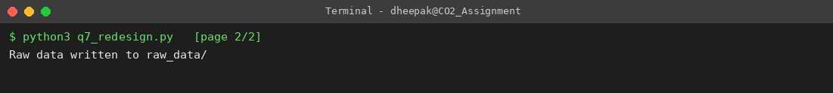
Screenshot 7 – Q7 program output (screen 2 of 2)

F. Defend the final design (2 marks)
- Was the prediction supported? Yes on all three points. Feasibility pruning alone gave only 42% fewer nodes at n = 20 (611,441 vs 1,048,576) – as predicted, modest. The fractional bound cut the nodes at n = 20 from 1,048,576 to 79 (≈ 13,273x) and at n = 22 from 4,194,304 to 42 (≈ 100,663x), beating the 100× target by two to three orders of magnitude. On the adversarial instances the improvement was only 2.9x (n = 20) – as predicted.
- Magnitude. Random instances: n = 20 took 1.642 s (3 instances) originally against 0.00007 s – and the redesign solves n = 60 (2⁶⁰ ≈ 1.2×10¹⁸ subsets) in 0.0002 s. The deployable size under the 5 s limit rises from about 21 packages to well beyond 60 for this kind of data.
- New costs / trade-offs. O(n log n) preprocessing, O(n) memory, a bound computation of up to O(n) per node, and more complex code that is harder to verify (hence the assertion against the exhaustive optimum). Tiny instances (n ≈ 10) are solved in microseconds by either; the sorting overhead dominates there.
- Where the original may still be preferable. (i) Very small n, where its simplicity and obvious correctness outweigh any gain; (ii) when all optimal/feasible solutions must be listed (e.g. to show planners alternative loads) – pruning discards tied solutions that cannot beat the best; (iii) on adversarial data: on subset-sum instances the redesign still needed about 27% of 2ⁿ nodes (1,146,303 nodes at n = 22 versus 4,194,304), and because each node costs more, the time advantage was a modest ≈ 9x and would vanish as n grows.
- Does the redesign sufficiently address the limitation? For realistic airlift data (varied weights and values) yes – the exponential growth is replaced by near-flat growth in nodes. But the worst case is still exponential: the redesign does not change the problem's nature, it exploits structure present in typical data. The honest engineering conclusion is therefore: deploy the pruned search for realistic loads, keep a node/time limit as a safety net, and treat the worst-case behaviour as a documented risk. A fundamentally different strategy (reusing sub-results, as in dynamic programming over payload) would be needed for a guarantee, and is beyond the scope of this CO2 task.

9. Overall Conclusion
Q | Key finding (evidence) | Engineering decision
Q1 | Selection: always 499,500 comparisons; Insertion adapts (26,212 on D6); Bubble fails on displaced batches (499,364). | Insertion sort for the 95%-ordered order stream.
Q2 | Comparisons: 1, n/2, n for first/middle/last; n if absent. Lookup stays < 1 ms up to ≈ 35,151 records. | Sequential search per hangar; hash index for a central 20-facility system.
Q3 | Same n and m: 9,993 vs 79,944 comparisons. Cost depends on repeated partial matches. | Size logging systems for the repetitive worst case.
Q4 | Pairs = n(n−1)/2 exactly; 1 s limit reached at ≈ 3,433 drones. | Brute force only for small fleets; use spatial pre-processing beyond.
Q5 | Half-plane rule gives exact hulls; work between n²/… and n³; verified on four sets. | Brute force acceptable for ≤ a few hundred points.
Q6 | Candidates = 2ⁿ exactly; 5 s limit at n ≈ 21. | Deploy only for ≤ 21 packages.
Q7 | Pruned search: 13,273x fewer nodes at n = 20 (random); only 2.9x on adversarial instances. | Use pruned search with a safety limit; worst case remains exponential.
Table 22 – Summary
Across all questions, input size alone failed to predict the work: it was the structure of the data (order in Q1, repeated prefixes in Q3, density correlation in Q7) and the solution-space size (Q4–Q6) that determined cost. Operation counts, not wall-clock time, exposed these effects reliably.

Appendix A – Repository structure and how to reproduce
CO2_Assignment/
├── Q1_Sorting_Algorithms/ Pseudocode/ (txt + flowchart) Implementation_Code/ (+ raw_data/) Output_Screenshots/
├── Q2_Sequential_Search/ ... same three folders
├── Q3_Brute_Force_String_Matching/
├── Q4_Brute_Force_Closest_Pair/
├── Q5_Brute_Force_Convex_Hull/
├── Q6_Exhaustive_Search/
├── Q7_Day4_Design_Challenge/
├── Final_Report/CO2_Assignment_Report.docx
├── tools/ (run_all.py, make_graphs.py, make_diagrams.py, render_terminal.py, build_report.py)
├── diagrams/ (Graphviz sources and PNG flowcharts)
└── README.md

To reproduce: `cd Qx_.../Implementation_Code && python3 qx_*.py` (Python 3.8+; Q5 and the graphs need matplotlib; no other libraries). `python3 tools/run_all.py` re-runs every program, stores the console output in raw_data/ and regenerates the screenshots. Terminal screenshots in this report are renderings of the real captured console output of these runs.

Appendix B – Mark-scheme coverage map
Question | Marks | Evidence required → where found
Q1 | 6 | Prediction (Table 1), three designed datasets (Table 2), implementation, operation counts (Table 3), prediction vs observation (2.6), recommendation (2.7)
Q2 | 4 | Experiments on positions, unsuccessful and sizes (Table 5), boundary (3.5), changed condition (3.6, Table 7)
Q3 | 6 | Three+ tests with predictions before execution (Table 8), character-comparison counts, inquiry (4.3)
Q4 | 6 | Design and pair-count derivation (5.1), three+ sizes (Table 10), acceptability criterion and limit (5.4), source of inefficiency
Q5 | 7 | Derived rule (Table 11), pseudocode, two test configurations (Table 12), visualisations (Figs 12–14), growth analysis (6.3), correctness argument (6.4)
Q6 | 8 | Design (Table 14), correctness instance (Table 15), growth prediction and validation (Table 16), inquiry (7.4), deployment boundary (7.5)
Q7 | 13 | A Diagnosis (2), B Objective (2), C Strategy (4), D Prediction (1), E Validation (2), F Defence (2)

