SAVEETHA INSTITUTE OF MEDICAL AND TECHNICAL SCIENCES (SIMATS ENGINEERING)
DEPARTMENT OF COMPUTER SCIENCE AND ENGINEERING
CO2 – Debugging and Optimisation Task
SOC Alert-Triage Module of “SentinelOps”
CSA06 – Design and Analysis of Algorithms
Course Outcome CO2: Apply Brute Force technique to solve sorting, searching, Closest-Pair and Convex-Hull problems.
Maximum Marks: 50 Mode: Individual
Student name: K DHEEPAK
Student Reg. No.: 192411108

0. Overview, Method and Repository
This report debugs and optimises the four functions of the SentinelOps alert-triage module (sort_alerts, is_blocked, find_signature, closest_logins). The code was debugged in place (same names, same algorithms, minimal edits tagged # FIX Dn), never rewritten from scratch. Every number in this report (outputs, traces, operation counts, timings) was produced by running the programs in Source_Code/; the raw logs are in Supporting_Files/logs/ and the screenshots are renderings of those real logs.
Assumptions. (1) The PDF flattened the indentation of the code under investigation; it was restored in the natural way (original_module.py). The else: return False of is_blocked was read as the else of the if inside the loop – the only reading that produces the reported symptom “blocked addresses got through” together with the stated count of nine defects. (2) Distances are Euclidean in km, severity is an integer, “highest first, equal severity in arrival order” means a stable descending sort. (3) For fewer than two login events no pair exists, so the function returns (None, None). (4) Counts of the “basic operation” are exact (instrumented code); timings are wall-clock seconds on the machine used and are indicative only.
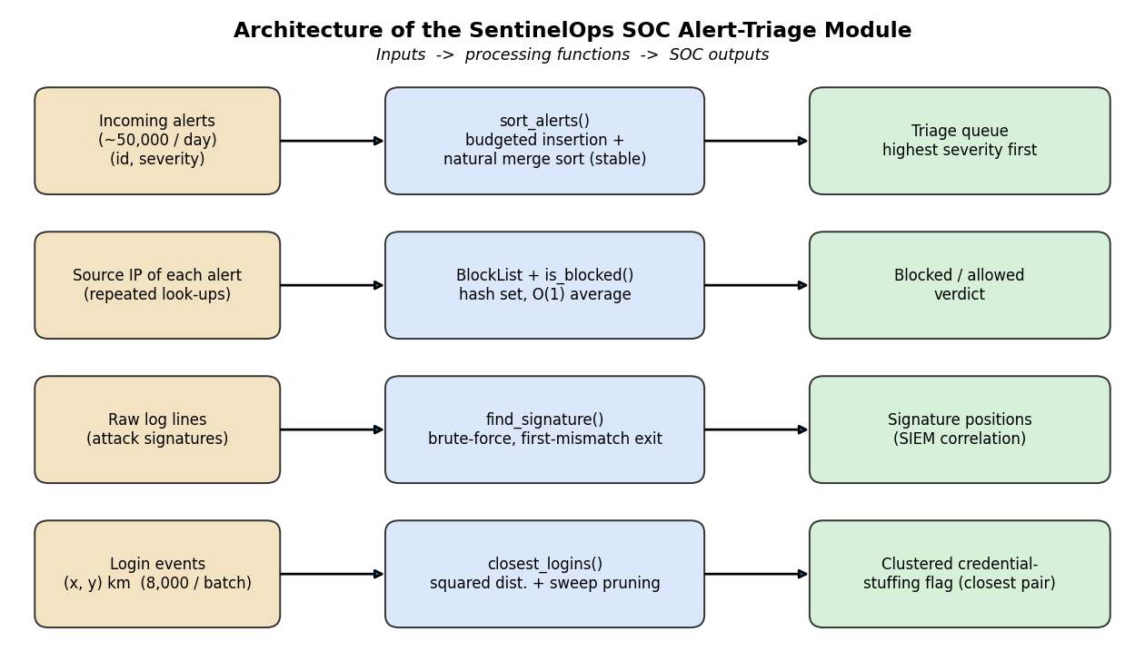
Figure 1 – Architecture of the SentinelOps SOC Alert-Triage Module
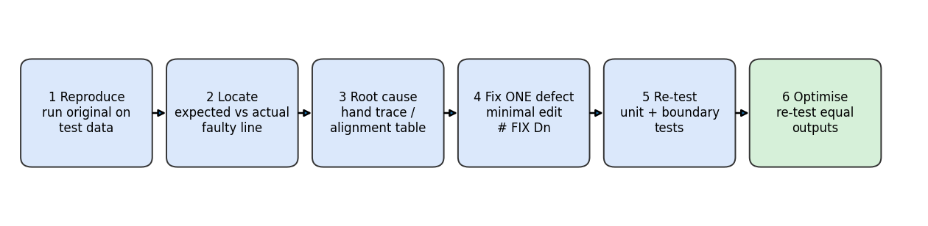
Figure 2 – Systematic debugging workflow followed for every defect
Folder / file | Content
Pseudocode/ | 01_sort_alerts.txt, 02_is_blocked.txt, 03_find_signature.txt, 04_closest_logins.txt (corrected + optimised pseudocode of each function)
Source_Code/ | original_module.py, corrected_module.py, optimised_module.py, run_original.py, debug_trace.py, boundary_report.py, test_harness.py, experiments.py, make_figures.py
Report/ | this report (CO2_Report.docx)
Supporting_Files/ | logs/ (execution logs), results.json (experiment data), figures/ (screenshots, flowcharts, graphs)
README.md | how to run everything

(a) Reproduce and Identify the Defects
The original module was run on the test data of the question paper (python run_original.py):
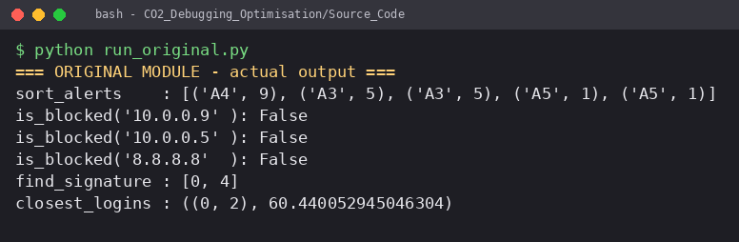
Figure 3 – Screenshot: actual output of the ORIGINAL module

Expected output versus actual output
Function | Expected output | Actual output | Observation
sort_alerts | [(A2,9), (A4,9), (A3,5), (A1,3), (A5,1)] | [(A4,9), (A3,5), (A3,5), (A5,1), (A5,1)] | A1 and A2 disappeared, A3 and A5 duplicated, A4 now precedes A2
is_blocked  (10.0.0.9 / 10.0.0.5 / 8.8.8.8) | True / True / False | False / False / False | blocked addresses get through
find_signature | [0, 8] | [0, 4] | signature at the end missed (8), false hit at 4 (“FAIX”)
closest_logins | ((0, 5), 1.4142…) i.e. (2,3) and (3,4) | ((0, 2), 60.44…) | reports the FARTHEST pair, (2,3) and (40,50)

Defect list (the module contains nine defects)
ID | Function | Line* | Faulty line | Nature of the error
D1 | sort_alerts | 13 | while j > 0 and … | Boundary error: element at index 0 is never compared or shifted (must be j >= 0)
D2 | sort_alerts | 16 | alerts[j] = key | Off-by-one: the key must go to j + 1, the slot left free; it overwrites an element instead
D3 | is_blocked | 23 | return False (on match) | Wrong return value: a found IP is reported as not blocked
D4 | is_blocked | 25 | else: return False inside the loop | Misplaced control flow: returns after the FIRST entry, the remaining entries are never examined
D5 | find_signature | 31 | range(n - m) | Off-by-one: the last alignment (i = n − m) is never tried
D6 | find_signature | 35 | if j == m - 1: | Wrong match condition: j equals m − 1 also when the break happened at the last character, so a mismatch is recorded as a hit
D7 | closest_logins | 41 | min_dist = 0 | Wrong initial value: a minimum must start at +∞
D8 | closest_logins | 47 | if d > min_dist: | Wrong comparison direction: keeps the maximum, i.e. the farthest pair
D9 | closest_logins | 44 | for j in range(len(events)) | Wrong loop range: pairs (i,i) with distance 0 and each pair twice; must be range(i + 1, …)
*Line numbers refer to original_module.py.
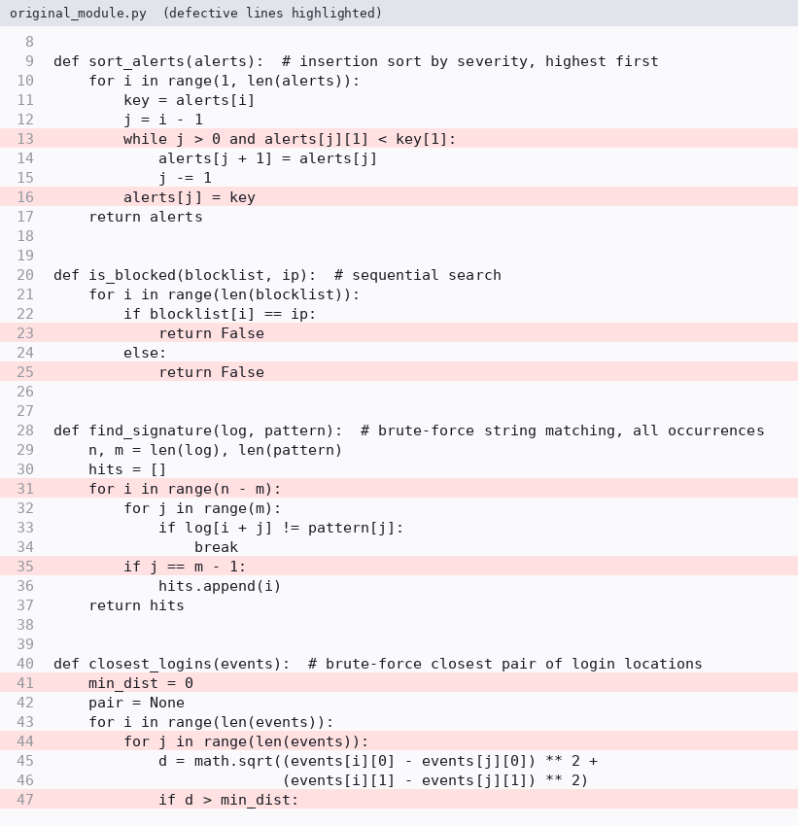
Figure 4 – Screenshot: original source, defective lines highlighted

(b) Root Causes and Systematic Debugging
Method: one defect at a time → edit one line → re-run the function on the test data → compare with the expected output → trace by hand. The intermediate results below come from debug_trace.py (Supporting_Files/logs/02_debug_trace.log).

1. sort_alerts (D1, D2)
Root cause D1. Insertion sort must be able to shift an element into position 0. With j > 0 the loop stops when j = 0, so alerts[0] is never compared with the key; an element smaller than the first one is not placed in front of it. Root cause D2. When the inner loop ends, j points at the element that is not smaller than the key (or at −1); the free slot is j + 1. Writing the key to alerts[j] overwrites that element. Together: elements are overwritten (disappear) and others are shifted twice (duplicated).
Trace of the ORIGINAL code (list after each insertion) shows exactly how A1 and A2 are lost:
i | key | list after the step (original, defective) | what went wrong
1 | (A2,9) | A2, A2, A3, A4, A5 | j = 0 → loop not entered (D1); alerts[0] = key overwrites A1 (D2) – A1 lost, A2 twice
2 | (A3,5) | A2, A3, A3, A4, A5 | A2 (9) is not < 5, so j = 1; alerts[1] = key overwrites a copy – A3 duplicated
3 | (A4,9) | A4, A3, A3, A3, A5 | shifts down to j = 0, loop stops (D1), key overwrites A2 – A2 lost
4 | (A5,1) | A4, A3, A3, A5, A5 | overwrites again – A5 duplicated; final list has 3 distinct alerts of 5

Fix D1 only gives [A1, A1, A1, A1, A4] (still wrong: D2 remains). Fix D1 + D2 gives the expected list. Trace of the CORRECTED code:
i | key | comparisons / shifts | list after the step
1 | (A2,9) | A1(3) < 9 → shift; j = −1 → place at 0 | A2:9, A1:3, A3:5, A4:9, A5:1
2 | (A3,5) | A1(3) < 5 → shift; A2(9) < 5? no → place at 1 | A2:9, A3:5, A1:3, A4:9, A5:1
3 | (A4,9) | A1 < 9 shift; A3 < 9 shift; A2(9) < 9? no (strict) → place at 1 | A2:9, A4:9, A3:5, A1:3, A5:1
4 | (A5,1) | A1(3) < 1? no → stays at 4 | A2:9, A4:9, A3:5, A1:3, A5:1
The strict < is what keeps A2 before A4 (equal severity, arrival order): the sort is stable.
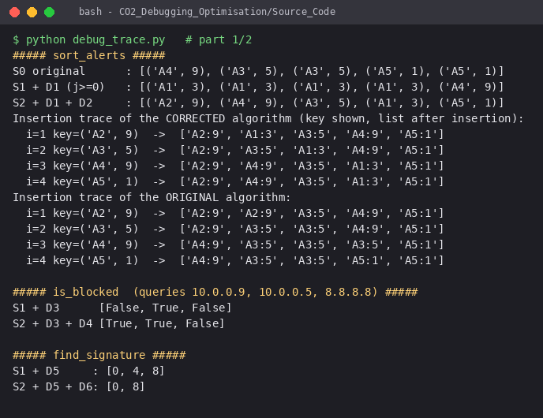
Figure 5 – Screenshot: stage-by-stage re-testing and insertion traces (debug_trace.py)

2. is_blocked (D3, D4)
Root cause D3: the success branch returns False, so even a found IP is reported as allowed. Root cause D4: the else belongs to the if inside the loop, so the first entry that is not equal makes the function return False immediately; only blocklist[0] is ever tested and a search that never examines all entries is not a search. After the loop nothing is returned, so an empty blocklist gives None instead of False. Fix D3 alone: results False, True, False (only “10.0.0.5”, the first entry, is found – this exposes D4). Fix D3 + D4 (return True inside the loop, return False after the loop): True, True, False, as expected.

3. find_signature (D5, D6)
Root cause D5: an alignment i is valid for 0 ≤ i ≤ n − m, i.e. n − m + 1 values, but range(n - m) stops at n − m − 1, so a signature at the end of the log is never seen. Root cause D6: the inner loop leaves with j = m - 1 in two different situations – all characters matched (loop finished) and the mismatch occurred at the last character (break). The test j == m - 1 cannot tell them apart; at i = 4 (“FAIX”) the break happens at j = 3 and a false hit is stored. The loop else clause runs only when no break happened, which is the correct condition. Fix D5 only: [0, 4, 8] (the end signature now found, the false hit remains); fix D5 + D6: [0, 8].
Alignment table for log = FAILFAIXFAIL, pattern = FAIL (n = 12, m = 4, 9 alignments):
i | window | first mismatch | result
0 | FAIL | none (4 matches) | HIT
1 | AILF | j = 0 | miss
2 | ILFA | j = 0 | miss
3 | LFAI | j = 0 | miss
4 | FAIX | j = 3 | miss (original wrongly reported a hit)
5 | AIXF | j = 0 | miss
6 | IXFA | j = 0 | miss
7 | XFAI | j = 0 | miss
8 | FAIL | none (4 matches) | HIT

4. closest_logins (D7, D8, D9)
Root cause D7 + D8: the update rule d > min_dist with min_dist = 0 is a running maximum: the first positive distance is accepted and then only larger ones, so the result is the farthest pair, (2,3)–(40,50) = 60.44 km. Replacing only D7 (∞) while keeping > never accepts any distance and returns (None, inf); replacing D8 as well (<) but keeping D9 returns ((0, 0), 0.0), the self pair. Root cause D9: j runs over all events, so each event is paired with itself (distance 0, always the minimum) and every pair is evaluated twice, once as (i, j) and once as (j, i). With range(i + 1, n) the result is ((0, 5), 1.4142…).
Stage | Applied fixes | Output
S0 | none (original) | ((0, 2), 60.440…) – farthest pair
S1 | D7 | (None, inf) – nothing accepted
S2 | D7 + D8 | ((0, 0), 0.0) – self pair
S3 | D7 + D8 + D9 | ((0, 5), 1.4142…) – correct
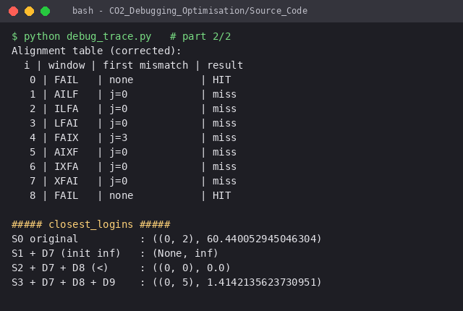
Figure 6 – Screenshot: remaining stages (is_blocked, find_signature, closest_logins)
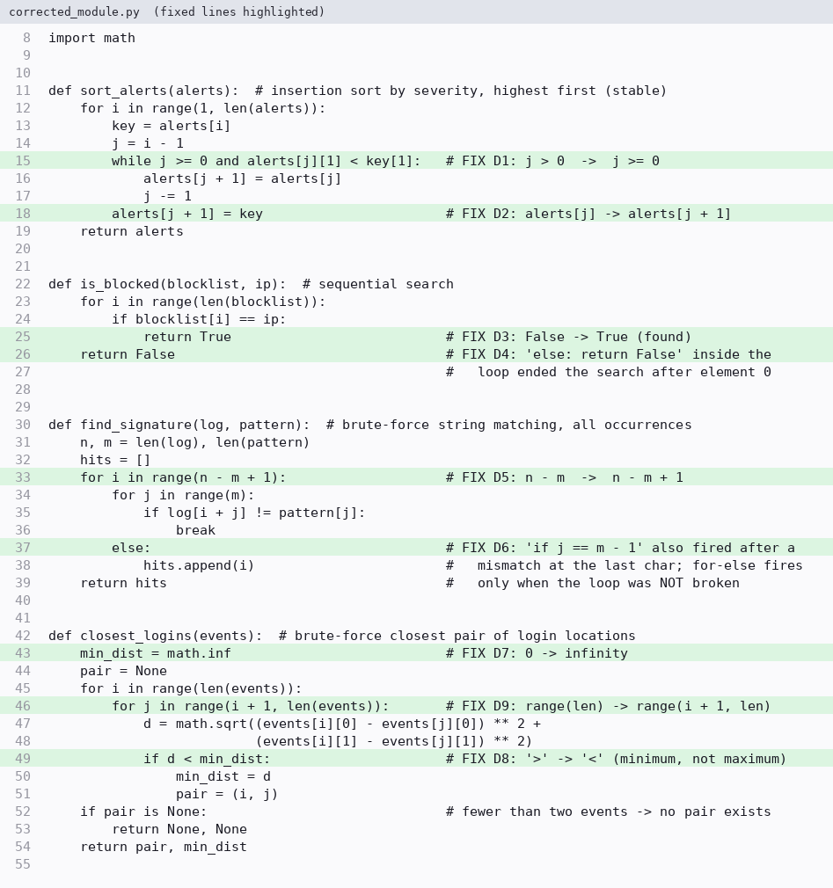
Figure 7 – Screenshot: corrected source, every fix tagged # FIX Dn

Pseudocode of the corrected functions
SortAlerts(A[0..n-1]): IsBlocked(B[0..n-1], ip):
for i <- 1 to n-1 for i <- 0 to n-1
key <- A[i]; j <- i-1 if B[i] = ip then return True
while j >= 0 and A[j].sev < key.sev return False
A[j+1] <- A[j]; j <- j-1
A[j+1] <- key FindSignature(T[0..n-1], P[0..m-1]):
return A for i <- 0 to n-m // n-m+1 alignments
j <- 0
ClosestPairBF(E[0..n-1]): while j < m and T[i+j] = P[j]: j <- j+1
best <- inf; pair <- none if j = m then hits.append(i)
for i <- 0 to n-2 return hits
for j <- i+1 to n-1
d <- sqrt((xi-xj)^2 + (yi-yj)^2)
if d < best: best <- d; pair <- (i,j)
return (pair, best) or (none, none) if n < 2

Boundary tests (re-tested after the corrections)
boundary_report.py runs the same inputs on the original, corrected and optimised modules; the unit-test harness (test_harness.py, 29 tests, all passing) checks all of them automatically.
Boundary case | Original | Corrected | Expected → verdict
equal severities (a,b,c all 5) | [b, c, c] | [a, b, c] | arrival order kept → PASS
empty alert list / single alert | [] / [x] | [] / [x] | unchanged → PASS
empty blocklist | None | False | False → PASS
IP is the last blocklist entry | False | True | True → PASS
pattern at the very end of the log | [] | [3] | [3] → PASS
pattern longer than the log | [] | [] | [] → PASS (original correct only by accident)
pattern equal to the log | [] | [0] | [0] → PASS
mismatch only at the last character (FAIX) | [] | [] | [] → PASS (D6 is hidden here because D5 skips the window)
0 or 1 login event | (None, 0) | (None, None) | no pair → PASS
2 login events (0,0),(3,4) | ((0,1), 5.0) | ((0,1), 5.0) | 5.0 → PASS
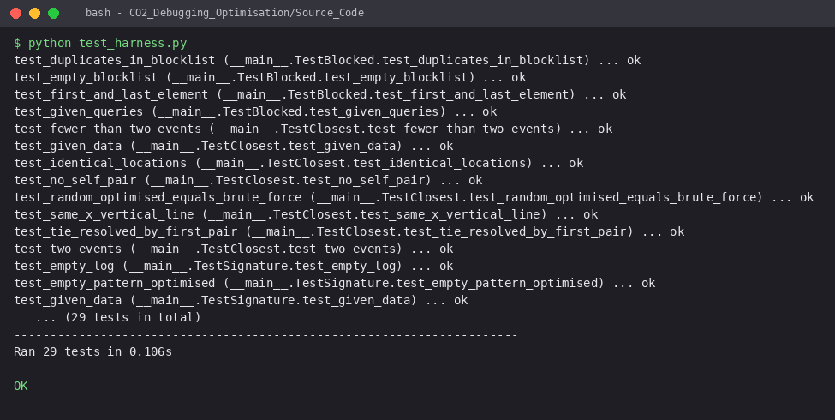
Figure 8 – Screenshot: test harness output (29 tests, all passing)

(c) Optimise the Corrected Module
Every optimisation was accepted only if test_harness.py showed identical outputs to the corrected module (it also compares 600 random closest-pair inputs, including grids with many ties, and 300 random sorts/signature scans).

1. sort_alerts – is insertion sort still suitable?
Insertion sort performs n − 1 + I comparisons (I = number of inversions), so it is Θ(n) on nearly sorted input and is the best choice there. It is not suitable as the only method: for 50,000 unordered alerts it needs about n²/4 ≈ 6.25 × 10⁸ comparisons on average, and a list with one displaced block (e.g. a rotated list) has a single out-of-order point but ≈ n²/4 inversions. Optimised design: an insertion sort with a budget of 4n comparisons; if the list is not sorted by then, the sorted prefix is kept as one run and the rest is sorted by a stable natural merge sort (O(n log n)). Nearly sorted alerts therefore keep the Θ(n) behaviour of insertion sort, and every other input is capped at O(n log n). Stability is preserved because ties are always taken from the left (earlier) run.
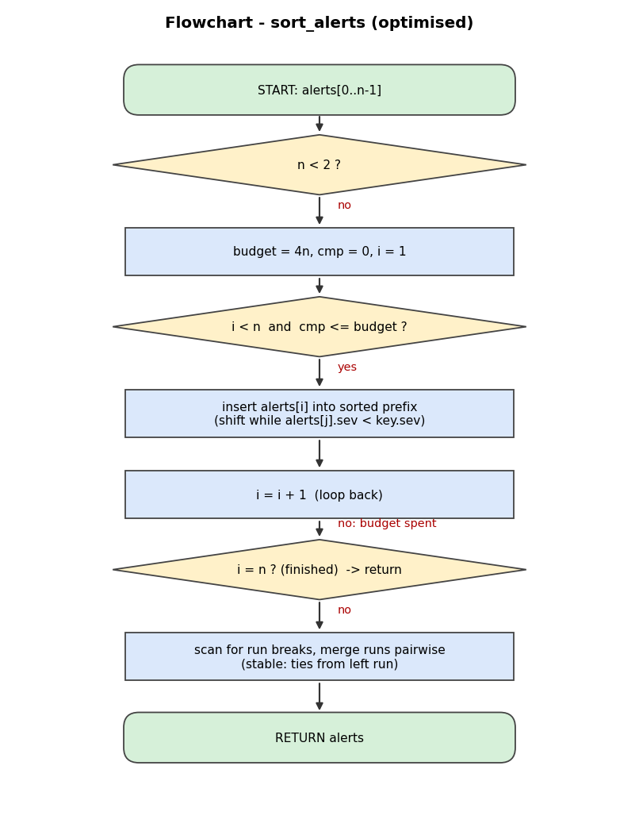
Figure 9 – Flowchart of the optimised sort_alerts

2. is_blocked – repeated blocklist look-ups
A sequential search costs up to |B| comparisons per query, so Q queries cost O(Q·|B|). The blocklist is static between updates, so it is loaded once into a hash set (BlockList): build O(|B|), every query one hash probe, O(1) on average. (An alternative is to sort the list once and use binary search, O(log |B|) per query, if hashing is not allowed.) A plain list is still accepted for compatibility.
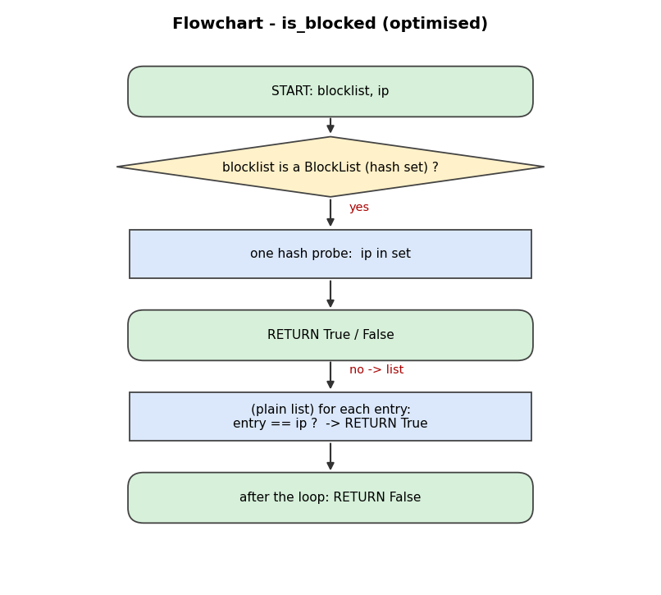
Figure 10 – Flowchart of the optimised is_blocked

3. find_signature – no redundant comparisons
The brute-force scan is kept (CO2) but made tight: each alignment stops at its first mismatch (so a window costs between 1 and m comparisons instead of always m), a complete match is recorded without re-comparing, there is no post-loop test that re-reads j, an empty pattern or a pattern longer than the log returns [] immediately without entering the loops, and n − m + 1 is the exact number of alignments (no wasted or missing window). Occurrences that overlap are all reported.
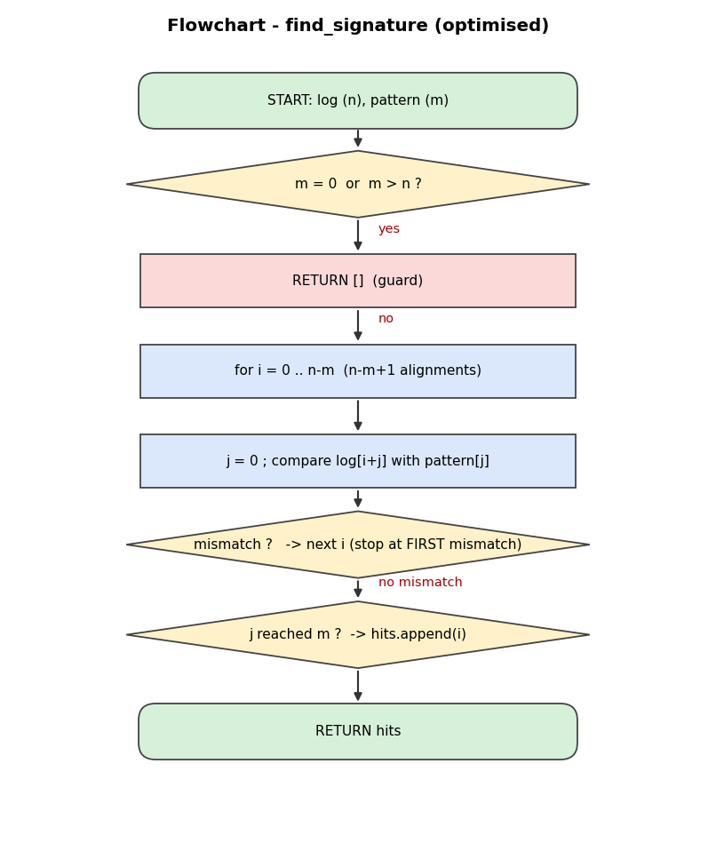
Figure 11 – Flowchart of the optimised find_signature

4. closest_logins – three optimisations
- No self or repeated pairs: inner loop starts at i + 1, the n² computations of the original become n(n − 1)/2.
- No unnecessary square roots: comparing squared distances gives the same ordering; math.sqrt is called once, for the final answer (n(n − 1)/2 square roots → 1).
- Pruning: the events are visited in increasing x. For the point i, once (xj − xi)² is larger than the best squared distance found so far, every later point (with even larger x) is farther than the current best and the inner loop is stopped. The comparison is strict (>), so points at exactly the best distance are still examined and the tie rule (“first pair in (i, j) order”) of the corrected function is reproduced exactly.
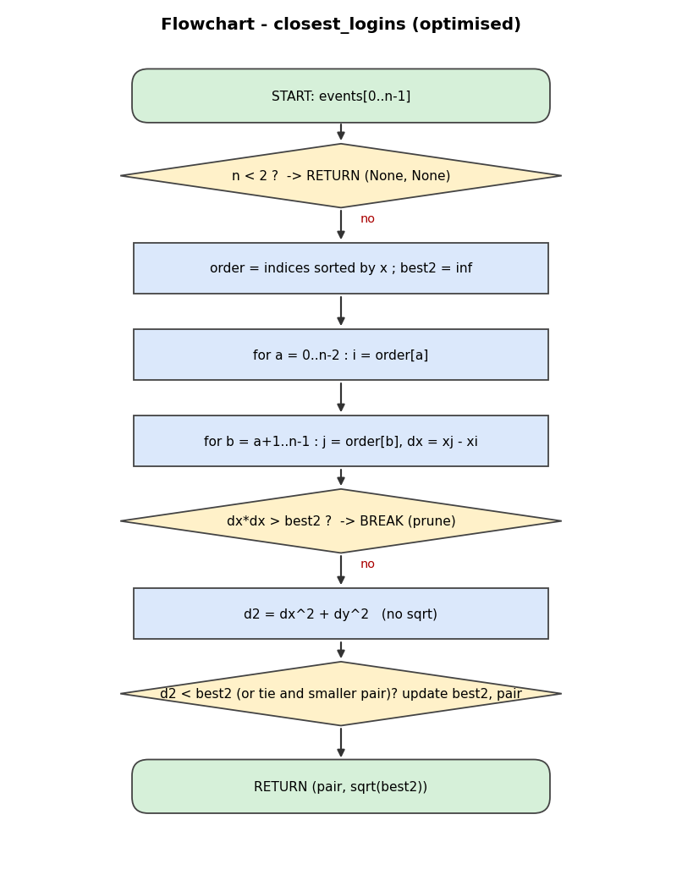
Figure 12 – Flowchart of the optimised closest_logins
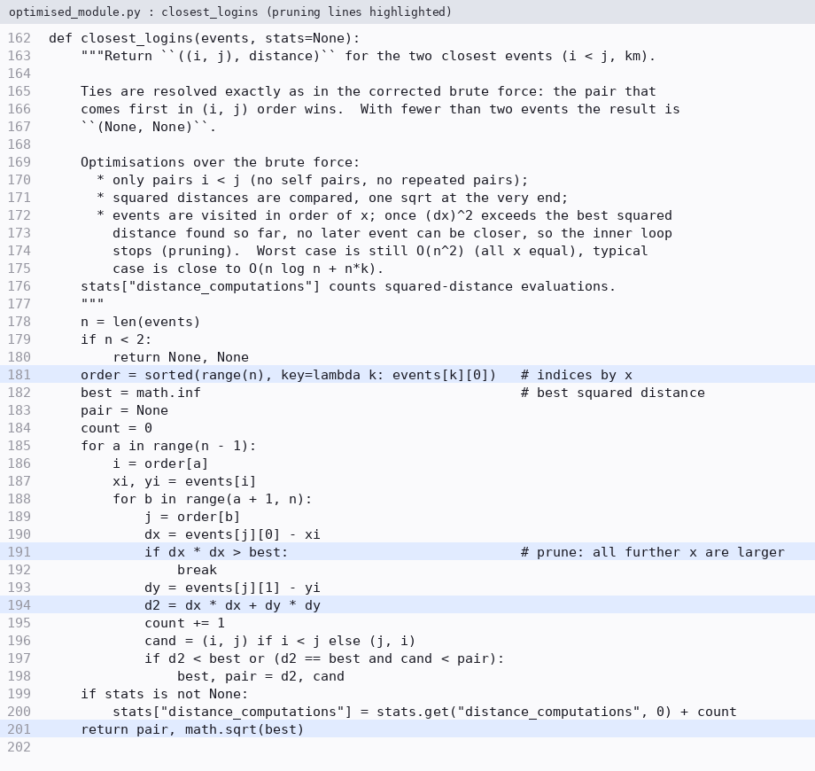
Figure 13 – Screenshot: optimised closest_logins (pruning lines highlighted)

(d) Analyse Before and After

Operation counts and time complexity (derivations)
sort_alerts, basic operation = severity comparison. Insertion sort: the inner test runs once for each shift plus at most once more per insertion, so C(n) = (n − 1) + I − (number of insertions that stop at j = −1) ≈ n − 1 + I. Best case (already ordered, I = 0): n − 1. Worst case (strictly reversed order, I = n(n − 1)/2): Σ_{i=1}^{n−1} i = n(n − 1)/2. Average (random): I ≈ n(n − 1)/4, i.e. ≈ n²/4. So Θ(n) best, Θ(n²) average and worst. Optimised: phase 1 uses ≤ 4n + n comparisons; phase 2 scans n − 1 and merges r runs in ⌈log₂ r⌉ passes of ≤ n comparisons: ≤ 5n + (n − 1) + n⌈log₂ n⌉ = O(n log n) worst case; Θ(n) for nearly sorted input.
is_blocked, basic operation = equality test / hash probe. Sequential: a miss costs |B| tests, a hit at position p costs p; worst case |B|, average of a hit (|B| + 1)/2; for Q queries O(Q·|B|). Hash set: build |B| insertions + Q probes = Θ(|B| + Q) expected; one query is O(1) average, O(|B|) in the (unlikely) worst case of all keys colliding; space Θ(|B|).
find_signature, basic operation = character comparison. There are n − m + 1 alignments and each costs between 1 and m comparisons: best case n − m + 1 (first character mismatches everywhere), worst case m(n − m + 1) (e.g. aaaa…a against aaa…ab) = Θ(nm). For a random text over an alphabet of σ symbols an alignment costs about 1 + 1/σ + 1/σ² + … ≈ σ/(σ − 1) comparisons, i.e. ≈ 1.33(n − m + 1) for σ = 4 (Θ(n)). The “before” module also scanned n − m windows (missing one) and performed an extra post-loop test per window; the early exit is what separates the tight scan from the m(n − m + 1) no-early-exit variant.
closest_logins, basic operation = distance computation. Original: n² (every ordered pair incl. self) → Θ(n²), and n² square roots. Corrected: Σ_{i=0}^{n−2}(n − 1 − i) = n(n − 1)/2 = Θ(n²). Optimised: the sort costs Θ(n log n) comparisons plus P(n) distance computations, with P(n) ≤ n(n − 1)/2 always; for points spread evenly over a region P(n) grows roughly linearly with n (pruning window ≈ 2δ wide, δ = best distance), while it degenerates to n(n − 1)/2 when all points have the same x (nothing can be pruned). Worst case therefore stays Θ(n²) – a sweep-line / divide-and-conquer closest pair (O(n log n)) would be needed to improve the worst case, but it is outside the brute-force scope of CO2.
Function | Before (corrected) | After (optimised) | Best / worst after
sort_alerts | n − 1 … n(n − 1)/2 comparisons; Θ(n²) avg | ≈ n − 1 + I for nearly sorted; ≤ ~n log₂ n + 6n otherwise | Θ(n) / O(n log n)
is_blocked (Q queries) | up to Q·|B| equality tests, O(Q·|B|) | |B| + Q probes, Θ(|B| + Q) expected | O(1) per query / O(|B|) per query (collisions)
find_signature | m(n − m + 1) worst; n − m windows scanned (1 missed) | n − m + 1 … m(n − m + 1); guards for m = 0, m > n | Θ(n) typical / Θ(nm) worst
closest_logins | n² (orig.) → n(n − 1)/2 distances + as many sqrt | P(n) distances (data dependent) + 1 sqrt + n log n sort | about Θ(n) pairs typical / Θ(n²) worst

Measurement 1 – closest_logins: distance computations (n = 1,000 … 8,000)
Events were generated uniformly at random in a 1000 km × 1000 km square (fixed seeds). “Corrected” counts every distance computation of the corrected brute force; the formula column is n(n − 1)/2.
n | original n² | corrected n(n−1)/2 (measured) | formula | optimised (measured) | saved | time corrected (s) | time optimised (s)
1,000 | 1,000,000 | 499,500 | 499,500 | 579 | 99.88 % | 0.115 | 0.0006
2,000 | 4,000,000 | 1,999,000 | 1,999,000 | 3,214 | 99.84 % | 0.529 | 0.0015
4,000 | 16,000,000 | 7,998,000 | 7,998,000 | 4,825 | 99.94 % | 2.122 | 0.0059
8,000 | 64,000,000 | 31,996,000 | 31,996,000 | 8,674 | 99.97 % | 8.716 | 0.0083
Worst case for the pruning rule (n = 2,000, all events with the same x): optimised = 1,999,000 distance computations = brute force 1,999,000; no pruning is possible, as predicted.
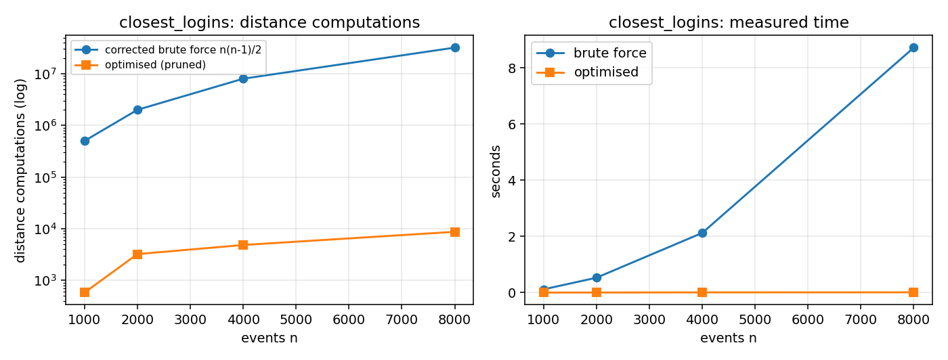
Figure 14 – closest_logins: distance computations (log scale) and measured time
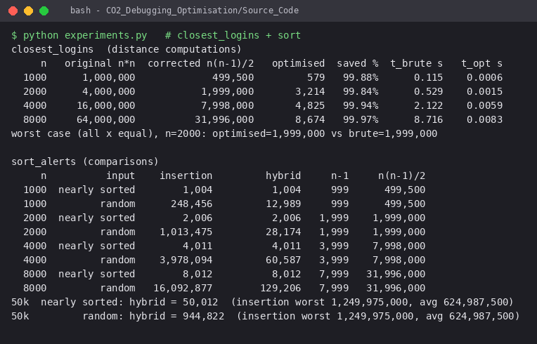
Figure 15 – Screenshot: experiment output (closest_logins and sort_alerts)

Measurement 2 – sort_alerts: comparisons on nearly sorted and random alerts
“Nearly sorted” = a list in descending severity order in which about 1 % of the adjacent pairs were swapped; “random” = severities drawn uniformly from 1…1000. Results of both sorts were compared and are identical.
n | input | insertion (corrected) | optimised | best n − 1 | worst n(n − 1)/2
1,000 | nearly sorted | 1,004 | 1,004 | 999 | 499,500
1,000 | random | 248,456 | 12,989 | 999 | 499,500
2,000 | nearly sorted | 2,006 | 2,006 | 1,999 | 1,999,000
2,000 | random | 1,013,475 | 28,174 | 1,999 | 1,999,000
4,000 | nearly sorted | 4,011 | 4,011 | 3,999 | 7,998,000
4,000 | random | 3,978,094 | 60,587 | 3,999 | 7,998,000
8,000 | nearly sorted | 8,012 | 8,012 | 7,999 | 31,996,000
8,000 | random | 16,092,877 | 129,206 | 7,999 | 31,996,000
At the production size n = 50,000 the optimised sort needs 50,012 comparisons for nearly sorted and 944,822 for random alerts, whereas insertion sort needs ≈ 624,987,500 on average (1,249,975,000 worst case).
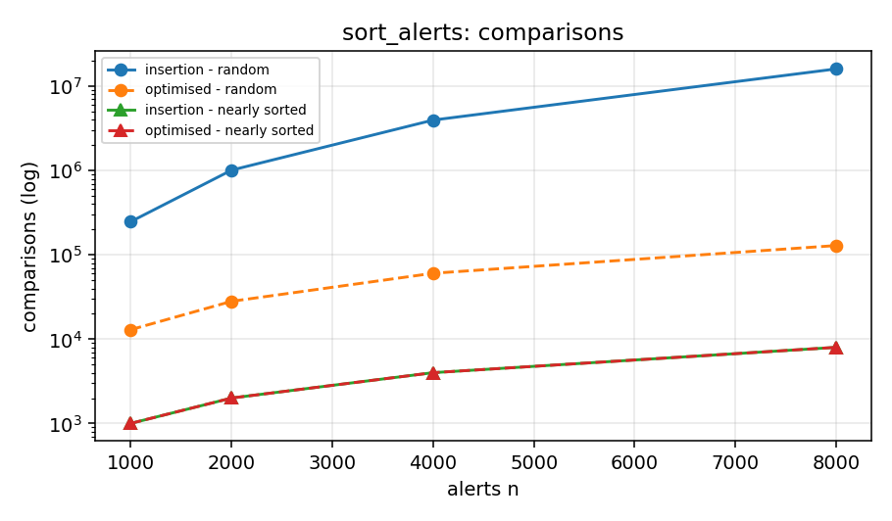
Figure 16 – sort_alerts: comparisons (log scale)

Measurement 3 – is_blocked and find_signature
|B| | queries Q | sequential (equality tests) | hash set (build + probes)
500 | 2,000 | 762,713 | 2,500
1,000 | 2,000 | 1,492,011 | 3,000
2,000 | 2,000 | 3,030,541 | 4,000

n | case | alignments | early exit (optimised) | no early exit m(n − m + 1)
1,000 | random DNA, m=8 | 993 | 1,314 | 7,944
1,000 | worst case a^n, pattern a^(m-1)b | 993 | 7,944 | 7,944
5,000 | random DNA, m=8 | 4,993 | 6,736 | 39,944
5,000 | worst case a^n, pattern a^(m-1)b | 4,993 | 39,944 | 39,944
10,000 | random DNA, m=8 | 9,993 | 13,248 | 79,944
10,000 | worst case a^n, pattern a^(m-1)b | 9,993 | 79,944 | 79,944
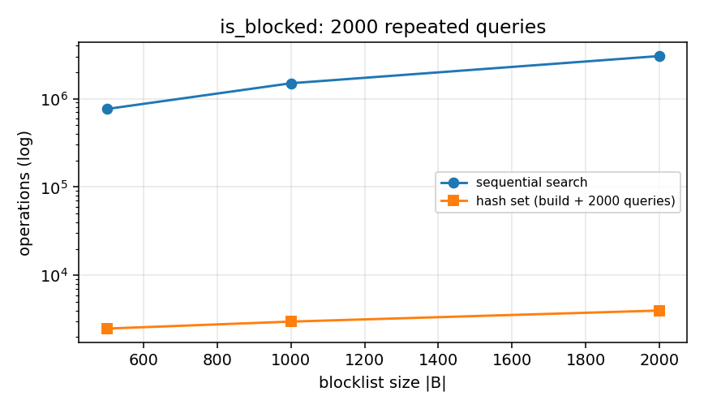
Figure 17 – is_blocked: operations for 2,000 repeated queries
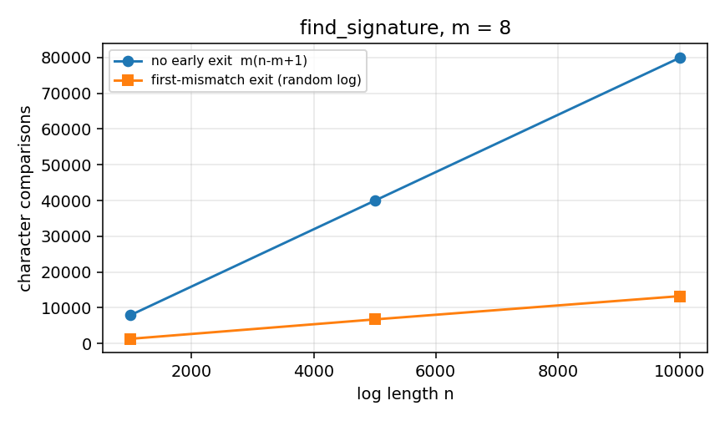
Figure 18 – find_signature: character comparisons (m = 8, random log)
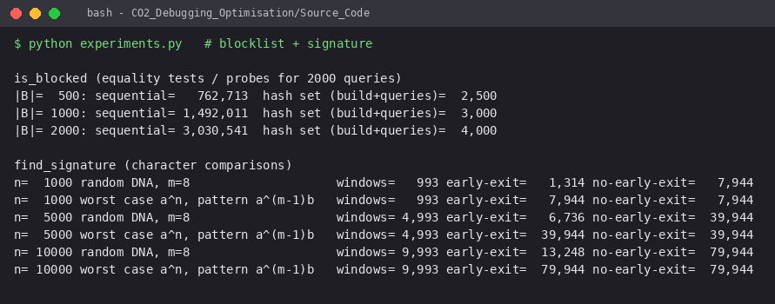
Figure 19 – Screenshot: experiment output (blocklist and signature)

Do the measurements agree with the analysis?
- closest_logins – yes. The measured brute-force count equals n(n − 1)/2 exactly for all four batch sizes (499,500; 1,999,000; 7,998,000; 31,996,000) and the original code would do n² = 64 million computations for n = 8,000. Doubling n multiplies the time by about 4, as Θ(n²) predicts. The optimised count is smaller by more than 99.8 % and grows far more slowly (579 → 8,674 for 8 times more events) but not in a perfectly smooth way (3,214 at n = 2,000 vs 4,825 at n = 4,000): P(n) depends on how small the best distance δ becomes early in the sweep, so the analysis only gives bounds and a typical order, which the measurements respect. The same-x test confirms the Θ(n²) worst case.
- sort_alerts – yes, with a nuance. Insertion-sort counts match n − 1 + I: ≈ n for nearly sorted data and ≈ n²/4 for random data (e.g. 1,013,475 vs n²/4 = 1,000,000 for n = 2,000). The optimised sort equals insertion sort on nearly sorted data (it finishes inside the budget) and is about 20 to 125 times cheaper on random data (n = 1,000 to 8,000), where its count ≈ 4n + n log₂ n (n = 8,000: 129,206 against 16,092,877). Plain insertion sort is therefore the right tool for nearly sorted alerts, but not a safe default.
- is_blocked – yes. The sequential cost grows linearly with |B| (762,713 → 3,030,541 equality tests when |B| grows from 500 to 2,000, ≈ Q·|B|·0.75 because half of the queries are hits found on average half-way), the hash-set cost is |B| + Q (2,500 → 4,000).
- find_signature – yes. On random text the early-exit scan used 1.33 comparisons per alignment (13,248 / 9,993) as the σ/(σ − 1) estimate predicts, versus m = 8 per alignment without early exit (6× fewer); on the adversarial text aaa… the count equals the worst case m(n − m + 1) exactly, confirming Θ(nm). Timing numbers are machine dependent, the operation counts are not.

(e) Production-Quality Code
- optimised_module.py has a module docstring, a docstring for every function (purpose, method, complexity, stats counters), and comments at every non-obvious step (run detection, tie rule, pruning).
- Optional stats dictionaries count the basic operations without changing any result – used by experiments.py.
- test_harness.py (unittest, 29 tests) checks both the corrected and the optimised module on the given data, all boundary cases of part (b) (empty blocklist, pattern at the very end, pattern longer than the log, equal severities, fewer than two events, rotated list, identical locations, tie pairs, same-x points) and random equivalence with brute-force / Python references. Result: Ran 29 tests … OK.
- To run: cd Source_Code; python run_original.py; python debug_trace.py; python test_harness.py; python experiments.py; python make_figures.py.
GitHub repository link: ____________________________________ (to be inserted after pushing the folder CO2_Debugging_Optimisation/; the link is then submitted through Google Classroom).

Self-check against the rubric
Criterion (weight) | Where it is evidenced
Problem identification (20 %) | Part (a): expected vs actual table, nine defects with function, line and nature; Figures 3–4
Debugging (25 %) | Part (b): root causes, one-fix-at-a-time stages, insertion trace, alignment table, boundary tests; Figures 5–8
Optimisation (20 %) | Part (c): hybrid sort, hash-set blocklist, early-exit scan, pruned closest pair; flowcharts and pseudocode
Analysis (20 %) | Part (d): derivations, five measurement tables, graphs, comparison with the theory
Code quality (15 %) | Part (e): docstrings, comments, 29-test harness, repository structure and README

