** INTERNITY FOUNDATIONS**

**A PROJECT REPORT**

**ON**

**“AI Virtual Mouse”**

**PRESENTED BY** DHEERAJ P

**INTERN AT INTERNITY FOUNDATIONS**

**STREAM :** DATASCIENCE WITH PYTHON (BATCH 2)

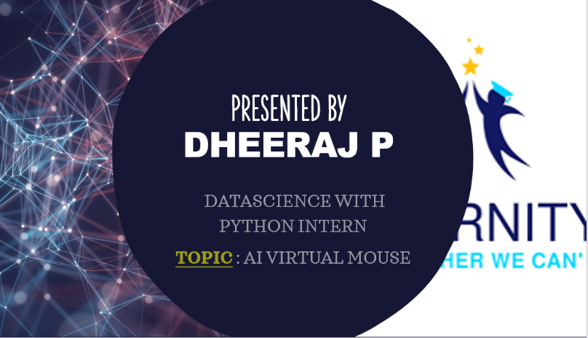**STREAM HEAD :** SANTOSH MOURYA

**PROJECT TOPIC :** AI VIRTUAL MOUSE

**Under the guidance of**

Harshit Garg, Sontosh mourya

**ABSTRACT**

AI virtual mouse is the project designed to meet the highly emerging technology without any flaws. The need for the technology with the application has the most effective marks. Every technology that emerges has its own field of interest and applications extended to various fields. The technology will be changing and the superior leads the world. One such of changing the technology is what our project speaks out. Presently we have mechanical mouse which is the fruit of one the computer application technology. The Marks these technologies have created so far is mesmerizing. The idea of our project is to purely change the application of mouse through virtual reality. The brief introduction or idea of our project is to replace the functionality of mouse. For example, In a wired mouse, there is no such provision to extend the limit, we need to be confined to the length of the wire. Coming to wireless mouse, we should have Bluetooth hardware installed in their computer and dongle should be attached to it. The advancement of these two concepts is Trackpad.

The advancement more is needed in this growing technological era. AI virtual mouse is the concept which ends the usage of hardware mouse. Through human computer interface (HCI) it is possible to interact with the computer considering them as a member in our family. The webcam identifies the human hand and maps the fingers and palm position. After mapping, the movement of the palm is observed and correspondingly the cursor or pointer is moved. There is the synchronization between the palm and the cursor. Hence by applying computer vision technology and machine learning algorithms we are able to design the solution to replace the present mechanical mouse.

**TABLE OF CONTENTS**

**CHAPTER 1 :** Project Background

* 1. Introduction

**CHAPTER 2 :** Mechanical Mouse

**2.1** Working

**2.1.1** Wired Mouse

**2.1.2** Wireless Mouse

**2.1.3** Trackpad

**2.2** Drawbacks

**CHAPTER 3 :** Virtual Mouse

**3.1** Need for Virtual Mouse

**3.2** Solution

**3.3** Software Requirements

**3.3.1** Libraries

**CHAPTER 4 :** Demonstration

**4.1** Code Snippet

**4.2** Explanation

**CHAPTER 5 :** Conclusion

**5.1** Overview

**5.2** Limitation

**5.3** Future Works

**1. Project Background**

**1.1 Introduction**

Our proposed project heals to use the technology most efficiently. The technologies such as computer vision technology and machine learning are utilized to ensure the project meets the present technology. Smart is the word most widely for example, smart bin, smart bot etc. So there is smartness required in utilizing the technology. Palm recognition and identifying the fingers and tracking them is all about our project. After tracking them the cursor has to moved correspondingly. The detailed explanation is given in Demonstration section. The lead for the same is the must required concept for children, youths, and old ones. The joy of playing with the computer through the use of technology is mesmerizing.

**2. Mechanical Mouse**

**2.1 Working**

**2.1.1 Wired Mouse**

In wired mouse there is a physical connection between the system and the mouse itself. Through the wire connection the communication between the system and the mouse takes place. computer mouse is a pointing device that detect 2-D motion relative to a surface. This motion is typically translated into the motion of a pointer on a display, which allows a smooth control of the GUI of a Computer.

The first mouse controlling a computer system was in 1968. Mouse originally uses two separate wheels to track movement across a surface that is in X and Y dimension.the standard design shifted to utilise a ball rolling on a surface to detect motion.

**Operation**

A mouse typically controls the motion of a pointer in two dimensions in a graphical user interface. The mouse can be used to move the pointer left, right, forward, backward .

The relative movements of the mouse on the surface are applied to the position of the pointer on the screen, which signals the point where actions of the user take place, so hand movements are Clicking or hovering (stopping movement while the cursor is within the bounds of an area can select files, programs or actions from a list of names through small images called "icons" and other elements.

Different ways of operating the mouse cause specific things to happen in the GUI:

• single click: clicking the main button.

• Double click: clicking the button two times in quick succession counts as a different gesture than two separate single clicks.

• Triple click: clicking the button three times in quick succession counts as a different gesture than three separate single clicks. Triple clicks are far less common in traditional navigation.

• Right click: clicking the secondary button. In modern applications, this frequently opens a menu.

• Middle-click: clicking the tertiary button.

• Drag: pressing and holding a button, and moving the mouse before releasing the button. This is frequently used to move or copy files or other objects via drag drop; other uses include selecting text and drawing in graphics applications.

Gestures:-

Gestural interfaces occur more rarely than plain pointing-and-clicking; and people often find them more difficult to use, because they require finer motor control from the user. However, a few gestural conventions have become widespread, including the drag drop gesture, in which:

1. The user presses the mouse button while the mouse cursor hovers over an interface object

2. The user moves the cursor to a different location while holding the button down

3. The user releases the mouse button

**2.1.2 Wireless Mouse**

A wireless mouse operates without any physical connection between the system and the mouse itself. To operate the wireless mouse we need Bluetooth hardware installed in our system and Bluetooth dongle attached to it. The advancement of this wireless mouse is what known as Trackpad. The serial communication is what the technology involving Bluetooth operates on. The functionality of the wireless mouse remains the same as that of the wired mouse.

**2.1.3 Trackpad**

Trackpad which can also be called as touchpad is the advance form of mouse. Rather than using mouse as the separate hardware device, touchpad increase the compactness over mouse. Touchpad is embedded in laptops and can be available as a separate hardware too. Its widely used to control the mouse pointer. Touchpad has tactile sensor which is used to track the motion and position of the user finger with respect to the user position.

**3. Virtual Mouse**

**3.1 Need for Virtual Mouse**

Due the various limitation in using the hardware mouse there is a need to switch from the present to place where the solution can patch the limitation. This is place where our virtual mouse benefits the user with the at most care towards the system utilizing and enhancing human computer interface. In the case where user looks for speed and time constraints then our virtual mouse is the best fit.

**3.2 Solution**

First, from the python library we import 5 modules namely, cv2, numpy, HandTrackingModule, Time, Autopy. After importing these modules from the python library into the pycharm environment the execution goes like this. Firstly we find hand landmarks, then get the tip of the middle finger and the index fingers, check which fingers are up, check whether index finger is up to perform operation of moving mode, convert coordinates, smoothen values, move mouse, if both index finger and middle are up then clicking mode, find the distance between fingers, click mouse if the distance between the index and the middle finger is short, Frame rate , displaying the vedio that is captured using cv2 module. This is how the condition flows and the program is executed.

**3.3 Software Requirements**

There are few prerequisites to make sure that our application is working those are explained in library section.

**3.3.1 Libraries**

* **OpenCV**

Face recognition, Object recognition can be performed using OpenCV module. It mainly focusses on computer vision technology and it is a cross platform library where image processing can be performed.

* **Autopy**

It is GUI library. It is mainly used to control the mouse and keyboard.

* **Time**

For performing any delay operations, or scheduling any task we use time module and also its application is extended to perform synchronization task.

* **HandTrackingModule**

Inside the given frame the hand is tracked using this module. After tracking the hand the fingers are mapped then identifying of index finger and the middle finger takes place.

* **Numpy**

Numpy stands for numerical python. We can use arrays and list for holding any data but when it comes to machine learning algorithms there is a need to care for usage of time. Time is constrained and valuable in case of synchronization so Numpy plays its role in constrained time.

**4. Demonstration**

**4.1 Code snippet**

There are totally 2 python files are used named as “AiVirtualMouse.py” and “HandTrackingModule.py”. Out of these files “AiVirtualMouse.py” file is termed as main file consisting the main program and in the main program we need to import a module named as “HandTrackingModule” so we are using the same file as the supporting file.

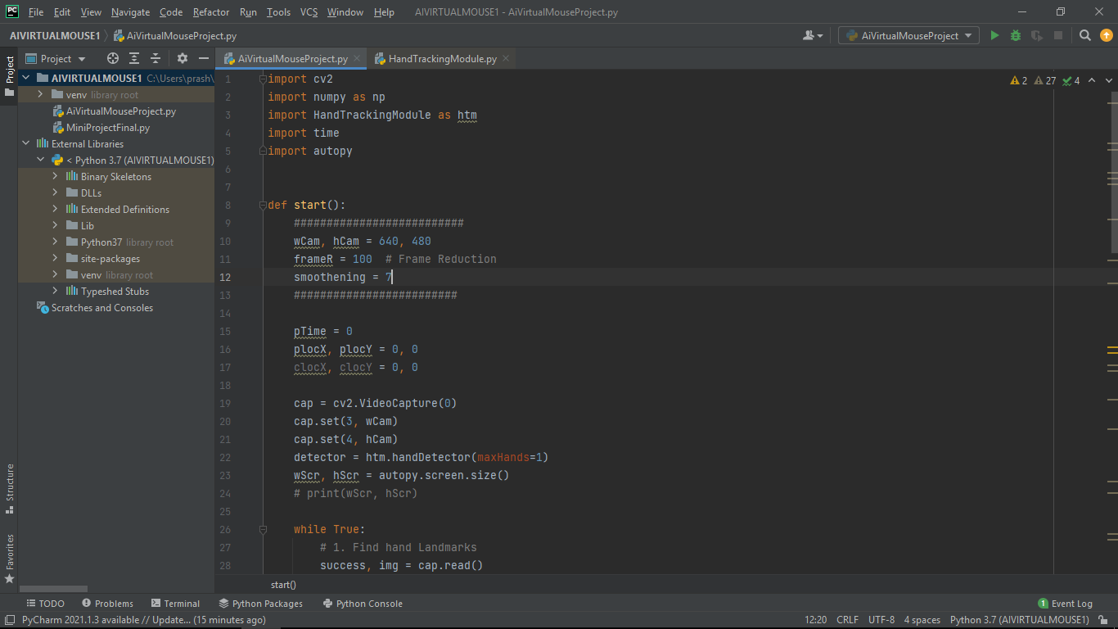

**Fig 1** : Code snippet of “AIVIRTUALMOUSE” file

**4.2 Explanation**

The datasets of continuous tracking is stored in a array using the numpy module. Using this data the cursor movement is eventually performed with pre inbuilt libraries. The hands are kept at the max of 1 wherein only one hand is recognized. After recognition of hand using a handtracking module. The system of events has to performed without any abnormal delays.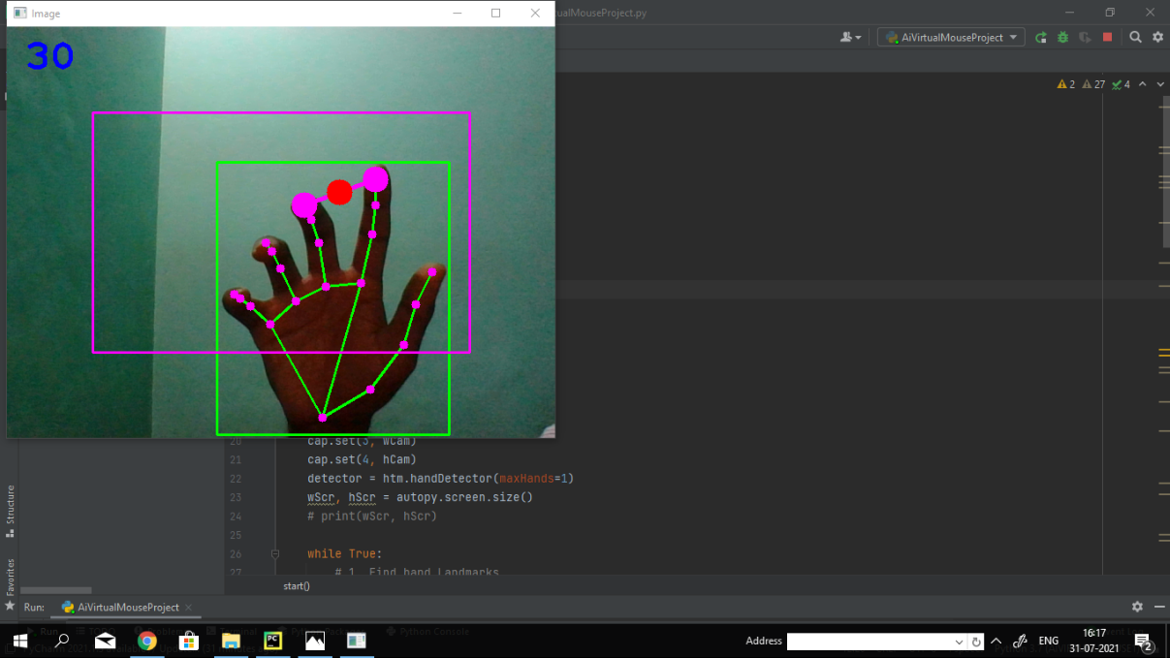

**Fig 2**: Fingers mapping

The functionality lies in between tracking the hand and keeping the cursor synchronized. After the hand is recognized the index finger and the middle finger is tracked. As the index finger moves the cursor on the desktop moves irrespective of any.This synchronization is performed using the autopy module. Basically we use OpenCV which is prestigiously used as the machine learning module to eventually capture the video.

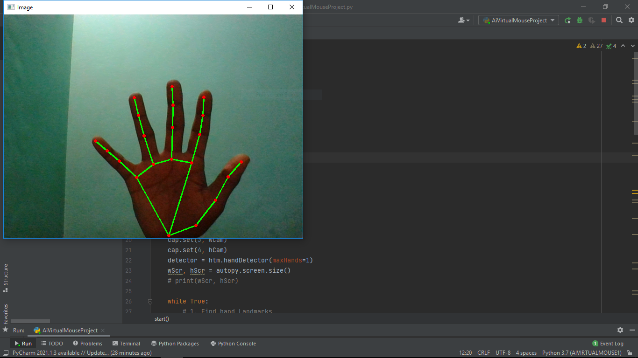

**Fig 3:** Palm recognition

For a right click operation the index finger and the middle finger has to be bought closer as possible. That is there is the threshold distance of 1.5cm as these fingers distance is less than the threshold the right click operation is performed.

We have kept width as 640 and height as 480 to have the maximum video capture with high efficiency. Smoothening is limited to 7 to avoid the user unsatisfaction.

With the unique module named Handtracking module the vast functionality extends beyond expectations. The Handtracking Tracking module is designed specially to overcome the disadvantages of failure of hand recognition, Race colors, mismatch due to glare, etc

The high competition between the inbuilt module to recognize the arrays intern ally that is our hands in grey scale is a big challenge. Fig 2 shows the recognition of palm. Then it is matched by tracking the fingers, then identifying the thumb, middle and index finger. The process continues until it is matched. After the match is successful then the distance between the middle and the index finger is tracked. If the distance between the same goes less than the threshold the right click operation is performed enabling the user to choose the item, opening any folder , zooming and so on. Fig 3 clearly illustrates this concept. In today’s technological era, many technologies are evolving day by day. One such promising concept is human machine interface. For example, In a wired mouse there is a provision to extend limit. In 0wireless mouse, one should have Bluetooth dongle attached.

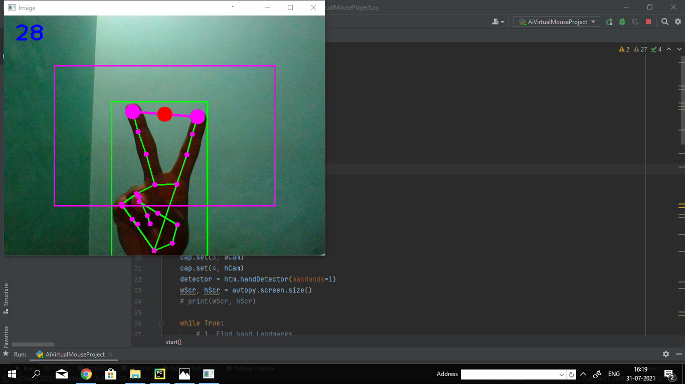

**Fig 4** : Right click operation.

**5. Conclusion**

**5.1 Overview**

There are few advantages we need to look on. The first advantage is humans interacting with computer machine which is termed as human computer interactions. The second point is hardware cost is reduced that is we need not want to buy a separate mouse and hardware failure reduction. The third point is its more convenient for user as it is stepping towards smart environment. To look back the history first mouse was introduced, then touchpad, because of reducing more peripherals. Compacting it into one is a quit challenging but the technology never remained quite and gave rise to touchpad. Advancement of mouse is touchpad. Virtual mouse is the advancement of touchpad, increasing user satisfaction. Since we use user defined gestures its application can be extended like for communication through sign language and further more.

**5.2 Limitation**

The limitations of our project is limited but its suitable to use the word challenge than to use limitation. It would be difficult to identity the hands in the darker background environment. Due to synchronization issues, the movement of our hand should be with the limited speed not exceeding the max. The poor quality of camera fail to identify the palm even if the code is right. It is difficult to get the stable results due to the limitations mentioned earlier. Eventually in future these all can be hoped with no flaw it can be executed.

**5.3 Future Works**

It is no doubt in future the mechanical mouse will be replaced by Virtual mouse which works on gestures. The speed of technology growing in todays world is mesmerizing. The gesture recognition as demonstrated and reported in the detailed report showcases the superimposing need to change the revolutionary world. Computer vision technology is able to recognize the hand in vital environment which is very challenging. The machine learning algorithms are vast with the speed and the growth of it is touching the peak clearing the roof. There is no hesitation to say the technology will be changing with the replacement of each and everything with one or the other. Hence, Virtual mouse working on gestures can be the future ruling the future world.

**Reference**

[1] Abdul Khaliq and A. Shahid Khan, “Virtual Mouse Implementation Using Color Pointer Detection”, International Journal of Electrical Electronics & Computer Science Engineering, Volume 2, Issue 4, August, 2015

[2] using Hand Gesture Recognition”, InternationalJournal of Engineering Sciences & Research Technology,ISSN:2277-9655,March 2014.

[3] Abhik Banerjee, Abhirup Ghosh, Koustuvmoni Bharadwaj, HemantaSaik, Mouse Control using a Web Camera based on ColourDetection”, International Journal of Computer Trends and Technology (IJCTT) –volume 9 number 1, ISSN:2231-2803, March 2014.