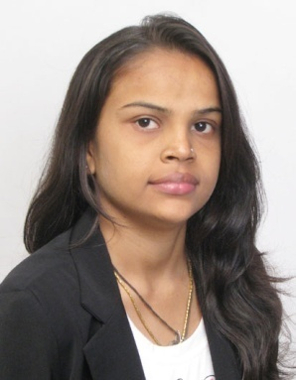

Name: BHARTI JAYPALSINH RATHOD
Contact Address: 3/29,SECTOR 13-B,
PARIJAT APARTMENT, VAVOL ROAD,
GANDHINAGAR
Contact Number: 9825205270
Email_Id: bharti.rahevar@yahoo.co.in

CAREER OBJECTIVE:______________________________________________

To work and create an atmosphere conducive to best performance, develop a cultural of perpetual learning and Evolve a policies and programmes within the organization as would promote a strong organizational orientation….

EDUCATIONAL QUALIFICATIONS:___________________________

Professional:
DEGREE | YEAR OF PASSING | INSTITUTE/UNIVERSITY | PERCENTAGE
MBA  (ISBE)  Certified Course from IIPM | Currently pursuing | IIPM(Indian Institute of Planning and Management) | 53%

Academic:

DEGREE | YEAR OF PASSING | INSTITUTE/UNIVERSITY | PERCENTAGE
GRADUATION  (B.Com) | 2010-2011 | Mumbai University | 48%
HSC | 2008 | Mumbai University | 51%
SSC | 2006 | Mumbai University | 56.37%

Summer training details:

Name of the organization: ING VYSYA BANK LTD.

Duration : 2 month

Project title : Recruitment and selections process

Project objective : Recruitment and selection objectives include a variety of components related to finding, hiring and retaining qualified employees. Clear definitions of the job qualifications allow easier identification of potential candidates. Recruitment consists of attracting capable individuals using methods such as outsourcing and the internet. Selection objectives consist of evaluation techniques such as interviews, background checks and competence tests.
PROJECTS HANDLED:________________________________________
Desk Projects:
Project Title | Project Objective
GROUP DYNAMICS  COMPENSION MANAGEMENT  HUMAN RESOURCE PLANNING | Leadership is about people coming together to work towards making a positive change we work within groups and understand group dynamics.  Within our organizations if we want to be successful.  Compensation management is something that companies must take seriously if they are to achieve a competitive advantage in the market for talent.  The PROCESS by which the GUIDING MEMBERS of an organization manages and leads the people who will be responsible for implementing the strategies necessary to fulfill its mission and reach its vision

HOBBIES AND INTEREST: ______________________

- Singing Song and
- Playing Outdoor game

PERSONAL DETAILS :_______________________________________

Date of Birth | 12th November 1988 | Nationality | Indian
Gender | Female | Marital Status | Married
Fathers Name | Mr. Ramsinh Rahevar | Languages Known | English, Marathi,Gujrati

I hereby declare that all the information provided by me in this application is factual and
Correct to the best of my knowledge and belief.

-------------------
BHARTI RAHEVAR

