COMMUNICATION ADDRESS
#72/3, 3rd Floor
Yellamma Temple Road
Near Jaraganahalli Field
JP Nagar 6th Phase
Bangalore-78
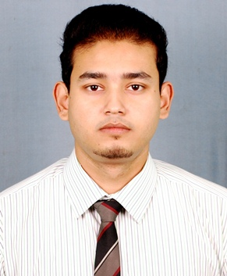
JEETJYOTI MEDHI

Email: jeet.medhi@gmail.com
Tel :+917760175240

CAREER OBJECTIVE

To be a successful professional and to work in an organization that provides me with opportunities to apply my skills and knowledge and also presents me with a good platform to learn and grow.

EXPERIENCE

- Executive at Systems & Services (Dec, 2012 - July, 2013)
Worked on several projects involving brands like FICCI, NERAMAC, NEFIT and IIE. Key responsibilities include Background Research; Create, Update & Maintain Database; Corporate Communications; Corporate Marketing; Client Servicing; Event Designing; Team Management; Corporate Sales and Onsite Event Handling.
Key Projects Handled:

- NDMA-PNGRB-FICCI- National Seminar on Chemical Industrial Disaster Management

- FICCI- National Conclave on Marketing and Brand Building.

- FICCI-NERAMAC National Conference on Beekeeping and Honey Processing.

- Research Associate at D. Konwar& Associates (July, 2012-Nov, 2012)
Worked as an associate in the consultancy firm. Key responsibilities includeOnsite Inspection and Data Collection, Prepare Training Modules, Implement Training Programs, Evaluate Training Programs, Documentation, Corporate Communications, Team Management.

- IIE-Quality Management Systems/Quality Techniques & Tools (QMS/QTT) Workshops at various industrial clusters in North East

EDUCATION

2012 | DepartmentOfBusinessAdministration  (Guwahati University). Assam | 8.62(CGPA) | M.B.A(Finance)
2010 | PriyadarshiniCollege ofEngineering,Nagpur  (R.T.M.N.U), Maharashtra | 72.8% | B.E(InformationTechnology)

SKILLS AND PROFICIENCIES

- Languages known | : English, Hindi, Assamese, Bengali
- Software packages | : MSOffice.
- OS | : MS-DOS, MS Windows, Linux Ubuntu

STRENGTHS

Good analytical and communication skills, Quick learner, Dedicated, Good team player, Result-oriented.
HOBBIES

Cricket, Badminton, Music and Driving.

PERSONAL DETAILS

Father’s Name | : Mr. Balendra Kr Medhi
Date of Birth | : 10th of November, 1986
Sex | : Male
Marital Status | : Unmarried
Nationality | : Indian

I pledge and pronounce that all the above information is true to the best of my knowledge and belief.

Place: Bengaluru JEETJYOTI MEDHI
Date: 23/10/2013

