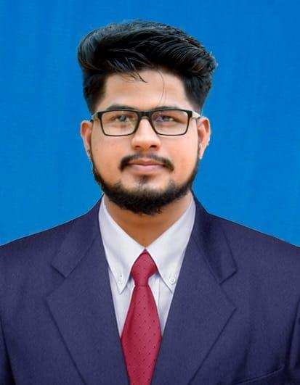
KIRAN KUMAR
Bachelor of Science
Mobile: +91 7676433848
Mail: kiranbyndoor29@outlook.com

CAREER OBJECTIVE
To work in a good environment by exposing my skills effectively with sincere hard work and following professional ethics, work for the development of your company and also for my professional growth.
SKILLS SUMMARY
- HTML5, CSS
- PYTHON
- MySQL
- Oracle SQL
- Django
QUALIFICATION
- Completed BSC in William Carey University during 2017.
- Completed PUC in Govt. Pre-University, Byndoor during 2013.
- Completed SSLC in Govt. College Byndoor during 2011

CERTIFICATION
- Oracle SQL Certified Professional Course, in Besant Technologies, Bangalore (2020)
- Python Certified Professional Course, in Besant Technologies, Bangalore (2020)
WORK EXPERIENCE
- Company Profile – Al Howail Group, (glass fabricator company) An ISO certified company based in Dammam, Saudi Arabia.
- Worked in Optimization department’s, Production and purchase data managing.
- Period – 2.5 years.
PERSONAL DETAILS
- Father’s Name : Krishna devadiga
- Mother’s Name : Girija devadiga
- Date of Birth : 29/04/1995
- Marital Status : Single
- Languages Known : English ,Hindi and Kannada
- Permanent Address : Kiran Kumar , S/O Krishna Devadiga ,Kallarhitlu Paduvary ,Byndoor ,Udupi ,Karnataka
Declaration
I, Kiran hereby declare that the information furnished above is true up to the best of my knowledge
Date :
Place :Udupi | ( Kiran kumar )

