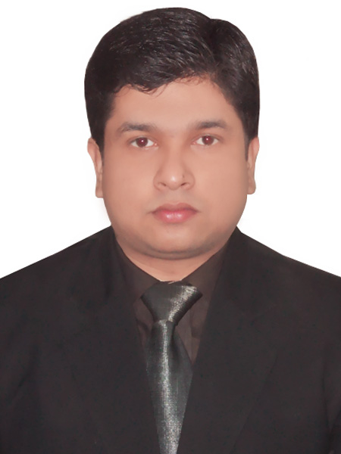
Md Zaid Quamar

Mobile No: +91 – 9310721555, +91 – 8882189240
Email: zaid.jmi@gmail.com & zaid.quamar2007@gmail.com
Residence Ph No: +91- 09310721555
Correspondence address: FA/2, Abul Fazal Enclave, Thokar No-4
Jamia Nagar ,Okhla ,New Delhi-25

Career Objective:

To grow and work with organization which continuously develop my professional and personal skills that will help me to prove myself as an integral part of a productive team.

Educational Qualifications:
- PGDM (Finance and Marketing): New Delhi Institute of Management, New Delhi, Pursuing (2012-2014)
- B.Com (Delhi University) ; 2012; (55%)
- Higher Secondary: Jamia Sr. Sec. School, (Jamia Board); 2009 (66%)
- Secondary: Jamia Sr.Sec.School, (Jamia Board); 2007; (54%)

Summer Internship Project:

M/s Lall & Co. (23rd April, 2013 – 21st June, 2013)
Project Title: Security Portfolio and Analysis in Delhi
Project Synopsis: Invested in Portfolio and Mutual funds where I learnt to analyze the market scenario prior to investing in any stock and also to select mutual funds on the basis of their performance ratios to fulfill my investment objective.

Other Projects/ Training:

Worked on social responsibilities issues under Real Cause NGO related to health and education camp.

Achievements/ Awards/ Certification:

- Winner of Inter school skit competition (2007-08) organized by Jamia Senior Secondry school , New Delhi on its Foundation Day.
- First Runner Up in the Inter House Urdu Competition (2007-08) held at Jamia Senior Secondary School, New Delhi in the year 2007.

Co-Curricular /Extra-Curricular Activities

- Participated in Slogan Writing Competition in English Literary Fest - EXUBERANCE 2012, held at Shaheed Bhagat Singh College (Delhi University).
- Member Central Placement Cell for arranging and organising recruitment related activities for seniors at Shaheed Bhagat Singh College(Delhi University).
- Contributed in the Commerce Association in organising events, seminars (social and economic), debate management etc in Shaheed Bhagat Singh Collage (Delhi University).

Core Competencies:

- Adaptable
- Flexible
- Positive attitude

Personal Information:

Date of Birth : 07-01-1991
Nationality : Indian
Gender : Male
Marital Status : Single
Permanent Address : Aiyub Manzil, Line Bazar, Near Abu Bakr Masjid, Purnea(Bihar)
Languages known : English, Hindi, Urdu

