Yallappa Sattigeri  Quick Learner, Good Communicator and Critical Thinker. | Address: At Post:Sampagaon, Tq: Bailhongal Dt: Belgaum  Contact: +916360734634  Email Address: yallappasattigeri@gmail.com
EXPERIENCE  Government of Karnataka- Crop Investigation Officer  July/2017 -April/2019  Worked AT REVENUE DEPARTMENT OF KARNATAKA ASSISTANT VILLAGE ACCOUNT 2019 - 2020 APRIL TO DECEMBER  WORKED AT ASSISTANT HR IN INDIA AISA MANEGE MENT 2020-2021 January to December  Roles and responsibilities:  Getting information about Field and Owner of the field.  Collecting information about the land and the crop information  And sharing the report to government.  EDUCATION  Graduation  SGSV Composite PU College, Location — Bailhongal  Bachelor of Arts  June/2012- June-2016  Percentage: 66%  PUC  SGSV Composite PU College, Location — Bailhongal  Arts Domain  June/2010 – June/2012  Percentage: 55%  High School:  RES High School, Location — Sampagaon  June-2007 – June-2010  Percentage: 43%  EXTRA ACTIVITIES/PROJECTS  Took Training on Speaking Skills.  Participated in School College sports Activities.  References  1.Balayya Yaragamblimath  Mob: 8951472295  Test Analyst ,Infosys Limited  Address: Sampagaon, TQ: Bailhongal, Dt: Belagavi  2.Anand Goni  Mob: 7892183704  QA Manager , Virtusa  Address: Pularkoppa, TQ: Bailhongal Dt: Belagavi | 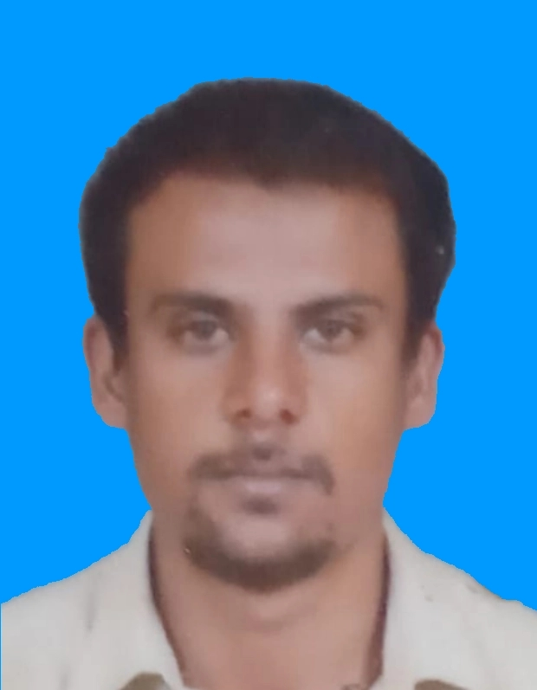  SKILLS  - Creative writing  - Communication skills  - MS office  - Quick Learner  - Tally  - Basic of computer  - Python  AWARDS/CERTIFICATES  1st Prize in Discuss throw  1st Prize in Long Jump  LANGUAGES  English, Hindi and Kannada

