# **PASSPORT AUTOMATION SYSTEM** **UML DIAGRAMS**

## **USE CASE DIAGRAM:**

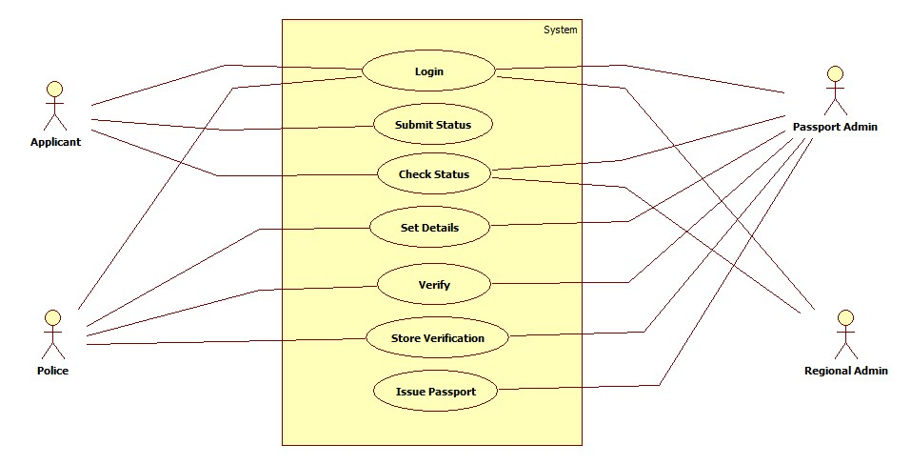

## **DOMAIN MODEL:**

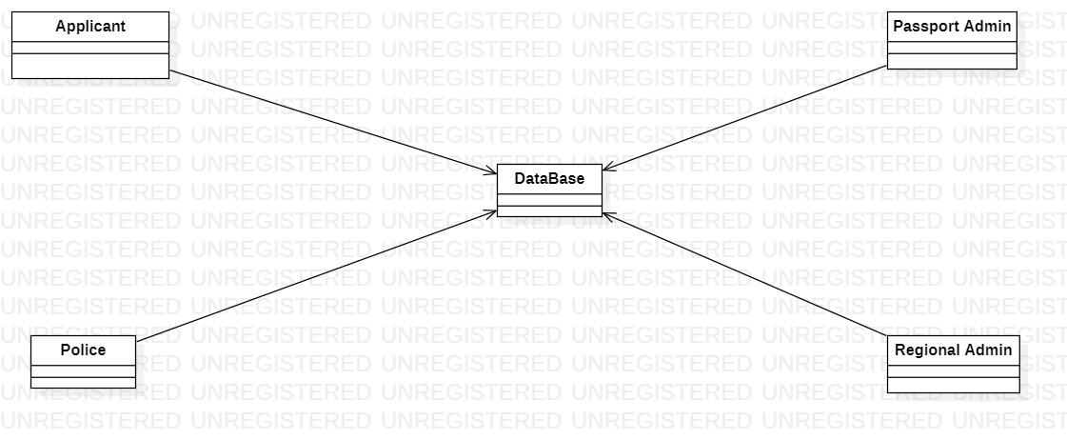

## **CLASS DIAGRAM:**

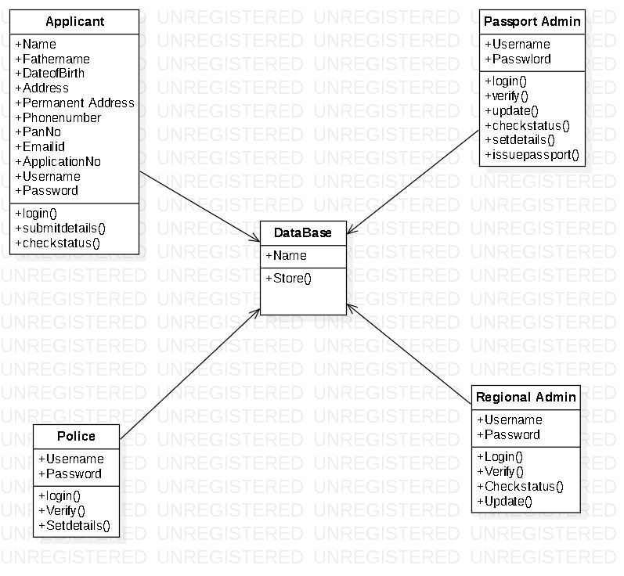

## **SEQUENCE DIAGRAM:**

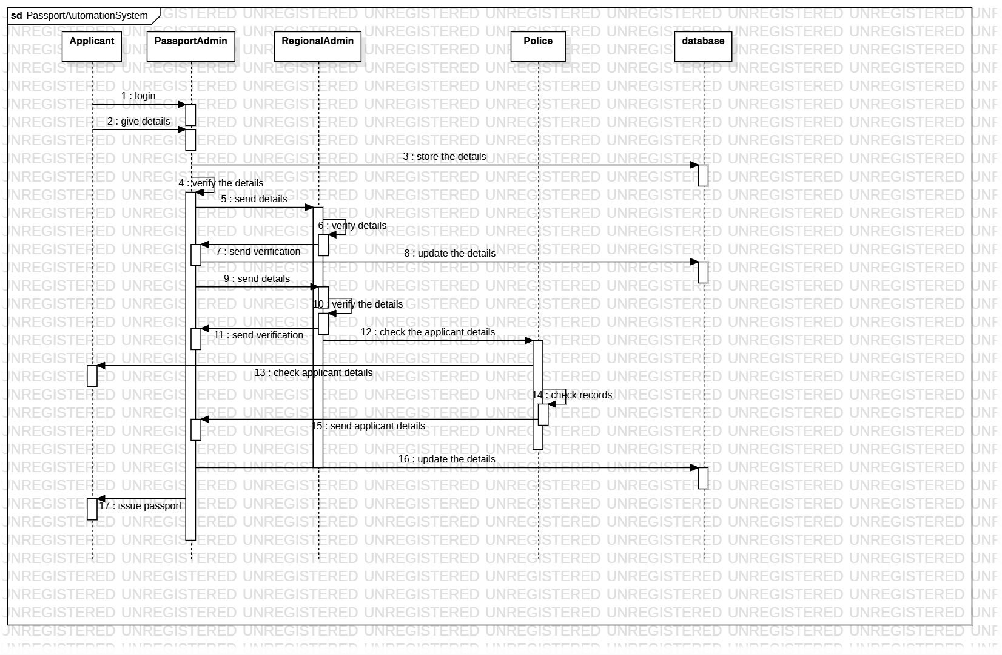

## **COLABORATION DIAGRAM:**

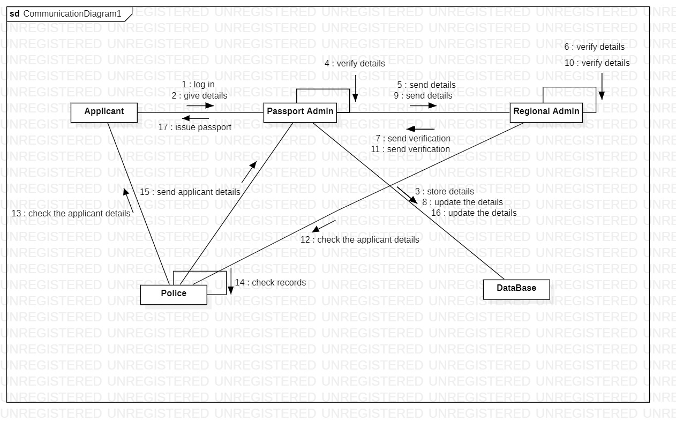

**ACTIVITY DIAGRAM:**

