How to Deploy Domain Services Project Templates

# Exporting the Templates

1. Build and run the project to test that it is OK
2. Export using **Project -> Export Template**
3. Fill out and run wizard.

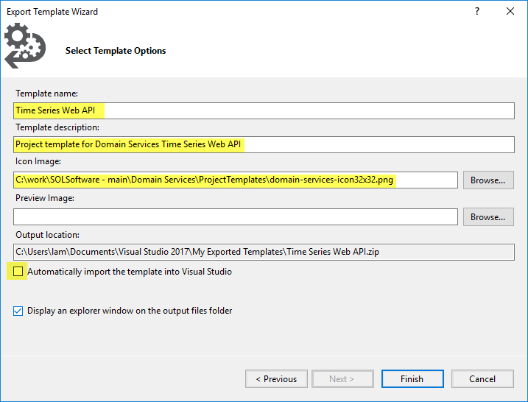

1. Manually modify the <TemplateData>-section in the MyTemplate.vstemplate file with the contents of the TemplateData.txt file.

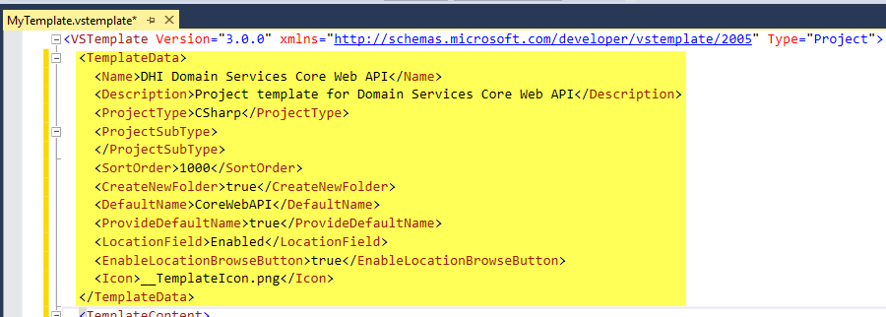

# Deploying the Visual Studio extension (VSIX)

1. Add or Update the project templates with the exported templates from above

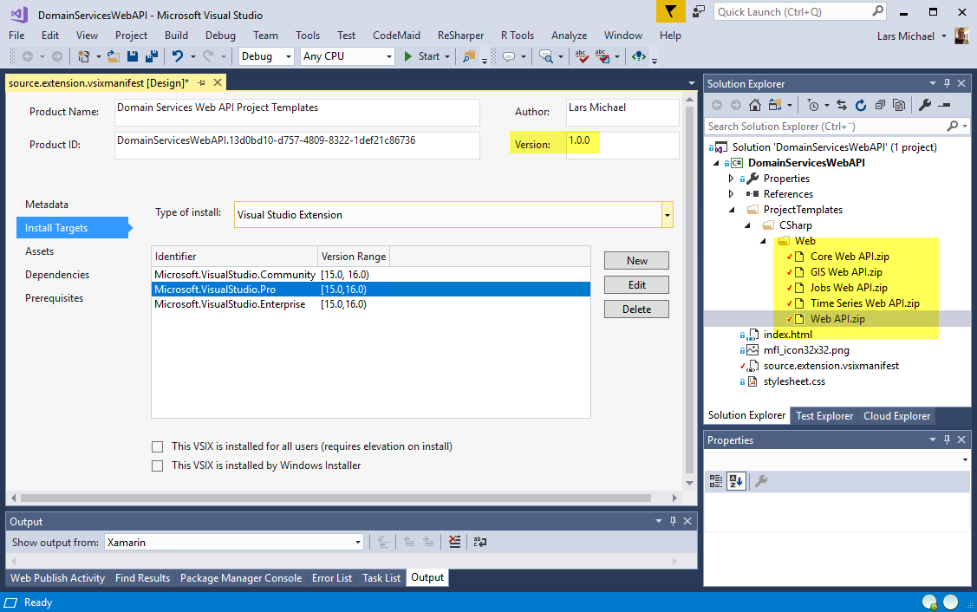

1. If new templates are added, create new assets:

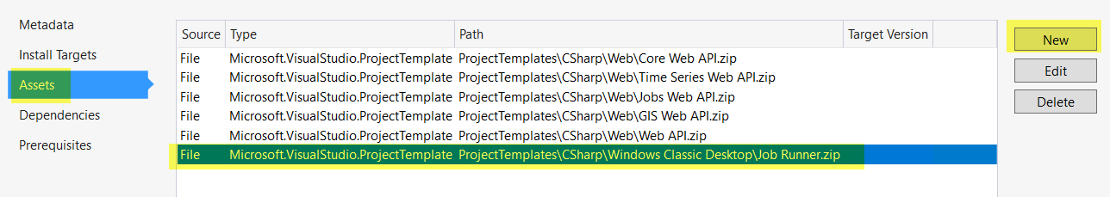

1. Change the version number
2. Build
3. Check-in changes to source control
4. Upload the DomainServicesTemplates.vsix from the bin folder to Visual Studio Marketplace