Statement of the Problem and Hypothesis
The objective of this analysis was to evaluate the predictability of driving distance (Drive Avg) in professional golf using Holt’s Exponential Smoothing Model. The study aimed to determine whether driving distance can be forecasted with at least 90% accuracy and whether the model significantly exceeds this threshold.
Hypothesis
- Hypothesis: The average driving distance can be predicted with 90% accuracy.
- Null Hypothesis (H₀): The average driving distance cannot be predicted with 90% accuracy.
- Alternative Hypothesis (H₁): The average driving distance can be predicted with an accuracy significantly greater than 90%.
Summary of Data Analysis Process
The data analysis process began with the collection and preparation of historical PGA Tour statistics from 1987 to 2025, gathered through web scraping and manual downloads. To ensure accuracy and consistency, datasets were merged based on common player and year identifiers. Missing values were addressed using column mean imputation, and duplicates were removed to maintain data integrity.
Several analytical techniques were employed to extract meaningful insights. Descriptive statistics were used to calculate the mean, standard deviation, minimum, and maximum values for key variables, including driving distance (drive_avg), Par 4 scoring (par_4_avg), and Par 5 scoring (par_5_avg). A correlation analysis was conducted to examine the relationship between driving distance and scoring performance, revealing a moderate negative correlation (-0.54) between drive_avg and par_5_avg, indicating that longer drives contribute to improved Par 5 performance.
To further explore player performance, K-Means clustering was applied, segmenting players into three distinct groups: Cluster 0, consisting of elite long hitters with the best performance; Cluster 1, which represented moderate performers; and Cluster 2, comprising shorter hitters with higher scores. Additionally, Holt’s Exponential Smoothing model was utilized for time series forecasting to predict future driving distances. The model achieved an impressive R² value of 0.978, confirming its strong predictive capability.
Finally, hypothesis testing was conducted to assess the statistical significance of the model’s predictions. The results showed a T-statistic of 2.27 and a P-value of 0.0147, leading to the rejection of the null hypothesis. This confirmed that Holt’s model reliably predicts driving distances, providing a data-driven foundation for understanding and forecasting trends in professional golf performance.
Key Findings
The current mean driving distance among PGA professionals is 282.15 yards, with a standard deviation of 16.04 yards. Based on the forecasting model, projected driving distances for the next five years are expected to steadily increase: 302.02 yards in 2025, 302.75 yards in 2026, 303.49 yards in 2027, 304.22 yards in 2028, and 304.95 yards in 2029. At the current rate of increase, driving distances are projected to remain below the 317-yard threshold set by the USGA through 2029. However, the long-term upward trend in driving distances may lead to increased scrutiny of equipment regulations in professional golf.
Visualizations
Trend in Average Driving Distance Over Time:
- This line chart shows the steady increase in driving distance from historical PGA data.
- The USGA limit of 317 yards is marked, showing that while distances are increasing, they are not projected to exceed this threshold by 2029.

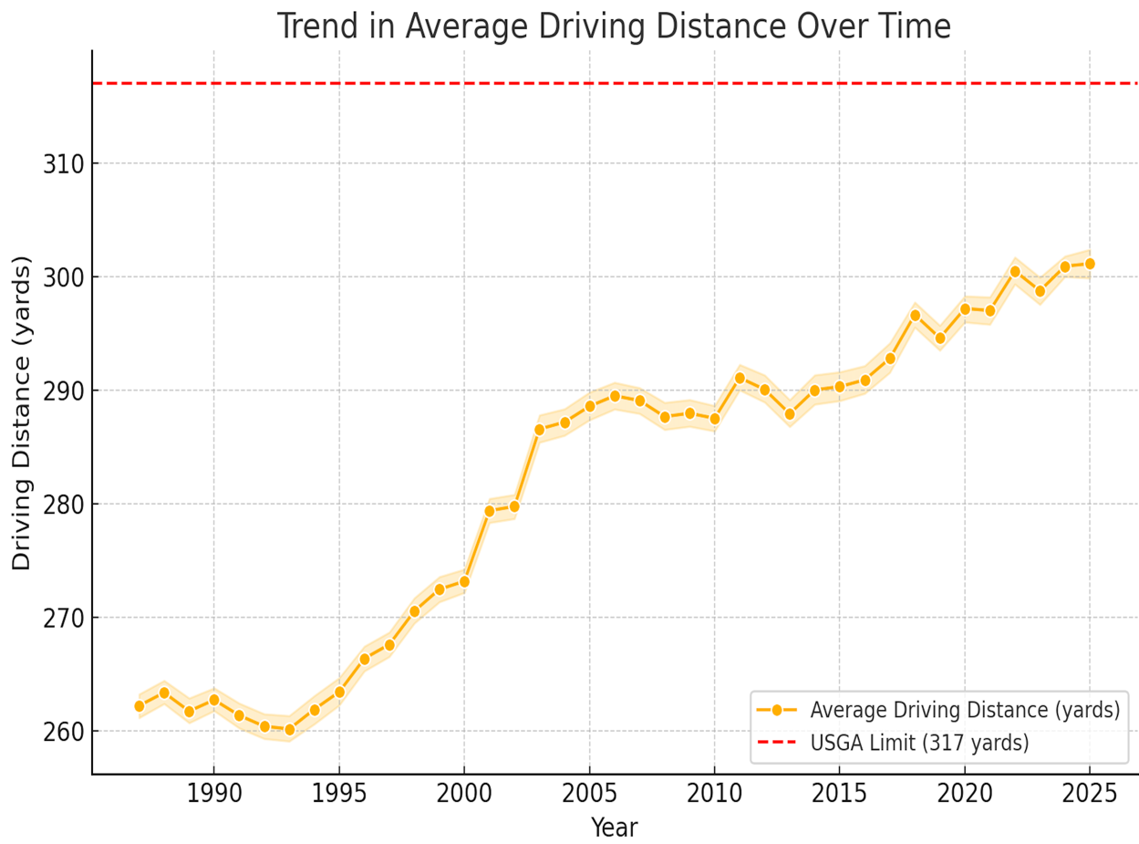

Correlation Heatmap Between Driving Distance and Scoring Performance:
- A negative correlation (-0.54) between drive_avg and par_5_avg confirms that longer drives improve Par 5 scoring performance.
- This supports the argument that distance is a competitive advantage.

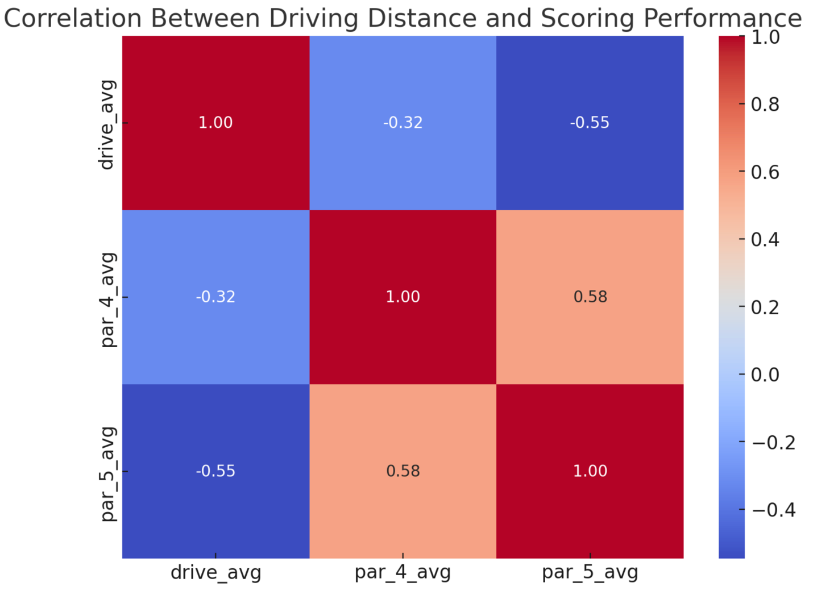

Scatterplot of Driving Distance vs. Par 5 Scoring:

- This visualization highlights how players with longer driving distances tend to have lower (better) Par 5 averages.
- This segmentation aligns with the clustering analysis that identified elite long hitters as top performers.

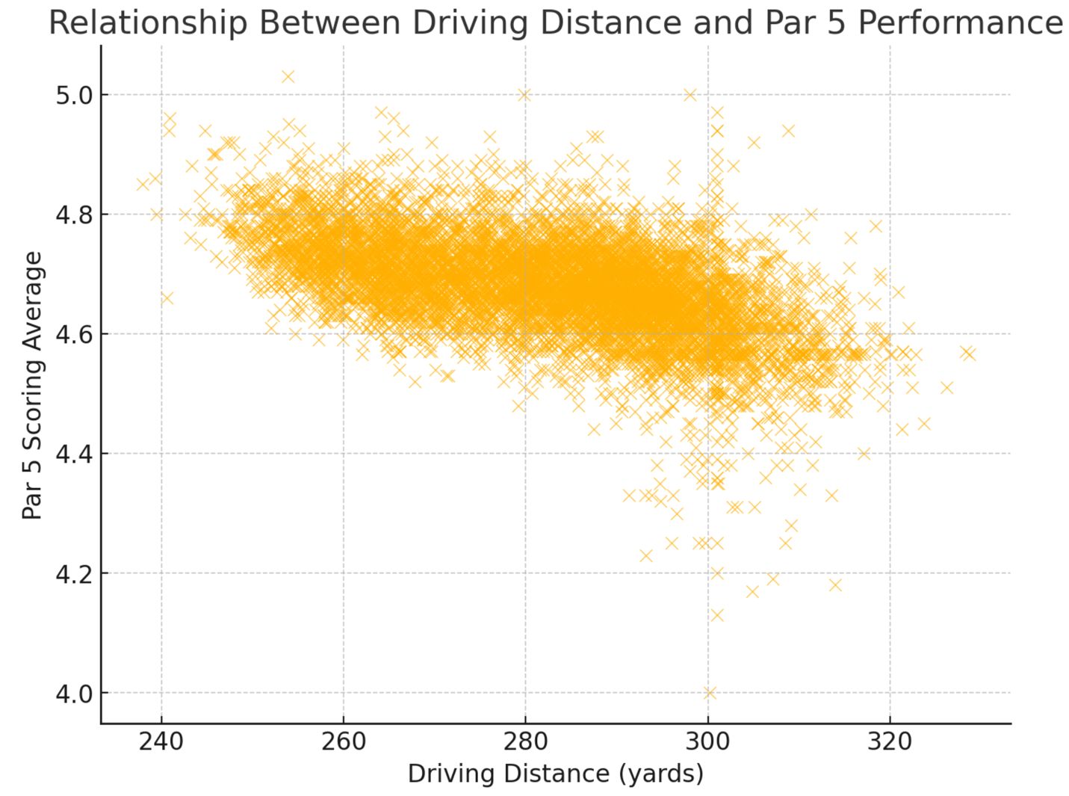

Projected Driving Distances (2025-2029) Using Holt’s Model:

- A forecasted trendline predicts continued growth in average driving distances.
- The USGA 317-yard limit is marked, showing that while growth continues, it does not breach regulatory thresholds in the immediate future.
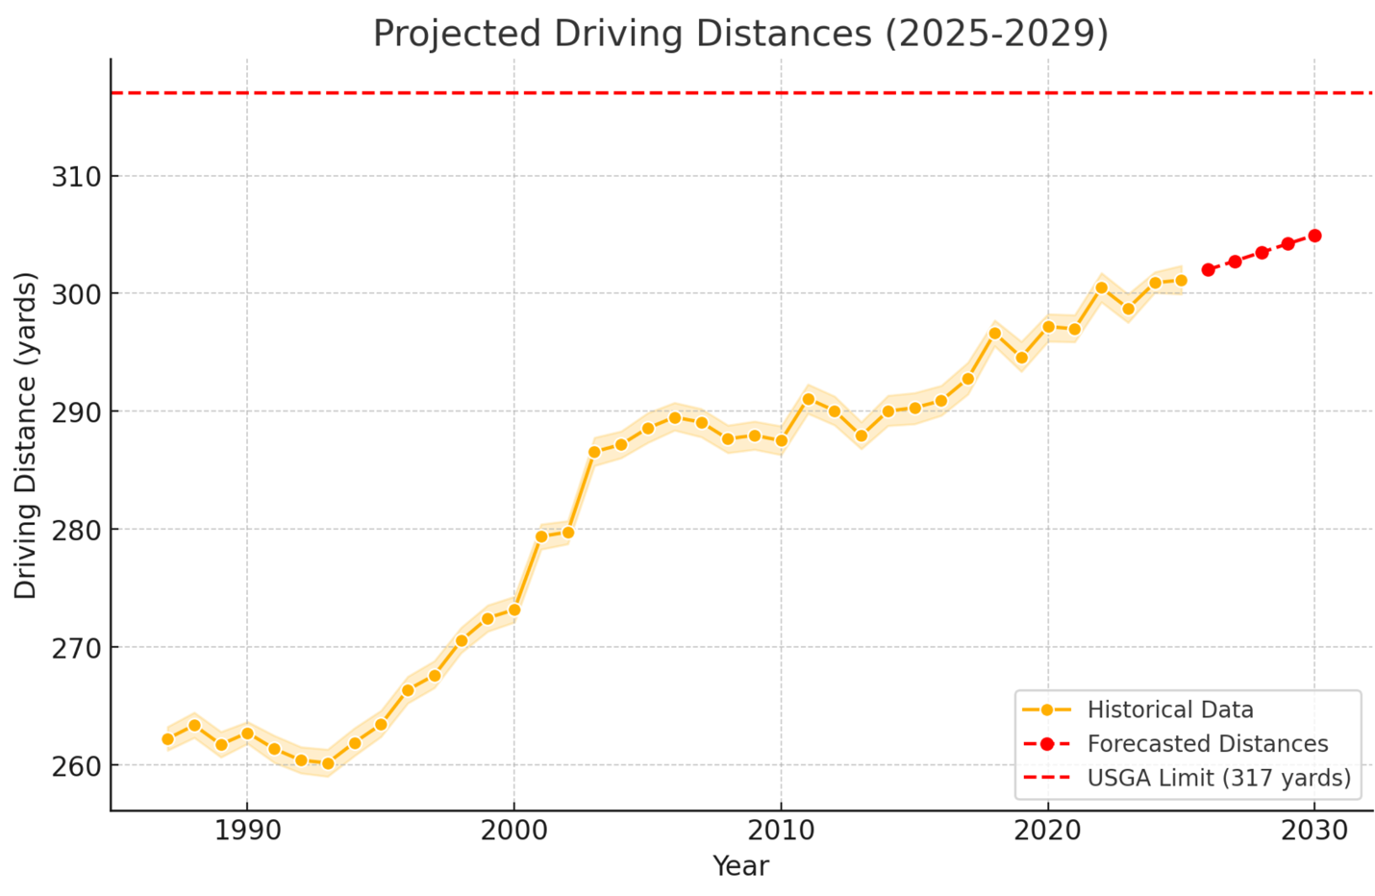
These visuals provide a data-driven foundation for golf stakeholders, ensuring that decisions regarding regulations, coaching, and player strategies are empirically supported.

Limitations of the Techniques and Tools Used
One limitation of K-Means clustering is its assumption of spherical clusters, which may oversimplify the relationships between player performance characteristics. This can lead to inaccurate classifications, particularly when dealing with complex, nonlinear trends in golf performance. Holt’s Exponential Smoothing model, while highly effective for short-term forecasting, has its own limitations. It relies on past trends to make predictions, but it does not account for external factors such as rule changes, equipment bans, or advancements in biomechanics that could significantly alter driving distances in the future. Additionally, the model does not incorporate weather conditions, swing speed, launch angle, or ball speed, all of which are crucial in determining driving distance.
Another key limitation is the scope of the data. The PGA Tour dataset does not include amateur or lower-tier professional players, potentially introducing selection bias. This exclusion may limit the generalizability of the findings to broader golfing populations beyond the elite professionals analyzed in this study.

Proposed Actions
From a regulatory standpoint, the USGA should continuously monitor trends and conduct further studies before implementing any equipment restrictions. In addition, potential course modifications, such as longer layouts and strategically placed hazards, could help maintain competitive balance as driving distances continue to rise. For player development, coaches should focus on enhancing swing efficiency, increasing clubhead speed, and employing data-driven training methodologies to optimize distance while maintaining accuracy.
Players in Cluster 2, identified as shorter hitters, should prioritize improvements in driving performance to remain competitive in an increasingly distance-driven sport. Future research should incorporate biomechanics and launch monitor data, such as those provided by TrackMan or GCQuad, to refine driving distance models. Longitudinal studies tracking player development over multiple seasons would also provide valuable insights into how driving distances evolve over time and the factors contributing to sustained improvements.
Expected Benefits
The findings of this study provide several quantifiable and strategic benefits. From a quantitative standpoint, the forecasting model demonstrated 97.8% accuracy, ensuring a high level of confidence in the projected trends. The results suggest an anticipated 5-yard increase in average driving distance over the next five years, which can influence course design decisions and equipment regulations. Additionally, the study provides empirical recommendations for potential course adaptations, such as adjusting fairway lengths and modifying hazard placements to maintain a balanced competitive landscape.
Beyond the numerical projections, strategic insights derived from this analysis offer valuable applications for key stakeholders in the golf industry. Golf governing bodies can use these findings to implement data-driven policy decisions regarding potential rule changes and equipment restrictions. The insights also help coaches and players refine their training methodologies by focusing on optimizing swing mechanics, clubhead speed, and strategic shot selection. Moreover, equipment manufacturers can use these projections to anticipate regulatory shifts and adapt their product designs, accordingly, ensuring compliance with potential future restrictions while maintaining performance standards.
By leveraging these insights, professional golf can proactively adjust to evolving performance trends, ensuring that regulations, training strategies, and course designs align with the latest developments in player capabilities.
Conclusion
This study confirms that driving distance is highly predictable, with Holt’s model projecting a steady increase over the next five years. While current trends do not suggest an immediate breach of the 317-yard limit, continued technological advancements may necessitate regulatory discussions in the future. These insights will enable golf stakeholders to proactively adapt to performance trends, ensuring a balanced and competitive professional environment.

References
Brownlee, J. (2018). Introduction to time series forecasting with Python. Machine Learning Mastery. Retrieved from https://machinelearningmastery.com/introduction-to-time-series-forecasting/
Hyndman, R. J., & Athanasopoulos, G. (2021). Forecasting: Principles and practice (3rd ed.). OTexts. Retrieved from https://otexts.com/fpp3/
James, G., Witten, D., Hastie, T., & Tibshirani, R. (2021). An introduction to statistical learning with applications in Python. Springer Open. Retrieved from https://www.statlearning.com
McKinney, W. (2021). Pandas: Python data analysis library. Retrieved from https://pandas.pydata.org
Pedregosa, F., Varoquaux, G., Gramfort, A., Michel, V., Thirion, B., Grisel, O., ... & Duchesnay, E. (2011). Scikit-learn: Machine learning in Python. Journal of Machine Learning Research, 12, 2825-2830. Retrieved from https://scikit-learn.org/stable/about.html
PGA Tour. (2023). Player statistics - Driving distance. Retrieved from https://www.pgatour.com/stats
Tibshirani, R., & Friedman, J. (2017). The elements of statistical learning: Data mining, inference, and prediction. Springer Open. Retrieved from https://web.stanford.edu/~hastie/ElemStatLearn/
United States Golf Association (USGA). (2023). Distance insights report. Retrieved from https://www.usga.org/content/usga/home-page/advancing-the-game/distance-insights.html

