

* Introduction
* Exploratory Data Analysis
* Feature Selection
* Data Preprocessing
* Modeling
* Conclusion

***Abstract –*** ***Sharing Bike has come a new concept now a days where one doesn’t have to buy a bike to enjoy their daily ride. Currently It has introduced in so many urban countries for enhancement of mobility comfort. One can rent bikes on several basis like hourly, daily, monthly etc. It has a significant role to the rising issues related to the global warming, climate change, carbon emission and many more environmental anomalies. It is very important to make rental bikes available and accessible to the customers to the right time as it lessens the waiting time.***

***In this project, we choose to analyse a dataset containing the rental bike count and other climate related variables of Seoul city, The capital of South Korea. First, we have focused on the data pre-processing and data transformation, then we have used “Linear Regression” and “Polynomial Regression” to predict the rent bike count required at each hour very efficiently.***



***Introduction***

Bike Sharing systems are a means of renting bicycles where the process of obtaining membership, rental, and bike return is automated via a network of kiosk locations throughout a city. Using these systems, people are able rent a bike from a one location and return it to a different place on an as-needed basis.

The first bike-share programs began in 1960s Europe, but the concept did not take off worldwide until the mid-2000s. In North America, they tend to be affiliated with municipal governments, though some programs, particularly in small college towns, centre on university campuses.

The typical bike-share has several defining characteristics and features, including station-based bikes and payment systems, membership, and pass fees, and per-hour usage fees. Programs are generally intuitive enough for novice users to understand. And, despite some variation, the differences are usually small enough to prevent confusion when a regular user of one city’s bike-share uses another city’s program for the first time.

With the onset of Industry 4.0, integration of Internet of Things (IoT) systems with bike-sharing ecosystem has eased the rental process to a significant extent. Real-time tracking of bikes, traffic density, and climate variables aids in gaining useful knowledge about trends, and patterns of renting process, thereby allowing an incisive prediction to meet future demand.

Considering the current ecosystem, bike-sharing can play a vital role in reducing the impact of carbon emissions and other greenhouse gases- major contributors in climate change. Sustainable and clean transport system, if successful, can provide a greener alternative to the traditional car-pool system, and help in reducing traffic congestion, too.

In addition to the environmental benefits, the sharing systems will impart healthier habits among commuting public, who in the hustle of tasking daily routine, often are unable to integrate optimum level of physical activity, which results in a barrage of ailments.

***Exploratory Data Analysis***

In this part of EDA each individual features are analysed by proper statistical methods.

So first let’s look at the dataset attributes:-

* **Attribute Information:**
* Date : year-month-day
* Rented Bike count - Count of bikes rented at each hour
* Hour - Hour of the day
* Temperature-Temperature in Celsius
* Humidity - %
* Wind speed - m/s
* Visibility - 10m
* Dew point temperature - Celsius
* Solar radiation - MJ/m2
* Rainfall - mm
* Snowfall - cm
* Seasons - Winter, Spring, Summer, Autumn
* Holiday - Holiday/No holiday
* Functional Day - NoFunc(Non Functional Hours), Fun(Functional hours)

* **Dataset Statistics**

|  |  |
| --- | --- |
| Number of variables | 14 |
| Number of observations | 8760 |
| Missing cells | 0 |
| Missing cells (%) | 0.0% |
| Duplicate rows | 0 |
| Duplicate rows (%) | 0.0% |
| DateTime | 1 |
| Numeric | 10 |
| Categorical | 2 |
| Boolean | 1 |

* **Variables**
* **Date**

|  |  |
| --- | --- |
| Distinct | 365 |
| Distinct (%) | 4.2% |
| Missing | 0 |
| Missing (%) | 0.0% |
| Minimum | 2017-01-12 00:00:00 |
| Maximum | 2018-12-11 00:00:00 |

* 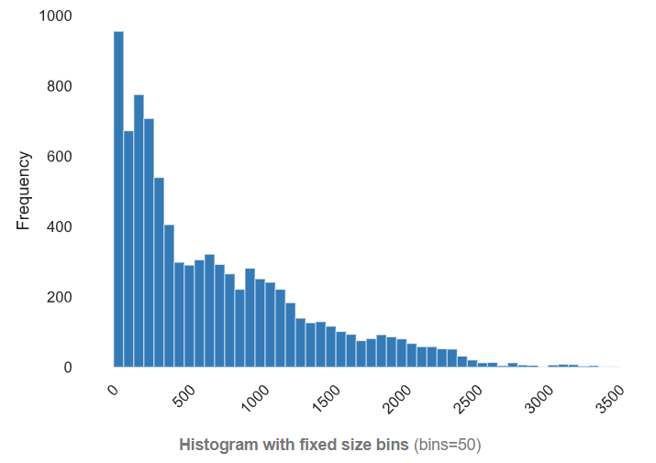**Bike Count**

|  |  |
| --- | --- |
| Distinct | 2166 |
| Distinct (%) | 24.7% |
| Missing | 0 |
| Mean | 704.6020548 |
| Minimum | 0 |
| Maximum | 3556 |
| Zeros | 295 |
| Zeros (%) | 3.4% |
| Negative | 0 |

Quantile statistics

|  |  |
| --- | --- |
| Minimum | 0 |
| 5-th percentile | 22 |
| Q1 | 191 |
| median | 504.5 |
| Q3 | 1065.25 |
| 95-th percentile | 2043 |
| Maximum | 3556 |
| Range | 3556 |
| Interquartile range (IQR) | 874.25 |

Descriptive statistics

|  |  |
| --- | --- |
| Standard deviation | 644.9974677 |
| Coefficient of variation (CV) | 0.9154067368 |
| Kurtosis | 0.8533869902 |
| Mean | 704.6020548 |
| Median Absolute Deviation (MAD) | 373.5 |
| Skewness | 1.153428177 |
| Sum | 6172314 |
| Variance | 416021.7334 |
| Monotonicity | Not monotonic |

* **Temperature**

|  |  |
| --- | --- |
| Distinct | 546 |
| Distinct (%) | 6.2% |
| Missing | 0 |
| Mean | 12.88292237 |
| Minimum | -17.8 |
| Maximum | 39.4 |
| Zeros | 21 |
| Zeros (%) | 0.2% |
| Negative | 1433 |
| Negative (%) | 16.4% |

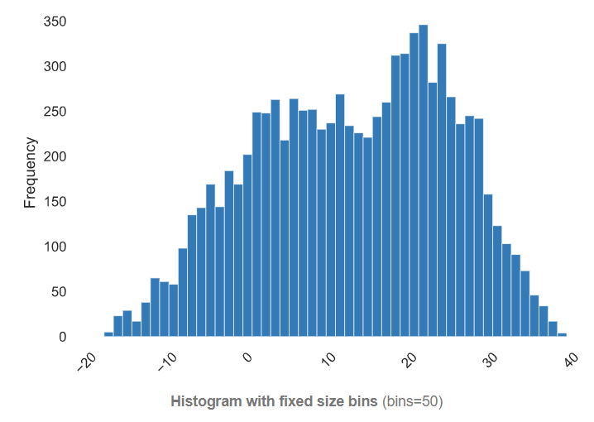  
 Quantile statistics

|  |  |
| --- | --- |
| Minimum | -17.8 |
| 5-th percentile | -7.1 |
| Q1 | 3.5 |
| median | 13.7 |
| Q3 | 22.5 |
| 95-th percentile | 30.7 |
| Maximum | 39.4 |
| Range | 57.2 |
| Interquartile range (IQR) | 19 |

Descriptive statistics

|  |  |
| --- | --- |
| Standard deviation | 11.94482523 |
| Coefficient of variation (CV) | 0.9271828924 |
| Kurtosis | -0.837786292 |
| Mean | 12.88292237 |
| Median Absolute Deviation (MAD) | 9.4 |
| Skewness | -0.1983255345 |
| Sum | 112854.4 |
| Variance | 142.6788498 |
| Monotonicity | Not monotonic |

* **Hour**

|  |  |
| --- | --- |
| Distinct | 24 |
| Distinct (%) | 0.3% |
| Missing | 0 |
| Mean | 11.5 |
| Minimum | 0 |
| Maximum | 23 |
| Zeros | 365 |
| Zeros (%) | 4.2% |
| Negative | 0 |

* **Humidity**

|  |  |
| --- | --- |
| Distinct | 90 |
| Distinct (%) | 1.0% |
| Missing | 0 |
| Mean | 58.22625571 |
| Minimum | 0 |
| Maximum | 98 |
| Zeros | 17 |
| Zeros (%) | 0.2% |
| Negative | 0 |

Quantile statistics

|  |  |
| --- | --- |
| Minimum | 0 |
| 5-th percentile | 27 |
| Q1 | 42 |
| median | 57 |
| Q3 | 74 |
| 95-th percentile | 94 |
| Maximum | 98 |
| Range | 98 |
| Interquartile range (IQR) | 32 |

Descriptive statistics

|  |  |
| --- | --- |
| Standard deviation | 20.3624133 |
| Coefficient of variation (CV) | 0.3497118792 |
| Kurtosis | -0.8035591857 |
| Mean | 58.22625571 |
| Median Absolute Deviation (MAD) | 16 |
| Skewness | 0.05957897258 |
| Sum | 510062 |
| Variance | 414.6278755 |
| Monotonicity | Not monotonic |

* **Wind Speed**

|  |  |
| --- | --- |
| Distinct | 65 |
| Distinct (%) | 0.7% |
| Missing | 0 |
| Mean | 1.724908676 |
| Minimum | 0 |
| Maximum | 7.4 |
| Zeros | 74 |
| Zeros (%) | 0.8% |
| Negative | 0 |

Quantile statistics

|  |  |
| --- | --- |
| Minimum | 0 |
| 5-th percentile | 0.4 |
| Q1 | 0.9 |
| median | 1.5 |
| Q3 | 2.3 |
| 95-th percentile | 3.7 |
| Maximum | 7.4 |
| Range | 7.4 |
| Interquartile range (IQR) | 1.4 |

Descriptive statistics

|  |  |
| --- | --- |
| Standard deviation | 1.036299993 |
| Coefficient of variation (CV) | 0.6007854259 |
| Kurtosis | 0.7271794546 |
| Mean | 1.724908676 |
| Median Absolute Deviation (MAD) | 0.7 |
| Skewness | 0.890954798 |
| Sum | 15110.2 |
| Variance | 1.073917676 |
| Monotonicity | Not monotonic |

* **Visibility**

|  |  |
| --- | --- |
| Distinct | 1789 |
| Distinct (%) | 20.4% |
| Missing | 0 |
| Mean | 1436.825799 |
| Minimum | 27 |
| Maximum | 2000 |
| Zeros | 0 |
| Zeros (%) | 0.0% |
| Negative | 0 |

Quantile statistics

|  |  |
| --- | --- |
| Minimum | 27 |
| 5-th percentile | 300 |
| Q1 | 940 |
| median | 1698 |
| Q3 | 2000 |
| 95-th percentile | 2000 |
| Maximum | 2000 |
| Range | 1973 |
| Interquartile range (IQR) | 1060 |

Descriptive statistics

|  |  |
| --- | --- |
| Standard deviation | 608.298712 |
| Coefficient of variation (CV) | 0.4233628825 |
| Kurtosis | -0.961980131 |
| Mean | 1436.825799 |
| Median Absolute Deviation (MAD) | 302 |
| Skewness | -0.701786449 |
| Sum | 12586594 |
| Variance | 370027.323 |
| Monotonicity | Not monotonic |

* **Dew Point Temperature**

|  |  |
| --- | --- |
| Distinct | 556 |
| Distinct (%) | 6.3% |
| Missing | 0 |
| Mean | 4.073812785 |
| Minimum | -30.6 |
| Maximum | 27.2 |
| Zeros | 60 |
| Zeros (%) | 0.7% |
| Negative | 3138 |
| Negative (%) | 35.8% |

Quantile statistics

|  |  |
| --- | --- |
| Minimum | -30.6 |
| 5-th percentile | -19.505 |
| Q1 | -4.7 |
| median | 5.1 |
| Q3 | 14.8 |
| 95-th percentile | 22.405 |
| Maximum | 27.2 |
| Range | 57.8 |
| Interquartile range (IQR) | 19.5 |

Descriptive statistics

|  |  |
| --- | --- |
| Standard deviation | 13.06036934 |
| Coefficient of variation (CV) | 3.20593263 |
| Kurtosis | -0.7554295071 |
| Mean | 4.073812785 |
| Median Absolute Deviation (MAD) | 9.7 |
| Skewness | -0.3672984397 |
| Sum | 35686.6 |
| Variance | 170.5732472 |
| Monotonicity | Not monotonic |

* **Solar Radiation**

|  |  |
| --- | --- |
| Distinct | 345 |
| Distinct (%) | 3.9% |
| Missing | 0 |
| Mean | 0.5691107306 |
| Minimum | 0 |
| Maximum | 3.52 |
| Zeros | 4300 |
| Zeros (%) | 49.1% |
| Negative | 0 |

Quantile statistics

|  |  |
| --- | --- |
| Minimum | 0 |
| 5-th percentile | 0 |
| Q1 | 0 |
| median | 0.01 |
| Q3 | 0.93 |
| 95-th percentile | 2.56 |
| Maximum | 3.52 |
| Range | 3.52 |
| Interquartile range (IQR) | 0.93 |

Descriptive statistics

|  |  |
| --- | --- |
| Standard deviation | 0.8687462422 |
| Coefficient of variation (CV) | 1.526497737 |
| Kurtosis | 1.126432996 |
| Mean | 0.5691107306 |
| Median Absolute Deviation (MAD) | 0.01 |
| Skewness | 1.504039717 |
| Sum | 4985.41 |
| Variance | 0.7547200334 |
| Monotonicity | Not monotonic |

* **Rainfall**

|  |  |
| --- | --- |
| Distinct | 61 |
| Distinct (%) | 0.7% |
| Missing | 0 |
| Mean | 0.1486872146 |
| Minimum | 0 |
| Maximum | 35 |
| Zeros | 8232 |
| Zeros (%) | 94.0% |
| Negative | 0 |

Quantile statistics

|  |  |
| --- | --- |
| Minimum | 0 |
| 5-th percentile | 0 |
| Q1 | 0 |
| median | 0 |
| Q3 | 0 |
| 95-th percentile | 0.4 |
| Maximum | 35 |
| Range | 35 |
| Interquartile range (IQR) | 0 |

Descriptive statistics

|  |  |
| --- | --- |
| Standard deviation | 1.128192969 |
| Coefficient of variation (CV) | 7.58769321 |
| Kurtosis | 284.9910986 |
| Mean | 0.1486872146 |
| Median Absolute Deviation (MAD) | 0 |
| Skewness | 14.53323224 |
| Sum | 1302.5 |
| Variance | 1.272819375 |
| Monotonicity | Not monotonic |

* **Snowfall**

|  |  |
| --- | --- |
| Distinct | 51 |
| Distinct (%) | 0.6% |
| Missing | 0 |
| Mean | 0.07506849315 |
| Minimum | 0 |
| Maximum | 8.8 |
| Zeros | 8317 |
| Zeros (%) | 94.9% |
| Negative | 0 |

Quantile statistics

|  |  |
| --- | --- |
| Minimum | 0 |
| 5-th percentile | 0 |
| Q1 | 0 |
| median | 0 |
| Q3 | 0 |
| 95-th percentile | 0.2 |
| Maximum | 8.8 |
| Range | 8.8 |
| Interquartile range (IQR) | 0 |

Descriptive statistics

|  |  |
| --- | --- |
| Standard deviation | 0.4367461811 |
| Coefficient of variation (CV) | 5.817969201 |
| Kurtosis | 93.80332357 |
| Mean | 0.07506849315 |
| Median Absolute Deviation (MAD) | 0 |
| Skewness | 8.440800781 |
| Sum | 657.6 |
| Variance | 0.1907472267 |
| Monotonicity | Not monotonic |

* 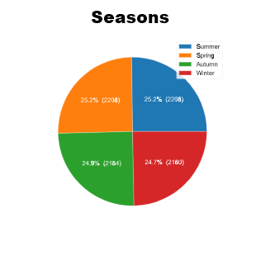**Seasons**

|  |  |
| --- | --- |
| Distinct | 4 |
| Distinct (%) | < 0.1% |
| Missing | 0 |
| Max length | 6 |
| Median length | 6 |
| Mean length | 6 |
| Min length | 6 |

* 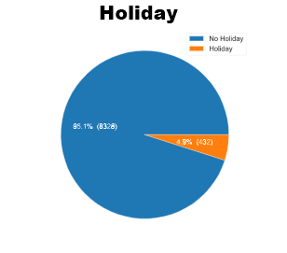**Holiday**

|  |  |
| --- | --- |
| Distinct | 2 |
| Distinct (%) | < 0.1% |
| Missing | 0 |
| Max length | 10 |
| Median length | 10 |
| Mean length | 9.852054795 |
| Min length | 7 |

* **Functional Day**

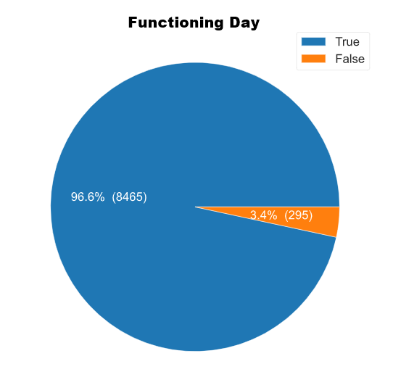

|  |  |
| --- | --- |
| Distinct | 2 |
| Distinct (%) | < 0.1% |
| Missing | 0 |
| Missing (%) | 0.0% |
| Memory size | 8.7 KiB |

**Violin Plot**

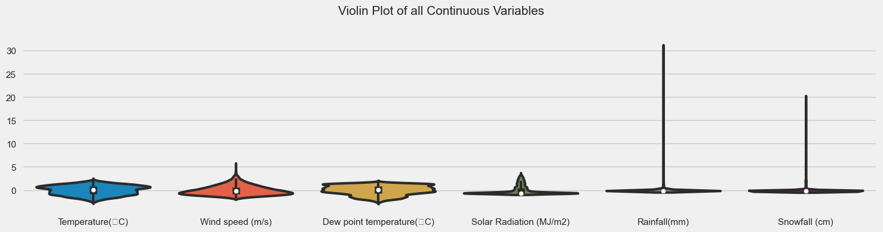

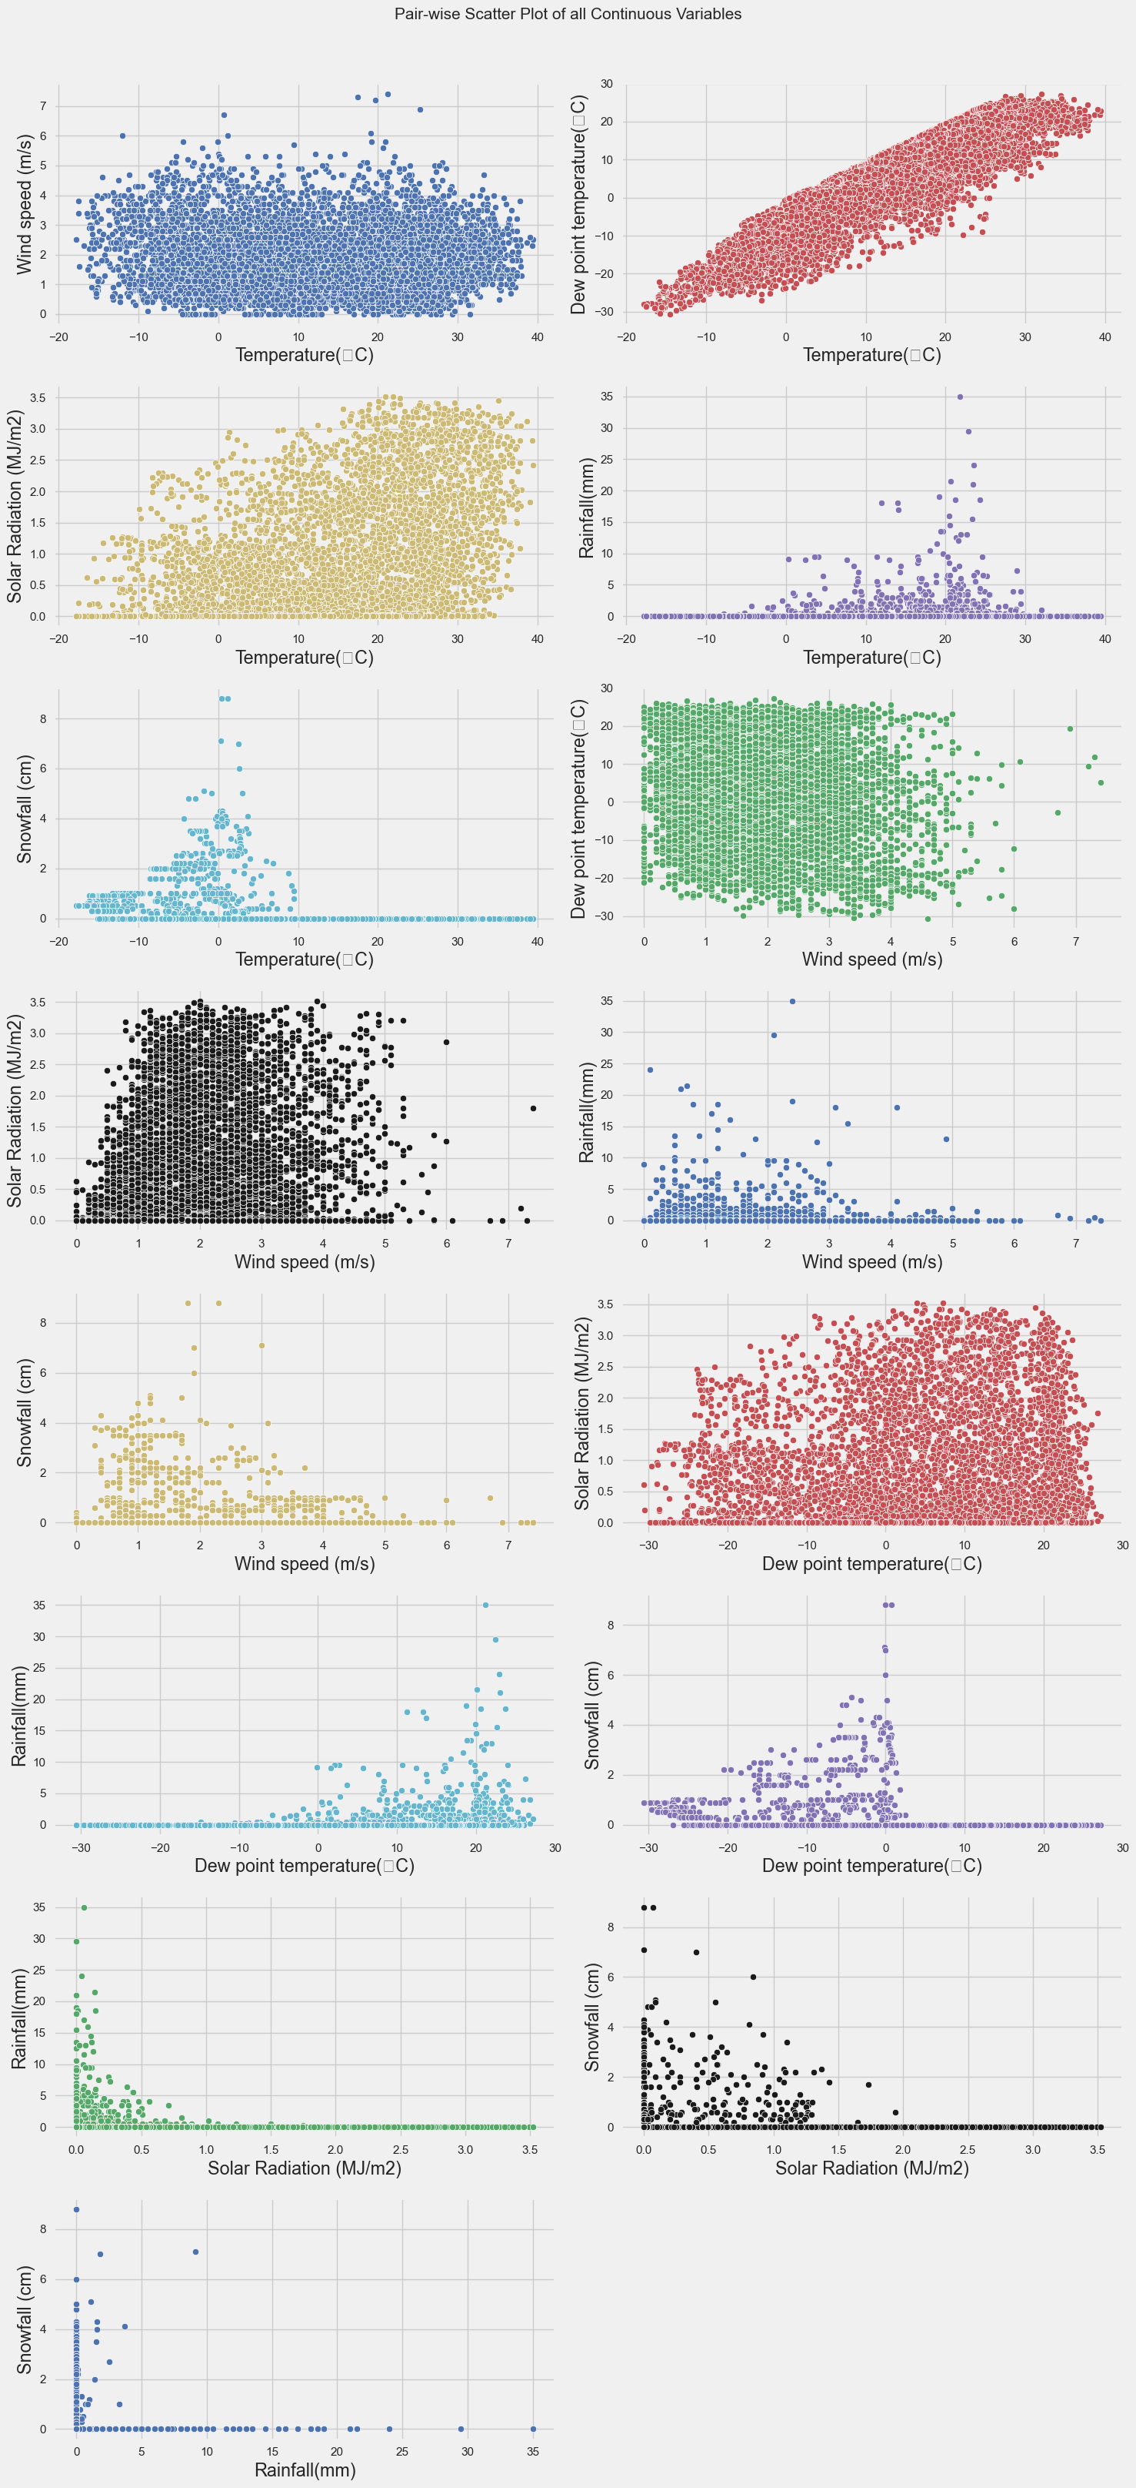 **Pair-wise Scatter Plot**

**Histogram Plot Box Plot QQ-plot**

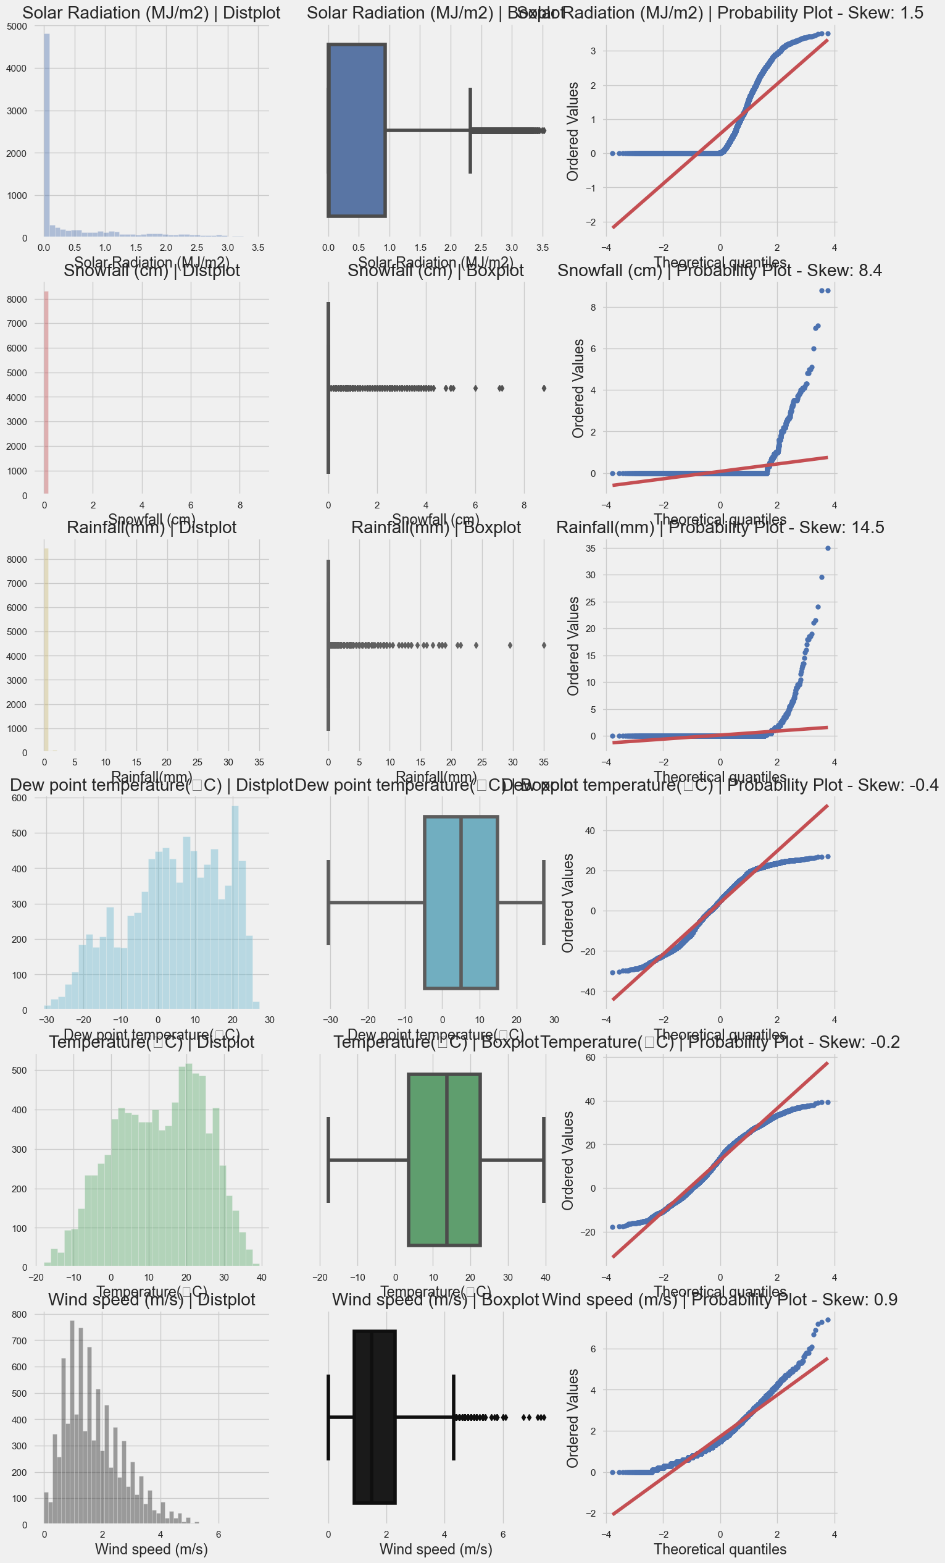

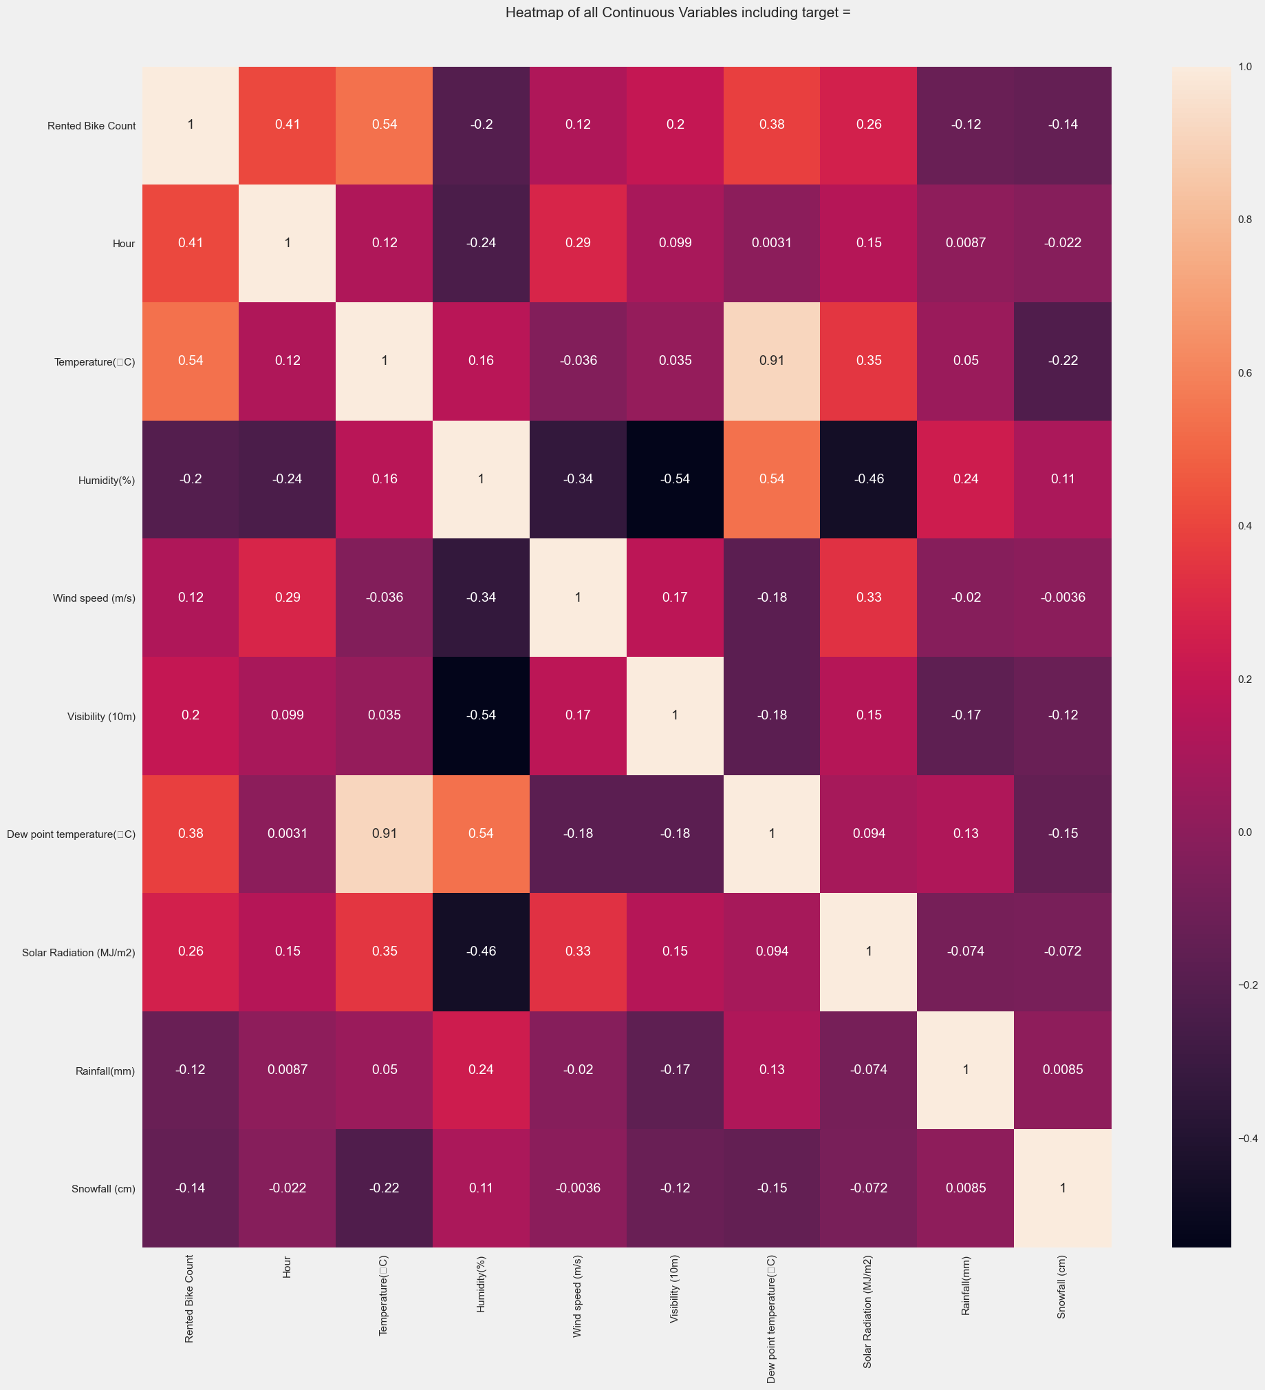**Scatter Plot**

**Insights of our Data Visualizations**

* **Rented Bike Count (Dependent Variable) and wind speed (Independent Variable) are Positive skewed and their skewness are 1.15 and 0.89.**
* **There are many outliers present in Rainfall and Snowfall.**
* **The data points of temperature and Dew point temperature are nearly symmetrical.**
* **Rental Bike Count (Dependent Variable) is highly correlated with Temperature (Independent Variable).**
* **Temperature (Independent Variable) is highly correlated with Dew point Temperature (Independent variable).**
* **Solar Radiation has 4300 (49.1%) zero values**
* **Rainfall has 8232 (94.0%) zero values**
* **Snowfall has 8317 (94.9%) zero values**
* **The categories in Seasons attribute (summer, Spring, Autumn, Winter) are equally distributed in our dataset.**

***Data Preprocessing***

* **Data Cleaning**
* **Missing Values**

There are 14 attributes in our dataset and there is no any missing value in any of the attributes.

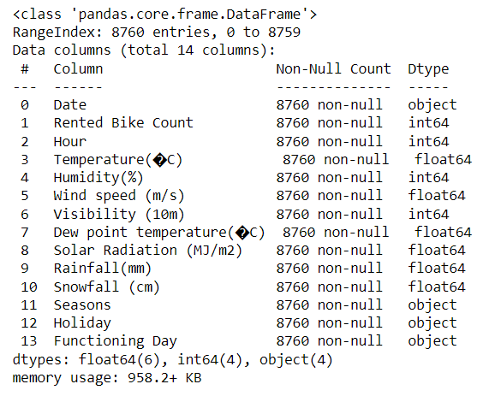

* **Data Transformation**
* **One Hot Encoding :** a **one-hot** is a group of bits among which the legal combinations of values are only those with a single high (1) bit and all the others low (0). One-hot encoding is often used for indicating the state of a state machine. When using binary or Gray code, a decoder is needed to determine the state. A one-hot state machine, however, does not need a decoder as the state machine is in the *n*th state if and only if the *n*th bit is high.

We have considered four categorical attributes for one hot encoding and these variables are **Hour,Seasons,Holiday,Functioning Day.**

**After One-Hot Encoding some variables increased in our dataset**

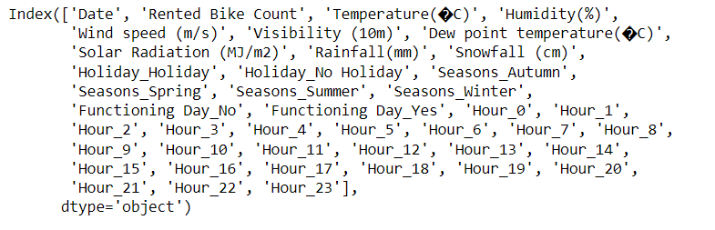

* **Standardization :** The standard score of a sample x is calculated as

z = (x - u) / s

Standardization of a dataset is a common requirement for many machine learning estimators: they might behave badly if the individual features do not more or less look like standard normally distributed data (e.g. Gaussian with 0 mean and unit variance).

Whole dataset is Standardized by the class Standard Scaler.

**After applying Standard Scaler in our dataset**

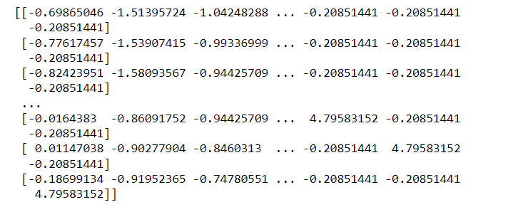

***Feature Selection***

* **Forward Feature Selection**

Forward Feature Selection is to train n models using each feature individually and checking the performance. So if you have three independent variables, we will train three models using each of these three features individually .

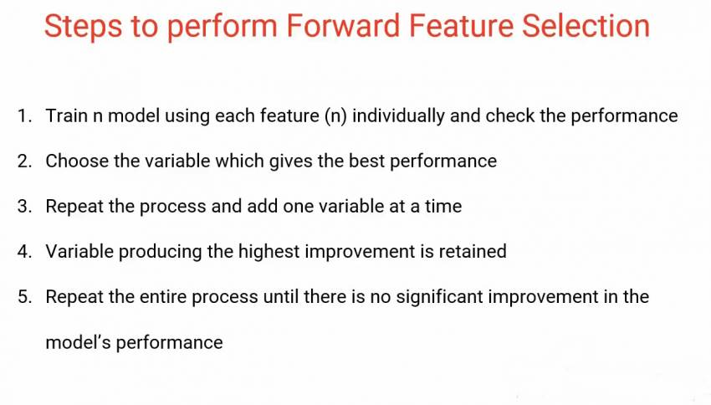

E

Each individual accuracy for different number of features in our model.

{1: 0.26730074786068014,

2: 0.470858021787809,

3: 0.5856553463150498,

4: 0.6311192862328596,

5: 0.6563970661427261,

6: 0.6799649834207429,

7: 0.6977112704795301,

8: 0.7152804174388814,

9: 0.7313535640856988,

10: 0.7424889291410854,

11: 0.7525072538157692,

12: 0.7595327258022639,

13: 0.7669392996384695,

14: 0.77287347113809,

15: 0.7783699334615449,

16: 0.784337887575459,

17: 0.7889450855082414,

18: 0.7940760200330776,

19: 0.7961989596579642,

20: 0.7978050281453273,

21: 0.7989428711131319,

22: 0.7998778832199286,

23: 0.8005563204861882,

24: 0.8012500787889908,

25: 0.8017588079547893,

26: 0.8027400452841543,

27: 0.8038855573969617,

28: 0.8064158435626755,

29: 0.8073601296528087,

30: 0.8077159976037313,

31: 0.807977216413485,

32: 0.8080482523538419,

33: 0.8081223477207902,

34: 0.8081382584674834,

35: 0.8081455442342659,

36: 0.808147444898313,

37: 0.8081474752575182,

38: 0.8081443434221877}

**On the basis of forward feature selection we have selected all 38 features for our model.**

***Model Selection***

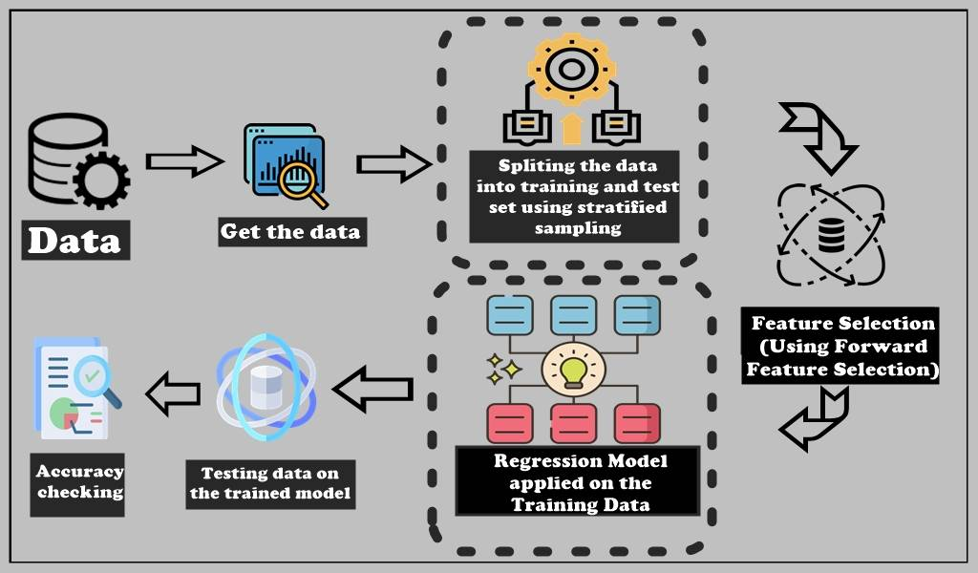

* **Multiple Linear Regression**

Multiple linear regression (MLR), also known simply as multiple regression, is a statistical technique that uses several explanatory variables to predict the outcome of a response variable. The goal of multiple linear regression is to model the linear relationship between the explanatory (independent) variables and response (dependent) variables. In essence, multiple regression is the extension of ordinary least-squares (OLS) regression because it involves more than one explanatory variable.

*Yi*​ = *β*0​ + *β*1​*xi*1​ + *β*2​*xi*2​ +...+ *βp*​*xip*​ + *ϵ*

where, for *i*=*n* observations:

*Yi*​ = Dependent variable

*xi*​ =Explanatory variables

*β*0 ​ = Y-intercept (constant term)

*βp*=Slope coefficients for each explanatory

variable

*ϵ*=the model’s error term (also known as the residuals)​

The multiple regression model is based on the following assumptions:

* There is a linear relationship between the dependent variables and the independent variables.
* The independent variables are not too highly correlated with each other.
* Yi observations are selected independently and randomly from the population.
* Residuals should be normally distributed with a mean of 0 and variance *σ.*

The coefficient of determination (R-squared) is a statistical metric that is used to measure how much of the variation in outcome can be explained by the variation in the independent variables. R2 always increases as more predictors are added to the MLR model, even though the predictors may not be related to the outcome variable. R2 by itself can't thus be used to identify which predictors should be included in a model and which should be excluded. So, we use Adjusted-R2 to decide the test accuracy.

|  |  |  |  |
| --- | --- | --- | --- |
| OLS Regression Results | | | |
| **Dep. Variable:** | y | **R-squared (uncentered):** | 0.809 |
| **Model:** | OLS | **Adj. R-squared (uncentered):** | 0.808 |
| **Method:** | Least Squares | **F-statistic:** | 770.6 |
| **Date:** | Thu, 28 Apr 2022 | **Prob (F-statistic):** | 0.00 |
| **Time:** | 11:31:16 | **Log-Likelihood:** | -3877.7 |
| **No. Observations:** | 6570 | **AIC:** | 7827. |
| **Df Residuals:** | 6534 | **BIC:** | 8072. |
| **Df Model:** | 36 |  |  |
| **Covariance Type:** | nonrobust |  |  |

|  |  |  |  |  |  |  |
| --- | --- | --- | --- | --- | --- | --- |
|  | **coef** | **std err** | **t** | **P>|t|** | **[0.025** | **0.975]** |
| **x1** | 6.025e+10 | 1.1e+11 | 0.546 | 0.585 | -1.56e+11 | 2.76e+11 |
| **x2** | 6.033e+10 | 1.1e+11 | 0.546 | 0.585 | -1.56e+11 | 2.77e+11 |
| **x3** | 6.02e+10 | 1.1e+11 | 0.546 | 0.585 | -1.56e+11 | 2.76e+11 |
| **x4** | 6.028e+10 | 1.1e+11 | 0.546 | 0.585 | -1.56e+11 | 2.77e+11 |
| **x5** | 0.3638 | 0.013 | 28.955 | 0.000 | 0.339 | 0.388 |
| **x6** | -0.1194 | 0.009 | -13.084 | 0.000 | -0.137 | -0.102 |
| **x7** | -0.0172 | 0.006 | -2.658 | 0.008 | -0.030 | -0.005 |
| **x8** | 0.0050 | 0.007 | 0.719 | 0.472 | -0.009 | 0.019 |
| **x9** | 0.2349 | 0.016 | 14.651 | 0.000 | 0.203 | 0.266 |
| **x10** | -0.2554 | 0.006 | -42.001 | 0.000 | -0.267 | -0.244 |
| **x11** | 0.0046 | 0.006 | 0.777 | 0.437 | -0.007 | 0.016 |
| **x12** | -0.0455 | 0.005 | -8.312 | 0.000 | -0.056 | -0.035 |
| **x13** | 0.4877 | 0.006 | 86.895 | 0.000 | 0.477 | 0.499 |
| **x14** | -0.0202 | 0.007 | -2.698 | 0.007 | -0.035 | -0.006 |
| **x15** | -0.0585 | 0.008 | -7.774 | 0.000 | -0.073 | -0.044 |
| **x16** | -0.1068 | 0.008 | -14.125 | 0.000 | -0.122 | -0.092 |
| **x17** | -0.1428 | 0.008 | -18.919 | 0.000 | -0.158 | -0.128 |
| **x18** | -0.1970 | 0.008 | -26.237 | 0.000 | -0.212 | -0.182 |
| **x19** | -0.1803 | 0.007 | -24.256 | 0.000 | -0.195 | -0.166 |
| **x20** | -0.0961 | 0.007 | -13.070 | 0.000 | -0.110 | -0.082 |
| **x21** | -0.0181 | 0.008 | -2.385 | 0.017 | -0.033 | -0.003 |
| **x22** | 0.0428 | 0.008 | 5.319 | 0.000 | 0.027 | 0.059 |
| **x23** | -0.0583 | 0.009 | -6.641 | 0.000 | -0.076 | -0.041 |
| **x24** | -0.1383 | 0.009 | -14.622 | 0.000 | -0.157 | -0.120 |
| **x25** | -0.1389 | 0.010 | -14.239 | 0.000 | -0.158 | -0.120 |
| **x26** | -0.1134 | 0.010 | -11.631 | 0.000 | -0.133 | -0.094 |
| **x27** | -0.1249 | 0.010 | -12.581 | 0.000 | -0.144 | -0.105 |
| **x28** | -0.1216 | 0.010 | -12.447 | 0.000 | -0.141 | -0.102 |
| **x29** | -0.1004 | 0.010 | -10.483 | 0.000 | -0.119 | -0.082 |
| **x30** | -0.0755 | 0.009 | -8.061 | 0.000 | -0.094 | -0.057 |
| **x31** | -0.0107 | 0.009 | -1.211 | 0.226 | -0.028 | 0.007 |
| **x32** | 0.0927 | 0.008 | 11.535 | 0.000 | 0.077 | 0.108 |
| **x33** | 0.0616 | 0.008 | 8.105 | 0.000 | 0.047 | 0.076 |
| **x34** | 0.0661 | 0.008 | 8.808 | 0.000 | 0.051 | 0.081 |
| **x35** | 0.0752 | 0.007 | 10.103 | 0.000 | 0.061 | 0.090 |
| **x36** | 0.0497 | 0.007 | 6.684 | 0.000 | 0.035 | 0.064 |

|  |  |  |  |
| --- | --- | --- | --- |
| **Omnibus:** | 311.672 | **Durbin-Watson:** | 2.011 |
| **Prob(Omnibus):** | 0.000 | **Jarque-Bera (JB):** | 588.843 |
| **Skew:** | -0.358 | **Prob(JB):** | 1.36e-128 |
| **Kurtosis:** | 4.280 | **Cond. No.** | 6.76e+13 |

From the above plot we can say that “Temperature” has the most linear relationship with the “Rented Bike Count” among others. Next, we have plotted the scatter plots of the “Rented Bike Count” with the other independent continuous variables

We have finished our Data preprocessing phase of our analysis.

Next, we have split the dataset into training and testing using Stratified Sampling technique based on “Season”, 80% of the samples are used to train the proposed model and rest to validate that our model is doing well with the previously unseen data. Here we have used Stratification technique based on “Season” to avoid over or underfitting. There may be a situation that for some seasons our model is working very well, but for other it’s giving bad results. Stratification will remove this issue.

Now, it’s time to build some regression models based on our training data. In this project, we have used “Linear Regression” to get desired results.

* **Conclusion**

From the above results we can see that the Adjusted R2 score for Multiple Linear Regression model is 0.808 which means our model is able to explain 80.8% of the variability in the dataset.

1. REFERENCES
2. V E, S., Park, J., & Cho, Y. (2020). Seoul bike trip duration prediction using data mining techniques. *IET Intelligent Transport Systems*, *14*(11), 1465–1474.
3. V E, S., & Cho, Y. (2020). A rule-based model for Seoul Bike sharing demand prediction using weather data. *European Journal of Remote Sensing*, *53*(sup1), 166–183.
4. Liu, X., & Pelechrinis, K. (2021). Excess demand prediction for bike sharing systems. *PLOS ONE*, *16*(6), e0252894.
5. V E, S., & Cho, Y. (2020b). Season wise bike sharing demand analysis using random forest algorithm. *Computational Intelligence*. Published.
6. Wang, Z. (2019). Regression Model for Bike-Sharing Service by Using Machine Learning. *Asian Journal of Social Science Studies*, *4*(4), 16.
7. Eren, E., & Uz, V. E. (2020). A review on bike-sharing: The factors affecting bike-sharing demand. *Sustainable Cities and Society*, *54*, 101882.
8. Goh, C. Y., Yan, C., & Jaillet, P. (2019). Estimating Primary Demand in Bike-sharing Systems. *SSRN Electronic Journal*. Published.
9. Almannaa, M. H., Elhenawy, M., & Rakha, H. A. (2019). Dynamic linear models to predict bike availability in a bike sharing system. *International Journal of Sustainable Transportation*, *14*(3), 232–242.
10. Sachdeva, P., & Sarvanan, K. N. (2017). Prediction of Bike Sharing Demand. *Oriental Journal of Computer Science and Technology*, *10*(1), 219–226.
11. Liu, X. N., Wang, J. J., & Zhang, T. F. (2014). A Method of Bike Sharing Demand Forecasting. *Applied Mechanics and Materials*, *587–589*, 1813–1816.