Modeling and Simulation Report
AUC0-last and Cmax as co-primary endpoints, and the sampling schedule, for a single-dose pharmacokinetic similarity study of a proposed dupilumab biosimilar
2026-09-29
Table of Contents

Document control
Field | Entry
Document | Modeling and Simulation Report (this document), with appendices A to H
Version and status | 1.0.1 (draft for sponsor review)
Generated (UTC) | 2026-09-29 05:12
Source commit | aa92eff2e8ac96e4d93eb68295602aeaa4c5e2ba
Working tree clean at generation | yes
Generator | regulatory/src/MS_report.Rmd rendered by scripts/60_regulatory_package.R
Numbers | Every number is read from a committed result or configuration file at rendering time; each value, its source file, row filter and SHA-256 are listed in regulatory/traceability.csv (Appendix G).
Preparation | The simulation code, the analyses and this text were prepared with the assistance of an AI coding assistant (Claude Code, Anthropic) under the direction of the sponsor. They must be reviewed, independently quality-controlled and approved by qualified sponsor personnel before any regulatory use (signature page).

Signature page
Role | Name | Signature | Date
Author (pharmacometrics)
Independent QC reviewer (pharmacometrics or clinical pharmacology)
Clinical pharmacology lead
Biostatistics
Approver

Synopsis
Background. Dupilumab is eliminated by a linear pathway and a saturable target-mediated pathway in parallel. As concentrations fall toward the lower limit of quantification (LLOQ, 0.078 mg/L), target-mediated elimination accelerates the decline: in the primary model, the true concentration falls from about 0.88 mg/L to the LLOQ within a median of 1.38 days (the “terminal cliff”). A non-compartmental terminal rate constant (lambda-z) is therefore estimated on the decline before the cliff and does not represent the true terminal phase. The originator’s population pharmacokinetic (PK) analysis concluded that a meaningful terminal half-life cannot be calculated (Kovalenko 2020), and a published device-comparison study did not calculate half-life or AUC0-inf for this reason (Cohen 2022).
Questions of interest. (1) Can AUC0-last together with Cmax serve as the co-primary endpoints of the PK similarity study in place of AUC0-inf together with Cmax? (2) Do additional samples between study Day 36 and Day 50 improve the PK assessment enough to justify them?
Methods. Two published population PK models, used without re-estimation or tuning: Kovalenko 2016 (primary) and Kovalenko 2020 Model 1 (structural sensitivity). Simulated study: 300 mg subcutaneous single dose, parallel groups, 117 evaluable subjects per arm, body weight 60 to 90 kg, 13 post-dose samples to study Day 57. Non-compartmental analysis (NCA) follows Phoenix WinNonlin rules. Equivalence: 90% confidence interval (CI) of the geometric mean ratio (GMR) within 80.00% to 125.00%. The operating-characteristic design was fixed and committed before any result was generated (commit 779e068). For six mechanisms of product difference in both directions, test-product parameter multipliers were found such that the true (model-integrated) population AUC0-inf ratio equals 0.80 or 1.25, and 10,000 trials were simulated for each boundary scenario and model. The primary metric is the boundary type I error: the probability of concluding similarity when the true AUC0-inf ratio lies exactly at an equivalence limit.
Results.
- Boundary scenarios in which AUC0-last + Cmax exceeds 5% (point estimate). 2020 model, peripheral volume (V2) up (multiplier 2.28), true AUC0-inf ratio 0.7998: M0 5.18% (95% CI 4.88 to 5.50), nominal; M1 5.63% (95% CI 5.31 to 5.95), exceeding; M2 5.75% (95% CI 5.43 to 6.08), exceeding. Quantitative cause: under M0 the AUC0-last GMR is biased by 0.41% relative to the true AUC0-inf ratio (toward 1), which moves the pass rate from 4.59% for the unbiased reference to 5.20% for AUC0-last alone; Cmax failures change it by -0.02 percentage points; under M1 the AUC0-last GMR is biased by 0.41% relative to the true AUC0-inf ratio (toward 1), which moves the pass rate from 4.94% for the unbiased reference to 5.65% for AUC0-last alone; Cmax failures change it by -0.02 percentage points; under M2 the AUC0-last GMR is biased by 0.41% relative to the true AUC0-inf ratio (toward 1), which moves the pass rate from 4.97% for the unbiased reference to 5.77% for AUC0-last alone; Cmax failures change it by -0.03 percentage points.
- Headline. AUC0-last + Cmax is at or below nominal (Wilson 95% interval not entirely above 5%) in 16 of 16 boundary scenarios with the pooled t-test (M0), 15 of 16 with the weight stratum in the model (M1) and 15 of 16 with log body weight (M2).
- AUC0-last captures essentially all of the exposure. The true extrapolated fraction beyond the last quantifiable sample has a median of 0.65% (95th percentile 3.63%) in the primary model and 0.64% (3.54%) in the 2020 model. The share of subjects whose window coverage (true AUC0-tlast / true AUC0-inf) is below 80% is 0.00% (95% CI 0.00 to 0.02) in the primary model and 0.00% (95% CI 0.00 to 0.02) in the 2020 model.
- In the trial population (healthy adults of 60 to 90 kg, randomization stratified by body weight), NCA AUC0-inf fails criteria set (i) (adjusted R-squared at least 0.80, extrapolation at most 20%) in 8.2% to 13.4% of subjects in the two models, leaving a median of 101 to 107 (5th to 95th percentile 95 to 112) of 117 subjects per arm in the analysis under rule A. These criteria are statistical analysis plan conventions, not software defaults (Phoenix WinNonlin applies lambda-z acceptance criteria only when the user enters them, and then only flags the profiles), and set (i) is the lower end of the conventional range: with the adjusted R-squared of at least 0.90 used in public statistical analysis plans (set (iii)) 33.2% to 38.8% fail and a median of 72 to 78 (5th to 95th percentile 63 to 86) remain per arm.
- The failures are not random within the trial. Failing subjects have a lower true AUC0-inf (geometric mean ratio to retained subjects 0.786 to 0.815 under set (i)), the heavier randomization stratum fails more often (by 1.5 to 2.7 percentage points), the rule A analysis set loses the stratified balance of body weight between the arms, and when the products differ the share failing differs between the arms by up to 12.3 percentage points, in a direction set by the mechanism of the difference. Rule A therefore compares different subjects in the two arms.
- With the pooled t-test (M0), AUC0-last + Cmax (proposed) is conservative in 15, nominal in 1 and exceeding in 0 of the 16 boundary scenarios (Wilson 95% interval versus 5%). The largest value is 5.18% (95% CI 4.88 to 5.50) (20,000 trials) for a 2.28-fold peripheral volume in the 2020 model. In the primary model the largest value is 3.97% (95% CI 3.60 to 4.37).
- The randomization is stratified by body weight. With the stratum in the analysis model (M1, ANOVA), AUC0-last + Cmax is conservative in 15, nominal in 0 and exceeding in 1 scenarios (0.00% to 5.63%). M0 ignores the stratum, so its standard error overstates the sampling variability (between-trial SD / within-trial SE of the unbiased reference 0.961 to 0.993 under M0 and 0.991 to 1.020 under M1).
- AUC0-inf + Cmax analysed in subjects meeting the reliability criteria (the pre-specified guidance-default configuration) exceeds 5% in 12 of 16 boundary scenarios, with the Wilson lower bound above 5% in all 12. The largest value is 27.60% (95% CI 26.73 to 28.48). Including every subject with an estimable lambda-z still exceeds 5% in 8 of 16 scenarios (largest 15.06% (95% CI 14.37 to 15.77)). Substituting AUC0-last for subjects failing the criteria (rule C) gives results close to AUC0-last + Cmax: largest 5.01% (95% CI 4.71 to 5.32) under M0 and 5.39% (95% CI 5.09 to 5.71) under M1, in the same 2020-model peripheral-volume scenario in which AUC0-last + Cmax is highest.
- Under the stricter conventional criteria, AUC0-inf + Cmax with rule A exceeds 5% (point estimate) in 9 (set (iii)) and 12 (set (iv)) of 16 boundary scenarios under M0 (10 and 12 under M1); with rule C the range is 0.00% to 5.21% (set (iii), M0).
- The inflation has two sources. First, NCA AUC0-inf is biased toward a ratio of 1, because the pre-cliff lambda-z overstates the unobserved tail equally in both arms. Second, excluding subjects who fail the criteria selects a non-random subset.
- Power for identical products is 99.6% (95% CI 99.4 to 99.7) (primary model) and 99.0% (95% CI 98.8 to 99.2) (2020 model) for AUC0-last + Cmax.
- Changing the Michaelis-Menten constant of target-mediated elimination (Km), through which a target-binding difference acts in this model, from 0.01-fold to 100-fold moves the true AUC0-inf ratio only within 0.999 to 1.059. A binding difference is therefore not detectable by any AUC endpoint and must be addressed by the comparative analytical assessment.
- Between assay LLOQs of 0.02 and 0.5 mg/L, the share of subjects with window coverage below 80% stays within 0.00% to 0.01% (primary model), and the boundary type I error of AUC0-last + Cmax within 2.22% to 4.22% (M0) in the three scenarios examined.
- At the protocol CV of 43% and a true GMR of 0.95, 117 evaluable subjects per arm give P2 power of 94.0% (M0) and 94.5% (M1); 90% power needs 100 (M0) or 97 (M1) evaluable per arm, and at a CV of 50% 129 or 126.
- The criteria for adding samples, set before any result was reported, were not met in either model. In one sensitivity variant (Vmax x0.8 in both arms), one criterion was met at 20,000 subjects but not on re-evaluation in 200,000 subjects. The cliff is shorter than any feasible visit interval, and denser late sampling does not improve AUC0-inf reliability. The planned schedule is retained, including Day 50.
Conclusion. AUC0-last and Cmax quantify total exposure. Their boundary type I error is at or near the nominal 5% across six mechanisms, both directions and two structural models, with the exceptions stated first in the results above. Configurations that rely on NCA AUC0-inf, as commonly analysed, exceed 5% in many scenarios. The sponsor proposes:
- AUC0-last and Cmax as co-primary endpoints;
- AUC0-inf as a secondary endpoint, reported with pre-specified lambda-z criteria;
- the planned 13-sample schedule to Day 57;
- the primary analysis model (pooled t-test or ANOVA with the randomization stratum), the assay LLOQ and the target power to be fixed by the sponsor (proposed SAP text: regulatory/sap_text_proposals_en.md).
Principal limitations.
- The models come from the literature, and the individual data were not available to the sponsor.
- The terminal phase below the LLOQ cannot be observed. This is addressed by Km and Vmax curve-shape sensitivity analyses and by two structural models.
- Several study-design inputs are placeholders pending confirmation (Appendix B).
- Cmax is over-predicted by up to 27%.
- The faster absorption of the 200 mg (175 mg/mL) presentation, which is not the study presentation, is not reproduced.

1. Introduction

1.1 Dupilumab pharmacokinetics
Dupilumab is a human IgG4 monoclonal antibody against the interleukin-4 receptor alpha subunit. After subcutaneous administration it shows nonlinear, target-mediated PK. Elimination runs through two parallel pathways: linear (proteolytic) elimination and saturable elimination mediated by the membrane-bound target. At concentrations well above the Michaelis-Menten constant (Km, estimated or fixed at 0.01 mg/L in the published models), the target-mediated pathway is saturated and contributes at a nearly constant rate. As concentrations approach the LLOQ, the target-mediated pathway dominates and the decline accelerates.
Published descriptions of this terminal behaviour:
- Kovalenko 2020. The instantaneous half-life decreases toward zero, the terminal slope becomes almost vertical near the LLOQ, and a meaningful terminal half-life cannot be calculated (such values were not submitted to regulators).
- Li 2020. Elimination is steeper at lower concentrations, and AUC0-last increases more than dose-proportionally.
- Cohen 2022. A 200 mg device comparison did not calculate half-life or AUC0-inf because of the terminal nonlinearity.
- Kovalenko 2016. Below-LLOQ observations had to be included (M3 method) to characterise the steep target-mediated phase.

1.2 Regulatory context
The FDA guidance on clinical pharmacology data to support a demonstration of biosimilarity (December 2016) identifies AUC0-inf and Cmax as the primary PK parameters of a single-dose PK similarity study. It also sets 80% to 125% as the limits for the 90% CI of the GMR.
For dupilumab, AUC0-inf from NCA depends on a lambda-z that is estimated before the accelerating decline, and on subject-level reliability criteria that remove a non-random subset of subjects. The sponsor therefore proposes AUC0-last (AUC0-t in FDA terminology, the area to the last quantifiable concentration) and Cmax as the co-primary endpoints, with AUC0-inf as a secondary endpoint. This report provides the quantitative basis for that proposal.
Two further developments raise the weight of this study:
- In its October 2025 draft guidance on assessing the need for comparative efficacy studies, FDA indicated that such studies may not be needed when comparative analytical data support high similarity and a PK similarity study is feasible and clinically relevant. This increases the weight of the PK similarity study in the totality of the evidence.
- The report follows the framework of ICH M15, General Principles for Model-Informed Drug Development (Step 4, 2026): question of interest, context of use, model risk and a proportionate credibility assessment.

1.3 Proposed study, as simulated
- Design: randomized, parallel groups, single subcutaneous dose of 300 mg (2 mL of 150 mg/mL), healthy subjects, body weight 60 to 90 kg.
- Sample size: 130 subjects randomized and 117 evaluable per arm. Dropout itself is not simulated.
- Randomization: stratified by body weight (two strata).
- Sampling (study days): pre-dose, then Days 1 (post-dose), 2, 4, 6, 8, 11, 15, 22, 29, 36, 43, 50 and 57. In days after dosing these are 0.25, 1, 3, 5, 7, 10, 14, 21, 28, 35, 42, 49, 56.
- Bioanalysis: LLOQ 0.078 mg/L.
- Equivalence: 90% CI of the GMR (pooled two-sample t on the log scale) within 80.00% to 125.00% for each co-primary endpoint.

2. Question of interest, context of use and model risk
Element | Description
Question of interest 1 | Can AUC0-last with Cmax replace AUC0-inf with Cmax as the co-primary endpoints of the single-dose PK similarity study, i.e. does AUC0-last measure total exposure and control the probability of concluding similarity for a product whose true AUC0-inf ratio lies at an equivalence limit, at least as well as AUC0-inf?
Question of interest 2 | Do additional samples between study Day 36 and Day 50 improve AUC0-last precision, sensitivity to product differences or the reliability of AUC0-inf enough to justify them (decision rule set before any result was reported)?
Context of use | Simulation of the planned study with published population PK models to (a) quantify the fraction of total exposure captured by AUC0-last under the planned schedule, (b) estimate the operating characteristics (boundary type I error, power) of alternative endpoint configurations and AUC0-inf handling rules, and (c) evaluate added samples. The results support the endpoint and sampling proposal discussed with FDA; they do not replace the study, whose observed data will determine the equivalence conclusion.
Model influence | Medium. The simulations are the main quantitative evidence for the endpoint choice; they are complemented by the mechanistic understanding of target-mediated elimination and by the originator’s published statements on the terminal phase.
Consequence of a wrong decision | Medium. An endpoint that fails to control the boundary type I error would raise the chance of concluding PK similarity for a product with a true AUC0-inf ratio outside 80% to 125%; an overly conservative endpoint would raise the chance of failing a similar product. Mitigations: Cmax remains co-primary, AUC0-inf is reported as a secondary endpoint, and the comparative analytical assessment addresses target binding directly.
Model risk | Medium.
Credibility activities (proportionate to risk) | Code verification against analytical solutions and two reference NCA implementations; independent re-implementation by a reviewer; external validation against published data for the study presentation; two structural models; curve-shape (Km, Vmax), variability, residual error, body weight and ADA-like sensitivity analyses; pre-specification of the operating-characteristic design before any result; reproduction in a clean computing environment; traceability of every reported number to its source file.

3. Methods

3.1 Models
Table 3-1. Model parameters (sources per parameter in Appendix A). No parameter was re-estimated, calibrated or adjusted to any validation target.
Parameter | Kovalenko 2016 (primary) | Kovalenko 2020 Model 1 (sensitivity)
Central volume Vc (L) at 75 kg | 2.74 | 2.48
Linear elimination ke (1/day) | 0.0459 | 0.0534
Central to peripheral k12 (1/day) | 0.0652 | 0.213
Peripheral to central k21 (1/day) | 0.129 | 0.31
Absorption ka (1/day) | 0.254 | 0.256
Transit compartments / mean transit time (day) | none (first-order absorption) | 3 / 0.105
Vmax (mg/L/day) | 0.968 | 1.07
Km (mg/L) | 0.01 (fixed) | 0.01 (fixed)
Bioavailability F | 0.607 | 0.643
Weight exponent on Vc | 0.705 | 0.711
IIV (variance) Vc / ke / ka / Vmax | 0.0225 / 0.131 / 0.251 / 0.0428 | 0.0369 / 0.0812 / 0.2247 / 0.0557
IIV (variance) mean transit time | not applicable | 0.2756
Residual error: proportional / additive (mg/L) | 24.2% / 0.03 | 15% / 0.03
Both models are two-compartment models with first-order absorption (the 2020 model adds three transit compartments before absorption) and parallel linear and Michaelis-Menten elimination from the central compartment. The Michaelis-Menten term is Vmax x C / (Km + C), in concentration units, multiplied by the central volume. Individual parameters are log-normally distributed. The central volume is scaled by (weight/75)^exponent.
Other models from the same publications were not used, for the following reasons:
- Kovalenko 2020 Model 2 excludes below-LLOQ data and has an additive residual error of 0.403 mg/L. This makes it unsuitable for simulating concentrations near the LLOQ.
- Kovalenko 2020 Models 3 and 4 (phase 3 data) estimate inter-individual variability on the central volume and ke only, with an additive error of about 6 mg/L. They are unsuitable for single-dose studies in healthy subjects. Only their covariate coefficients were borrowed, for the body-weight generalization (Section 5.8).

3.2 Virtual subjects and design
- Body weight: normal, mean 75 kg, standard deviation (SD) 9 kg, truncated to 60 to 90 kg.
- Sex ratio: 0.5.
- Randomization: stratified into two strata split at 75 kg, with 1:1 allocation within strata.
- Arms: 117 evaluable subjects per arm.
The weight distribution, the sex ratio and the stratification split are placeholders pending confirmation (Appendix B).
Common random numbers are used throughout: subjects, allocation, sampling-time deviations and residual errors of trial j are identical across scenarios and schedules. Differences between scenarios, schedules or configurations are therefore estimated as paired differences within the same virtual trials.

3.3 Observations
- Sample times: actual sampling times deviate within visit windows of plus or minus 2 hours up to Day 1, plus or minus 6 hours up to Day 14 and plus or minus 1 day thereafter (placeholders). The Day 1 post-dose sample is at 0.25 day after dosing (placeholder).
- Residual error: observations are the model concentration with the model’s proportional and additive residual error.
- LLOQ: observations below 0.078 mg/L are reported as below the LLOQ (BLQ).

3.4 Non-compartmental analysis
The NCA engine reproduces the Phoenix WinNonlin rules. It was verified against the reference implementations NonCompart and PKNCA (Section 4.1).
BLQ handling, applied before NCA because Phoenix does not do it automatically:
- values before the first quantifiable concentration are set to zero (the pre-dose anchor is (0, 0));
- BLQ values between quantifiable values are set to missing;
- values after the last quantifiable concentration are excluded;
- quantifiable values after two consecutive BLQ values are set to missing.
AUC0-last: linear-up log-down trapezoidal rule on actual sampling times.
lambda-z (Best Fit):
- candidate windows are the last 3, 4, 5, … positive concentrations after Cmax;
- the slope is estimated by unweighted log-linear regression;
- windows with a positive slope are excluded;
- the window with the largest adjusted R-squared is selected, and ties within 0.0001 go to the window with more points;
- lambda-z is not estimable if fewer than 3 positive concentrations follow Cmax.
AUC0-inf is AUCINF_obs (AUC0-last + Clast/lambda-z).
Reliability criteria for AUC0-inf. Phoenix WinNonlin does not define reliability criteria for lambda-z. Its Lambda Z Acceptance Criteria (Rules tab) are optional entries in which the user sets a minimum adjusted R-squared, a maximum extrapolated percentage and a minimum span; profiles that do not meet them are flagged, not excluded, and no values are applied unless entered (Certara Phoenix 8.2 NCA documentation). The criteria below are therefore statistical analysis plan conventions. An adjusted R-squared of at least 0.80 is one convention; at least 0.90, sometimes with a span of at least 3 half-lives, is common in public statistical analysis plans (NCT04117607: adjusted R-squared at least 0.90, span at least 3.0 half-lives and at least 3 points after tmax; NCT04441905: adjusted R-squared at least 0.90 and at least 3 points; NCT04700163: adjusted R-squared above 0.90, otherwise AUC0-inf and the other terminal parameters are excluded from the summaries and the statistical analysis; the last was verified from a web-search excerpt because the registry document could not be opened from the analysis environment). All sets require an estimable lambda-z and an extrapolated area of at most 20%.
- Criteria set (i): adjusted R-squared at least 0.80.
- Criteria set (ii): set (i) plus a span ratio of at least 2, where span ratio = (last time - first time of the lambda-z window) / half-life.
- Criteria set (iii) (version 1.0.1): adjusted R-squared at least 0.90.
- Criteria set (iv) (version 1.0.1): set (iii) plus a span ratio of at least 3.
Handling of subjects failing the criteria when AUC0-inf enters an equivalence test:
- rule A excludes them;
- rule B includes every subject with an estimable lambda-z;
- rule C substitutes AUC0-last for AUC0-inf in them.
Each of the three rules defines an endpoint that could be pre-specified in a statistical analysis plan.

3.5 Statistical analysis
- Primary analysis: log-transformed endpoints are compared with a pooled two-sample t-test (degrees of freedom 232). The 90% CI of the GMR must lie within 80.00% to 125.00%.
- Configurations: a configuration passes if every endpoint in it passes.
- Analysis models (version 1.0.1, pre-registered): the randomization is stratified 1:1 within two body-weight strata (60 to 75 kg, above 75 to 90 kg). Three analyses of each log-transformed endpoint are compared on the same trials: M0, the pooled two-sample t-test above (the stratum is not in the model); M1, ANOVA with treatment and weight stratum (degrees of freedom n - 3); M2, ANCOVA with treatment and log body weight (n - 3). M1 follows ICH E9 section 5.7 (factors used to stratify the randomization are accounted for in the analysis). Results are in Section 5.9.

3.6 True values (estimands)
The true value is the ratio of the test to the reference population geometric means, using model-integrated AUC0-inf and Cmax without residual error. It is estimated in 200,000 common virtual subjects who receive the reference and the test parameters in turn.
A scenario counts as “inside the limits” when the true AUC0-inf ratio, not the AUC0-last ratio, lies within 0.80 to 1.25. Judging against total exposure is the conservative choice for the proposed endpoint.
At the subject level, the model gives the true concentration-time curve without residual error. Two ratios are computed from it: the window coverage (true AUC from dosing to the observed last quantifiable time divided by the true AUC0-inf) and the observed-to-true ratio (observed AUC0-last, or NCA AUC0-inf, divided by the true AUC0-inf). The first depends only on where sampling ends; the second also contains the proportional residual error and the trapezoidal approximation, which enter both arms in the same way.

3.7 Operating characteristics (pre-specified)
The design below was committed before any result was generated (commit 779e06840e35ada5e3dbdadf6b0554078b7cd2b9). The configuration file has not been changed since.
- Mechanisms (test arm only): F, ka, ke, Vmax, Km and the peripheral volume V2, each in both directions. V2 is changed through k21 with the inter-compartmental clearance held constant. The F multiplier is capped so that the test F is at most 1.
- Inversion: for each mechanism, direction and target true AUC0-inf ratio (0.70 to 1.43), the multiplier was found by log-scale bisection, first on 20,000 subjects and then confirmed on 200,000 subjects to within plus or minus 0.1%. Targets that cannot be reached within the search range are reported as unreachable, with the true ratio at the end of the range.
- Trials: 10,000 per boundary scenario (true ratio 0.80 or 1.25) and model, 10,000 for identical products, and 2,000 for the other targets. Each trial has 117 subjects per arm, the planned schedule and the pooled t-test.
- Configurations: AUC0-last + Cmax (proposed); AUC0-inf (rule A, criteria (ii)) + Cmax (the guidance default as pre-specified); AUC0-last + AUC0-inf + Cmax under rules A, B and C; AUC0-last alone and AUC0-inf alone (reference).
- Primary metric: boundary type I error, with Wilson 95% intervals. A cell is classified as conservative if the upper bound is below 5%, as exceeding if the lower bound is above 5%, and as nominal otherwise.
- Post hoc additions (after the design was fixed, before results were reported; Appendix D):
  - AUC0-inf + Cmax under rules B and C and under criteria set (i), obtained by regenerating the same trials with the same seeds;
  - the extension to 20,000 trials of a boundary scenario whose AUC0-last + Cmax Wilson interval included 5% at the pre-specified 10,000 trials. Both values are reported.

3.8 Random product space (secondary metric)
20,000 virtual products per model were drawn by Latin hypercube sampling of log-uniform multipliers (F 0.80 to 1.25, ka 0.67 to 1.50, ke 0.80 to 1.25, Vmax 0.67 to 1.50, Km 0.20 to 5, V2 0.90 to 1.11). One trial was simulated per product, and consumer and producer risks were estimated. These risks depend on the assumed product distribution and are therefore a secondary metric.

3.9 Sampling schedule evaluation (decision rule set before any result was reported)
The rule was written after the first schedule simulations had run and before any result was reported (Appendix D); it is therefore not described as pre-specified.
Candidate schedules add two to four samples between Day 32 and Day 53, or remove Day 50:
- D1 adds Days 39 and 46;
- D2 adds Days 39, 46 and 53;
- D3 adds Days 32, 39, 46 and 53;
- D4 adds Days 40 and 47;
- B-minus removes Day 50.
Additional samples are recommended over the planned schedule only if at least one of the following holds:
- criterion (a): the mean width of the AUC0-last 90% CI decreases by at least 2%;
- criterion (b): the AUC0-last pass rate at ke x1.10 increases by at least 2 percentage points;
- criterion (c): the AUC0-inf reliability rate increases by at least 5 percentage points;
- criterion (d): the share of subjects with NCA extrapolation above 20% falls to at most 50% of the planned schedule’s share.
The data are 20,000 virtual subjects and 500 trials per model and variant, with 200,000 subjects for criterion (d) where the rule was met at 20,000.

3.10 Terminal cliff analysis
The instantaneous half-life after tmax is ln 2 / (-d ln C / dt), computed exactly from the model states. The cliff is the interval from the first time it falls below 1 day (2 days in a sensitivity definition) until the true concentration reaches the LLOQ. The analysis used 20,000 subjects per model and body-weight band, with nominal and windowed sampling times.

3.11 Monte Carlo precision, seeds and software
- Intervals: proportions carry Wilson 95% intervals; mean GMRs carry Monte Carlo standard error intervals; comparisons carry paired intervals within the same virtual trials or subjects.
- Seeds: every run derives its seeds deterministically from a master seed (20260923 for the trials) and records them in its log.
- Software: R 4.3.3 and rxode2 5.1.7, with the package versions locked in renv.lock (Appendix E).

3.12 Analyses added in version 1.0.1 (pre-registered)
The following analyses were registered in config/prereg_20260926.yaml and committed before any of their results were generated (Appendix D):
- Analysis model (Section 5.9). The trials of the 16 boundary scenarios, identical products (S00) and a test product with bioavailability x0.97 (F097) were regenerated at subject level with the seeds of the operating-characteristic runs, 10,000 per scenario and model, and analysed with M0, M1 and M2. The regenerated M0 results equal the stored results in 1,553,000 trial-scenario-endpoint rows. The rule for extending a boundary scenario to 20,000 trials (Section 3.7) was applied to M0 and to M1.
- LLOQ (Section 5.10). The study LLOQ is set in a single configuration file (config/assay.yaml). The same subjects, sampling times and residual draws were re-censored at LLOQs of 0.02, 0.05, 0.078, 0.1, 0.2 and 0.5 mg/L, with the residual error as estimated (primary) and with the additive residual scaled by the LLOQ (secondary). At 0.078 mg/L every result equals the stored result.
- Sample size (Section 5.11). P2 power over a grid of AUC0-last coefficient of variation (CV), true GMR and evaluable subjects per arm, by an analytic approximation and by simulation, for M0 and M1, checked against PK-model trials.

3.13 Analyses added in version 1.0.1: criteria convention and trial-population analyses (pre-registered)
The following analyses were registered in config/prereg_20260926.yaml (sections 4 to 6) and committed before any of their results were generated (Appendix D):
- Criteria convention (Sections 5.3 and 5.4). Criteria sets (iii) and (iv) were added (Section 3.4). The individual-level failure shares of the study population come from the stored subject-level NCA of 20,000 subjects per model; no new simulation was needed. AUC0-inf + Cmax under rules A and C for each set, and under rule B, was computed on the trials regenerated for Section 3.12 and analysed with M0 and M1. To add these endpoints, the regeneration was restarted from trial 1; the rows of the trials completed before the restart (5,000 (2016 model) and 3,500 (2020 Model 1)) are identical after it (2,040,000 rows).
- Trial-population analyses (Sections 5.2 and 5.3; registered in section 6 before any of their results). In the trial population, criteria-set failure with Wilson intervals and reasons, retained subjects per arm in the operating-characteristic trials of identical products, failure by randomization stratum, failing-subject characteristics, and the window coverage and observed-to-true ratios use the stored subject-level NCA (20,000 subjects per model) and the regenerated trials of Section 3.12. The arm-by-stratum composition of the analysis sets and the difference between arms in the share failing were computed by regenerating trials 1 to 2,000 with the same seeds for identical products, bioavailability x0.97, linear elimination x1.10 and x1.20, Vmax x1.25 and the 16 boundary scenarios; the per-arm counts equal those of the operating-characteristic trials in every regenerated trial (264,000 rows). True AUC0-inf ratios of the added scenarios were computed as in Section 3.6.
- Body weight outside the trial population. Uniform weight bands, a population with a mean of 100 kg and an adult atopic dermatitis body-weight distribution are robustness checks (Appendix I), not evidence for the proposal.

4. Model credibility

4.1 Verification
- Model code: automated tests (87 tests, 0 failures in the clean-environment run) confirm the following:
  - agreement with the analytical solution of the linear two-compartment model;
  - mass balance;
  - the zero-order limit of the Michaelis-Menten term;
  - the transit-compartment mean transit time;
  - the propagation of scenario multipliers to the test arm only;
  - the NCA rules on hand-calculated examples;
  - the pooled t-test and ANCOVA against base R (t.test, lm and confint).
- NCA engine: compared with NonCompart 0.8.4 and PKNCA 0.12.1 on the Theoph (12 profiles) and Indometh (6 profiles) data sets and on 1,000 simulated dupilumab profiles. The lambda-z windows were identical in 3,054 of 3,054 comparisons, and the largest relative difference in any parameter was 4.9e-13 (criterion 1e-6).
- Independent re-implementation: a reviewer re-implemented the simulation (Python, adaptive Runge-Kutta, without sampling-time deviations).
  - Model 1: 16 of 19 metrics agreed within 3%. The rest are small percentages that differ by fractions of a percentage point.
  - Curve-shape and body-weight metrics: 46 of 51 non-rare metrics agreed within 10%.
- Reproducibility: the reproducibility check (pre-specified tolerances) was repeated on a clean GitHub-hosted runner with a fresh restore of the locked package versions.
  - It regenerates committed trials exactly, recomputes a true ratio on a subset of the common subjects, and recomputes an individual-level extrapolation median.
  - Run 1 at commit 52f525b passed 7 of 7 items, and all reproduced values were identical to the local run to 8 significant digits (Appendix E).

4.2 External validation for the study presentation
The acceptance criteria were fixed before the comparison:
- the simulated mean AUC0-last is within plus or minus 15% of the observed mean;
- the simulated log-scale coefficient of variation is 35% to 51%;
- the observed median last quantifiable time lies within the 5th to 95th percentile of simulated cohort medians;
- the weight effect has the observed sign and magnitude.
Model parameters were not adjusted. The scope of the validation was restricted to the study presentation (300 mg as 2 mL of 150 mg/mL, and 600 mg as two 300 mg injections). The restriction was decided after the first comparison showed that both 200 mg data sets of the 1.14 mL (175 mg/mL) presentation fell outside plus or minus 15% (Appendix D). That presentation is absorbed faster: the observed median tmax is 3.0 to 3.1 days, against 7.0 days at 300 mg.
Table 4-1. Simulated versus observed exposure (simulated cohorts matched on dose, body weight and sampling schedule of each data set).
Data set | Role | n | Mean weight (kg) | Observed AUC0-last mean (mg*day/L) | AUC0-last sim/obs, 2016 | AUC0-last sim/obs, 2020 | Cmax sim/obs, 2016 | Cmax sim/obs, 2020
300 mg non-Asian, pooled (Clot 2021 Table 5) | validation (study presentation) | 40 | 78 | 544 | 1.04 | 1.13 | 1.12 | 1.03
300 mg Japanese (TDU12265) | validation (study presentation) | 6 | 64 | 700 | 1.00 | 1.08 | 1.08 | 1.00
300 mg Chinese (Clot 2021) | validation (study presentation) | 8 | 60 | 792 | 0.94 | 1.02 | 1.16 | 1.07
600 mg Chinese (Clot 2021) | validation (study presentation) | 8 | 58 | 2110 | 0.98 | 1.03 | 1.22 | 1.13
600 mg Japanese (TDU12265) | validation (study presentation) | not reported | 64 | 1780 | 1.07 | 1.13 | 1.27 | 1.17
200 mg (175 mg/mL) PKM14271 test | external check (other presentation) | 19 | 80 | 339 | 0.82 | 0.90 | 0.92 | 0.86
200 mg (175 mg/mL) PKM14271 reference | external check (other presentation) | 19 | 80 | 323 | 0.86 | 0.94 | 0.94 | 0.87
200 mg (175 mg/mL) Cohen 2022 autoinjector | external check (other presentation) | 62 | 81 | 311 | 0.84 | 0.92 | 0.94 | 0.88
200 mg (175 mg/mL) Cohen 2022 prefilled syringe | external check (other presentation) | 63 | 81 | 284 | 0.91 | 1.00 | 1.01 | 0.94
Results for the study presentation:
- Simulated/observed AUC0-last is 0.94 to 1.07 for the primary model and 1.02 to 1.13 for the 2020 model.
- The simulated log-scale coefficient of variation is 36 to 41% (primary model).
- Cmax is over-predicted: 1.08 to 1.27 (primary) and 1.00 to 1.17 (2020 model). Cmax is a co-primary endpoint, but the questions of this report concern the terminal phase and AUC. The over-prediction is listed as a limitation.
Re-judgement on fully external data only (data sets that were not part of each model’s development data):
- The primary model fails one item: PKM12350 test 1.17.
- The 2020 model fails 3 items: PKM12350 test 1.27; PKM12350 reference 1.24; HV-1108 reference 1.17.
- These single-arm studies report no body weight and were simulated at an assumed 78 kg. The primary-model ratio for the PKM12350 test arm is 1.31 at 70 kg, 1.23 at 74 kg, 1.16 at 78 kg, 1.10 at 82 kg, 1.04 at 86 kg, 0.99 at 90 kg, so the failure depends on the assumed weight.

4.3 Consistency with published exposure coverage
In Clot 2021 (300 mg), the published NCA ratio of mean AUC0-last to mean AUC0-inf was 98.1%. The simulated NCA ratio was 96.7% (primary model), and the true simulated ratio (model integral) was 99.2%.
At 600 mg, the simulated window coverage (96.8%) is below the published NCA value (98.1%). Published NCA coverage is a lower bound of true coverage because NCA overstates the tail, so the models under-estimate AUC0-last coverage at this dose. That is the conservative direction for the proposal.

4.4 Credibility summary
Table 4-2. Credibility evidence (ICH M15).
Aspect | Evidence | Outcome
Code verification | Automated tests (analytical solutions, mass balance, NCA rules, statistics) | All tests pass
NCA engine | Identical lambda-z windows and parameters versus NonCompart and PKNCA | Pass
Independent implementation | Reviewer’s Python implementation | Agreement (Section 4.1)
Reproducibility | Clean-environment rerun with locked versions | 7 of 7 items within pre-specified tolerance; identical to 8 significant digits
External validation (study presentation) | Five data sets of the study presentation, two models | AUC0-last within plus or minus 15%; Cmax over-predicted
Structural uncertainty | Two published structural models (with and without transit absorption; own variability) | Conclusions identical in both models
Terminal curve shape (unobservable below the LLOQ) | Km x0.5 to x10 and Vmax x0.5 to x1.25 in both arms; Km x0.01 to x100 in the test arm | AUC0-last coverage and conclusions unchanged (Sections 5.2, 5.6)
Variability and residual error | Variances x1.5; proportional residual 12% | Schedule recommendation unchanged; reliability rates change (reported as two-model ranges)
Population | Body weight 40 to 150 kg bands; ADA-like subgroup (10%, ke x2 after Day 14) | Coverage preserved in every band and in the ADA-like subgroup
Pre-specification | Design committed before results; post hoc items listed (Appendix D) | Primary metric and configurations as pre-specified

5. Results

5.1 Terminal phase: the cliff
In the primary model, the true concentration reaches the LLOQ at a median of study Day 38.5 (5th to 95th percentile 27.2 to 54.2). Only 2.5% of subjects are still above the LLOQ after Day 58. The 2020 model gives Day 40.8 (28.7 to 57.6) and 4.6%.
The cliff starts at a median true concentration of 0.88 mg/L. It lasts a median of 1.38 days (95th percentile 1.43) under the 1-day definition and 2.94 days under the 2-day definition, and the lengths are the same in both models.
Consequences for sampling:
- Any schedule with added samples has a minimum visit interval of 3 days after Day 22.
- With a fixed schedule at nominal days, the share of subjects with two or more samples on the cliff is 0.0% at most.
- Even daily sampling from Day 29 to Day 57 gives three samples on the cliff (the minimum for lambda-z) in 0.0% of subjects.
Lambda-z is therefore always estimated on the decline before the cliff. Estimated on the cliff itself, it would give an extrapolated area close to zero, so AUC0-inf would tend to AUC0-last.
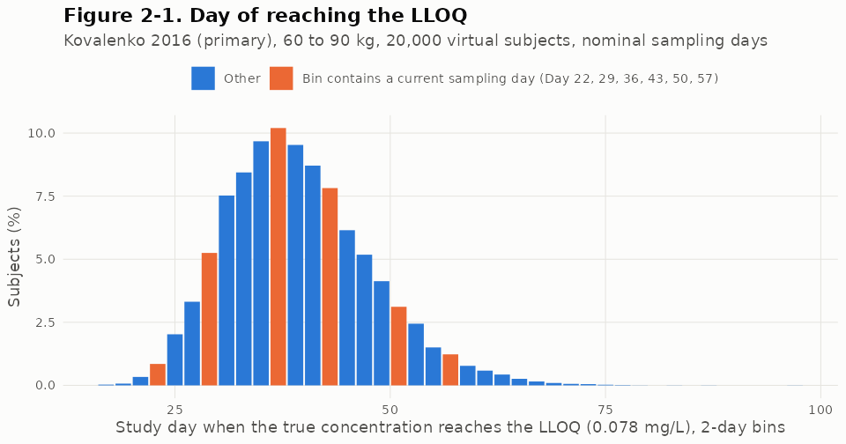
Figure 5-1. Study day at which the true concentration reaches the LLOQ (primary model, 60 to 90 kg, 300 mg, 20,000 virtual subjects, nominal days). Analysis figure 2-1 (results/cliff/fig2_1_lloq_day_en.png).
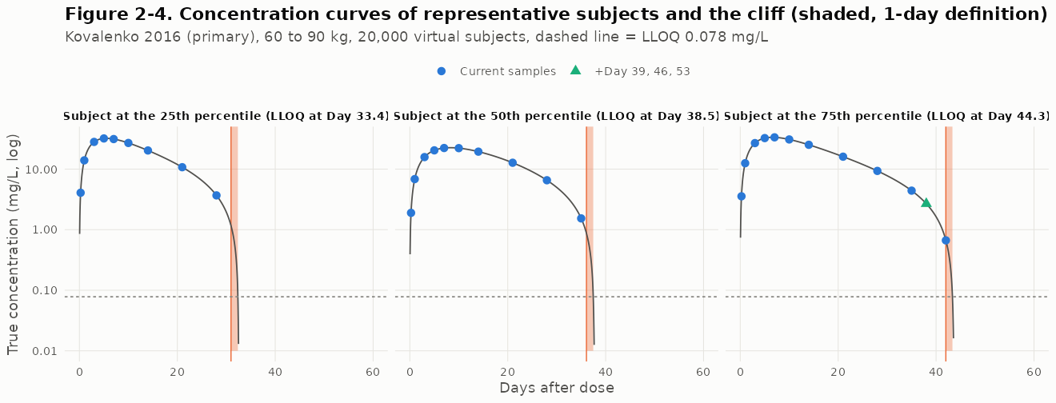
Figure 5-2. True concentration of three representative subjects with the cliff shaded (1-day definition), planned samples and the samples of the added-sampling schedules (primary model). Analysis figure 2-4 (results/cliff/fig2_4_representative_en.png).

5.2 Coverage of total exposure by AUC0-last
Two quantities are kept apart throughout this report. Window coverage is the true AUC from dosing to the last quantifiable sample divided by the true AUC0-inf; it states how much of total exposure lies inside the interval that AUC0-last measures, and “coverage” means only this. The observed-to-true ratio is the observed AUC0-last (or NCA AUC0-inf) divided by the true AUC0-inf; it also contains the assay (residual) error and the trapezoidal approximation (Table 5-3).
Table 5-1. True extrapolated fraction beyond the last quantifiable sample (model integral) and NCA-estimated extrapolation, planned schedule, 60 to 90 kg.
Model | Subjects | True extrapolated %, median | 95th percentile | Maximum | Window coverage below 80%, % [95% CI] | NCA extrapolated %, median | NCA extrapolation above 20%, % [95% CI]
Kovalenko 2016 (primary model) | 20,000 | 0.65 | 3.63 | 15.2 | 0.00 [0.00, 0.02] | 2.7 | 1.10 [0.96, 1.25]
Kovalenko 2020 Model 1 (structural sensitivity model) | 20,000 | 0.64 | 3.54 | 15.7 | 0.00 [0.00, 0.02] | 2.9 | 0.80 [0.69, 0.94]

Table 5-2. Sensitivity of coverage to the unobservable curve shape (multipliers applied to both arms; primary model, 20,000 subjects each). These runs use an independent draw of subjects, sampling times and residual errors, so the primary-model row differs slightly from Tables 5-1 and 5-3.
Variant | True extrapolated %, median | 95th percentile | Maximum | Window coverage below 80% (%) | NCA extrapolated %, median | Reliable, (i) [(ii)] % | Median tlast (day) | AUC0-last vs observed (300 mg, ~78 kg)
Primary model | 0.65 | 3.59 | 16.6 | 0.00 | 2.7 | 86.0 [80.8] | 34.7 | 1.04
Km x0.5 | 0.67 | 3.67 | 17.6 | 0.00 | 2.8 | 86.3 [80.3] | 34.7 | 1.03
Km x2 | 0.65 | 3.56 | 17.7 | 0.00 | 2.7 | 86.3 [81.0] | 34.8 | 1.04
Km x5 | 0.55 | 3.26 | 16.4 | 0.00 | 2.3 | 86.1 [81.1] | 34.9 | 1.04
Km x10 | 0.40 | 2.79 | 14.0 | 0.00 | 1.6 | 86.1 [82.6] | 35.2 | 1.06
Vmax x0.8 | 0.53 | 2.80 | 14.2 | 0.00 | 2.2 | 90.5 [85.0] | 41.3 | 1.18
Vmax x1.25 | 0.93 | 5.29 | 19.9 | 0.00 | 3.6 | 79.4 [72.5] | 28.2 | 0.89
Vmax x0.5 (stress test; fails validation) | 0.63 | 6.41 | 23.1 | 0.04 | 2.3 | 92.9 [80.9] | 55.0 | 1.48
Coverage:
- In 95% of subjects the window coverage is at least 94.7%. This holds under both models and all curve-shape variants that remain consistent with the observed data (the lowest value is for Vmax x1.25).
- No subject has a window coverage below 80% in these variants.
- In the Vmax x0.5 stress test, which does not match the observed exposure, the 95th percentile rises to 6.41%.
NCA extrapolation overstates the tail. The NCA-estimated extrapolation is about 4.2 times the true value at the median: 2.7% against 0.65% in the primary model. This is the direct consequence of estimating lambda-z before the cliff.
ADA-like subgroup. In the subgroup whose linear clearance doubles after Day 14 (10% of subjects), the median true extrapolation is 0.65% (0.68% in the remaining subjects), and window coverage below 80% is 0.00%.
Observed-to-true ratio. The observed AUC0-last and the NCA AUC0-inf of each subject can be compared with the true AUC0-inf of the same subject (Table 5-3; trial population, 20,000 subjects per model).
Table 5-3. Trial population: window coverage and observed-to-true ratios of AUC0-last and NCA AUC0-inf at the subject level (planned schedule, 300 mg, 20,000 subjects per model).
Model | Quantity | Subjects | Median | 5th percentile | 95th percentile | Minimum | Maximum | SD of log
2016 model | Window coverage (true AUC0-tlast / true AUC0-inf), all subjects | 20,000 | 0.993 | 0.964 | 1.000 | 0.848 | 1.000 | 0.013
2016 model | Observed AUC0-last / true AUC0-inf, all subjects | 20,000 | 0.962 | 0.811 | 1.111 | 0.598 | 1.316 | 0.096
2016 model | Observed AUC0-last / true AUC0-inf, lambda-z estimable | 19,708 | 0.963 | 0.811 | 1.112 | 0.598 | 1.316 | 0.096
2016 model | NCA AUC0-inf / true AUC0-inf, lambda-z estimable (rule B) | 19,708 | 1.003 | 0.847 | 1.165 | 0.622 | 5.281 | 0.101
2016 model | Observed AUC0-last / true AUC0-inf, meeting set (i) | 17,313 | 0.967 | 0.819 | 1.115 | 0.614 | 1.316 | 0.094
2016 model | NCA AUC0-inf / true AUC0-inf, meeting set (i) (rule A) | 17,313 | 1.005 | 0.852 | 1.160 | 0.622 | 1.401 | 0.094
2016 model | Extrapolation factor NCA AUC0-inf / observed AUC0-last, lambda-z estimable | 19,708 | 1.028 | 1.002 | 1.138 | 1.000 | 7.192 | 0.057
2020 Model 1 | Window coverage (true AUC0-tlast / true AUC0-inf), all subjects | 20,000 | 0.994 | 0.965 | 1.000 | 0.843 | 1.000 | 0.013
2020 Model 1 | Observed AUC0-last / true AUC0-inf, all subjects | 20,000 | 0.967 | 0.873 | 1.058 | 0.742 | 1.185 | 0.058
2020 Model 1 | Observed AUC0-last / true AUC0-inf, lambda-z estimable | 19,877 | 0.967 | 0.874 | 1.058 | 0.742 | 1.185 | 0.058
2020 Model 1 | NCA AUC0-inf / true AUC0-inf, lambda-z estimable (rule B) | 19,877 | 1.007 | 0.909 | 1.117 | 0.779 | 1.866 | 0.063
2020 Model 1 | Observed AUC0-last / true AUC0-inf, meeting set (i) | 18,367 | 0.968 | 0.876 | 1.059 | 0.742 | 1.185 | 0.058
2020 Model 1 | NCA AUC0-inf / true AUC0-inf, meeting set (i) (rule A) | 18,367 | 1.009 | 0.912 | 1.113 | 0.802 | 1.288 | 0.061
2020 Model 1 | Extrapolation factor NCA AUC0-inf / observed AUC0-last, lambda-z estimable | 19,877 | 1.030 | 1.002 | 1.136 | 1.000 | 2.315 | 0.045
- The residual (assay) error enters AUC0-last and NCA AUC0-inf in the same way, because NCA AUC0-inf is AUC0-last plus an extrapolated area. NCA AUC0-inf adds an extrapolation error on top: its largest subject-level observed-to-true ratio is 1.87 to 5.28 (two models) against 1.19 to 1.32 for AUC0-last, and the SD of its log ratio is 0.063 to 0.101 against 0.058 to 0.096 (subjects with an estimable lambda-z).
- The lowest subject-level values of the observed AUC0-last / true AUC0-inf (59.8% to 74.2%) come from the proportional residual error on sparse samples, not from the sampling window, whose coverage is at least 84.3% in every subject. The residual error model is the same in both arms, so these deviations are symmetric between arms.
- In the quantity that is compared, the geometric mean of the trial GMRs, AUC0-last agrees with the true AUC0-inf ratio to within 0.012 in every scenario examined (the 8 boundary scenarios, identical products and bioavailability x0.97 in each model; pooled t-test).

5.3 Reliability of NCA AUC0-inf
Table 5-4. Reliability of NCA AUC0-inf under the planned schedule (20,000 subjects per model; flags overlap).
Model | Reliable, set (i), % (95% CI) | Reliable, set (ii), % (95% CI) | lambda-z not estimable (%) | adjusted R-squared below 0.80 (%) | extrapolation above 20% (%) | span ratio below 2 (%)
Kovalenko 2016 (primary model) | 86.6 (86.1 to 87.0) | 80.7 (80.2 to 81.3) | 1.5 | 11.4 | 1.1 | 8.3
Kovalenko 2020 Model 1 (structural sensitivity model) | 91.8 (91.4 to 92.2) | 83.9 (83.4 to 84.4) | 0.6 | 7.0 | 0.8 | 9.2
Denser late sampling does not improve reliability. Best Fit selects a later and shorter window (usually the last three samples, including the added days). A span ratio of at least 2 then requires a half-life of at most 3.5 days, instead of 7 days under the planned schedule. The span flag therefore increases, and reliability under set (ii) falls in 26 of 32 added-sampling schedule and model-variant combinations (Figure 5-3). Section 5.7 reports the changes.
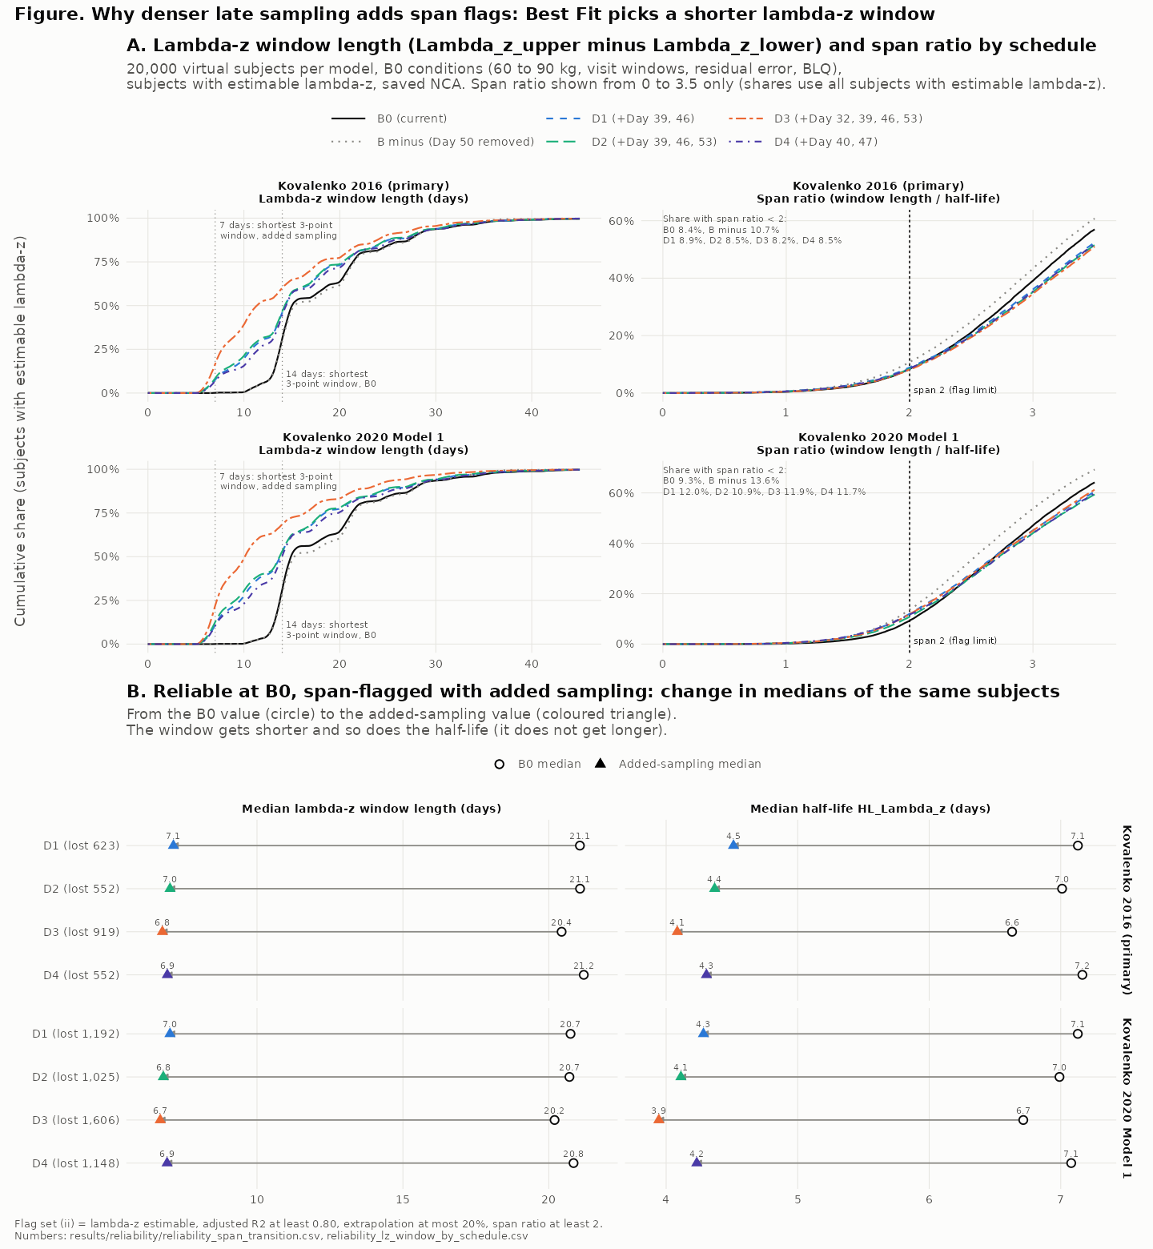
Figure 5-3. Why denser late sampling adds span-ratio flags: lambda-z window length and span ratio by schedule, and the change in window and half-life in subjects who lose reliability with added samples (both models, 20,000 subjects each). In the figure, B0 is the planned schedule, D1 to D4 the added-sampling schedules and B minus the schedule without Day 50 (Section 3.9); flag set (ii) is criteria set (ii). Analysis figure (results/reliability/fig_reliability_mechanism_en.png).
The trial population is the basis of the proposal. The analyses below use only the population in which similarity is tested: healthy adults of 60 to 90 kg, randomized 1:1 within two body-weight strata, planned schedule, 300 mg (pre-registered, Section 3.13). Subject-level results use 20,000 subjects per model; trial-level results use the regenerated trials with the operating-characteristic seeds (117 subjects per arm).
Table 5-5. Trial population: subjects without a reliable AUC0-inf by criteria set (20,000 subjects per model, Wilson 95% intervals); reasons in hierarchical order (lambda-z not estimable, then adjusted R-squared below the threshold, then extrapolation above 20%, then span ratio below the threshold); retained subjects per arm under rule A in simulated trials of identical products (both arms of each trial).
Model | Criteria set | Failing, % [95% CI] | Lambda-z not estimable, % | Estimable but failing, % [95% CI] | Adjusted R-squared below threshold, % | Extrapolation above 20%, % | Span ratio below threshold, % | Retained per arm of 117, median (5th to 95th percentile)
2016 model | (i) | 13.4 [13.0, 13.9] | 1.46 | 12.0 [11.5, 12.4] | 11.4 | 0.6 | 0.0 | 101 (95 to 107)
2016 model | (ii) | 19.3 [18.7, 19.8] | 1.46 | 17.8 [17.3, 18.3] | 11.4 | 0.6 | 5.8 | 94 (87 to 101)
2016 model | (iii) | 38.8 [38.1, 39.4] | 1.46 | 37.3 [36.6, 38.0] | 36.8 | 0.5 | 0.0 | 72 (63 to 80)
2016 model | (iv) | 65.9 [65.2, 66.5] | 1.46 | 64.4 [63.7, 65.1] | 36.8 | 0.5 | 27.1 | 40 (31 to 48)
2020 Model 1 | (i) | 8.2 [7.8, 8.6] | 0.62 | 7.6 [7.2, 7.9] | 7.0 | 0.6 | 0.0 | 107 (102 to 112)
2020 Model 1 | (ii) | 16.1 [15.6, 16.6] | 0.62 | 15.5 [15.0, 16.0] | 7.0 | 0.6 | 7.9 | 98 (91 to 104)
2020 Model 1 | (iii) | 33.2 [32.6, 33.9] | 0.62 | 32.6 [32.0, 33.3] | 32.1 | 0.5 | 0.0 | 78 (69 to 86)
2020 Model 1 | (iv) | 72.5 [71.8, 73.1] | 0.62 | 71.8 [71.2, 72.5] | 32.1 | 0.5 | 39.2 | 32 (24 to 40)
- The share failing criteria set (i) (adjusted R-squared at least 0.80) is 8.2% to 13.4% in the two models, and a median of 101 to 107 (5th to 95th percentile 95 to 112) of 117 subjects per arm remain in the analysis under rule A. With the adjusted R-squared of at least 0.90 used in public statistical analysis plans (set (iii); Section 3.4) the share is 33.2% to 38.8%, leaving a median of 72 to 78 (5th to 95th percentile 63 to 86); adding a span of at least 3 half-lives (set (iv)) gives 65.9% to 72.5% and a median of 32 to 40 (5th to 95th percentile 24 to 48). Set (i) is therefore the lower end of the conventional range.
- Lambda-z is not estimable in 0.62% to 1.46% of subjects; the rest of the failures have an estimable lambda-z that does not meet the criteria, mostly because of the adjusted R-squared.
- Residual error. The failure share under sets (iii) and (iv) is the two-model range because it depends on the size of the residual error: the 2016 model has a proportional residual of 24.2% and Model 1 of 15.0%. A larger proportional residual scatters the terminal log concentrations around the regression line and lowers the adjusted R-squared, so a stricter threshold removes more subjects. With the 2016 model and a residual of 12.0%, the set (iii) share falls from 38.8% to 27.2%, whereas the set (iv) share stays at 66.0% because the span requirement fails for a structural reason: the lambda-z window lies before the cliff and cannot span 3 half-lives.
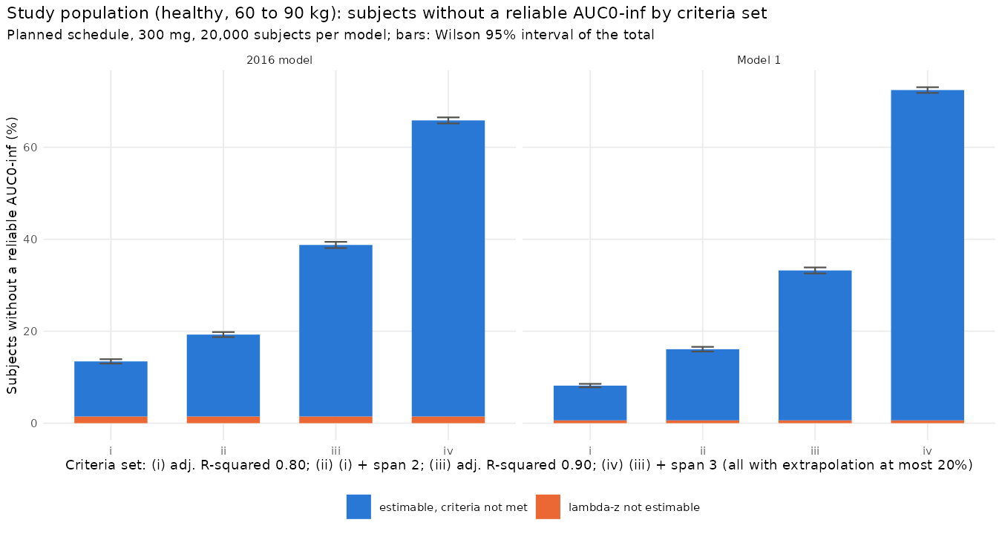
Figure 5-4. Trial population: share of subjects without a reliable AUC0-inf by criteria set, split into lambda-z not estimable and estimable but not meeting the criteria (planned schedule, 300 mg, 20,000 subjects per model; bars: Wilson 95% intervals of the total). Analysis figure results/trialpop/fig_tp_failure_by_set.png.
Failures are not random within the trial population.
Table 5-6. Trial population: characteristics of subjects failing each criteria set (20,000 subjects per model; Welch 95% intervals, geometric mean ratios on the log scale) and the share failing by randomization stratum (Newcombe 95% interval of the difference).
Model | Criteria set | Failing subjects | Body weight, failing minus retained, kg [95% CI] | True AUC0-inf, geometric mean ratio failing to retained [95% CI] | AUC0-last, geometric mean ratio [95% CI] | Failing, 60 to 75 kg stratum, % | Failing, above 75 to 90 kg stratum, % | Difference, heavier minus lighter, points [95% CI]
2016 model | (i) | 2,687 | 1.13 [0.84, 1.42] | 0.815 [0.802, 0.828] | 0.783 [0.770, 0.797] | 12.1 | 14.8 | 2.7 [1.7, 3.6]
2016 model | (ii) | 3,853 | 0.96 [0.70, 1.21] | 0.842 [0.830, 0.854] | 0.808 [0.796, 0.820] | 17.6 | 20.9 | 3.2 [2.1, 4.3]
2016 model | (iii) | 7,752 | 0.42 [0.21, 0.62] | 0.928 [0.918, 0.938] | 0.910 [0.900, 0.920] | 37.6 | 39.9 | 2.3 [0.9, 3.6]
2016 model | (iv) | 13,170 | 0.48 [0.27, 0.69] | 0.934 [0.924, 0.943] | 0.909 [0.899, 0.919] | 64.6 | 67.1 | 2.5 [1.1, 3.8]
2020 Model 1 | (i) | 1,633 | 0.81 [0.44, 1.18] | 0.786 [0.768, 0.804] | 0.772 [0.753, 0.790] | 7.4 | 8.9 | 1.5 [0.7, 2.2]
2020 Model 1 | (ii) | 3,217 | 0.55 [0.27, 0.82] | 0.847 [0.833, 0.862] | 0.828 [0.813, 0.843] | 15.1 | 17.0 | 1.9 [0.9, 2.9]
2020 Model 1 | (iii) | 6,643 | 0.35 [0.14, 0.56] | 0.895 [0.885, 0.906] | 0.891 [0.880, 0.902] | 32.2 | 34.2 | 2.0 [0.7, 3.4]
2020 Model 1 | (iv) | 14,490 | 0.40 [0.17, 0.62] | 0.909 [0.899, 0.920] | 0.897 [0.886, 0.908] | 71.7 | 73.3 | 1.6 [0.4, 2.8]
- Subjects failing set (i) have a true AUC0-inf 0.786 to 0.815 times that of retained subjects (geometric mean ratio), and are 0.81 kg to 1.13 kg heavier. Under set (iii) the ratio is 0.895 to 0.928. Rule A therefore removes subjects with lower exposure.
- The heavier randomization stratum (above 75 to 90 kg) fails more often than the lighter stratum (60 to 75 kg): by 1.5 to 2.7 percentage points under set (i) and 2.0 to 2.3 under set (iii) (Table 5-6, Figure 5-5).
- Loss of the stratified balance. The randomization balances the strata between arms (the between-arm difference in the share of the heavier stratum is at most 0.9 points), and the AUC0-last analysis set keeps this balance in every trial (5th to 95th percentile -0.9 to 0.9 points). The rule A AUC0-inf analysis set does not: for identical products the between-arm difference in the share of the heavier stratum has a 5th to 95th percentile range of -4.4 to 4.6 points under set (i) and -8.7 to 8.5 points under set (iii), and exceeds 5 points in 1.6% to 6.5% and 28.6% to 33.4% of trials, respectively (two models; 2,000 trials per model).
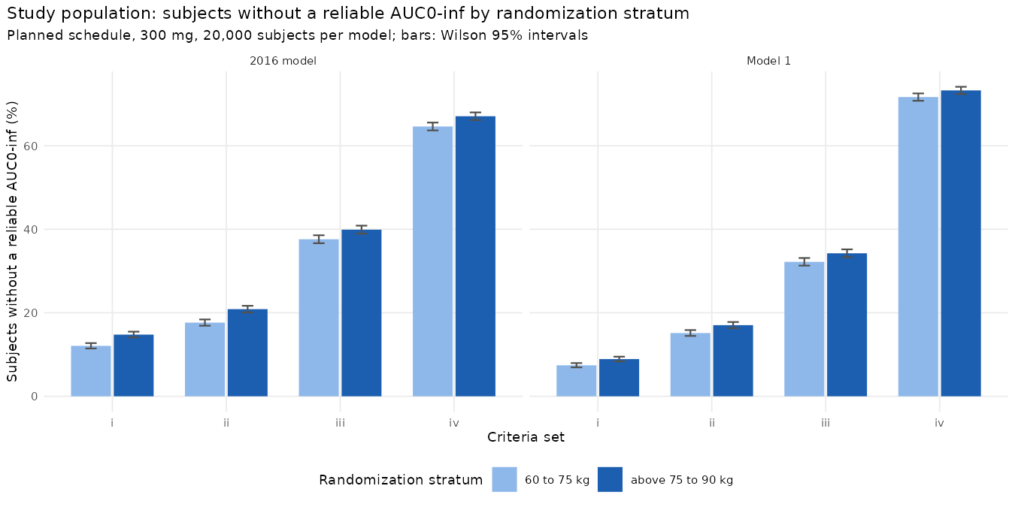
Figure 5-5. Trial population: share of subjects without a reliable AUC0-inf by randomization stratum and criteria set (20,000 subjects per model; bars: Wilson 95% intervals). Analysis figure results/trialpop/fig_tp_strata.png.
The failure share depends on the product.
Table 5-7. Trial population: difference between arms (test minus reference) in the share of subjects failing the criteria, mean over 2,000 trials per scenario with 95% interval, by scenario and true AUC0-inf ratio.
Model | Scenario | True AUC0-inf ratio | Set (i), test minus reference, points [95% CI] | Set (iii), test minus reference, points [95% CI]
2016 model | identical products | 1.000 | -0.09 [-0.29, 0.11] | 0.06 [-0.22, 0.34]
2016 model | F x0.97 | 0.952 | 0.58 [0.38, 0.79] | 0.61 [0.32, 0.89]
2016 model | ke x1.10 | 0.949 | -0.10 [-0.30, 0.10] | -0.48 [-0.76, -0.20]
2016 model | ke x1.20 | 0.904 | 0.05 [-0.15, 0.25] | -0.60 [-0.87, -0.32]
2016 model | Vmax x1.25 | 0.865 | 6.64 [6.42, 6.85] | 5.58 [5.30, 5.86]
2016 model | F decreased, true AUC0-inf ratio 0.80 | 0.800 | 3.54 [3.33, 3.75] | 3.01 [2.73, 3.29]
2016 model | F increased, true AUC0-inf ratio 1.25 | 1.250 | -2.90 [-3.09, -2.71] | -2.58 [-2.86, -2.31]
2016 model | ka decreased, true AUC0-inf ratio 0.80 | 0.799 | 12.29 [12.06, 12.52] | 12.60 [12.31, 12.89]
2016 model | ke decreased, true AUC0-inf ratio 1.25 | 1.249 | 0.07 [-0.13, 0.27] | 1.74 [1.45, 2.02]
2016 model | ke increased, true AUC0-inf ratio 0.80 | 0.800 | 0.29 [0.09, 0.50] | -1.38 [-1.66, -1.11]
2016 model | V2 increased, true AUC0-inf ratio 0.80 | 0.800 | -3.49 [-3.68, -3.30] | -8.45 [-8.72, -8.18]
2016 model | Vmax decreased, true AUC0-inf ratio 1.25 | 1.251 | -6.41 [-6.59, -6.23] | -7.13 [-7.41, -6.86]
2016 model | Vmax increased, true AUC0-inf ratio 0.80 | 0.799 | 11.03 [10.79, 11.26] | 8.95 [8.66, 9.23]
2020 Model 1 | identical products | 1.000 | 0.00 [-0.16, 0.16] | -0.17 [-0.44, 0.11]
2020 Model 1 | F x0.97 | 0.952 | 0.36 [0.21, 0.52] | 0.45 [0.18, 0.73]
2020 Model 1 | ke x1.10 | 0.948 | -0.11 [-0.27, 0.04] | -0.46 [-0.73, -0.20]
2020 Model 1 | ke x1.20 | 0.901 | -0.16 [-0.31, 0.00] | -0.76 [-1.03, -0.50]
2020 Model 1 | Vmax x1.25 | 0.866 | 4.27 [4.10, 4.45] | 4.53 [4.26, 4.81]
2020 Model 1 | F decreased, true AUC0-inf ratio 0.80 | 0.800 | 2.21 [2.04, 2.38] | 2.60 [2.33, 2.88]
2020 Model 1 | F increased, true AUC0-inf ratio 1.25 | 1.250 | -1.54 [-1.69, -1.38] | -2.82 [-3.09, -2.55]
2020 Model 1 | ka decreased, true AUC0-inf ratio 0.80 | 0.801 | 10.26 [10.06, 10.45] | 12.96 [12.67, 13.24]
2020 Model 1 | ke decreased, true AUC0-inf ratio 1.25 | 1.250 | 0.51 [0.35, 0.67] | 0.61 [0.34, 0.88]
2020 Model 1 | ke increased, true AUC0-inf ratio 0.80 | 0.800 | -0.47 [-0.63, -0.32] | -2.06 [-2.33, -1.79]
2020 Model 1 | V2 increased, true AUC0-inf ratio 0.80 | 0.800 | -4.06 [-4.20, -3.91] | -9.38 [-9.64, -9.12]
2020 Model 1 | Vmax decreased, true AUC0-inf ratio 1.25 | 1.251 | -4.08 [-4.21, -3.94] | -9.22 [-9.48, -8.96]
2020 Model 1 | Vmax increased, true AUC0-inf ratio 0.80 | 0.800 | 7.29 [7.10, 7.48] | 7.19 [6.91, 7.47]
- For identical products the share failing is the same in both arms (test minus reference -0.09 to 0.00 percentage points under set (i)). When the products differ, the arms differ by an amount, and in a direction, that depend on the mechanism of the difference rather than on the exposure ratio alone (Table 5-7, Figure 5-6). Under set (i), test minus reference, in percentage points (range over the two models): Vmax x1.25: 4.27 to 6.64; Vmax increased to a true AUC0-inf ratio of 0.80: 7.29 to 11.03; absorption rate decreased to 0.80: 10.26 to 12.29; bioavailability decreased to 0.80: 2.21 to 3.54; peripheral volume increased to 0.80: -4.06 to -3.49 (-9.38 to -8.45 under set (iii)); linear elimination x1.20: -0.16 to 0.05.
- A descriptive linear fit of the mean difference on the log true AUC0-inf ratio across the 13 test scenarios of each model has an R-squared of 0.23 to 0.36 under set (i) and 0.17 to 0.18 under set (iii): the true exposure ratio explains little of the difference, because each mechanism changes the terminal profile, and therefore the lambda-z regression, in its own way.
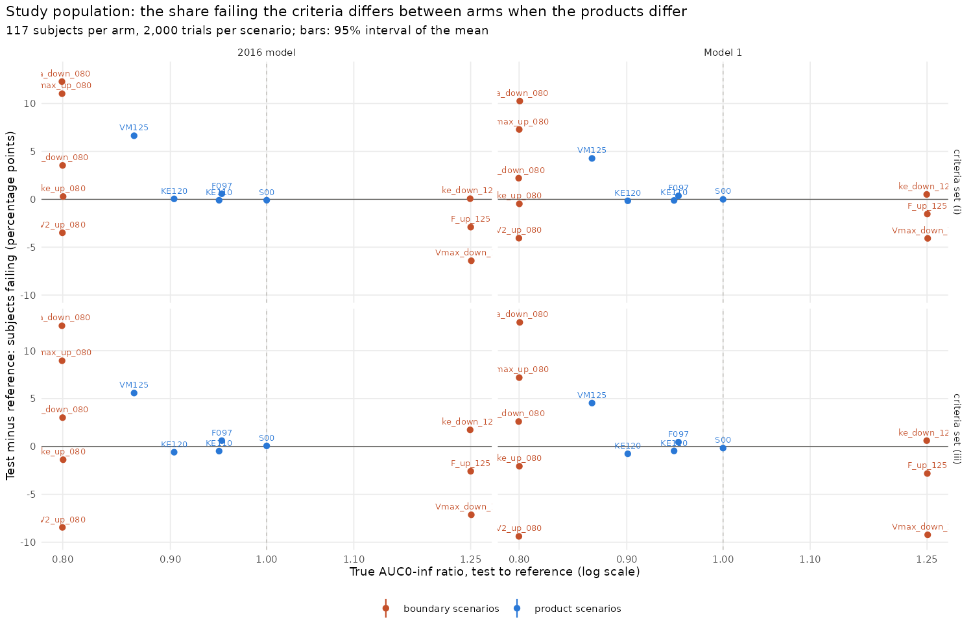
Figure 5-6. Trial population: test minus reference share failing criteria set (i) (top) and (iii) (bottom) against the true AUC0-inf ratio, product scenarios and boundary scenarios, both models (bars: 95% intervals of the mean). Analysis figure results/trialpop/fig_tp_arm_difference.png.
- Consequence. An analysis restricted to reliable subjects (rule A) removes subjects with lower true exposure, loses the stratified balance of body weight between the arms, and removes a different share of subjects in the two arms when the products differ, by an amount that depends on the mechanism of the difference (up to 12.3 percentage points under set (i)). The subjects compared then depend on the product difference that the study is meant to detect. The regenerated trials reproduce the per-arm counts of the operating-characteristic trials exactly (264,000 rows compared).

5.4 Operating characteristics

Boundary scenarios
Table 5-8. Test-arm multipliers giving a true AUC0-inf ratio of 0.80 or 1.25 (200,000 common subjects, within 0.1%), and the true Cmax ratio at that multiplier. Unreachable: the multiplier at the end of the search range and its true AUC0-inf ratio.
Mechanism | 2016 model, 0.80 | 2016 model, 1.25 | 2020 Model 1, 0.80 | 2020 Model 1, 1.25
bioavailability (F) | x0.872 (down); Cmax ratio 0.852 | x1.151 (up); Cmax ratio 1.176 | x0.871 (down); Cmax ratio 0.852 | x1.153 (up); Cmax ratio 1.176
Michaelis-Menten constant (Km) | unreachable (x0.01: 0.999) | unreachable (x100: 1.059) | unreachable (x0.01: 0.999) | unreachable (x100: 1.054)
peripheral volume (V2) | x3.210 (up); Cmax ratio 0.963 | unreachable (x0.1: 1.191) | x2.277 (up); Cmax ratio 0.891 | unreachable (x0.1: 1.223)
maximum target-mediated elimination rate (Vmax) | x1.395 (up); Cmax ratio 0.938 | x0.660 (down); Cmax ratio 1.054 | x1.397 (up); Cmax ratio 0.941 | x0.651 (down); Cmax ratio 1.053
absorption rate constant (ka) | x0.440 (down); Cmax ratio 0.632 | unreachable (x10: 1.118) | x0.424 (down); Cmax ratio 0.633 | unreachable (x10: 1.109)
linear elimination rate constant (ke) | x1.471 (up); Cmax ratio 0.929 | x0.633 (down); Cmax ratio 1.067 | x1.457 (up); Cmax ratio 0.933 | x0.643 (down); Cmax ratio 1.064
16 boundary scenarios (8 per model) are reachable. Several are not:
- Km cannot move the true AUC0-inf ratio to either limit within x0.01 to x100 (Section 5.6).
- Increased ka and decreased V2 cannot reach 1.25.
- The ka decrease that reaches 0.80 lowers the true Cmax ratio to 0.632 to 0.633, so any configuration containing Cmax fails in that scenario.

Boundary type I error (primary metric)
Table 5-9. Boundary type I error (true AUC0-inf ratio 0.80 or 1.25): number of the 8 boundary scenarios per model with a point estimate above 5% (Wilson lower bound above 5%); largest value, % [Wilson 95% CI], and its scenario. 10,000 trials per scenario (20,000 for the 2020 model V2 scenario, see text).
Configuration | Status | 2016 model | 2020 Model 1
AUC0-last + Cmax (proposed) | pre-specified | 0 (0); 3.97 [3.60, 4.37], V2 increased, true AUC0-inf ratio 0.80 | 1 (0); 5.18 [4.88, 5.50], V2 increased, true AUC0-inf ratio 0.80
AUC0-last alone (reference) | pre-specified (reference) | 0 (0); 4.74 [4.34, 5.17], ka decreased, true AUC0-inf ratio 0.80 | 2 (0); 5.20 [4.90, 5.51], V2 increased, true AUC0-inf ratio 0.80
AUC0-inf + Cmax, rule A, criteria (ii) (guidance default as pre-specified) | pre-specified | 6 (6); 24.58 [23.75, 25.43], Vmax decreased, true AUC0-inf ratio 1.25 | 6 (6); 27.60 [26.73, 28.48], Vmax decreased, true AUC0-inf ratio 1.25
AUC0-inf + Cmax, rule A, criteria (i) | post hoc | 4 (4); 19.91 [19.14, 20.70], Vmax increased, true AUC0-inf ratio 0.80 | 4 (4); 17.37 [16.64, 18.13], Vmax increased, true AUC0-inf ratio 0.80
AUC0-inf + Cmax, rule B | post hoc | 4 (3); 15.06 [14.37, 15.77], Vmax increased, true AUC0-inf ratio 0.80 | 4 (3); 11.87 [11.25, 12.52], Vmax increased, true AUC0-inf ratio 0.80
AUC0-inf + Cmax, rule C, criteria (ii) | post hoc | 0 (0); 3.85 [3.49, 4.25], ke increased, true AUC0-inf ratio 0.80 | 1 (0); 5.01 [4.71, 5.32], V2 increased, true AUC0-inf ratio 0.80
AUC0-inf + Cmax, rule C, criteria (i) | post hoc | 0 (0); 4.13 [3.76, 4.54], F decreased, true AUC0-inf ratio 0.80 | 0 (0); 4.63 [4.34, 4.92], V2 increased, true AUC0-inf ratio 0.80
AUC0-last + AUC0-inf + Cmax, rule A, criteria (ii) | pre-specified | 0 (0); 2.69 [2.39, 3.03], F decreased, true AUC0-inf ratio 0.80 | 0 (0); 3.03 [2.71, 3.38], F decreased, true AUC0-inf ratio 0.80
AUC0-last + AUC0-inf + Cmax, rule C, criteria (ii) | pre-specified | 0 (0); 3.51 [3.17, 3.89], F decreased, true AUC0-inf ratio 0.80 | 0 (0); 4.76 [4.47, 5.06], V2 increased, true AUC0-inf ratio 0.80
AUC0-inf alone, rule A, criteria (ii) | pre-specified (reference) | 7 (7); 35.84 [34.91, 36.79], ka decreased, true AUC0-inf ratio 0.80 | 7 (7); 36.53 [35.59, 37.48], ka decreased, true AUC0-inf ratio 0.80
AUC0-inf alone, rule B | post hoc (reference) | 5 (5); 16.02 [15.31, 16.75], ka decreased, true AUC0-inf ratio 0.80 | 5 (4); 16.23 [15.52, 16.97], ka decreased, true AUC0-inf ratio 0.80
AUC0-inf alone, rule C, criteria (ii) | post hoc (reference) | 0 (0); 4.00 [3.63, 4.40], ka decreased, true AUC0-inf ratio 0.80 | 1 (0); 5.03 [4.73, 5.34], V2 increased, true AUC0-inf ratio 0.80
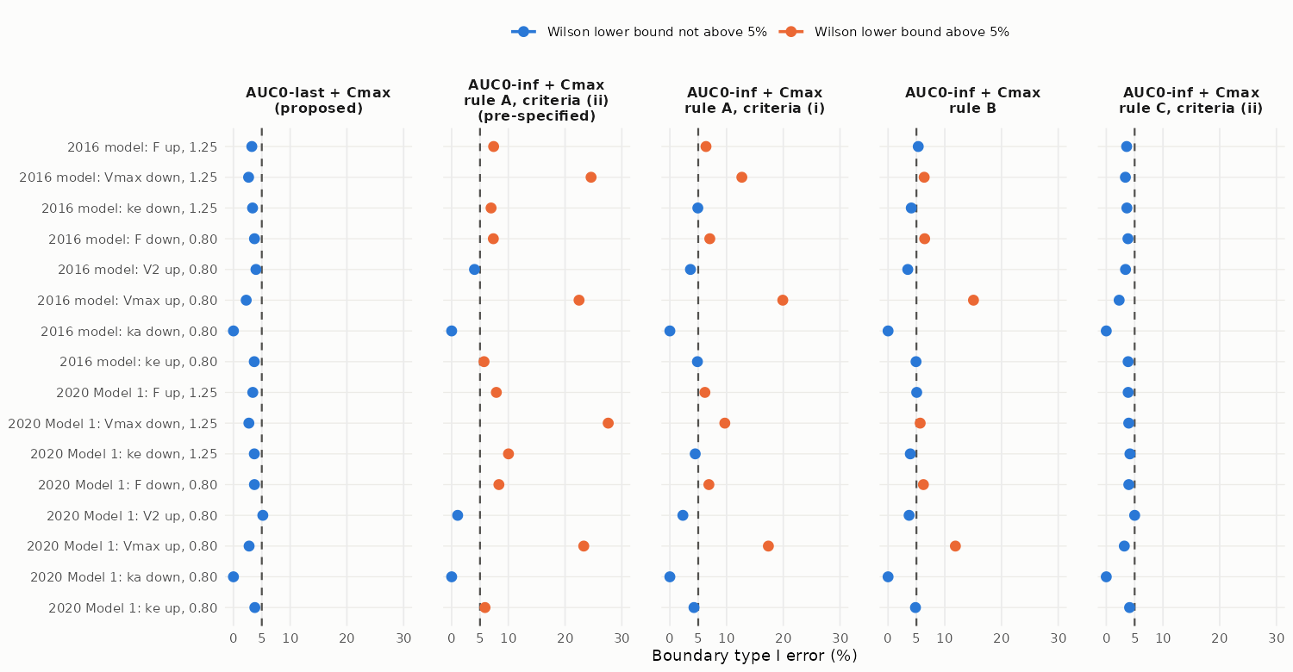
Figure 5-7. Boundary type I error of the proposed configuration and of AUC0-inf + Cmax under three handling rules, for the 16 boundary scenarios (rows: model and scenario). Points: estimate; horizontal lines: Wilson 95% intervals; dashed line: 5%. Orange marks scenarios whose Wilson lower bound is above 5%. 10,000 trials per scenario (20,000 for the 2020 model V2 scenario). Drawn from results/oc/g2_rules_flags.csv.

Interpretation for the proposed configuration
Table 5-10. AUC0-last + Cmax at each boundary scenario, with the pass rate of the unbiased reference (model-integrated AUC0-inf of the same trial subjects, analysed identically), the bias of AUC0-last relative to the true AUC0-inf ratio and the Cmax pass rate.
Model | Scenario | Trials | AUC0-last + Cmax, % [95% CI] | Class | Unbiased reference (true AUC0-inf), % | AUC0-last bias vs true AUC0-inf (%) | Cmax pass (%)
2016 model | F decreased, true AUC0-inf ratio 0.80 (x0.87) | 10,000 | 3.71 [3.36, 4.10] | conservative | 4.48 | -0.51 | 39.8
2016 model | V2 increased, true AUC0-inf ratio 0.80 (x3.21) | 10,000 | 3.97 [3.60, 4.37] | conservative | 4.39 | -0.30 | 99.2
2016 model | Vmax increased, true AUC0-inf ratio 0.80 (x1.39) | 10,000 | 2.25 [1.98, 2.56] | conservative | 4.64 | -1.50 | 96.0
2016 model | ka decreased, true AUC0-inf ratio 0.80 (x0.44) | 10,000 | 0.00 [0.00, 0.04] | conservative | 5.11 | -0.23 | 0.0
2016 model | ke increased, true AUC0-inf ratio 0.80 (x1.47) | 10,000 | 3.67 [3.32, 4.06] | conservative | 4.62 | -0.57 | 94.4
2016 model | F increased, true AUC0-inf ratio 1.25 (x1.15) | 10,000 | 3.24 [2.91, 3.61] | conservative | 4.33 | 0.48 | 39.2
2016 model | Vmax decreased, true AUC0-inf ratio 1.25 (x0.66) | 10,000 | 2.67 [2.37, 3.00] | conservative | 4.12 | 0.92 | 98.8
2016 model | ke decreased, true AUC0-inf ratio 1.25 (x0.63) | 10,000 | 3.37 [3.03, 3.74] | conservative | 4.55 | 0.50 | 97.0
2020 Model 1 | F decreased, true AUC0-inf ratio 0.80 (x0.87) | 10,000 | 3.70 [3.35, 4.09] | conservative | 4.61 | -0.46 | 40.3
2020 Model 1 | V2 increased, true AUC0-inf ratio 0.80 (x2.28) | 20,000 | 5.18 [4.88, 5.50] | nominal | 4.59 | 0.41 | 65.3
2020 Model 1 | Vmax increased, true AUC0-inf ratio 0.80 (x1.40) | 10,000 | 2.76 [2.46, 3.10] | conservative | 4.75 | -1.34 | 96.8
2020 Model 1 | ka decreased, true AUC0-inf ratio 0.80 (x0.42) | 10,000 | 0.00 [0.00, 0.04] | conservative | 5.43 | -0.24 | 0.0
2020 Model 1 | ke increased, true AUC0-inf ratio 0.80 (x1.46) | 10,000 | 3.77 [3.41, 4.16] | conservative | 4.67 | -0.55 | 96.0
2020 Model 1 | F increased, true AUC0-inf ratio 1.25 (x1.15) | 10,000 | 3.41 [3.07, 3.78] | conservative | 4.32 | 0.40 | 39.3
2020 Model 1 | Vmax decreased, true AUC0-inf ratio 1.25 (x0.65) | 10,000 | 2.72 [2.42, 3.06] | conservative | 4.24 | 0.73 | 99.0
2020 Model 1 | ke decreased, true AUC0-inf ratio 1.25 (x0.64) | 10,000 | 3.68 [3.33, 4.07] | conservative | 4.42 | 0.34 | 97.6
Baseline for an unbiased estimator. With 232 degrees of freedom, the two one-sided tests reject at the near limit with probability 5% when the true ratio is exactly at that limit, so the boundary type I error of an unbiased estimator is 5% minus a negligible far-limit probability.
- At the inverted true ratios (within 0.1% of the limits), the theoretical value is 4.85 to 5.12%.
- The unbiased reference passed in 4.12 to 5.43% of trials.
- The reference leans slightly below 5% because the between-trial SD of the log GMR is slightly smaller than the average within-trial standard error (ratio 0.961 to 0.993). The cause of this was not investigated further; a candidate is the stratified 1:1 allocation, which the pooled t-test does not model.
AUC0-last against total exposure. In 15 of 16 scenarios, AUC0-last is biased away from 1 relative to the true AUC0-inf ratio, which is conservative.
The single nominal cell (2020 model, peripheral volume increased 2.28-fold, which is 3.21-fold in the primary model):
- The AUC0-last ratio is biased toward 1 by 0.41%.
- The excess of 0.180 percentage points over 5% decomposes exactly within the same trials into three components (they sum to the excess):
  - the unbiased reference minus 5%: -0.415 points;
  - the AUC0-last effect: 0.610 points;
  - the Cmax effect: -0.015 points.
- The value at the pre-specified 10,000 trials was 5.32% (95% CI 4.90 to 5.78), which was also nominal.
- Section 6.2 states the facts relevant to the plausibility of this mechanism.

Why configurations based on NCA AUC0-inf exceed 5%
Table 5-11. Relative bias (%) of the geometric mean of trial GMRs against the truth at the boundary scenarios (AUC endpoints against the true AUC0-inf ratio, Cmax against the true Cmax ratio). A negative bias at 1.25 and a positive bias at 0.80 point toward 1 and raise the boundary type I error.
Model | Scenario | AUC0-last | AUC0-inf rule A (ii) | AUC0-inf rule B | AUC0-inf rule C (ii) | Cmax
2016 model | F decreased, true AUC0-inf ratio 0.80 | -0.5 | 2.0 | 1.1 | -0.4 | -0.2
2016 model | V2 increased, true AUC0-inf ratio 0.80 | -0.3 | -0.2 | -0.6 | -0.7 | -1.1
2016 model | Vmax increased, true AUC0-inf ratio 0.80 | -1.5 | 5.2 | 3.3 | -1.4 | -0.6
2016 model | ka decreased, true AUC0-inf ratio 0.80 | -0.2 | 8.0 | 3.7 | -0.7 | 1.2
2016 model | ke increased, true AUC0-inf ratio 0.80 | -0.6 | 0.5 | 0.1 | -0.5 | -0.8
2016 model | F increased, true AUC0-inf ratio 1.25 | 0.5 | -1.7 | -0.6 | 0.3 | 0.3
2016 model | Vmax decreased, true AUC0-inf ratio 1.25 | 0.9 | -4.8 | -0.9 | 0.4 | 0.6
2016 model | ke decreased, true AUC0-inf ratio 1.25 | 0.5 | -1.1 | 0.1 | 0.4 | 0.9
2020 Model 1 | F decreased, true AUC0-inf ratio 0.80 | -0.5 | 2.1 | 0.8 | -0.2 | -0.1
2020 Model 1 | V2 increased, true AUC0-inf ratio 0.80 | 0.4 | -3.3 | -0.5 | 0.3 | -1.7
2020 Model 1 | Vmax increased, true AUC0-inf ratio 0.80 | -1.3 | 5.5 | 2.6 | -1.0 | -0.5
2020 Model 1 | ka decreased, true AUC0-inf ratio 0.80 | -0.2 | 8.2 | 3.9 | -0.9 | 0.7
2020 Model 1 | ke increased, true AUC0-inf ratio 0.80 | -0.5 | 0.6 | 0.0 | -0.3 | -0.7
2020 Model 1 | F increased, true AUC0-inf ratio 1.25 | 0.4 | -1.9 | -0.5 | 0.1 | 0.2
2020 Model 1 | Vmax decreased, true AUC0-inf ratio 1.25 | 0.7 | -5.4 | -0.7 | 0.1 | 0.5
2020 Model 1 | ke decreased, true AUC0-inf ratio 1.25 | 0.3 | -2.1 | 0.3 | 0.1 | 0.7
Extrapolation bias. NCA AUC0-inf adds the tail Clast/lambda-z, estimated with a lambda-z from the decline before the cliff. This lambda-z is smaller than the true terminal decline in both arms, so the added tail dilutes a true exposure difference toward a ratio of 1. AUC0-inf including every subject with a lambda-z (rule B) is biased toward 1 in 12 of 16 scenarios, and rule A in 14 (Table 5-11). The effect of adding the extrapolated area to all subjects with a lambda-z (rule B minus AUC0-last + Cmax, paired) ranges from -1.47 to 12.81 percentage points across the boundary scenarios.
Selection bias. Excluding subjects who fail the criteria (rule A) changes the subjects compared in each arm, in a way that depends on the product difference itself. The effect of the exclusion (rule B minus rule A, criteria (ii), paired) ranges from -21.94 to 2.65 percentage points. It is negative, meaning that exclusion raises the pass rate, in 13 of 16 scenarios.
Rule C (substituting AUC0-last for subjects failing the criteria) removes most of both effects: its pass rate minus that of AUC0-last + Cmax ranges from -0.58 to 1.24 percentage points.

AUC0-inf configurations under the conventional criteria sets
Table 5-12. Boundary type I error of AUC0-inf + Cmax by handling rule and criteria set, 16 boundary scenarios: number of scenarios with a point estimate above 5% (Wilson lower bound above 5%); range of the pass rate. Same regenerated trials as Section 5.9 (10,000 per scenario, extended to 20,000 where the Section 3.7 rule applied).
Configuration | M0 (pooled t-test) | M1 (ANOVA with weight stratum)
AUC0-inf + Cmax, rule A, criteria (i) | 8 (8); 0.00% to 19.91% | 10 (8); 0.00% to 20.27%
AUC0-inf + Cmax, rule A, criteria (ii) | 12 (12); 0.00% to 27.60% | 12 (12); 0.00% to 27.44%
AUC0-inf + Cmax, rule A, criteria (iii) | 9 (8); 0.00% to 17.04% | 10 (9); 0.00% to 17.47%
AUC0-inf + Cmax, rule A, criteria (iv) | 12 (9); 0.00% to 27.04% | 12 (11); 0.00% to 27.19%
AUC0-inf + Cmax, rule B (any estimable lambda-z) | 8 (6); 0.00% to 15.06% | 10 (8); 0.00% to 16.03%
AUC0-inf + Cmax, rule C, criteria (i) | 0 (0); 0.00% to 4.63% | 1 (0); 0.00% to 5.06%
AUC0-inf + Cmax, rule C, criteria (ii) | 1 (0); 0.00% to 5.01% | 1 (1); 0.00% to 5.39%
AUC0-inf + Cmax, rule C, criteria (iii) | 1 (0); 0.00% to 5.21% | 1 (1); 0.00% to 5.65%
AUC0-inf + Cmax, rule C, criteria (iv) | 1 (1); 0.00% to 6.05% | 1 (1); 0.00% to 6.65%
- With rule A, AUC0-inf + Cmax exceeds 5% (point estimate) in 8, 12, 9 and 12 of 16 boundary scenarios under criteria sets (i) to (iv) (M0).
- Bias of the AUC0-inf GMR against the true AUC0-inf ratio across the boundary scenarios (M0): rule A -2.73% to 8.13% (set (i)) and -2.72% to 11.05% (set (iii)); rule B -0.90% to 3.89%; rule C -0.93% to 0.43% (set (i)) and -1.13% to 0.49% (set (iii)).
- Decision instability. In the same trials, the AUC0-inf + Cmax decision differs between the nine rule and criteria-set variants in a median of 12.6% and up to 39.6% of trials per boundary scenario (M0). Between rules A, B and C it differs in a median of 4.7% and up to 19.7% of trials with set (i) and a median of 6.2% and up to 20.7% with set (iii); between criteria sets it differs in a median of 11.4% and up to 37.5% within rule A and a median of 1.2% and up to 1.7% within rule C. With AUC0-inf as a primary endpoint, the equivalence decision of a given study would thus depend on handling choices that the software leaves to the analysis plan.
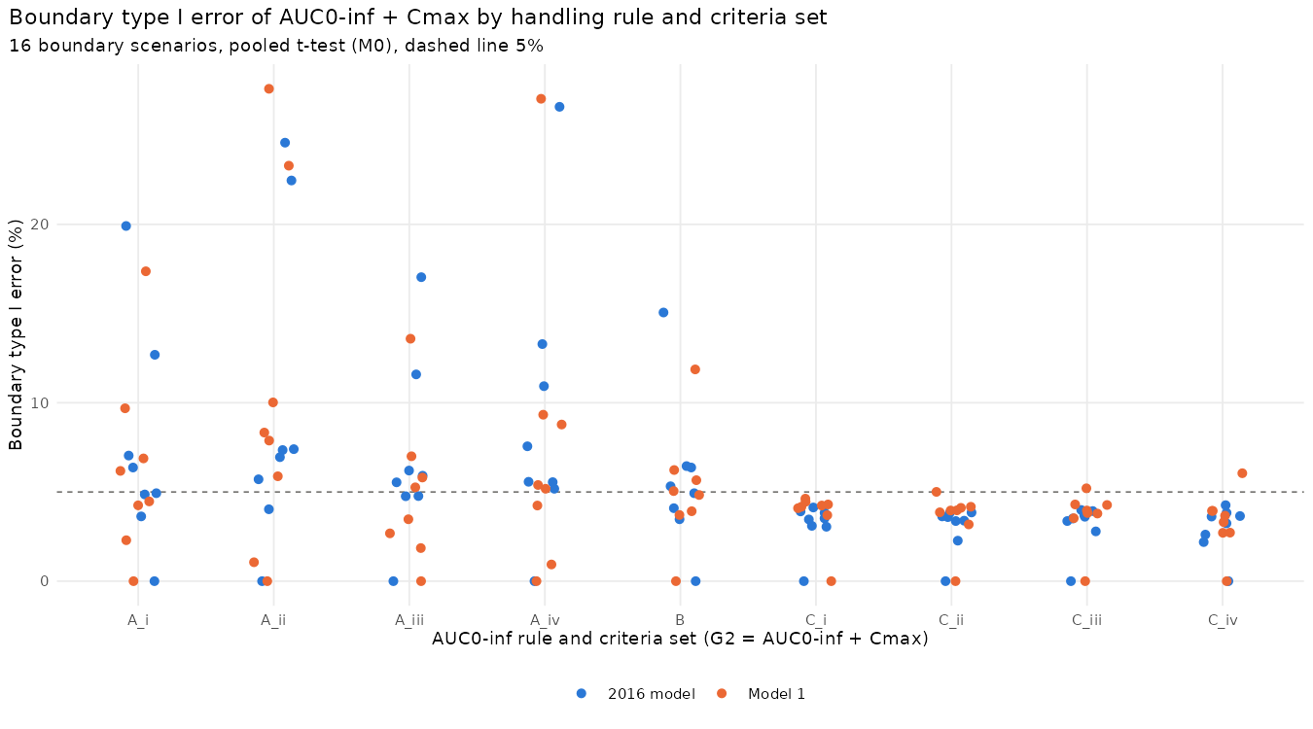
Figure 5-8. Boundary type I error of AUC0-inf + Cmax by handling rule and criteria set, 16 boundary scenarios, pooled t-test (M0); dashed line 5%. Analysis figure results/criteria/fig_criteria_g2.png.

Power and comparison of configurations
Power:
- For identical products, power is 99.6% (95% CI 99.4 to 99.7) for AUC0-last + Cmax and 99.3% (95% CI 99.2 to 99.5) for AUC0-inf (rule A, criteria (ii)) + Cmax in the primary model. In the 2020 model the values are 99.0% (95% CI 98.8 to 99.2) and 98.9% (95% CI 98.7 to 99.1).
- At true AUC0-inf ratios of 0.95 or 1.05, power for AUC0-last + Cmax ranges from 52.4 to 97.3% (primary model) and from 34.0 to 94.8% (2020 model), depending on the mechanism. It is lowest when absorption is faster (ka increased to a true AUC0-inf ratio of 1.05, true Cmax ratio 1.19 to 1.21), because Cmax then changes more than AUC.
Adding AUC0-inf (rule A, criteria (ii)) as a third co-primary endpoint:
- It prevents passing in only 0.00 to 4.23 percentage points of boundary trials.
- It causes additional failures in up to 20.50 percentage points of trials of products whose true AUC0-inf ratio is inside the limits.

5.5 Random product space (secondary metric)
These risks depend on the assumed distribution of virtual products and are not used for the primary judgement. Consumer risk is the share of products with a true AUC0-inf ratio outside the limits that pass; producer risk is the share of products inside the limits that fail. Near the boundaries means true ratios of 0.75 to 0.80 and 1.25 to 1.33 for consumer risk, and 0.80 to 0.85 and 1.18 to 1.25 for producer risk.
Table 5-13. Consumer and producer risk in the random product space (20,000 products per model, one trial each).
Model | Configuration | Risk | Scope | % [95% CI] | Products
2016 model | AUC0-inf + Cmax, rule A, criteria (ii) (guidance default as pre-specified) | consumer | all | 1.08 [0.88, 1.32] | 8,540
2016 model | AUC0-last + AUC0-inf + Cmax, rule A, criteria (ii) | consumer | all | 0.12 [0.06, 0.22] | 8,540
2016 model | AUC0-last + AUC0-inf + Cmax, rule C, criteria (ii) | consumer | all | 0.14 [0.08, 0.25] | 8,540
2016 model | AUC0-last + Cmax (proposed) | consumer | all | 0.14 [0.08, 0.25] | 8,540
2016 model | AUC0-inf + Cmax, rule A, criteria (ii) (guidance default as pre-specified) | consumer | near boundary | 3.42 [2.78, 4.21] | 2,483
2016 model | AUC0-last + AUC0-inf + Cmax, rule A, criteria (ii) | consumer | near boundary | 0.40 [0.22, 0.74] | 2,483
2016 model | AUC0-last + AUC0-inf + Cmax, rule C, criteria (ii) | consumer | near boundary | 0.48 [0.28, 0.84] | 2,483
2016 model | AUC0-last + Cmax (proposed) | consumer | near boundary | 0.48 [0.28, 0.84] | 2,483
2016 model | AUC0-inf + Cmax, rule A, criteria (ii) (guidance default as pre-specified) | producer | all | 45.42 [44.51, 46.33] | 11,460
2016 model | AUC0-last + AUC0-inf + Cmax, rule A, criteria (ii) | producer | all | 52.57 [51.65, 53.48] | 11,460
2016 model | AUC0-last + AUC0-inf + Cmax, rule C, criteria (ii) | producer | all | 49.84 [48.93, 50.76] | 11,460
2016 model | AUC0-last + Cmax (proposed) | producer | all | 49.59 [48.67, 50.51] | 11,460
2016 model | AUC0-inf + Cmax, rule A, criteria (ii) (guidance default as pre-specified) | producer | near boundary | 81.54 [80.05, 82.94] | 2,763
2016 model | AUC0-last + AUC0-inf + Cmax, rule A, criteria (ii) | producer | near boundary | 92.47 [91.43, 93.40] | 2,763
2016 model | AUC0-last + AUC0-inf + Cmax, rule C, criteria (ii) | producer | near boundary | 90.84 [89.71, 91.86] | 2,763
2016 model | AUC0-last + Cmax (proposed) | producer | near boundary | 90.73 [89.60, 91.76] | 2,763
2020 Model 1 | AUC0-inf + Cmax, rule A, criteria (ii) (guidance default as pre-specified) | consumer | all | 1.39 [1.17, 1.67] | 8,460
2020 Model 1 | AUC0-last + AUC0-inf + Cmax, rule A, criteria (ii) | consumer | all | 0.13 [0.07, 0.23] | 8,460
2020 Model 1 | AUC0-last + AUC0-inf + Cmax, rule C, criteria (ii) | consumer | all | 0.17 [0.10, 0.28] | 8,460
2020 Model 1 | AUC0-last + Cmax (proposed) | consumer | all | 0.18 [0.11, 0.29] | 8,460
2020 Model 1 | AUC0-inf + Cmax, rule A, criteria (ii) (guidance default as pre-specified) | consumer | near boundary | 4.44 [3.70, 5.32] | 2,498
2020 Model 1 | AUC0-last + AUC0-inf + Cmax, rule A, criteria (ii) | consumer | near boundary | 0.44 [0.25, 0.79] | 2,498
2020 Model 1 | AUC0-last + AUC0-inf + Cmax, rule C, criteria (ii) | consumer | near boundary | 0.52 [0.30, 0.89] | 2,498
2020 Model 1 | AUC0-last + Cmax (proposed) | consumer | near boundary | 0.56 [0.33, 0.94] | 2,498
2020 Model 1 | AUC0-inf + Cmax, rule A, criteria (ii) (guidance default as pre-specified) | producer | all | 46.20 [45.29, 47.11] | 11,540
2020 Model 1 | AUC0-last + AUC0-inf + Cmax, rule A, criteria (ii) | producer | all | 54.02 [53.11, 54.93] | 11,540
2020 Model 1 | AUC0-last + AUC0-inf + Cmax, rule C, criteria (ii) | producer | all | 51.15 [50.24, 52.06] | 11,540
2020 Model 1 | AUC0-last + Cmax (proposed) | producer | all | 50.94 [50.02, 51.85] | 11,540
2020 Model 1 | AUC0-inf + Cmax, rule A, criteria (ii) (guidance default as pre-specified) | producer | near boundary | 80.37 [78.85, 81.81] | 2,756
2020 Model 1 | AUC0-last + AUC0-inf + Cmax, rule A, criteria (ii) | producer | near boundary | 91.69 [90.60, 92.66] | 2,756
2020 Model 1 | AUC0-last + AUC0-inf + Cmax, rule C, criteria (ii) | producer | near boundary | 90.31 [89.15, 91.36] | 2,756
2020 Model 1 | AUC0-last + Cmax (proposed) | producer | near boundary | 90.13 [88.96, 91.19] | 2,756

5.6 Target binding (Km)
A 100-fold range of the Michaelis-Menten constant of target-mediated elimination (Km; not the binding affinity itself) in either direction (Km x0.01 to x100 in the test arm) moves the true AUC0-inf ratio only within 0.999 to 1.059, in both models. Of the 12 pre-specified target ratios (0.70 to 1.43), only 1.05 is reachable, at Km x84 (primary model) and x92 (2020 model).
Differences in target binding therefore cannot be detected by AUC0-last, by AUC0-inf or by Cmax, and the choice between AUC endpoints does not affect sensitivity to binding. Binding similarity must be demonstrated by the comparative analytical assessment (binding kinetics and functional assays).

5.7 Sampling schedule
Table 5-14. Decision criteria for added samples (set before any result was reported) versus the planned schedule (20,000 subjects and 500 trials per model; B-minus removes Day 50).
Model | Schedule | Added visits | (a) CI width change (%, negative = wider) | (b) ke x1.10 pass change (points) | (c) reliability change, set (ii) (points) | (d) share with extrapolation above 20%, ratio to planned | Recommend
Primary model | Bminus | -260 | 0.69 | 0.2 | -1.82 | 1.29 | no
Primary model | D1 | 520 | -0.39 | -0.4 | -0.60 | 0.92 | no
Primary model | D2 | 780 | -0.47 | -0.4 | -0.27 | 0.93 | no
Primary model | D3 | 1,040 | -0.13 | -0.2 | 1.69 | 0.60 | no
Primary model | D4 | 520 | -0.40 | 0.0 | -0.83 | 0.93 | no
2020 Model 1 | Bminus | -260 | 0.87 | 0.4 | -3.18 | 1.29 | no
2020 Model 1 | D1 | 520 | -0.32 | -0.4 | -3.11 | 0.97 | no
2020 Model 1 | D2 | 780 | -0.43 | -0.4 | -2.29 | 0.97 | no
2020 Model 1 | D3 | 1,040 | 0.06 | 0.0 | -1.94 | 0.69 | no
2020 Model 1 | D4 | 520 | -0.34 | -0.4 | -3.50 | 0.97 | no
The results below cover both models and all six sensitivity variants: Vmax x0.8 and x1.25 in both arms, variances x1.5, proportional residual error of 12%, an alternative weight distribution, and an ADA-like subgroup.
Decision criteria:
- At 20,000 subjects, the rule recommends added samples in 1 schedule and variant combination (Vmax x0.8 (both arms), schedule D3), on criterion (d) alone. Re-evaluated in 200,000 subjects, criterion (d) was not met.
- Criterion (c) is not met under either criteria set. For the D3 schedule, with four added samples, reliability changes by 2.76 points under set (i) [1.69 under set (ii)] in the 2016 model, and 1.24 points under set (i) [-1.94 under set (ii)] in the 2020 Model 1, against the 5-point threshold.
Effect of added samples:
- The AUC0-last CI does not become meaningfully narrower (largest decrease 0.37% against the 2% criterion; most added-sampling schedules widen it slightly). Adding tail samples lengthens tlast and adds variability from the tail area.
- The planned schedule is retained.
- Removing Day 50 is not recommended. It would narrow the CI by only 0.24 to 1.02% (below the 2% threshold of criterion (a)), while the share of subjects with NCA extrapolation above 20% would be 1.04 to 2.45 times that of the planned schedule, weakening AUC0-inf as a secondary endpoint.

5.8 Body weight outside the trial population
The endpoint proposal rests on the trial population: healthy adults of 60 to 90 kg, randomized within two body-weight strata (Sections 5.2 to 5.4). Results for body weights outside this range (uniform bands from 40 to 150 kg, a population with a mean of 100 kg, and a body-weight distribution of adults with atopic dermatitis) are robustness checks and are not part of the evidence. They are reported in Appendix I.

5.9 Analysis model: pooled t-test versus stratified ANOVA
Table 5-15. Boundary type I error in the 16 boundary scenarios by analysis model (Wilson 95% intervals; classification versus 5%).
Configuration | Model | Range (%) | Conservative / nominal / exceeding | Above 5% (point) | Largest (95% CI)
AUC0-last + Cmax (P2, proposed) | M0 | 0.00 to 5.18 | 15 / 1 / 0 | 1 | 5.18 [4.88, 5.50], 2020 V2 up
AUC0-last + Cmax (P2, proposed) | M1 | 0.00 to 5.63 | 15 / 0 / 1 | 1 | 5.63 [5.31, 5.95], 2020 V2 up
AUC0-last + Cmax (P2, proposed) | M2 | 0.00 to 5.75 | 15 / 0 / 1 | 1 | 5.75 [5.43, 6.08], 2020 V2 up
true AUC0-inf alone (unbiased reference) | M0 | 4.12 to 5.43 | 9 / 6 / 1 | 2 | 5.43 [5.00, 5.89], 2020 ka down
true AUC0-inf alone (unbiased reference) | M1 | 4.53 to 5.83 | 1 / 13 / 2 | 7 | 5.83 [5.39, 6.31], 2020 ka down
true AUC0-inf alone (unbiased reference) | M2 | 4.54 to 5.81 | 1 / 13 / 2 | 7 | 5.81 [5.37, 6.29], 2020 ka down
AUC0-last alone | M0 | 2.25 to 5.20 | 13 / 3 / 0 | 2 | 5.20 [4.90, 5.51], 2020 V2 up
AUC0-last alone | M1 | 2.54 to 5.65 | 13 / 1 / 2 | 3 | 5.65 [5.33, 5.97], 2020 V2 up
AUC0-last alone | M2 | 2.61 to 5.77 | 13 / 1 / 2 | 3 | 5.77 [5.46, 6.10], 2020 V2 up
AUC0-inf rule A (ii) + Cmax | M0 | 0.00 to 27.60 | 4 / 0 / 12 | 12 | 27.60 [26.73, 28.48], 2020 Vmax down
AUC0-inf rule A (ii) + Cmax | M1 | 0.00 to 27.44 | 4 / 0 / 12 | 12 | 27.44 [26.57, 28.32], 2020 Vmax down
AUC0-inf rule A (ii) + Cmax | M2 | 0.00 to 27.37 | 4 / 0 / 12 | 12 | 27.37 [26.50, 28.25], 2020 Vmax down
AUC0-inf rule A (i) + Cmax | M0 | 0.00 to 19.91 | 6 / 2 / 8 | 8 | 19.91 [19.14, 20.70], 2016 Vmax up
AUC0-inf rule A (i) + Cmax | M1 | 0.00 to 20.27 | 4 / 4 / 8 | 10 | 20.27 [19.49, 21.07], 2016 Vmax up
AUC0-inf rule A (i) + Cmax | M2 | 0.00 to 20.49 | 4 / 4 / 8 | 10 | 20.49 [19.71, 21.29], 2016 Vmax up
AUC0-inf rule B + Cmax | M0 | 0.00 to 15.06 | 6 / 4 / 6 | 8 | 15.06 [14.37, 15.77], 2016 Vmax up
AUC0-inf rule B + Cmax | M1 | 0.00 to 16.03 | 6 / 2 / 8 | 10 | 16.03 [15.32, 16.76], 2016 Vmax up
AUC0-inf rule B + Cmax | M2 | 0.00 to 16.31 | 5 / 3 / 8 | 10 | 16.31 [15.60, 17.05], 2016 Vmax up
AUC0-inf rule C (ii) + Cmax | M0 | 0.00 to 5.01 | 15 / 1 / 0 | 1 | 5.01 [4.71, 5.32], 2020 V2 up
AUC0-inf rule C (ii) + Cmax | M1 | 0.00 to 5.39 | 14 / 1 / 1 | 1 | 5.39 [5.09, 5.71], 2020 V2 up
AUC0-inf rule C (ii) + Cmax | M2 | 0.00 to 5.51 | 15 / 0 / 1 | 1 | 5.51 [5.20, 5.83], 2020 V2 up
AUC0-inf rule C (i) + Cmax | M0 | 0.00 to 4.63 | 16 / 0 / 0 | 0 | 4.63 [4.34, 4.92], 2020 V2 up
AUC0-inf rule C (i) + Cmax | M1 | 0.00 to 5.06 | 11 / 5 / 0 | 1 | 5.06 [4.76, 5.37], 2020 V2 up
AUC0-inf rule C (i) + Cmax | M2 | 0.00 to 5.10 | 11 / 5 / 0 | 1 | 5.10 [4.80, 5.41], 2020 V2 up
AUC0-last + AUC0-inf rule A + Cmax | M0 | 0.00 to 3.03 | 16 / 0 / 0 | 0 | 3.03 [2.71, 3.38], 2020 F down
AUC0-last + AUC0-inf rule A + Cmax | M1 | 0.00 to 3.39 | 16 / 0 / 0 | 0 | 3.39 [3.05, 3.76], 2020 F down
AUC0-last + AUC0-inf rule A + Cmax | M2 | 0.00 to 3.41 | 16 / 0 / 0 | 0 | 3.41 [3.07, 3.78], 2020 F down
AUC0-last + AUC0-inf rule B + Cmax | M0 | 0.00 to 3.57 | 16 / 0 / 0 | 0 | 3.57 [3.32, 3.84], 2020 V2 up
AUC0-last + AUC0-inf rule B + Cmax | M1 | 0.00 to 3.95 | 16 / 0 / 0 | 0 | 3.95 [3.59, 4.35], 2020 F down
AUC0-last + AUC0-inf rule B + Cmax | M2 | 0.00 to 3.99 | 16 / 0 / 0 | 0 | 3.99 [3.73, 4.27], 2020 V2 up
AUC0-last + AUC0-inf rule C + Cmax | M0 | 0.00 to 4.76 | 15 / 1 / 0 | 0 | 4.76 [4.47, 5.06], 2020 V2 up
AUC0-last + AUC0-inf rule C + Cmax | M1 | 0.00 to 5.16 | 15 / 1 / 0 | 1 | 5.16 [4.86, 5.48], 2020 V2 up
AUC0-last + AUC0-inf rule C + Cmax | M2 | 0.00 to 5.27 | 15 / 1 / 0 | 1 | 5.27 [4.96, 5.58], 2020 V2 up
- Classification of P2. M0: 15 conservative, 1 nominal, 0 exceeding (0.00% to 5.18%). M1: 15, 0, 1 (0.00% to 5.63%). M2: 15, 0, 1 (0.00% to 5.75%).
- Cells above 5%. 2020 model, peripheral volume (V2) up (multiplier 2.28), true AUC0-inf ratio 0.7998: M0 5.18% (95% CI 4.88 to 5.50), nominal; M1 5.63% (95% CI 5.31 to 5.95), exceeding; M2 5.75% (95% CI 5.43 to 6.08), exceeding. Quantitative cause: under M0 the AUC0-last GMR is biased by 0.41% relative to the true AUC0-inf ratio (toward 1), which moves the pass rate from 4.59% for the unbiased reference to 5.20% for AUC0-last alone; Cmax failures change it by -0.02 percentage points; under M1 the AUC0-last GMR is biased by 0.41% relative to the true AUC0-inf ratio (toward 1), which moves the pass rate from 4.94% for the unbiased reference to 5.65% for AUC0-last alone; Cmax failures change it by -0.02 percentage points; under M2 the AUC0-last GMR is biased by 0.41% relative to the true AUC0-inf ratio (toward 1), which moves the pass rate from 4.97% for the unbiased reference to 5.77% for AUC0-last alone; Cmax failures change it by -0.03 percentage points.
- Why the models differ. The randomization balances the arms within the weight strata, so the treatment difference in means is free of the between-stratum variance. The pooled t-test nevertheless includes that variance in its standard error. The between-trial SD of the log GMR divided by the median within-trial SE of the unbiased reference is 0.961 to 0.993 under M0, 0.991 to 1.020 under M1 and 0.991 to 1.021 under M2; for AUC0-last it is 0.965 to 1.001, 0.992 to 1.026 and 0.992 to 1.028. With an SE that matches the sampling variability, the unbiased reference passes in 4.53% to 5.83% of trials under M1 (theoretical value at a true ratio at the limit: just below 5%), against 4.12% to 5.43% under M0.
- Power of P2. Identical products: 99.6% (95% CI 99.4 to 99.7) (M0) and 99.7% (95% CI 99.5 to 99.7) (M1) in the primary model, 99.0% (95% CI 98.8 to 99.2) and 99.2% (95% CI 99.0 to 99.3) in the 2020 model. Bioavailability x0.97: 96.8% (95% CI 96.4 to 97.1) and 97.1% (95% CI 96.7 to 97.4); 94.7% (95% CI 94.2 to 95.1) and 95.3% (95% CI 94.9 to 95.7).
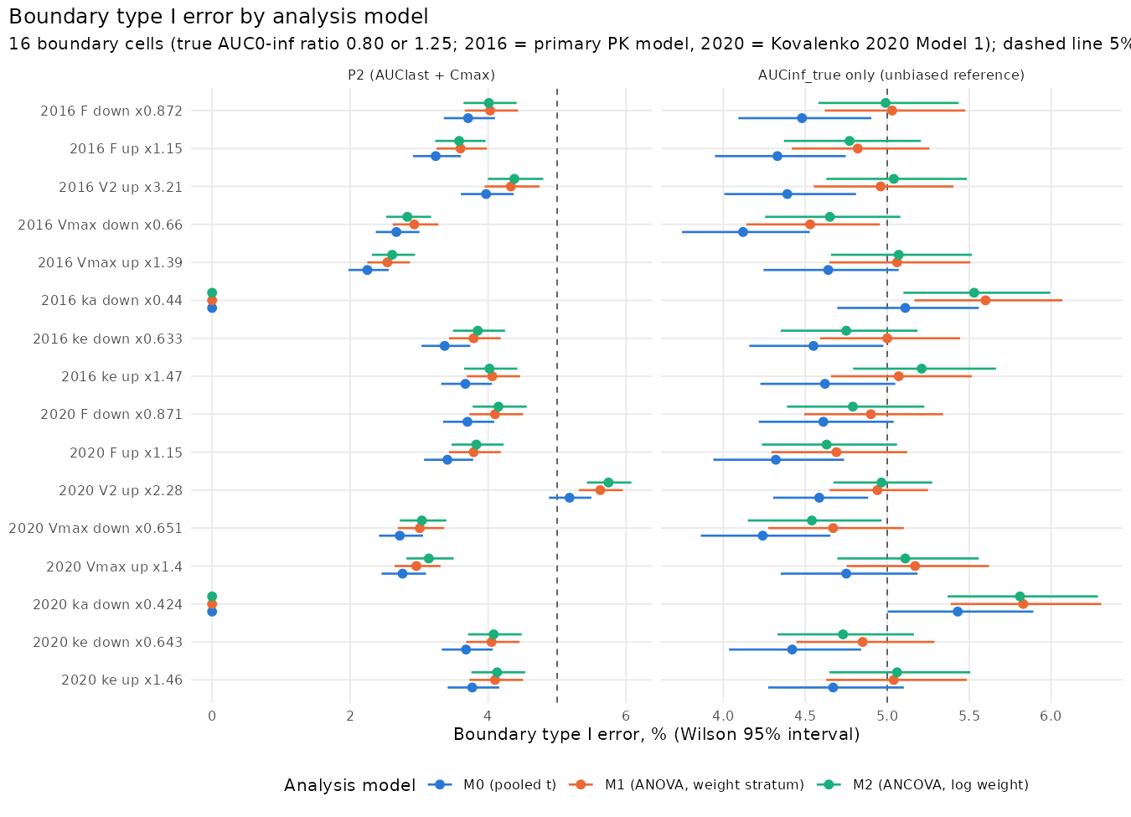
Figure 5-9. Boundary type I error of AUC0-last + Cmax and of the unbiased reference by analysis model, 16 boundary scenarios (Wilson 95% intervals). Analysis figure results/oc_models/fig_type1_models.png.
Table 5-16. Expectations of the sponsor’s clinical pharmacology recorded before the results, with the numeric criteria registered before any result was read.
Expectation | Criterion (registered before results) | Observed | Consistent
M1: unbiased reference (AUCinf_true only) close to 5% | pooled 16-cell Wilson 95% interval includes 5% and every cell within 4-6% | pooled 5.01% [4.90, 5.11]; cells 4.53 to 5.83% (M0 4.12 to 5.43%) | yes
M1: between-trial SD / within-trial SE close to 1 | every cell within 0.97-1.03 (AUCinf_true) | M1 0.991 to 1.020 (M0 0.961 to 0.993) | yes
P2 rises slightly under M1 | M1 minus M0 > 0 in at least 14 of 16 cells and mean rise above 0 and at most 1.5 points | M1 minus M0 > 0 in 14 of 16 cells; mean +0.30 points (range +0.00 to +0.45) | yes
Model 1 V2 x2.28 cell about 5.6% under M1 (exceeding) | point estimate within 5.6 +/- 0.3% | 5.63% [5.31, 5.95], exceeding, 20,000 trials (M0 5.18% [4.88, 5.50], nominal) | yes
Note to Table 5-16: in 2 boundary cells (absorption rate down), Cmax fails in every trial, so AUC0-last + Cmax passes in no trial under any analysis model and cannot rise; the registered criterion counts these cells as not rising.

5.10 Sensitivity to the assay LLOQ
Table 5-17. Individual-level metrics by LLOQ (planned schedule, 60 to 90 kg, 20,000 subjects per model, same subjects and residual draws; residual error as estimated). Cliff columns: cliff populations, nominal days, 1-day definition.
Model | LLOQ (mg/L) | Reliable (i) (%) | Reliable (ii) (%) | Lambda-z not estimable (%) | Window coverage below 80% (%) | True extrapolation, median (%) | tlast, median (days) | LLOQ reached, study day | 2 or more cliff samples (%)
2016 | 0.020 | 84.2 | 80.9 | 0.73 | 0.00 | 0.03 | 41.6 | 38.6 | 0.0
2016 | 0.050 | 86.0 | 80.9 | 1.31 | 0.00 | 0.50 | 35.0 | 38.5 | 0.0
2016 | 0.078 | 86.6 | 80.7 | 1.46 | 0.00 | 0.65 | 34.7 | 38.5 | 0.0
2016 | 0.100 | 86.9 | 80.9 | 1.48 | 0.00 | 0.69 | 34.7 | 38.4 | 0.0
2016 | 0.200 | 87.7 | 81.1 | 1.57 | 0.00 | 0.76 | 34.6 | 38.2 | 0.0
2016 | 0.500 | 88.0 | 79.8 | 1.88 | 0.01 | 1.00 | 34.5 | 37.7 | 0.0
2020 | 0.020 | 85.9 | 81.4 | 0.28 | 0.00 | 0.05 | 42.2 | 40.9 | 0.0
2020 | 0.050 | 90.4 | 83.4 | 0.55 | 0.00 | 0.51 | 35.7 | 40.8 | 0.0
2020 | 0.078 | 91.8 | 83.9 | 0.62 | 0.00 | 0.64 | 35.4 | 40.8 | 0.0
2020 | 0.100 | 92.3 | 84.1 | 0.64 | 0.00 | 0.67 | 35.3 | 40.7 | 0.0
2020 | 0.200 | 93.6 | 84.6 | 0.68 | 0.00 | 0.74 | 35.3 | 40.5 | 0.0
2020 | 0.500 | 95.0 | 83.6 | 0.83 | 0.00 | 0.96 | 35.1 | 40.0 | 0.0

Table 5-18. Boundary type I error (%) by LLOQ (columns, mg/L), primary PK model, 5,000 trials per cell, residual error as estimated.
Scenario | Model | Configuration | 0.02 | 0.05 | 0.078 | 0.1 | 0.2 | 0.5
F_down_080 | M0 | AUC0-inf A (ii) + Cmax | 6.74 | 7.34 | 7.60 | 7.58 | 8.10 | 8.60
F_down_080 | M0 | AUC0-inf B + Cmax | 5.38 | 6.60 | 6.94 | 7.04 | 7.30 | 7.48
F_down_080 | M0 | P2 | 4.22 | 4.12 | 3.98 | 3.96 | 4.02 | 3.86
F_down_080 | M1 | AUC0-inf A (ii) + Cmax | 6.84 | 7.72 | 8.26 | 8.36 | 8.56 | 9.14
F_down_080 | M1 | AUC0-inf B + Cmax | 5.78 | 7.06 | 7.40 | 7.36 | 7.78 | 8.16
F_down_080 | M1 | P2 | 4.62 | 4.36 | 4.36 | 4.36 | 4.34 | 4.30
Vmax_down_125 | M0 | AUC0-inf A (ii) + Cmax | 14.96 | 21.82 | 25.28 | 26.18 | 27.22 | 28.70
Vmax_down_125 | M0 | AUC0-inf B + Cmax | 3.58 | 5.80 | 6.74 | 6.80 | 7.10 | 7.94
Vmax_down_125 | M0 | P2 | 2.92 | 2.58 | 2.56 | 2.54 | 2.48 | 2.46
Vmax_down_125 | M1 | AUC0-inf A (ii) + Cmax | 14.98 | 22.26 | 25.52 | 26.08 | 27.34 | 28.52
Vmax_down_125 | M1 | AUC0-inf B + Cmax | 3.92 | 6.36 | 7.36 | 7.36 | 7.58 | 8.66
Vmax_down_125 | M1 | P2 | 3.20 | 2.90 | 2.86 | 2.82 | 2.78 | 2.82
Vmax_up_080 | M0 | AUC0-inf A (ii) + Cmax | 12.26 | 18.60 | 22.28 | 23.02 | 23.66 | 24.68
Vmax_up_080 | M0 | AUC0-inf B + Cmax | 7.54 | 13.22 | 15.26 | 15.70 | 16.24 | 17.54
Vmax_up_080 | M0 | P2 | 3.02 | 2.44 | 2.32 | 2.26 | 2.24 | 2.22
Vmax_up_080 | M1 | AUC0-inf A (ii) + Cmax | 12.48 | 18.58 | 22.28 | 23.04 | 23.86 | 24.76
Vmax_up_080 | M1 | AUC0-inf B + Cmax | 8.06 | 13.94 | 16.20 | 16.56 | 17.12 | 18.36
Vmax_up_080 | M1 | P2 | 3.38 | 2.80 | 2.66 | 2.64 | 2.60 | 2.62
- With the residual error as estimated, lowering the LLOQ below 0.078 mg/L lets measurement noise near zero become quantifiable (additive SD 0.03 mg/L): reliability under criteria (i) is 84.2% at 0.02 mg/L against 86.6% at 0.078 mg/L in the primary model. With the additive error scaled with the LLOQ (constant precision at the LLOQ) it is 84.6%.
- Window coverage does not depend materially on the LLOQ in this range: window coverage below 80% in 0.00% (0.02 mg/L) to 0.01% (0.5 mg/L) of subjects, median true extrapolation 0.03% to 1.00%, because the true concentration falls through the whole range within the cliff (LLOQ reached at a median of study Day 38.6 at 0.02 mg/L and Day 37.7 at 0.5 mg/L).
- Boundary type I error of P2 across the LLOQs: 2.22% to 4.22% (M0) and 2.60% to 4.62% (M1); AUC0-inf (rule A, criteria (ii)) + Cmax 6.74% to 28.70% and 6.84% to 28.52%; rule B + Cmax 3.58% to 17.54% and 3.92% to 18.36%.
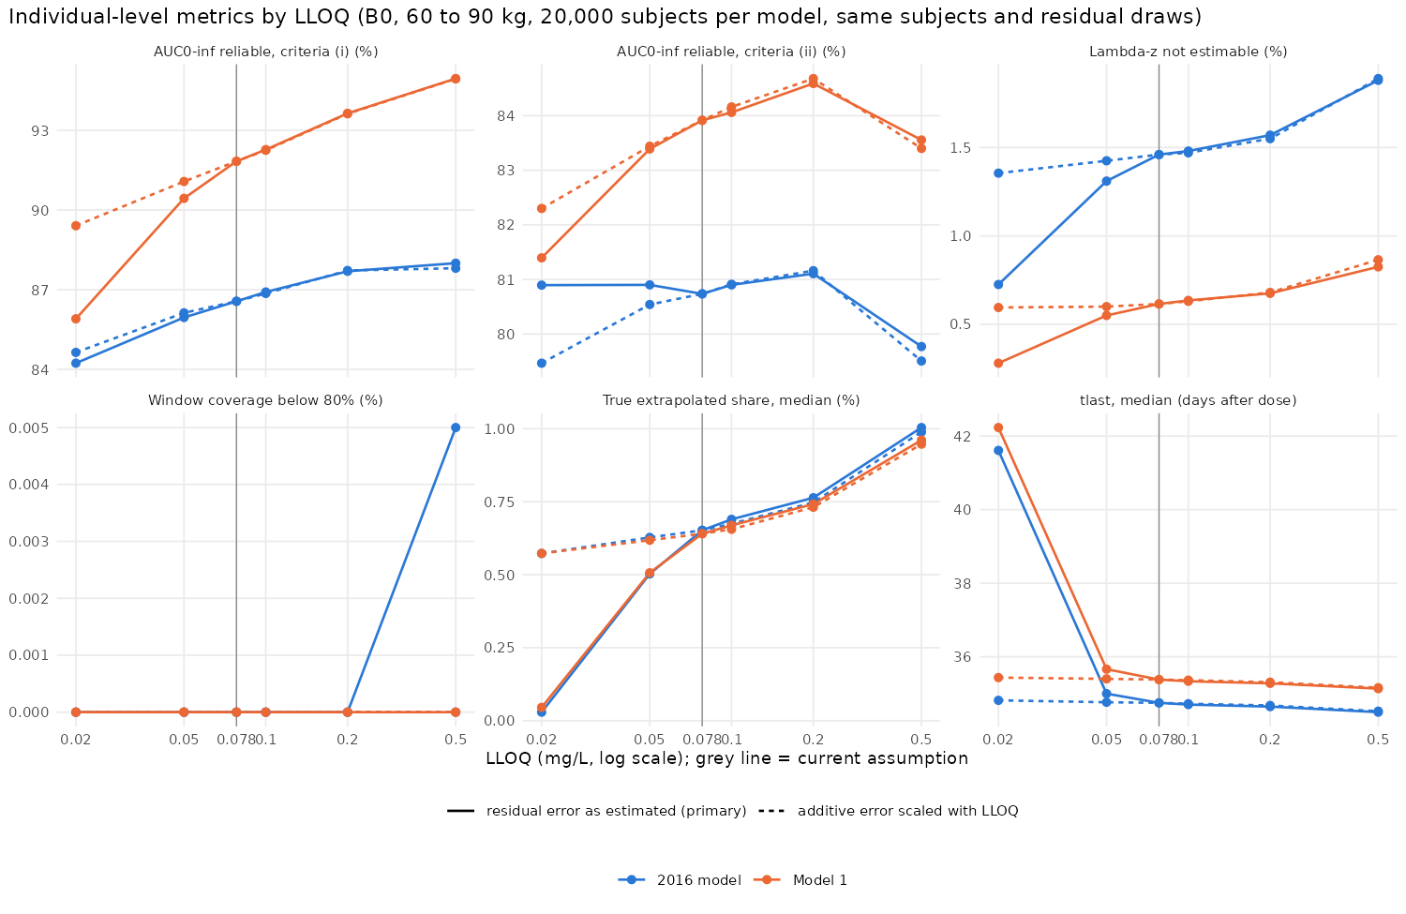
Figure 5-10. Individual-level metrics by LLOQ, both models, residual error as estimated and scaled. Analysis figure results/lloq/fig_lloq_individual.png.

5.11 Sample size
Table 5-19. Evaluable subjects per arm (randomized per arm, 117/130 evaluable) for 90% and 85% P2 power at a true GMR of 0.95 for both endpoints; Cmax CV and correlation from the primary model.
AUC0-last CV (%) | 90%, M0 | 90%, M1 | 85%, M0 | 85%, M1
35 | 76 (85) | 73 (82) | 65 (73) | 63 (70)
40 | 89 (99) | 87 (97) | 77 (86) | 74 (83)
43 | 100 (112) | 97 (108) | 85 (95) | 83 (93)
46 | 112 (125) | 109 (122) | 95 (106) | 93 (104)
50 | 129 (144) | 126 (140) | 110 (123) | 107 (119)
52 | 138 (154) | 135 (150) | 118 (132) | 115 (128)
- Inputs from the primary model (planned schedule, 60 to 90 kg): Cmax log-scale CV 34.3%, correlation of log AUC0-last and log Cmax 0.75, the weight stratum explaining 5.5% of the AUC0-last variance.
- With 117 evaluable subjects per arm, P2 power at GMR 0.95 is 94.0% (M0) and 94.5% (M1) at CV 43%, and 87.2% and 88.0% at CV 50%.
- The analytic approximation lies inside the Wilson 95% interval of the statistical simulation (5,000 trials per cell) in 277 of 288 grid cells (largest difference 1.50 percentage points). Against PK-model trials with 117 evaluable subjects per arm at the models’ own CV (both models, M0 and M1), it is within 0.61 percentage points of the empirical power at true GMRs of 0.95 (the GMR of Table 5-19) and 1.00, and higher than the empirical power by 1.15 to 2.48 percentage points at a true GMR of 0.90 (results/sample_size/ss_power_mc.csv, ss_pk_check.csv).
- CV sources: Li 2020 (Table 3, 300 mg arms, SD/mean 35% to 51%), Cohen 2022 (about 52%; 200 mg, a different presentation, device comparison), the PK models (40% and 43%).
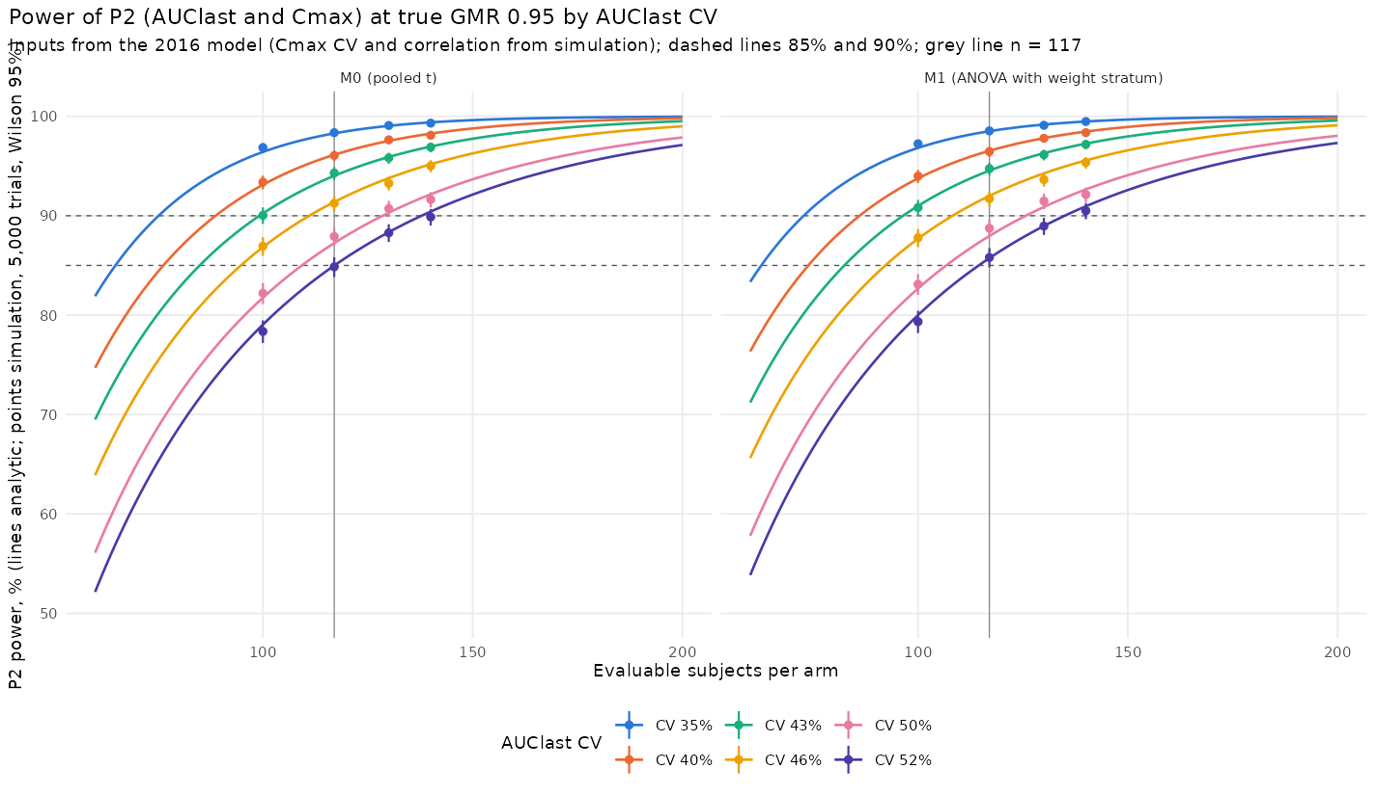
Figure 5-11. P2 power at a true GMR of 0.95 by evaluable subjects per arm and AUC0-last CV, M0 and M1 (lines analytic, points simulation). Analysis figure results/sample_size/fig_ss_power.png.

6. Discussion

6.1 The estimand and the choice of AUC0-last
The relevant quantity for PK similarity is total exposure, the ratio of the population geometric means of AUC0-inf. For dupilumab under the planned schedule, AUC0-last differs from AUC0-inf by less than 1% in the median subject. As an estimator of the true AUC0-inf ratio, the AUC0-last ratio is biased by at most 1.5% across the boundary scenarios, and in 15 of 16 scenarios the bias points away from 1.
NCA AUC0-inf, by contrast, estimates a quantity that is not observed. Its extrapolated part is about 4.2 times the true tail at the median and is estimated in the same way in both arms, which dilutes differences. Its subject-level reliability criteria remove a non-random subset of subjects.
AUC0-inf is therefore not a better measure of total exposure than AUC0-last for this product. Used as the primary endpoint, it fails to control the probability of concluding similarity at the equivalence limits in 8 to 12 of the 16 boundary scenarios with the pooled t-test (10 to 12 with the weight stratum in the model), under the handling rules that are usual in practice (rule A under either criteria set, or rule B).

6.2 Boundary cells above 5%
2020 model, peripheral volume (V2) up (multiplier 2.28), true AUC0-inf ratio 0.7998: M0 5.18% (95% CI 4.88 to 5.50), nominal; M1 5.63% (95% CI 5.31 to 5.95), exceeding; M2 5.75% (95% CI 5.43 to 6.08), exceeding. Quantitative cause: under M0 the AUC0-last GMR is biased by 0.41% relative to the true AUC0-inf ratio (toward 1), which moves the pass rate from 4.59% for the unbiased reference to 5.20% for AUC0-last alone; Cmax failures change it by -0.02 percentage points; under M1 the AUC0-last GMR is biased by 0.41% relative to the true AUC0-inf ratio (toward 1), which moves the pass rate from 4.94% for the unbiased reference to 5.65% for AUC0-last alone; Cmax failures change it by -0.02 percentage points; under M2 the AUC0-last GMR is biased by 0.41% relative to the true AUC0-inf ratio (toward 1), which moves the pass rate from 4.97% for the unbiased reference to 5.77% for AUC0-last alone; Cmax failures change it by -0.03 percentage points.
Facts relevant to the plausibility of this mechanism: a proposed biosimilar has the same amino-acid sequence as the reference IgG4 antibody; the cell corresponds to a peripheral volume of distribution 2.28 times that of the reference in the 2020 model (3.21 times in the primary model for the same true AUC0-inf ratio), with absorption and clearance unchanged. Under M0, the Wilson interval at the pre-specified 10,000 trials was 5.32% (95% CI 4.90 to 5.78); the 20,000-trial extension was decided after that result was known (Appendix D). Both values are reported. Under M1 the value at 10,000 trials was 5.74% (95% CI 5.30 to 6.21), already above 5%; the cell was extended for both analysis models together, as registered.

6.3 AUC0-inf as a secondary endpoint
The sponsor proposes to report AUC0-inf as a secondary endpoint:
- AUCINF_obs with Best Fit lambda-z;
- the reliability criteria of set (i) (adjusted R-squared at least 0.80, extrapolation at most 20%) as the primary definition, with set (iii) (adjusted R-squared at least 0.90) reported alongside, because both are conventional and the software applies neither by default (Section 3.4);
- the GMR and 90% CI, both in all subjects with an estimable lambda-z and in subjects meeting the criteria;
- the number and characteristics (including body weight) of subjects excluded, by arm;
- the individual lambda-z windows as a listing.
AUC0-inf is not used for the equivalence decision.
A span-ratio criterion is not proposed. It penalizes denser late sampling (Section 5.3), and with a span of at least 3 half-lives (set (iv)) 65.9% to 72.5% of subjects of the study population would fail.
Rule C (substituting AUC0-last for subjects failing the criteria) may be pre-specified as a sensitivity analysis. Its boundary type I error is close to that of AUC0-last + Cmax under each analysis model (largest 5.01% (95% CI 4.71 to 5.32) under M0 and 5.39% (95% CI 5.09 to 5.71) under M1, in the same scenario).

6.4 Sampling schedule
The planned 13-sample schedule to Day 57 is retained. No added-sampling schedule met a decision criterion in either model (in one sensitivity variant, a criterion met at 20,000 subjects was not confirmed in 200,000), and the cliff cannot be sampled at feasible visit intervals. The last planned sample (Day 57) lies after the median time at which the true concentration reaches the LLOQ, and only 2.5% (primary model) to 4.6% (2020 model) of subjects remain above the LLOQ after Day 58. Extending sampling beyond Day 57 would therefore add few quantifiable samples.

6.5 Limitations and uncertainties
- Literature models. The models are published population models whose individual data were not available to the sponsor. They were used as published, and no parameter was re-estimated or tuned. Parameter uncertainty (an outer Monte Carlo layer) was not simulated. Structural uncertainty is represented by two models, and the conclusions are the same in both.
- Unobservable terminal curve. The terminal curve below the LLOQ cannot be observed, and Km is fixed in both models without between-subject variability. The Km and Vmax sensitivity analyses in both arms, and the Km inversion in the test arm, show that coverage and the operating characteristics do not depend on these assumptions within ranges consistent with the observed data.
- Cmax. Cmax is over-predicted (Section 4.2). The operating characteristics of Cmax itself are not the subject of this report.
- 200 mg presentation. The faster absorption of the 200 mg (175 mg/mL) presentation is not reproduced. The study uses the 300 mg (150 mg/mL, 2 mL) presentation, whose absorption timing and exposure are reproduced.
- Design placeholders. Several study-design inputs are placeholders pending confirmation (Appendix B), in particular the bioanalytical LLOQ of the sponsor’s assay (its effect between 0.02 and 0.5 mg/L is shown in Section 5.10, and the value is set in one configuration file for regeneration), the Day 1 post-dose sampling time, the visit windows, the weight distribution and the stratification.
- Analysis model. The primary analysis model (pooled t-test or ANOVA with the randomization stratum) is not yet selected; both are reported (Section 5.9).
- Body weight outside the trial population. The proposal is judged in the trial population of healthy adults of 60 to 90 kg. Results for heavier or lighter subjects and for an adult atopic dermatitis body-weight distribution (a placeholder built from published summaries) are robustness checks in Appendix I. The body-weight ranges of the models’ development data are not reported, so results above about 130 kg may be extrapolations.
- Manual lambda-z review. The automated Best Fit is simulated. In the study, a pharmacokineticist may review the lambda-z windows; this is not simulated.
- Dropout. Dropout is not simulated: 117 evaluable subjects per arm are assumed.
- Immunogenicity. Anti-drug antibodies are represented only by an ADA-like subgroup sensitivity analysis, not in the operating characteristics.
- Post hoc analyses are listed in Appendix D.

7. Conclusions
- Boundary scenarios in which AUC0-last + Cmax exceeds 5% (point estimate) under any analysis model: 2020 model, peripheral volume (V2) up (multiplier 2.28), true AUC0-inf ratio 0.7998: M0 5.18% (95% CI 4.88 to 5.50), nominal; M1 5.63% (95% CI 5.31 to 5.95), exceeding; M2 5.75% (95% CI 5.43 to 6.08), exceeding. Quantitative cause: under M0 the AUC0-last GMR is biased by 0.41% relative to the true AUC0-inf ratio (toward 1), which moves the pass rate from 4.59% for the unbiased reference to 5.20% for AUC0-last alone; Cmax failures change it by -0.02 percentage points; under M1 the AUC0-last GMR is biased by 0.41% relative to the true AUC0-inf ratio (toward 1), which moves the pass rate from 4.94% for the unbiased reference to 5.65% for AUC0-last alone; Cmax failures change it by -0.02 percentage points; under M2 the AUC0-last GMR is biased by 0.41% relative to the true AUC0-inf ratio (toward 1), which moves the pass rate from 4.97% for the unbiased reference to 5.77% for AUC0-last alone; Cmax failures change it by -0.03 percentage points. Facts relevant to plausibility are stated in Section 6.2.
- Under the planned schedule, AUC0-last captures essentially all of the total exposure to dupilumab after a 300 mg subcutaneous dose (median true extrapolation 0.65% and 0.64% in the two models), and this holds for assay LLOQs between 0.02 and 0.5 mg/L.
- In the trial population, a reliable AUC0-inf cannot be obtained in 8.2% to 13.4% of subjects under criteria set (i) and in 33.2% to 38.8% under criteria set (iii) (two models); the share under set (i) is the lower end of the conventional range. Rule A removes subjects with lower true exposure and more subjects of the heavier stratum, loses the stratified balance of body weight between the arms, and removes a different share of subjects in the two arms when the products differ (up to 12.3 percentage points under set (i)). The window coverage of AUC0-last is at least 84.3% in every subject, and the geometric mean of trial AUC0-last GMRs is within 0.012 of the true AUC0-inf ratio.
- With the pooled t-test (M0), AUC0-last + Cmax is 15 conservative, 1 nominal and 0 exceeding of 16 boundary cells; with the weight stratum in the model (M1), 15, 0 and 1. M1 corrects the standard error of M0, which ignores the stratified randomization. Power for identical products is 99.6% (95% CI 99.4 to 99.7) (M0) and 99.7% (95% CI 99.5 to 99.7) (M1) in the primary model.
- Configurations based on NCA AUC0-inf exceed 5% in 8 to 12 of 16 boundary scenarios with the pooled t-test (10 to 12 with the weight stratum in the model) under the usual handling rules, because of extrapolation and selection bias; under the stricter criteria set (iii), rule A exceeds 5% in 9 of 16 (M0), and the decision changes with the handling rule or criteria set in a median of 12.6% and up to 39.6% of trials per boundary scenario. They add little protection at the limits and cause additional failures of similar products.
- Differences in target binding, represented in this model by Km, do not change exposure enough to be detected by any PK endpoint.
- Additional samples between Day 36 and Day 50 are not justified. The planned schedule, including Day 50, is retained.
- At the protocol CV of 43%, 117 evaluable subjects per arm give P2 power of 94.0% (M0) and 94.5% (M1) at a true GMR of 0.95; at a CV of 50% power is 87.2% and 88.0%.
- The sponsor proposes AUC0-last and Cmax as co-primary endpoints, with AUC0-inf as a secondary endpoint with pre-specified lambda-z criteria. The primary analysis model, the assay LLOQ and the target power remain sponsor decisions.

8. References
- FDA. Clinical Pharmacology Data to Support a Demonstration of Biosimilarity to a Reference Product. Guidance for Industry. December 2016.
- FDA. Scientific Considerations in Demonstrating Biosimilarity to a Reference Product: Updated Recommendations for Assessing the Need for Comparative Efficacy Studies. Draft Guidance for Industry. October 2025.
- ICH. M15 General Principles for Model-Informed Drug Development. Step 4, 2026; FDA guidance for industry, 2026.
- Kovalenko P, et al. CPT Pharmacometrics Syst Pharmacol. 2016;5(11):617-624 (Table 2, “BLQ data included”).
- Kovalenko P, et al. Clin Pharmacol Drug Dev. 2020;9(6):756-767 (Table 1; Supplementary Table 2).
- Li Z, et al. Clin Pharmacol Drug Dev. 2020;9(6):742-755 (Tables 1 to 3; Figure 2).
- Clot PA, et al. Int Immunopharmacol. 2021;99:107985 (Tables 1, 3 and 5).
- Cohen S, et al. Clin Pharmacol Drug Dev. 2022;11(5):675-682 (Table 2).
- FDA. BLA 761055 (dupilumab) Clinical Pharmacology Review. 2016.
- Schuirmann DJ. A comparison of the two one-sided tests procedure and the power approach for assessing the equivalence of average bioavailability. J Pharmacokinet Biopharm. 1987;15:657-680.
- Wilson EB. Probable inference, the law of succession, and statistical inference. J Am Stat Assoc. 1927;22:209-212.
- R Core Team. R: A Language and Environment for Statistical Computing, version 4.3.3. Fidler M, et al. rxode2, version 5.1.7. Denney W, et al. PKNCA, version 0.12.1. Bae KS. NonCompart, version 0.8.4.
- FDA. Statistical Software Clarifying Statement. 2015.
Journal, volume, pages and tables of references 4 to 9 were verified by the analysis team; full titles are to be added by medical writing. The wording of references 1 to 3 should be re-checked against the current FDA and ICH versions before submission.

Appendix A. Parameter provenance
Table A-1. Model parameters, values and published sources (generated from the model configuration files).
Model | Parameter | Value | Unit | Status | Source
Kovalenko 2016 (primary) | Vc (central volume, L at 75 kg; V2 in Kovalenko 2016) | 2.74 | L | confirmed | Kovalenko 2016 Table 2 (V2, BLQ included)
Kovalenko 2016 (primary) | ke | 0.0459 | 1/day | confirmed | Kovalenko 2016 Table 2
Kovalenko 2016 (primary) | k12 (k23 in Kovalenko 2016; kcp in 2020) | 0.0652 | 1/day | confirmed | Kovalenko 2016 Table 2 (k23)
Kovalenko 2016 (primary) | k21 (k32 in Kovalenko 2016; kpc in 2020) | 0.129 | 1/day | confirmed | Kovalenko 2016 Table 2 (k32)
Kovalenko 2016 (primary) | ka | 0.254 | 1/day | confirmed | Kovalenko 2016 Table 2
Kovalenko 2016 (primary) | Vmax | 0.968 | mg/L/day | confirmed | Kovalenko 2016 Table 2
Kovalenko 2016 (primary) | Km | 0.01 | mg/L | confirmed | Kovalenko 2016 Table 2 (fixed)
Kovalenko 2016 (primary) | F | 0.607 | fraction | confirmed | Kovalenko 2016 Table 2
Kovalenko 2016 (primary) | Weight exponent on Vc | 0.705 |  | confirmed | Kovalenko 2016 Table 2
Kovalenko 2016 (primary) | Reference weight | 75 | kg | confirmed | Kovalenko 2016 Table 2
Kovalenko 2016 (primary) | IIV variance Vc | 0.0225 | log-scale variance | confirmed | Kovalenko 2016 Table 2 (V2)
Kovalenko 2016 (primary) | IIV variance ke | 0.131 | log-scale variance | confirmed | Kovalenko 2016 Table 2
Kovalenko 2016 (primary) | IIV variance ka | 0.251 | log-scale variance | confirmed | Kovalenko 2016 Table 2
Kovalenko 2016 (primary) | IIV variance Vmax | 0.0428 | log-scale variance | confirmed | Kovalenko 2016 Table 2
Kovalenko 2016 (primary) | IIV variance k12 | 0 | log-scale variance | confirmed | Kovalenko 2016 Table 2 (no IIV estimated)
Kovalenko 2016 (primary) | IIV variance k21 | 0 | log-scale variance | confirmed | Kovalenko 2016 Table 2 (no IIV estimated)
Kovalenko 2016 (primary) | IIV variance F | 0 | log-scale variance | confirmed | Kovalenko 2016 Table 2 (no IIV estimated)
Kovalenko 2016 (primary) | IIV variance Km | 0 | log-scale variance | confirmed | Km fixed; no IIV
Kovalenko 2016 (primary) | Residual proportional | 0.242 | fraction (SD) | confirmed | Kovalenko 2016 Table 2 (proportional 24.2% CV)
Kovalenko 2016 (primary) | Residual additive | 0.03 | mg/L (SD) | confirmed | Kovalenko 2016 Table 2 (additive 0.03 mg/L, fixed)
Kovalenko 2020 Model 1 (sensitivity) | Vc (central volume, L at 75 kg; V2 in Kovalenko 2016) | 2.48 | L | confirmed | Kovalenko 2020 Table 1 Model 1 (Vc)
Kovalenko 2020 Model 1 (sensitivity) | ke | 0.0534 | 1/day | confirmed | Kovalenko 2020 Table 1 Model 1
Kovalenko 2020 Model 1 (sensitivity) | k12 (k23 in Kovalenko 2016; kcp in 2020) | 0.213 | 1/day | confirmed | Kovalenko 2020 Table 1 Model 1 (kcp)
Kovalenko 2020 Model 1 (sensitivity) | k21 (k32 in Kovalenko 2016; kpc in 2020) | 0.31 | 1/day | confirmed | Kovalenko 2020 Table 1 Model 1 (kpc, derived from Mpc 0.686)
Kovalenko 2020 Model 1 (sensitivity) | ka | 0.256 | 1/day | confirmed | Kovalenko 2020 Table 1 Model 1
Kovalenko 2020 Model 1 (sensitivity) | MTT | 0.105 | day | confirmed | Kovalenko 2020 Table 1 Model 1
Kovalenko 2020 Model 1 (sensitivity) | n_transit | 3 |  | confirmed | Kovalenko 2020 Table 1 Model 1
Kovalenko 2020 Model 1 (sensitivity) | Vmax | 1.07 | mg/L/day | confirmed | Kovalenko 2020 Table 1 Model 1 (Vm)
Kovalenko 2020 Model 1 (sensitivity) | Km | 0.01 | mg/L | confirmed | Kovalenko 2020 Table 1 Model 1 (fixed; determined by likelihood profiling)
Kovalenko 2020 Model 1 (sensitivity) | F | 0.643 | fraction | confirmed | Kovalenko 2020 Table 1 Model 1
Kovalenko 2020 Model 1 (sensitivity) | Weight exponent on Vc | 0.711 |  | confirmed | Kovalenko 2020 Table 1 Model 1
Kovalenko 2020 Model 1 (sensitivity) | Reference weight | 75 | kg | confirmed | Kovalenko 2020 Model 1 (reference weight 75 kg)
Kovalenko 2020 Model 1 (sensitivity) | IIV variance Vc | 0.0369 | log-scale variance (SD 0.192) | confirmed | Kovalenko 2020 Supplementary Table 2 (Model 1; reported as SD, squared; covariances not reported, diagonal)
Kovalenko 2020 Model 1 (sensitivity) | IIV variance ke | 0.0812 | log-scale variance (SD 0.285) | confirmed | Kovalenko 2020 Supplementary Table 2 (Model 1; reported as SD, squared; covariances not reported, diagonal)
Kovalenko 2020 Model 1 (sensitivity) | IIV variance ka | 0.2247 | log-scale variance (SD 0.474) | confirmed | Kovalenko 2020 Supplementary Table 2 (Model 1; reported as SD, squared; covariances not reported, diagonal)
Kovalenko 2020 Model 1 (sensitivity) | IIV variance Vmax | 0.0557 | log-scale variance (SD 0.236) | confirmed | Kovalenko 2020 Supplementary Table 2 (Model 1; reported as SD, squared; covariances not reported, diagonal)
Kovalenko 2020 Model 1 (sensitivity) | IIV variance MTT | 0.2756 | log-scale variance (SD 0.525) | confirmed | Kovalenko 2020 Supplementary Table 2 (Model 1; reported as SD, squared; covariances not reported, diagonal)
Kovalenko 2020 Model 1 (sensitivity) | IIV variance k12 | 0 | log-scale variance (SD 0) | confirmed | not estimated in Kovalenko 2020 Model 1
Kovalenko 2020 Model 1 (sensitivity) | IIV variance k21 | 0 | log-scale variance (SD 0) | confirmed | not estimated in Kovalenko 2020 Model 1
Kovalenko 2020 Model 1 (sensitivity) | IIV variance F | 0 | log-scale variance (SD 0) | confirmed | not estimated in Kovalenko 2020 Model 1
Kovalenko 2020 Model 1 (sensitivity) | IIV variance Km | 0 | log-scale variance (SD 0) | confirmed | not estimated in Kovalenko 2020 Model 1
Kovalenko 2020 Model 1 (sensitivity) | Residual proportional | 0.15 | fraction (SD) | confirmed | Kovalenko 2020 Supplementary Table 2 (proportional 15.0%)
Kovalenko 2020 Model 1 (sensitivity) | Residual additive | 0.03 | mg/L (SD) | confirmed | Kovalenko 2020 Supplementary Table 2 (additive 0.03 mg/L, fixed)
both | LLOQ (study assay, config/assay.yaml) | 0.078 | mg/L | assumption for the sponsor’s assay | Clot 2021 section 2.4 (originator’s assay, the LLOQ of the data used to develop the PK models); placeholder until the sponsor’s validated assay LLOQ is fixed
Appendix I robustness check (adult atopic dermatitis body weight) | Body weight, primary distribution | lognormal mean 78 kg, SD 19 kg, 40 to 180 kg | kg | placeholder (assumption) | Kamal 2022 (phase 2b, 379 adults with atopic dermatitis: mean body weight 74.0 to 80.6 kg by dose group); Kovalenko 2021 (adult phase 3 population PK data: BMI SD 5.47 kg/m2); NCT03389893 (71 adults: 80.2 kg, SD 19.0); used only in the Appendix I robustness check
Appendix I robustness check (adult atopic dermatitis body weight) | Body weight, sensitivity distribution | lognormal mean 80 kg, SD 19 kg, 40 to 180 kg | kg | placeholder (assumption) | NCT03389893 (71 adults with atopic dermatitis: 80.2 kg, SD 19.0)
Appendix I robustness check (adult atopic dermatitis body weight) | Body weight, sensitivity distribution | lognormal mean 75 kg, SD 18 kg, 40 to 180 kg | kg | placeholder (assumption) | sensitivity with a lower mean (analyst)
Appendix I robustness check (adult atopic dermatitis body weight) | Height (for BMI) | normal, mean 172 cm, SD 10 cm, truncated 150 to 200 cm, independent of weight | cm | placeholder (assumption) | NCT03389893 (172.5 cm, SD 10.4)
Appendix I robustness check (adult atopic dermatitis body weight) | Male fraction | 0.5 |  | placeholder (assumption) | assumption
2016 model with phase 3 covariates (weight sensitivity) | Exponent of BMI on linear elimination (ke) | 0.368 |  | confirmed | Kovalenko 2020 Table 3 and Supplementary Table 3 (Model 4)
2016 model with phase 3 covariates (weight sensitivity) | Reference BMI | 26 | kg/m2 | assumption | phase 3 mean BMI 25.4 to 27.3 (Kamal 2022)
2016 model with phase 3 covariates (weight sensitivity) | Weight exponent on Vc (replaces the 2016 value) | 0.817 |  | confirmed | Kovalenko 2020 Table 3 and Supplementary Table 3 (Model 4)

Appendix B. Assumptions register
Table B-1. Assumptions, their basis, the evidence on their impact and the action required before submission.
ID | Assumption | Value used | Basis | Impact evidence | Action before submission
B01 | Bioanalytical LLOQ of the sponsor’s assay | 0.078 mg/L | Clot 2021 (originator’s assay) | Simulated at 0.02 to 0.5 mg/L with the same subjects (Section 5.10): window coverage of AUC0-last below 80% in 0.00 to 0.00% of subjects; reliability under criteria (i) 84.2% (0.02 mg/L) to 88.0% (0.5 mg/L); boundary type I error of AUC0-last + Cmax 2.22 to 4.22% (M0) and 2.60 to 4.62% (M1) in three boundary scenarios. | Set the LLOQ of the validated assay in config/assay.yaml and regenerate all results (scripts/run_all.sh).
B02 | Day 1 post-dose sampling time | 0.25 day after dosing | placeholder; protocol not final | Affects Cmax sampling only; terminal-phase results unaffected. | Set to the protocol time.
B03 | Visit windows | plus or minus 2 h to Day 1, 6 h to Day 14, 1 day thereafter | placeholder; typical protocol windows | Simulated in all trial-level analyses; cliff analysis with and without windows. | Align with the protocol.
B04 | Body weight distribution and sex ratio of enrolled subjects | normal, mean 75 kg, SD 9 kg, truncated 60 to 90 kg; male fraction 0.5 | placeholder based on the inclusion range 60 to 90 kg | Alternative distribution (mean 72, SD 10, 50 to 90 kg) and weight bands 40 to 150 kg: coverage preserved; schedule recommendation unchanged. | Confirm expected enrolment; rerun only if materially different.
B05 | Randomization stratification | two strata split at 75 kg, 1:1 within strata | placeholder | The pooled t-test (M0) does not model the stratum: between-trial SD / within-trial SE of the unbiased reference 0.961 to 0.993 (M0) against 0.991 to 1.020 with the stratum in the model (M1). AUC0-last + Cmax: M0 15 conservative, 1 nominal, 0 exceeding; M1 15 conservative, 0 nominal, 1 exceeding (Section 5.9). | Confirm the randomization plan; select the primary analysis model (M0 or M1) in the SAP.
B06 | Evaluable subjects per arm; dropout | 117 evaluable per arm (130 randomized); dropout not simulated | sample-size assumption of the protocol | P2 power with 117 evaluable per arm at a true GMR of 0.95: 94.0% (M0) and 94.5% (M1) at CV 43%, 87.2% and 88.0% at CV 50% (Section 5.11). | Select the target power (90% or 85%) and the sample size (Section 5.11).
B07 | Km fixed, without between-subject variability | 0.01 mg/L in both models | as published (Km determined by likelihood profiling; the objective function was insensitive below 0.01 mg/L) | Km x0.5 to x10 in both arms and Km x0.01 to x100 in the test arm: coverage and conclusions unchanged. | None; state as limitation.
B08 | No parameter uncertainty layer | single-layer Monte Carlo (parameters fixed at published estimates) | parameter estimation uncertainty was not propagated | Two structural models, variance x1.5 and curve-shape sensitivity; conclusions unchanged. | None; state as limitation.
B09 | Residual error model | as published: proportional 24.2% (2016) and 15.0% (2020), additive 0.03 mg/L | as published | Reliability rates depend on the residual error (reported as two-model ranges; proportional 12% sensitivity); operating-characteristic conclusions identical in both models. | None; report residual-sensitive metrics as two-model ranges.
B10 | Immunogenicity (ADA) | not in the operating characteristics; ADA-like subgroup sensitivity (10% of subjects, ke x2 after Day 14) | no ADA model in the published PK models | In the ADA-like subgroup coverage is preserved and the schedule recommendation unchanged. | Consider the ADA incidence reported for the reference product in healthy subjects; describe ADA handling in the SAP.
B11 | Automated lambda-z selection without manual review | Phoenix Best Fit rules | standard NCA practice | Manual review could change lambda-z windows and AUC0-inf; AUC0-last and Cmax unaffected. | Pre-specify lambda-z rules in the SAP and document any manual changes.
B12 | Presentation of test and reference products | 300 mg as 2 mL of 150 mg/mL for both | study design | The 200 mg 175 mg/mL presentation (faster absorption) is not reproduced; not relevant if both products use the 300 mg 150 mg/mL presentation. | Confirm presentations of both products.
B13 | Population: healthy subjects | healthy adults, BMI 18 to 32 (BMI not modelled) | study design | Results apply to healthy adults 60 to 90 kg. | None.
B14 | Body weight of single-arm literature studies (validation only) | normal, mean 78 kg, SD 10 kg | weights not reported in Li 2020 | External-only validation result depends on it (Section 4.2); not used in any analysis of the proposal. | None.
B15 | BMI reference for the ke-BMI covariate (weight generalization only) | 26 kg/m2 | phase 3 mean BMI 25.4 to 27.3 (Kamal 2022) | Used only for the weight generalization sensitivity. | None.
B16 | Body weight of adults with atopic dermatitis (Appendix I robustness check) | lognormal mean 78 kg, SD 19 kg, 40 to 180 kg | published summaries (Kamal 2022, Kovalenko 2021, NCT03389893) | 40.4% of simulated patients outside 60 to 90 kg; without a reliable AUC0-inf: 8.9 to 15.3% (criteria set (i)) and 33.6 to 39.8% (set (iii)) across three model variants; sensitivity distributions (80/19 and 75/18 kg): 8.5 to 15.6% and 33.1 to 40.0% (Appendix I; robustness check, not evidence). | None; robustness check only, not evidence for the proposal (principle of section 6).
B17 | Height independent of body weight (Appendix I robustness check) | height normal, mean 172 cm, SD 10 cm, independent of weight | specified in the request | Overstates the BMI SD (7.17 against 5.45 kg/m2). With the correlation implied by NCT03389893 (0.51), failure of the BMI-covariate variant changes from 15.34% to 15.22% (set (i)); exploratory, not pre-registered (Appendix I). | None; robustness check only.

Appendix C. Verification and quality control record
Table C-1. Verification and quality-control activities, acceptance criteria, results and evidence files.
Activity | Method | Acceptance criterion | Result | Evidence
Model code against the analytical solution | Automated test: linear limit (Vmax = 0) against the closed-form two-compartment solution | Relative difference below tolerance | Pass | tests/testthat/test-model-structure.R
Mass balance, Michaelis-Menten zero-order limit, transit mean transit time | Automated tests | As specified in the tests | Pass | tests/testthat/test-model-structure.R
NCA rules on hand-calculated examples | Automated tests (linear-up log-down AUC, lambda-z windows, BLQ rules, ties) | As specified in the tests | Pass | tests/testthat/test-nca.R, test-nca-wnl.R
NCA engine against reference implementations | Theoph, Indometh and 1,000 simulated profiles: this engine, NonCompart 0.8.4, PKNCA 0.12.1 | Identical lambda-z windows; relative difference at most 1e-6 | Pass: 3,054 of 3,054 window comparisons identical; largest relative difference 4.9e-13 | results/nca_engine/engine_validation_summary.csv
Equivalence statistics | Automated tests against t.test (var.equal) and lm/confint | Identical to base R | Pass | tests/testthat/test-be-stats.R
Scenario multipliers act on the test arm only | Automated tests over all product scenarios | Reference arm unchanged; test arm shifted by the multiplier | Pass | tests/testthat/test-scenario-propagation.R
Configuration schema and coding rules | Automated tests (YAML boolean keys, types, data.table scoping lint) | No violation | Pass | tests/testthat/test-config-schema.R, test-lint-datatable-scope.R
Deterministic seeds | Automated tests | Same inputs give same seeds | Pass | tests/testthat/test-seeds.R
Independent re-implementation (Model 1) | Reviewer’s Python implementation, 20,000 subjects | Within 3% (small percentages: absolute difference) | 16 of 19 metrics within 3%; the others are small percentages that differ by fractions of a percentage point | results/crossval/crossval_model1.csv
Independent re-implementation (curve shape and weight bands) | Reviewer’s Python implementation, 8,000 subjects per condition | Within 10% (non-rare metrics) | 46 of 51 within 10% | results/crossval/reviewer_reference_round5.csv
Trial regeneration identity | 5,000-trial set versus the earlier 500-trial run (trials 1 to 500) | Maximum difference 0 | 22,500 rows, maximum difference 0 | results/trials5000/mc_consistency_identity.csv
Monte Carlo consistency | 500-trial estimates versus the independent later trials | Differences within Monte Carlo error | 0 of 45 comparisons outside Monte Carlo error | results/trials5000/mc_consistency_500_vs_5000.csv
Regeneration for post hoc rules (same seeds) | Regenerated boundary trials versus stored rows (6 original endpoints) | Relative 1e-6 and identical pass flags | 1,080,000 stored rows matched (540,000 per model) | logs/oc_rejudge_k2016.out, logs/oc_rejudge_k2020.out
Reproducibility in a clean environment | Pre-specified tolerances (config/repro_check.yaml); GitHub-hosted runner with a fresh renv restore | All items within tolerance | Local 7 of 7; clean runner 7 of 7, identical to the local values to 8 significant digits | results/repro/repro_check.csv, results/repro/repro_github_items.csv, results/repro/repro_github_run.csv
Continuous integration | Fast-scope tests on every commit that changes code, configuration or dependencies | No failure | 5 successful runs after the fix; latest code commit c777170: success | results/ci/ci_runs_after_fix.csv
Premise checks of generated conclusions | Generated conclusion texts stop with an error if a stated premise is contradicted by the results | No premise violated | Pass (all generated texts produced) | scripts/33_oc_summary.R, 36_cliff_conclusion.R, 39_reliability_flags.R, 43_p2_interpretation.R
Analysis models M1 and M2 (closed form) | Automated tests against lm/confint, including unequal arms and a singular design | Relative difference at most 1e-10 | Pass | tests/testthat/test-oc-models.R
Regeneration for the analysis-model re-judgement (same seeds) | Regenerated M0 versus stored rows of the operating-characteristic and product runs | Relative 1e-6 (1e-12 for product runs) and identical pass flags | Pass: 1,553,000 rows | results/oc_models/m0_reverification.csv, logs/oc_models_k2016.out, logs/oc_models_k2020.out
LLOQ re-censoring at the current LLOQ | Individual, cliff and trial results at 0.078 mg/L versus the stored results; rescaled residual at scale 1 versus the stored residual | Identical (tolerance 0) or relative 1e-9 | Pass: 10 checks | results/lloq/lloq_individual_check_k2016.csv, lloq_individual_check_k2020.csv, lloq_cliff_check.csv, logs/lloq_trials.out
Sample-size analytic approximation | Simulation of every grid cell (5,000 trials) and PK-model trials at n = 117 | Analytic value inside the Wilson 95% interval | Analytic inside the interval in 277 of 288 grid cells (largest difference 1.50 points); PK-model trials: 13 of 16 | results/sample_size/ss_power_mc.csv, results/sample_size/ss_pk_check.csv
Restart of the regenerated trials (criteria sets (iii) and (iv) added) | Rows of the trials completed before the restart versus the same rows after it | Identical | Pass: 2,040,000 rows (5,000 and 3,500 trials) | results/criteria/restart_identity_check.csv
AUC0-inf + Cmax under the new criteria file versus version 1.0 | M0 pass rates of rules A and C (criteria (i), (ii)) and rule B versus results/oc/g2_rules_flags.csv where the trial counts are equal | Identical (tolerance 1e-9) | Pass: 80 of 80 cells compared (equal trial counts), all identical | results/criteria/criteria_check_vs_v10.csv
Adult atopic dermatitis population summaries | Analytic weight shares versus the independent reference; simulated versus analytic shares; stored flags recomputed; stored run reproduced before the exploratory check | Within 0.06 points; binomial z at most 4; identical | Pass (the summary stops on any failed check) | scripts/53_atopic_summary.R; results/atopic/atopic_weight_table.csv, atopic_exploratory_height_corr.csv
Trial-population regeneration (same seeds, added scenarios) | Per-arm counts (AUC0-last, lambda-z estimable, criteria sets (i) to (iv)) of the regenerated trials versus the section1 n_R and n_T, checked per batch and again over the whole file | Identical | Pass: 264,000 rows identical (k2016: 2,000 trials; k2020: 2,000 trials) | results/trialpop/tp_identity_check.csv, logs/trialpop_trials_k2016.out, logs/trialpop_trials_k2020.out
Independent human QC of this report | Line-by-line check of every number against regulatory/traceability.csv and of the text against the results | No discrepancy | PENDING (sponsor) | signature page of the report

Appendix D. Pre-specification and post hoc analyses
Table D-1. What was fixed before results were generated, what was added afterwards, and how each is reported (dates and commits from the version-control history).
Item | Status | Date (evidence) | First results | How reported
Models and parameter values | pre-specified | 2026-09-23 05:18 UTC (commit 8d69d82) | 2026-09-23 06:09 UTC (commit d2592d7) | Appendix A
Model validation criteria | pre-specified | 2026-09-23 05:18 UTC (commit 8d69d82) | 2026-09-23 06:09 UTC (commit d2592d7) | Section 4.2
Scope of model validation restricted to the study presentation | post hoc (after the first validation results) | 2026-09-24 02:52 UTC (commit c018729) | same commit as the decision | 200 mg data sets reported as external checks with their ratios; re-judgement on fully external data reported
Sampling-schedule decision rule (criteria a to d) | specified after the first schedule simulations were run, before any result was reported | 2026-09-24 02:52 UTC (commit c018729) | first schedule simulations: see Date of the models row; results withheld until validation was accepted | Section 5.7; recommendation unchanged in every variant
NCA engine replaced by a Phoenix-compatible engine | change after initial results; all dependent outputs regenerated | 2026-09-24 13:23 UTC (commit d26f169) | outputs regenerated before the operating characteristics were run | Previous versus new engine differences tabulated (results/nca_engine/); conclusions unchanged
Operating-characteristic design (mechanisms, targets, trials, configurations, seeds, truth definition) | pre-specified | 2026-09-24 13:28 UTC (commit 779e068) | 2026-09-25 00:55 UTC (commit b8a5351) | Primary metric; every mechanism and configuration reported (Appendix F)
Cliff analysis design | pre-specified | 2026-09-24 13:28 UTC (commit 779e068) | 2026-09-24 13:58 UTC (commit 5f972bd) | Section 5.1
Reliability criteria set (i) (without the span ratio) | post hoc | 2026-09-25 00:49 UTC (commit 0f6bf72) | 2026-09-25 00:49 UTC (commit 0f6bf72) | Reported first, with set (ii) alongside (set (ii) is the pre-specified definition)
AUC0-inf + Cmax under rules B and C, and rules A and C under criteria set (i) | post hoc | 2026-09-25 00:49 UTC (commit 0f6bf72) | 2026-09-25 03:06 UTC (commit bf9a5b1) | Labelled post hoc in Table 5-9; same trials regenerated with the same seeds
Extension to 20,000 trials of a boundary scenario whose Wilson interval included 5% | post hoc (data-dependent) | 2026-09-25 02:21 UTC (commit 68be707) | 2026-09-25 03:06 UTC (commit bf9a5b1) | Both the pre-specified 10,000-trial value and the 20,000-trial value are reported
Interpretation of AUC0-last + Cmax at the boundaries (unbiased baseline, classification, decomposition) | post hoc | 2026-09-25 02:21 UTC (commit 68be707) | 2026-09-25 03:06 UTC (commit bf9a5b1) | Section 5.4
Random product space reported as a secondary metric | post hoc reporting priority; the analysis itself was pre-specified | 2026-09-25 02:21 UTC (commit 68be707) | 2026-09-25 00:55 UTC (commit b8a5351) | Section 5.5
Analysis-model re-judgement: M0, M1, M2 on regenerated trials; extension rule per model; expectations and reporting rule (version 1.0.1) | pre-registered (config/prereg_20260926.yaml section1) | 2026-09-25 10:00 UTC (commit 521645a) | 2026-09-25 15:40 UTC (commit 5b94d3e) | Section 5.9; M0 and M1 side by side; primary model left to the sponsor
Numeric criteria for the expectation checks | registered amendment: after the runs started, before any result was read | 2026-09-25 10:06 UTC (commit c5b304b) | 2026-09-25 15:40 UTC (commit 5b94d3e) | Table 5-16
Single study-LLOQ source and LLOQ sensitivity, including the scaled additive residual variant | pre-registered (section2); the scaled residual variant was added by the analyst, not requested | 2026-09-25 10:26 UTC (commit 211e8ed) | 2026-09-25 15:18 UTC (commit b207bf2) | Section 5.10 (residual as estimated first, scaled variant alongside)
Sample-size table (analytic, simulation, PK-model check) | pre-registered (section3) | 2026-09-25 10:26 UTC (commit 211e8ed) | 2026-09-25 15:45 UTC (commit c0957a6) | Section 5.11
Criteria sets (iii) and (iv): individual level from stored NCA, AUC0-inf + Cmax by rule and set, bias, decision instability | pre-registered (section4) | 2026-09-25 11:04 UTC (commit 325e63b) | 2026-09-25 15:40 UTC (commit 5b94d3e) | Sections 5.3 and 5.4
Regenerated trials restarted from trial 1 to add the criteria-set endpoints | registered change before any result of the restarted runs; identity of the earlier rows checked | 2026-09-25 11:04 UTC (commit 325e63b) | 2026-09-25 15:40 UTC (commit 5b94d3e) | Section 3.13; results/criteria/restart_identity_check.csv
Adult atopic dermatitis body-weight analyses (three model variants, three distributions; trials) | pre-registered (section5) | 2026-09-25 11:04 UTC (commit 325e63b) | 2026-09-25 12:12 UTC (commit fa60914) | Appendix I (robustness check)
Coverage measure in the summary sentence of the atopic analysis (sampling-window coverage of the true AUC0-inf) | decided after the first individual-level summary; the pre-registered observed-AUC0-last ratio is reported alongside | 2026-09-25 11:25 UTC (commit 167e2f5) | 2026-09-25 12:12 UTC (commit fa60914) | Appendix I
Weight-height correlation check (BMI covariate variant) | post hoc, exploratory (after the simulated BMI SD was seen) | 2026-09-25 11:25 UTC (commit 167e2f5) | 2026-09-25 12:12 UTC (commit fa60914) | Appendix I, labelled exploratory
Principle: the case against AUC0-inf rests on the trial population; atopic and out-of-range results reclassified as robustness checks | sponsor decision after the atopic results were seen; no analysis changed, only where the results are reported | 2026-09-25 12:45 UTC (commit bae3574) | not applicable (reporting decision) | Sections 5.3, 5.8 and Appendix I
Trial-population analyses: failure by criteria set, strata, treatment-dependent failure, failing-subject characteristics, coverage versus observed-to-true ratio | pre-registered (section6); analyses seen before registration are listed in the registration | 2026-09-25 12:45 UTC (commit bae3574) | 2026-09-25 15:18 UTC (commit b207bf2) | Sections 5.2 and 5.3

Appendix E. Software environment and reproducibility
Table E-1. Software versions (renv.lock) and roles.
Software | Version | Role
R | 4.3.3 | Computing environment
rxode2 | 5.1.7 | ODE solution of the PK models
data.table | 1.14.10 | Data handling
NonCompart | 0.8.4 | Reference NCA implementation (verification)
PKNCA | 0.12.1 | Second reference NCA implementation (verification)
digest | 0.6.34 | Seed derivation and SHA-256
yaml | 2.3.8 | Configuration files
ggplot2 | 3.4.4 | Figures
patchwork | 1.2.0 | Figure layout
knitr | 1.45 | Report generation
rmarkdown | 2.25 | Report generation
testthat | 3.2.1 | Automated tests
renv | 1.2.4 | Package version locking
Own code | this repository | Virtual population, sampling, NCA (Phoenix WinNonlin-compatible rules), equivalence statistics, operating characteristics (R/, scripts/)

Table E-2. Reproducibility check with pre-specified tolerances (config/repro_check.yaml): local run and clean GitHub-hosted run 1 (commit 52f525b, ubuntu-24.04 (Ubuntu 24.04.5 LTS), GitHub-hosted, R 4.3.3 (2024-02-29), rxode2 5.1.7).
Item | Committed | Tolerance | Reproduced, local | Reproduced, clean runner | Pass | Identical to 8 significant digits
Regenerated operating-characteristic trials (primary model, trials 1 to 100, identical products and Vmax decreased 1.25): largest relative difference in GMR and 90% CI limits | 0 | 1e-06 relative | 4.9389296e-07 | 4.9389296e-07 | yes | yes
Same trials: rows whose pass flag, missing status or arm size differ (of 1,200) | 0 | 0 count | 0 | 0 | yes | yes
Same trials: AUC0-last + Cmax pass rate, identical products (%) | 100 | 0 absolute (pct points) | 100 | 100 | yes | yes
Same trials: AUC0-last + Cmax pass rate, Vmax decreased (%) | 5 | 0 absolute (pct points) | 5 | 5 | yes | yes
True AUC0-inf ratio at the Vmax inversion multiplier, first 20,000 of 200,000 common subjects | 1.2508839 | 0.0016162633 absolute log ratio | 1.2501589 | 1.2501589 | yes | yes
Inversion screening consistency on the same 20,000 subjects | 1.25 | 2e-04 relative | 1.2501589 | 1.2501589 | yes | yes
Median true extrapolated fraction (%), 2,000 new subjects versus the committed 20,000 | 0.65205005 | 0.13 absolute (pct) | 0.68475085 | 0.68475085 | yes | yes
To reproduce every result, restore the locked environment with renv::restore() and run scripts/run_all.sh. Each run writes a log in logs/ recording the derived seeds, the number of replicates, the SHA-256 of the configuration files and the session information. This document is regenerated by scripts/60_regulatory_package.R.

Appendix F. Boundary type I error, all configurations and scenarios
Table F-1. Boundary type I error for every configuration and boundary scenario.
Model | Scenario | Configuration | Trials | Pass, % [Wilson 95% CI]
2016 model | F decreased, true AUC0-inf ratio 0.80 (x0.87) | AUC0-last + Cmax (proposed) | 10,000 | 3.71 [3.36, 4.10]
2016 model | F decreased, true AUC0-inf ratio 0.80 (x0.87) | AUC0-last alone (reference) | 10,000 | 3.80 [3.44, 4.19]
2016 model | F decreased, true AUC0-inf ratio 0.80 (x0.87) | AUC0-last + AUC0-inf + Cmax, rule A, criteria (ii) | 10,000 | 2.69 [2.39, 3.03]
2016 model | F decreased, true AUC0-inf ratio 0.80 (x0.87) | AUC0-last + AUC0-inf + Cmax, rule B | 10,000 | 3.48 [3.14, 3.86]
2016 model | F decreased, true AUC0-inf ratio 0.80 (x0.87) | AUC0-last + AUC0-inf + Cmax, rule C, criteria (ii) | 10,000 | 3.51 [3.17, 3.89]
2016 model | F decreased, true AUC0-inf ratio 0.80 (x0.87) | AUC0-inf + Cmax, rule A, criteria (ii) (guidance default as pre-specified) | 10,000 | 7.35 [6.85, 7.88]
2016 model | F decreased, true AUC0-inf ratio 0.80 (x0.87) | AUC0-inf + Cmax, rule A, criteria (i) | 10,000 | 7.04 [6.55, 7.56]
2016 model | F decreased, true AUC0-inf ratio 0.80 (x0.87) | AUC0-inf + Cmax, rule B | 10,000 | 6.45 [5.99, 6.95]
2016 model | F decreased, true AUC0-inf ratio 0.80 (x0.87) | AUC0-inf + Cmax, rule C, criteria (ii) | 10,000 | 3.82 [3.46, 4.21]
2016 model | F decreased, true AUC0-inf ratio 0.80 (x0.87) | AUC0-inf + Cmax, rule C, criteria (i) | 10,000 | 4.13 [3.76, 4.54]
2016 model | F decreased, true AUC0-inf ratio 0.80 (x0.87) | AUC0-inf alone, rule A, criteria (ii) | 10,000 | 9.49 [8.93, 10.08]
2016 model | F decreased, true AUC0-inf ratio 0.80 (x0.87) | AUC0-inf alone, rule A, criteria (i) | 10,000 | 8.57 [8.04, 9.13]
2016 model | F decreased, true AUC0-inf ratio 0.80 (x0.87) | AUC0-inf alone, rule B | 10,000 | 7.05 [6.56, 7.57]
2016 model | F decreased, true AUC0-inf ratio 0.80 (x0.87) | AUC0-inf alone, rule C, criteria (ii) | 10,000 | 3.94 [3.58, 4.34]
2016 model | F decreased, true AUC0-inf ratio 0.80 (x0.87) | AUC0-inf alone, rule C, criteria (i) | 10,000 | 4.29 [3.91, 4.71]
2016 model | V2 increased, true AUC0-inf ratio 0.80 (x3.21) | AUC0-last + Cmax (proposed) | 10,000 | 3.97 [3.60, 4.37]
2016 model | V2 increased, true AUC0-inf ratio 0.80 (x3.21) | AUC0-last alone (reference) | 10,000 | 3.97 [3.60, 4.37]
2016 model | V2 increased, true AUC0-inf ratio 0.80 (x3.21) | AUC0-last + AUC0-inf + Cmax, rule A, criteria (ii) | 10,000 | 1.96 [1.71, 2.25]
2016 model | V2 increased, true AUC0-inf ratio 0.80 (x3.21) | AUC0-last + AUC0-inf + Cmax, rule B | 10,000 | 2.74 [2.44, 3.08]
2016 model | V2 increased, true AUC0-inf ratio 0.80 (x3.21) | AUC0-last + AUC0-inf + Cmax, rule C, criteria (ii) | 10,000 | 3.35 [3.01, 3.72]
2016 model | V2 increased, true AUC0-inf ratio 0.80 (x3.21) | AUC0-inf + Cmax, rule A, criteria (ii) (guidance default as pre-specified) | 10,000 | 4.03 [3.66, 4.43]
2016 model | V2 increased, true AUC0-inf ratio 0.80 (x3.21) | AUC0-inf + Cmax, rule A, criteria (i) | 10,000 | 3.63 [3.28, 4.01]
2016 model | V2 increased, true AUC0-inf ratio 0.80 (x3.21) | AUC0-inf + Cmax, rule B | 10,000 | 3.47 [3.13, 3.85]
2016 model | V2 increased, true AUC0-inf ratio 0.80 (x3.21) | AUC0-inf + Cmax, rule C, criteria (ii) | 10,000 | 3.39 [3.05, 3.76]
2016 model | V2 increased, true AUC0-inf ratio 0.80 (x3.21) | AUC0-inf + Cmax, rule C, criteria (i) | 10,000 | 3.10 [2.78, 3.46]
2016 model | V2 increased, true AUC0-inf ratio 0.80 (x3.21) | AUC0-inf alone, rule A, criteria (ii) | 10,000 | 4.03 [3.66, 4.43]
2016 model | V2 increased, true AUC0-inf ratio 0.80 (x3.21) | AUC0-inf alone, rule A, criteria (i) | 10,000 | 3.63 [3.28, 4.01]
2016 model | V2 increased, true AUC0-inf ratio 0.80 (x3.21) | AUC0-inf alone, rule B | 10,000 | 3.47 [3.13, 3.85]
2016 model | V2 increased, true AUC0-inf ratio 0.80 (x3.21) | AUC0-inf alone, rule C, criteria (ii) | 10,000 | 3.39 [3.05, 3.76]
2016 model | V2 increased, true AUC0-inf ratio 0.80 (x3.21) | AUC0-inf alone, rule C, criteria (i) | 10,000 | 3.10 [2.78, 3.46]
2016 model | Vmax increased, true AUC0-inf ratio 0.80 (x1.39) | AUC0-last + Cmax (proposed) | 10,000 | 2.25 [1.98, 2.56]
2016 model | Vmax increased, true AUC0-inf ratio 0.80 (x1.39) | AUC0-last alone (reference) | 10,000 | 2.25 [1.98, 2.56]
2016 model | Vmax increased, true AUC0-inf ratio 0.80 (x1.39) | AUC0-last + AUC0-inf + Cmax, rule A, criteria (ii) | 10,000 | 2.07 [1.81, 2.37]
2016 model | Vmax increased, true AUC0-inf ratio 0.80 (x1.39) | AUC0-last + AUC0-inf + Cmax, rule B | 10,000 | 2.25 [1.98, 2.56]
2016 model | Vmax increased, true AUC0-inf ratio 0.80 (x1.39) | AUC0-last + AUC0-inf + Cmax, rule C, criteria (ii) | 10,000 | 2.06 [1.80, 2.36]
2016 model | Vmax increased, true AUC0-inf ratio 0.80 (x1.39) | AUC0-inf + Cmax, rule A, criteria (ii) (guidance default as pre-specified) | 10,000 | 22.46 [21.65, 23.29]
2016 model | Vmax increased, true AUC0-inf ratio 0.80 (x1.39) | AUC0-inf + Cmax, rule A, criteria (i) | 10,000 | 19.91 [19.14, 20.70]
2016 model | Vmax increased, true AUC0-inf ratio 0.80 (x1.39) | AUC0-inf + Cmax, rule B | 10,000 | 15.06 [14.37, 15.77]
2016 model | Vmax increased, true AUC0-inf ratio 0.80 (x1.39) | AUC0-inf + Cmax, rule C, criteria (ii) | 10,000 | 2.27 [2.00, 2.58]
2016 model | Vmax increased, true AUC0-inf ratio 0.80 (x1.39) | AUC0-inf + Cmax, rule C, criteria (i) | 10,000 | 3.05 [2.73, 3.41]
2016 model | Vmax increased, true AUC0-inf ratio 0.80 (x1.39) | AUC0-inf alone, rule A, criteria (ii) | 10,000 | 22.52 [21.71, 23.35]
2016 model | Vmax increased, true AUC0-inf ratio 0.80 (x1.39) | AUC0-inf alone, rule A, criteria (i) | 10,000 | 19.95 [19.18, 20.74]
2016 model | Vmax increased, true AUC0-inf ratio 0.80 (x1.39) | AUC0-inf alone, rule B | 10,000 | 15.06 [14.37, 15.77]
2016 model | Vmax increased, true AUC0-inf ratio 0.80 (x1.39) | AUC0-inf alone, rule C, criteria (ii) | 10,000 | 2.27 [2.00, 2.58]
2016 model | Vmax increased, true AUC0-inf ratio 0.80 (x1.39) | AUC0-inf alone, rule C, criteria (i) | 10,000 | 3.05 [2.73, 3.41]
2016 model | ka decreased, true AUC0-inf ratio 0.80 (x0.44) | AUC0-last + Cmax (proposed) | 10,000 | 0.00 [0.00, 0.04]
2016 model | ka decreased, true AUC0-inf ratio 0.80 (x0.44) | AUC0-last alone (reference) | 10,000 | 4.74 [4.34, 5.17]
2016 model | ka decreased, true AUC0-inf ratio 0.80 (x0.44) | AUC0-last + AUC0-inf + Cmax, rule A, criteria (ii) | 10,000 | 0.00 [0.00, 0.04]
2016 model | ka decreased, true AUC0-inf ratio 0.80 (x0.44) | AUC0-last + AUC0-inf + Cmax, rule B | 10,000 | 0.00 [0.00, 0.04]
2016 model | ka decreased, true AUC0-inf ratio 0.80 (x0.44) | AUC0-last + AUC0-inf + Cmax, rule C, criteria (ii) | 10,000 | 0.00 [0.00, 0.04]
2016 model | ka decreased, true AUC0-inf ratio 0.80 (x0.44) | AUC0-inf + Cmax, rule A, criteria (ii) (guidance default as pre-specified) | 10,000 | 0.00 [0.00, 0.04]
2016 model | ka decreased, true AUC0-inf ratio 0.80 (x0.44) | AUC0-inf + Cmax, rule A, criteria (i) | 10,000 | 0.00 [0.00, 0.04]
2016 model | ka decreased, true AUC0-inf ratio 0.80 (x0.44) | AUC0-inf + Cmax, rule B | 10,000 | 0.00 [0.00, 0.04]
2016 model | ka decreased, true AUC0-inf ratio 0.80 (x0.44) | AUC0-inf + Cmax, rule C, criteria (ii) | 10,000 | 0.00 [0.00, 0.04]
2016 model | ka decreased, true AUC0-inf ratio 0.80 (x0.44) | AUC0-inf + Cmax, rule C, criteria (i) | 10,000 | 0.00 [0.00, 0.04]
2016 model | ka decreased, true AUC0-inf ratio 0.80 (x0.44) | AUC0-inf alone, rule A, criteria (ii) | 10,000 | 35.84 [34.91, 36.79]
2016 model | ka decreased, true AUC0-inf ratio 0.80 (x0.44) | AUC0-inf alone, rule A, criteria (i) | 10,000 | 33.85 [32.93, 34.78]
2016 model | ka decreased, true AUC0-inf ratio 0.80 (x0.44) | AUC0-inf alone, rule B | 10,000 | 16.02 [15.31, 16.75]
2016 model | ka decreased, true AUC0-inf ratio 0.80 (x0.44) | AUC0-inf alone, rule C, criteria (ii) | 10,000 | 4.00 [3.63, 4.40]
2016 model | ka decreased, true AUC0-inf ratio 0.80 (x0.44) | AUC0-inf alone, rule C, criteria (i) | 10,000 | 4.60 [4.21, 5.03]
2016 model | ke increased, true AUC0-inf ratio 0.80 (x1.47) | AUC0-last + Cmax (proposed) | 10,000 | 3.67 [3.32, 4.06]
2016 model | ke increased, true AUC0-inf ratio 0.80 (x1.47) | AUC0-last alone (reference) | 10,000 | 3.67 [3.32, 4.06]
2016 model | ke increased, true AUC0-inf ratio 0.80 (x1.47) | AUC0-last + AUC0-inf + Cmax, rule A, criteria (ii) | 10,000 | 2.29 [2.01, 2.60]
2016 model | ke increased, true AUC0-inf ratio 0.80 (x1.47) | AUC0-last + AUC0-inf + Cmax, rule B | 10,000 | 3.26 [2.93, 3.63]
2016 model | ke increased, true AUC0-inf ratio 0.80 (x1.47) | AUC0-last + AUC0-inf + Cmax, rule C, criteria (ii) | 10,000 | 3.47 [3.13, 3.85]
2016 model | ke increased, true AUC0-inf ratio 0.80 (x1.47) | AUC0-inf + Cmax, rule A, criteria (ii) (guidance default as pre-specified) | 10,000 | 5.71 [5.27, 6.18]
2016 model | ke increased, true AUC0-inf ratio 0.80 (x1.47) | AUC0-inf + Cmax, rule A, criteria (i) | 10,000 | 4.86 [4.46, 5.30]
2016 model | ke increased, true AUC0-inf ratio 0.80 (x1.47) | AUC0-inf + Cmax, rule B | 10,000 | 4.93 [4.52, 5.37]
2016 model | ke increased, true AUC0-inf ratio 0.80 (x1.47) | AUC0-inf + Cmax, rule C, criteria (ii) | 10,000 | 3.85 [3.49, 4.25]
2016 model | ke increased, true AUC0-inf ratio 0.80 (x1.47) | AUC0-inf + Cmax, rule C, criteria (i) | 10,000 | 3.91 [3.55, 4.31]
2016 model | ke increased, true AUC0-inf ratio 0.80 (x1.47) | AUC0-inf alone, rule A, criteria (ii) | 10,000 | 5.71 [5.27, 6.18]
2016 model | ke increased, true AUC0-inf ratio 0.80 (x1.47) | AUC0-inf alone, rule A, criteria (i) | 10,000 | 4.86 [4.46, 5.30]
2016 model | ke increased, true AUC0-inf ratio 0.80 (x1.47) | AUC0-inf alone, rule B | 10,000 | 4.93 [4.52, 5.37]
2016 model | ke increased, true AUC0-inf ratio 0.80 (x1.47) | AUC0-inf alone, rule C, criteria (ii) | 10,000 | 3.85 [3.49, 4.25]
2016 model | ke increased, true AUC0-inf ratio 0.80 (x1.47) | AUC0-inf alone, rule C, criteria (i) | 10,000 | 3.91 [3.55, 4.31]
2016 model | F increased, true AUC0-inf ratio 1.25 (x1.15) | AUC0-last + Cmax (proposed) | 10,000 | 3.24 [2.91, 3.61]
2016 model | F increased, true AUC0-inf ratio 1.25 (x1.15) | AUC0-last alone (reference) | 10,000 | 3.34 [3.01, 3.71]
2016 model | F increased, true AUC0-inf ratio 1.25 (x1.15) | AUC0-last + AUC0-inf + Cmax, rule A, criteria (ii) | 10,000 | 2.63 [2.33, 2.96]
2016 model | F increased, true AUC0-inf ratio 1.25 (x1.15) | AUC0-last + AUC0-inf + Cmax, rule B | 10,000 | 3.11 [2.79, 3.47]
2016 model | F increased, true AUC0-inf ratio 1.25 (x1.15) | AUC0-last + AUC0-inf + Cmax, rule C, criteria (ii) | 10,000 | 3.14 [2.82, 3.50]
2016 model | F increased, true AUC0-inf ratio 1.25 (x1.15) | AUC0-inf + Cmax, rule A, criteria (ii) (guidance default as pre-specified) | 10,000 | 7.40 [6.90, 7.93]
2016 model | F increased, true AUC0-inf ratio 1.25 (x1.15) | AUC0-inf + Cmax, rule A, criteria (i) | 10,000 | 6.37 [5.91, 6.87]
2016 model | F increased, true AUC0-inf ratio 1.25 (x1.15) | AUC0-inf + Cmax, rule B | 10,000 | 5.32 [4.90, 5.78]
2016 model | F increased, true AUC0-inf ratio 1.25 (x1.15) | AUC0-inf + Cmax, rule C, criteria (ii) | 10,000 | 3.59 [3.24, 3.97]
2016 model | F increased, true AUC0-inf ratio 1.25 (x1.15) | AUC0-inf + Cmax, rule C, criteria (i) | 10,000 | 3.83 [3.47, 4.22]
2016 model | F increased, true AUC0-inf ratio 1.25 (x1.15) | AUC0-inf alone, rule A, criteria (ii) | 10,000 | 9.10 [8.55, 9.68]
2016 model | F increased, true AUC0-inf ratio 1.25 (x1.15) | AUC0-inf alone, rule A, criteria (i) | 10,000 | 7.42 [6.92, 7.95]
2016 model | F increased, true AUC0-inf ratio 1.25 (x1.15) | AUC0-inf alone, rule B | 10,000 | 5.76 [5.32, 6.23]
2016 model | F increased, true AUC0-inf ratio 1.25 (x1.15) | AUC0-inf alone, rule C, criteria (ii) | 10,000 | 3.75 [3.40, 4.14]
2016 model | F increased, true AUC0-inf ratio 1.25 (x1.15) | AUC0-inf alone, rule C, criteria (i) | 10,000 | 4.00 [3.63, 4.40]
2016 model | Vmax decreased, true AUC0-inf ratio 1.25 (x0.66) | AUC0-last + Cmax (proposed) | 10,000 | 2.67 [2.37, 3.00]
2016 model | Vmax decreased, true AUC0-inf ratio 1.25 (x0.66) | AUC0-last alone (reference) | 10,000 | 2.67 [2.37, 3.00]
2016 model | Vmax decreased, true AUC0-inf ratio 1.25 (x0.66) | AUC0-last + AUC0-inf + Cmax, rule A, criteria (ii) | 10,000 | 2.65 [2.35, 2.98]
2016 model | Vmax decreased, true AUC0-inf ratio 1.25 (x0.66) | AUC0-last + AUC0-inf + Cmax, rule B | 10,000 | 2.64 [2.34, 2.97]
2016 model | Vmax decreased, true AUC0-inf ratio 1.25 (x0.66) | AUC0-last + AUC0-inf + Cmax, rule C, criteria (ii) | 10,000 | 2.64 [2.34, 2.97]
2016 model | Vmax decreased, true AUC0-inf ratio 1.25 (x0.66) | AUC0-inf + Cmax, rule A, criteria (ii) (guidance default as pre-specified) | 10,000 | 24.58 [23.75, 25.43]
2016 model | Vmax decreased, true AUC0-inf ratio 1.25 (x0.66) | AUC0-inf + Cmax, rule A, criteria (i) | 10,000 | 12.69 [12.05, 13.36]
2016 model | Vmax decreased, true AUC0-inf ratio 1.25 (x0.66) | AUC0-inf + Cmax, rule B | 10,000 | 6.37 [5.91, 6.87]
2016 model | Vmax decreased, true AUC0-inf ratio 1.25 (x0.66) | AUC0-inf + Cmax, rule C, criteria (ii) | 10,000 | 3.37 [3.03, 3.74]
2016 model | Vmax decreased, true AUC0-inf ratio 1.25 (x0.66) | AUC0-inf + Cmax, rule C, criteria (i) | 10,000 | 3.46 [3.12, 3.84]
2016 model | Vmax decreased, true AUC0-inf ratio 1.25 (x0.66) | AUC0-inf alone, rule A, criteria (ii) | 10,000 | 24.58 [23.75, 25.43]
2016 model | Vmax decreased, true AUC0-inf ratio 1.25 (x0.66) | AUC0-inf alone, rule A, criteria (i) | 10,000 | 12.69 [12.05, 13.36]
2016 model | Vmax decreased, true AUC0-inf ratio 1.25 (x0.66) | AUC0-inf alone, rule B | 10,000 | 6.37 [5.91, 6.87]
2016 model | Vmax decreased, true AUC0-inf ratio 1.25 (x0.66) | AUC0-inf alone, rule C, criteria (ii) | 10,000 | 3.37 [3.03, 3.74]
2016 model | Vmax decreased, true AUC0-inf ratio 1.25 (x0.66) | AUC0-inf alone, rule C, criteria (i) | 10,000 | 3.46 [3.12, 3.84]
2016 model | ke decreased, true AUC0-inf ratio 1.25 (x0.63) | AUC0-last + Cmax (proposed) | 10,000 | 3.37 [3.03, 3.74]
2016 model | ke decreased, true AUC0-inf ratio 1.25 (x0.63) | AUC0-last alone (reference) | 10,000 | 3.37 [3.03, 3.74]
2016 model | ke decreased, true AUC0-inf ratio 1.25 (x0.63) | AUC0-last + AUC0-inf + Cmax, rule A, criteria (ii) | 10,000 | 2.24 [1.97, 2.55]
2016 model | ke decreased, true AUC0-inf ratio 1.25 (x0.63) | AUC0-last + AUC0-inf + Cmax, rule B | 10,000 | 2.94 [2.63, 3.29]
2016 model | ke decreased, true AUC0-inf ratio 1.25 (x0.63) | AUC0-last + AUC0-inf + Cmax, rule C, criteria (ii) | 10,000 | 3.23 [2.90, 3.59]
2016 model | ke decreased, true AUC0-inf ratio 1.25 (x0.63) | AUC0-inf + Cmax, rule A, criteria (ii) (guidance default as pre-specified) | 10,000 | 6.95 [6.47, 7.47]
2016 model | ke decreased, true AUC0-inf ratio 1.25 (x0.63) | AUC0-inf + Cmax, rule A, criteria (i) | 10,000 | 4.93 [4.52, 5.37]
2016 model | ke decreased, true AUC0-inf ratio 1.25 (x0.63) | AUC0-inf + Cmax, rule B | 10,000 | 4.09 [3.72, 4.50]
2016 model | ke decreased, true AUC0-inf ratio 1.25 (x0.63) | AUC0-inf + Cmax, rule C, criteria (ii) | 10,000 | 3.63 [3.28, 4.01]
2016 model | ke decreased, true AUC0-inf ratio 1.25 (x0.63) | AUC0-inf + Cmax, rule C, criteria (i) | 10,000 | 3.52 [3.18, 3.90]
2016 model | ke decreased, true AUC0-inf ratio 1.25 (x0.63) | AUC0-inf alone, rule A, criteria (ii) | 10,000 | 6.95 [6.47, 7.47]
2016 model | ke decreased, true AUC0-inf ratio 1.25 (x0.63) | AUC0-inf alone, rule A, criteria (i) | 10,000 | 4.93 [4.52, 5.37]
2016 model | ke decreased, true AUC0-inf ratio 1.25 (x0.63) | AUC0-inf alone, rule B | 10,000 | 4.09 [3.72, 4.50]
2016 model | ke decreased, true AUC0-inf ratio 1.25 (x0.63) | AUC0-inf alone, rule C, criteria (ii) | 10,000 | 3.63 [3.28, 4.01]
2016 model | ke decreased, true AUC0-inf ratio 1.25 (x0.63) | AUC0-inf alone, rule C, criteria (i) | 10,000 | 3.52 [3.18, 3.90]
2020 Model 1 | F decreased, true AUC0-inf ratio 0.80 (x0.87) | AUC0-last + Cmax (proposed) | 10,000 | 3.70 [3.35, 4.09]
2020 Model 1 | F decreased, true AUC0-inf ratio 0.80 (x0.87) | AUC0-last alone (reference) | 10,000 | 3.74 [3.39, 4.13]
2020 Model 1 | F decreased, true AUC0-inf ratio 0.80 (x0.87) | AUC0-last + AUC0-inf + Cmax, rule A, criteria (ii) | 10,000 | 3.03 [2.71, 3.38]
2020 Model 1 | F decreased, true AUC0-inf ratio 0.80 (x0.87) | AUC0-last + AUC0-inf + Cmax, rule B | 10,000 | 3.55 [3.20, 3.93]
2020 Model 1 | F decreased, true AUC0-inf ratio 0.80 (x0.87) | AUC0-last + AUC0-inf + Cmax, rule C, criteria (ii) | 10,000 | 3.56 [3.21, 3.94]
2020 Model 1 | F decreased, true AUC0-inf ratio 0.80 (x0.87) | AUC0-inf + Cmax, rule A, criteria (ii) (guidance default as pre-specified) | 10,000 | 8.33 [7.80, 8.89]
2020 Model 1 | F decreased, true AUC0-inf ratio 0.80 (x0.87) | AUC0-inf + Cmax, rule A, criteria (i) | 10,000 | 6.88 [6.40, 7.39]
2020 Model 1 | F decreased, true AUC0-inf ratio 0.80 (x0.87) | AUC0-inf + Cmax, rule B | 10,000 | 6.23 [5.77, 6.72]
2020 Model 1 | F decreased, true AUC0-inf ratio 0.80 (x0.87) | AUC0-inf + Cmax, rule C, criteria (ii) | 10,000 | 3.97 [3.60, 4.37]
2020 Model 1 | F decreased, true AUC0-inf ratio 0.80 (x0.87) | AUC0-inf + Cmax, rule C, criteria (i) | 10,000 | 4.45 [4.06, 4.87]
2020 Model 1 | F decreased, true AUC0-inf ratio 0.80 (x0.87) | AUC0-inf alone, rule A, criteria (ii) | 10,000 | 9.57 [9.01, 10.16]
2020 Model 1 | F decreased, true AUC0-inf ratio 0.80 (x0.87) | AUC0-inf alone, rule A, criteria (i) | 10,000 | 7.55 [7.05, 8.08]
2020 Model 1 | F decreased, true AUC0-inf ratio 0.80 (x0.87) | AUC0-inf alone, rule B | 10,000 | 6.42 [5.96, 6.92]
2020 Model 1 | F decreased, true AUC0-inf ratio 0.80 (x0.87) | AUC0-inf alone, rule C, criteria (ii) | 10,000 | 3.99 [3.62, 4.39]
2020 Model 1 | F decreased, true AUC0-inf ratio 0.80 (x0.87) | AUC0-inf alone, rule C, criteria (i) | 10,000 | 4.50 [4.11, 4.92]
2020 Model 1 | V2 increased, true AUC0-inf ratio 0.80 (x2.28) | AUC0-last + Cmax (proposed) | 20,000 | 5.18 [4.88, 5.50]
2020 Model 1 | V2 increased, true AUC0-inf ratio 0.80 (x2.28) | AUC0-last alone (reference) | 20,000 | 5.20 [4.90, 5.51]
2020 Model 1 | V2 increased, true AUC0-inf ratio 0.80 (x2.28) | AUC0-last + AUC0-inf + Cmax, rule A, criteria (ii) | 20,000 | 0.95 [0.82, 1.09]
2020 Model 1 | V2 increased, true AUC0-inf ratio 0.80 (x2.28) | AUC0-last + AUC0-inf + Cmax, rule B | 20,000 | 3.57 [3.32, 3.84]
2020 Model 1 | V2 increased, true AUC0-inf ratio 0.80 (x2.28) | AUC0-last + AUC0-inf + Cmax, rule C, criteria (ii) | 20,000 | 4.76 [4.47, 5.06]
2020 Model 1 | V2 increased, true AUC0-inf ratio 0.80 (x2.28) | AUC0-inf + Cmax, rule A, criteria (ii) (guidance default as pre-specified) | 20,000 | 1.06 [0.93, 1.21]
2020 Model 1 | V2 increased, true AUC0-inf ratio 0.80 (x2.28) | AUC0-inf + Cmax, rule A, criteria (i) | 20,000 | 2.30 [2.10, 2.51]
2020 Model 1 | V2 increased, true AUC0-inf ratio 0.80 (x2.28) | AUC0-inf + Cmax, rule B | 20,000 | 3.71 [3.46, 3.98]
2020 Model 1 | V2 increased, true AUC0-inf ratio 0.80 (x2.28) | AUC0-inf + Cmax, rule C, criteria (ii) | 20,000 | 5.01 [4.71, 5.32]
2020 Model 1 | V2 increased, true AUC0-inf ratio 0.80 (x2.28) | AUC0-inf + Cmax, rule C, criteria (i) | 20,000 | 4.63 [4.34, 4.92]
2020 Model 1 | V2 increased, true AUC0-inf ratio 0.80 (x2.28) | AUC0-inf alone, rule A, criteria (ii) | 20,000 | 1.07 [0.93, 1.22]
2020 Model 1 | V2 increased, true AUC0-inf ratio 0.80 (x2.28) | AUC0-inf alone, rule A, criteria (i) | 20,000 | 2.31 [2.11, 2.52]
2020 Model 1 | V2 increased, true AUC0-inf ratio 0.80 (x2.28) | AUC0-inf alone, rule B | 20,000 | 3.73 [3.47, 4.00]
2020 Model 1 | V2 increased, true AUC0-inf ratio 0.80 (x2.28) | AUC0-inf alone, rule C, criteria (ii) | 20,000 | 5.03 [4.73, 5.34]
2020 Model 1 | V2 increased, true AUC0-inf ratio 0.80 (x2.28) | AUC0-inf alone, rule C, criteria (i) | 20,000 | 4.65 [4.37, 4.95]
2020 Model 1 | Vmax increased, true AUC0-inf ratio 0.80 (x1.40) | AUC0-last + Cmax (proposed) | 10,000 | 2.76 [2.46, 3.10]
2020 Model 1 | Vmax increased, true AUC0-inf ratio 0.80 (x1.40) | AUC0-last alone (reference) | 10,000 | 2.76 [2.46, 3.10]
2020 Model 1 | Vmax increased, true AUC0-inf ratio 0.80 (x1.40) | AUC0-last + AUC0-inf + Cmax, rule A, criteria (ii) | 10,000 | 2.64 [2.34, 2.97]
2020 Model 1 | Vmax increased, true AUC0-inf ratio 0.80 (x1.40) | AUC0-last + AUC0-inf + Cmax, rule B | 10,000 | 2.76 [2.46, 3.10]
2020 Model 1 | Vmax increased, true AUC0-inf ratio 0.80 (x1.40) | AUC0-last + AUC0-inf + Cmax, rule C, criteria (ii) | 10,000 | 2.72 [2.42, 3.06]
2020 Model 1 | Vmax increased, true AUC0-inf ratio 0.80 (x1.40) | AUC0-inf + Cmax, rule A, criteria (ii) (guidance default as pre-specified) | 10,000 | 23.29 [22.47, 24.13]
2020 Model 1 | Vmax increased, true AUC0-inf ratio 0.80 (x1.40) | AUC0-inf + Cmax, rule A, criteria (i) | 10,000 | 17.37 [16.64, 18.13]
2020 Model 1 | Vmax increased, true AUC0-inf ratio 0.80 (x1.40) | AUC0-inf + Cmax, rule B | 10,000 | 11.87 [11.25, 12.52]
2020 Model 1 | Vmax increased, true AUC0-inf ratio 0.80 (x1.40) | AUC0-inf + Cmax, rule C, criteria (ii) | 10,000 | 3.18 [2.85, 3.54]
2020 Model 1 | Vmax increased, true AUC0-inf ratio 0.80 (x1.40) | AUC0-inf + Cmax, rule C, criteria (i) | 10,000 | 4.24 [3.86, 4.65]
2020 Model 1 | Vmax increased, true AUC0-inf ratio 0.80 (x1.40) | AUC0-inf alone, rule A, criteria (ii) | 10,000 | 23.32 [22.50, 24.16]
2020 Model 1 | Vmax increased, true AUC0-inf ratio 0.80 (x1.40) | AUC0-inf alone, rule A, criteria (i) | 10,000 | 17.37 [16.64, 18.13]
2020 Model 1 | Vmax increased, true AUC0-inf ratio 0.80 (x1.40) | AUC0-inf alone, rule B | 10,000 | 11.87 [11.25, 12.52]
2020 Model 1 | Vmax increased, true AUC0-inf ratio 0.80 (x1.40) | AUC0-inf alone, rule C, criteria (ii) | 10,000 | 3.18 [2.85, 3.54]
2020 Model 1 | Vmax increased, true AUC0-inf ratio 0.80 (x1.40) | AUC0-inf alone, rule C, criteria (i) | 10,000 | 4.24 [3.86, 4.65]
2020 Model 1 | ka decreased, true AUC0-inf ratio 0.80 (x0.42) | AUC0-last + Cmax (proposed) | 10,000 | 0.00 [0.00, 0.04]
2020 Model 1 | ka decreased, true AUC0-inf ratio 0.80 (x0.42) | AUC0-last alone (reference) | 10,000 | 5.07 [4.66, 5.52]
2020 Model 1 | ka decreased, true AUC0-inf ratio 0.80 (x0.42) | AUC0-last + AUC0-inf + Cmax, rule A, criteria (ii) | 10,000 | 0.00 [0.00, 0.04]
2020 Model 1 | ka decreased, true AUC0-inf ratio 0.80 (x0.42) | AUC0-last + AUC0-inf + Cmax, rule B | 10,000 | 0.00 [0.00, 0.04]
2020 Model 1 | ka decreased, true AUC0-inf ratio 0.80 (x0.42) | AUC0-last + AUC0-inf + Cmax, rule C, criteria (ii) | 10,000 | 0.00 [0.00, 0.04]
2020 Model 1 | ka decreased, true AUC0-inf ratio 0.80 (x0.42) | AUC0-inf + Cmax, rule A, criteria (ii) (guidance default as pre-specified) | 10,000 | 0.00 [0.00, 0.04]
2020 Model 1 | ka decreased, true AUC0-inf ratio 0.80 (x0.42) | AUC0-inf + Cmax, rule A, criteria (i) | 10,000 | 0.00 [0.00, 0.04]
2020 Model 1 | ka decreased, true AUC0-inf ratio 0.80 (x0.42) | AUC0-inf + Cmax, rule B | 10,000 | 0.00 [0.00, 0.04]
2020 Model 1 | ka decreased, true AUC0-inf ratio 0.80 (x0.42) | AUC0-inf + Cmax, rule C, criteria (ii) | 10,000 | 0.00 [0.00, 0.04]
2020 Model 1 | ka decreased, true AUC0-inf ratio 0.80 (x0.42) | AUC0-inf + Cmax, rule C, criteria (i) | 10,000 | 0.00 [0.00, 0.04]
2020 Model 1 | ka decreased, true AUC0-inf ratio 0.80 (x0.42) | AUC0-inf alone, rule A, criteria (ii) | 10,000 | 36.53 [35.59, 37.48]
2020 Model 1 | ka decreased, true AUC0-inf ratio 0.80 (x0.42) | AUC0-inf alone, rule A, criteria (i) | 10,000 | 38.12 [37.17, 39.08]
2020 Model 1 | ka decreased, true AUC0-inf ratio 0.80 (x0.42) | AUC0-inf alone, rule B | 10,000 | 16.23 [15.52, 16.97]
2020 Model 1 | ka decreased, true AUC0-inf ratio 0.80 (x0.42) | AUC0-inf alone, rule C, criteria (ii) | 10,000 | 4.15 [3.78, 4.56]
2020 Model 1 | ka decreased, true AUC0-inf ratio 0.80 (x0.42) | AUC0-inf alone, rule C, criteria (i) | 10,000 | 5.01 [4.60, 5.46]
2020 Model 1 | ke increased, true AUC0-inf ratio 0.80 (x1.46) | AUC0-last + Cmax (proposed) | 10,000 | 3.77 [3.41, 4.16]
2020 Model 1 | ke increased, true AUC0-inf ratio 0.80 (x1.46) | AUC0-last alone (reference) | 10,000 | 3.77 [3.41, 4.16]
2020 Model 1 | ke increased, true AUC0-inf ratio 0.80 (x1.46) | AUC0-last + AUC0-inf + Cmax, rule A, criteria (ii) | 10,000 | 2.54 [2.25, 2.87]
2020 Model 1 | ke increased, true AUC0-inf ratio 0.80 (x1.46) | AUC0-last + AUC0-inf + Cmax, rule B | 10,000 | 3.46 [3.12, 3.84]
2020 Model 1 | ke increased, true AUC0-inf ratio 0.80 (x1.46) | AUC0-last + AUC0-inf + Cmax, rule C, criteria (ii) | 10,000 | 3.65 [3.30, 4.04]
2020 Model 1 | ke increased, true AUC0-inf ratio 0.80 (x1.46) | AUC0-inf + Cmax, rule A, criteria (ii) (guidance default as pre-specified) | 10,000 | 5.88 [5.44, 6.36]
2020 Model 1 | ke increased, true AUC0-inf ratio 0.80 (x1.46) | AUC0-inf + Cmax, rule A, criteria (i) | 10,000 | 4.25 [3.87, 4.66]
2020 Model 1 | ke increased, true AUC0-inf ratio 0.80 (x1.46) | AUC0-inf + Cmax, rule B | 10,000 | 4.83 [4.43, 5.27]
2020 Model 1 | ke increased, true AUC0-inf ratio 0.80 (x1.46) | AUC0-inf + Cmax, rule C, criteria (ii) | 10,000 | 4.11 [3.74, 4.52]
2020 Model 1 | ke increased, true AUC0-inf ratio 0.80 (x1.46) | AUC0-inf + Cmax, rule C, criteria (i) | 10,000 | 4.30 [3.92, 4.72]
2020 Model 1 | ke increased, true AUC0-inf ratio 0.80 (x1.46) | AUC0-inf alone, rule A, criteria (ii) | 10,000 | 5.88 [5.44, 6.36]
2020 Model 1 | ke increased, true AUC0-inf ratio 0.80 (x1.46) | AUC0-inf alone, rule A, criteria (i) | 10,000 | 4.25 [3.87, 4.66]
2020 Model 1 | ke increased, true AUC0-inf ratio 0.80 (x1.46) | AUC0-inf alone, rule B | 10,000 | 4.83 [4.43, 5.27]
2020 Model 1 | ke increased, true AUC0-inf ratio 0.80 (x1.46) | AUC0-inf alone, rule C, criteria (ii) | 10,000 | 4.11 [3.74, 4.52]
2020 Model 1 | ke increased, true AUC0-inf ratio 0.80 (x1.46) | AUC0-inf alone, rule C, criteria (i) | 10,000 | 4.30 [3.92, 4.72]
2020 Model 1 | F increased, true AUC0-inf ratio 1.25 (x1.15) | AUC0-last + Cmax (proposed) | 10,000 | 3.41 [3.07, 3.78]
2020 Model 1 | F increased, true AUC0-inf ratio 1.25 (x1.15) | AUC0-last alone (reference) | 10,000 | 3.43 [3.09, 3.80]
2020 Model 1 | F increased, true AUC0-inf ratio 1.25 (x1.15) | AUC0-last + AUC0-inf + Cmax, rule A, criteria (ii) | 10,000 | 2.67 [2.37, 3.00]
2020 Model 1 | F increased, true AUC0-inf ratio 1.25 (x1.15) | AUC0-last + AUC0-inf + Cmax, rule B | 10,000 | 3.22 [2.89, 3.58]
2020 Model 1 | F increased, true AUC0-inf ratio 1.25 (x1.15) | AUC0-last + AUC0-inf + Cmax, rule C, criteria (ii) | 10,000 | 3.26 [2.93, 3.63]
2020 Model 1 | F increased, true AUC0-inf ratio 1.25 (x1.15) | AUC0-inf + Cmax, rule A, criteria (ii) (guidance default as pre-specified) | 10,000 | 7.88 [7.37, 8.42]
2020 Model 1 | F increased, true AUC0-inf ratio 1.25 (x1.15) | AUC0-inf + Cmax, rule A, criteria (i) | 10,000 | 6.18 [5.72, 6.67]
2020 Model 1 | F increased, true AUC0-inf ratio 1.25 (x1.15) | AUC0-inf + Cmax, rule B | 10,000 | 5.05 [4.64, 5.50]
2020 Model 1 | F increased, true AUC0-inf ratio 1.25 (x1.15) | AUC0-inf + Cmax, rule C, criteria (ii) | 10,000 | 3.86 [3.50, 4.26]
2020 Model 1 | F increased, true AUC0-inf ratio 1.25 (x1.15) | AUC0-inf + Cmax, rule C, criteria (i) | 10,000 | 4.17 [3.80, 4.58]
2020 Model 1 | F increased, true AUC0-inf ratio 1.25 (x1.15) | AUC0-inf alone, rule A, criteria (ii) | 10,000 | 8.94 [8.40, 9.52]
2020 Model 1 | F increased, true AUC0-inf ratio 1.25 (x1.15) | AUC0-inf alone, rule A, criteria (i) | 10,000 | 6.58 [6.11, 7.08]
2020 Model 1 | F increased, true AUC0-inf ratio 1.25 (x1.15) | AUC0-inf alone, rule B | 10,000 | 5.18 [4.76, 5.63]
2020 Model 1 | F increased, true AUC0-inf ratio 1.25 (x1.15) | AUC0-inf alone, rule C, criteria (ii) | 10,000 | 3.90 [3.54, 4.30]
2020 Model 1 | F increased, true AUC0-inf ratio 1.25 (x1.15) | AUC0-inf alone, rule C, criteria (i) | 10,000 | 4.24 [3.86, 4.65]
2020 Model 1 | Vmax decreased, true AUC0-inf ratio 1.25 (x0.65) | AUC0-last + Cmax (proposed) | 10,000 | 2.72 [2.42, 3.06]
2020 Model 1 | Vmax decreased, true AUC0-inf ratio 1.25 (x0.65) | AUC0-last alone (reference) | 10,000 | 2.72 [2.42, 3.06]
2020 Model 1 | Vmax decreased, true AUC0-inf ratio 1.25 (x0.65) | AUC0-last + AUC0-inf + Cmax, rule A, criteria (ii) | 10,000 | 2.71 [2.41, 3.05]
2020 Model 1 | Vmax decreased, true AUC0-inf ratio 1.25 (x0.65) | AUC0-last + AUC0-inf + Cmax, rule B | 10,000 | 2.70 [2.40, 3.04]
2020 Model 1 | Vmax decreased, true AUC0-inf ratio 1.25 (x0.65) | AUC0-last + AUC0-inf + Cmax, rule C, criteria (ii) | 10,000 | 2.72 [2.42, 3.06]
2020 Model 1 | Vmax decreased, true AUC0-inf ratio 1.25 (x0.65) | AUC0-inf + Cmax, rule A, criteria (ii) (guidance default as pre-specified) | 10,000 | 27.60 [26.73, 28.48]
2020 Model 1 | Vmax decreased, true AUC0-inf ratio 1.25 (x0.65) | AUC0-inf + Cmax, rule A, criteria (i) | 10,000 | 9.69 [9.13, 10.29]
2020 Model 1 | Vmax decreased, true AUC0-inf ratio 1.25 (x0.65) | AUC0-inf + Cmax, rule B | 10,000 | 5.66 [5.22, 6.13]
2020 Model 1 | Vmax decreased, true AUC0-inf ratio 1.25 (x0.65) | AUC0-inf + Cmax, rule C, criteria (ii) | 10,000 | 3.96 [3.60, 4.36]
2020 Model 1 | Vmax decreased, true AUC0-inf ratio 1.25 (x0.65) | AUC0-inf + Cmax, rule C, criteria (i) | 10,000 | 4.09 [3.72, 4.50]
2020 Model 1 | Vmax decreased, true AUC0-inf ratio 1.25 (x0.65) | AUC0-inf alone, rule A, criteria (ii) | 10,000 | 27.61 [26.74, 28.49]
2020 Model 1 | Vmax decreased, true AUC0-inf ratio 1.25 (x0.65) | AUC0-inf alone, rule A, criteria (i) | 10,000 | 9.69 [9.13, 10.29]
2020 Model 1 | Vmax decreased, true AUC0-inf ratio 1.25 (x0.65) | AUC0-inf alone, rule B | 10,000 | 5.66 [5.22, 6.13]
2020 Model 1 | Vmax decreased, true AUC0-inf ratio 1.25 (x0.65) | AUC0-inf alone, rule C, criteria (ii) | 10,000 | 3.96 [3.60, 4.36]
2020 Model 1 | Vmax decreased, true AUC0-inf ratio 1.25 (x0.65) | AUC0-inf alone, rule C, criteria (i) | 10,000 | 4.09 [3.72, 4.50]
2020 Model 1 | ke decreased, true AUC0-inf ratio 1.25 (x0.64) | AUC0-last + Cmax (proposed) | 10,000 | 3.68 [3.33, 4.07]
2020 Model 1 | ke decreased, true AUC0-inf ratio 1.25 (x0.64) | AUC0-last alone (reference) | 10,000 | 3.68 [3.33, 4.07]
2020 Model 1 | ke decreased, true AUC0-inf ratio 1.25 (x0.64) | AUC0-last + AUC0-inf + Cmax, rule A, criteria (ii) | 10,000 | 2.80 [2.49, 3.14]
2020 Model 1 | ke decreased, true AUC0-inf ratio 1.25 (x0.64) | AUC0-last + AUC0-inf + Cmax, rule B | 10,000 | 3.10 [2.78, 3.46]
2020 Model 1 | ke decreased, true AUC0-inf ratio 1.25 (x0.64) | AUC0-last + AUC0-inf + Cmax, rule C, criteria (ii) | 10,000 | 3.58 [3.23, 3.96]
2020 Model 1 | ke decreased, true AUC0-inf ratio 1.25 (x0.64) | AUC0-inf + Cmax, rule A, criteria (ii) (guidance default as pre-specified) | 10,000 | 10.02 [9.45, 10.62]
2020 Model 1 | ke decreased, true AUC0-inf ratio 1.25 (x0.64) | AUC0-inf + Cmax, rule A, criteria (i) | 10,000 | 4.47 [4.08, 4.89]
2020 Model 1 | ke decreased, true AUC0-inf ratio 1.25 (x0.64) | AUC0-inf + Cmax, rule B | 10,000 | 3.92 [3.56, 4.32]
2020 Model 1 | ke decreased, true AUC0-inf ratio 1.25 (x0.64) | AUC0-inf + Cmax, rule C, criteria (ii) | 10,000 | 4.17 [3.80, 4.58]
2020 Model 1 | ke decreased, true AUC0-inf ratio 1.25 (x0.64) | AUC0-inf + Cmax, rule C, criteria (i) | 10,000 | 3.70 [3.35, 4.09]
2020 Model 1 | ke decreased, true AUC0-inf ratio 1.25 (x0.64) | AUC0-inf alone, rule A, criteria (ii) | 10,000 | 10.02 [9.45, 10.62]
2020 Model 1 | ke decreased, true AUC0-inf ratio 1.25 (x0.64) | AUC0-inf alone, rule A, criteria (i) | 10,000 | 4.47 [4.08, 4.89]
2020 Model 1 | ke decreased, true AUC0-inf ratio 1.25 (x0.64) | AUC0-inf alone, rule B | 10,000 | 3.92 [3.56, 4.32]
2020 Model 1 | ke decreased, true AUC0-inf ratio 1.25 (x0.64) | AUC0-inf alone, rule C, criteria (ii) | 10,000 | 4.17 [3.80, 4.58]
2020 Model 1 | ke decreased, true AUC0-inf ratio 1.25 (x0.64) | AUC0-inf alone, rule C, criteria (i) | 10,000 | 3.70 [3.35, 4.09]

Appendix G. Traceability
Every number in this document was read from a committed file when the document was generated. For each printed value, regulatory/traceability.csv gives:
- the section;
- the source file and its SHA-256;
- the row filter and column;
- the raw value and the printed value.
Tables list their source files. regulatory/manifest_sha256.csv gives the SHA-256 of every program, configuration and result file of the analysis at the source commit stated under Document control.

Appendix H. Terms and configurations
Term | Definition
AUC0-last | Area under the concentration-time curve from dosing to the last quantifiable concentration (linear-up log-down); AUC0-t in FDA terminology.
AUC0-inf | AUC0-last + Clast/lambda-z (AUCINF_obs) from NCA.
True AUC0-inf ratio | Ratio of test to reference population geometric means of model-integrated AUC0-inf without residual error (200,000 common subjects).
Window coverage | True AUC from dosing to the last quantifiable sample divided by the true AUC0-inf (subject level); the only meaning of coverage in this report.
Observed-to-true ratio | Observed AUC0-last, or NCA AUC0-inf, divided by the true AUC0-inf (subject level); contains the residual error and the trapezoidal approximation.
Trial population | Healthy adults of 60 to 90 kg, randomized 1:1 within two body-weight strata (60 to 75 kg, above 75 to 90 kg); the population in which the proposal is judged.
Boundary type I error | Proportion of simulated trials concluding similarity when the true AUC0-inf ratio is 0.80 or 1.25.
Conservative / nominal / exceeding | Wilson 95% interval of the boundary type I error entirely below 5% / including 5% / entirely above 5%.
Criteria set (i) / (ii) / (iii) / (iv) | All require an estimable lambda-z and extrapolation at most 20%. (i) adjusted R-squared at least 0.80; (ii) = (i) and span ratio at least 2; (iii) adjusted R-squared at least 0.90; (iv) = (iii) and span ratio at least 3.
Rule A / B / C | Handling of subjects failing the criteria: A exclude; B include all with lambda-z; C substitute AUC0-last.
Common random numbers | The same virtual subjects, allocation, sampling-time deviations and residual errors are used across scenarios and schedules within a trial.
Cliff | From the first time after tmax at which the instantaneous half-life falls below 1 day until the true concentration reaches the LLOQ.
Planned schedule | Pre-dose and study Days 1, 2, 4, 6, 8, 11, 15, 22, 29, 36, 43, 50 and 57.

Appendix I. Robustness across body weight
These analyses are not part of the evidence for the endpoint proposal, which rests on the trial population (healthy adults of 60 to 90 kg, randomization stratified by body weight; Sections 5.2 to 5.4). They check whether the conclusions change when body weight extends beyond the study range.
Methods.
- Uniform body-weight bands from 40 to 150 kg (primary model, 20,000 subjects per band) and a population with body weight normal, mean 100 kg, SD 20 kg, truncated to 60 to 150 kg (2,000 trials of 117 subjects per arm; version 1.0).
- An adult atopic dermatitis body-weight distribution: lognormal, mean 78 kg, SD 19 kg, truncated to 40 to 180 kg, a placeholder based on Kamal 2022 (phase 2b, 379 adults with atopic dermatitis: mean body weight 74.0 to 80.6 kg by dose group, mean BMI 25.4 to 27.3 kg/m2), Kovalenko 2021 (adult phase 3 population PK data: BMI SD 5.47 kg/m2) and NCT03389893 (71 adults with atopic dermatitis: body weight 80.2 kg, SD 19.0; height 172.5 cm, SD 10.4; BMI 26.9 kg/m2, SD 5.45), with sensitivity distributions of mean 80 kg (SD 19 kg) and mean 75 kg (SD 18 kg). Height (for BMI) is normal, mean 172 cm, SD 10 cm, truncated to 150 to 200 cm, drawn independently of weight. Model variants: the 2016 model, 2020 Model 1, and the 2016 model with the adult phase 3 covariates of Kovalenko 2020 (linear elimination on BMI, exponent 0.368 at a reference BMI of 26 kg/m2; central volume on body weight, exponent 0.817; Kovalenko 2020 Table 3 and Supplementary Table 3, Model 4). 20,000 subjects per variant and distribution; trials of 117 subjects per arm, 2,000 per scenario, randomization strata 40 to 75 kg and above 75 to 180 kg. Pre-registered in config/prereg_20260926.yaml section 5 (Appendix D); reclassified as a robustness check by the sponsor before the trial-population analyses were run (section 6).
- Height drawn independently of weight overstates the BMI SD (7.17 kg/m2 against 5.45 kg/m2 in NCT03389893). With the weight-height correlation implied by NCT03389893 (0.51), the BMI SD is 5.48 kg/m2, and the failure share of the BMI-covariate variant changes from 15.34% to 15.23% under set (i) and from 39.76% to 39.82% under set (iii) (exploratory, not pre-registered; the other two variants do not use BMI).
Adult atopic dermatitis body-weight distribution. The distribution (methods above) places 40.4% of patients outside the study range of 60 to 90 kg: 16.2% below 60 kg, 24.2% above 90 kg and 12.9% above 100 kg (20,000 simulated patients; mean 78.3 kg, SD 18.9 kg). Before truncation, the shares are 16.5%, 23.7% and 12.4%, equal to an independent calculation (16.5%, 23.7% and 12.4%) within 0.03 percentage points. The sensitivity distributions place 39.6% to 39.8% outside 60 to 90 kg (Figure I-1).
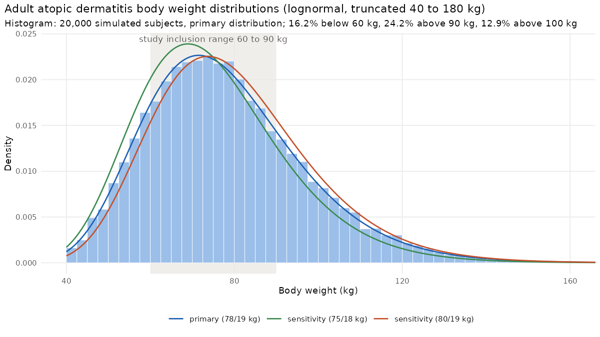
Figure I-1. Adult atopic dermatitis body weight distributions (lognormal, truncated 40 to 180 kg): primary (mean 78 kg, SD 19 kg) and sensitivity distributions, with the study inclusion range shaded; histogram of 20,000 simulated patients from the primary distribution. Analysis figure results/atopic/fig_atopic_weight.png.
Table I-1. Adult atopic dermatitis population by body weight band (primary weight distribution, planned schedule, 300 mg, 20,000 patients per model): coverage of total exposure and share without a reliable AUC0-inf (Wilson 95% interval).
Model | Body weight | Share of population, % | True extrapolated %, median (maximum) | Window coverage below 80%, % | Failing set (i), % [95% CI] | Failing set (iii), % [95% CI]
2016 model | below 60 kg | 16.2 | 0.53 (16.8) | 0.00 | 9.7 [8.7, 10.8] | 33.9 [32.3, 35.5]
2016 model | 60 to 90 kg | 59.6 | 0.66 (15.1) | 0.00 | 13.8 [13.2, 14.4] | 38.8 [37.9, 39.6]
2016 model | above 90 to 100 kg | 11.3 | 0.87 (18.6) | 0.00 | 18.5 [16.9, 20.1] | 42.0 [40.0, 44.0]
2016 model | above 100 kg | 12.9 | 1.11 (13.9) | 0.00 | 23.6 [22.0, 25.3] | 47.5 [45.5, 49.4]
2016 model | all | 100.0 | 0.69 (18.6) | 0.00 | 14.9 [14.4, 15.4] | 39.5 [38.8, 40.1]
2020 Model 1 | below 60 kg | 16.2 | 0.53 (16.9) | 0.00 | 5.9 [5.1, 6.7] | 28.5 [27.0, 30.1]
2020 Model 1 | 60 to 90 kg | 59.6 | 0.65 (14.7) | 0.00 | 8.2 [7.7, 8.7] | 33.2 [32.4, 34.1]
2020 Model 1 | above 90 to 100 kg | 11.3 | 0.82 (19.2) | 0.00 | 11.3 [10.1, 12.7] | 36.4 [34.5, 38.4]
2020 Model 1 | above 100 kg | 12.9 | 0.97 (18.8) | 0.00 | 13.6 [12.3, 15.0] | 39.3 [37.5, 41.2]
2020 Model 1 | all | 100.0 | 0.68 (19.2) | 0.00 | 8.9 [8.5, 9.3] | 33.6 [33.0, 34.3]
2016 model with phase 3 covariates | below 60 kg | 16.2 | 0.50 (21.0) | 0.03 | 9.4 [8.5, 10.5] | 34.1 [32.4, 35.7]
2016 model with phase 3 covariates | 60 to 90 kg | 59.6 | 0.67 (14.7) | 0.00 | 13.7 [13.1, 14.3] | 38.6 [37.7, 39.5]
2016 model with phase 3 covariates | above 90 to 100 kg | 11.3 | 0.94 (16.9) | 0.00 | 20.3 [18.7, 22.0] | 44.5 [42.4, 46.5]
2016 model with phase 3 covariates | above 100 kg | 12.9 | 1.20 (19.8) | 0.00 | 25.9 [24.2, 27.6] | 48.0 [46.1, 49.9]
2016 model with phase 3 covariates | all | 100.0 | 0.71 (21.0) | 0.01 | 15.3 [14.8, 15.8] | 39.8 [39.1, 40.4]
Coverage. AUC0-last remains close to total exposure across the patient weight range: the median true extrapolated fraction is 0.68% to 0.71% in the three model variants and 0.97% to 1.20% above 100 kg, and the share of patients whose window coverage is below 80% is 0.00% to 0.01%.
Reliability of AUC0-inf. In this population, a reliable AUC0-inf cannot be obtained in 14.9% (criteria set (i)) to 39.5% (criteria set (iii)) of patients in the primary model (8.9% to 15.3% and 33.6% to 39.8% across the three model variants). The failures are concentrated in heavier patients (Table I-1, Figure I-2), whereas the sampling window of AUC0-last covers at least 78.9% of the true AUC0-inf in every patient failing set (iii) (median 99.5% to 99.8%). The sensitivity weight distributions give 8.5% to 15.6% (set (i)) and 33.1% to 40.1% (set (iii)).
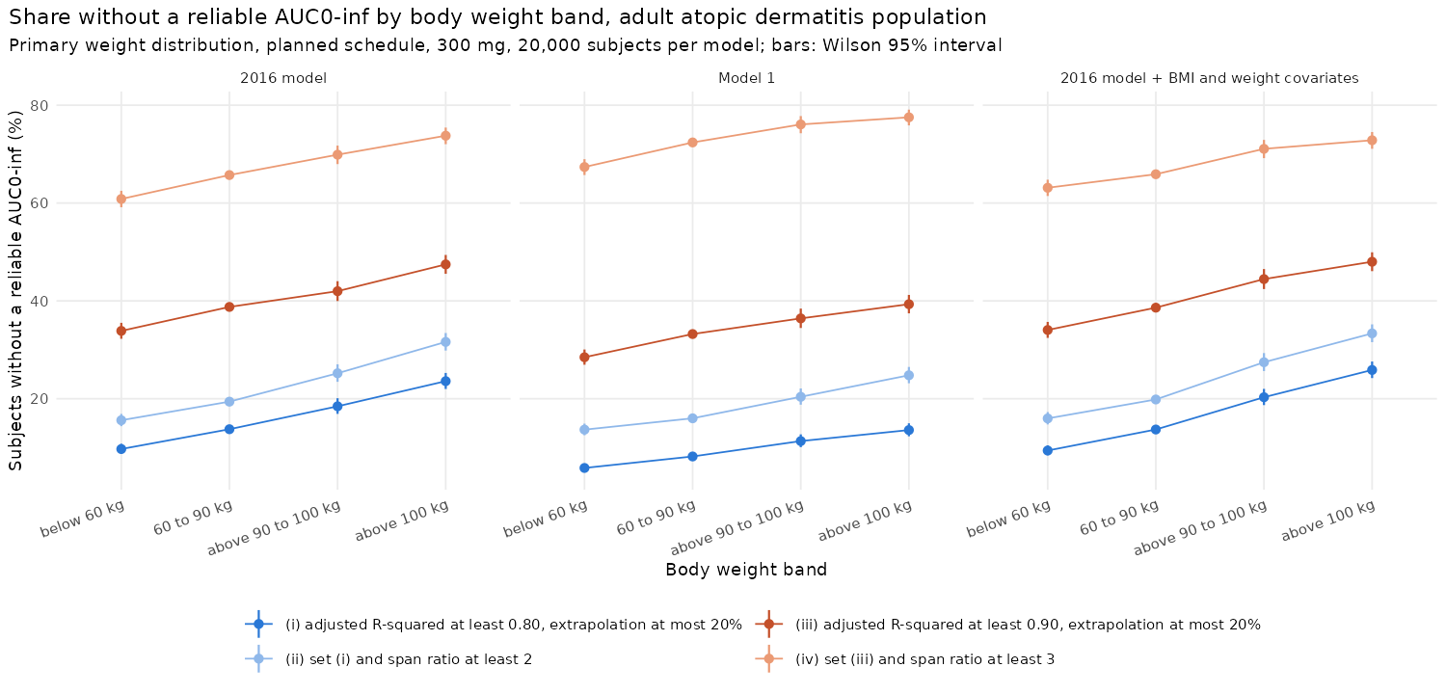
Figure I-2. Share of patients without a reliable AUC0-inf by body weight band and criteria set, adult atopic dermatitis population (primary weight distribution, 20,000 patients per model; bars: Wilson 95% intervals). Analysis figure results/atopic/fig_atopic_failure_by_band.png.
Trials with the atopic dermatitis body-weight distribution (Table I-2; 117 patients per arm, 2,000 trials per scenario, M0):
- The AUC0-last GMR is biased by -0.94% to 0.39% against the true AUC0-inf ratio. AUC0-inf is biased by -2.56% to 3.97% under rule A with set (i), -2.42% to 3.97% with set (iii), and -1.73% to 2.61% under rule B; rule C with set (i) gives -0.67% to 0.09%.
- The decision of AUC0-last + Cmax agrees with that of AUC0-inf + Cmax in 66.9% to 96.7% of trials under rule A with set (i), 70.2% to 88.7% with set (iii), and 95.4% to 99.5% under rule C with set (i).
- The share of subjects failing the criteria differs between arms when the products differ: set (i) -0.03 to 0.05 points for identical products, 1.83 to 2.85 for F x0.90 and 4.59 to 6.99 for Vmax x1.25 (set (iii): 0.11 to 0.20, 2.12 to 2.43 and 4.86 to 5.71). Rule A therefore compares different patients in the two arms, in a way that depends on the product difference.
Table I-2. Trials in the adult atopic dermatitis population (primary weight distribution, 117 patients per arm, pooled t-test M0): bias (%) of the geometric mean of trial GMRs against the true ratio (AUC endpoints against the true AUC0-inf ratio), pass rate of AUC0-last + Cmax (P2), agreement of the P2 decision with AUC0-inf + Cmax under rule A (criteria (i) or (iii)) and rule C (criteria (i)), and the mean difference between arms (test minus reference) in the share of subjects failing criteria set (i) or (iii).
Model | Scenario | True AUC0-inf ratio | AUC0-last | AUC0-inf A (i) | AUC0-inf A (iii) | AUC0-inf B | AUC0-inf C (i) | P2 pass, % | Agreement A (i), % | Agreement A (iii), % | Agreement C (i), % | Arm difference (i), points | Arm difference (iii), points
2016 model | identical | 1.000 | 0.07 | 0.07 | 0.22 | 0.08 | 0.08 | 97.2 | 96.7 | 88.7 | 99.5 | -0.03 | 0.11
2016 model | F x0.90 | 0.842 | -0.34 | 1.62 | 1.78 | 1.07 | -0.12 | 15.6 | 86.9 | 86.4 | 98.2 | 2.85 | 2.35
2016 model | ke x1.20 | 0.904 | -0.19 | 0.09 | 0.10 | 0.14 | -0.13 | 65.6 | 83.4 | 73.1 | 97.1 | 0.13 | -0.76
2016 model | Vmax x1.25 | 0.863 | -0.89 | 3.62 | 3.89 | 2.52 | -0.51 | 25.2 | 66.9 | 70.4 | 96.5 | 6.99 | 5.71
2016 model | Km x10 | 1.007 | 0.37 | -2.30 | -1.99 | -1.62 | -0.59 | 97.0 | 96.1 | 84.7 | 99.1 | -0.10 | 4.14
2020 Model 1 | identical | 1.000 | 0.05 | -0.02 | -0.01 | 0.03 | 0.06 | 96.1 | 96.4 | 88.0 | 99.2 | 0.05 | 0.11
2020 Model 1 | F x0.90 | 0.843 | -0.32 | 1.24 | 1.17 | 0.78 | 0.00 | 16.1 | 88.8 | 87.6 | 97.8 | 1.83 | 2.12
2020 Model 1 | ke x1.20 | 0.901 | -0.19 | -0.11 | -0.51 | 0.05 | -0.08 | 59.3 | 85.7 | 72.9 | 96.3 | -0.14 | -0.66
2020 Model 1 | Vmax x1.25 | 0.865 | -0.81 | 2.99 | 2.58 | 1.86 | -0.15 | 25.3 | 71.2 | 76.2 | 95.4 | 4.59 | 4.86
2020 Model 1 | Km x10 | 1.007 | 0.30 | -1.62 | -1.09 | -1.30 | -0.67 | 96.2 | 95.5 | 84.1 | 98.9 | 1.88 | 6.51
2016 model with phase 3 covariates | identical | 1.000 | 0.08 | 0.07 | 0.14 | 0.07 | 0.09 | 94.2 | 93.6 | 79.9 | 99.5 | -0.02 | 0.20
2016 model with phase 3 covariates | F x0.90 | 0.842 | -0.36 | 1.77 | 1.71 | 1.10 | -0.18 | 12.2 | 88.0 | 86.3 | 98.7 | 2.81 | 2.43
2016 model with phase 3 covariates | ke x1.20 | 0.904 | -0.15 | 0.25 | 0.12 | 0.16 | -0.11 | 56.0 | 78.9 | 70.2 | 96.5 | 0.18 | -0.60
2016 model with phase 3 covariates | Vmax x1.25 | 0.863 | -0.94 | 3.97 | 3.97 | 2.61 | -0.63 | 20.1 | 68.1 | 71.6 | 97.4 | 6.96 | 5.61
2016 model with phase 3 covariates | Km x10 | 1.007 | 0.39 | -2.56 | -2.42 | -1.73 | -0.53 | 93.7 | 90.5 | 74.2 | 98.1 | -0.37 | 3.86
Population with a mean of 100 kg and uniform weight bands. In simulated trials of a heavier population (body weight normal, mean 100 kg, SD 20 kg, 60 to 150 kg; a stress test, not a population estimate), subjects failing the criteria are 3.2 to 6.4 kg heavier than those retained. Across uniform weight bands of the primary model, reliability under set (i) falls from 90.8% at 40-60 kg to 70.9% at 130-150 kg. Across uniform body-weight bands from 40 to 150 kg (primary model, 20,000 subjects per band), the median true extrapolated fraction ranges from 0.51 to 1.40%, and window coverage below 80% is at most 0.01%.
The body-weight ranges of the models’ development data are not reported, so results above about 130 kg (1.2% of the primary distribution) may be extrapolations.

