build

Autogenerated data summary from dataMaid

2021-06-21 12:41:50

# Data report overview

The dataset examined has the following dimensions:

|  |  |
| --- | --- |
| Feature | Result |
| Number of observations | 11134 |
| Number of variables | 73 |

### Checks performed

The following variable checks were performed, depending on the data type of each variable:

|  |  |  |  |  |  |  |  |  |
| --- | --- | --- | --- | --- | --- | --- | --- | --- |
|  | character | factor | labelled | haven labelled | numeric | integer | logical | Date |
| Identify miscoded missing values | × | × | × | × | × | × |  | × |
| Identify prefixed and suffixed whitespace | × | × | × | × |  |  |  |  |
| Identify levels with < 6 obs. | × | × | × | × |  |  |  |  |
| Identify case issues | × | × | × | × |  |  |  |  |
| Identify misclassified numeric or integer variables | × | × | × | × |  |  |  |  |
| Identify outliers |  |  |  |  | × | × |  | × |

Please note that all numerical values in the following have been rounded to 2 decimals.

# Summary table

|  |  |  |  |  |
| --- | --- | --- | --- | --- |
|  | Variable class | # unique values | Missing observations | Any problems? |
| ID_Build | numeric | 11134 | 0.00 % |  |
| ID_Parcel | numeric | 6162 | 0.00 % |  |
| parcel_AIN | numeric | 6405 | 0.00 % |  |
| damage_cat | character | 2 | 0.00 % |  |
| damage_binary | numeric | 2 | 0.00 % |  |
| damage_severity | numeric | 5 | 0.00 % |  |
| build_structures_DAMAGE | character | 5 | 86.63 % |  |
| build_Mean_elev_30m | numeric | 11134 | 0.00 % | × |
| build_Mean_elev_100m | numeric | 11134 | 0.00 % | × |
| build_Mean_slope_30m_DEM | numeric | 11134 | 0.00 % | × |
| build_Mean_slope_100m_DEM | numeric | 11134 | 0.00 % | × |
| build_Mean_aspect_30m_DEM | numeric | 11134 | 0.00 % | × |
| build_Mean_aspect_100m_DEM | numeric | 11134 | 0.00 % | × |
| build_Mean_distroad | numeric | 9017 | 0.79 % |  |
| build_Mean_builddens | numeric | 8844 | 0.79 % |  |
| build_Mean_distall_road | numeric | 6190 | 0.11 % | × |
| build_min_dist_tree | numeric | 584 | 0.00 % | × |
| build_min_dist_shrub | numeric | 9253 | 0.00 % | × |
| build_has_tree_overhang | numeric | 3 | 0.42 % |  |
| build_overhang_ht | numeric | 7844 | 0.42 % | × |
| build_perc_overhang | numeric | 7533 | 0.42 % |  |
| build_dist_angle | numeric | 11064 | 0.00 % |  |
| build_dist_to_build_ft | numeric | 7594 | 0.00 % | × |
| build_dist_to_build_ft_jod | numeric | 7635 | 0.42 % | × |
| build_p_tree_10 | numeric | 10163 | 0.00 % |  |
| build_p_tree_100 | numeric | 11107 | 0.00 % | × |
| build_p_tree_200 | numeric | 11132 | 0.00 % | × |
| build_p_tree_300 | numeric | 11133 | 0.00 % | × |
| build_p_grass_10 | numeric | 10292 | 0.00 % | × |
| build_p_grass_100 | numeric | 11054 | 0.00 % | × |
| build_p_grass_200 | numeric | 11084 | 0.00 % | × |
| build_p_grass_300 | numeric | 11103 | 0.00 % | × |
| build_p_soil_10 | numeric | 9047 | 0.00 % |  |
| build_p_soil_100 | numeric | 11117 | 0.00 % |  |
| build_p_soil_200 | numeric | 11134 | 0.00 % |  |
| build_p_soil_300 | numeric | 11134 | 0.00 % | × |
| build_p_water_10 | numeric | 9 | 0.00 % | × |
| build_p_water_100 | numeric | 159 | 0.00 % | × |
| build_p_water_200 | numeric | 336 | 0.00 % | × |
| build_p_water_300 | numeric | 538 | 0.00 % | × |
| build_p_building_10 | numeric | 10441 | 0.00 % | × |
| build_p_building_100 | numeric | 11023 | 0.00 % | × |
| build_p_building_200 | numeric | 11082 | 0.00 % |  |
| build_p_building_300 | numeric | 11101 | 0.00 % |  |
| build_p_road_10 | numeric | 1296 | 0.00 % | × |
| build_p_road_100 | numeric | 8663 | 0.00 % | × |
| build_p_road_200 | numeric | 10022 | 0.00 % | × |
| build_p_road_300 | numeric | 10549 | 0.00 % | × |
| build_p_otherpaved_10 | numeric | 7791 | 0.00 % |  |
| build_p_otherpaved_100 | numeric | 10428 | 0.00 % | × |
| build_p_otherpaved_200 | numeric | 10851 | 0.00 % | × |
| build_p_otherpaved_300 | numeric | 10974 | 0.00 % | × |
| build_p_shrub_10 | numeric | 261 | 0.00 % | × |
| build_p_shrub_100 | numeric | 3711 | 0.00 % | × |
| build_p_shrub_200 | numeric | 5926 | 0.00 % |  |
| build_p_shrub_300 | numeric | 7399 | 0.00 % |  |
| build_area | numeric | 11134 | 0.00 % | × |
| parcel_UseType | character | 9 | 0.22 % |  |
| parcel_UseDescription | character | 44 | 0.22 % | × |
| parcel_Roll_ImpValue | numeric | 5507 | 3.32 % | × |
| parcel_Roll_HomeOwnersExemp | numeric | 4 | 3.32 % |  |
| parcel_Can_P | numeric | 6216 | 0.00 % | × |
| parcel_Grass_P | numeric | 6169 | 0.00 % | × |
| parcel_Soil_P | numeric | 5885 | 0.00 % |  |
| parcel_Water_P | numeric | 38 | 0.00 % | × |
| parcel_Build_P | numeric | 6186 | 0.00 % |  |
| parcel_Road_P | numeric | 2194 | 0.00 % |  |
| parcel_Paved_P | numeric | 5367 | 0.00 % | × |
| parcel_Shrub_P | numeric | 1723 | 0.00 % |  |
| parcel_Perv_P | numeric | 6239 | 0.00 % | × |
| parcel_Imperv_P | numeric | 6239 | 0.00 % | × |
| parcel_year_built | numeric | 95 | 9.05 % | × |
| parcel_area | numeric | 6406 | 0.00 % | × |

# Variable list

## ID_Build

|  |  |
| --- | --- |
| Feature | Result |
| Variable type | numeric |
| Number of missing obs. | 0 (0 %) |
| Number of unique values | 11134 |
| Median | 5573.5 |
| 1st and 3rd quartiles | 2786.25; 8356.75 |
| Min. and max. | 1; 11140 |

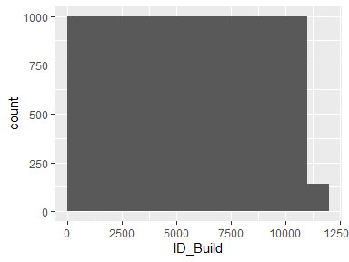

## ID_Parcel

|  |  |
| --- | --- |
| Feature | Result |
| Variable type | numeric |
| Number of missing obs. | 0 (0 %) |
| Number of unique values | 6162 |
| Median | 5432 |
| 1st and 3rd quartiles | 2594; 9436.75 |
| Min. and max. | 4; 13396 |

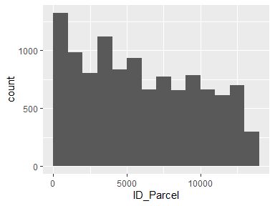

## parcel_AIN

|  |  |
| --- | --- |
| Feature | Result |
| Variable type | numeric |
| Number of missing obs. | 0 (0 %) |
| Number of unique values | 6405 |
| Median | 4458032006 |
| 1st and 3rd quartiles | 2059021271.25; 4467033762.25 |
| Min. and max. | 2049004901; 4473027903 |

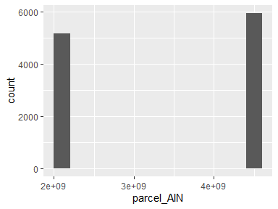

## damage_cat

|  |  |
| --- | --- |
| Feature | Result |
| Variable type | character |
| Number of missing obs. | 0 (0 %) |
| Number of unique values | 2 |
| Mode | “Survived” |

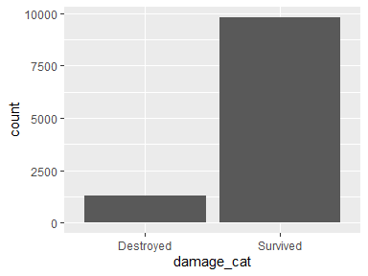

## damage_binary

* Note that this variable is treated as a factor variable below, as it only takes a few unique values.

|  |  |
| --- | --- |
| Feature | Result |
| Variable type | numeric |
| Number of missing obs. | 0 (0 %) |
| Number of unique values | 2 |
| Mode | “0” |
| Reference category | 0 |

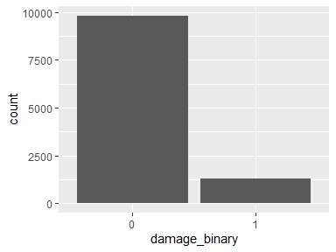

## damage_severity

* Note that this variable is treated as a factor variable below, as it only takes a few unique values.

|  |  |
| --- | --- |
| Feature | Result |
| Variable type | numeric |
| Number of missing obs. | 0 (0 %) |
| Number of unique values | 5 |
| Mode | “1” |
| Reference category | 1 |

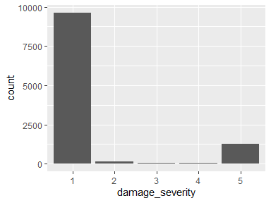

## build_structures_DAMAGE

|  |  |
| --- | --- |
| Feature | Result |
| Variable type | character |
| Number of missing obs. | 9645 (86.63 %) |
| Number of unique values | 4 |
| Mode | “Destroyed (>50%)” |

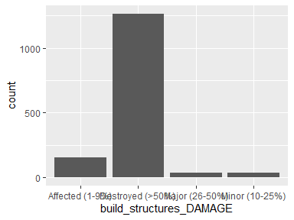

## build_Mean_elev_30m

|  |  |
| --- | --- |
| Feature | Result |
| Variable type | numeric |
| Number of missing obs. | 0 (0 %) |
| Number of unique values | 11134 |
| Median | 793.26 |
| 1st and 3rd quartiles | 254.07; 934.71 |
| Min. and max. | 12.07; 2817.77 |

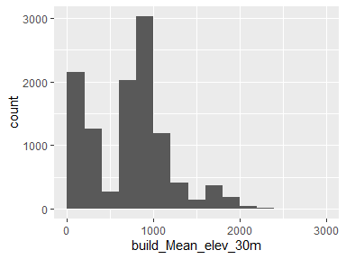

* Note that the following possible outlier values were detected: "1223.06", "1223.21", "1223.78", "1223.99", "1224.5", "1224.76", "1225.14", "1225.39", "1226.05", "1226.42" (1065 additional values omitted).

## build_Mean_elev_100m

|  |  |
| --- | --- |
| Feature | Result |
| Variable type | numeric |
| Number of missing obs. | 0 (0 %) |
| Number of unique values | 11134 |
| Median | 794.58 |
| 1st and 3rd quartiles | 250.25; 939.89 |
| Min. and max. | 11.47; 2769.59 |

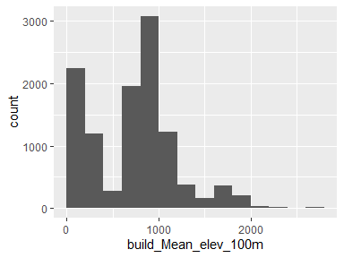

* Note that the following possible outlier values were detected: "1221.83", "1222.49", "1223.12", "1223.65", "1223.74", "1223.77", "1223.82", "1224.42", "1224.45", "1224.86" (1065 additional values omitted).

## build_Mean_slope_30m_DEM

|  |  |
| --- | --- |
| Feature | Result |
| Variable type | numeric |
| Number of missing obs. | 0 (0 %) |
| Number of unique values | 11134 |
| Median | 9 |
| 1st and 3rd quartiles | 5.55; 13.62 |
| Min. and max. | 0.85; 34.37 |

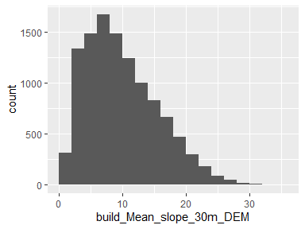

* Note that the following possible outlier values were detected: "34.37".

## build_Mean_slope_100m_DEM

|  |  |
| --- | --- |
| Feature | Result |
| Variable type | numeric |
| Number of missing obs. | 0 (0 %) |
| Number of unique values | 11134 |
| Median | 10.97 |
| 1st and 3rd quartiles | 7.43; 15.41 |
| Min. and max. | 1.28; 34.82 |

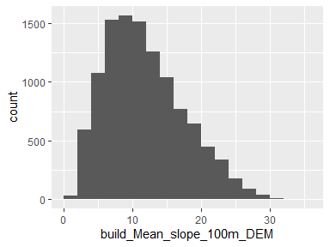

* Note that the following possible outlier values were detected: "34.58", "34.82".

## build_Mean_aspect_30m_DEM

|  |  |
| --- | --- |
| Feature | Result |
| Variable type | numeric |
| Number of missing obs. | 0 (0 %) |
| Number of unique values | 11134 |
| Median | 183.25 |
| 1st and 3rd quartiles | 147.36; 214.31 |
| Min. and max. | 41.01; 322.87 |

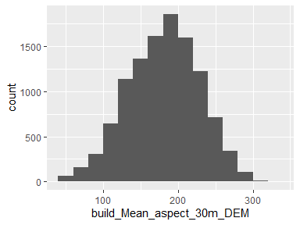

* Note that the following possible outlier values were detected: "292.09", "292.17", "292.36", "292.38", "292.43", "292.69", "292.75", "293.25", "293.35", "293.35" (27 additional values omitted).

## build_Mean_aspect_100m_DEM

|  |  |
| --- | --- |
| Feature | Result |
| Variable type | numeric |
| Number of missing obs. | 0 (0 %) |
| Number of unique values | 11134 |
| Median | 182.13 |
| 1st and 3rd quartiles | 154.53; 207.27 |
| Min. and max. | 58.76; 295.16 |

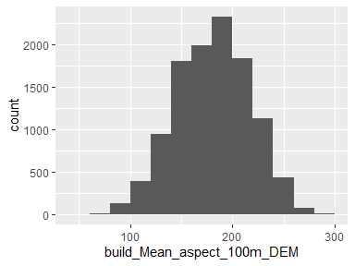

* Note that the following possible outlier values were detected: "58.76", "59.17", "59.94", "60.56", "61.56", "63.43", "63.44", "65.79", "66.49", "276.66" (21 additional values omitted).

## build_Mean_distroad

|  |  |
| --- | --- |
| Feature | Result |
| Variable type | numeric |
| Number of missing obs. | 88 (0.79 %) |
| Number of unique values | 9016 |
| Median | 600.75 |
| 1st and 3rd quartiles | 216.33; 1252.51 |
| Min. and max. | 0; 3666.9 |

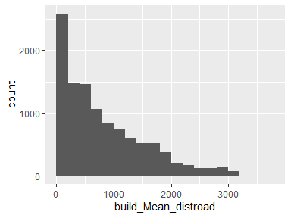

## build_Mean_builddens

|  |  |
| --- | --- |
| Feature | Result |
| Variable type | numeric |
| Number of missing obs. | 88 (0.79 %) |
| Number of unique values | 8843 |
| Median | 1.42 |
| 1st and 3rd quartiles | 0.74; 2.26 |
| Min. and max. | 0; 4.41 |

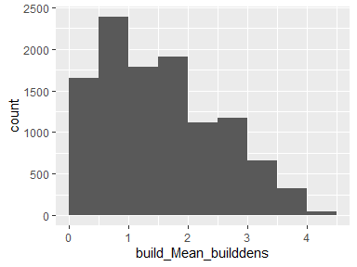

## build_Mean_distall_road

|  |  |
| --- | --- |
| Feature | Result |
| Variable type | numeric |
| Number of missing obs. | 12 (0.11 %) |
| Number of unique values | 6189 |
| Median | 28.66 |
| 1st and 3rd quartiles | 7.99; 33.31 |
| Min. and max. | 0; 430.68 |

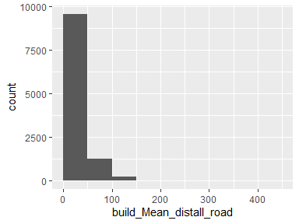

* Note that the following possible outlier values were detected: "40.69", "40.69", "40.7", "40.72", "40.73", "40.76", "40.76", "40.78", "40.8", "40.8" (1408 additional values omitted).

## build_min_dist_tree

|  |  |
| --- | --- |
| Feature | Result |
| Variable type | numeric |
| Number of missing obs. | 0 (0 %) |
| Number of unique values | 584 |
| Median | 0.75 |
| 1st and 3rd quartiles | 0.75; 0.75 |
| Min. and max. | 0.75; 346.53 |

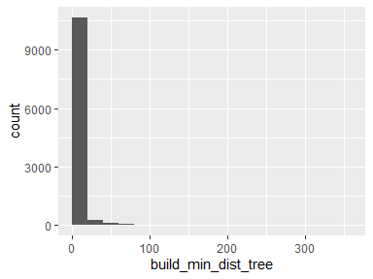

* Note that the following possible outlier values were detected: "1.06", "1.5", "1.68", "2.12", "2.25", "2.37", "2.7", "3", "3.09", "3.18" (573 additional values omitted).

## build_min_dist_shrub

|  |  |
| --- | --- |
| Feature | Result |
| Variable type | numeric |
| Number of missing obs. | 0 (0 %) |
| Number of unique values | 9253 |
| Median | 180.1 |
| 1st and 3rd quartiles | 73.27; 407.28 |
| Min. and max. | 0.75; 2377.11 |

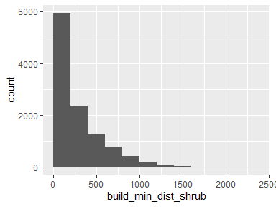

* Note that the following possible outlier values were detected: "2229.43", "2239.67", "2297.74", "2299.24", "2300.25", "2311.74", "2377.11".

## build_has_tree_overhang

* Note that this variable is treated as a factor variable below, as it only takes a few unique values.

|  |  |
| --- | --- |
| Feature | Result |
| Variable type | numeric |
| Number of missing obs. | 47 (0.42 %) |
| Number of unique values | 2 |
| Mode | “1” |
| Reference category | 0 |

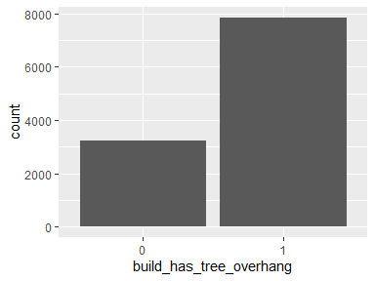

## build_overhang_ht

|  |  |
| --- | --- |
| Feature | Result |
| Variable type | numeric |
| Number of missing obs. | 47 (0.42 %) |
| Number of unique values | 7843 |
| Median | 13.37 |
| 1st and 3rd quartiles | 0; 22.07 |
| Min. and max. | -0.04; 90.21 |

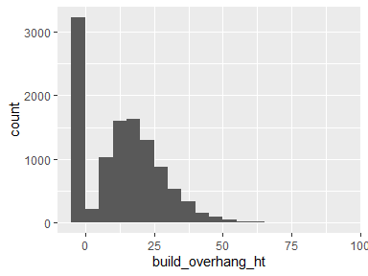

* Note that the following possible outlier values were detected: "55.25", "55.28", "55.61", "55.62", "55.86", "56.02", "56.32", "56.46", "56.65", "57.07" (36 additional values omitted).

## build_perc_overhang

|  |  |
| --- | --- |
| Feature | Result |
| Variable type | numeric |
| Number of missing obs. | 47 (0.42 %) |
| Number of unique values | 7532 |
| Median | 0.01 |
| 1st and 3rd quartiles | 0; 0.07 |
| Min. and max. | 0; 1 |

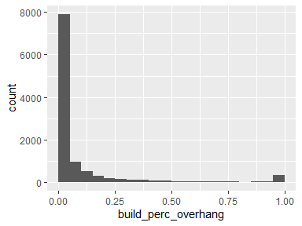

## build_dist_angle

|  |  |
| --- | --- |
| Feature | Result |
| Variable type | numeric |
| Number of missing obs. | 0 (0 %) |
| Number of unique values | 11064 |
| Median | 0 |
| 1st and 3rd quartiles | -86.74; 90.69 |
| Min. and max. | -179.99; 180 |

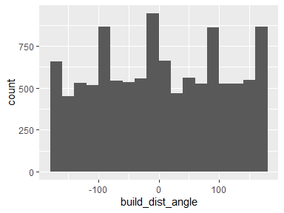

## build_dist_to_build_ft

|  |  |
| --- | --- |
| Feature | Result |
| Variable type | numeric |
| Number of missing obs. | 0 (0 %) |
| Number of unique values | 7594 |
| Median | 16.22 |
| 1st and 3rd quartiles | 7.9; 39.72 |
| Min. and max. | 0; 3916.03 |

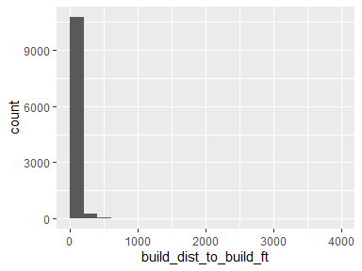

* Note that the following possible outlier values were detected: "0", "0.02", "0.05", "0.11", "0.12", "0.16", "0.21", "0.24", "0.26", "0.3" (420 additional values omitted).

## build_dist_to_build_ft_jod

|  |  |
| --- | --- |
| Feature | Result |
| Variable type | numeric |
| Number of missing obs. | 47 (0.42 %) |
| Number of unique values | 7634 |
| Median | 75.68 |
| 1st and 3rd quartiles | 54.52; 108.3 |
| Min. and max. | 0; 8639.64 |

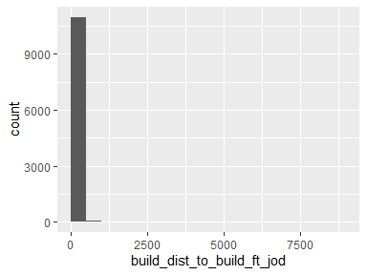

* Note that the following possible outlier values were detected: "0", "1.06", "1.59", "2.02", "2.14", "2.37", "3.5", "3.66", "3.69", "4.06" (444 additional values omitted).

## build_p_tree_10

|  |  |
| --- | --- |
| Feature | Result |
| Variable type | numeric |
| Number of missing obs. | 0 (0 %) |
| Number of unique values | 10163 |
| Median | 22.04 |
| 1st and 3rd quartiles | 9.26; 39.06 |
| Min. and max. | 0; 100 |

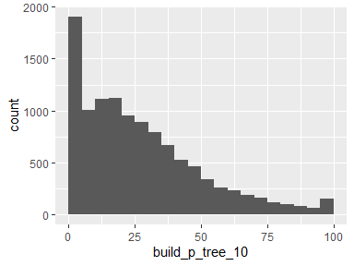

## build_p_tree_100

|  |  |
| --- | --- |
| Feature | Result |
| Variable type | numeric |
| Number of missing obs. | 0 (0 %) |
| Number of unique values | 11107 |
| Median | 27.67 |
| 1st and 3rd quartiles | 17.88; 40.7 |
| Min. and max. | 0; 99.01 |

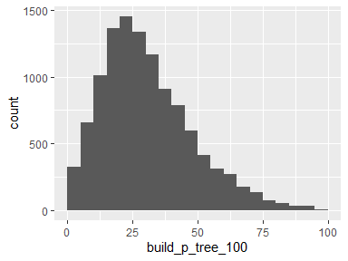

* Note that the following possible outlier values were detected: "0", "0.01", "0.09", "0.09", "0.1", "0.11", "0.11", "0.18", "0.19", "0.19" (16 additional values omitted).

## build_p_tree_200

|  |  |
| --- | --- |
| Feature | Result |
| Variable type | numeric |
| Number of missing obs. | 0 (0 %) |
| Number of unique values | 11132 |
| Median | 26.51 |
| 1st and 3rd quartiles | 18.14; 37.61 |
| Min. and max. | 0; 95.06 |

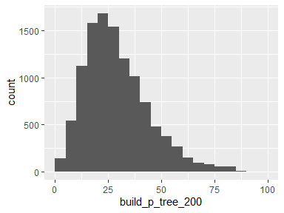

* Note that the following possible outlier values were detected: "0", "0.09", "0.21", "0.22", "0.25", "0.25", "0.26", "0.26", "0.3", "0.3" (83 additional values omitted).

## build_p_tree_300

|  |  |
| --- | --- |
| Feature | Result |
| Variable type | numeric |
| Number of missing obs. | 0 (0 %) |
| Number of unique values | 11133 |
| Median | 26.54 |
| 1st and 3rd quartiles | 18.58; 36.08 |
| Min. and max. | 0; 92.34 |

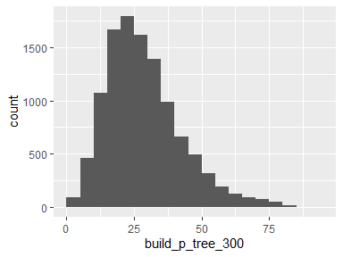

* Note that the following possible outlier values were detected: "0", "0.08", "0.14", "0.14", "0.14", "0.25", "0.48", "0.75", "0.8", "0.85" (111 additional values omitted).

## build_p_grass_10

|  |  |
| --- | --- |
| Feature | Result |
| Variable type | numeric |
| Number of missing obs. | 0 (0 %) |
| Number of unique values | 10292 |
| Median | 28.83 |
| 1st and 3rd quartiles | 14.57; 43.27 |
| Min. and max. | 0; 97.5 |

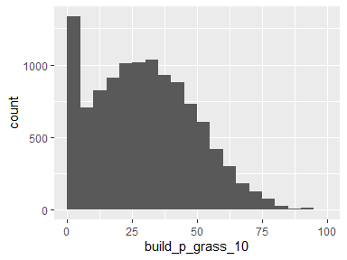

* Note that the following possible outlier values were detected: "90.03", "90.35", "90.64", "90.94", "91.1", "91.41", "91.83", "92.61", "93.09", "93.86" (5 additional values omitted).

## build_p_grass_100

|  |  |
| --- | --- |
| Feature | Result |
| Variable type | numeric |
| Number of missing obs. | 0 (0 %) |
| Number of unique values | 11054 |
| Median | 16.34 |
| 1st and 3rd quartiles | 10.24; 22.84 |
| Min. and max. | 0; 76.05 |

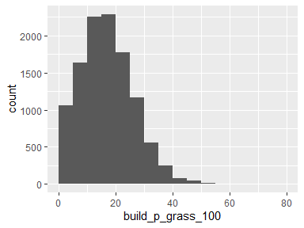

* Note that the following possible outlier values were detected: "45.01", "45.03", "45.04", "45.05", "45.05", "45.06", "45.1", "45.11", "45.11", "45.16" (60 additional values omitted).

## build_p_grass_200

|  |  |
| --- | --- |
| Feature | Result |
| Variable type | numeric |
| Number of missing obs. | 0 (0 %) |
| Number of unique values | 11084 |
| Median | 14.95 |
| 1st and 3rd quartiles | 9.61; 20.61 |
| Min. and max. | 0; 64.26 |

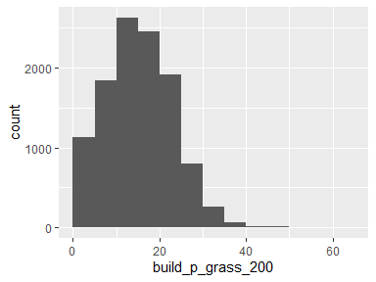

* Note that the following possible outlier values were detected: "38.43", "38.43", "38.46", "38.61", "38.62", "38.71", "38.88", "38.89", "38.92", "39.19" (48 additional values omitted).

## build_p_grass_300

|  |  |
| --- | --- |
| Feature | Result |
| Variable type | numeric |
| Number of missing obs. | 0 (0 %) |
| Number of unique values | 11103 |
| Median | 14.11 |
| 1st and 3rd quartiles | 8.85; 19.41 |
| Min. and max. | 0; 60.05 |

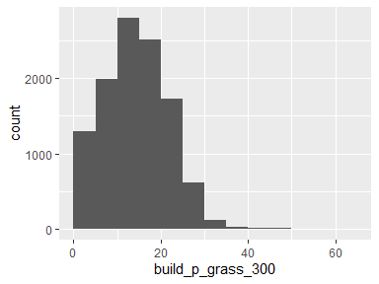

* Note that the following possible outlier values were detected: "35.94", "35.97", "36.19", "36.2", "36.29", "36.65", "36.84", "37.18", "37.36", "37.56" (47 additional values omitted).

## build_p_soil_10

|  |  |
| --- | --- |
| Feature | Result |
| Variable type | numeric |
| Number of missing obs. | 0 (0 %) |
| Number of unique values | 9047 |
| Median | 15.24 |
| 1st and 3rd quartiles | 4.23; 30.94 |
| Min. and max. | 0; 100 |

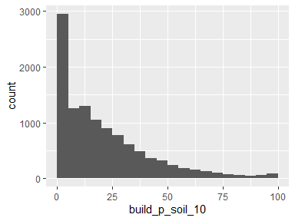

## build_p_soil_100

|  |  |
| --- | --- |
| Feature | Result |
| Variable type | numeric |
| Number of missing obs. | 0 (0 %) |
| Number of unique values | 11117 |
| Median | 14.21 |
| 1st and 3rd quartiles | 6.62; 29.86 |
| Min. and max. | 0; 100 |

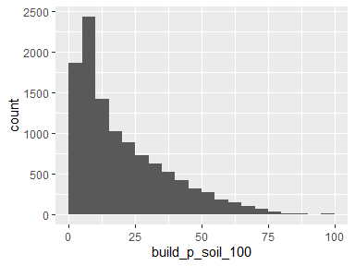

## build_p_soil_200

|  |  |
| --- | --- |
| Feature | Result |
| Variable type | numeric |
| Number of missing obs. | 0 (0 %) |
| Number of unique values | 11134 |
| Median | 19.54 |
| 1st and 3rd quartiles | 9.03; 34.19 |
| Min. and max. | 0.22; 96.64 |

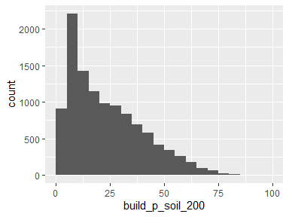

## build_p_soil_300

|  |  |
| --- | --- |
| Feature | Result |
| Variable type | numeric |
| Number of missing obs. | 0 (0 %) |
| Number of unique values | 11134 |
| Median | 22.68 |
| 1st and 3rd quartiles | 11.62; 35.72 |
| Min. and max. | 0.62; 96.24 |

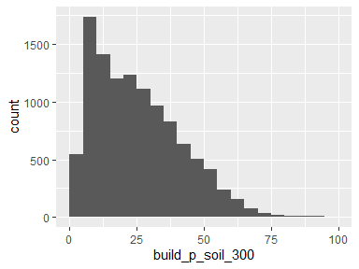

* Note that the following possible outlier values were detected: "93.91", "93.96", "93.97", "96.24".

## build_p_water_10

|  |  |
| --- | --- |
| Feature | Result |
| Variable type | numeric |
| Number of missing obs. | 0 (0 %) |
| Number of unique values | 9 |
| Median | 0 |
| 1st and 3rd quartiles | 0; 0 |
| Min. and max. | 0; 21.07 |

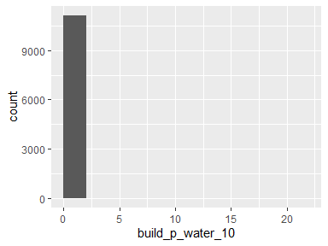

* Note that the following possible outlier values were detected: "0.04", "0.11", "0.49", "0.55", "3.36", "10.79", "15.15", "21.07".

## build_p_water_100

|  |  |
| --- | --- |
| Feature | Result |
| Variable type | numeric |
| Number of missing obs. | 0 (0 %) |
| Number of unique values | 159 |
| Median | 0 |
| 1st and 3rd quartiles | 0; 0 |
| Min. and max. | 0; 42.63 |

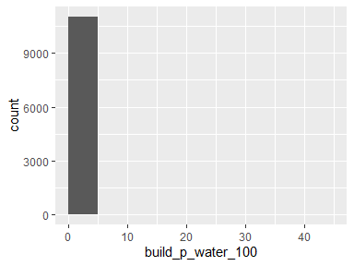

* Note that the following possible outlier values were detected: "0", "0", "0.01", "0.01", "0.02", "0.02", "0.07", "0.08", "0.14", "0.18" (148 additional values omitted).

## build_p_water_200

|  |  |
| --- | --- |
| Feature | Result |
| Variable type | numeric |
| Number of missing obs. | 0 (0 %) |
| Number of unique values | 336 |
| Median | 0 |
| 1st and 3rd quartiles | 0; 0 |
| Min. and max. | 0; 49.8 |

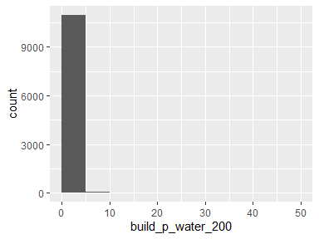

* Note that the following possible outlier values were detected: "0", "0", "0", "0", "0", "0.01", "0.01", "0.01", "0.02", "0.02" (325 additional values omitted).

## build_p_water_300

|  |  |
| --- | --- |
| Feature | Result |
| Variable type | numeric |
| Number of missing obs. | 0 (0 %) |
| Number of unique values | 538 |
| Median | 0 |
| 1st and 3rd quartiles | 0; 0 |
| Min. and max. | 0; 50.39 |

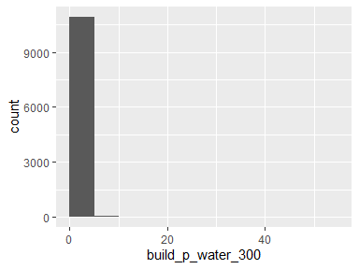

* Note that the following possible outlier values were detected: "0", "0", "0", "0", "0", "0", "0.01", "0.01", "0.01", "0.01" (527 additional values omitted).

## build_p_building_10

|  |  |
| --- | --- |
| Feature | Result |
| Variable type | numeric |
| Number of missing obs. | 0 (0 %) |
| Number of unique values | 10441 |
| Median | 2.24 |
| 1st and 3rd quartiles | 1.3; 3.87 |
| Min. and max. | 0; 86.56 |

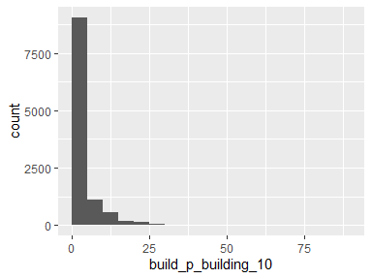

* Note that the following possible outlier values were detected: "0", "0.02", "0.03", "0.03", "0.03", "0.03", "0.04", "0.04", "0.04", "0.04" (743 additional values omitted).

## build_p_building_100

|  |  |
| --- | --- |
| Feature | Result |
| Variable type | numeric |
| Number of missing obs. | 0 (0 %) |
| Number of unique values | 11023 |
| Median | 9.5 |
| 1st and 3rd quartiles | 3.19; 16.56 |
| Min. and max. | 0; 54.2 |

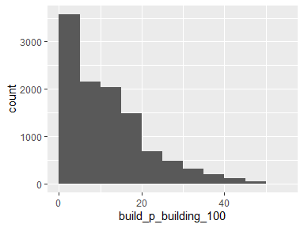

* Note that the following possible outlier values were detected: "47.74", "47.91", "47.92", "47.96", "48", "48.02", "48.05", "48.09", "48.1", "48.14" (25 additional values omitted).

## build_p_building_200

|  |  |
| --- | --- |
| Feature | Result |
| Variable type | numeric |
| Number of missing obs. | 0 (0 %) |
| Number of unique values | 11082 |
| Median | 9.4 |
| 1st and 3rd quartiles | 4.17; 17.81 |
| Min. and max. | 0; 47.11 |

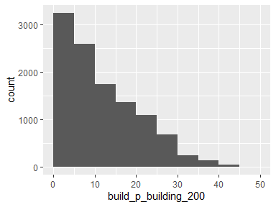

## build_p_building_300

|  |  |
| --- | --- |
| Feature | Result |
| Variable type | numeric |
| Number of missing obs. | 0 (0 %) |
| Number of unique values | 11101 |
| Median | 8.68 |
| 1st and 3rd quartiles | 4.02; 16.6 |
| Min. and max. | 0; 41.7 |

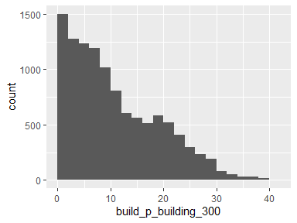

## build_p_road_10

|  |  |
| --- | --- |
| Feature | Result |
| Variable type | numeric |
| Number of missing obs. | 0 (0 %) |
| Number of unique values | 1296 |
| Median | 0 |
| 1st and 3rd quartiles | 0; 0 |
| Min. and max. | 0; 86.85 |

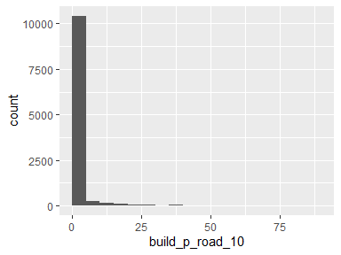

* Note that the following possible outlier values were detected: "0.02", "0.02", "0.02", "0.02", "0.02", "0.02", "0.02", "0.02", "0.03", "0.03" (1285 additional values omitted).

## build_p_road_100

|  |  |
| --- | --- |
| Feature | Result |
| Variable type | numeric |
| Number of missing obs. | 0 (0 %) |
| Number of unique values | 8663 |
| Median | 6.63 |
| 1st and 3rd quartiles | 0.77; 12.7 |
| Min. and max. | 0; 53.93 |

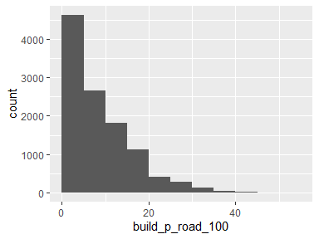

* Note that the following possible outlier values were detected: "43.16", "43.29", "43.42", "43.69", "43.73", "43.91", "44.11", "44.27", "44.43", "44.97" (8 additional values omitted).

## build_p_road_200

|  |  |
| --- | --- |
| Feature | Result |
| Variable type | numeric |
| Number of missing obs. | 0 (0 %) |
| Number of unique values | 10022 |
| Median | 6.81 |
| 1st and 3rd quartiles | 3.09; 11.79 |
| Min. and max. | 0; 56.26 |

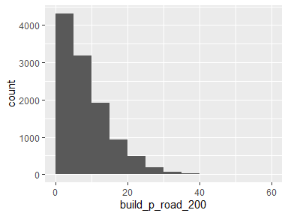

* Note that the following possible outlier values were detected: "35.52", "35.58", "35.62", "35.87", "35.91", "35.96", "36.29", "36.34", "36.57", "36.68" (24 additional values omitted).

## build_p_road_300

|  |  |
| --- | --- |
| Feature | Result |
| Variable type | numeric |
| Number of missing obs. | 0 (0 %) |
| Number of unique values | 10549 |
| Median | 6.7 |
| 1st and 3rd quartiles | 3.34; 11.36 |
| Min. and max. | 0; 51.26 |

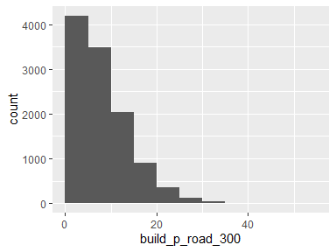

* Note that the following possible outlier values were detected: "33.67", "33.67", "33.96", "34.18", "34.19", "34.26", "34.33", "34.67", "35.13", "35.18" (12 additional values omitted).

## build_p_otherpaved_10

|  |  |
| --- | --- |
| Feature | Result |
| Variable type | numeric |
| Number of missing obs. | 0 (0 %) |
| Number of unique values | 7791 |
| Median | 11.93 |
| 1st and 3rd quartiles | 0; 27.24 |
| Min. and max. | 0; 100 |

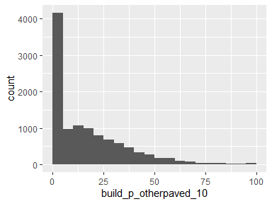

## build_p_otherpaved_100

|  |  |
| --- | --- |
| Feature | Result |
| Variable type | numeric |
| Number of missing obs. | 0 (0 %) |
| Number of unique values | 10428 |
| Median | 9.07 |
| 1st and 3rd quartiles | 4.44; 14.97 |
| Min. and max. | 0; 89.96 |

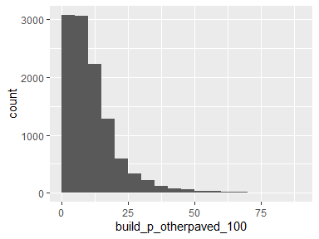

* Note that the following possible outlier values were detected: "41.88", "41.92", "42.04", "42.04", "42.06", "42.14", "42.24", "42.27", "42.35", "42.42" (201 additional values omitted).

## build_p_otherpaved_200

|  |  |
| --- | --- |
| Feature | Result |
| Variable type | numeric |
| Number of missing obs. | 0 (0 %) |
| Number of unique values | 10851 |
| Median | 7.86 |
| 1st and 3rd quartiles | 4.24; 11.94 |
| Min. and max. | 0; 72.16 |

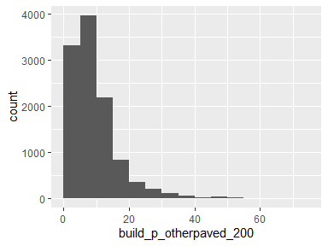

* Note that the following possible outlier values were detected: "28.42", "28.63", "28.64", "28.64", "28.65", "28.67", "28.69", "28.7", "28.74", "28.76" (310 additional values omitted).

## build_p_otherpaved_300

|  |  |
| --- | --- |
| Feature | Result |
| Variable type | numeric |
| Number of missing obs. | 0 (0 %) |
| Number of unique values | 10974 |
| Median | 7.26 |
| 1st and 3rd quartiles | 4.06; 10.87 |
| Min. and max. | 0; 59.9 |

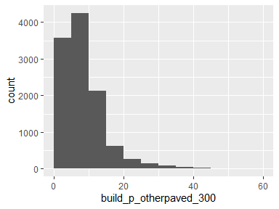

* Note that the following possible outlier values were detected: "25.02", "25.03", "25.06", "25.07", "25.12", "25.21", "25.21", "25.3", "25.31", "25.31" (300 additional values omitted).

## build_p_shrub_10

|  |  |
| --- | --- |
| Feature | Result |
| Variable type | numeric |
| Number of missing obs. | 0 (0 %) |
| Number of unique values | 261 |
| Median | 0 |
| 1st and 3rd quartiles | 0; 0 |
| Min. and max. | 0; 89.43 |

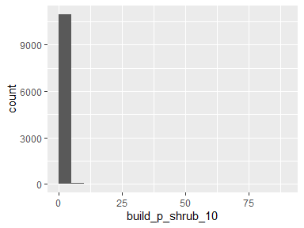

* Note that the following possible outlier values were detected: "0.03", "0.04", "0.04", "0.07", "0.08", "0.09", "0.12", "0.13", "0.15", "0.15" (250 additional values omitted).

## build_p_shrub_100

|  |  |
| --- | --- |
| Feature | Result |
| Variable type | numeric |
| Number of missing obs. | 0 (0 %) |
| Number of unique values | 3711 |
| Median | 0 |
| 1st and 3rd quartiles | 0; 0.44 |
| Min. and max. | 0; 55.47 |

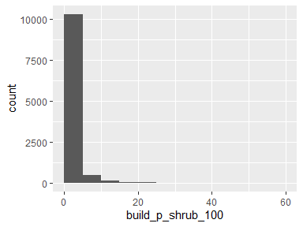

* Note that the following possible outlier values were detected: "13.62", "13.63", "13.68", "13.69", "13.7", "13.84", "14.03", "14.04", "14.05", "14.12" (205 additional values omitted).

## build_p_shrub_200

|  |  |
| --- | --- |
| Feature | Result |
| Variable type | numeric |
| Number of missing obs. | 0 (0 %) |
| Number of unique values | 5926 |
| Median | 0.07 |
| 1st and 3rd quartiles | 0; 3.02 |
| Min. and max. | 0; 66.57 |

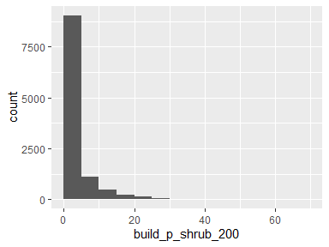

## build_p_shrub_300

|  |  |
| --- | --- |
| Feature | Result |
| Variable type | numeric |
| Number of missing obs. | 0 (0 %) |
| Number of unique values | 7399 |
| Median | 0.91 |
| 1st and 3rd quartiles | 0; 5.79 |
| Min. and max. | 0; 64.28 |

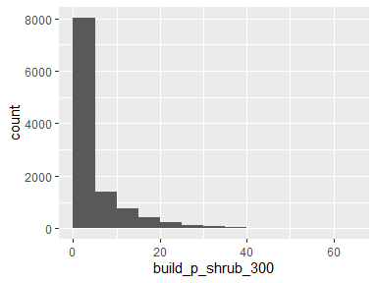

## build_area

|  |  |
| --- | --- |
| Feature | Result |
| Variable type | numeric |
| Number of missing obs. | 0 (0 %) |
| Number of unique values | 11134 |
| Median | 2263.19 |
| 1st and 3rd quartiles | 996; 3545.23 |
| Min. and max. | 0; 115867.77 |

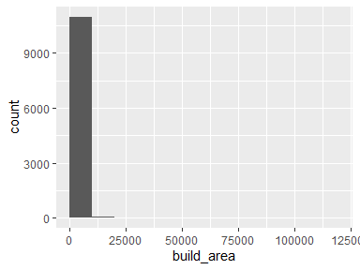

* Note that the following possible outlier values were detected: "9069.15", "9121.41", "9190.92", "9200.73", "9263.26", "9275.18", "9279.45", "9285.05", "9303.99", "9312.87" (175 additional values omitted).

## parcel_UseType

|  |  |
| --- | --- |
| Feature | Result |
| Variable type | character |
| Number of missing obs. | 25 (0.22 %) |
| Number of unique values | 8 |
| Mode | “Residential” |

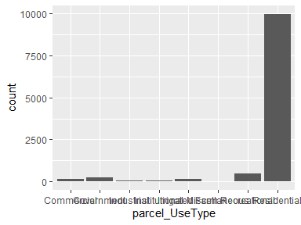

## parcel_UseDescription

|  |  |
| --- | --- |
| Feature | Result |
| Variable type | character |
| Number of missing obs. | 25 (0.22 %) |
| Number of unique values | 43 |
| Mode | “Single” |

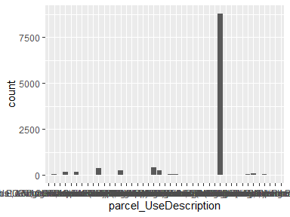

* Note that the following levels have at most five observations: "Auto, Recreation EQPT, Construction EQPT, Sales & Service", "Fruit & Nuts", "Hotel & Motels", "Irrigated Farm", "Lgt Manf.Sm. EQPT. Manuf Sm.Shps Instr.Manuf. Prnt Plnts", "Nurseries or Greenhouses", "Professional Buildings", "Restaurants, Cocktail Lounges", "Supermarkets", "Water Recreation".

## parcel_Roll_ImpValue

|  |  |
| --- | --- |
| Feature | Result |
| Variable type | numeric |
| Number of missing obs. | 370 (3.32 %) |
| Number of unique values | 5506 |
| Median | 318311 |
| 1st and 3rd quartiles | 155330; 816736 |
| Min. and max. | 0; 63350373 |

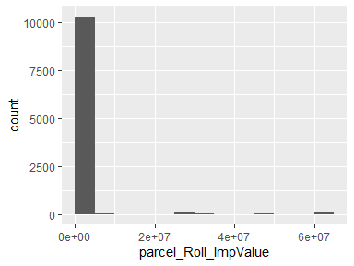

* Note that the following possible outlier values were detected: "0", "100", "126", "132", "137", "206", "387", "585", "595", "1105" (167 additional values omitted).

## parcel_Roll_HomeOwnersExemp

* Note that this variable is treated as a factor variable below, as it only takes a few unique values.

|  |  |
| --- | --- |
| Feature | Result |
| Variable type | numeric |
| Number of missing obs. | 370 (3.32 %) |
| Number of unique values | 3 |
| Mode | “0” |
| Reference category | 0 |

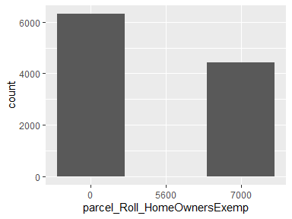

## parcel_Can_P

|  |  |
| --- | --- |
| Feature | Result |
| Variable type | numeric |
| Number of missing obs. | 0 (0 %) |
| Number of unique values | 6216 |
| Median | 27.87 |
| 1st and 3rd quartiles | 16.5; 39.85 |
| Min. and max. | 0; 100 |

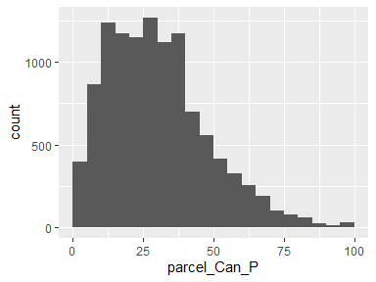

* Note that the following possible outlier values were detected: "86.04", "86.06", "86.36", "86.55", "86.65", "86.74", "87.65", "87.76", "87.83", "88.18" (32 additional values omitted).

## parcel_Grass_P

|  |  |
| --- | --- |
| Feature | Result |
| Variable type | numeric |
| Number of missing obs. | 0 (0 %) |
| Number of unique values | 6169 |
| Median | 14.23 |
| 1st and 3rd quartiles | 8.06; 22.93 |
| Min. and max. | 0; 63.72 |

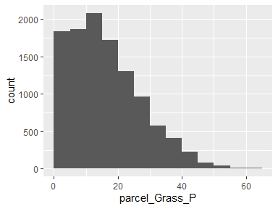

* Note that the following possible outlier values were detected: "63.26", "63.52", "63.72".

## parcel_Soil_P

|  |  |
| --- | --- |
| Feature | Result |
| Variable type | numeric |
| Number of missing obs. | 0 (0 %) |
| Number of unique values | 5885 |
| Median | 15.83 |
| 1st and 3rd quartiles | 6.54; 32.56 |
| Min. and max. | 0; 96.59 |

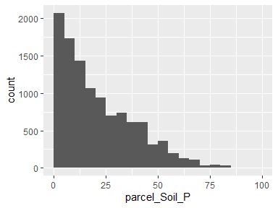

## parcel_Water_P

|  |  |
| --- | --- |
| Feature | Result |
| Variable type | numeric |
| Number of missing obs. | 0 (0 %) |
| Number of unique values | 38 |
| Median | 0 |
| 1st and 3rd quartiles | 0; 0 |
| Min. and max. | 0; 87.09 |

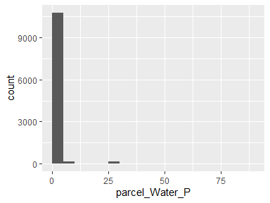

* Note that the following possible outlier values were detected: "0", "0.01", "0.03", "0.07", "0.19", "0.2", "0.23", "0.24", "0.24", "0.26" (27 additional values omitted).

## parcel_Build_P

|  |  |
| --- | --- |
| Feature | Result |
| Variable type | numeric |
| Number of missing obs. | 0 (0 %) |
| Number of unique values | 6186 |
| Median | 12.82 |
| 1st and 3rd quartiles | 4.89; 25.91 |
| Min. and max. | 0; 100 |

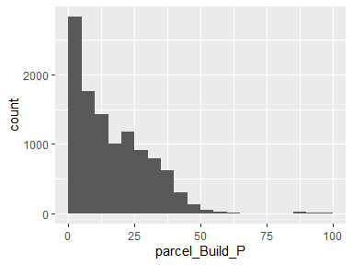

## parcel_Road_P

|  |  |
| --- | --- |
| Feature | Result |
| Variable type | numeric |
| Number of missing obs. | 0 (0 %) |
| Number of unique values | 2194 |
| Median | 0 |
| 1st and 3rd quartiles | 0; 2.61 |
| Min. and max. | 0; 32.21 |

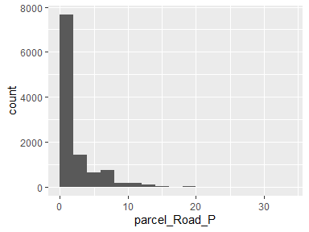

## parcel_Paved_P

|  |  |
| --- | --- |
| Feature | Result |
| Variable type | numeric |
| Number of missing obs. | 0 (0 %) |
| Number of unique values | 5367 |
| Median | 6.34 |
| 1st and 3rd quartiles | 1.99; 12.98 |
| Min. and max. | 0; 69.33 |

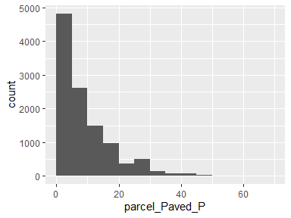

* Note that the following possible outlier values were detected: "49.34", "49.63", "49.85", "50.11", "50.59", "50.99", "52.11", "52.37", "52.39", "52.99" (22 additional values omitted).

## parcel_Shrub_P

|  |  |
| --- | --- |
| Feature | Result |
| Variable type | numeric |
| Number of missing obs. | 0 (0 %) |
| Number of unique values | 1723 |
| Median | 0 |
| 1st and 3rd quartiles | 0; 3.82 |
| Min. and max. | 0; 74.81 |

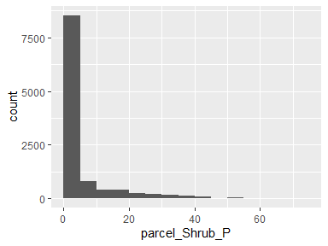

## parcel_Perv_P

|  |  |
| --- | --- |
| Feature | Result |
| Variable type | numeric |
| Number of missing obs. | 0 (0 %) |
| Number of unique values | 6239 |
| Median | 74.64 |
| 1st and 3rd quartiles | 59.95; 88.74 |
| Min. and max. | 0; 100 |

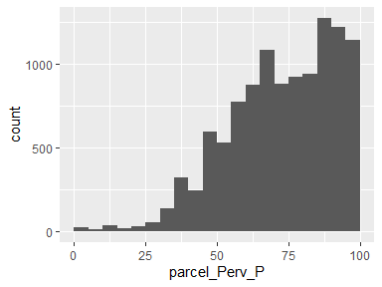

* Note that the following possible outlier values were detected: "0", "0.71", "0.91", "1.19", "1.64", "1.72", "1.76", "2.11", "2.8", "3.01" (2 additional values omitted).

## parcel_Imperv_P

|  |  |
| --- | --- |
| Feature | Result |
| Variable type | numeric |
| Number of missing obs. | 0 (0 %) |
| Number of unique values | 6239 |
| Median | 25.36 |
| 1st and 3rd quartiles | 11.26; 40.05 |
| Min. and max. | 0; 100 |

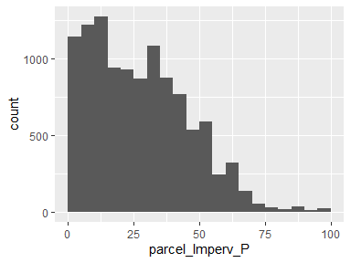

* Note that the following possible outlier values were detected: "96.47", "96.79", "96.99", "97.2", "97.89", "98.24", "98.28", "98.36", "98.81", "99.09" (2 additional values omitted).

## parcel_year_built

|  |  |
| --- | --- |
| Feature | Result |
| Variable type | numeric |
| Number of missing obs. | 1008 (9.05 %) |
| Number of unique values | 94 |
| Median | 1981 |
| 1st and 3rd quartiles | 1970; 1990 |
| Min. and max. | 0; 2015 |

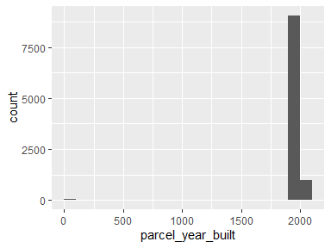

* Note that the following possible outlier values were detected: "0", "1907", "1923", "1924", "1925", "1926", "1928", "1929", "1930", "1931" (8 additional values omitted).

## parcel_area

|  |  |
| --- | --- |
| Feature | Result |
| Variable type | numeric |
| Number of missing obs. | 0 (0 %) |
| Number of unique values | 6406 |
| Median | 48567.12 |
| 1st and 3rd quartiles | 15036.2; 260172.17 |
| Min. and max. | 830.39; 65882419.74 |

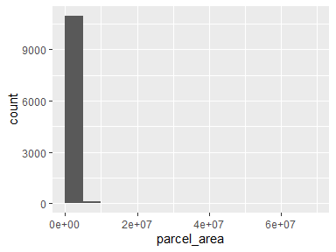

* Note that the following possible outlier values were detected: "4487445.51", "4742700.78", "4876361.44", "4941275.61", "5074257.67", "5167371.46", "5206496.02", "5232169.14", "5255859.63", "5572907.02" (11 additional values omitted).

Report generation information:

* Created by: mmockrin (username: mhmockrin).
* Report creation time: Mon Jun 21 2021 12:42:06
* Report was run from directory: C:/Users/mhmockrin/Box/_Workspace/Proj_GitHub/LA_wui
* dataMaid v1.4.0 [Pkg: 2019-12-10 from CRAN (R 4.0.5)]
* R version 4.0.5 (2021-03-31).
* Platform: x86_64-w64-mingw32/x64 (64-bit)(Windows 10 x64 (build 18363)).
* Function call: makeDataReport(data = build, file = paste0(getwd(), "/output_data/dataMaid_", gsub("[[:punct:]]", "_", Sys.time()), ".Rmd"))