build

Autogenerated data summary from dataMaid

2021-09-22 15:26:55

# Data report overview

The dataset examined has the following dimensions:

|  |  |
| --- | --- |
| Feature | Result |
| Number of observations | 6597 |
| Number of variables | 127 |

### Checks performed

The following variable checks were performed, depending on the data type of each variable:

|  |  |  |  |  |  |  |  |  |
| --- | --- | --- | --- | --- | --- | --- | --- | --- |
|  | character | factor | labelled | haven labelled | numeric | integer | logical | Date |
| Identify miscoded missing values | × | × | × | × | × | × |  | × |
| Identify prefixed and suffixed whitespace | × | × | × | × |  |  |  |  |
| Identify levels with < 6 obs. | × | × | × | × |  |  |  |  |
| Identify case issues | × | × | × | × |  |  |  |  |
| Identify misclassified numeric or integer variables | × | × | × | × |  |  |  |  |
| Identify outliers |  |  |  |  | × | × |  | × |

Please note that all numerical values in the following have been rounded to 2 decimals.

# Summary table

|  |  |  |  |  |
| --- | --- | --- | --- | --- |
|  | Variable class | # unique values | Missing observations | Any problems? |
| ID_Build | numeric | 6597 | 0.00 % |  |
| ID_Parcel | numeric | 3313 | 0.00 % | × |
| build_Mean_elev_30m | numeric | 6597 | 0.00 % |  |
| build_Mean_elev_100m | numeric | 6597 | 0.00 % |  |
| build_Mean_slope_30m_DEM | numeric | 6597 | 0.00 % | × |
| build_Mean_slope_100m_DEM | numeric | 6597 | 0.00 % | × |
| build_Mean_aspect_30m_DEM | numeric | 6597 | 0.00 % | × |
| build_Mean_aspect_100m_DEM | numeric | 6597 | 0.00 % | × |
| build_Mean_distroad | numeric | 5345 | 0.26 % |  |
| build_Mean_builddens | numeric | 5091 | 0.26 % |  |
| build_Mean_distall_road | numeric | 3558 | 0.08 % | × |
| build_structures_DAMAGE | character | 5 | 78.81 % |  |
| build_NEAR_FID | numeric | 4769 | 0.00 % |  |
| build_NEAR_DIST | numeric | 4520 | 0.00 % | × |
| build_NEAR_ANGLE | numeric | 6530 | 0.00 % |  |
| build_Shape_Length | numeric | 6597 | 0.00 % | × |
| build_Shape_Area | numeric | 6597 | 0.00 % | × |
| damage_cat | character | 2 | 0.00 % |  |
| damage_binary | numeric | 2 | 0.00 % |  |
| damage_severity | numeric | 5 | 0.00 % |  |
| build_area | numeric | 6597 | 0.00 % | × |
| near_dest | numeric | 6196 | 0.00 % | × |
| near_exp | numeric | 6149 | 0.00 % | × |
| build_dist_to_build_ft | numeric | 4567 | 0.50 % | × |
| build_min_dist_tree | numeric | 393 | 0.00 % | × |
| build_min_dist_shrub | numeric | 5579 | 0.00 % | × |
| build_has_tree_overhang | numeric | 3 | 0.50 % |  |
| build_overhang_ht | numeric | 4712 | 0.50 % | × |
| build_perc_overhang | numeric | 4503 | 0.50 % |  |
| parcel_AIN.x | numeric | 3398 | 0.00 % | × |
| parcel_UseType.x | character | 10 | 0.05 % | × |
| parcel_UseDescription.x | character | 34 | 0.06 % | × |
| parcel_Roll_ImpValue.x | numeric | 2842 | 3.55 % | × |
| parcel_Roll_HomeOwnersExemp.x | numeric | 4 | 3.55 % | × |
| parcel_Can_P.x | numeric | 3341 | 0.02 % | × |
| parcel_Grass_P.x | numeric | 3350 | 0.02 % | × |
| parcel_Soil_P.x | numeric | 3272 | 0.02 % | × |
| parcel_Water_P.x | numeric | 23 | 0.02 % | × |
| parcel_Build_P.x | numeric | 3337 | 0.02 % | × |
| parcel_Road_P.x | numeric | 1798 | 0.02 % |  |
| parcel_Paved_P.x | numeric | 2893 | 0.02 % | × |
| parcel_Shrub_P.x | numeric | 1332 | 0.02 % |  |
| parcel_Perv_P.x | numeric | 3373 | 0.02 % |  |
| parcel_Imperv_P.x | numeric | 3373 | 0.02 % |  |
| parcel_EffectiveYear1.x | numeric | 96 | 11.70 % | × |
| parcel_EffectiveYear2.x | numeric | 46 | 88.99 % | × |
| parcel_EffectiveYear3.x | numeric | 18 | 94.06 % | × |
| parcel_EffectiveYear4.x | numeric | 15 | 95.18 % | × |
| parcel_EffectiveYear5.x | numeric | 11 | 95.45 % | × |
| parcel_area.x | numeric | 3400 | 0.02 % | × |
| parcel_recent.x | numeric | 95 | 11.70 % | × |
| build_treecan10 | numeric | 376 | 0.05 % | × |
| build_treecan100 | numeric | 5996 | 0.05 % |  |
| build_treecan200 | numeric | 6436 | 0.05 % | × |
| build_treecan300 | numeric | 6504 | 0.05 % | × |
| build_grass10 | numeric | 219 | 0.05 % | × |
| build_grass_100 | numeric | 5402 | 0.05 % | × |
| build_grass_200 | numeric | 6171 | 0.05 % | × |
| build_grass_300 | numeric | 6355 | 0.05 % | × |
| build_soil_10 | numeric | 241 | 0.05 % | × |
| build_soil_100 | numeric | 5773 | 0.05 % |  |
| build_soil_200 | numeric | 6424 | 0.05 % |  |
| build_soil_300 | numeric | 6512 | 0.05 % |  |
| build_water_10 | numeric | 3 | 0.05 % | × |
| build_water_100 | numeric | 68 | 0.05 % | × |
| build_water_200 | numeric | 171 | 0.05 % | × |
| build_water_300 | numeric | 262 | 0.05 % | × |
| build_build_10 | numeric | 433 | 0.05 % |  |
| build_build_100 | numeric | 5289 | 0.05 % | × |
| build_build_200 | numeric | 5884 | 0.05 % | × |
| build_build_300 | numeric | 5966 | 0.05 % | × |
| build_road_10 | numeric | 30 | 0.05 % | × |
| build_road_100 | numeric | 3568 | 0.05 % | × |
| build_road_200 | numeric | 5285 | 0.05 % | × |
| build_road_300 | numeric | 5878 | 0.05 % | × |
| build_oth_imp_10 | numeric | 166 | 0.05 % | × |
| build_oth_imp_100 | numeric | 4651 | 0.05 % | × |
| build_oth_imp_200 | numeric | 5645 | 0.05 % | × |
| build_oth_imp_300 | numeric | 5946 | 0.05 % | × |
| build_shrub_10 | numeric | 35 | 0.05 % | × |
| build_shrub_100 | numeric | 1304 | 0.05 % | × |
| build_shrub_200 | numeric | 3182 | 0.05 % |  |
| build_shrub_300 | numeric | 4229 | 0.05 % |  |
| parcel_AIN.y | numeric | 3399 | 0.02 % | × |
| parcel_UseType.y | character | 9 | 0.06 % |  |
| parcel_UseDescription.y | character | 34 | 0.06 % | × |
| parcel_Roll_ImpValue.y | numeric | 2842 | 3.55 % | × |
| parcel_Roll_HomeOwnersExemp.y | numeric | 4 | 3.55 % | × |
| parcel_Can_P.y | numeric | 3341 | 0.02 % | × |
| parcel_Grass_P.y | numeric | 3350 | 0.02 % | × |
| parcel_Soil_P.y | numeric | 3272 | 0.02 % | × |
| parcel_Water_P.y | numeric | 23 | 0.02 % | × |
| parcel_Build_P.y | numeric | 3337 | 0.02 % | × |
| parcel_Road_P.y | numeric | 1798 | 0.02 % |  |
| parcel_Paved_P.y | numeric | 2893 | 0.02 % | × |
| parcel_Shrub_P.y | numeric | 1332 | 0.02 % |  |
| parcel_Perv_P.y | numeric | 3373 | 0.02 % |  |
| parcel_Imperv_P.y | numeric | 3373 | 0.02 % |  |
| parcel_EffectiveYear1.y | numeric | 96 | 11.70 % | × |
| parcel_EffectiveYear2.y | numeric | 46 | 88.99 % | × |
| parcel_EffectiveYear3.y | numeric | 18 | 94.06 % | × |
| parcel_EffectiveYear4.y | numeric | 15 | 95.18 % | × |
| parcel_EffectiveYear5.y | numeric | 11 | 95.45 % | × |
| parcel_area.y | numeric | 3400 | 0.02 % | × |
| parcel_recent.y | numeric | 95 | 11.70 % | × |
| parcel_AIN | numeric | 3399 | 0.02 % | × |
| parcel_UseType | character | 9 | 0.06 % |  |
| parcel_UseDescription | character | 34 | 0.06 % | × |
| parcel_Roll_ImpValue | numeric | 2842 | 3.55 % | × |
| parcel_Roll_HomeOwnersExemp | numeric | 4 | 3.55 % | × |
| parcel_Can_P | numeric | 3341 | 0.02 % | × |
| parcel_Grass_P | numeric | 3350 | 0.02 % | × |
| parcel_Soil_P | numeric | 3272 | 0.02 % | × |
| parcel_Water_P | numeric | 23 | 0.02 % | × |
| parcel_Build_P | numeric | 3337 | 0.02 % | × |
| parcel_Road_P | numeric | 1798 | 0.02 % |  |
| parcel_Paved_P | numeric | 2893 | 0.02 % | × |
| parcel_Shrub_P | numeric | 1332 | 0.02 % |  |
| parcel_Perv_P | numeric | 3373 | 0.02 % |  |
| parcel_Imperv_P | numeric | 3373 | 0.02 % |  |
| parcel_EffectiveYear1 | numeric | 96 | 11.70 % | × |
| parcel_EffectiveYear2 | numeric | 46 | 88.99 % | × |
| parcel_EffectiveYear3 | numeric | 18 | 94.06 % | × |
| parcel_EffectiveYear4 | numeric | 15 | 95.18 % | × |
| parcel_EffectiveYear5 | numeric | 11 | 95.45 % | × |
| parcel_area | numeric | 3400 | 0.02 % | × |
| parcel_recent | numeric | 95 | 11.70 % | × |

# Variable list

## ID_Build

|  |  |
| --- | --- |
| Feature | Result |
| Variable type | numeric |
| Number of missing obs. | 0 (0 %) |
| Number of unique values | 6597 |
| Median | 3302 |
| 1st and 3rd quartiles | 1650; 4952 |
| Min. and max. | 1; 6603 |

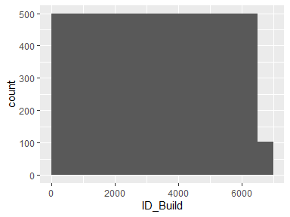

## ID_Parcel

|  |  |
| --- | --- |
| Feature | Result |
| Variable type | numeric |
| Number of missing obs. | 0 (0 %) |
| Number of unique values | 3313 |
| Median | 5746 |
| 1st and 3rd quartiles | 3503; 9758 |
| Min. and max. | 7; 13396 |

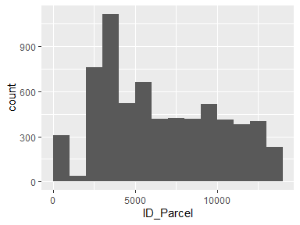

* Note that the following possible outlier values were detected: "7", "14", "24", "26", "35", "60", "61", "64", "68", "72" (11 additional values omitted).

## build_Mean_elev_30m

|  |  |
| --- | --- |
| Feature | Result |
| Variable type | numeric |
| Number of missing obs. | 0 (0 %) |
| Number of unique values | 6597 |
| Median | 364.6 |
| 1st and 3rd quartiles | 148.14; 910.27 |
| Min. and max. | 12.07; 2817.77 |

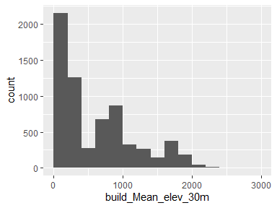

## build_Mean_elev_100m

|  |  |
| --- | --- |
| Feature | Result |
| Variable type | numeric |
| Number of missing obs. | 0 (0 %) |
| Number of unique values | 6597 |
| Median | 358.78 |
| 1st and 3rd quartiles | 147.97; 912.02 |
| Min. and max. | 11.47; 2769.59 |

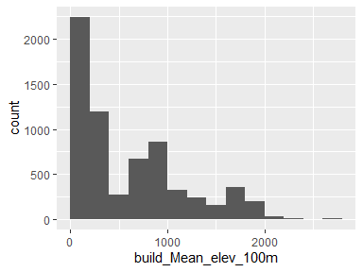

## build_Mean_slope_30m_DEM

|  |  |
| --- | --- |
| Feature | Result |
| Variable type | numeric |
| Number of missing obs. | 0 (0 %) |
| Number of unique values | 6597 |
| Median | 11.23 |
| 1st and 3rd quartiles | 7.38; 15.8 |
| Min. and max. | 1.02; 34.37 |

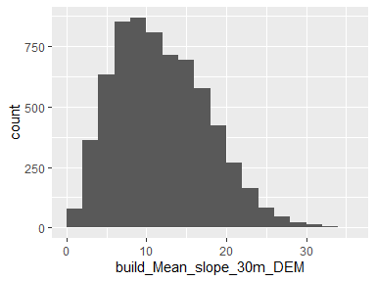

* Note that the following possible outlier values were detected: "33.55", "34.37".

## build_Mean_slope_100m_DEM

|  |  |
| --- | --- |
| Feature | Result |
| Variable type | numeric |
| Number of missing obs. | 0 (0 %) |
| Number of unique values | 6597 |
| Median | 13.08 |
| 1st and 3rd quartiles | 9.54; 17.63 |
| Min. and max. | 1.5; 34.82 |

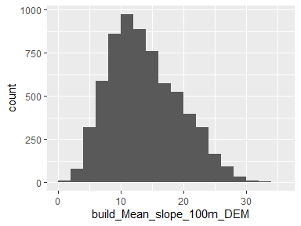

* Note that the following possible outlier values were detected: "1.5", "1.58", "1.61", "1.63", "1.65", "1.66", "1.71", "1.8", "1.86", "1.96" (4 additional values omitted).

## build_Mean_aspect_30m_DEM

|  |  |
| --- | --- |
| Feature | Result |
| Variable type | numeric |
| Number of missing obs. | 0 (0 %) |
| Number of unique values | 6597 |
| Median | 183.49 |
| 1st and 3rd quartiles | 145.94; 213.76 |
| Min. and max. | 41.01; 322.87 |

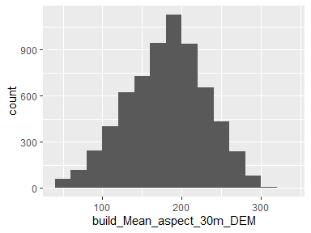

* Note that the following possible outlier values were detected: "286.61", "286.63", "286.63", "286.9", "287.07", "287.4", "287.41", "287.83", "287.99", "288.06" (47 additional values omitted).

## build_Mean_aspect_100m_DEM

|  |  |
| --- | --- |
| Feature | Result |
| Variable type | numeric |
| Number of missing obs. | 0 (0 %) |
| Number of unique values | 6597 |
| Median | 181.34 |
| 1st and 3rd quartiles | 154.53; 205.56 |
| Min. and max. | 58.76; 287.5 |

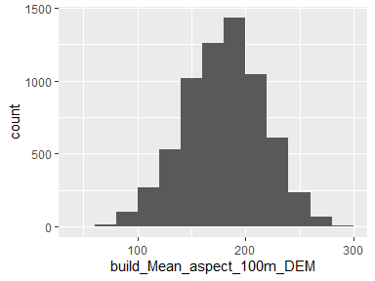

* Note that the following possible outlier values were detected: "58.76", "59.17", "59.94", "60.56", "61.56", "63.43", "63.44", "65.79", "66.49", "68.1" (22 additional values omitted).

## build_Mean_distroad

|  |  |
| --- | --- |
| Feature | Result |
| Variable type | numeric |
| Number of missing obs. | 17 (0.26 %) |
| Number of unique values | 5344 |
| Median | 554.54 |
| 1st and 3rd quartiles | 166.41; 1153.67 |
| Min. and max. | 0; 3666.9 |

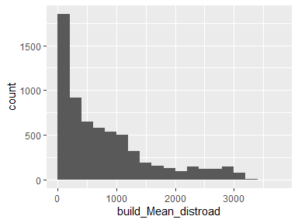

## build_Mean_builddens

|  |  |
| --- | --- |
| Feature | Result |
| Variable type | numeric |
| Number of missing obs. | 17 (0.26 %) |
| Number of unique values | 5090 |
| Median | 1 |
| 1st and 3rd quartiles | 0.53; 1.68 |
| Min. and max. | 0; 4.09 |

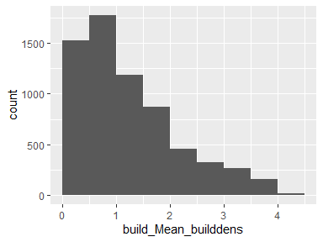

## build_Mean_distall_road

|  |  |
| --- | --- |
| Feature | Result |
| Variable type | numeric |
| Number of missing obs. | 5 (0.08 %) |
| Number of unique values | 3557 |
| Median | 30 |
| 1st and 3rd quartiles | 6.62; 37.5 |
| Min. and max. | 0; 430.68 |

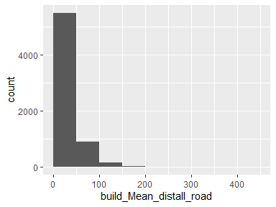

* Note that the following possible outlier values were detected: "74.81", "74.86", "74.96", "75.19", "75.29", "75.31", "75.32", "75.38", "75.45", "75.58" (269 additional values omitted).

## build_structures_DAMAGE

|  |  |
| --- | --- |
| Feature | Result |
| Variable type | character |
| Number of missing obs. | 5199 (78.81 %) |
| Number of unique values | 4 |
| Mode | “Destroyed (>50%)” |

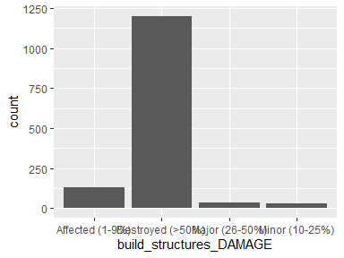

## build_NEAR_FID

|  |  |
| --- | --- |
| Feature | Result |
| Variable type | numeric |
| Number of missing obs. | 0 (0 %) |
| Number of unique values | 4769 |
| Median | 3342 |
| 1st and 3rd quartiles | 1679; 5003 |
| Min. and max. | 1; 6686 |

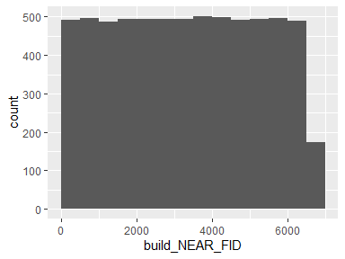

## build_NEAR_DIST

|  |  |
| --- | --- |
| Feature | Result |
| Variable type | numeric |
| Number of missing obs. | 0 (0 %) |
| Number of unique values | 4520 |
| Median | 21.54 |
| 1st and 3rd quartiles | 8.34; 56.72 |
| Min. and max. | 0; 3916.03 |

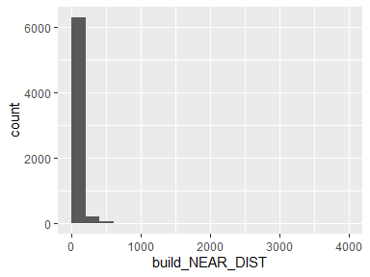

* Note that the following possible outlier values were detected: "399.68", "400.38", "400.67", "410.85", "415.3", "416.39", "417.03", "417.67", "420.24", "423.53" (68 additional values omitted).

## build_NEAR_ANGLE

|  |  |
| --- | --- |
| Feature | Result |
| Variable type | numeric |
| Number of missing obs. | 0 (0 %) |
| Number of unique values | 6530 |
| Median | 0 |
| 1st and 3rd quartiles | -84.5; 91.08 |
| Min. and max. | -179.99; 180 |

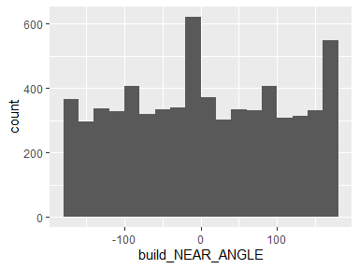

## build_Shape_Length

|  |  |
| --- | --- |
| Feature | Result |
| Variable type | numeric |
| Number of missing obs. | 0 (0 %) |
| Number of unique values | 6597 |
| Median | 196.01 |
| 1st and 3rd quartiles | 121.5; 280.48 |
| Min. and max. | 1.56; 3246.96 |

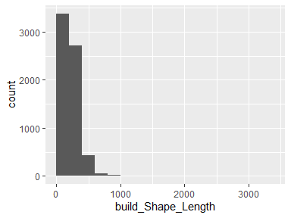

* Note that the following possible outlier values were detected: "646.49", "650.48", "650.97", "651.34", "652.75", "652.89", "656.42", "657.38", "666.34", "667.12" (50 additional values omitted).

## build_Shape_Area

|  |  |
| --- | --- |
| Feature | Result |
| Variable type | numeric |
| Number of missing obs. | 0 (0 %) |
| Number of unique values | 6597 |
| Median | 1853.18 |
| 1st and 3rd quartiles | 791.36; 3263.67 |
| Min. and max. | 0.07; 84114.78 |

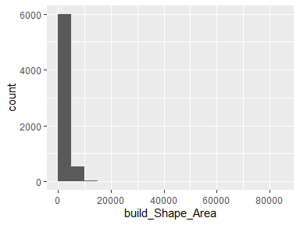

* Note that the following possible outlier values were detected: "10505.13", "10549.37", "10649.12", "10731.14", "11149.36", "11204.63", "11762", "11827.76", "11849.52", "11853.82" (40 additional values omitted).

## damage_cat

|  |  |
| --- | --- |
| Feature | Result |
| Variable type | character |
| Number of missing obs. | 0 (0 %) |
| Number of unique values | 2 |
| Mode | “Survived” |

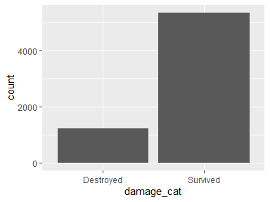

## damage_binary

* Note that this variable is treated as a factor variable below, as it only takes a few unique values.

|  |  |
| --- | --- |
| Feature | Result |
| Variable type | numeric |
| Number of missing obs. | 0 (0 %) |
| Number of unique values | 2 |
| Mode | “0” |
| Reference category | 0 |

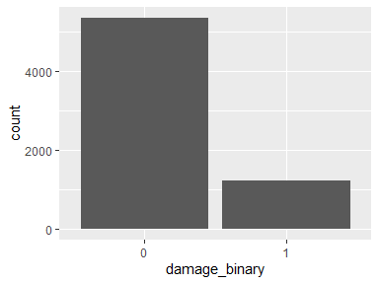

## damage_severity

* Note that this variable is treated as a factor variable below, as it only takes a few unique values.

|  |  |
| --- | --- |
| Feature | Result |
| Variable type | numeric |
| Number of missing obs. | 0 (0 %) |
| Number of unique values | 5 |
| Mode | “1” |
| Reference category | 1 |

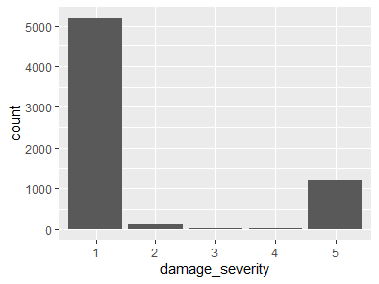

## build_area

|  |  |
| --- | --- |
| Feature | Result |
| Variable type | numeric |
| Number of missing obs. | 0 (0 %) |
| Number of unique values | 6597 |
| Median | 1853.18 |
| 1st and 3rd quartiles | 791.36; 3263.67 |
| Min. and max. | 0.07; 84114.78 |

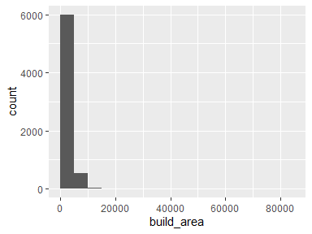

* Note that the following possible outlier values were detected: "10505.13", "10549.37", "10649.12", "10731.14", "11149.36", "11204.63", "11762", "11827.76", "11849.52", "11853.82" (40 additional values omitted).

## near_dest

|  |  |
| --- | --- |
| Feature | Result |
| Variable type | numeric |
| Number of missing obs. | 0 (0 %) |
| Number of unique values | 6196 |
| Median | 305.77 |
| 1st and 3rd quartiles | 89.95; 831.29 |
| Min. and max. | 0.12; 13312.67 |

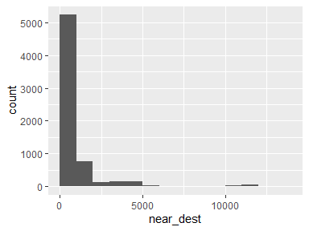

* Note that the following possible outlier values were detected: "5609.28", "5703.26", "5772.02", "5777.53", "5818.42", "5822.86", "6005.55", "6711.82", "7263.55", "7272.48" (123 additional values omitted).

## near_exp

|  |  |
| --- | --- |
| Feature | Result |
| Variable type | numeric |
| Number of missing obs. | 0 (0 %) |
| Number of unique values | 6149 |
| Median | 247.39 |
| 1st and 3rd quartiles | 77.4; 697.75 |
| Min. and max. | 0.05; 13148.46 |

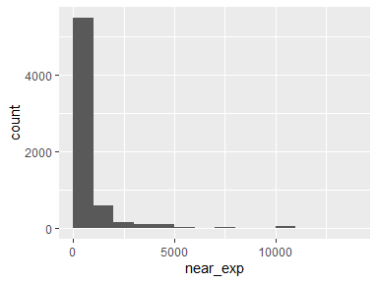

* Note that the following possible outlier values were detected: "5230.79", "5236.83", "5267.67", "5270.52", "5278.36", "5307.79", "5327.41", "5389.39", "5510.41", "5524.45" (120 additional values omitted).

## build_dist_to_build_ft

|  |  |
| --- | --- |
| Feature | Result |
| Variable type | numeric |
| Number of missing obs. | 33 (0.5 %) |
| Number of unique values | 4566 |
| Median | 81.51 |
| 1st and 3rd quartiles | 55.03; 122.45 |
| Min. and max. | 0; 2852.9 |

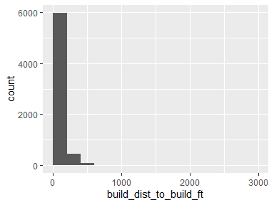

* Note that the following possible outlier values were detected: "0", "1.06", "2.02", "2.14", "3.69", "4.06", "4.37", "5.23", "10.1", "10.46" (196 additional values omitted).

## build_min_dist_tree

|  |  |
| --- | --- |
| Feature | Result |
| Variable type | numeric |
| Number of missing obs. | 0 (0 %) |
| Number of unique values | 393 |
| Median | 0.75 |
| 1st and 3rd quartiles | 0.75; 0.75 |
| Min. and max. | 0.75; 345.25 |

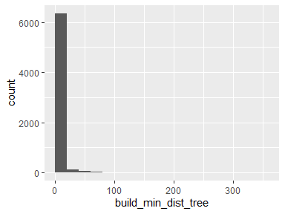

* Note that the following possible outlier values were detected: "1.06", "1.5", "1.68", "2.12", "2.25", "2.37", "2.7", "3", "3.09", "3.18" (382 additional values omitted).

## build_min_dist_shrub

|  |  |
| --- | --- |
| Feature | Result |
| Variable type | numeric |
| Number of missing obs. | 0 (0 %) |
| Number of unique values | 5579 |
| Median | 146.42 |
| 1st and 3rd quartiles | 61.12; 332.94 |
| Min. and max. | 0.75; 2377.11 |

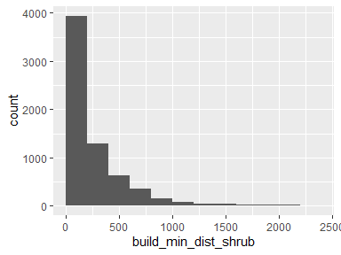

* Note that the following possible outlier values were detected: "1894.28", "1898.88", "1937.93", "1959.06", "1981.97", "1986.9", "1989.85", "2012.14", "2026.69", "2037.25" (23 additional values omitted).

## build_has_tree_overhang

* Note that this variable is treated as a factor variable below, as it only takes a few unique values.

|  |  |
| --- | --- |
| Feature | Result |
| Variable type | numeric |
| Number of missing obs. | 33 (0.5 %) |
| Number of unique values | 2 |
| Mode | “1” |
| Reference category | 0 |

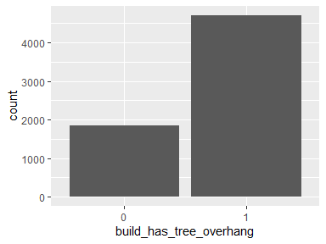

## build_overhang_ht

|  |  |
| --- | --- |
| Feature | Result |
| Variable type | numeric |
| Number of missing obs. | 33 (0.5 %) |
| Number of unique values | 4711 |
| Median | 13.64 |
| 1st and 3rd quartiles | 0; 22.75 |
| Min. and max. | -0.04; 90.21 |

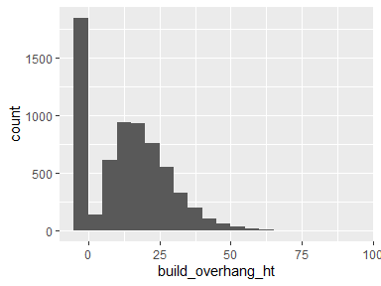

* Note that the following possible outlier values were detected: "57.85", "57.94", "58.19", "58.29", "58.3", "58.32", "58.88", "59.16", "60.6", "60.85" (19 additional values omitted).

## build_perc_overhang

|  |  |
| --- | --- |
| Feature | Result |
| Variable type | numeric |
| Number of missing obs. | 33 (0.5 %) |
| Number of unique values | 4502 |
| Median | 0.02 |
| 1st and 3rd quartiles | 0; 0.1 |
| Min. and max. | 0; 1 |

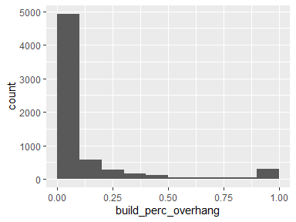

## parcel_AIN.x

|  |  |
| --- | --- |
| Feature | Result |
| Variable type | numeric |
| Number of missing obs. | 0 (0 %) |
| Number of unique values | 3398 |
| Median | 4467014005 |
| 1st and 3rd quartiles | 4461013014; 4469044009 |
| Min. and max. | 2058005013; 4473027903 |

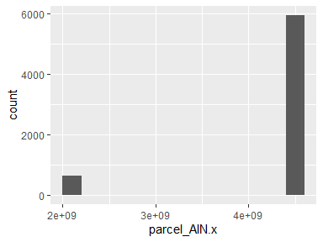

* Note that the following possible outlier values were detected: "2058005013", "2058005015", "2058005016", "2058005019", "2058005021", "2058008010", "2058008015", "2058008017", "2058008018", "2058008019" (618 additional values omitted).

## parcel_UseType.x

|  |  |
| --- | --- |
| Feature | Result |
| Variable type | character |
| Number of missing obs. | 3 (0.05 %) |
| Number of unique values | 9 |
| Mode | “Residential” |

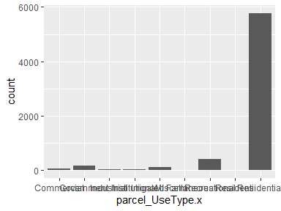

* Note that the following levels have at most five observations: "Residenti".

## parcel_UseDescription.x

|  |  |
| --- | --- |
| Feature | Result |
| Variable type | character |
| Number of missing obs. | 4 (0.06 %) |
| Number of unique values | 33 |
| Mode | “Single” |

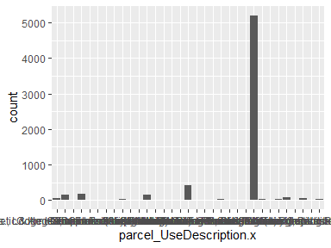

* Note that the following levels have at most five observations: "Commercial", "Fruit & Nuts", "Hotel & Motels", "Industrial", "Irrigated Farm", "Nurseries or Greenhouses", "Restaurants, Cocktail Lounges", "Schools (Private)", "Service Stations", "Warehousing, Distribution, Storage".

## parcel_Roll_ImpValue.x

|  |  |
| --- | --- |
| Feature | Result |
| Variable type | numeric |
| Number of missing obs. | 234 (3.55 %) |
| Number of unique values | 2841 |
| Median | 342819 |
| 1st and 3rd quartiles | 167121; 809280.5 |
| Min. and max. | 0; 45525741 |

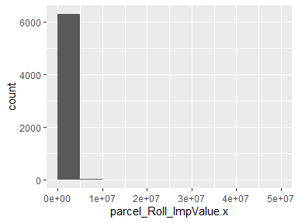

* Note that the following possible outlier values were detected: "4568625", "4588909", "4652362", "4724626", "5005981", "5043196", "5177673", "5262749", "5371051", "6320982" (14 additional values omitted).

## parcel_Roll_HomeOwnersExemp.x

* Note that this variable is treated as a factor variable below, as it only takes a few unique values.

|  |  |
| --- | --- |
| Feature | Result |
| Variable type | numeric |
| Number of missing obs. | 234 (3.55 %) |
| Number of unique values | 3 |
| Mode | “0” |
| Reference category | 0 |

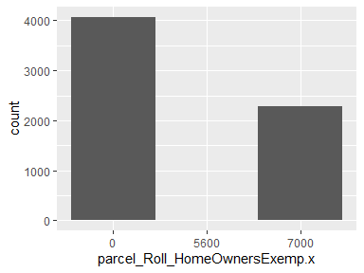

* Note that the following levels have at most five observations: "5600".

## parcel_Can_P.x

|  |  |
| --- | --- |
| Feature | Result |
| Variable type | numeric |
| Number of missing obs. | 1 (0.02 %) |
| Number of unique values | 3340 |
| Median | 31.82 |
| 1st and 3rd quartiles | 19.61; 44.05 |
| Min. and max. | 0; 97.37 |

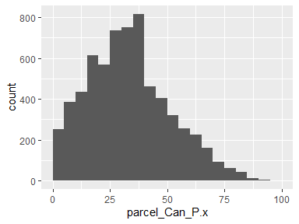

* Note that the following possible outlier values were detected: "87.76", "87.83", "88.8", "89.31", "89.32", "89.48", "89.74", "91.09", "91.13", "92.92" (2 additional values omitted).

## parcel_Grass_P.x

|  |  |
| --- | --- |
| Feature | Result |
| Variable type | numeric |
| Number of missing obs. | 1 (0.02 %) |
| Number of unique values | 3349 |
| Median | 11.74 |
| 1st and 3rd quartiles | 6.01; 18.72 |
| Min. and max. | 0; 63.52 |

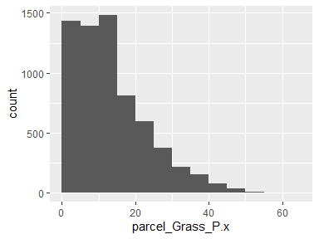

* Note that the following possible outlier values were detected: "47.73", "47.75", "48.25", "48.29", "48.33", "48.55", "48.73", "48.84", "49.68", "49.89" (16 additional values omitted).

## parcel_Soil_P.x

|  |  |
| --- | --- |
| Feature | Result |
| Variable type | numeric |
| Number of missing obs. | 1 (0.02 %) |
| Number of unique values | 3271 |
| Median | 22.15 |
| 1st and 3rd quartiles | 11.77; 36.01 |
| Min. and max. | 0; 96.59 |

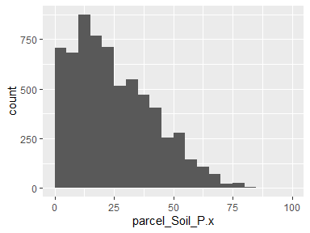

* Note that the following possible outlier values were detected: "96.59".

## parcel_Water_P.x

|  |  |
| --- | --- |
| Feature | Result |
| Variable type | numeric |
| Number of missing obs. | 1 (0.02 %) |
| Number of unique values | 22 |
| Median | 0 |
| 1st and 3rd quartiles | 0; 0 |
| Min. and max. | 0; 28.72 |

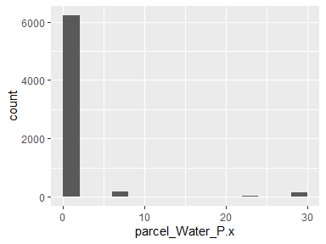

* Note that the following possible outlier values were detected: "0", "0.01", "0.03", "0.07", "0.24", "0.32", "0.32", "0.52", "0.66", "0.89" (11 additional values omitted).

## parcel_Build_P.x

|  |  |
| --- | --- |
| Feature | Result |
| Variable type | numeric |
| Number of missing obs. | 1 (0.02 %) |
| Number of unique values | 3336 |
| Median | 8.27 |
| 1st and 3rd quartiles | 3.41; 15.75 |
| Min. and max. | 0; 94.41 |

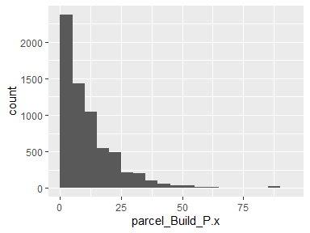

* Note that the following possible outlier values were detected: "57.59", "57.62", "58.37", "58.59", "58.87", "58.9", "59.74", "60", "60.22", "60.33" (48 additional values omitted).

## parcel_Road_P.x

|  |  |
| --- | --- |
| Feature | Result |
| Variable type | numeric |
| Number of missing obs. | 1 (0.02 %) |
| Number of unique values | 1797 |
| Median | 0.98 |
| 1st and 3rd quartiles | 0; 3.96 |
| Min. and max. | 0; 29.1 |

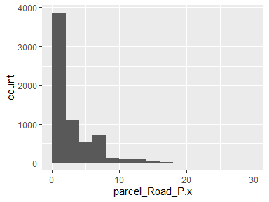

## parcel_Paved_P.x

|  |  |
| --- | --- |
| Feature | Result |
| Variable type | numeric |
| Number of missing obs. | 1 (0.02 %) |
| Number of unique values | 2892 |
| Median | 4.74 |
| 1st and 3rd quartiles | 1.42; 9.67 |
| Min. and max. | 0; 69.01 |

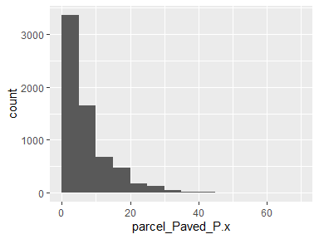

* Note that the following possible outlier values were detected: "42.09", "42.82", "42.96", "43", "43.22", "43.34", "44.3", "45.02", "45.77", "47.25" (8 additional values omitted).

## parcel_Shrub_P.x

|  |  |
| --- | --- |
| Feature | Result |
| Variable type | numeric |
| Number of missing obs. | 1 (0.02 %) |
| Number of unique values | 1331 |
| Median | 0.05 |
| 1st and 3rd quartiles | 0; 8.68 |
| Min. and max. | 0; 74.81 |

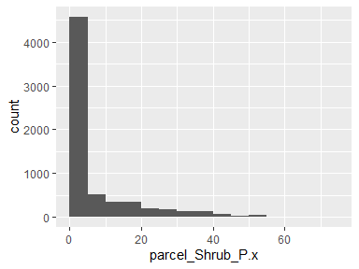

## parcel_Perv_P.x

|  |  |
| --- | --- |
| Feature | Result |
| Variable type | numeric |
| Number of missing obs. | 1 (0.02 %) |
| Number of unique values | 3372 |
| Median | 83.21 |
| 1st and 3rd quartiles | 68.64; 91.51 |
| Min. and max. | 0.71; 100 |

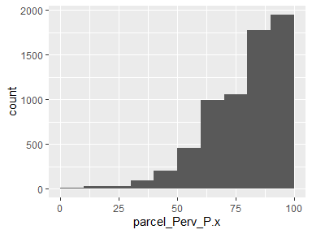

## parcel_Imperv_P.x

|  |  |
| --- | --- |
| Feature | Result |
| Variable type | numeric |
| Number of missing obs. | 1 (0.02 %) |
| Number of unique values | 3372 |
| Median | 16.79 |
| 1st and 3rd quartiles | 8.49; 31.36 |
| Min. and max. | 0; 99.29 |

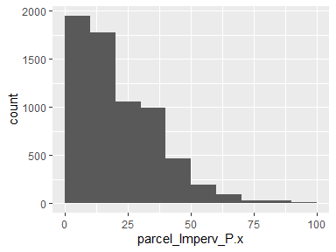

## parcel_EffectiveYear1.x

|  |  |
| --- | --- |
| Feature | Result |
| Variable type | numeric |
| Number of missing obs. | 772 (11.7 %) |
| Number of unique values | 95 |
| Median | 1980 |
| 1st and 3rd quartiles | 1964; 1990 |
| Min. and max. | 0; 2015 |

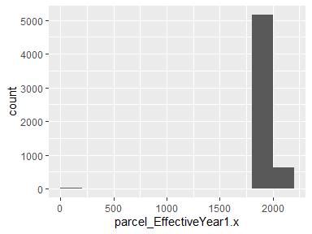

* Note that the following possible outlier values were detected: "0", "1907", "2015".

## parcel_EffectiveYear2.x

|  |  |
| --- | --- |
| Feature | Result |
| Variable type | numeric |
| Number of missing obs. | 5871 (88.99 %) |
| Number of unique values | 45 |
| Median | 1969 |
| 1st and 3rd quartiles | 1955; 1972 |
| Min. and max. | 1926; 2012 |

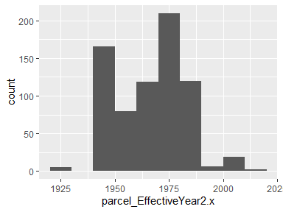

* Note that the following possible outlier values were detected: "1980", "1981", "1982", "1983", "1984", "1985", "1986", "1988", "1990", "1996" (6 additional values omitted).

## parcel_EffectiveYear3.x

|  |  |
| --- | --- |
| Feature | Result |
| Variable type | numeric |
| Number of missing obs. | 6205 (94.06 %) |
| Number of unique values | 17 |
| Median | 1958 |
| 1st and 3rd quartiles | 1950; 1976 |
| Min. and max. | 0; 2013 |

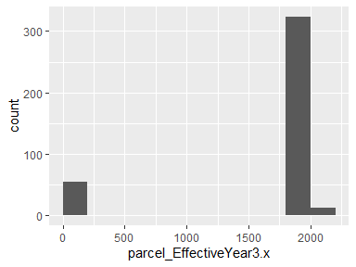

* Note that the following possible outlier values were detected: "0".

## parcel_EffectiveYear4.x

|  |  |
| --- | --- |
| Feature | Result |
| Variable type | numeric |
| Number of missing obs. | 6279 (95.18 %) |
| Number of unique values | 14 |
| Median | 1971 |
| 1st and 3rd quartiles | 1962.25; 1971 |
| Min. and max. | 1936; 2013 |

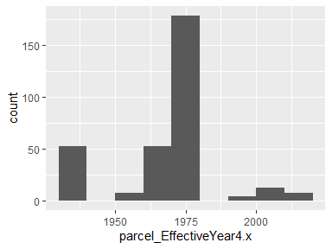

* Note that the following possible outlier values were detected: "1973", "1997", "2001", "2008", "2013".

## parcel_EffectiveYear5.x

|  |  |
| --- | --- |
| Feature | Result |
| Variable type | numeric |
| Number of missing obs. | 6297 (95.45 %) |
| Number of unique values | 10 |
| Median | 1969 |
| 1st and 3rd quartiles | 1452.75; 1969 |
| Min. and max. | 0; 2013 |

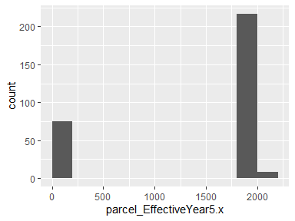

* Note that the following possible outlier values were detected: "1984", "1997", "2013".

## parcel_area.x

|  |  |
| --- | --- |
| Feature | Result |
| Variable type | numeric |
| Number of missing obs. | 1 (0.02 %) |
| Number of unique values | 3399 |
| Median | 73189.69 |
| 1st and 3rd quartiles | 28701.38; 351805.94 |
| Min. and max. | 1942.45; 65882419.74 |

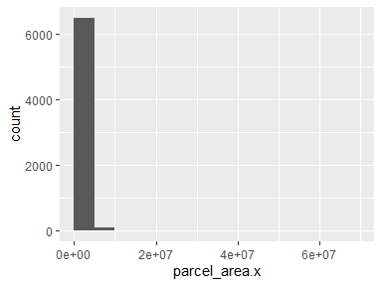

* Note that the following possible outlier values were detected: "1942.45", "1991.13", "2270.63", "2595.07", "2658.44", "2796.47", "2910.17", "3124.34", "3194.38", "3322.22" (206 additional values omitted).

## parcel_recent.x

|  |  |
| --- | --- |
| Feature | Result |
| Variable type | numeric |
| Number of missing obs. | 772 (11.7 %) |
| Number of unique values | 94 |
| Median | 1980 |
| 1st and 3rd quartiles | 1965; 1991 |
| Min. and max. | 0; 2015 |

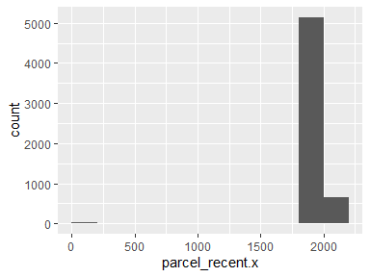

* Note that the following possible outlier values were detected: "0", "1907".

## build_treecan10

|  |  |
| --- | --- |
| Feature | Result |
| Variable type | numeric |
| Number of missing obs. | 3 (0.05 %) |
| Number of unique values | 375 |
| Median | 0 |
| 1st and 3rd quartiles | 0; 0 |
| Min. and max. | 0; 100 |

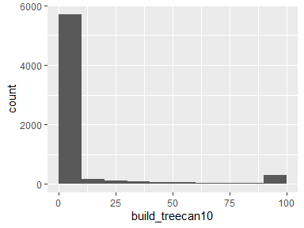

* Note that the following possible outlier values were detected: "0.19", "0.38", "0.57", "0.76", "0.95", "1.14", "1.33", "1.52", "1.7", "1.89" (364 additional values omitted).

## build_treecan100

|  |  |
| --- | --- |
| Feature | Result |
| Variable type | numeric |
| Number of missing obs. | 3 (0.05 %) |
| Number of unique values | 5995 |
| Median | 30.02 |
| 1st and 3rd quartiles | 18.02; 44.37 |
| Min. and max. | 0; 99.99 |

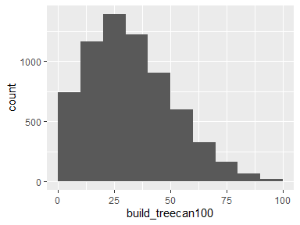

## build_treecan200

|  |  |
| --- | --- |
| Feature | Result |
| Variable type | numeric |
| Number of missing obs. | 3 (0.05 %) |
| Number of unique values | 6435 |
| Median | 29.07 |
| 1st and 3rd quartiles | 19.51; 40.74 |
| Min. and max. | 0; 93.99 |

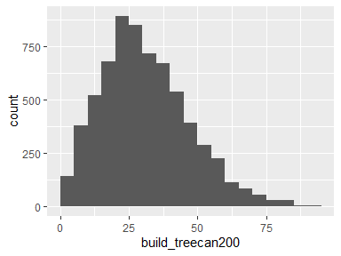

* Note that the following possible outlier values were detected: "86.35", "86.83", "87.67", "88.35", "91.44", "92.22", "92.7", "93.99".

## build_treecan300

|  |  |
| --- | --- |
| Feature | Result |
| Variable type | numeric |
| Number of missing obs. | 3 (0.05 %) |
| Number of unique values | 6503 |
| Median | 28.37 |
| 1st and 3rd quartiles | 19.47; 38.63 |
| Min. and max. | 0; 92.23 |

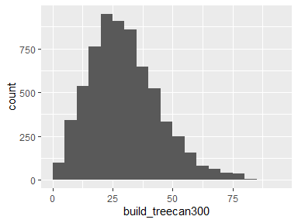

* Note that the following possible outlier values were detected: "76.68", "76.75", "77.3", "77.33", "77.36", "77.36", "77.47", "77.5", "77.65", "77.65" (22 additional values omitted).

## build_grass10

|  |  |
| --- | --- |
| Feature | Result |
| Variable type | numeric |
| Number of missing obs. | 3 (0.05 %) |
| Number of unique values | 218 |
| Median | 0 |
| 1st and 3rd quartiles | 0; 0 |
| Min. and max. | 0; 100 |

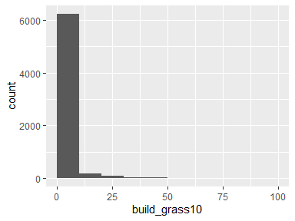

* Note that the following possible outlier values were detected: "0.19", "0.38", "0.57", "0.76", "0.95", "0.95", "1.14", "1.33", "1.52", "1.7" (207 additional values omitted).

## build_grass_100

|  |  |
| --- | --- |
| Feature | Result |
| Variable type | numeric |
| Number of missing obs. | 3 (0.05 %) |
| Number of unique values | 5401 |
| Median | 13.59 |
| 1st and 3rd quartiles | 8.07; 20.21 |
| Min. and max. | 0; 74.57 |

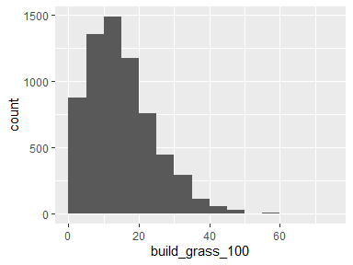

* Note that the following possible outlier values were detected: "47.26", "47.45", "47.9", "47.95", "48.11", "48.5", "48.55", "48.58", "49.15", "49.43" (15 additional values omitted).

## build_grass_200

|  |  |
| --- | --- |
| Feature | Result |
| Variable type | numeric |
| Number of missing obs. | 3 (0.05 %) |
| Number of unique values | 6170 |
| Median | 12.52 |
| 1st and 3rd quartiles | 7.67; 17.48 |
| Min. and max. | 0; 66.03 |

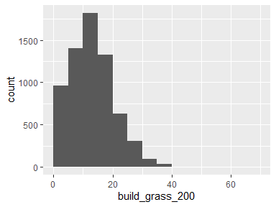

* Note that the following possible outlier values were detected: "35.05", "35.24", "35.29", "35.41", "35.45", "35.63", "35.68", "35.79", "35.81", "35.84" (40 additional values omitted).

## build_grass_300

|  |  |
| --- | --- |
| Feature | Result |
| Variable type | numeric |
| Number of missing obs. | 3 (0.05 %) |
| Number of unique values | 6354 |
| Median | 11.65 |
| 1st and 3rd quartiles | 6.93; 16.15 |
| Min. and max. | 0; 59.09 |

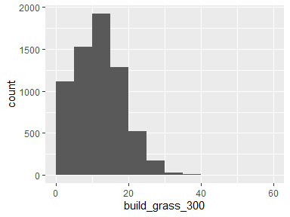

* Note that the following possible outlier values were detected: "30.28", "30.3", "30.34", "30.49", "30.5", "30.72", "30.72", "30.76", "30.86", "30.9" (35 additional values omitted).

## build_soil_10

|  |  |
| --- | --- |
| Feature | Result |
| Variable type | numeric |
| Number of missing obs. | 3 (0.05 %) |
| Number of unique values | 240 |
| Median | 0 |
| 1st and 3rd quartiles | 0; 0 |
| Min. and max. | 0; 100 |

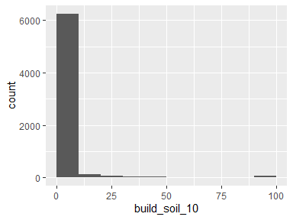

* Note that the following possible outlier values were detected: "0.19", "0.38", "0.57", "0.76", "0.95", "1.14", "1.33", "1.52", "1.7", "1.89" (229 additional values omitted).

## build_soil_100

|  |  |
| --- | --- |
| Feature | Result |
| Variable type | numeric |
| Number of missing obs. | 3 (0.05 %) |
| Number of unique values | 5772 |
| Median | 16.1 |
| 1st and 3rd quartiles | 7.25; 30.5 |
| Min. and max. | 0; 98.57 |

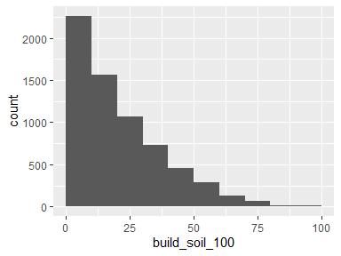

## build_soil_200

|  |  |
| --- | --- |
| Feature | Result |
| Variable type | numeric |
| Number of missing obs. | 3 (0.05 %) |
| Number of unique values | 6423 |
| Median | 22.9 |
| 1st and 3rd quartiles | 12.35; 36.82 |
| Min. and max. | 0.44; 96.31 |

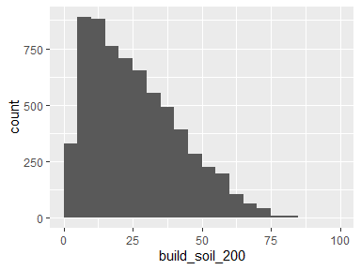

## build_soil_300

|  |  |
| --- | --- |
| Feature | Result |
| Variable type | numeric |
| Number of missing obs. | 3 (0.05 %) |
| Number of unique values | 6511 |
| Median | 24.84 |
| 1st and 3rd quartiles | 15.08; 36.94 |
| Min. and max. | 0.54; 88.5 |

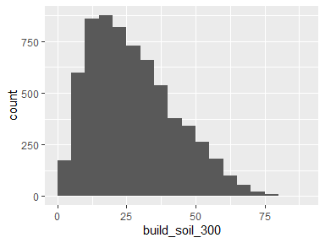

## build_water_10

* Note that this variable is treated as a factor variable below, as it only takes a few unique values.

|  |  |
| --- | --- |
| Feature | Result |
| Variable type | numeric |
| Number of missing obs. | 3 (0.05 %) |
| Number of unique values | 2 |
| Mode | “0” |
| Reference category | 0 |

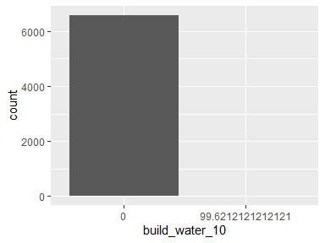

* Note that the following levels have at most five observations: "99.6212121212121".

## build_water_100

|  |  |
| --- | --- |
| Feature | Result |
| Variable type | numeric |
| Number of missing obs. | 3 (0.05 %) |
| Number of unique values | 67 |
| Median | 0 |
| 1st and 3rd quartiles | 0; 0 |
| Min. and max. | 0; 35.59 |

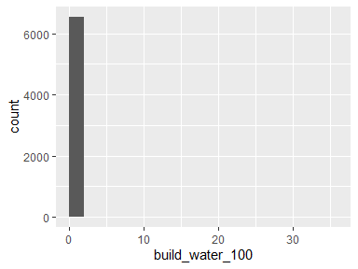

* Note that the following possible outlier values were detected: "0", "0.01", "0.01", "0.02", "0.1", "0.11", "0.15", "0.19", "0.2", "0.21" (56 additional values omitted).

## build_water_200

|  |  |
| --- | --- |
| Feature | Result |
| Variable type | numeric |
| Number of missing obs. | 3 (0.05 %) |
| Number of unique values | 170 |
| Median | 0 |
| 1st and 3rd quartiles | 0; 0 |
| Min. and max. | 0; 41.96 |

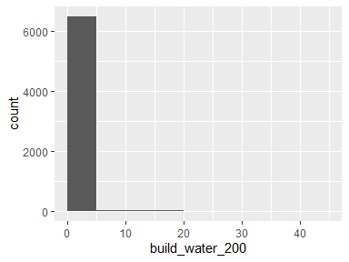

* Note that the following possible outlier values were detected: "0", "0.01", "0.04", "0.05", "0.06", "0.07", "0.07", "0.11", "0.11", "0.11" (159 additional values omitted).

## build_water_300

|  |  |
| --- | --- |
| Feature | Result |
| Variable type | numeric |
| Number of missing obs. | 3 (0.05 %) |
| Number of unique values | 261 |
| Median | 0 |
| 1st and 3rd quartiles | 0; 0 |
| Min. and max. | 0; 45.65 |

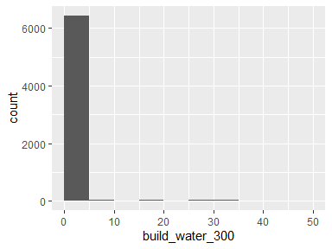

* Note that the following possible outlier values were detected: "0", "0", "0.01", "0.02", "0.02", "0.03", "0.03", "0.05", "0.05", "0.05" (250 additional values omitted).

## build_build_10

|  |  |
| --- | --- |
| Feature | Result |
| Variable type | numeric |
| Number of missing obs. | 3 (0.05 %) |
| Number of unique values | 432 |
| Median | 100 |
| 1st and 3rd quartiles | 90.91; 100 |
| Min. and max. | 0; 100 |

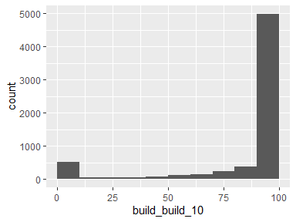

## build_build_100

|  |  |
| --- | --- |
| Feature | Result |
| Variable type | numeric |
| Number of missing obs. | 3 (0.05 %) |
| Number of unique values | 5288 |
| Median | 12.81 |
| 1st and 3rd quartiles | 7.03; 19.86 |
| Min. and max. | 0; 87.49 |

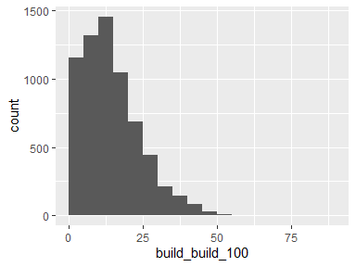

* Note that the following possible outlier values were detected: "49.36", "49.82", "49.99", "50.21", "50.28", "51.65", "53.52", "53.9", "54.18", "54.79" (14 additional values omitted).

## build_build_200

|  |  |
| --- | --- |
| Feature | Result |
| Variable type | numeric |
| Number of missing obs. | 3 (0.05 %) |
| Number of unique values | 5883 |
| Median | 7.63 |
| 1st and 3rd quartiles | 4.2; 12.72 |
| Min. and max. | 0; 54.15 |

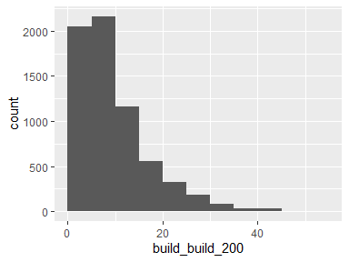

* Note that the following possible outlier values were detected: "40.69", "40.78", "40.83", "40.85", "40.86", "41.01", "41.44", "41.45", "41.57", "41.85" (24 additional values omitted).

## build_build_300

|  |  |
| --- | --- |
| Feature | Result |
| Variable type | numeric |
| Number of missing obs. | 3 (0.05 %) |
| Number of unique values | 5965 |
| Median | 6.46 |
| 1st and 3rd quartiles | 3.21; 10.49 |
| Min. and max. | 0; 43.28 |

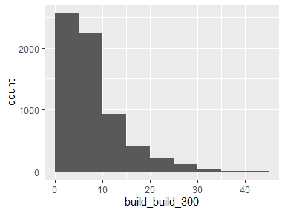

* Note that the following possible outlier values were detected: "30.34", "30.44", "30.54", "30.6", "30.76", "30.8", "30.87", "30.88", "30.95", "30.98" (65 additional values omitted).

## build_road_10

|  |  |
| --- | --- |
| Feature | Result |
| Variable type | numeric |
| Number of missing obs. | 3 (0.05 %) |
| Number of unique values | 29 |
| Median | 0 |
| 1st and 3rd quartiles | 0; 0 |
| Min. and max. | 0; 44.7 |

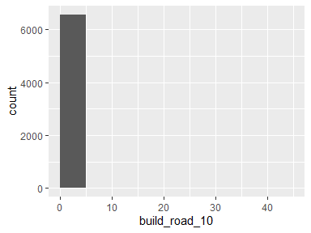

* Note that the following possible outlier values were detected: "0.19", "0.57", "0.95", "1.14", "1.52", "1.7", "1.89", "2.27", "3.22", "3.98" (18 additional values omitted).

## build_road_100

|  |  |
| --- | --- |
| Feature | Result |
| Variable type | numeric |
| Number of missing obs. | 3 (0.05 %) |
| Number of unique values | 3567 |
| Median | 3.49 |
| 1st and 3rd quartiles | 0; 8.58 |
| Min. and max. | 0; 45.61 |

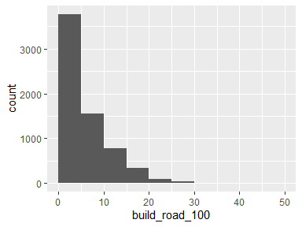

* Note that the following possible outlier values were detected: "40.28", "45.61".

## build_road_200

|  |  |
| --- | --- |
| Feature | Result |
| Variable type | numeric |
| Number of missing obs. | 3 (0.05 %) |
| Number of unique values | 5284 |
| Median | 5.37 |
| 1st and 3rd quartiles | 2.1; 8.96 |
| Min. and max. | 0; 39.9 |

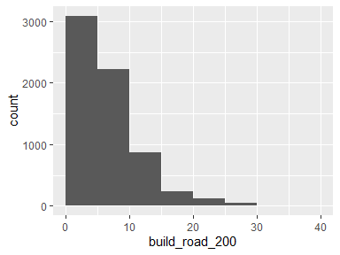

* Note that the following possible outlier values were detected: "23.77", "23.88", "23.95", "23.95", "23.99", "24.19", "24.23", "24.24", "24.36", "24.38" (64 additional values omitted).

## build_road_300

|  |  |
| --- | --- |
| Feature | Result |
| Variable type | numeric |
| Number of missing obs. | 3 (0.05 %) |
| Number of unique values | 5877 |
| Median | 5.36 |
| 1st and 3rd quartiles | 2.85; 8.27 |
| Min. and max. | 0; 30.19 |

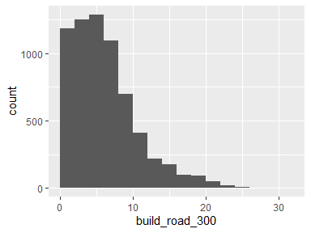

* Note that the following possible outlier values were detected: "19.89", "19.94", "20.01", "20.01", "20.04", "20.04", "20.06", "20.1", "20.14", "20.19" (77 additional values omitted).

## build_oth_imp_10

|  |  |
| --- | --- |
| Feature | Result |
| Variable type | numeric |
| Number of missing obs. | 3 (0.05 %) |
| Number of unique values | 165 |
| Median | 0 |
| 1st and 3rd quartiles | 0; 0 |
| Min. and max. | 0; 100 |

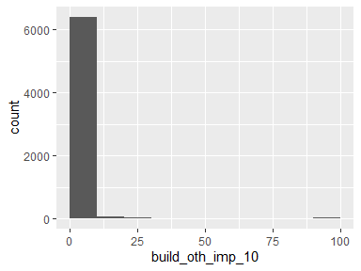

* Note that the following possible outlier values were detected: "0.19", "0.38", "0.57", "0.76", "0.95", "1.14", "1.33", "1.52", "1.7", "1.89" (154 additional values omitted).

## build_oth_imp_100

|  |  |
| --- | --- |
| Feature | Result |
| Variable type | numeric |
| Number of missing obs. | 3 (0.05 %) |
| Number of unique values | 4650 |
| Median | 7.35 |
| 1st and 3rd quartiles | 2.73; 13.4 |
| Min. and max. | 0; 87.36 |

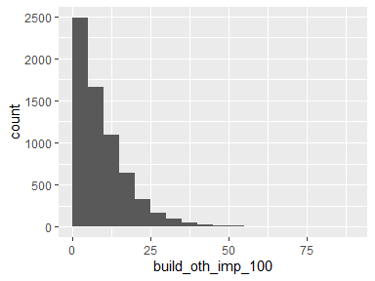

* Note that the following possible outlier values were detected: "42.71", "42.91", "43.02", "43.05", "43.09", "43.3", "43.32", "43.4", "43.57", "44" (49 additional values omitted).

## build_oth_imp_200

|  |  |
| --- | --- |
| Feature | Result |
| Variable type | numeric |
| Number of missing obs. | 3 (0.05 %) |
| Number of unique values | 5644 |
| Median | 6.11 |
| 1st and 3rd quartiles | 3.02; 9.88 |
| Min. and max. | 0; 74.97 |

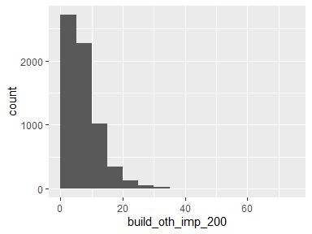

* Note that the following possible outlier values were detected: "26.32", "26.43", "26.56", "26.56", "26.61", "26.68", "26.68", "26.87", "26.89", "26.98" (82 additional values omitted).

## build_oth_imp_300

|  |  |
| --- | --- |
| Feature | Result |
| Variable type | numeric |
| Number of missing obs. | 3 (0.05 %) |
| Number of unique values | 5945 |
| Median | 5.46 |
| 1st and 3rd quartiles | 2.86; 8.47 |
| Min. and max. | 0; 61.67 |

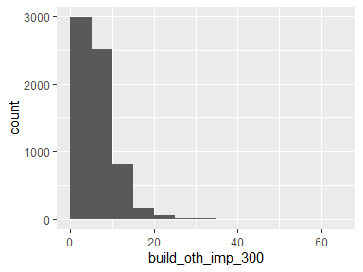

* Note that the following possible outlier values were detected: "21.01", "21.15", "21.2", "21.22", "21.24", "21.27", "21.29", "21.3", "21.33", "21.63" (79 additional values omitted).

## build_shrub_10

|  |  |
| --- | --- |
| Feature | Result |
| Variable type | numeric |
| Number of missing obs. | 3 (0.05 %) |
| Number of unique values | 34 |
| Median | 0 |
| 1st and 3rd quartiles | 0; 0 |
| Min. and max. | 0; 39.2 |

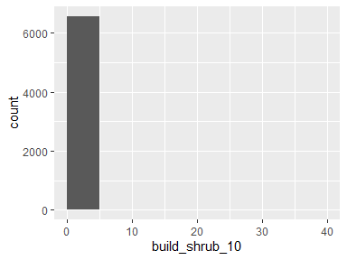

* Note that the following possible outlier values were detected: "0.76", "1.14", "1.33", "1.52", "1.7", "1.89", "2.08", "2.27", "3.6", "3.98" (23 additional values omitted).

## build_shrub_100

|  |  |
| --- | --- |
| Feature | Result |
| Variable type | numeric |
| Number of missing obs. | 3 (0.05 %) |
| Number of unique values | 1303 |
| Median | 0 |
| 1st and 3rd quartiles | 0; 0.09 |
| Min. and max. | 0; 50.87 |

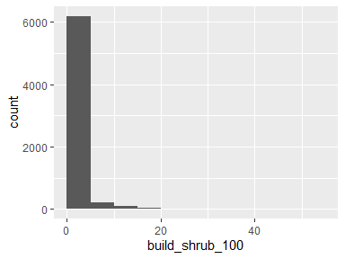

* Note that the following possible outlier values were detected: "2.8", "2.81", "2.82", "2.83", "2.85", "2.86", "2.86", "2.88", "2.88", "2.89" (602 additional values omitted).

## build_shrub_200

|  |  |
| --- | --- |
| Feature | Result |
| Variable type | numeric |
| Number of missing obs. | 3 (0.05 %) |
| Number of unique values | 3181 |
| Median | 0.1 |
| 1st and 3rd quartiles | 0; 3.37 |
| Min. and max. | 0; 67.43 |

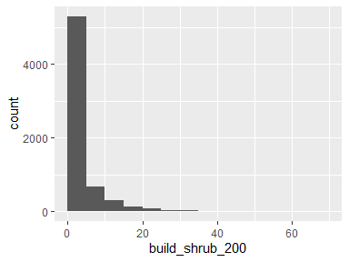

## build_shrub_300

|  |  |
| --- | --- |
| Feature | Result |
| Variable type | numeric |
| Number of missing obs. | 3 (0.05 %) |
| Number of unique values | 4228 |
| Median | 1.27 |
| 1st and 3rd quartiles | 0; 6.7 |
| Min. and max. | 0; 60.77 |

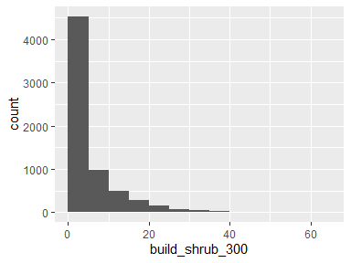

## parcel_AIN.y

|  |  |
| --- | --- |
| Feature | Result |
| Variable type | numeric |
| Number of missing obs. | 1 (0.02 %) |
| Number of unique values | 3398 |
| Median | 4467014009.5 |
| 1st and 3rd quartiles | 4461013014.75; 4469044009.25 |
| Min. and max. | 2058005013; 4473027903 |

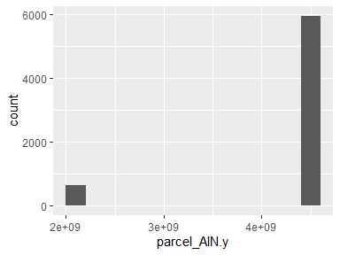

* Note that the following possible outlier values were detected: "2058005013", "2058005015", "2058005016", "2058005019", "2058005021", "2058008010", "2058008015", "2058008017", "2058008018", "2058008019" (618 additional values omitted).

## parcel_UseType.y

|  |  |
| --- | --- |
| Feature | Result |
| Variable type | character |
| Number of missing obs. | 4 (0.06 %) |
| Number of unique values | 8 |
| Mode | “Residential” |

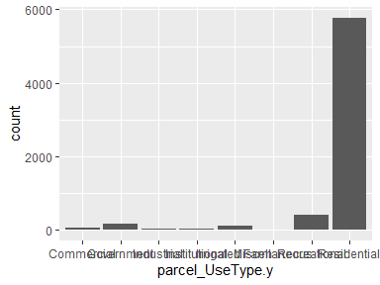

## parcel_UseDescription.y

|  |  |
| --- | --- |
| Feature | Result |
| Variable type | character |
| Number of missing obs. | 4 (0.06 %) |
| Number of unique values | 33 |
| Mode | “Single” |

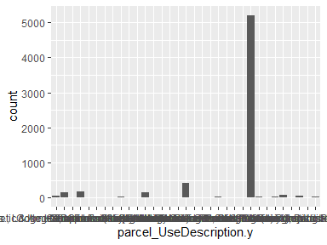

* Note that the following levels have at most five observations: "Commercial", "Fruit & Nuts", "Hotel & Motels", "Industrial", "Irrigated Farm", "Nurseries or Greenhouses", "Restaurants, Cocktail Lounges", "Schools (Private)", "Service Stations", "Warehousing, Distribution, Storage".

## parcel_Roll_ImpValue.y

|  |  |
| --- | --- |
| Feature | Result |
| Variable type | numeric |
| Number of missing obs. | 234 (3.55 %) |
| Number of unique values | 2841 |
| Median | 342819 |
| 1st and 3rd quartiles | 167121; 809280.5 |
| Min. and max. | 0; 45525741 |

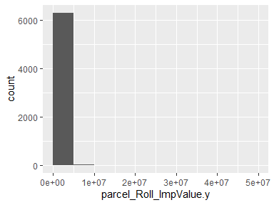

* Note that the following possible outlier values were detected: "4568625", "4588909", "4652362", "4724626", "5005981", "5043196", "5177673", "5262749", "5371051", "6320982" (14 additional values omitted).

## parcel_Roll_HomeOwnersExemp.y

* Note that this variable is treated as a factor variable below, as it only takes a few unique values.

|  |  |
| --- | --- |
| Feature | Result |
| Variable type | numeric |
| Number of missing obs. | 234 (3.55 %) |
| Number of unique values | 3 |
| Mode | “0” |
| Reference category | 0 |

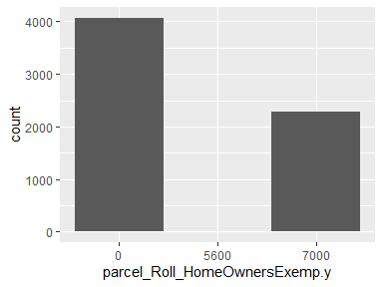

* Note that the following levels have at most five observations: "5600".

## parcel_Can_P.y

|  |  |
| --- | --- |
| Feature | Result |
| Variable type | numeric |
| Number of missing obs. | 1 (0.02 %) |
| Number of unique values | 3340 |
| Median | 31.82 |
| 1st and 3rd quartiles | 19.61; 44.05 |
| Min. and max. | 0; 97.37 |

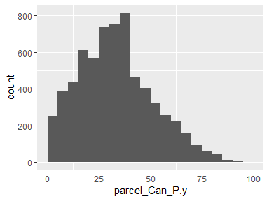

* Note that the following possible outlier values were detected: "87.76", "87.83", "88.8", "89.31", "89.32", "89.48", "89.74", "91.09", "91.13", "92.92" (2 additional values omitted).

## parcel_Grass_P.y

|  |  |
| --- | --- |
| Feature | Result |
| Variable type | numeric |
| Number of missing obs. | 1 (0.02 %) |
| Number of unique values | 3349 |
| Median | 11.74 |
| 1st and 3rd quartiles | 6.01; 18.72 |
| Min. and max. | 0; 63.52 |

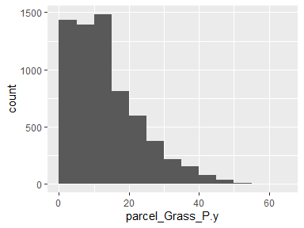

* Note that the following possible outlier values were detected: "47.73", "47.75", "48.25", "48.29", "48.33", "48.55", "48.73", "48.84", "49.68", "49.89" (16 additional values omitted).

## parcel_Soil_P.y

|  |  |
| --- | --- |
| Feature | Result |
| Variable type | numeric |
| Number of missing obs. | 1 (0.02 %) |
| Number of unique values | 3271 |
| Median | 22.15 |
| 1st and 3rd quartiles | 11.77; 36.01 |
| Min. and max. | 0; 96.59 |

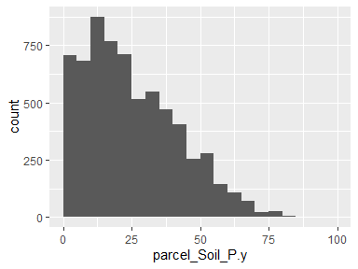

* Note that the following possible outlier values were detected: "96.59".

## parcel_Water_P.y

|  |  |
| --- | --- |
| Feature | Result |
| Variable type | numeric |
| Number of missing obs. | 1 (0.02 %) |
| Number of unique values | 22 |
| Median | 0 |
| 1st and 3rd quartiles | 0; 0 |
| Min. and max. | 0; 28.72 |

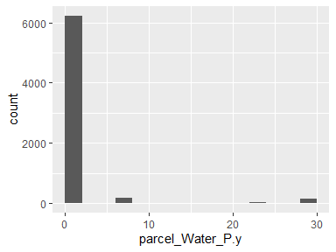

* Note that the following possible outlier values were detected: "0", "0.01", "0.03", "0.07", "0.24", "0.32", "0.32", "0.52", "0.66", "0.89" (11 additional values omitted).

## parcel_Build_P.y

|  |  |
| --- | --- |
| Feature | Result |
| Variable type | numeric |
| Number of missing obs. | 1 (0.02 %) |
| Number of unique values | 3336 |
| Median | 8.27 |
| 1st and 3rd quartiles | 3.41; 15.75 |
| Min. and max. | 0; 94.41 |

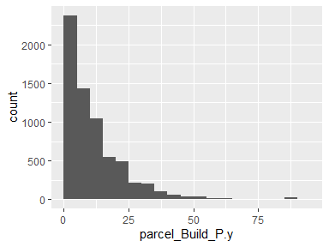

* Note that the following possible outlier values were detected: "57.59", "57.62", "58.37", "58.59", "58.87", "58.9", "59.74", "60", "60.22", "60.33" (48 additional values omitted).

## parcel_Road_P.y

|  |  |
| --- | --- |
| Feature | Result |
| Variable type | numeric |
| Number of missing obs. | 1 (0.02 %) |
| Number of unique values | 1797 |
| Median | 0.98 |
| 1st and 3rd quartiles | 0; 3.96 |
| Min. and max. | 0; 29.1 |

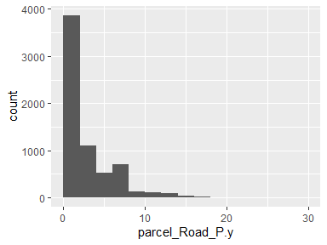

## parcel_Paved_P.y

|  |  |
| --- | --- |
| Feature | Result |
| Variable type | numeric |
| Number of missing obs. | 1 (0.02 %) |
| Number of unique values | 2892 |
| Median | 4.74 |
| 1st and 3rd quartiles | 1.42; 9.67 |
| Min. and max. | 0; 69.01 |

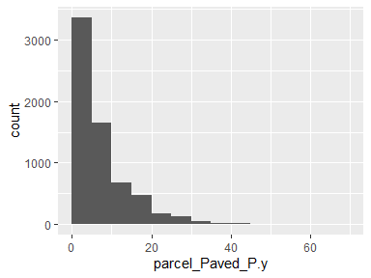

* Note that the following possible outlier values were detected: "42.09", "42.82", "42.96", "43", "43.22", "43.34", "44.3", "45.02", "45.77", "47.25" (8 additional values omitted).

## parcel_Shrub_P.y

|  |  |
| --- | --- |
| Feature | Result |
| Variable type | numeric |
| Number of missing obs. | 1 (0.02 %) |
| Number of unique values | 1331 |
| Median | 0.05 |
| 1st and 3rd quartiles | 0; 8.68 |
| Min. and max. | 0; 74.81 |

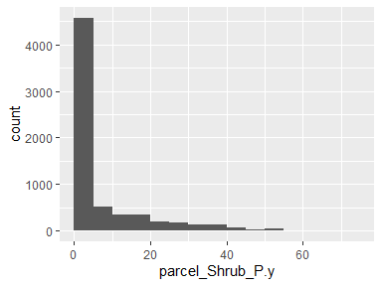

## parcel_Perv_P.y

|  |  |
| --- | --- |
| Feature | Result |
| Variable type | numeric |
| Number of missing obs. | 1 (0.02 %) |
| Number of unique values | 3372 |
| Median | 83.21 |
| 1st and 3rd quartiles | 68.64; 91.51 |
| Min. and max. | 0.71; 100 |

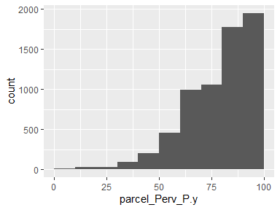

## parcel_Imperv_P.y

|  |  |
| --- | --- |
| Feature | Result |
| Variable type | numeric |
| Number of missing obs. | 1 (0.02 %) |
| Number of unique values | 3372 |
| Median | 16.79 |
| 1st and 3rd quartiles | 8.49; 31.36 |
| Min. and max. | 0; 99.29 |

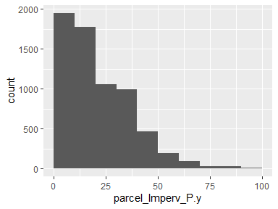

## parcel_EffectiveYear1.y

|  |  |
| --- | --- |
| Feature | Result |
| Variable type | numeric |
| Number of missing obs. | 772 (11.7 %) |
| Number of unique values | 95 |
| Median | 1980 |
| 1st and 3rd quartiles | 1964; 1990 |
| Min. and max. | 0; 2015 |

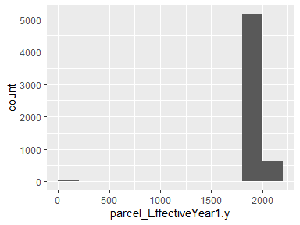

* Note that the following possible outlier values were detected: "0", "1907", "2015".

## parcel_EffectiveYear2.y

|  |  |
| --- | --- |
| Feature | Result |
| Variable type | numeric |
| Number of missing obs. | 5871 (88.99 %) |
| Number of unique values | 45 |
| Median | 1969 |
| 1st and 3rd quartiles | 1955; 1972 |
| Min. and max. | 1926; 2012 |

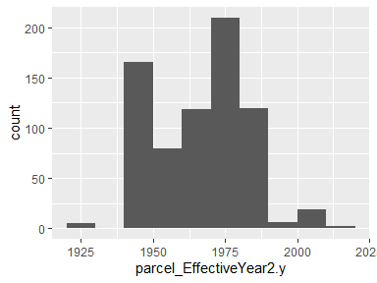

* Note that the following possible outlier values were detected: "1980", "1981", "1982", "1983", "1984", "1985", "1986", "1988", "1990", "1996" (6 additional values omitted).

## parcel_EffectiveYear3.y

|  |  |
| --- | --- |
| Feature | Result |
| Variable type | numeric |
| Number of missing obs. | 6205 (94.06 %) |
| Number of unique values | 17 |
| Median | 1958 |
| 1st and 3rd quartiles | 1950; 1976 |
| Min. and max. | 0; 2013 |

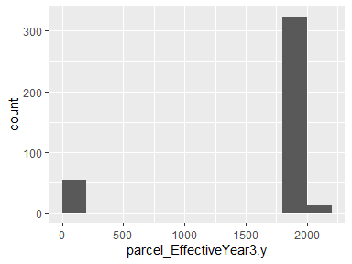

* Note that the following possible outlier values were detected: "0".

## parcel_EffectiveYear4.y

|  |  |
| --- | --- |
| Feature | Result |
| Variable type | numeric |
| Number of missing obs. | 6279 (95.18 %) |
| Number of unique values | 14 |
| Median | 1971 |
| 1st and 3rd quartiles | 1962.25; 1971 |
| Min. and max. | 1936; 2013 |

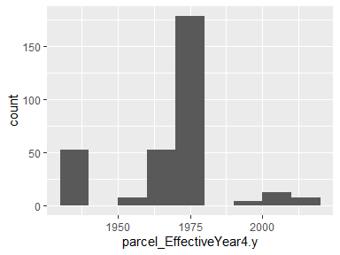

* Note that the following possible outlier values were detected: "1973", "1997", "2001", "2008", "2013".

## parcel_EffectiveYear5.y

|  |  |
| --- | --- |
| Feature | Result |
| Variable type | numeric |
| Number of missing obs. | 6297 (95.45 %) |
| Number of unique values | 10 |
| Median | 1969 |
| 1st and 3rd quartiles | 1452.75; 1969 |
| Min. and max. | 0; 2013 |

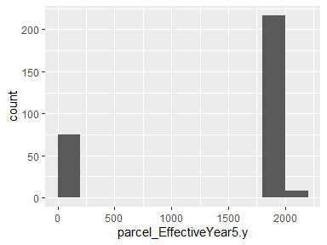

* Note that the following possible outlier values were detected: "1984", "1997", "2013".

## parcel_area.y

|  |  |
| --- | --- |
| Feature | Result |
| Variable type | numeric |
| Number of missing obs. | 1 (0.02 %) |
| Number of unique values | 3399 |
| Median | 73189.69 |
| 1st and 3rd quartiles | 28701.38; 351805.94 |
| Min. and max. | 1942.45; 65882419.74 |

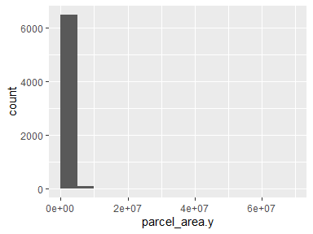

* Note that the following possible outlier values were detected: "1942.45", "1991.13", "2270.63", "2595.07", "2658.44", "2796.47", "2910.17", "3124.34", "3194.38", "3322.22" (206 additional values omitted).

## parcel_recent.y

|  |  |
| --- | --- |
| Feature | Result |
| Variable type | numeric |
| Number of missing obs. | 772 (11.7 %) |
| Number of unique values | 94 |
| Median | 1980 |
| 1st and 3rd quartiles | 1965; 1991 |
| Min. and max. | 0; 2015 |

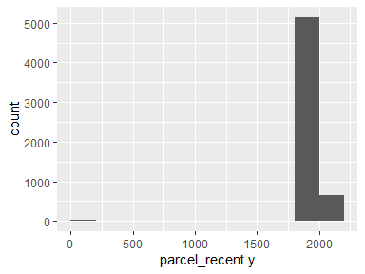

* Note that the following possible outlier values were detected: "0", "1907".

## parcel_AIN

|  |  |
| --- | --- |
| Feature | Result |
| Variable type | numeric |
| Number of missing obs. | 1 (0.02 %) |
| Number of unique values | 3398 |
| Median | 4467014009.5 |
| 1st and 3rd quartiles | 4461013014.75; 4469044009.25 |
| Min. and max. | 2058005013; 4473027903 |

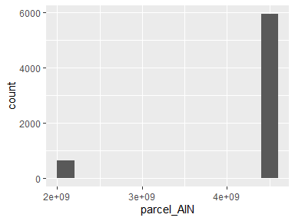

* Note that the following possible outlier values were detected: "2058005013", "2058005015", "2058005016", "2058005019", "2058005021", "2058008010", "2058008015", "2058008017", "2058008018", "2058008019" (618 additional values omitted).

## parcel_UseType

|  |  |
| --- | --- |
| Feature | Result |
| Variable type | character |
| Number of missing obs. | 4 (0.06 %) |
| Number of unique values | 8 |
| Mode | “Residential” |

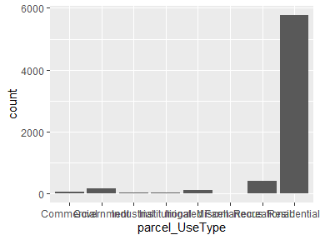

## parcel_UseDescription

|  |  |
| --- | --- |
| Feature | Result |
| Variable type | character |
| Number of missing obs. | 4 (0.06 %) |
| Number of unique values | 33 |
| Mode | “Single” |

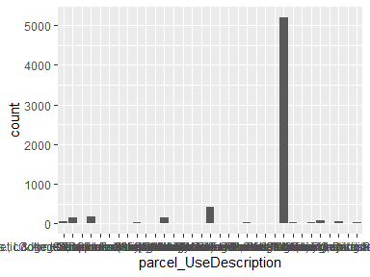

* Note that the following levels have at most five observations: "Commercial", "Fruit & Nuts", "Hotel & Motels", "Industrial", "Irrigated Farm", "Nurseries or Greenhouses", "Restaurants, Cocktail Lounges", "Schools (Private)", "Service Stations", "Warehousing, Distribution, Storage".

## parcel_Roll_ImpValue

|  |  |
| --- | --- |
| Feature | Result |
| Variable type | numeric |
| Number of missing obs. | 234 (3.55 %) |
| Number of unique values | 2841 |
| Median | 342819 |
| 1st and 3rd quartiles | 167121; 809280.5 |
| Min. and max. | 0; 45525741 |

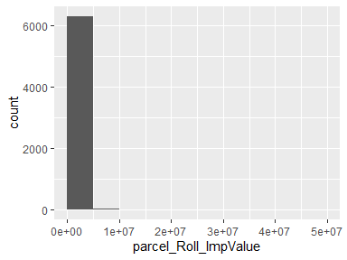

* Note that the following possible outlier values were detected: "4568625", "4588909", "4652362", "4724626", "5005981", "5043196", "5177673", "5262749", "5371051", "6320982" (14 additional values omitted).

## parcel_Roll_HomeOwnersExemp

* Note that this variable is treated as a factor variable below, as it only takes a few unique values.

|  |  |
| --- | --- |
| Feature | Result |
| Variable type | numeric |
| Number of missing obs. | 234 (3.55 %) |
| Number of unique values | 3 |
| Mode | “0” |
| Reference category | 0 |

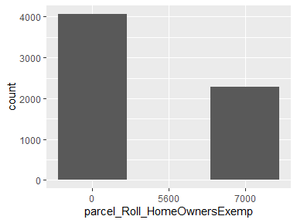

* Note that the following levels have at most five observations: "5600".

## parcel_Can_P

|  |  |
| --- | --- |
| Feature | Result |
| Variable type | numeric |
| Number of missing obs. | 1 (0.02 %) |
| Number of unique values | 3340 |
| Median | 31.82 |
| 1st and 3rd quartiles | 19.61; 44.05 |
| Min. and max. | 0; 97.37 |

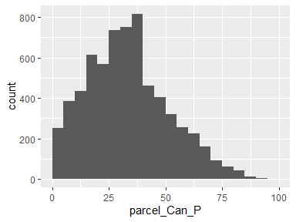

* Note that the following possible outlier values were detected: "87.76", "87.83", "88.8", "89.31", "89.32", "89.48", "89.74", "91.09", "91.13", "92.92" (2 additional values omitted).

## parcel_Grass_P

|  |  |
| --- | --- |
| Feature | Result |
| Variable type | numeric |
| Number of missing obs. | 1 (0.02 %) |
| Number of unique values | 3349 |
| Median | 11.74 |
| 1st and 3rd quartiles | 6.01; 18.72 |
| Min. and max. | 0; 63.52 |

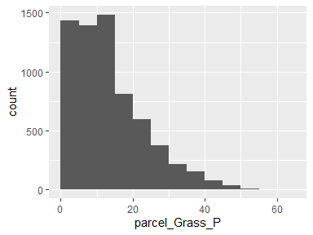

* Note that the following possible outlier values were detected: "47.73", "47.75", "48.25", "48.29", "48.33", "48.55", "48.73", "48.84", "49.68", "49.89" (16 additional values omitted).

## parcel_Soil_P

|  |  |
| --- | --- |
| Feature | Result |
| Variable type | numeric |
| Number of missing obs. | 1 (0.02 %) |
| Number of unique values | 3271 |
| Median | 22.15 |
| 1st and 3rd quartiles | 11.77; 36.01 |
| Min. and max. | 0; 96.59 |

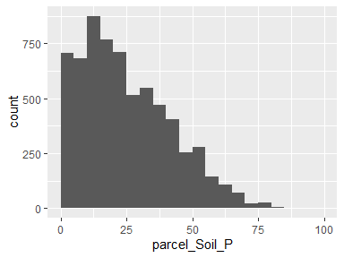

* Note that the following possible outlier values were detected: "96.59".

## parcel_Water_P

|  |  |
| --- | --- |
| Feature | Result |
| Variable type | numeric |
| Number of missing obs. | 1 (0.02 %) |
| Number of unique values | 22 |
| Median | 0 |
| 1st and 3rd quartiles | 0; 0 |
| Min. and max. | 0; 28.72 |

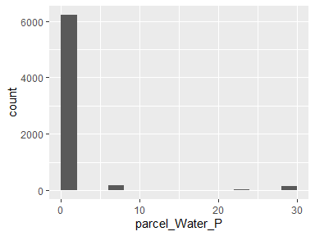

* Note that the following possible outlier values were detected: "0", "0.01", "0.03", "0.07", "0.24", "0.32", "0.32", "0.52", "0.66", "0.89" (11 additional values omitted).

## parcel_Build_P

|  |  |
| --- | --- |
| Feature | Result |
| Variable type | numeric |
| Number of missing obs. | 1 (0.02 %) |
| Number of unique values | 3336 |
| Median | 8.27 |
| 1st and 3rd quartiles | 3.41; 15.75 |
| Min. and max. | 0; 94.41 |

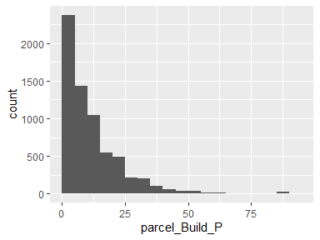

* Note that the following possible outlier values were detected: "57.59", "57.62", "58.37", "58.59", "58.87", "58.9", "59.74", "60", "60.22", "60.33" (48 additional values omitted).

## parcel_Road_P

|  |  |
| --- | --- |
| Feature | Result |
| Variable type | numeric |
| Number of missing obs. | 1 (0.02 %) |
| Number of unique values | 1797 |
| Median | 0.98 |
| 1st and 3rd quartiles | 0; 3.96 |
| Min. and max. | 0; 29.1 |

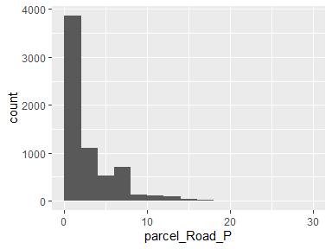

## parcel_Paved_P

|  |  |
| --- | --- |
| Feature | Result |
| Variable type | numeric |
| Number of missing obs. | 1 (0.02 %) |
| Number of unique values | 2892 |
| Median | 4.74 |
| 1st and 3rd quartiles | 1.42; 9.67 |
| Min. and max. | 0; 69.01 |

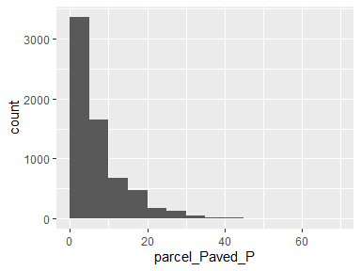

* Note that the following possible outlier values were detected: "42.09", "42.82", "42.96", "43", "43.22", "43.34", "44.3", "45.02", "45.77", "47.25" (8 additional values omitted).

## parcel_Shrub_P

|  |  |
| --- | --- |
| Feature | Result |
| Variable type | numeric |
| Number of missing obs. | 1 (0.02 %) |
| Number of unique values | 1331 |
| Median | 0.05 |
| 1st and 3rd quartiles | 0; 8.68 |
| Min. and max. | 0; 74.81 |

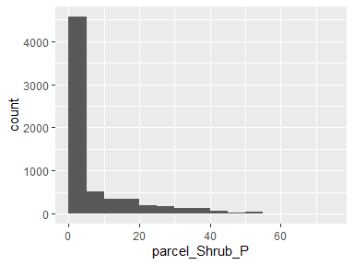

## parcel_Perv_P

|  |  |
| --- | --- |
| Feature | Result |
| Variable type | numeric |
| Number of missing obs. | 1 (0.02 %) |
| Number of unique values | 3372 |
| Median | 83.21 |
| 1st and 3rd quartiles | 68.64; 91.51 |
| Min. and max. | 0.71; 100 |

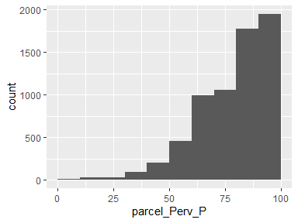

## parcel_Imperv_P

|  |  |
| --- | --- |
| Feature | Result |
| Variable type | numeric |
| Number of missing obs. | 1 (0.02 %) |
| Number of unique values | 3372 |
| Median | 16.79 |
| 1st and 3rd quartiles | 8.49; 31.36 |
| Min. and max. | 0; 99.29 |

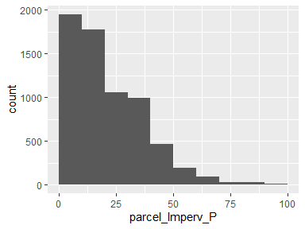

## parcel_EffectiveYear1

|  |  |
| --- | --- |
| Feature | Result |
| Variable type | numeric |
| Number of missing obs. | 772 (11.7 %) |
| Number of unique values | 95 |
| Median | 1980 |
| 1st and 3rd quartiles | 1964; 1990 |
| Min. and max. | 0; 2015 |

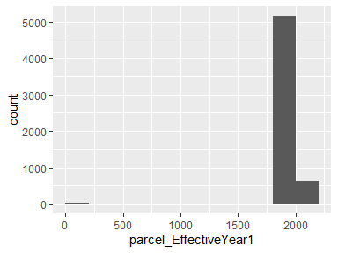

* Note that the following possible outlier values were detected: "0", "1907", "2015".

## parcel_EffectiveYear2

|  |  |
| --- | --- |
| Feature | Result |
| Variable type | numeric |
| Number of missing obs. | 5871 (88.99 %) |
| Number of unique values | 45 |
| Median | 1969 |
| 1st and 3rd quartiles | 1955; 1972 |
| Min. and max. | 1926; 2012 |

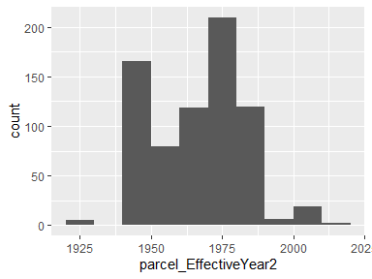

* Note that the following possible outlier values were detected: "1980", "1981", "1982", "1983", "1984", "1985", "1986", "1988", "1990", "1996" (6 additional values omitted).

## parcel_EffectiveYear3

|  |  |
| --- | --- |
| Feature | Result |
| Variable type | numeric |
| Number of missing obs. | 6205 (94.06 %) |
| Number of unique values | 17 |
| Median | 1958 |
| 1st and 3rd quartiles | 1950; 1976 |
| Min. and max. | 0; 2013 |

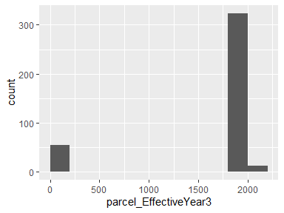

* Note that the following possible outlier values were detected: "0".

## parcel_EffectiveYear4

|  |  |
| --- | --- |
| Feature | Result |
| Variable type | numeric |
| Number of missing obs. | 6279 (95.18 %) |
| Number of unique values | 14 |
| Median | 1971 |
| 1st and 3rd quartiles | 1962.25; 1971 |
| Min. and max. | 1936; 2013 |

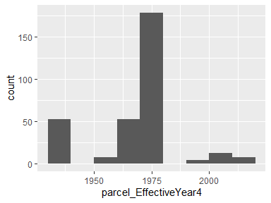

* Note that the following possible outlier values were detected: "1973", "1997", "2001", "2008", "2013".

## parcel_EffectiveYear5

|  |  |
| --- | --- |
| Feature | Result |
| Variable type | numeric |
| Number of missing obs. | 6297 (95.45 %) |
| Number of unique values | 10 |
| Median | 1969 |
| 1st and 3rd quartiles | 1452.75; 1969 |
| Min. and max. | 0; 2013 |

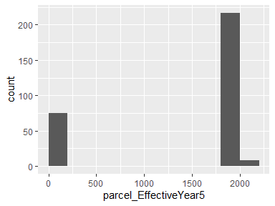

* Note that the following possible outlier values were detected: "1984", "1997", "2013".

## parcel_area

|  |  |
| --- | --- |
| Feature | Result |
| Variable type | numeric |
| Number of missing obs. | 1 (0.02 %) |
| Number of unique values | 3399 |
| Median | 73189.69 |
| 1st and 3rd quartiles | 28701.38; 351805.94 |
| Min. and max. | 1942.45; 65882419.74 |

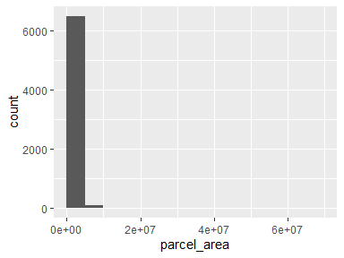

* Note that the following possible outlier values were detected: "1942.45", "1991.13", "2270.63", "2595.07", "2658.44", "2796.47", "2910.17", "3124.34", "3194.38", "3322.22" (206 additional values omitted).

## parcel_recent

|  |  |
| --- | --- |
| Feature | Result |
| Variable type | numeric |
| Number of missing obs. | 772 (11.7 %) |
| Number of unique values | 94 |
| Median | 1980 |
| 1st and 3rd quartiles | 1965; 1991 |
| Min. and max. | 0; 2015 |

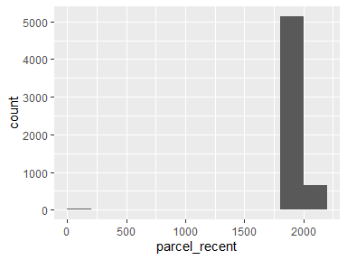

* Note that the following possible outlier values were detected: "0", "1907".

Report generation information:

* Created by: mmockrin (username: mhmockrin).
* Report creation time: Wed Sep 22 2021 15:27:15
* Report was run from directory: C:/Users/mhmockrin/Box/_Workspace/Proj_GitHub/la_wui
* dataMaid v1.4.0 [Pkg: 2019-12-10 from CRAN (R 4.0.5)]
* R version 4.0.5 (2021-03-31).
* Platform: x86_64-w64-mingw32/x64 (64-bit)(Windows 10 x64 (build 18363)).
* Function call: makeDataReport(data = build, file = paste0(getwd(), "/output_data/dataMaid_", gsub("[[:punct:]]", "_", Sys.time()), ".Rmd"))