build

Autogenerated data summary from dataMaid

2021-12-01 09:42:16

# Data report overview

The dataset examined has the following dimensions:

|  |  |
| --- | --- |
| Feature | Result |
| Number of observations | 11181 |
| Number of variables | 57 |

### Checks performed

The following variable checks were performed, depending on the data type of each variable:

|  |  |  |  |  |  |  |  |  |
| --- | --- | --- | --- | --- | --- | --- | --- | --- |
|  | character | factor | labelled | haven labelled | numeric | integer | logical | Date |
| Identify miscoded missing values | × | × | × | × | × | × |  | × |
| Identify prefixed and suffixed whitespace | × | × | × | × |  |  |  |  |
| Identify levels with < 6 obs. | × | × | × | × |  |  |  |  |
| Identify case issues | × | × | × | × |  |  |  |  |
| Identify misclassified numeric or integer variables | × | × | × | × |  |  |  |  |
| Identify outliers |  |  |  |  | × | × |  | × |

Please note that all numerical values in the following have been rounded to 2 decimals.

# Summary table

|  |  |  |  |  |
| --- | --- | --- | --- | --- |
|  | Variable class | # unique values | Missing observations | Any problems? |
| ID_Build | numeric | 11134 | 0.00 % |  |
| ID_Parcel | numeric | 6162 | 0.00 % |  |
| build_Mean_elev_30m | numeric | 11134 | 0.00 % | × |
| build_Mean_elev_100m | numeric | 11134 | 0.00 % | × |
| build_Mean_slope_30m_DEM | numeric | 11134 | 0.00 % | × |
| build_Mean_slope_100m_DEM | numeric | 11134 | 0.00 % | × |
| build_Mean_aspect_30m_DEM | numeric | 11134 | 0.00 % | × |
| build_Mean_aspect_100m_DEM | numeric | 11134 | 0.00 % | × |
| build_Mean_distroad | numeric | 9017 | 0.79 % |  |
| build_Mean_builddens | numeric | 8844 | 0.79 % |  |
| build_Mean_distall_road | numeric | 6190 | 0.11 % | × |
| build_structures_DAMAGE | character | 5 | 86.26 % |  |
| build_NEAR_FID | numeric | 8112 | 0.00 % |  |
| build_NEAR_DIST | numeric | 7594 | 0.00 % | × |
| build_NEAR_ANGLE | numeric | 11064 | 0.00 % |  |
| build_Shape_Length | numeric | 11134 | 0.00 % | × |
| build_Shape_Area | numeric | 11134 | 0.00 % | × |
| build_Shape | character | 11134 | 0.00 % | × |
| damage_cat | character | 2 | 0.00 % |  |
| damage_binary | numeric | 2 | 0.00 % |  |
| damage_severity | numeric | 5 | 0.00 % |  |
| build_area | numeric | 11134 | 0.00 % | × |
| dist_to_build_ft | numeric | 7635 | 0.42 % | × |
| parcel_AIN | numeric | 6405 | 0.00 % |  |
| parcel_UseType | character | 9 | 0.22 % |  |
| parcel_UseDescription | character | 44 | 0.22 % | × |
| parcel_Roll_ImpValue | numeric | 5507 | 3.32 % | × |
| parcel_Roll_HomeOwnersExemp | numeric | 4 | 3.32 % |  |
| parcel_Can_P | numeric | 6216 | 0.00 % | × |
| parcel_Grass_P | numeric | 6169 | 0.00 % | × |
| parcel_Soil_P | numeric | 5885 | 0.00 % |  |
| parcel_Water_P | numeric | 38 | 0.00 % | × |
| parcel_Build_P | numeric | 6186 | 0.00 % |  |
| parcel_Road_P | numeric | 2194 | 0.00 % |  |
| parcel_Paved_P | numeric | 5367 | 0.00 % | × |
| parcel_Shrub_P | numeric | 1723 | 0.00 % |  |
| parcel_Perv_P | numeric | 6239 | 0.00 % | × |
| parcel_Imperv_P | numeric | 6239 | 0.00 % | × |
| parcel_EffectiveYear1 | numeric | 96 | 9.05 % | × |
| parcel_EffectiveYear2 | numeric | 56 | 91.03 % |  |
| parcel_EffectiveYear3 | numeric | 23 | 94.57 % | × |
| parcel_EffectiveYear4 | numeric | 20 | 95.29 % | × |
| parcel_EffectiveYear5 | numeric | 15 | 95.48 % | × |
| parcel_area | numeric | 6406 | 0.00 % | × |
| parcel_recent | numeric | 95 | 9.05 % | × |
| build_EXTERIORSI | character | 3 | 89.62 % |  |
| build_FENCEATTAC | character | 4 | 90.39 % |  |
| build_DECKPORCHO | character | 5 | 91.17 % |  |
| build_DECKPORCHE | character | 5 | 92.44 % |  |
| build_ROOFCONSTR | character | 7 | 90.13 % |  |
| build_PATIOCOVER | character | 4 | 91.25 % |  |
| build_PROPANETAN | character | 5 | 97.40 % |  |
| build_WINDOWPANE | character | 4 | 94.68 % |  |
| build_VEGCLEARAN | character | 4 | 89.46 % |  |
| build_EAVES | character | 4 | 95.48 % |  |
| build_VENTSCREEN | character | 5 | 96.10 % |  |
| build_DINS | numeric | 2 | 86.28 % | × |

# Variable list

## ID_Build

|  |  |
| --- | --- |
| Feature | Result |
| Variable type | numeric |
| Number of missing obs. | 0 (0 %) |
| Number of unique values | 11134 |
| Median | 5561 |
| 1st and 3rd quartiles | 2778; 8345 |
| Min. and max. | 1; 11140 |

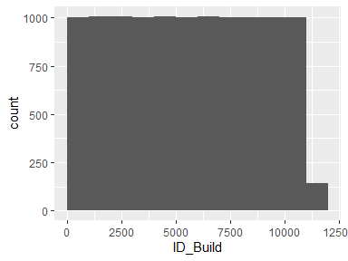

## ID_Parcel

|  |  |
| --- | --- |
| Feature | Result |
| Variable type | numeric |
| Number of missing obs. | 0 (0 %) |
| Number of unique values | 6162 |
| Median | 5432 |
| 1st and 3rd quartiles | 2598; 9443 |
| Min. and max. | 4; 13396 |

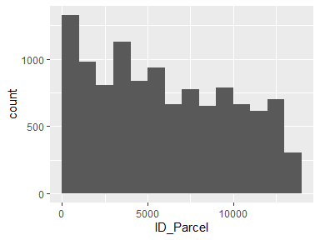

## build_Mean_elev_30m

|  |  |
| --- | --- |
| Feature | Result |
| Variable type | numeric |
| Number of missing obs. | 0 (0 %) |
| Number of unique values | 11134 |
| Median | 793.06 |
| 1st and 3rd quartiles | 254.36; 934.5 |
| Min. and max. | 12.07; 2817.77 |

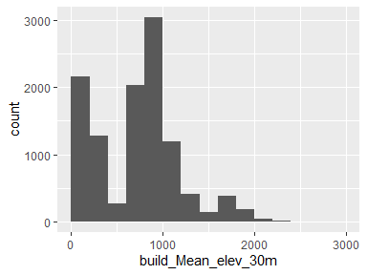

* Note that the following possible outlier values were detected: "1221.98", "1222.13", "1222.28", "1222.34", "1222.46", "1222.56", "1222.56", "1222.63", "1222.79", "1223.06" (1074 additional values omitted).

## build_Mean_elev_100m

|  |  |
| --- | --- |
| Feature | Result |
| Variable type | numeric |
| Number of missing obs. | 0 (0 %) |
| Number of unique values | 11134 |
| Median | 794.41 |
| 1st and 3rd quartiles | 250.23; 939.7 |
| Min. and max. | 11.47; 2769.59 |

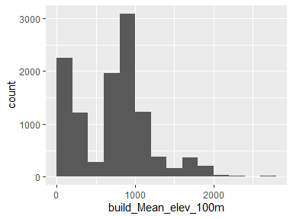

* Note that the following possible outlier values were detected: "1221.34", "1221.35", "1221.53", "1221.62", "1221.68", "1221.83", "1222.49", "1223.12", "1223.65", "1223.74" (1070 additional values omitted).

## build_Mean_slope_30m_DEM

|  |  |
| --- | --- |
| Feature | Result |
| Variable type | numeric |
| Number of missing obs. | 0 (0 %) |
| Number of unique values | 11134 |
| Median | 9.02 |
| 1st and 3rd quartiles | 5.56; 13.62 |
| Min. and max. | 0.85; 34.37 |

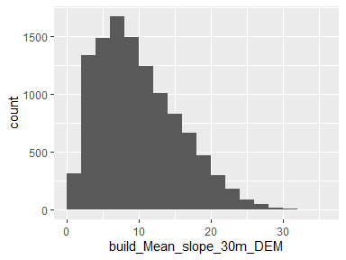

* Note that the following possible outlier values were detected: "34.37".

## build_Mean_slope_100m_DEM

|  |  |
| --- | --- |
| Feature | Result |
| Variable type | numeric |
| Number of missing obs. | 0 (0 %) |
| Number of unique values | 11134 |
| Median | 10.99 |
| 1st and 3rd quartiles | 7.43; 15.43 |
| Min. and max. | 1.28; 34.82 |

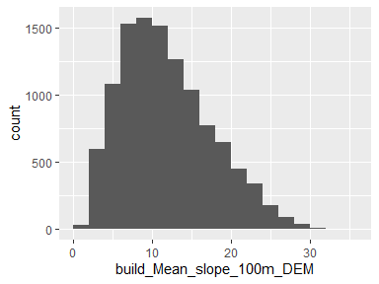

* Note that the following possible outlier values were detected: "34.58", "34.82".

## build_Mean_aspect_30m_DEM

|  |  |
| --- | --- |
| Feature | Result |
| Variable type | numeric |
| Number of missing obs. | 0 (0 %) |
| Number of unique values | 11134 |
| Median | 183.28 |
| 1st and 3rd quartiles | 147.36; 214.29 |
| Min. and max. | 41.01; 322.87 |

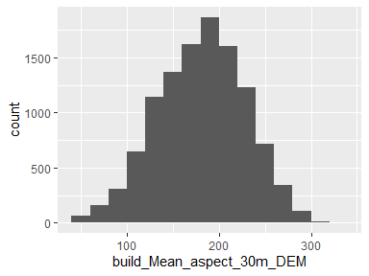

* Note that the following possible outlier values were detected: "291.72", "291.79", "291.86", "292.09", "292.17", "292.36", "292.38", "292.43", "292.69", "292.75" (30 additional values omitted).

## build_Mean_aspect_100m_DEM

|  |  |
| --- | --- |
| Feature | Result |
| Variable type | numeric |
| Number of missing obs. | 0 (0 %) |
| Number of unique values | 11134 |
| Median | 182.17 |
| 1st and 3rd quartiles | 154.53; 207.26 |
| Min. and max. | 58.76; 295.16 |

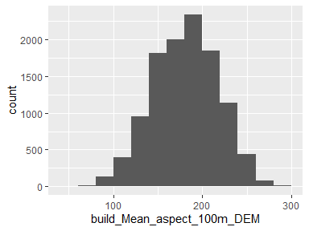

* Note that the following possible outlier values were detected: "58.76", "59.17", "59.94", "60.56", "61.56", "63.43", "63.44", "65.79", "276", "276.66" (21 additional values omitted).

## build_Mean_distroad

|  |  |
| --- | --- |
| Feature | Result |
| Variable type | numeric |
| Number of missing obs. | 88 (0.79 %) |
| Number of unique values | 9016 |
| Median | 602.94 |
| 1st and 3rd quartiles | 217.28; 1252.96 |
| Min. and max. | 0; 3666.9 |

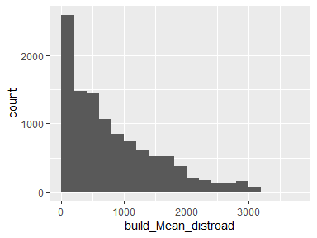

## build_Mean_builddens

|  |  |
| --- | --- |
| Feature | Result |
| Variable type | numeric |
| Number of missing obs. | 88 (0.79 %) |
| Number of unique values | 8843 |
| Median | 1.42 |
| 1st and 3rd quartiles | 0.74; 2.26 |
| Min. and max. | 0; 4.41 |

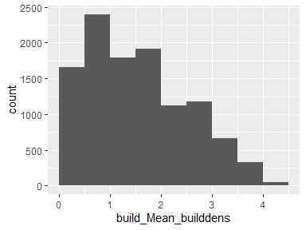

## build_Mean_distall_road

|  |  |
| --- | --- |
| Feature | Result |
| Variable type | numeric |
| Number of missing obs. | 12 (0.11 %) |
| Number of unique values | 6189 |
| Median | 28.66 |
| 1st and 3rd quartiles | 8.02; 33.29 |
| Min. and max. | 0; 430.68 |

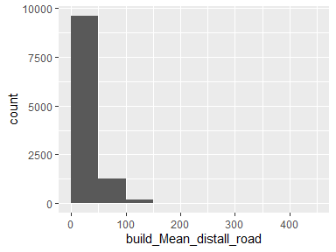

* Note that the following possible outlier values were detected: "40.51", "40.52", "40.52", "40.53", "40.55", "40.57", "40.6", "40.61", "40.61", "40.69" (1417 additional values omitted).

## build_structures_DAMAGE

|  |  |
| --- | --- |
| Feature | Result |
| Variable type | character |
| Number of missing obs. | 9645 (86.26 %) |
| Number of unique values | 4 |
| Mode | “Destroyed (>50%)” |

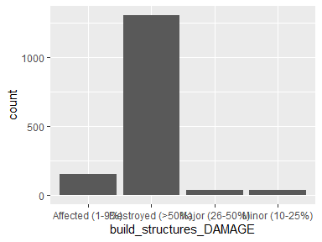

## build_NEAR_FID

|  |  |
| --- | --- |
| Feature | Result |
| Variable type | numeric |
| Number of missing obs. | 0 (0 %) |
| Number of unique values | 8112 |
| Median | 5619 |
| 1st and 3rd quartiles | 2816; 8415 |
| Min. and max. | 1; 11211 |

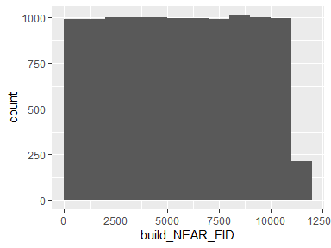

## build_NEAR_DIST

|  |  |
| --- | --- |
| Feature | Result |
| Variable type | numeric |
| Number of missing obs. | 0 (0 %) |
| Number of unique values | 7594 |
| Median | 16.15 |
| 1st and 3rd quartiles | 7.81; 39.63 |
| Min. and max. | 0; 3916.03 |

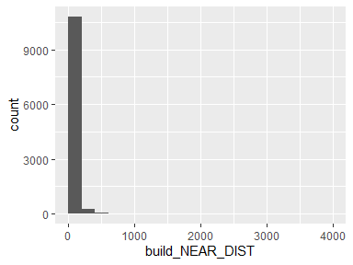

* Note that the following possible outlier values were detected: "0", "0.02", "0.05", "0.11", "0.12", "0.16", "0.21", "0.24", "0.26", "0.3" (402 additional values omitted).

## build_NEAR_ANGLE

|  |  |
| --- | --- |
| Feature | Result |
| Variable type | numeric |
| Number of missing obs. | 0 (0 %) |
| Number of unique values | 11064 |
| Median | 0 |
| 1st and 3rd quartiles | -86.48; 90.47 |
| Min. and max. | -179.99; 180 |

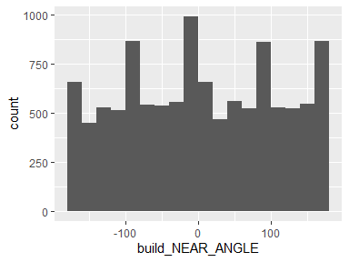

## build_Shape_Length

|  |  |
| --- | --- |
| Feature | Result |
| Variable type | numeric |
| Number of missing obs. | 0 (0 %) |
| Number of unique values | 11134 |
| Median | 216.68 |
| 1st and 3rd quartiles | 139.66; 291.77 |
| Min. and max. | 0.15; 3246.96 |

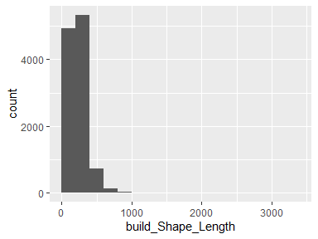

* Note that the following possible outlier values were detected: "572.09", "572.21", "574.09", "574.4", "574.42", "574.84", "575.14", "575.52", "575.67", "576.11" (229 additional values omitted).

## build_Shape_Area

|  |  |
| --- | --- |
| Feature | Result |
| Variable type | numeric |
| Number of missing obs. | 0 (0 %) |
| Number of unique values | 11134 |
| Median | 2267.17 |
| 1st and 3rd quartiles | 998.83; 3552.82 |
| Min. and max. | 0; 115867.77 |

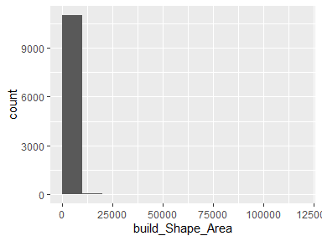

* Note that the following possible outlier values were detected: "9121.41", "9190.92", "9200.73", "9263.26", "9275.18", "9279.45", "9285.05", "9303.99", "9312.87", "9326.77" (174 additional values omitted).

## build_Shape

|  |  |
| --- | --- |
| Feature | Result |
| Variable type | character |
| Number of missing obs. | 0 (0 %) |
| Number of unique values | 11134 |
| Mode | “list(list(c(6313316.74012734, 6313329.71025324, 6313334.26995803, 6313346.34999333, 6313337.78996615, 6313349.1800418, 6313356.91001768, 6313370.36997227, 6313360.55010436, 6313359.43002722, 6313339.01010877, 6313337.50650199, 6313330.79522544, 6313319.56591071, 6313326.27718726, 6313303.89008, 6313300.34021629, 6313286.68013075, 6313316.74012734, 1834050.19016749, 1834038.63014457, 1834043.74988794, 1834032.97989014, 1834023.36999568, 1834013.22007574, 1834021.89001091, 1834009.88018548, 1833998.87003054, \n1833999.87002912, 1833976.97012733, 1833978.3106766, 1833970.78247209, 1833980.7936127, 1833988.32148913, 1834008.28012215, 1834004.30014093, 1834016.47007111, 1834050.19016749)))” |

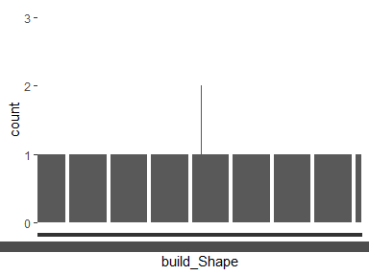

* Note that the following levels have at most five observations: "list(list(c(6276222.95990887, 6276215.97008942, 6276182.62991378, 6276189.62006131, 6276222.95990887, 1840303.31020591, 1840280.25019936, 1840290.3600931, 1840313.42009966, 1840303.31020591)))", "list(list(c(6276862.83006129, 6276854.20999482, 6276824.58011572, 6276828.56993943, 6276831.39998791, 6276836.02006008, 6276862.83006129, 1840127.38001007, 1840106.09985663, 1840118.08999705, 1840127.94989115, 1840126.80980091, 1840138.23006025, 1840127.38001007)))", "list(list(c(6276881.49998222, 6276900.59017816, 6276864.97015011, 6276865.0899006, 6276862.39994378, 6276858.89010626, 6276854.79004648, 6276850.08992194, 6276831.06993589, 6276850.70015728, 6276852.60008897, 6276857.3500822, 6276855.37009816, 6276881.49998222, 1851037.58003536, 1851011.48000687, 1850985.42000459, 1850981.48004957, 1850977.65000252, 1850975.29009776, 1850974.46988894, 1850974.52008572, 1851000.52989122, 1851014.89010702, 1851012.2998876, 1851015.77002703, 1851018.47015442, 1851037.58003536\n)))", "list(list(c(6276904.22599976, 6276900.80540095, 6276901.49995376, 6276896.95009148, 6276860.20014377, 6276864.75000606, 6276885.02261502, 6276888.28048439, 6276904.22599976, 1840113.54013476, 1840104.55589557, 1840104.26980674, 1840093.20978311, 1840108.34001093, 1840119.40003456, 1840111.05358975, 1840119.61099225, 1840113.54013476)))", "list(list(c(6276933.55994751, 6276930.4201882, 6276920.18004529, 6276914.24993563, 6276905.05998807, 6276911.11017631, 6276905.95007867, 6276908.9599169, 6276933.55994751, 1840095.43976681, 1840087.8498826, 1840092.09003405, 1840077.74983136, 1840081.5500228, 1840096.20977885, 1840098.34002516, 1840105.61002794, 1840095.43976681)))", "list(list(c(6276956.11995478, 6276913.41004181, 6276913.0934412, 6276897.05015695, 6276939.76006992, 6276956.06286825, 6276956.11995478, 1851054.35986713, 1851023.4701473, 1851023.9081388, 1851046.08986576, 1851076.97991367, 1851054.43893525, 1851054.35986713)))", "list(list(c(6276991.52311961, 6276984.39288042, 6276966.30858858, 6276973.43882777, 6276991.52311961, 1840073.80298658, 1840055.79382586, 1840062.95392066, 1840080.96340947, 1840073.80298658)))", "list(list(c(6277062.53023642, 6277076.01971854, 6277101.97998343, 6277101.96981284, 6277118.6899334, 6277118.6899334, 6277113.45995396, 6277113.45995396, 6277093.46982494, 6277093.46982494, 6277089.29988337, 6277060.78023891, 6277061.51022474, 6277046.39016752, 6277062.53023642, 1850947.86986119, 1850933.19009204, 1850933.19009204, 1850912.320043, 1850912.320043, 1850898.76986544, 1850898.76986544, 1850877.95001318, 1850877.95001318, 1850891.86994088, 1850896.80005197, 1850897.90995853, 1850916.57987946, \n1850933.02998729, 1850947.86986119)))", "list(list(c(6277094.40978423, 6277081.99969691, 6277068.25988705, 6277080.66997439, 6277094.40978423, 1851147.98014072, 1851132.67012313, 1851143.82004166, 1851159.12021673, 1851147.98014072)))", "list(list(c(6277204.53003435, 6277205.11992852, 6277208.86008067, 6277210.1399345, 6277215.66978227, 6277215.9499656, 6277218.80002716, 6277219.68978968, 6277227.11989722, 6277228.38990852, 6277227.05001542, 6277227.69994888, 6277222.55986433, 6277218.14976563, 6277212.87976, 6277209.6799614, 6277207.91979331, 6277200.24985671, 6277200.20983052, 6277186.26004723, 6277186.49003378, 6277179.18000481, 6277179.08978184, 6277172.97003989, 6277168.43002011, 6277166.54977344, 6277164.57995996, 6277152.18004322, \n6277152.80996358, 6277124.20993868, 6277124.15974189, 6277112.9497841, 6277111.34972075, 6277101.46981356, 6277101.10990593, 6277100.10990736, 6277098.78969926, 6277105.40976858, 6277103.42978452, 6277108.54985598, 6277108.44979049, 6277111.86973314, 6277114.25982159, 6277117.52983007, 6277119.40974866, 6277121.76998152, 6277121.84970582, 6277125.94976559, 6277126.10002784, 6277129.8798781, 6277130.3798774, 6277127.98978893, 6277128.44976203, 6277126.51997475, 6277127.46977656, 6277119.91991854, \n6277120.56000948, 6277132.1797436, 6277148.12985215, 6277148.71974631, 6277166.95003533, 6277166.38999675, 6277185.16982567, 6277182.7698947, 6277178.29975671, 6277177.63998075, 6277204.53003435, 1851209.64015795, 1851196.13000658, 1851196.29995385, 1851167.27998202, 1851167.52998166, 1851161.14022698, 1851161.25997746, 1851141.23999283, 1851141.56020235, 1851112.69016469, 1851112.6301254, 1851097.93001509, 1851096.51991211, 1851095.57011031, 1851096.59012198, 1851098.91000058, 1851101.18001047, \n1851100.88014212, 1851101.84995702, 1851101.30993155, 1851095.55009721, 1851095.26991388, 1851097.59012055, 1851098.349962, 1851100.95002392, 1851103.76005928, 1851107.93000086, 1851107.34010668, 1851093.72988984, 1851092.38999672, 1851093.32011351, 1851092.80010113, 1851127.07006548, 1851126.61009239, 1851134.15995041, 1851134.11008172, 1851162.29015972, 1851162.60019866, 1851204.94003341, 1851205.18019055, 1851207.35997747, 1851208.65000188, 1851208.92001462, 1851208.85013284, 1851208.44002843, \n1851207.6900295, 1851205.98005818, 1851206.17001854, 1851202.93019375, 1851203.10998352, 1851192.39018251, 1851192.27994645, 1851182.40003924, 1851182.31014435, 1851162.04016007, 1851161.67992437, 1851148.0201669, 1851137.54019494, 1851138.25016768, 1851125.05005524, 1851125.86009346, 1851138.52018042, 1851139.35023174, 1851193.79995739, 1851193.60015453, 1851208.46004152, 1851209.64015795)))" (11124 additional values omitted).

## damage_cat

|  |  |
| --- | --- |
| Feature | Result |
| Variable type | character |
| Number of missing obs. | 0 (0 %) |
| Number of unique values | 2 |
| Mode | “Survived” |

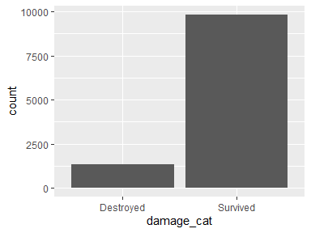

## damage_binary

* Note that this variable is treated as a factor variable below, as it only takes a few unique values.

|  |  |
| --- | --- |
| Feature | Result |
| Variable type | numeric |
| Number of missing obs. | 0 (0 %) |
| Number of unique values | 2 |
| Mode | “0” |
| Reference category | 0 |

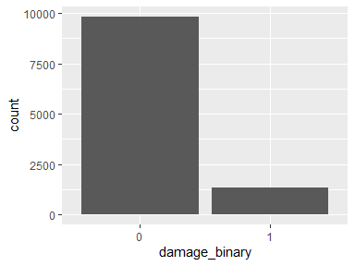

## damage_severity

* Note that this variable is treated as a factor variable below, as it only takes a few unique values.

|  |  |
| --- | --- |
| Feature | Result |
| Variable type | numeric |
| Number of missing obs. | 0 (0 %) |
| Number of unique values | 5 |
| Mode | “1” |
| Reference category | 1 |

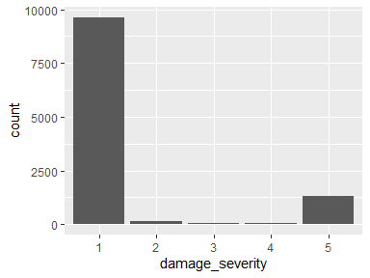

## build_area

|  |  |
| --- | --- |
| Feature | Result |
| Variable type | numeric |
| Number of missing obs. | 0 (0 %) |
| Number of unique values | 11134 |
| Median | 2267.17 |
| 1st and 3rd quartiles | 998.83; 3552.82 |
| Min. and max. | 0; 115867.77 |

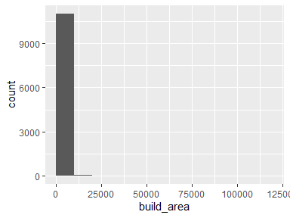

* Note that the following possible outlier values were detected: "9121.41", "9190.92", "9200.73", "9263.26", "9275.18", "9279.45", "9285.05", "9303.99", "9312.87", "9326.77" (174 additional values omitted).

## dist_to_build_ft

|  |  |
| --- | --- |
| Feature | Result |
| Variable type | numeric |
| Number of missing obs. | 47 (0.42 %) |
| Number of unique values | 7634 |
| Median | 75.7 |
| 1st and 3rd quartiles | 54.53; 108.57 |
| Min. and max. | 0; 8639.64 |

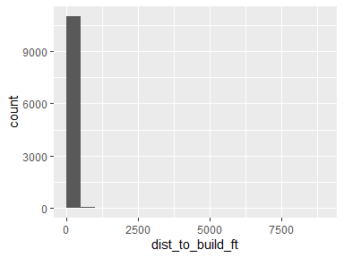

* Note that the following possible outlier values were detected: "0", "1.06", "1.59", "2.02", "2.14", "2.37", "3.5", "3.66", "3.69", "4.06" (446 additional values omitted).

## parcel_AIN

|  |  |
| --- | --- |
| Feature | Result |
| Variable type | numeric |
| Number of missing obs. | 0 (0 %) |
| Number of unique values | 6405 |
| Median | 4458032013 |
| 1st and 3rd quartiles | 2059022006; 4467034014 |
| Min. and max. | 2049004901; 4473027903 |

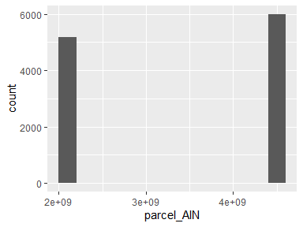

## parcel_UseType

|  |  |
| --- | --- |
| Feature | Result |
| Variable type | character |
| Number of missing obs. | 25 (0.22 %) |
| Number of unique values | 8 |
| Mode | “Residential” |

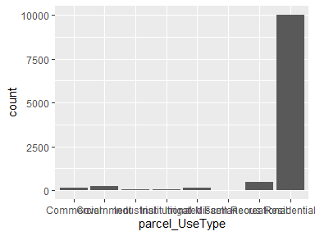

## parcel_UseDescription

|  |  |
| --- | --- |
| Feature | Result |
| Variable type | character |
| Number of missing obs. | 25 (0.22 %) |
| Number of unique values | 43 |
| Mode | “Single” |

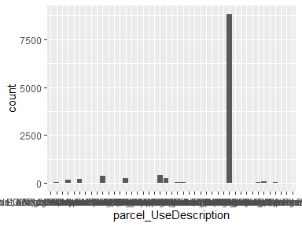

* Note that the following levels have at most five observations: "Auto, Recreation EQPT, Construction EQPT, Sales & Service", "Fruit & Nuts", "Hotel & Motels", "Irrigated Farm", "Lgt Manf.Sm. EQPT. Manuf Sm.Shps Instr.Manuf. Prnt Plnts", "Nurseries or Greenhouses", "Professional Buildings", "Restaurants, Cocktail Lounges", "Supermarkets", "Water Recreation".

## parcel_Roll_ImpValue

|  |  |
| --- | --- |
| Feature | Result |
| Variable type | numeric |
| Number of missing obs. | 371 (3.32 %) |
| Number of unique values | 5506 |
| Median | 318311 |
| 1st and 3rd quartiles | 155404.25; 816736 |
| Min. and max. | 0; 63350373 |

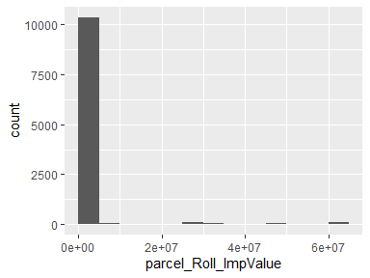

* Note that the following possible outlier values were detected: "0", "100", "126", "132", "137", "206", "387", "585", "595", "1105" (167 additional values omitted).

## parcel_Roll_HomeOwnersExemp

* Note that this variable is treated as a factor variable below, as it only takes a few unique values.

|  |  |
| --- | --- |
| Feature | Result |
| Variable type | numeric |
| Number of missing obs. | 371 (3.32 %) |
| Number of unique values | 3 |
| Mode | “0” |
| Reference category | 0 |

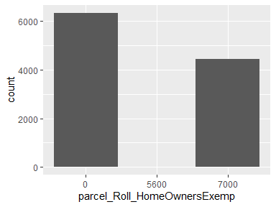

## parcel_Can_P

|  |  |
| --- | --- |
| Feature | Result |
| Variable type | numeric |
| Number of missing obs. | 0 (0 %) |
| Number of unique values | 6216 |
| Median | 27.89 |
| 1st and 3rd quartiles | 16.53; 39.84 |
| Min. and max. | 0; 100 |

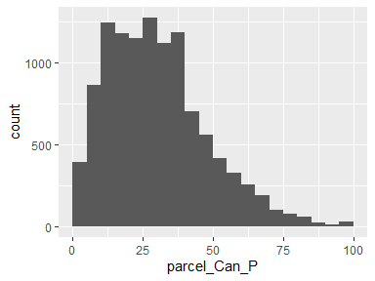

* Note that the following possible outlier values were detected: "85.93", "86.04", "86.06", "86.36", "86.55", "86.65", "86.74", "87.65", "87.76", "87.83" (33 additional values omitted).

## parcel_Grass_P

|  |  |
| --- | --- |
| Feature | Result |
| Variable type | numeric |
| Number of missing obs. | 0 (0 %) |
| Number of unique values | 6169 |
| Median | 14.2 |
| 1st and 3rd quartiles | 8.06; 22.91 |
| Min. and max. | 0; 63.72 |

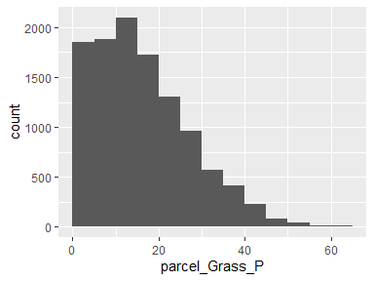

* Note that the following possible outlier values were detected: "63.26", "63.52", "63.72".

## parcel_Soil_P

|  |  |
| --- | --- |
| Feature | Result |
| Variable type | numeric |
| Number of missing obs. | 0 (0 %) |
| Number of unique values | 5885 |
| Median | 15.85 |
| 1st and 3rd quartiles | 6.58; 32.6 |
| Min. and max. | 0; 96.59 |

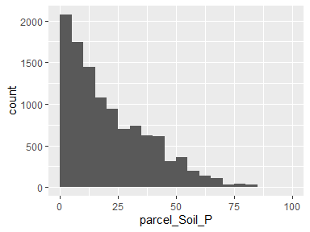

## parcel_Water_P

|  |  |
| --- | --- |
| Feature | Result |
| Variable type | numeric |
| Number of missing obs. | 0 (0 %) |
| Number of unique values | 38 |
| Median | 0 |
| 1st and 3rd quartiles | 0; 0 |
| Min. and max. | 0; 87.09 |

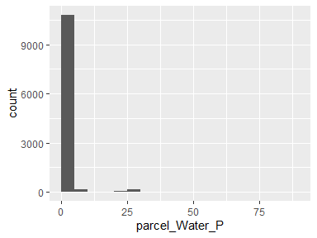

* Note that the following possible outlier values were detected: "0", "0.01", "0.03", "0.07", "0.19", "0.2", "0.23", "0.24", "0.24", "0.26" (27 additional values omitted).

## parcel_Build_P

|  |  |
| --- | --- |
| Feature | Result |
| Variable type | numeric |
| Number of missing obs. | 0 (0 %) |
| Number of unique values | 6186 |
| Median | 12.77 |
| 1st and 3rd quartiles | 4.86; 25.83 |
| Min. and max. | 0; 100 |

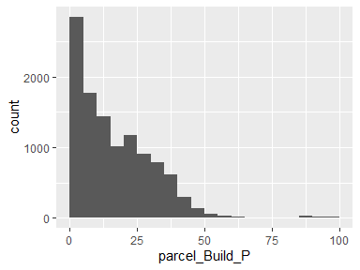

## parcel_Road_P

|  |  |
| --- | --- |
| Feature | Result |
| Variable type | numeric |
| Number of missing obs. | 0 (0 %) |
| Number of unique values | 2194 |
| Median | 0 |
| 1st and 3rd quartiles | 0; 2.62 |
| Min. and max. | 0; 32.21 |

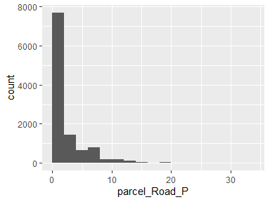

## parcel_Paved_P

|  |  |
| --- | --- |
| Feature | Result |
| Variable type | numeric |
| Number of missing obs. | 0 (0 %) |
| Number of unique values | 5367 |
| Median | 6.34 |
| 1st and 3rd quartiles | 1.98; 12.95 |
| Min. and max. | 0; 69.33 |

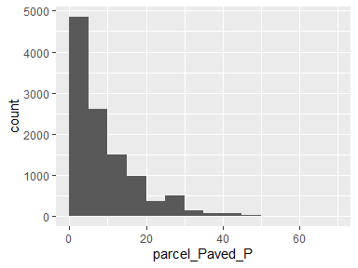

* Note that the following possible outlier values were detected: "49.34", "49.63", "49.85", "50.11", "50.59", "50.99", "52.11", "52.37", "52.39", "52.99" (22 additional values omitted).

## parcel_Shrub_P

|  |  |
| --- | --- |
| Feature | Result |
| Variable type | numeric |
| Number of missing obs. | 0 (0 %) |
| Number of unique values | 1723 |
| Median | 0 |
| 1st and 3rd quartiles | 0; 3.82 |
| Min. and max. | 0; 74.81 |

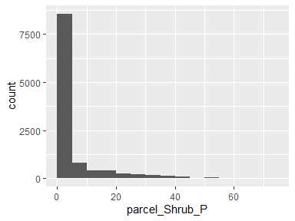

## parcel_Perv_P

|  |  |
| --- | --- |
| Feature | Result |
| Variable type | numeric |
| Number of missing obs. | 0 (0 %) |
| Number of unique values | 6239 |
| Median | 74.69 |
| 1st and 3rd quartiles | 60.09; 88.78 |
| Min. and max. | 0; 100 |

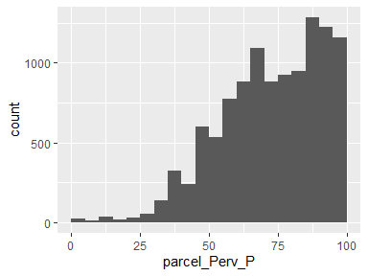

* Note that the following possible outlier values were detected: "0", "0.71", "0.91", "1.19", "1.64", "1.72", "1.76", "2.11", "2.8", "3.01" (3 additional values omitted).

## parcel_Imperv_P

|  |  |
| --- | --- |
| Feature | Result |
| Variable type | numeric |
| Number of missing obs. | 0 (0 %) |
| Number of unique values | 6239 |
| Median | 25.31 |
| 1st and 3rd quartiles | 11.22; 39.91 |
| Min. and max. | 0; 100 |

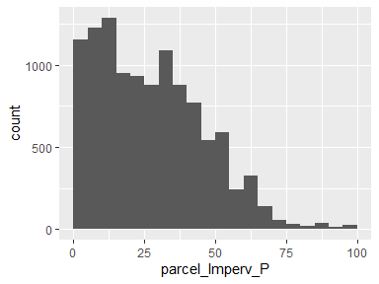

* Note that the following possible outlier values were detected: "96.03", "96.47", "96.79", "96.99", "97.2", "97.89", "98.24", "98.28", "98.36", "98.81" (3 additional values omitted).

## parcel_EffectiveYear1

|  |  |
| --- | --- |
| Feature | Result |
| Variable type | numeric |
| Number of missing obs. | 1012 (9.05 %) |
| Number of unique values | 95 |
| Median | 1981 |
| 1st and 3rd quartiles | 1968; 1990 |
| Min. and max. | 0; 2015 |

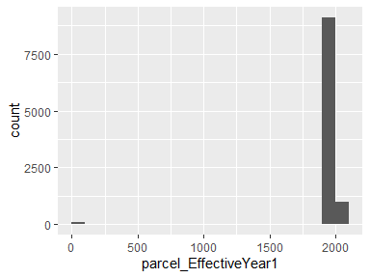

* Note that the following possible outlier values were detected: "0", "1907", "1922", "1923", "1924", "1925", "1926", "1928".

## parcel_EffectiveYear2

|  |  |
| --- | --- |
| Feature | Result |
| Variable type | numeric |
| Number of missing obs. | 10178 (91.03 %) |
| Number of unique values | 55 |
| Median | 1971 |
| 1st and 3rd quartiles | 1959; 1985 |
| Min. and max. | 1926; 2015 |

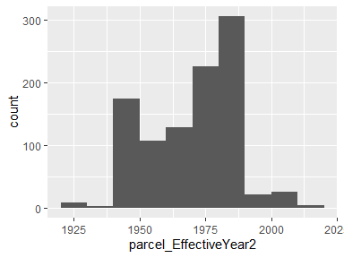

## parcel_EffectiveYear3

|  |  |
| --- | --- |
| Feature | Result |
| Variable type | numeric |
| Number of missing obs. | 10574 (94.57 %) |
| Number of unique values | 22 |
| Median | 1968 |
| 1st and 3rd quartiles | 1950; 1987 |
| Min. and max. | 0; 2013 |

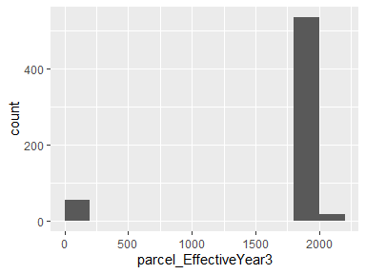

* Note that the following possible outlier values were detected: "0".

## parcel_EffectiveYear4

|  |  |
| --- | --- |
| Feature | Result |
| Variable type | numeric |
| Number of missing obs. | 10654 (95.29 %) |
| Number of unique values | 19 |
| Median | 1971 |
| 1st and 3rd quartiles | 1968; 1987 |
| Min. and max. | 1924; 2013 |

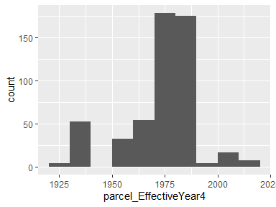

* Note that the following possible outlier values were detected: "1924", "1936", "1951", "1952", "1954".

## parcel_EffectiveYear5

|  |  |
| --- | --- |
| Feature | Result |
| Variable type | numeric |
| Number of missing obs. | 10676 (95.48 %) |
| Number of unique values | 14 |
| Median | 1974 |
| 1st and 3rd quartiles | 1969; 1987 |
| Min. and max. | 0; 2013 |

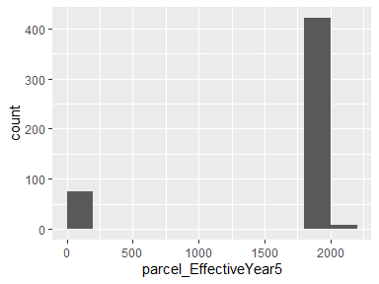

* Note that the following possible outlier values were detected: "0", "1937", "1955".

## parcel_area

|  |  |
| --- | --- |
| Feature | Result |
| Variable type | numeric |
| Number of missing obs. | 0 (0 %) |
| Number of unique values | 6406 |
| Median | 48728.31 |
| 1st and 3rd quartiles | 15110.89; 260847.14 |
| Min. and max. | 830.39; 65882419.74 |

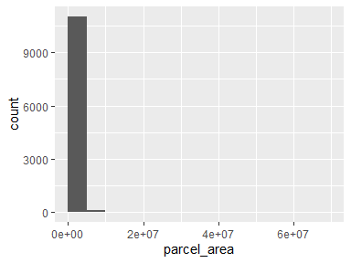

* Note that the following possible outlier values were detected: "4487445.51", "4742700.78", "4876361.44", "4941275.61", "5074257.67", "5167371.46", "5206496.02", "5232169.14", "5255859.63", "5572907.02" (11 additional values omitted).

## parcel_recent

|  |  |
| --- | --- |
| Feature | Result |
| Variable type | numeric |
| Number of missing obs. | 1012 (9.05 %) |
| Number of unique values | 94 |
| Median | 1981 |
| 1st and 3rd quartiles | 1970; 1990 |
| Min. and max. | 0; 2015 |

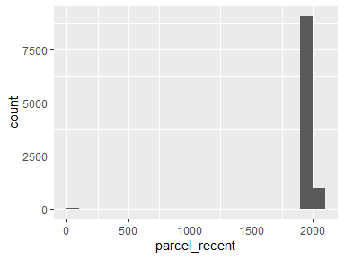

* Note that the following possible outlier values were detected: "0", "1907", "1923", "1924", "1925", "1926", "1928", "1929", "1930", "1931" (8 additional values omitted).

## build_EXTERIORSI

|  |  |
| --- | --- |
| Feature | Result |
| Variable type | character |
| Number of missing obs. | 10020 (89.62 %) |
| Number of unique values | 2 |
| Mode | “Ignition Resistant” |

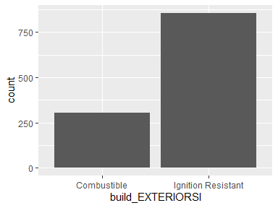

## build_FENCEATTAC

|  |  |
| --- | --- |
| Feature | Result |
| Variable type | character |
| Number of missing obs. | 10107 (90.39 %) |
| Number of unique values | 3 |
| Mode | “No Fence” |

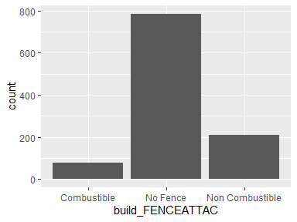

## build_DECKPORCHO

|  |  |
| --- | --- |
| Feature | Result |
| Variable type | character |
| Number of missing obs. | 10194 (91.17 %) |
| Number of unique values | 4 |
| Mode | “No Deck/Porch” |

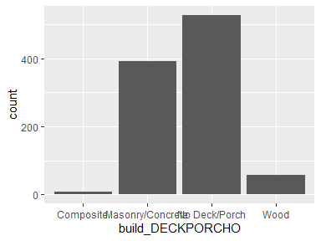

## build_DECKPORCHE

|  |  |
| --- | --- |
| Feature | Result |
| Variable type | character |
| Number of missing obs. | 10336 (92.44 %) |
| Number of unique values | 4 |
| Mode | “No Deck/Porch” |

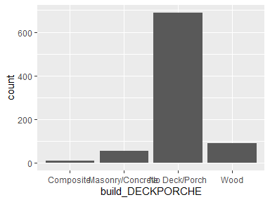

## build_ROOFCONSTR

|  |  |
| --- | --- |
| Feature | Result |
| Variable type | character |
| Number of missing obs. | 10077 (90.13 %) |
| Number of unique values | 6 |
| Mode | “Asphalt” |

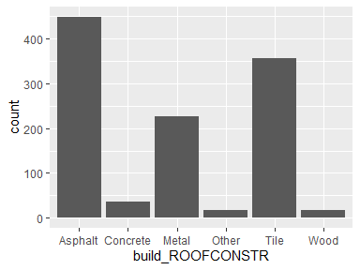

## build_PATIOCOVER

|  |  |
| --- | --- |
| Feature | Result |
| Variable type | character |
| Number of missing obs. | 10203 (91.25 %) |
| Number of unique values | 3 |
| Mode | “No Patio Cover/Carport” |

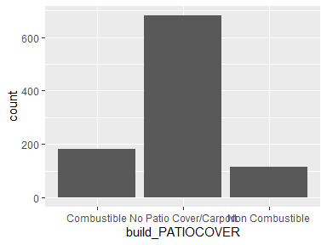

## build_PROPANETAN

|  |  |
| --- | --- |
| Feature | Result |
| Variable type | character |
| Number of missing obs. | 10890 (97.4 %) |
| Number of unique values | 4 |
| Mode | “4.>30” |

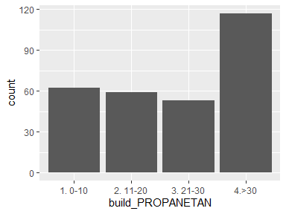

## build_WINDOWPANE

|  |  |
| --- | --- |
| Feature | Result |
| Variable type | character |
| Number of missing obs. | 10586 (94.68 %) |
| Number of unique values | 3 |
| Mode | “Multi Pane” |

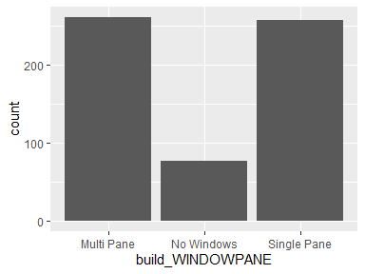

## build_VEGCLEARAN

|  |  |
| --- | --- |
| Feature | Result |
| Variable type | character |
| Number of missing obs. | 10003 (89.46 %) |
| Number of unique values | 3 |
| Mode | “1. 0-30” |

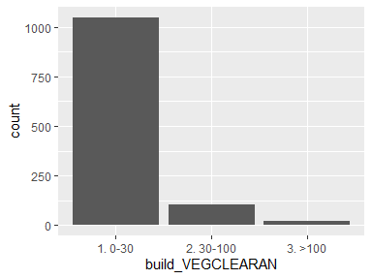

## build_EAVES

|  |  |
| --- | --- |
| Feature | Result |
| Variable type | character |
| Number of missing obs. | 10676 (95.48 %) |
| Number of unique values | 3 |
| Mode | “No Eaves” |

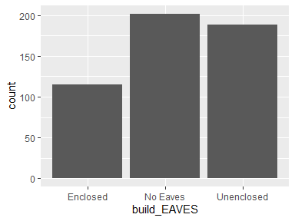

## build_VENTSCREEN

|  |  |
| --- | --- |
| Feature | Result |
| Variable type | character |
| Number of missing obs. | 10745 (96.1 %) |
| Number of unique values | 4 |
| Mode | “No Vents” |

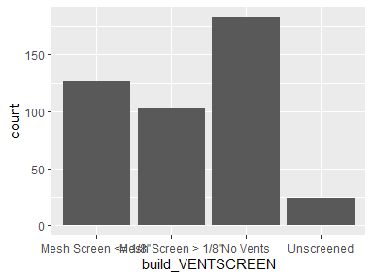

## build_DINS

* The variable only takes one (non-missing) value: "1". The variable contains 86.28 % missing observations.

Report generation information:

* Created by: mmockrin (username: mhmockrin).
* Report creation time: Wed Dec 01 2021 09:44:27
* Report was run from directory: C:/Users/mhmockrin/Box/_Workspace/Proj_GitHub/la_wui_2112
* dataMaid v1.4.0 [Pkg: 2019-12-10 from CRAN (R 4.0.5)]
* R version 4.0.5 (2021-03-31).
* Platform: x86_64-w64-mingw32/x64 (64-bit)(Windows 10 x64 (build 18363)).
* Function call: makeDataReport(data = build, file = paste0(getwd(), "/output_data/dataMaid_", gsub("[[:punct:]]", "_", Sys.time()), ".Rmd"))