build

Autogenerated data summary from dataMaid

2021-12-02 12:34:11

# Data report overview

The dataset examined has the following dimensions:

|  |  |
| --- | --- |
| Feature | Result |
| Number of observations | 11181 |
| Number of variables | 85 |

### Checks performed

The following variable checks were performed, depending on the data type of each variable:

|  |  |  |  |  |  |  |  |  |
| --- | --- | --- | --- | --- | --- | --- | --- | --- |
|  | character | factor | labelled | haven labelled | numeric | integer | logical | Date |
| Identify miscoded missing values | × | × | × | × | × | × |  | × |
| Identify prefixed and suffixed whitespace | × | × | × | × |  |  |  |  |
| Identify levels with < 6 obs. | × | × | × | × |  |  |  |  |
| Identify case issues | × | × | × | × |  |  |  |  |
| Identify misclassified numeric or integer variables | × | × | × | × |  |  |  |  |
| Identify outliers |  |  |  |  | × | × |  | × |

Please note that all numerical values in the following have been rounded to 2 decimals.

# Summary table

|  |  |  |  |  |
| --- | --- | --- | --- | --- |
|  | Variable class | # unique values | Missing observations | Any problems? |
| ID_Build | numeric | 11134 | 0.00 % |  |
| ID_Parcel | numeric | 6162 | 0.00 % |  |
| parcel_AIN | numeric | 6405 | 0.00 % |  |
| damage_cat | character | 2 | 0.00 % |  |
| damage_binary | numeric | 2 | 0.00 % |  |
| damage_severity | numeric | 5 | 0.00 % |  |
| build_structures_DAMAGE | character | 5 | 86.26 % |  |
| build_Mean_elev_30m | numeric | 11134 | 0.00 % | × |
| build_Mean_elev_100m | numeric | 11134 | 0.00 % | × |
| build_Mean_slope_30m_DEM | numeric | 11134 | 0.00 % | × |
| build_Mean_slope_100m_DEM | numeric | 11134 | 0.00 % | × |
| build_Mean_aspect_30m_DEM | numeric | 11134 | 0.00 % | × |
| build_Mean_aspect_100m_DEM | numeric | 11134 | 0.00 % | × |
| build_Mean_distroad | numeric | 9017 | 0.79 % |  |
| build_Mean_builddens | numeric | 8844 | 0.79 % |  |
| build_Mean_distall_road | numeric | 6190 | 0.11 % | × |
| build_min_dist_tree | numeric | 567 | 0.00 % | × |
| build_min_dist_shrub | numeric | 9253 | 0.00 % | × |
| build_has_tree_overhang | numeric | 3 | 0.42 % |  |
| build_overhang_ht | numeric | 7844 | 0.42 % | × |
| build_perc_overhang | numeric | 7533 | 0.42 % |  |
| build_near_dest | numeric | 10712 | 0.00 % | × |
| build_near_exp | numeric | 10661 | 0.00 % | × |
| build_dist_to_build_ft_jod | numeric | 7635 | 0.42 % | × |
| build_p_tree_10 | numeric | 10163 | 0.00 % |  |
| build_p_tree_100 | numeric | 11107 | 0.00 % | × |
| build_p_tree_200 | numeric | 11132 | 0.00 % | × |
| build_p_tree_300 | numeric | 11133 | 0.00 % | × |
| build_p_grass_10 | numeric | 10292 | 0.00 % | × |
| build_p_grass_100 | numeric | 11054 | 0.00 % | × |
| build_p_grass_200 | numeric | 11084 | 0.00 % | × |
| build_p_grass_300 | numeric | 11103 | 0.00 % | × |
| build_p_soil_10 | numeric | 9047 | 0.00 % |  |
| build_p_soil_100 | numeric | 11117 | 0.00 % |  |
| build_p_soil_200 | numeric | 11134 | 0.00 % |  |
| build_p_soil_300 | numeric | 11134 | 0.00 % | × |
| build_p_water_10 | numeric | 9 | 0.00 % | × |
| build_p_water_100 | numeric | 159 | 0.00 % | × |
| build_p_water_200 | numeric | 336 | 0.00 % | × |
| build_p_water_300 | numeric | 538 | 0.00 % | × |
| build_p_building_10 | numeric | 10441 | 0.00 % | × |
| build_p_building_100 | numeric | 11023 | 0.00 % | × |
| build_p_building_200 | numeric | 11082 | 0.00 % |  |
| build_p_building_300 | numeric | 11101 | 0.00 % |  |
| build_p_road_10 | numeric | 1296 | 0.00 % | × |
| build_p_road_100 | numeric | 8663 | 0.00 % | × |
| build_p_road_200 | numeric | 10022 | 0.00 % | × |
| build_p_road_300 | numeric | 10549 | 0.00 % | × |
| build_p_otherpaved_10 | numeric | 7791 | 0.00 % |  |
| build_p_otherpaved_100 | numeric | 10428 | 0.00 % | × |
| build_p_otherpaved_200 | numeric | 10851 | 0.00 % | × |
| build_p_otherpaved_300 | numeric | 10974 | 0.00 % | × |
| build_p_shrub_10 | numeric | 261 | 0.00 % | × |
| build_p_shrub_100 | numeric | 3711 | 0.00 % | × |
| build_p_shrub_200 | numeric | 5926 | 0.00 % |  |
| build_p_shrub_300 | numeric | 7399 | 0.00 % |  |
| build_area | numeric | 11134 | 0.00 % | × |
| parcel_UseType | character | 9 | 0.22 % |  |
| parcel_UseDescription | character | 44 | 0.22 % | × |
| parcel_Roll_ImpValue | numeric | 5507 | 3.32 % | × |
| parcel_Roll_HomeOwnersExemp | numeric | 4 | 3.32 % |  |
| parcel_Can_P | numeric | 6216 | 0.00 % | × |
| parcel_Grass_P | numeric | 6169 | 0.00 % | × |
| parcel_Soil_P | numeric | 5885 | 0.00 % |  |
| parcel_Water_P | numeric | 38 | 0.00 % | × |
| parcel_Build_P | numeric | 6186 | 0.00 % |  |
| parcel_Road_P | numeric | 2194 | 0.00 % |  |
| parcel_Paved_P | numeric | 5367 | 0.00 % | × |
| parcel_Shrub_P | numeric | 1723 | 0.00 % |  |
| parcel_Perv_P | numeric | 6239 | 0.00 % | × |
| parcel_Imperv_P | numeric | 6239 | 0.00 % | × |
| parcel_year_built | numeric | 95 | 9.05 % | × |
| parcel_area | numeric | 6406 | 0.00 % | × |
| build_EXTERIORSI | character | 3 | 89.62 % |  |
| build_FENCEATTAC | character | 4 | 90.39 % |  |
| build_DECKPORCHO | character | 5 | 91.17 % |  |
| build_DECKPORCHE | character | 5 | 92.44 % |  |
| build_ROOFCONSTR | character | 7 | 90.13 % |  |
| build_PATIOCOVER | character | 4 | 91.25 % |  |
| build_PROPANETAN | character | 5 | 97.40 % |  |
| build_WINDOWPANE | character | 4 | 94.68 % |  |
| build_VEGCLEARAN | character | 4 | 89.46 % |  |
| build_EAVES | character | 4 | 95.48 % |  |
| build_VENTSCREEN | character | 5 | 96.10 % |  |
| build_DINS | numeric | 2 | 86.28 % | × |

# Variable list

## ID_Build

|  |  |
| --- | --- |
| Feature | Result |
| Variable type | numeric |
| Number of missing obs. | 0 (0 %) |
| Number of unique values | 11134 |
| Median | 5561 |
| 1st and 3rd quartiles | 2778; 8345 |
| Min. and max. | 1; 11140 |

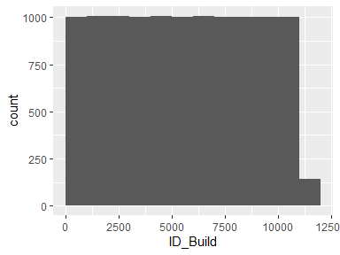

## ID_Parcel

|  |  |
| --- | --- |
| Feature | Result |
| Variable type | numeric |
| Number of missing obs. | 0 (0 %) |
| Number of unique values | 6162 |
| Median | 5432 |
| 1st and 3rd quartiles | 2598; 9443 |
| Min. and max. | 4; 13396 |

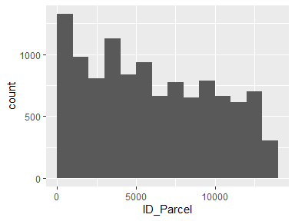

## parcel_AIN

|  |  |
| --- | --- |
| Feature | Result |
| Variable type | numeric |
| Number of missing obs. | 0 (0 %) |
| Number of unique values | 6405 |
| Median | 4458032013 |
| 1st and 3rd quartiles | 2059022006; 4467034014 |
| Min. and max. | 2049004901; 4473027903 |

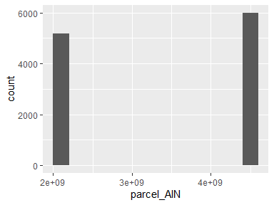

## damage_cat

|  |  |
| --- | --- |
| Feature | Result |
| Variable type | character |
| Number of missing obs. | 0 (0 %) |
| Number of unique values | 2 |
| Mode | “Survived” |

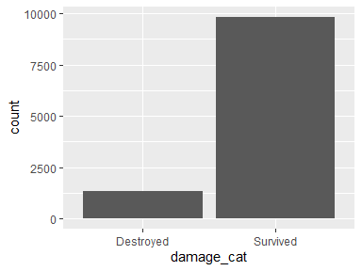

## damage_binary

* Note that this variable is treated as a factor variable below, as it only takes a few unique values.

|  |  |
| --- | --- |
| Feature | Result |
| Variable type | numeric |
| Number of missing obs. | 0 (0 %) |
| Number of unique values | 2 |
| Mode | “0” |
| Reference category | 0 |

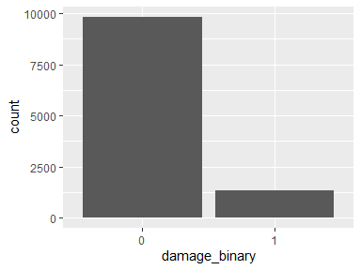

## damage_severity

* Note that this variable is treated as a factor variable below, as it only takes a few unique values.

|  |  |
| --- | --- |
| Feature | Result |
| Variable type | numeric |
| Number of missing obs. | 0 (0 %) |
| Number of unique values | 5 |
| Mode | “1” |
| Reference category | 1 |

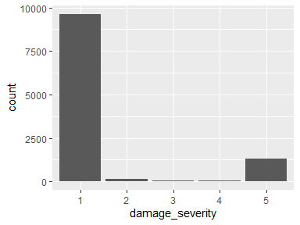

## build_structures_DAMAGE

|  |  |
| --- | --- |
| Feature | Result |
| Variable type | character |
| Number of missing obs. | 9645 (86.26 %) |
| Number of unique values | 4 |
| Mode | “Destroyed (>50%)” |

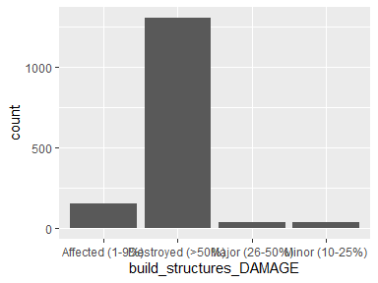

## build_Mean_elev_30m

|  |  |
| --- | --- |
| Feature | Result |
| Variable type | numeric |
| Number of missing obs. | 0 (0 %) |
| Number of unique values | 11134 |
| Median | 793.06 |
| 1st and 3rd quartiles | 254.36; 934.5 |
| Min. and max. | 12.07; 2817.77 |

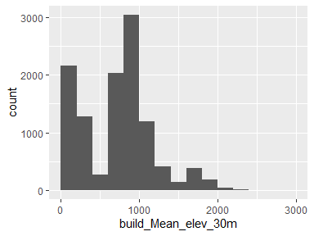

* Note that the following possible outlier values were detected: "1221.98", "1222.13", "1222.28", "1222.34", "1222.46", "1222.56", "1222.56", "1222.63", "1222.79", "1223.06" (1074 additional values omitted).

## build_Mean_elev_100m

|  |  |
| --- | --- |
| Feature | Result |
| Variable type | numeric |
| Number of missing obs. | 0 (0 %) |
| Number of unique values | 11134 |
| Median | 794.41 |
| 1st and 3rd quartiles | 250.23; 939.7 |
| Min. and max. | 11.47; 2769.59 |

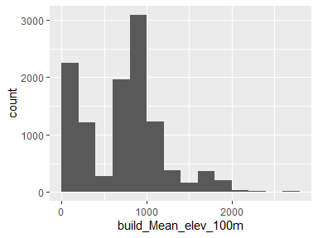

* Note that the following possible outlier values were detected: "1221.34", "1221.35", "1221.53", "1221.62", "1221.68", "1221.83", "1222.49", "1223.12", "1223.65", "1223.74" (1070 additional values omitted).

## build_Mean_slope_30m_DEM

|  |  |
| --- | --- |
| Feature | Result |
| Variable type | numeric |
| Number of missing obs. | 0 (0 %) |
| Number of unique values | 11134 |
| Median | 9.02 |
| 1st and 3rd quartiles | 5.56; 13.62 |
| Min. and max. | 0.85; 34.37 |

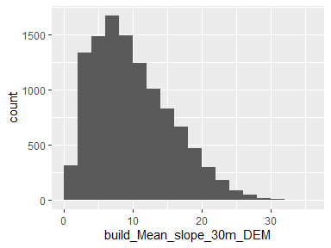

* Note that the following possible outlier values were detected: "34.37".

## build_Mean_slope_100m_DEM

|  |  |
| --- | --- |
| Feature | Result |
| Variable type | numeric |
| Number of missing obs. | 0 (0 %) |
| Number of unique values | 11134 |
| Median | 10.99 |
| 1st and 3rd quartiles | 7.43; 15.43 |
| Min. and max. | 1.28; 34.82 |

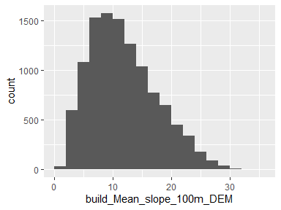

* Note that the following possible outlier values were detected: "34.58", "34.82".

## build_Mean_aspect_30m_DEM

|  |  |
| --- | --- |
| Feature | Result |
| Variable type | numeric |
| Number of missing obs. | 0 (0 %) |
| Number of unique values | 11134 |
| Median | 183.28 |
| 1st and 3rd quartiles | 147.36; 214.29 |
| Min. and max. | 41.01; 322.87 |

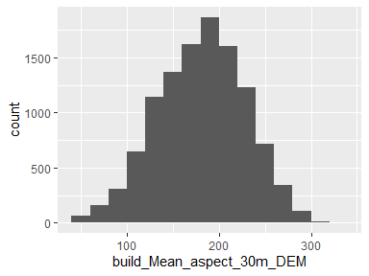

* Note that the following possible outlier values were detected: "291.72", "291.79", "291.86", "292.09", "292.17", "292.36", "292.38", "292.43", "292.69", "292.75" (30 additional values omitted).

## build_Mean_aspect_100m_DEM

|  |  |
| --- | --- |
| Feature | Result |
| Variable type | numeric |
| Number of missing obs. | 0 (0 %) |
| Number of unique values | 11134 |
| Median | 182.17 |
| 1st and 3rd quartiles | 154.53; 207.26 |
| Min. and max. | 58.76; 295.16 |

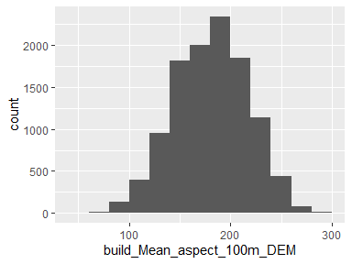

* Note that the following possible outlier values were detected: "58.76", "59.17", "59.94", "60.56", "61.56", "63.43", "63.44", "65.79", "276", "276.66" (21 additional values omitted).

## build_Mean_distroad

|  |  |
| --- | --- |
| Feature | Result |
| Variable type | numeric |
| Number of missing obs. | 88 (0.79 %) |
| Number of unique values | 9016 |
| Median | 602.94 |
| 1st and 3rd quartiles | 217.28; 1252.96 |
| Min. and max. | 0; 3666.9 |

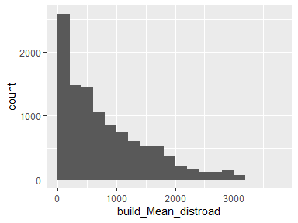

## build_Mean_builddens

|  |  |
| --- | --- |
| Feature | Result |
| Variable type | numeric |
| Number of missing obs. | 88 (0.79 %) |
| Number of unique values | 8843 |
| Median | 1.42 |
| 1st and 3rd quartiles | 0.74; 2.26 |
| Min. and max. | 0; 4.41 |

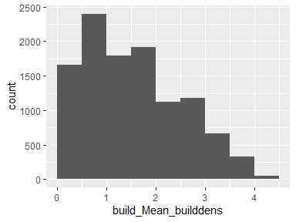

## build_Mean_distall_road

|  |  |
| --- | --- |
| Feature | Result |
| Variable type | numeric |
| Number of missing obs. | 12 (0.11 %) |
| Number of unique values | 6189 |
| Median | 28.66 |
| 1st and 3rd quartiles | 8.02; 33.29 |
| Min. and max. | 0; 430.68 |

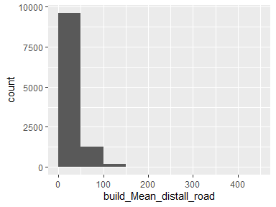

* Note that the following possible outlier values were detected: "40.51", "40.52", "40.52", "40.53", "40.55", "40.57", "40.6", "40.61", "40.61", "40.69" (1417 additional values omitted).

## build_min_dist_tree

|  |  |
| --- | --- |
| Feature | Result |
| Variable type | numeric |
| Number of missing obs. | 0 (0 %) |
| Number of unique values | 567 |
| Median | 0.75 |
| 1st and 3rd quartiles | 0.75; 0.75 |
| Min. and max. | 0.75; 345.25 |

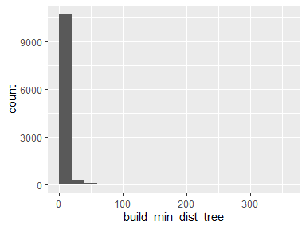

* Note that the following possible outlier values were detected: "1.06", "1.5", "1.68", "2.12", "2.25", "2.37", "2.7", "3", "3.09", "3.18" (556 additional values omitted).

## build_min_dist_shrub

|  |  |
| --- | --- |
| Feature | Result |
| Variable type | numeric |
| Number of missing obs. | 0 (0 %) |
| Number of unique values | 9253 |
| Median | 180.16 |
| 1st and 3rd quartiles | 73.19; 407.3 |
| Min. and max. | 0.75; 2377.11 |

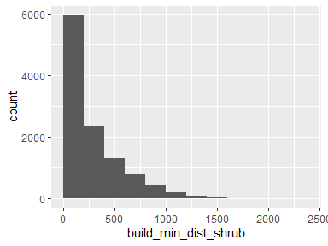

* Note that the following possible outlier values were detected: "2229.43", "2239.67", "2297.74", "2299.24", "2300.25", "2311.74", "2377.11".

## build_has_tree_overhang

* Note that this variable is treated as a factor variable below, as it only takes a few unique values.

|  |  |
| --- | --- |
| Feature | Result |
| Variable type | numeric |
| Number of missing obs. | 47 (0.42 %) |
| Number of unique values | 2 |
| Mode | “1” |
| Reference category | 0 |

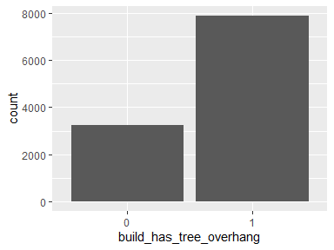

## build_overhang_ht

|  |  |
| --- | --- |
| Feature | Result |
| Variable type | numeric |
| Number of missing obs. | 47 (0.42 %) |
| Number of unique values | 7843 |
| Median | 13.38 |
| 1st and 3rd quartiles | 0; 22.08 |
| Min. and max. | -0.04; 90.21 |

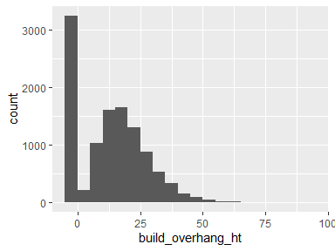

* Note that the following possible outlier values were detected: "55.25", "55.28", "55.61", "55.62", "55.86", "56.02", "56.32", "56.46", "56.65", "57.07" (36 additional values omitted).

## build_perc_overhang

|  |  |
| --- | --- |
| Feature | Result |
| Variable type | numeric |
| Number of missing obs. | 47 (0.42 %) |
| Number of unique values | 7532 |
| Median | 0.01 |
| 1st and 3rd quartiles | 0; 0.07 |
| Min. and max. | 0; 1 |

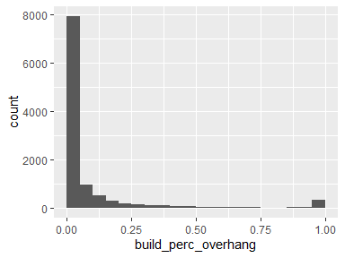

## build_near_dest

|  |  |
| --- | --- |
| Feature | Result |
| Variable type | numeric |
| Number of missing obs. | 0 (0 %) |
| Number of unique values | 10712 |
| Median | 708.49 |
| 1st and 3rd quartiles | 182.89; 1660.11 |
| Min. and max. | 0.12; 13312.67 |

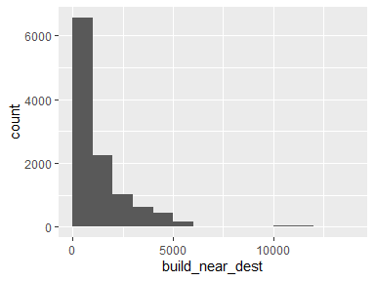

* Note that the following possible outlier values were detected: "9442.37", "9443.71", "9580.47", "9582.51", "9731.97", "10125.75", "10131.96", "10161.87", "10175.99", "10248.31" (93 additional values omitted).

## build_near_exp

|  |  |
| --- | --- |
| Feature | Result |
| Variable type | numeric |
| Number of missing obs. | 0 (0 %) |
| Number of unique values | 10661 |
| Median | 570.88 |
| 1st and 3rd quartiles | 147.85; 1399.98 |
| Min. and max. | 0.05; 13148.46 |

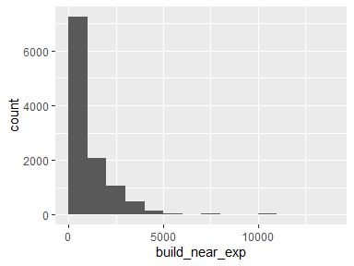

* Note that the following possible outlier values were detected: "8073.3", "8167.56", "8213.28", "8296.93", "8309.75", "8313.62", "8342.93", "8343.33", "9072.22", "9157.15" (68 additional values omitted).

## build_dist_to_build_ft_jod

|  |  |
| --- | --- |
| Feature | Result |
| Variable type | numeric |
| Number of missing obs. | 47 (0.42 %) |
| Number of unique values | 7634 |
| Median | 75.7 |
| 1st and 3rd quartiles | 54.53; 108.57 |
| Min. and max. | 0; 8639.64 |

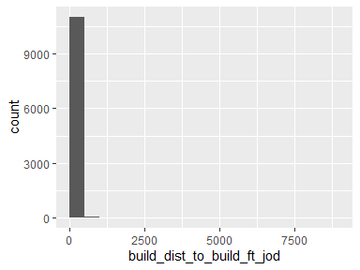

* Note that the following possible outlier values were detected: "0", "1.06", "1.59", "2.02", "2.14", "2.37", "3.5", "3.66", "3.69", "4.06" (446 additional values omitted).

## build_p_tree_10

|  |  |
| --- | --- |
| Feature | Result |
| Variable type | numeric |
| Number of missing obs. | 0 (0 %) |
| Number of unique values | 10163 |
| Median | 22.04 |
| 1st and 3rd quartiles | 9.26; 39.06 |
| Min. and max. | 0; 100 |

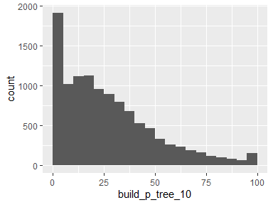

## build_p_tree_100

|  |  |
| --- | --- |
| Feature | Result |
| Variable type | numeric |
| Number of missing obs. | 0 (0 %) |
| Number of unique values | 11107 |
| Median | 27.69 |
| 1st and 3rd quartiles | 17.88; 40.72 |
| Min. and max. | 0; 99.01 |

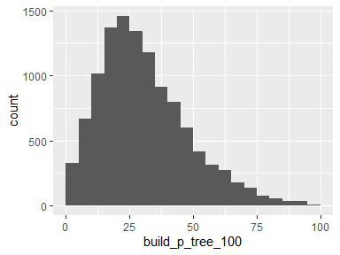

* Note that the following possible outlier values were detected: "0", "0.01", "0.09", "0.09", "0.1", "0.11", "0.11", "0.18", "0.19", "0.19" (14 additional values omitted).

## build_p_tree_200

|  |  |
| --- | --- |
| Feature | Result |
| Variable type | numeric |
| Number of missing obs. | 0 (0 %) |
| Number of unique values | 11132 |
| Median | 26.54 |
| 1st and 3rd quartiles | 18.16; 37.64 |
| Min. and max. | 0; 95.06 |

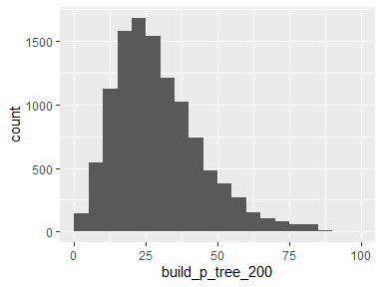

* Note that the following possible outlier values were detected: "0", "0.09", "0.21", "0.22", "0.25", "0.25", "0.26", "0.26", "0.3", "0.3" (83 additional values omitted).

## build_p_tree_300

|  |  |
| --- | --- |
| Feature | Result |
| Variable type | numeric |
| Number of missing obs. | 0 (0 %) |
| Number of unique values | 11133 |
| Median | 26.56 |
| 1st and 3rd quartiles | 18.58; 36.12 |
| Min. and max. | 0; 92.34 |

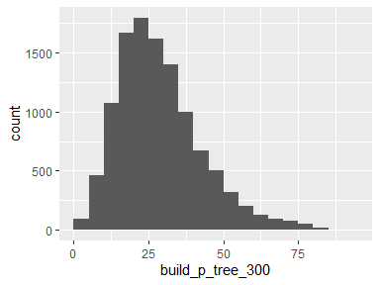

* Note that the following possible outlier values were detected: "0", "0.08", "0.14", "0.14", "0.14", "0.25", "0.48", "0.75", "0.8", "0.85" (108 additional values omitted).

## build_p_grass_10

|  |  |
| --- | --- |
| Feature | Result |
| Variable type | numeric |
| Number of missing obs. | 0 (0 %) |
| Number of unique values | 10292 |
| Median | 28.82 |
| 1st and 3rd quartiles | 14.56; 43.27 |
| Min. and max. | 0; 97.5 |

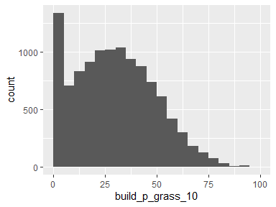

* Note that the following possible outlier values were detected: "90.35", "90.64", "90.94", "91.1", "91.41", "91.83", "92.61", "93.09", "93.86", "93.93" (4 additional values omitted).

## build_p_grass_100

|  |  |
| --- | --- |
| Feature | Result |
| Variable type | numeric |
| Number of missing obs. | 0 (0 %) |
| Number of unique values | 11054 |
| Median | 16.32 |
| 1st and 3rd quartiles | 10.23; 22.82 |
| Min. and max. | 0; 76.05 |

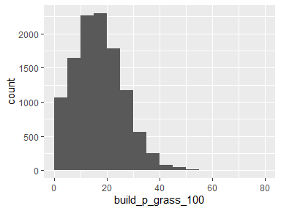

* Note that the following possible outlier values were detected: "45.01", "45.03", "45.04", "45.05", "45.05", "45.06", "45.1", "45.11", "45.11", "45.16" (60 additional values omitted).

## build_p_grass_200

|  |  |
| --- | --- |
| Feature | Result |
| Variable type | numeric |
| Number of missing obs. | 0 (0 %) |
| Number of unique values | 11084 |
| Median | 14.93 |
| 1st and 3rd quartiles | 9.6; 20.59 |
| Min. and max. | 0; 64.26 |

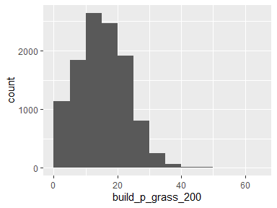

* Note that the following possible outlier values were detected: "38.43", "38.43", "38.46", "38.61", "38.62", "38.71", "38.88", "38.89", "38.92", "39.19" (48 additional values omitted).

## build_p_grass_300

|  |  |
| --- | --- |
| Feature | Result |
| Variable type | numeric |
| Number of missing obs. | 0 (0 %) |
| Number of unique values | 11103 |
| Median | 14.08 |
| 1st and 3rd quartiles | 8.84; 19.39 |
| Min. and max. | 0; 60.05 |

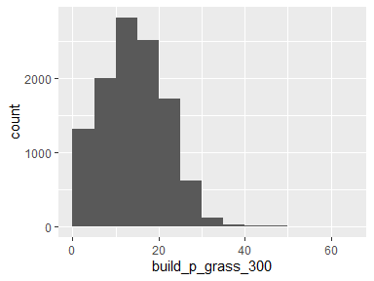

* Note that the following possible outlier values were detected: "35.94", "35.97", "36.19", "36.2", "36.29", "36.65", "36.84", "37.18", "37.36", "37.56" (47 additional values omitted).

## build_p_soil_10

|  |  |
| --- | --- |
| Feature | Result |
| Variable type | numeric |
| Number of missing obs. | 0 (0 %) |
| Number of unique values | 9047 |
| Median | 15.27 |
| 1st and 3rd quartiles | 4.25; 30.98 |
| Min. and max. | 0; 100 |

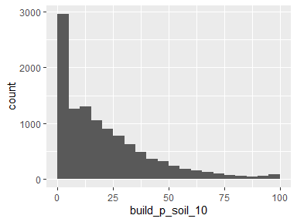

## build_p_soil_100

|  |  |
| --- | --- |
| Feature | Result |
| Variable type | numeric |
| Number of missing obs. | 0 (0 %) |
| Number of unique values | 11117 |
| Median | 14.27 |
| 1st and 3rd quartiles | 6.64; 29.94 |
| Min. and max. | 0; 100 |

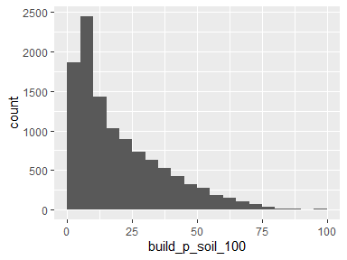

## build_p_soil_200

|  |  |
| --- | --- |
| Feature | Result |
| Variable type | numeric |
| Number of missing obs. | 0 (0 %) |
| Number of unique values | 11134 |
| Median | 19.57 |
| 1st and 3rd quartiles | 9.05; 34.25 |
| Min. and max. | 0.22; 96.64 |

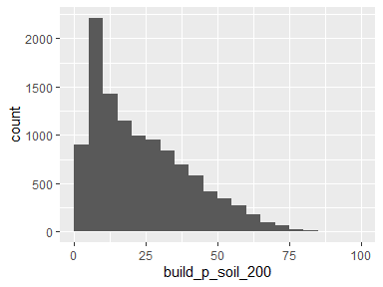

## build_p_soil_300

|  |  |
| --- | --- |
| Feature | Result |
| Variable type | numeric |
| Number of missing obs. | 0 (0 %) |
| Number of unique values | 11134 |
| Median | 22.71 |
| 1st and 3rd quartiles | 11.65; 35.77 |
| Min. and max. | 0.62; 96.24 |

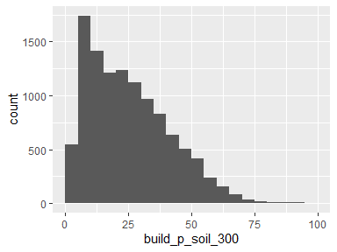

* Note that the following possible outlier values were detected: "93.91", "93.96", "93.97", "96.24".

## build_p_water_10

|  |  |
| --- | --- |
| Feature | Result |
| Variable type | numeric |
| Number of missing obs. | 0 (0 %) |
| Number of unique values | 9 |
| Median | 0 |
| 1st and 3rd quartiles | 0; 0 |
| Min. and max. | 0; 21.07 |

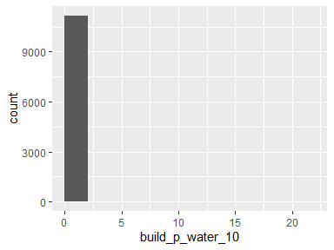

* Note that the following possible outlier values were detected: "0.04", "0.11", "0.49", "0.55", "3.36", "10.79", "15.15", "21.07".

## build_p_water_100

|  |  |
| --- | --- |
| Feature | Result |
| Variable type | numeric |
| Number of missing obs. | 0 (0 %) |
| Number of unique values | 159 |
| Median | 0 |
| 1st and 3rd quartiles | 0; 0 |
| Min. and max. | 0; 42.63 |

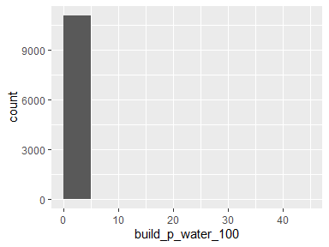

* Note that the following possible outlier values were detected: "0", "0", "0.01", "0.01", "0.02", "0.02", "0.07", "0.08", "0.14", "0.18" (148 additional values omitted).

## build_p_water_200

|  |  |
| --- | --- |
| Feature | Result |
| Variable type | numeric |
| Number of missing obs. | 0 (0 %) |
| Number of unique values | 336 |
| Median | 0 |
| 1st and 3rd quartiles | 0; 0 |
| Min. and max. | 0; 49.8 |

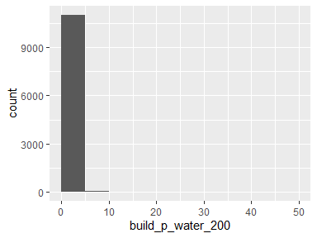

* Note that the following possible outlier values were detected: "0", "0", "0", "0", "0", "0.01", "0.01", "0.01", "0.02", "0.02" (325 additional values omitted).

## build_p_water_300

|  |  |
| --- | --- |
| Feature | Result |
| Variable type | numeric |
| Number of missing obs. | 0 (0 %) |
| Number of unique values | 538 |
| Median | 0 |
| 1st and 3rd quartiles | 0; 0 |
| Min. and max. | 0; 50.39 |

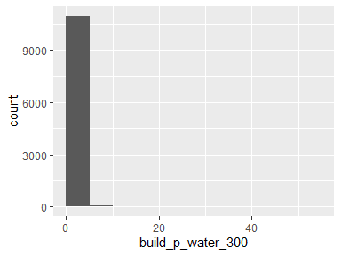

* Note that the following possible outlier values were detected: "0", "0", "0", "0", "0", "0", "0.01", "0.01", "0.01", "0.01" (527 additional values omitted).

## build_p_building_10

|  |  |
| --- | --- |
| Feature | Result |
| Variable type | numeric |
| Number of missing obs. | 0 (0 %) |
| Number of unique values | 10441 |
| Median | 2.24 |
| 1st and 3rd quartiles | 1.3; 3.87 |
| Min. and max. | 0; 86.56 |

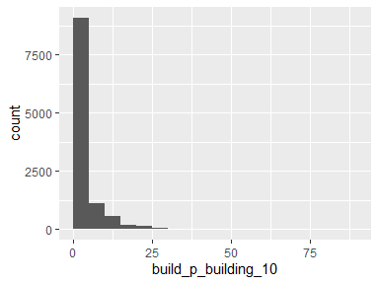

* Note that the following possible outlier values were detected: "0", "0.02", "0.03", "0.03", "0.03", "0.03", "0.04", "0.04", "0.04", "0.04" (739 additional values omitted).

## build_p_building_100

|  |  |
| --- | --- |
| Feature | Result |
| Variable type | numeric |
| Number of missing obs. | 0 (0 %) |
| Number of unique values | 11023 |
| Median | 9.46 |
| 1st and 3rd quartiles | 3.16; 16.55 |
| Min. and max. | 0; 54.2 |

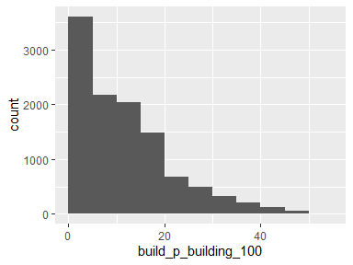

* Note that the following possible outlier values were detected: "47.96", "48", "48.02", "48.05", "48.09", "48.1", "48.14", "48.14", "48.2", "48.23" (22 additional values omitted).

## build_p_building_200

|  |  |
| --- | --- |
| Feature | Result |
| Variable type | numeric |
| Number of missing obs. | 0 (0 %) |
| Number of unique values | 11082 |
| Median | 9.35 |
| 1st and 3rd quartiles | 4.14; 17.78 |
| Min. and max. | 0; 47.11 |

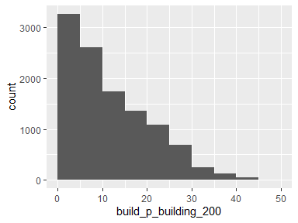

## build_p_building_300

|  |  |
| --- | --- |
| Feature | Result |
| Variable type | numeric |
| Number of missing obs. | 0 (0 %) |
| Number of unique values | 11101 |
| Median | 8.66 |
| 1st and 3rd quartiles | 3.99; 16.57 |
| Min. and max. | 0; 41.7 |

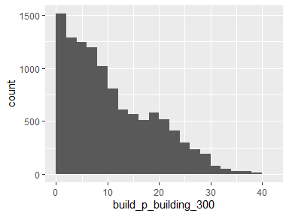

## build_p_road_10

|  |  |
| --- | --- |
| Feature | Result |
| Variable type | numeric |
| Number of missing obs. | 0 (0 %) |
| Number of unique values | 1296 |
| Median | 0 |
| 1st and 3rd quartiles | 0; 0 |
| Min. and max. | 0; 86.85 |

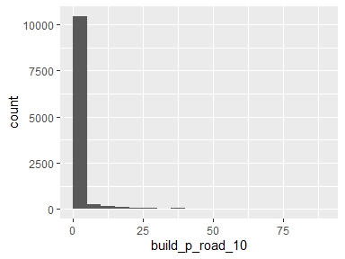

* Note that the following possible outlier values were detected: "0.02", "0.02", "0.02", "0.02", "0.02", "0.02", "0.02", "0.02", "0.03", "0.03" (1285 additional values omitted).

## build_p_road_100

|  |  |
| --- | --- |
| Feature | Result |
| Variable type | numeric |
| Number of missing obs. | 0 (0 %) |
| Number of unique values | 8663 |
| Median | 6.63 |
| 1st and 3rd quartiles | 0.78; 12.69 |
| Min. and max. | 0; 53.93 |

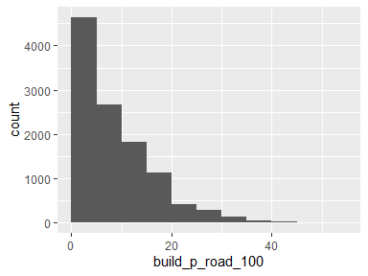

* Note that the following possible outlier values were detected: "43.16", "43.29", "43.42", "43.69", "43.73", "43.91", "44.11", "44.27", "44.43", "44.97" (8 additional values omitted).

## build_p_road_200

|  |  |
| --- | --- |
| Feature | Result |
| Variable type | numeric |
| Number of missing obs. | 0 (0 %) |
| Number of unique values | 10022 |
| Median | 6.8 |
| 1st and 3rd quartiles | 3.09; 11.78 |
| Min. and max. | 0; 56.26 |

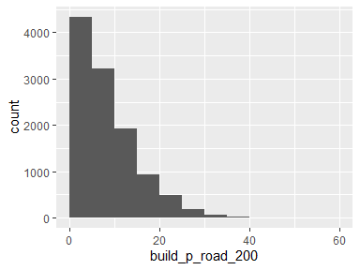

* Note that the following possible outlier values were detected: "34.65", "34.7", "35.52", "35.58", "35.62", "35.87", "35.91", "35.96", "36.29", "36.34" (26 additional values omitted).

## build_p_road_300

|  |  |
| --- | --- |
| Feature | Result |
| Variable type | numeric |
| Number of missing obs. | 0 (0 %) |
| Number of unique values | 10549 |
| Median | 6.7 |
| 1st and 3rd quartiles | 3.34; 11.33 |
| Min. and max. | 0; 51.26 |

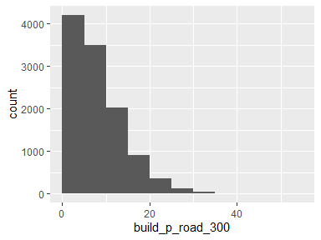

* Note that the following possible outlier values were detected: "33.59", "33.64", "33.64", "33.67", "33.67", "33.96", "34.18", "34.19", "34.26", "34.33" (15 additional values omitted).

## build_p_otherpaved_10

|  |  |
| --- | --- |
| Feature | Result |
| Variable type | numeric |
| Number of missing obs. | 0 (0 %) |
| Number of unique values | 7791 |
| Median | 11.92 |
| 1st and 3rd quartiles | 0; 27.2 |
| Min. and max. | 0; 100 |

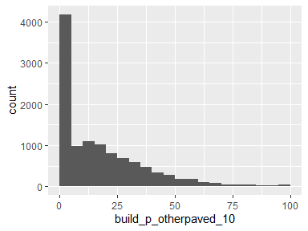

## build_p_otherpaved_100

|  |  |
| --- | --- |
| Feature | Result |
| Variable type | numeric |
| Number of missing obs. | 0 (0 %) |
| Number of unique values | 10428 |
| Median | 9.05 |
| 1st and 3rd quartiles | 4.43; 14.94 |
| Min. and max. | 0; 89.96 |

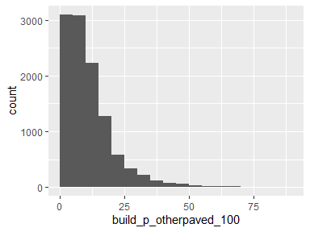

* Note that the following possible outlier values were detected: "41.64", "41.88", "41.92", "42.04", "42.04", "42.06", "42.14", "42.24", "42.27", "42.35" (202 additional values omitted).

## build_p_otherpaved_200

|  |  |
| --- | --- |
| Feature | Result |
| Variable type | numeric |
| Number of missing obs. | 0 (0 %) |
| Number of unique values | 10851 |
| Median | 7.85 |
| 1st and 3rd quartiles | 4.22; 11.92 |
| Min. and max. | 0; 72.16 |

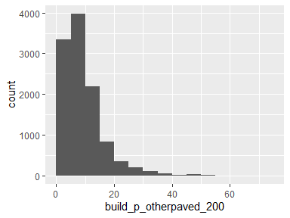

* Note that the following possible outlier values were detected: "28.63", "28.64", "28.64", "28.65", "28.67", "28.69", "28.7", "28.74", "28.76", "28.77" (309 additional values omitted).

## build_p_otherpaved_300

|  |  |
| --- | --- |
| Feature | Result |
| Variable type | numeric |
| Number of missing obs. | 0 (0 %) |
| Number of unique values | 10974 |
| Median | 7.25 |
| 1st and 3rd quartiles | 4.04; 10.85 |
| Min. and max. | 0; 59.9 |

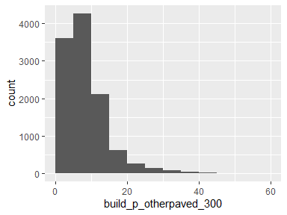

* Note that the following possible outlier values were detected: "25", "25.02", "25.03", "25.06", "25.07", "25.12", "25.21", "25.21", "25.3", "25.31" (301 additional values omitted).

## build_p_shrub_10

|  |  |
| --- | --- |
| Feature | Result |
| Variable type | numeric |
| Number of missing obs. | 0 (0 %) |
| Number of unique values | 261 |
| Median | 0 |
| 1st and 3rd quartiles | 0; 0 |
| Min. and max. | 0; 89.43 |

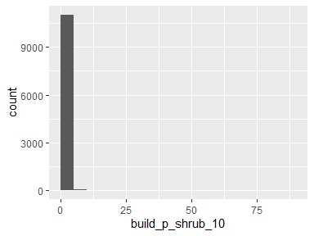

* Note that the following possible outlier values were detected: "0.03", "0.04", "0.04", "0.07", "0.08", "0.09", "0.12", "0.13", "0.15", "0.15" (250 additional values omitted).

## build_p_shrub_100

|  |  |
| --- | --- |
| Feature | Result |
| Variable type | numeric |
| Number of missing obs. | 0 (0 %) |
| Number of unique values | 3711 |
| Median | 0 |
| 1st and 3rd quartiles | 0; 0.44 |
| Min. and max. | 0; 55.47 |

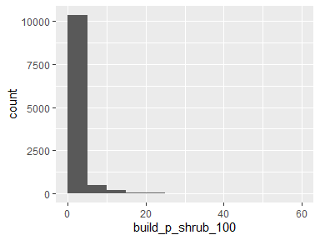

* Note that the following possible outlier values were detected: "13.84", "14.03", "14.04", "14.05", "14.12", "14.15", "14.15", "14.18", "14.18", "14.2" (200 additional values omitted).

## build_p_shrub_200

|  |  |
| --- | --- |
| Feature | Result |
| Variable type | numeric |
| Number of missing obs. | 0 (0 %) |
| Number of unique values | 5926 |
| Median | 0.07 |
| 1st and 3rd quartiles | 0; 3.02 |
| Min. and max. | 0; 66.57 |

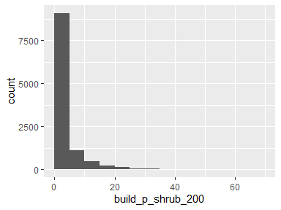

## build_p_shrub_300

|  |  |
| --- | --- |
| Feature | Result |
| Variable type | numeric |
| Number of missing obs. | 0 (0 %) |
| Number of unique values | 7399 |
| Median | 0.91 |
| 1st and 3rd quartiles | 0; 5.79 |
| Min. and max. | 0; 64.28 |

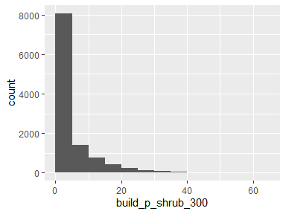

## build_area

|  |  |
| --- | --- |
| Feature | Result |
| Variable type | numeric |
| Number of missing obs. | 0 (0 %) |
| Number of unique values | 11134 |
| Median | 2267.17 |
| 1st and 3rd quartiles | 998.83; 3552.82 |
| Min. and max. | 0; 115867.77 |

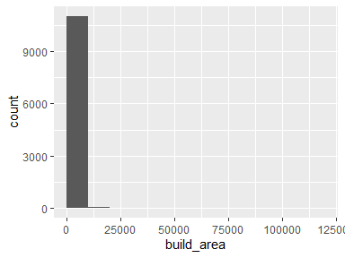

* Note that the following possible outlier values were detected: "9121.41", "9190.92", "9200.73", "9263.26", "9275.18", "9279.45", "9285.05", "9303.99", "9312.87", "9326.77" (174 additional values omitted).

## parcel_UseType

|  |  |
| --- | --- |
| Feature | Result |
| Variable type | character |
| Number of missing obs. | 25 (0.22 %) |
| Number of unique values | 8 |
| Mode | “Residential” |

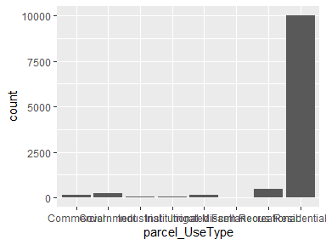

## parcel_UseDescription

|  |  |
| --- | --- |
| Feature | Result |
| Variable type | character |
| Number of missing obs. | 25 (0.22 %) |
| Number of unique values | 43 |
| Mode | “Single” |

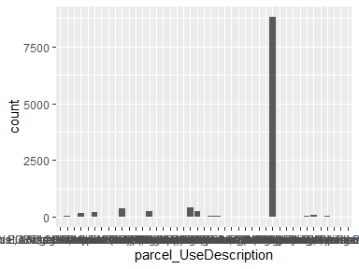

* Note that the following levels have at most five observations: "Auto, Recreation EQPT, Construction EQPT, Sales & Service", "Fruit & Nuts", "Hotel & Motels", "Irrigated Farm", "Lgt Manf.Sm. EQPT. Manuf Sm.Shps Instr.Manuf. Prnt Plnts", "Nurseries or Greenhouses", "Professional Buildings", "Restaurants, Cocktail Lounges", "Supermarkets", "Water Recreation".

## parcel_Roll_ImpValue

|  |  |
| --- | --- |
| Feature | Result |
| Variable type | numeric |
| Number of missing obs. | 371 (3.32 %) |
| Number of unique values | 5506 |
| Median | 318311 |
| 1st and 3rd quartiles | 155404.25; 816736 |
| Min. and max. | 0; 63350373 |

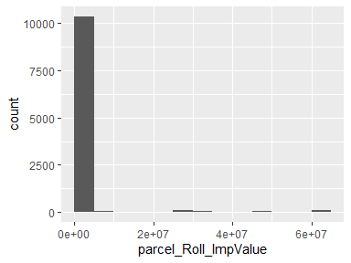

* Note that the following possible outlier values were detected: "0", "100", "126", "132", "137", "206", "387", "585", "595", "1105" (167 additional values omitted).

## parcel_Roll_HomeOwnersExemp

* Note that this variable is treated as a factor variable below, as it only takes a few unique values.

|  |  |
| --- | --- |
| Feature | Result |
| Variable type | numeric |
| Number of missing obs. | 371 (3.32 %) |
| Number of unique values | 3 |
| Mode | “0” |
| Reference category | 0 |

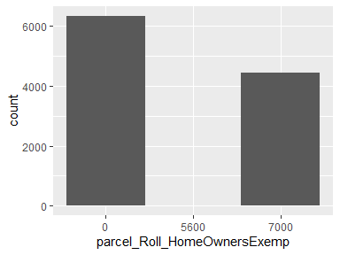

## parcel_Can_P

|  |  |
| --- | --- |
| Feature | Result |
| Variable type | numeric |
| Number of missing obs. | 0 (0 %) |
| Number of unique values | 6216 |
| Median | 27.89 |
| 1st and 3rd quartiles | 16.53; 39.84 |
| Min. and max. | 0; 100 |

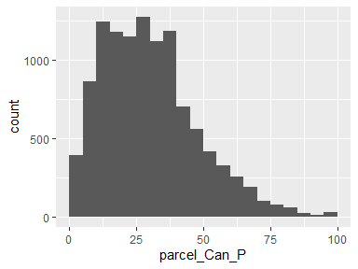

* Note that the following possible outlier values were detected: "85.93", "86.04", "86.06", "86.36", "86.55", "86.65", "86.74", "87.65", "87.76", "87.83" (33 additional values omitted).

## parcel_Grass_P

|  |  |
| --- | --- |
| Feature | Result |
| Variable type | numeric |
| Number of missing obs. | 0 (0 %) |
| Number of unique values | 6169 |
| Median | 14.2 |
| 1st and 3rd quartiles | 8.06; 22.91 |
| Min. and max. | 0; 63.72 |

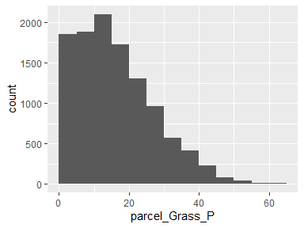

* Note that the following possible outlier values were detected: "63.26", "63.52", "63.72".

## parcel_Soil_P

|  |  |
| --- | --- |
| Feature | Result |
| Variable type | numeric |
| Number of missing obs. | 0 (0 %) |
| Number of unique values | 5885 |
| Median | 15.85 |
| 1st and 3rd quartiles | 6.58; 32.6 |
| Min. and max. | 0; 96.59 |

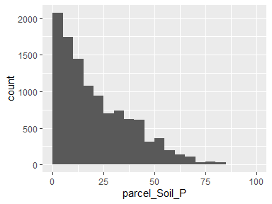

## parcel_Water_P

|  |  |
| --- | --- |
| Feature | Result |
| Variable type | numeric |
| Number of missing obs. | 0 (0 %) |
| Number of unique values | 38 |
| Median | 0 |
| 1st and 3rd quartiles | 0; 0 |
| Min. and max. | 0; 87.09 |

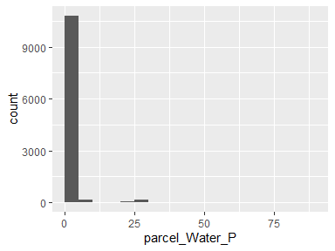

* Note that the following possible outlier values were detected: "0", "0.01", "0.03", "0.07", "0.19", "0.2", "0.23", "0.24", "0.24", "0.26" (27 additional values omitted).

## parcel_Build_P

|  |  |
| --- | --- |
| Feature | Result |
| Variable type | numeric |
| Number of missing obs. | 0 (0 %) |
| Number of unique values | 6186 |
| Median | 12.77 |
| 1st and 3rd quartiles | 4.86; 25.83 |
| Min. and max. | 0; 100 |

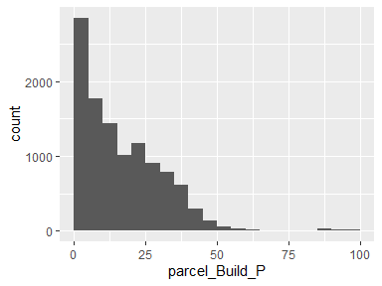

## parcel_Road_P

|  |  |
| --- | --- |
| Feature | Result |
| Variable type | numeric |
| Number of missing obs. | 0 (0 %) |
| Number of unique values | 2194 |
| Median | 0 |
| 1st and 3rd quartiles | 0; 2.62 |
| Min. and max. | 0; 32.21 |

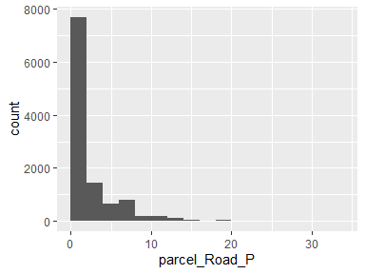

## parcel_Paved_P

|  |  |
| --- | --- |
| Feature | Result |
| Variable type | numeric |
| Number of missing obs. | 0 (0 %) |
| Number of unique values | 5367 |
| Median | 6.34 |
| 1st and 3rd quartiles | 1.98; 12.95 |
| Min. and max. | 0; 69.33 |

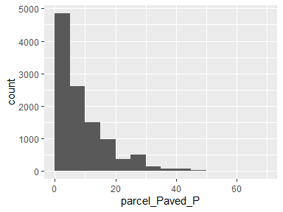

* Note that the following possible outlier values were detected: "49.34", "49.63", "49.85", "50.11", "50.59", "50.99", "52.11", "52.37", "52.39", "52.99" (22 additional values omitted).

## parcel_Shrub_P

|  |  |
| --- | --- |
| Feature | Result |
| Variable type | numeric |
| Number of missing obs. | 0 (0 %) |
| Number of unique values | 1723 |
| Median | 0 |
| 1st and 3rd quartiles | 0; 3.82 |
| Min. and max. | 0; 74.81 |

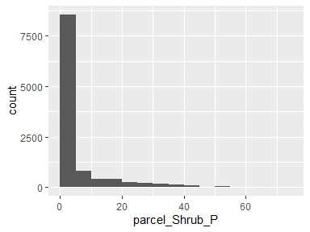

## parcel_Perv_P

|  |  |
| --- | --- |
| Feature | Result |
| Variable type | numeric |
| Number of missing obs. | 0 (0 %) |
| Number of unique values | 6239 |
| Median | 74.69 |
| 1st and 3rd quartiles | 60.09; 88.78 |
| Min. and max. | 0; 100 |

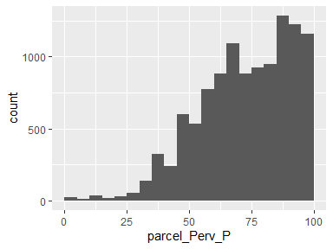

* Note that the following possible outlier values were detected: "0", "0.71", "0.91", "1.19", "1.64", "1.72", "1.76", "2.11", "2.8", "3.01" (3 additional values omitted).

## parcel_Imperv_P

|  |  |
| --- | --- |
| Feature | Result |
| Variable type | numeric |
| Number of missing obs. | 0 (0 %) |
| Number of unique values | 6239 |
| Median | 25.31 |
| 1st and 3rd quartiles | 11.22; 39.91 |
| Min. and max. | 0; 100 |

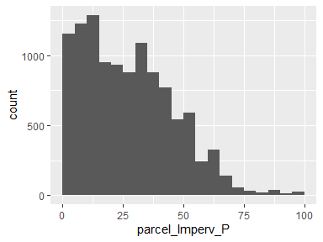

* Note that the following possible outlier values were detected: "96.03", "96.47", "96.79", "96.99", "97.2", "97.89", "98.24", "98.28", "98.36", "98.81" (3 additional values omitted).

## parcel_year_built

|  |  |
| --- | --- |
| Feature | Result |
| Variable type | numeric |
| Number of missing obs. | 1012 (9.05 %) |
| Number of unique values | 94 |
| Median | 1981 |
| 1st and 3rd quartiles | 1970; 1990 |
| Min. and max. | 0; 2015 |

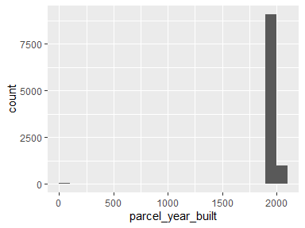

* Note that the following possible outlier values were detected: "0", "1907", "1923", "1924", "1925", "1926", "1928", "1929", "1930", "1931" (8 additional values omitted).

## parcel_area

|  |  |
| --- | --- |
| Feature | Result |
| Variable type | numeric |
| Number of missing obs. | 0 (0 %) |
| Number of unique values | 6406 |
| Median | 48728.31 |
| 1st and 3rd quartiles | 15110.89; 260847.14 |
| Min. and max. | 830.39; 65882419.74 |

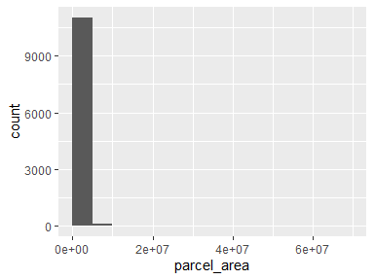

* Note that the following possible outlier values were detected: "4487445.51", "4742700.78", "4876361.44", "4941275.61", "5074257.67", "5167371.46", "5206496.02", "5232169.14", "5255859.63", "5572907.02" (11 additional values omitted).

## build_EXTERIORSI

|  |  |
| --- | --- |
| Feature | Result |
| Variable type | character |
| Number of missing obs. | 10020 (89.62 %) |
| Number of unique values | 2 |
| Mode | “Ignition Resistant” |

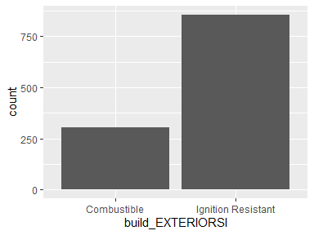

## build_FENCEATTAC

|  |  |
| --- | --- |
| Feature | Result |
| Variable type | character |
| Number of missing obs. | 10107 (90.39 %) |
| Number of unique values | 3 |
| Mode | “No Fence” |

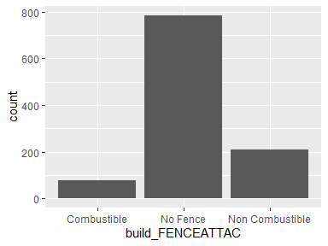

## build_DECKPORCHO

|  |  |
| --- | --- |
| Feature | Result |
| Variable type | character |
| Number of missing obs. | 10194 (91.17 %) |
| Number of unique values | 4 |
| Mode | “No Deck/Porch” |

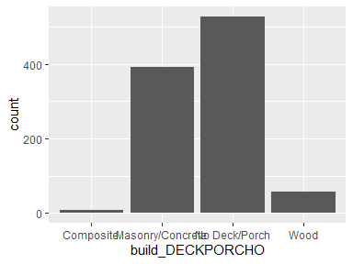

## build_DECKPORCHE

|  |  |
| --- | --- |
| Feature | Result |
| Variable type | character |
| Number of missing obs. | 10336 (92.44 %) |
| Number of unique values | 4 |
| Mode | “No Deck/Porch” |

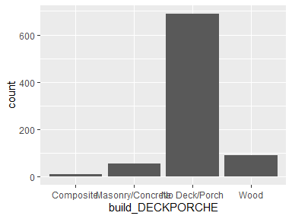

## build_ROOFCONSTR

|  |  |
| --- | --- |
| Feature | Result |
| Variable type | character |
| Number of missing obs. | 10077 (90.13 %) |
| Number of unique values | 6 |
| Mode | “Asphalt” |

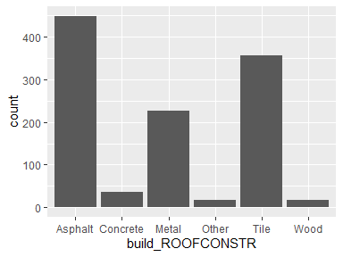

## build_PATIOCOVER

|  |  |
| --- | --- |
| Feature | Result |
| Variable type | character |
| Number of missing obs. | 10203 (91.25 %) |
| Number of unique values | 3 |
| Mode | “No Patio Cover/Carport” |

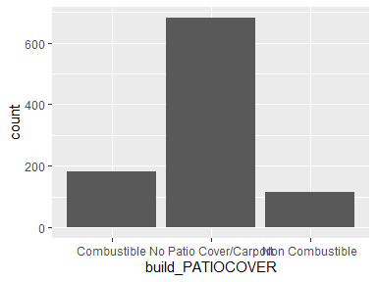

## build_PROPANETAN

|  |  |
| --- | --- |
| Feature | Result |
| Variable type | character |
| Number of missing obs. | 10890 (97.4 %) |
| Number of unique values | 4 |
| Mode | “4.>30” |

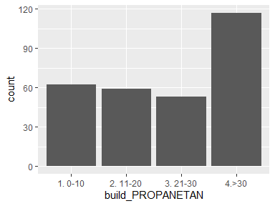

## build_WINDOWPANE

|  |  |
| --- | --- |
| Feature | Result |
| Variable type | character |
| Number of missing obs. | 10586 (94.68 %) |
| Number of unique values | 3 |
| Mode | “Multi Pane” |

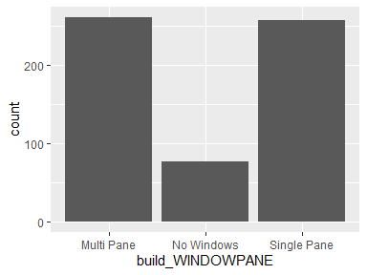

## build_VEGCLEARAN

|  |  |
| --- | --- |
| Feature | Result |
| Variable type | character |
| Number of missing obs. | 10003 (89.46 %) |
| Number of unique values | 3 |
| Mode | “1. 0-30” |

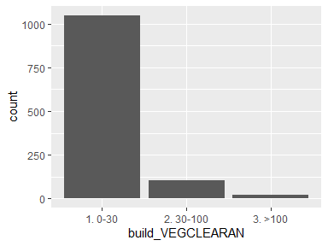

## build_EAVES

|  |  |
| --- | --- |
| Feature | Result |
| Variable type | character |
| Number of missing obs. | 10676 (95.48 %) |
| Number of unique values | 3 |
| Mode | “No Eaves” |

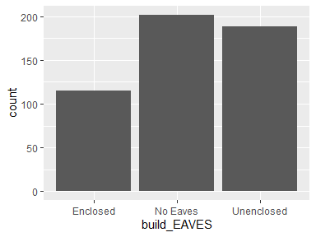

## build_VENTSCREEN

|  |  |
| --- | --- |
| Feature | Result |
| Variable type | character |
| Number of missing obs. | 10745 (96.1 %) |
| Number of unique values | 4 |
| Mode | “No Vents” |

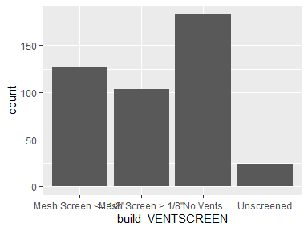

## build_DINS

* The variable only takes one (non-missing) value: "1". The variable contains 86.28 % missing observations.

Report generation information:

* Created by: mmockrin (username: mhmockrin).
* Report creation time: Thu Dec 02 2021 12:34:57
* Report was run from directory: C:/Users/mhmockrin/Box/_Workspace/Proj_GitHub/la_wui_2112
* dataMaid v1.4.0 [Pkg: 2019-12-10 from CRAN (R 4.0.5)]
* R version 4.0.5 (2021-03-31).
* Platform: x86_64-w64-mingw32/x64 (64-bit)(Windows 10 x64 (build 18363)).
* Function call: makeDataReport(data = build, file = paste0(getwd(), "/output_data/dataMaid_", gsub("[[:punct:]]", "_", Sys.time()), ".Rmd"))