Software Design Document (SDD)

Project Name:
Olist Executive Performance Dashboard
Prepared By:
Dhruv Kashyap
Business Analyst
Reviewed By:
Jack Danger
Data Analyst
Joey Tribbiani
Business Intelligence Developer
Approved By:
Rafael Costa
Business Stakeholder
Version:
1.0
Date:
26 July 2026
Status:
Draft

2. Document Control

2.1 Document Information
Field | Details
Document Title | Software Design Document (SDD)
Project Name | Olist Executive Performance Dashboard
Document Type | Technical Design Documentation
Version | 1.0
Status | Draft
Prepared By | Dhruv Kashyap (Business Analyst)
Reviewed By | Jack Danger (Data Analyst), Joey Tribbiani (Business Intelligence Developer)
Approved By | Rafael Costa (Business Stakeholder)
Created On | 26 July 2026
Last Updated | 29 August 2026

2.2 Version History
Version | Date | Author | Description
1.0 | 26 Jul 2026 | Dhruv Kashyap | Initial version of the Software Design Document.

2.3 Review & Approval

Name | Role | Responsibility | Status
Dhruv Kashyap | Business Analyst | Prepared | ✓
Jack Danger | Data Analyst | Reviewed | ✓
Joey Tribbiani | Business Intelligence Developer | Reviewed | ✓
Rafael Costa | Business Stakeholder | Approved | ✓

3. Table of Contents
Software Design Document (SDD) 1
Project Name: Olist Executive Performance Dashboard 1
2. Document Control 1
2.1 Document Information 1
2.2 Version History 2
2.3 Review & Approval 2
3. Table of Contents 2
4. Introduction 6
4.1 Purpose 6
4.2 Scope 6
4.3 Intended Audience 7
4.4 References 7
5. Business Intelligence Solution Development Workflow 7
5.1 Overview 8
5.2 Workflow Description 8
5.3 Roles and Responsibilities 9
5.4 Development Methodology 9
6. Solution Architecture 9
6.1 Overview 10
6.2 Architecture Layers 10
6.3 Data Flow 11
6.4 Design Considerations 11
6.5 Technologies Used 12
Why this architecture? 12
7. System Context Diagram 12
7.1 Overview 13
7.2 System Boundary 13
7.3 External Entities 13
7.4 Data Flows 13
7.5 Context Diagram Explanation 14
Key Design Considerations 14
8. Level-1 Data Flow Diagram (DFD) 14
8.1 Overview 15
8.2 Process Description 15
8.3 Data Store 16
8.4 External Entities 16
8.5 Data Flow Description 16
8.6 Data Processing Workflow 17
8.7 Design Considerations 17
9. Entity Relationship Diagram (ERD) 18
9.1 Overview 19
9.2 Purpose 20
9.3 Entity Description 20
9.4 Primary Keys 20
9.5 Entity Relationships 21
9.6 Relationship Summary 21
9.7 Design Considerations 22
9.8 Role in the BI Solution 22
10. Hybrid Fact Constellation (Galaxy) Schema 22
10.1 Overview 25
10.2 Purpose 25
10.3 Fact Tables 26
10.3.1 Fact_Orders 26
Table Structure 26
Attributes 26
10.3.2 Fact_OrderItems 27
Attributes 27
10.3.3 Fact_OrderPayment 27
Attributes 27
10.3.4 Fact_OrderReviews 28
Attributes 28
10.4 Dimension Tables 28
10.5 Dimension Descriptions 29
Dim_Calendar 29
Dim_Customer 30
Dim_Product 30
Dim_Seller 30
Dim_Category 31
Dim_Geography 31
10.6 Relationships 31
10.7 Fact Table Grain 32
10.8 Surrogate Keys 32
10.9 Design Decisions 33
10.10 Benefits 34
10.11 Transition to ETL Development 34
11. Source-to-Target Mapping (STM) 34
11.1 Overview 34
11.2 Purpose 34
11.3 Mapping Standards 35
11.4 Transformation Categories 35
11.5 ETL Business Rules 35
11.6 Source-to-Target Mapping Tables 36
11.6.1 Dim_Customer 36
11.6.2 Dim_Geography 37
11.6.3 Dim_Product 37
11.6.4 Dim_Category 38
11.6.5 Dim_Seller 38
11.6.6 Fact_Orders 38
11.6.7 Fact_OrderItems 39
11.6.8 Fact_OrderPayment 39
11.6.9 Fact_OrderReviews 40
11.6.10 Dim_Calendar 40
11.7 Data Validation Considerations 41
11.8 Benefits of Source-to-Target Mapping 41
12. Technical Design Standards 42
12.1 Overview 42
12.2 Naming Conventions 42
12.3 Dimensional Modelling Standards 43
12.4 Surrogate Key Standards 43
12.5 ETL Standards 43
12.6 Power BI Modelling Standards 44
12.7 Data Quality Standards 44
12.8 Performance Standards 45
12.9 Maintainability Standards 45
12.10 Documentation Standards 46
12.11 Summary 46
13. Technology Stack 46
13.1 Overview 46
13.2 Technology Stack 47
13.3 Technology Selection Rationale 47
14. Design Assumptions & Decisions 48
14.1 Overview 48
14.2 Design Assumptions 48
14.3 Design Decisions 48
14.4 Project Limitations 49
14.5 Future Enhancements 49
14.6 Summary 50
15. Conclusion 50
15.1 Conclusion 50
15.2 Document Completion 50
Appendix 51
Appendix A – Glossary of Terms 51
A.1 Overview 51
A.2 Glossary 51
Appendix B – Acronyms 54
B.1 Overview 54
B.2 Acronyms 54

4. Introduction

4.1 Purpose
The purpose of this Software Design Document (SDD) is to define the technical architecture, data models, and implementation design for the Olist Executive Performance Dashboard. The document serves as the primary technical reference for developing the Business Intelligence solution, describing how data will be extracted, transformed, modelled, and presented through interactive dashboards. It provides sufficient technical detail to support SQL ETL development, Power BI implementation, and future system maintenance.

4.2 Scope
This document covers the complete technical design of the Olist Executive Performance Dashboard solution. It includes the overall solution architecture, system context, data flow, operational database structure, dimensional data warehouse model, source-to-target mapping, technical design standards, and technology stack. The document does not cover business requirements, project planning, or dashboard user guides, as these are documented separately within the Business Requirements Document (BRD) and other project documentation.

4.3 Intended Audience
Audience | Purpose
Business Analyst | Understand and maintain the technical design documentation.
Data Analyst | Validate data structures, business rules, and reporting requirements.
Business Intelligence Developer | Implement the data warehouse, ETL processes, and Power BI semantic model.
Business Stakeholder | Review the proposed technical solution and confirm alignment with business objectives.

4.4 References
Document | Description
Business Requirements Document (BRD) | Defines the business objectives, functional requirements, and reporting requirements for the project.
Olist Brazilian E-Commerce Dataset | Source dataset used to develop the data warehouse and analytical model.
Jira Project | Project management tool used to manage sprint planning, user stories, and development tasks.
Confluence Workspace | Central repository for project documentation and collaboration.

5. Business Intelligence Solution Development Workflow
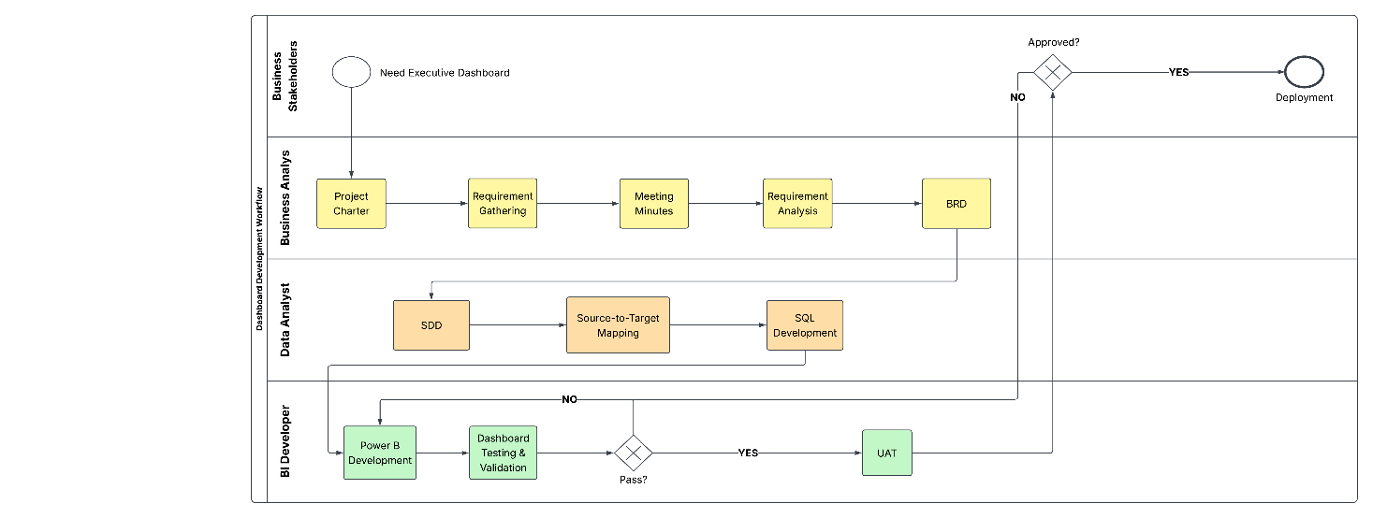

5.1 Overview
The Business Intelligence Solution Development Workflow illustrates the end-to-end process followed to design, develop, validate, and deploy the Olist Executive Performance Dashboard. The workflow defines the responsibilities of each project role and demonstrates how business requirements are transformed into a fully implemented Business Intelligence solution. It provides a structured development lifecycle that ensures traceability between business requirements, technical design, implementation, testing, and deployment.

5.2 Workflow Description
The dashboard development process follows the sequence below:
Phase | Description
Project Initiation | The project begins when business stakeholders identify the need for an executive dashboard to improve business decision-making.
Business Analysis | The Business Analyst prepares the Project Charter, conducts requirement gathering sessions, documents meeting minutes, performs requirement analysis, and develops the Business Requirements Document (BRD).
Solution Design | Based on the approved business requirements, the technical solution is documented within the Software Design Document (SDD), including architecture, data models, and implementation specifications.
ETL Development | The Data Analyst develops the SQL-based ETL processes to transform raw Olist data into a structured dimensional data warehouse.
Dashboard Development | The Business Intelligence Developer imports the prepared data model into Power BI, develops the semantic model, creates DAX measures, and designs interactive dashboard pages.
Testing & Validation | The completed dashboard undergoes functional testing, data validation, KPI verification, and visual validation to ensure the solution meets business and technical requirements.
Stakeholder Review (UAT) | Business stakeholders perform User Acceptance Testing (UAT) to confirm that the dashboard satisfies the agreed business requirements.
Deployment | Upon stakeholder approval, the dashboard is deployed for business use. If issues are identified during testing or review, the solution returns to the relevant development phase for corrections before final approval.

5.3 Roles and Responsibilities
Role | Responsibility
Business Stakeholder | Defines business objectives, reviews deliverables, performs User Acceptance Testing (UAT), and approves the final solution.
Business Analyst | Elicits business requirements, prepares project documentation, and designs the technical solution through the BRD and SDD.
Data Analyst | Develops SQL ETL processes, prepares the dimensional data warehouse, and validates transformed data.
Business Intelligence Developer | Develops the Power BI semantic model, creates DAX measures, builds dashboard reports, and supports testing activities.

5.4 Development Methodology
The project follows an iterative Business Intelligence development methodology, where each phase builds upon the outputs of the previous phase. Business requirements are translated into technical specifications before implementation begins, reducing ambiguity during development. Testing and stakeholder reviews are incorporated prior to deployment to ensure that the delivered dashboard aligns with both business expectations and technical quality standards.

6. Solution Architecture
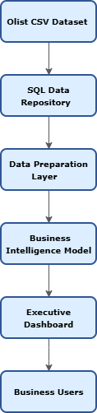

6.1 Overview
The Solution Architecture illustrates the high-level architecture of the Olist Executive Performance Dashboard solution. It describes how raw transactional data is transformed into meaningful business insights through a structured Business Intelligence architecture. The architecture separates data storage, data preparation, analytical modelling, and dashboard presentation into distinct layers to improve scalability, maintainability, and analytical performance.

6.2 Architecture Layers
Layer | Description
Olist CSV Dataset | The source layer containing the raw e-commerce datasets provided by Olist. These datasets include customer, order, product, seller, payment, review, and geolocation information.
SQL Data Repository | The raw datasets are imported into a SQL database, which acts as the central repository for storing source data before transformation.
Data Preparation Layer | SQL ETL processes clean, transform, integrate, and enrich the source data. This layer creates surrogate keys, calculated business attributes, and dimensional tables required for analytical reporting.
Business Intelligence Model | The transformed data is organised into a hybrid dimensional model consisting of fact and dimension tables. This semantic model provides the foundation for analytical reporting within Power BI.
Executive Dashboard | Interactive Power BI dashboards present KPIs, trends, and business insights through visual reports, enabling executives to monitor organisational performance.
Business Users | Executives and business stakeholders consume the dashboard to support strategic and operational decision-making.

6.3 Data Flow
The solution follows a structured data pipeline:
- Raw transactional datasets are imported into the SQL Data Repository.
- SQL ETL processes perform data cleansing, integration, and transformation.
- A dimensional Business Intelligence model is constructed using fact and dimension tables.
- Power BI connects to the semantic model to create interactive dashboards.
- Business users consume the dashboards to monitor organisational performance and make data-driven decisions.

6.4 Design Considerations
The solution architecture was designed based on the following principles:
- Layered Architecture – Separates data storage, transformation, modelling, and presentation into independent layers.
- Single Source of Truth – SQL serves as the central repository for all transformed analytical data.
- Scalability – Additional datasets and dashboards can be incorporated without redesigning the overall architecture.
- Maintainability – ETL logic and business rules are centralised within SQL, reducing duplication.
- Performance – The dimensional model is optimised for fast analytical queries in Power BI.

6.5 Technologies Used
Layer | Technology
Source Data | Olist CSV Dataset
Data Repository | MySQL
ETL & Data Preparation | SQL
Semantic Model | Power BI Data Model
Reporting | Microsoft Power BI
Documentation | Confluence
Project Management | Jira

Why this architecture?
The layered architecture separates operational data from analytical processing, ensuring that business reports are generated from a structured and optimised data model rather than directly from raw transactional data. This approach improves report performance, simplifies maintenance, and provides a scalable foundation for future enhancements.

7. System Context Diagram
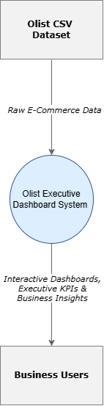

7.1 Overview
The System Context Diagram provides a high-level view of the Olist Executive Performance Dashboard by illustrating the system boundary and its interaction with external entities. It identifies the primary data source, the Business Intelligence system, and the end users who consume the generated analytical insights. Unlike the Solution Architecture, which focuses on the technical layers of the solution, the Context Diagram emphasises how information enters and exits the system.

7.2 System Boundary
The Olist Executive Performance Dashboard acts as the central Business Intelligence system responsible for processing raw e-commerce data and transforming it into interactive dashboards, executive KPIs, and analytical insights. The system receives raw transactional data from the Olist dataset and delivers business information to decision-makers through Power BI dashboards.

7.3 External Entities
External Entity | Description
Olist CSV Dataset | Provides the raw transactional data required to build the Business Intelligence solution. The dataset includes customer, order, product, seller, payment, review, and geolocation information.
Business Users | Executives, managers, and business stakeholders who access the dashboard to monitor organisational performance and support strategic decision-making.

7.4 Data Flows
Data Flow | Description
Raw E-Commerce Data | Raw transactional data imported from the Olist CSV datasets into the Business Intelligence system.
Interactive Dashboards, Executive KPIs & Business Insights | Analytical reports, KPIs, and dashboards generated by the Business Intelligence system and presented to business users.

7.5 Context Diagram Explanation
The Context Diagram illustrates the Olist Executive Performance Dashboard as a single Business Intelligence system positioned between the raw Olist dataset and business users. Raw transactional data enters the system, where it is processed and transformed into meaningful business information. The resulting dashboards and KPIs provide executives with timely, accurate, and interactive insights to support informed decision-making.

Key Design Considerations
The Context Diagram demonstrates the following design principles:
- Single Data Source – All analytical data originates from the Olist CSV datasets.
- Defined System Boundary – The Business Intelligence solution is treated as a single logical system interacting with external entities.
- Clear Information Flow – Data enters as raw transactions and exits as business insights and dashboards.
- User-Centric Design – The system is designed to support business users through meaningful analytical reporting rather than operational transaction processing.

8. Level-1 Data Flow Diagram (DFD)
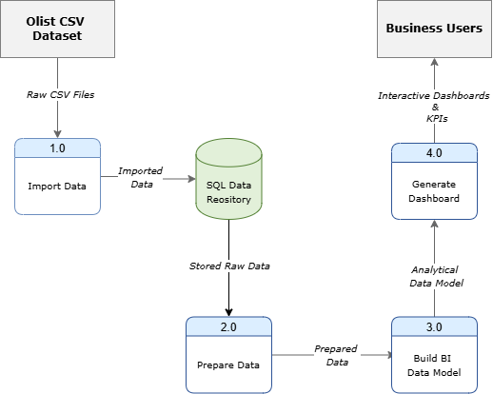

8.1 Overview
The Level-1 Data Flow Diagram (DFD) illustrates the internal flow of data within the Olist Executive Performance Dashboard solution. It decomposes the Business Intelligence system into its major processing components and demonstrates how raw transactional data is imported, transformed, modelled, and ultimately presented through interactive dashboards. The diagram provides a logical representation of the data processing workflow without describing implementation details.

8.2 Process Description
Process | Description
1.0 Import Data | Imports the raw Olist CSV datasets into the SQL Data Repository. This process establishes the initial storage layer for all source data before transformation.
2.0 Prepare Data | Performs data cleansing, validation, integration, and transformation using SQL ETL processes. Business rules, calculated attributes, and surrogate keys are generated during this stage.
3.0 Build BI Data Model | Organises the transformed data into a hybrid dimensional model consisting of fact and dimension tables. Relationships are established to support analytical reporting in Power BI.
4.0 Generate Dashboard | Connects Power BI to the dimensional model, creates DAX measures, develops interactive reports, and produces executive dashboards for business users.

8.3 Data Store
Data Store | Description
SQL Data Repository | Stores the imported raw datasets and the transformed analytical data used to build the Business Intelligence model. It acts as the central repository supporting all downstream analytical processes.

8.4 External Entities
External Entity | Description
Olist CSV Dataset | Supplies the raw e-commerce data to the Business Intelligence system.
Business Users | Access the completed Power BI dashboards to monitor business performance and support decision-making.

8.5 Data Flow Description
Data Flow | Description
Raw Dataset | Raw transactional data imported from the Olist CSV files.
Imported Data | Data stored within the SQL Data Repository after import.
Prepared Data | Cleaned, transformed, and integrated data produced by the ETL process.
Dimensional Model | Fact and dimension tables organised into a hybrid dimensional model for analytical reporting.
Interactive Dashboard | Final Power BI dashboards containing KPIs, visualisations, and business insights presented to users.

8.6 Data Processing Workflow
The Level-1 DFD represents the following logical sequence:
- The Olist CSV datasets are imported into the SQL Data Repository.
- SQL ETL processes clean, validate, and transform the imported data.
- The transformed data is organised into a hybrid dimensional model consisting of fact and dimension tables.
- Power BI connects to the dimensional model and generates interactive dashboards.
- Business users access the dashboards to analyse organisational performance and support business decisions.

8.7 Design Considerations
The Level-1 DFD has been designed using the following principles:
- Logical Process Separation – Each stage of data processing performs a distinct responsibility within the Business Intelligence solution.
- Centralised Data Repository – SQL acts as the single source of truth for both imported and transformed data.
- Sequential Data Processing – Data flows through clearly defined stages, ensuring consistency and traceability.
- Scalable Design – Additional ETL processes or reporting requirements can be incorporated without affecting the overall workflow.
- Analytical Focus – The final output of the system is designed to support business intelligence and executive reporting rather than operational transaction processing.

9. Entity Relationship Diagram (ERD)
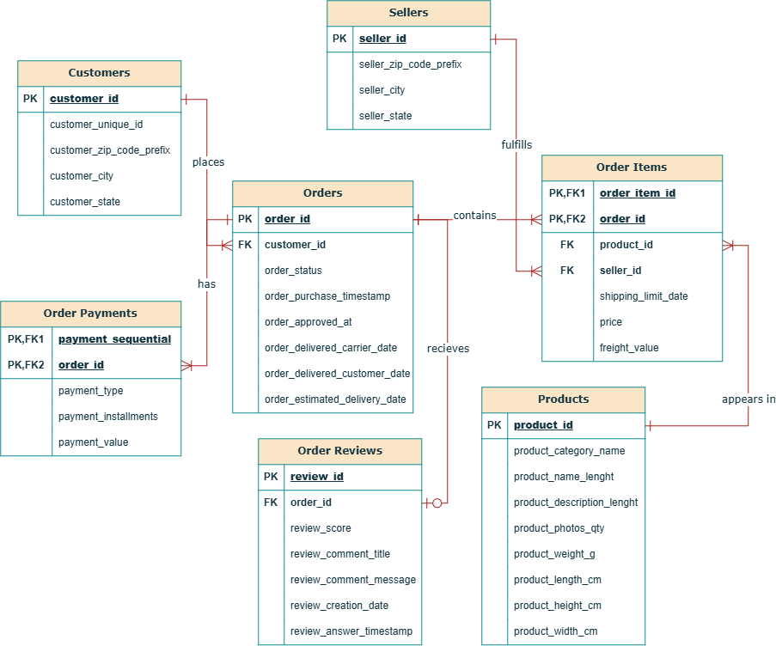

9.1 Overview
The Entity Relationship Diagram (ERD) represents the logical structure of the Olist e-commerce dataset used in the Olist Executive Performance Dashboard project. It identifies the primary business entities, their key attributes, and the relationships between them. The ERD serves as the foundation for understanding the operational data model before the data is transformed into a dimensional Business Intelligence model.

9.2 Purpose
The purpose of the ERD is to document the relationships between the source tables and provide a clear understanding of how business data is organised within the operational database. This logical model supports data integration, ETL development, and the design of the dimensional warehouse used for reporting.

9.3 Entity Description
Entity | Description
Customers | Stores customer identification and location information for each customer.
Orders | Contains order-level information including order status and important order lifecycle timestamps.
Order Items | Stores details of each product purchased within an order, including seller, price, and freight value.
Products | Contains product attributes such as category, dimensions, weight, and photo count.
Sellers | Stores seller identification and geographical information.
Order Payments | Contains payment information including payment type, number of instalments, and payment amount.
Order Reviews | Stores customer review scores and review submission dates for completed orders.

9.4 Primary Keys
Entity | Primary Key
Customers | customer_id
Orders | order_id
Products | product_id
Sellers | seller_id
Order Reviews | review_id
Order Items | (order_id, order_item_id) (Composite Primary Key)
Order Payments | (order_id, payment_sequential) (Composite Primary Key)

9.5 Entity Relationships
Relationship | Cardinality | Description
Customers → Orders | One-to-Many | A customer can place multiple orders, while each order belongs to one customer.
Orders → Order Items | One-to-Many | An order can contain multiple products.
Products → Order Items | One-to-Many | A product can appear in multiple order items.
Sellers → Order Items | One-to-Many | A seller can sell multiple products across different orders.
Orders → Order Payments | One-to-Many | An order may contain one or more payment transactions.
Orders → Order Reviews | One-to-One | Each completed order may receive a single customer review.

9.6 Relationship Summary
The operational data model follows a normalised relational database structure.
Key relationship characteristics include:
- Customer information is separated from order information.
- Orders act as the central business transaction.
- Order Items resolve the many-to-many relationship between orders and products.
- Sellers are linked through Order Items, representing the fulfilment of purchased products.
- Payments and Reviews extend the order lifecycle by storing transactional and customer feedback information.
This design reduces data redundancy while maintaining referential integrity between related entities.

9.7 Design Considerations
The Entity Relationship Diagram has been designed based on the following principles:
- Normalised Structure – Business entities are stored in separate tables to minimise data duplication.
- Referential Integrity – Primary and foreign key relationships maintain consistency across related entities.
- Transaction-Centred Design – Orders serve as the core transactional entity connecting customers, products, sellers, payments, and reviews.
- Scalability – The relational structure supports efficient storage and future expansion of operational data.

9.8 Role in the BI Solution
The ERD represents the operational source model and forms the basis for the ETL process. During data preparation, information from these normalised tables is extracted, transformed, and reorganised into a hybrid dimensional model optimised for analytical reporting. While the ERD focuses on transactional relationships, the dimensional model presented in the next section is specifically designed to improve reporting performance and simplify business analysis.

10. Hybrid Fact Constellation (Galaxy) Schema

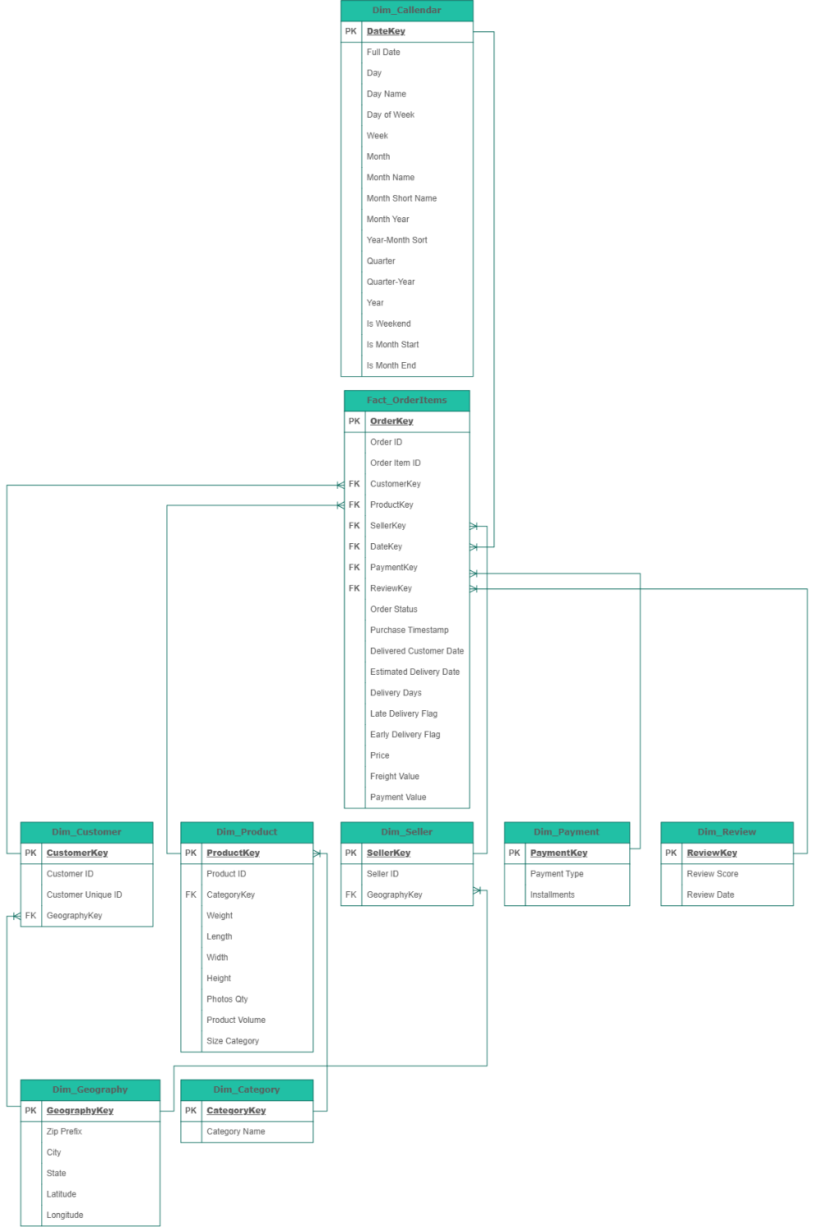

10.1 Overview
The Hybrid Fact Constellation Schema represents the analytical data model developed for the Olist Executive Performance Dashboard. Unlike the normalised operational database presented in the Entity Relationship Diagram (ERD), this dimensional model is designed specifically for Business Intelligence and analytical reporting.
The model consists of multiple fact tables that represent different business processes and shared dimension tables that provide common analytical context. Selected dimensions are further normalised into related tables where this improves consistency and maintainability.
The model therefore combines characteristics of a Fact Constellation (Galaxy) Schema with snowflaked dimensions.
The four fact tables represent the following business processes:
- Fact_Orders — order-level and delivery events
- Fact_OrderItems — product-level sales transactions
- Fact_OrderPayment — payment transactions
- Fact_OrderReviews — customer review events
Shared dimensions provide analytical context across these business processes.

10.2 Purpose
The purpose of the Hybrid Fact Constellation Schema is to organise transformed business data into a structure that supports efficient analytical queries, simplifies Power BI report development, and prevents incorrect aggregations caused by combining business events with different levels of detail.
The dimensional model enables business users to analyse organisational performance across multiple perspectives including:
- Sales
- Orders
- Customers
- Products
- Sellers
- Geography
- Payments
- Reviews
- Time
Separate fact tables are maintained because each business process has a different grain, ensuring that measures are calculated without unintended row multiplication or double-counting.

10.3 Fact Tables
The analytical model contains four fact tables.

10.3.1 Fact_Orders

Table Structure
Attribute | Description
Table Name | Fact_Orders
Grain | One row per customer order
Primary Key | OrderID
Purpose | Stores order-level and delivery-related business events

Attributes
- Order ID
- Customer Key
- Purchase Date Key
- Order Status
- Purchase Timestamp
- Approved Timestamp
- Carrier Date
- Customer Delivery Date
- Estimated Delivery Date
- Delivery Days
- Early Delivery Flag
- Late Delivery Flag
Fact_Orders is the order-level fact table. It should not be described as the single central fact table because the model contains multiple fact tables.

10.3.2 Fact_OrderItems
Attribute | Description
Table Name | Fact_OrderItems
Grain | One row per product sold within an order
Primary Key | OrderItemKey
Purpose | Stores product-level sales transactions

Attributes
- Order Item Key
- Order ID
- Order Item ID
- Product Key
- Seller Key
- Customer Key
- Shipping Limit Date
- Price
- Freight Value
Fact_OrderItems is the primary sales transaction fact because it contains the lowest-level sales information available in the dataset.

10.3.3 Fact_OrderPayment
Attribute | Description
Table Name | Fact_OrderPayment
Grain | One row per payment associated with an order
Primary Key | PaymentKey
Purpose | Stores payment transactions and payment behaviour

Attributes
- Payment Key
- Order ID
- Payment Sequential
- Payment Type
- Payment Installments
- Payment Value
An order can contain multiple payment records; therefore payment data is maintained separately from order items.

10.3.4 Fact_OrderReviews
Attribute | Description
Table Name | Fact_OrderReviews
Grain | One row per review record
Primary Key | ReviewKey
Purpose | Stores customer review events and satisfaction information

Attributes
- Review Key
- Review Date Key
- Order ID
- Review ID
- Review Score
- Comment Title
- Comment Message
- Review Creation Date
- Review Answer Timestamp
Review data is maintained separately because reviews represent a different business event and have a different grain from orders, order items, and payments.

10.4 Dimension Tables
The dimensional model contains the following dimensions:
Dimension | Purpose
Dim_Calendar | Supports time-based analysis
Dim_Customer | Stores customer identifiers and geography references
Dim_Product | Stores product characteristics and category references
Dim_Seller | Stores seller identifiers and geography references
Dim_Category | Stores Portuguese and English product category names
Dim_Geography | Stores geographic information by ZIP prefix
The Calendar dimension is created in Power BI rather than being stored in the MySQL analytical schema.

10.5 Dimension Descriptions

Dim_Calendar
Created in Power BI to support time intelligence and trend analysis.
Typical attributes include:
- DateKey
- Date
- Day
- Day Name
- Day of Week
- Week
- Month
- Month Name
- Month Short Name
- Month Year
- Year-Month Sort
- Quarter
- Quarter-Year
- Year
- Is Weekend
- Is Month Start
- Is Month End

Dim_Customer
Stores:
- CustomerKey
- Customer_ID
- Customer_Unique_ID
- GeographyKey
The GeographyKey links customers to the shared Dim_Geography dimension.

Dim_Product
Stores:
- ProductKey
- Product_ID
- CategoryKey
- Product Name Length
- Product Description Length
- Weight
- Length
- Width
- Height
- Photos Quantity
- Product Volume
- Size Category

Dim_Seller
Stores:
- SellerKey
- Seller_ID
- GeographyKey

Dim_Category
Stores:
- CategoryKey
- Category_Name_PT
- Category_Name_EN
The dimension contains 74 category records, including the Uncategorized category used for products where the source category is NULL.

Dim_Geography
Stores geographic information at the ZIP-prefix level.
Attributes include:
- GeographyKey
- Zip Prefix
- City
- State
- Latitude
- Longitude
Because the Olist customer and seller tables contain only ZIP-code prefixes rather than complete addresses, the original geolocation data contained multiple records for a single ZIP prefix.
Therefore, the analytical Geography dimension aggregates geolocation records to one record per ZIP prefix. Latitude and longitude are averaged, while city and state are selected consistently from the available records.
This creates a reliable one-to-one lookup from ZIP prefix to GeographyKey.

10.6 Relationships
The model contains the following relationships:
From | To | Relationship
Dim_Category | Dim_Product | One-to-Many
Dim_Geography | Dim_Customer | One-to-Many
Dim_Geography | Dim_Seller | One-to-Many
Dim_Customer | Fact_Orders | One-to-Many
Dim_Customer | Fact_OrderItems | One-to-Many
Dim_Product | Fact_OrderItems | One-to-Many
Dim_Seller | Fact_OrderItems | One-to-Many
Fact_Orders | Fact_OrderItems | One-to-Many
Fact_Orders | Fact_OrderPayment | One-to-Many
Fact_Orders | Fact_OrderReviews | One-to-Many
Dim_Calendar | Fact_Orders | One-to-Many
Dim_Calendar | Fact_OrderReviews | One-to-Many
The Calendar relationships will be implemented in Power BI using:
- Dim_Calendar[DateKey] → Fact_Orders[PurchaseDateKey]
- Dim_Calendar[DateKey] → Fact_OrderReviews[ReviewDateKey]

10.7 Fact Table Grain
The analytical model contains multiple fact-table grains:
Fact Table | Grain
Fact_Orders | One row per customer order
Fact_OrderItems | One row per order item
Fact_OrderPayment | One row per payment
Fact_OrderReviews | One row per review
Clearly defining the grain of each fact table prevents incompatible business events from being combined at the wrong level of detail.
For example, an order may contain multiple order items and multiple payment records. Combining these events into a single fact table could multiply rows and cause incorrect aggregations.

10.8 Surrogate Keys
Surrogate keys are generated for the analytical dimensions and fact tables where applicable.
Table | Key
Dim_Customer | CustomerKey
Dim_Product | ProductKey
Dim_Seller | SellerKey
Dim_Category | CategoryKey
Dim_Geography | GeographyKey
Fact_OrderItems | OrderItemKey
Fact_OrderPayment | PaymentKey
Fact_OrderReviews | ReviewKey
Fact_Orders uses the Olist OrderID as its primary business identifier.
The surrogate keys are generated using MySQL AUTO_INCREMENT during table loading rather than ROW_NUMBER().

10.9 Design Decisions
The following design decisions were adopted:
- A Hybrid Fact Constellation (Galaxy) Schema was selected because the dataset contains multiple business processes with different grains.
- Separate fact tables were created for orders, order items, payments, and reviews to prevent row multiplication and incorrect aggregations.
- Fact_OrderItems is treated as the primary sales transaction fact, while Fact_Orders provides order-level and delivery analysis.
- A shared Geography dimension is used by both customers and sellers.
- Category is separated from Product to avoid repeated category descriptions.
- Geography is snowflaked from Customer and Seller to provide a consistent geographic reference.
- A Calendar dimension is created in Power BI to support time intelligence.
- Product Volume and Size Category are calculated during SQL ETL.
- Delivery Days, Early Delivery Flag, and Late Delivery Flag are calculated during SQL ETL.
- Surrogate keys are generated using AUTO_INCREMENT.
- SQL foreign-key constraints enforce referential integrity within the MySQL analytical schema.

10.10 Benefits
The Hybrid Fact Constellation Schema provides:
- Accurate aggregation across different business processes
- Prevention of double-counting
- Reusable dimensions
- Consistent customer, seller, product, category and geographic analysis
- Efficient Power BI modelling
- Clear separation of business processes
- Easier DAX development
- Better scalability for future analytical requirements

10.11 Transition to ETL Development
The Hybrid Fact Constellation(Galaxy) Schema serves as the target analytical model for the ETL process. During data preparation, information from the normalised operational database is transformed, enriched, and loaded into this dimensional structure. The following section documents the Source-to-Target Mapping, which specifies how each attribute in the dimensional model is derived from the original Olist source data.

11. Source-to-Target Mapping (STM)

11.1 Overview
The Source-to-Target Mapping (STM) defines how data from the Olist operational dataset is transformed into the dimensional model used by the Olist Executive Performance Dashboard. It documents the relationship between source attributes and their corresponding target attributes, including the transformation logic and business rules applied during the Extract, Transform, and Load (ETL) process.
The STM serves as the technical specification for SQL ETL development and provides complete traceability between the source system and the analytical data warehouse.

11.2 Purpose
The Source-to-Target Mapping serves the following purposes:
- Documents the origin of every attribute within the dimensional model.
- Defines the transformation logic applied during the ETL process.
- Ensures consistency between the operational source data and the analytical warehouse.
- Supports ETL development, testing, and maintenance.
- Provides end-to-end traceability from the source dataset to the Power BI dashboards.

11.3 Mapping Standards
Each mapping table contains the following information.
Column | Description
Target Column | Attribute created within the target table.
Source Table | Original source table containing the data.
Source Column | Original source attribute used during transformation.
Transformation Logic | SQL logic or business rule applied during ETL.

11.4 Transformation Categories
Transformation Type | Description
Direct Mapping | Source value is copied directly into the target table without modification.
Lookup Transformation | Value is retrieved from another dimension table using a lookup operation.
Calculated Field | New attribute created using mathematical calculations or SQL expressions.
Generated Field | Attribute generated during ETL, such as surrogate keys or calendar values.
Derived Field | Attribute generated using conditional business logic (e.g., CASE statements).

11.5 ETL Business Rules
The following business rules are applied during data transformation.
Target Attribute | Business Rule
Delivery Days | Calculated using the difference between purchase date and customer delivery date
Late Delivery Flag | Set to 1 when actual delivery occurs after estimated delivery
Early Delivery Flag | Set to 1 when actual delivery occurs before estimated delivery
Product Volume | Calculated as Length × Width × Height
Size Category | Derived from Product Volume using predefined size ranges
CategoryKey | Retrieved from Dim_Category using the product category
GeographyKey | Retrieved from Dim_Geography using ZIP prefix
ReviewDateKey | Generated from Review Creation Date in YYYYMMDD format
PurchaseDateKey | Generated from Purchase Timestamp in YYYYMMDD format
Surrogate Keys | Generated using MySQL AUTO_INCREMENT
Geography Coordinates | Latitude and longitude aggregated to one record per ZIP prefix
Missing Product Category | Products with NULL category are assigned to Uncategorized

11.6 Source-to-Target Mapping Tables
Note: Due to the size of the dimensional model, the Source-to-Target Mapping is organised by target table. Each mapping table documents the corresponding source fields and transformation logic applied during the ETL process.

11.6.1 Dim_Customer
Target Column | Source Table | Source Column | Transformation Logic
CustomerKey | Customers | customer_id | ROW_NUMBER() (Surrogate Key)
Customer ID | Customers | customer_id | Direct Mapping
Customer Unique ID | Customers | customer_unique_id | Direct Mapping
GeographyKey | Dim_Geography | GeographyKey | Lookup using ZIP Prefix

11.6.2 Dim_Geography
Target Column | Source | Transformation
GeographyKey | Geolocation | AUTO_INCREMENT
Zip_Prefix | Geolocation | Group by ZIP prefix
City | Geolocation | Consistent city selection using aggregation
State | Geolocation | Consistent state selection using aggregation
Latitude | Geolocation | Average latitude per ZIP prefix
Longitude | Geolocation | Average longitude per ZIP prefix

11.6.3 Dim_Product
Target Column | Source | Transformation
ProductKey | Products | AUTO_INCREMENT
Product_ID | Products | Direct mapping
CategoryKey | Dim_Category | Lookup
Product_Name_Length | Products | Direct mapping
Product_Description_Length | Products | Direct mapping
Weight_G | Products | Direct mapping
Length_CM | Products | Direct mapping
Width_CM | Products | Direct mapping
Height_CM | Products | Direct mapping
Photos_Qty | Products | Direct mapping
Product_Volume | Products | Length × Width × Height
Size_Category | Products | CASE expression based on volume

11.6.4 Dim_Category
Target Column | Source | Transformation
CategoryKey | Product Category Translation | AUTO_INCREMENT
Category_Name_PT | Product Category Translation | Direct mapping
Category_Name_EN | Product Category Translation | Direct mapping

11.6.5 Dim_Seller
Target Column | Source | Transformation
SellerKey | Sellers | AUTO_INCREMENT
Seller_ID | Sellers | Direct mapping
GeographyKey | Dim_Geography | Lookup using ZIP prefix

11.6.6 Fact_Orders
Target Column | Source | Transformation
OrderID | Orders | Direct mapping
CustomerKey | Dim_Customer | Lookup using Customer ID
PurchaseDateKey | Orders | Derived from Purchase Timestamp as YYYYMMDD
Order_Status | Orders | Direct mapping
Purchase_Timestamp | Orders | Direct mapping
Approved_Timestamp | Orders | Direct mapping
Carrier_Date | Orders | Direct mapping
Customer_Delivery_Date | Orders | Direct mapping
Estimated_Delivery_Date | Orders | Direct mapping
Delivery_Days | Orders | DATEDIFF
Early_Delivery_Flag | Orders | CASE expression
Late_Delivery_Flag | Orders | CASE expression

11.6.7 Fact_OrderItems
Target Column | Source | Transformation
OrderItemKey | Order Items | AUTO_INCREMENT
Order_ID | Order Items | Direct mapping
Order_Item_ID | Order Items | Direct mapping
ProductKey | Dim_Product | Lookup
SellerKey | Dim_Seller | Lookup
CustomerKey | Dim_Customer | Lookup
Shipping_Limit_Date | Order Items | Direct mapping
Price | Order Items | Direct mapping
Freight_Value | Order Items | Direct mapping

11.6.8 Fact_OrderPayment
Target Column | Source | Transformation
PaymentKey | Order Payments | AUTO_INCREMENT
Order_ID | Order Payments | Direct mapping
Payment_Sequential | Order Payments | Direct mapping
Payment_Type | Order Payments | Direct mapping
Payment_Installments | Order Payments | Direct mapping
Payment_Value | Order Payments | Direct mapping

11.6.9 Fact_OrderReviews
Target Column | Source | Transformation
ReviewKey | Order Reviews | AUTO_INCREMENT
ReviewDateKey | Order Reviews | Derived from Review Creation Date as YYYYMMDD
Order_ID | Order Reviews | Direct mapping
Review_ID | Order Reviews | Direct mapping
Review_Score | Order Reviews | Direct mapping
Comment_Title | Order Reviews | Trim and Clean
Comment_Message | Order Reviews | Trim and Clean
Review_Creation_Date | Order Reviews | Direct mapping
Review_Answer_Timestamp | Order Reviews | Direct mapping

11.6.10 Dim_Calendar
Target Column | Source | Transformation
DateKey | Generated in Power BI | YYYYMMDD
Date | Generated | Calendar date
Day | Date | DAY
Day Name | Date | Day name
Day of Week | Date | Day number
Week | Date | Week number
Month | Date | Month number
Month Name | Date | Month name
Month Short Name | Date | Short month name
Month Year | Date | MMM YYYY
Year-Month Sort | Date | YYYYMM
Quarter | Date | Quarter
Quarter-Year | Date | Qn YYYY
Year | Date | Year
Is Weekend | Date | Conditional logic
Is Month Start | Date | Conditional logic
Is Month End | Date | Conditional logic

11.7 Data Validation Considerations
The following validation activities should be performed after the ETL process has been completed to ensure data quality and consistency.
Validation Check | Purpose
Fact Grain Validation | Confirm each fact table contains the intended level of detail
Fact-to-Fact Integrity | Confirm order IDs in Items, Payments and Reviews exist in Fact_Orders
Geography Uniqueness | Confirm one Geography record exists per ZIP prefix
Category Completeness | Confirm NULL product categories map to Uncategorized
Date Key Validation | Confirm PurchaseDateKey and ReviewDateKey contain valid YYYYMMDD values
NULL Handling Validation | Confirm legitimate missing dates remain NULL rather than being replaced with artificial values

11.8 Benefits of Source-to-Target Mapping
Maintaining a comprehensive Source-to-Target Mapping document provides a clear reference for ETL development and future maintenance. It ensures complete traceability between the operational source data and the analytical warehouse while documenting the business rules and transformation logic applied during data preparation. The mapping also supports testing, troubleshooting, and future enhancements by providing a single source of truth for all data transformations.

The Source-to-Target Mapping defines how data is transformed from the operational dataset into the analytical model. The next section documents the technical design standards adopted throughout the solution, including naming conventions, modelling principles, key generation strategies, and development guidelines to ensure consistency across the Business Intelligence implementation.

12. Technical Design Standards

12.1 Overview
The Technical Design Standards define the design principles, development conventions, and implementation guidelines adopted for the Olist Executive Performance Dashboard. These standards promote consistency, maintainability, scalability, and data integrity throughout the Business Intelligence solution. Adhering to these standards ensures that the data warehouse, ETL processes, and Power BI reports follow a uniform structure and can be efficiently maintained and extended in the future.

12.2 Naming Conventions
The following naming conventions have been adopted throughout the solution to ensure consistency and readability.
Component | Naming Standard | Example
Fact Tables | Prefix with Fact_ | Fact_OrderItems
Dimension Tables | Prefix with Dim_ | Dim_Product
Primary Keys | <Entity>Key | ProductKey
Foreign Keys | <Entity>Key | CustomerKey
Measures | Pascal Case | Total Revenue
Calculated Columns | Pascal Case | Delivery Days
Flags | Descriptive Name ending with "Flag" | Late Delivery Flag

12.3 Dimensional Modelling Standards
The dimensional model has been designed using the following standards:
- A Hybrid Fact Constellation (Galaxy) Schema is used to optimise analytical performance while reducing data redundancy.
- The model contains multiple fact tables representing separate business processes. Fact_OrderItems serves as the primary sales transaction fact, while Fact_Orders provides order-level and delivery analysis.
- The grain of the fact table is defined as one product sold by one seller within a single customer order.
- All dimensions are connected through one-to-many relationships.
- Category and Geography are implemented as snowflaked dimensions to improve maintainability.
- Calendar dimension is generated within Power BI to support time intelligence and date-based analysis.
- Relationships are designed to support efficient filtering and aggregation within Power BI.

12.4 Surrogate Key Standards
To simplify relationships and improve query performance, surrogate keys are implemented across all dimension tables.
Standard | Description
Key Generation | Generated using AUTO_INCREMENT during ETL.
Key Usage | Used as the primary key for all dimension tables.
Relationship Management | Fact table references dimensions using surrogate keys rather than operational identifiers.
Business Visibility | Surrogate keys are used internally and are not exposed in dashboard reports.

12.5 ETL Standards
The ETL process follows the standards below to ensure reliable and consistent data transformation.
Standard | Description
Data Cleansing | Remove invalid and duplicate records where applicable.
Null Handling | Handle missing values using predefined business rules.
Data Type Standardisation | Ensure consistent data types across all tables.
Lookup Operations | Populate foreign keys using dimension table lookups.
Business Rules | Apply calculations such as Delivery Days, Product Volume, and delivery status flags during ETL.
Derived Attributes | Generate calculated fields before loading data into the dimensional model.

12.6 Power BI Modelling Standards
The Power BI semantic model has been designed using the following standards.
Standard | Description
Data Model | Built using a hybrid dimensional model.
Relationships | One-to-many relationships with single-direction filtering.
Time Intelligence | Enabled through the Calendar dimension.
Measures | Business calculations implemented using DAX measures where appropriate.
Dashboard Design | Interactive visualisations designed for executive reporting and business analysis.
Performance | Reports optimised by using a dimensional model instead of querying raw transactional data.

12.7 Data Quality Standards
The following standards are applied to maintain data quality throughout the solution.
Standard | Description
Referential Integrity | Ensure all foreign keys reference valid dimension records.
Duplicate Prevention | Prevent duplicate surrogate keys and duplicate business records.
Data Validation | Validate transformed values against source data.
Consistency | Maintain consistent business definitions across reports.
Completeness | Verify that required fields are populated before loading into the warehouse.
Accuracy | Validate calculated fields using predefined business rules.

12.8 Performance Standards
The solution has been designed to support efficient analytical processing and dashboard performance.
Standard | Description
Dimensional Model | Optimised for analytical queries and aggregations.
Lookup Efficiency | Surrogate keys minimise join complexity.
ETL Processing | Business calculations performed during ETL to reduce report complexity.
Data Model | Minimise redundant attributes through selective snowflaking.
Report Performance | Power BI connects to a prepared analytical model rather than raw operational data.

12.9 Maintainability Standards
To support future enhancements and simplify maintenance, the following standards have been adopted.
- Modular ETL processes to simplify future modifications.
- Standardised naming conventions across all database objects.
- Centralised business rules within the ETL process.
- Reusable dimension tables to avoid duplication.
- Comprehensive documentation maintained within Confluence.
- Project tasks and changes tracked using Jira.
- Consistent design principles applied across the entire Business Intelligence solution.

12.10 Documentation Standards
Standard | Description
Documentation Repository | All project documentation is maintained in Confluence.
Version Control | Major document revisions are tracked through the document version history.
Project Tracking | Development tasks, user stories, and sprint activities are managed in Jira.
Traceability | Business requirements are traceable from the BRD through the SDD, Source-to-Target Mapping, ETL implementation, and dashboard development.

12.11 Summary
The Technical Design Standards establish the conventions and best practices followed throughout the Olist Executive Performance Dashboard project. By standardising naming conventions, dimensional modelling, ETL processes, Power BI development, and data quality practices, the solution remains scalable, maintainable, and aligned with Business Intelligence best practices. These standards also provide a consistent foundation for future enhancements and ongoing system maintenance.

13. Technology Stack

13.1 Overview
The Olist Executive Performance Dashboard is developed using a combination of technologies that support data storage, transformation, analytical modelling, reporting, and project documentation. Each technology has been selected based on its suitability for Business Intelligence development, scalability, and ease of integration within the overall solution architecture.

13.2 Technology Stack
Layer | Technology | Purpose
Source Data | Olist Brazilian E-Commerce Dataset (CSV Files) | Provides the raw transactional data used for analysis.
Database Management System | MySQL | Stores the source data and supports ETL processing.
ETL & Data Preparation | SQL | Performs data extraction, cleansing, transformation, enrichment, and loading into the dimensional model.
Data Warehouse | Hybrid Fact Constellation (Galaxy) Schema | Organises transformed data into fact and dimension tables optimised for analytical reporting.
Business Intelligence Tool | Microsoft Power BI | Develops the semantic model, DAX measures, and interactive executive dashboards.
Documentation | Confluence | Maintains project documentation, including the BRD, SDD, meeting minutes, and technical artefacts.
Project Management | Jira | Manages project planning, sprint tracking, epics, user stories, and development tasks.

13.3 Technology Selection Rationale
The selected technology stack provides an integrated environment for Business Intelligence development.
- MySQL offers a reliable relational database platform for storing and transforming the source data.
- SQL enables efficient implementation of ETL processes and business rules.
- Power BI provides interactive visualisations, DAX capabilities, and an optimised semantic model for business reporting.
- Confluence serves as the central repository for project documentation and collaboration.
- Jira supports Agile project management through sprint planning, issue tracking, and workflow management.
Together, these technologies provide a scalable and maintainable foundation for the successful implementation of the Olist Executive Performance Dashboard.

14. Design Assumptions & Decisions

14.1 Overview
This section documents the key assumptions, architectural decisions, and project limitations considered during the design of the Olist Executive Performance Dashboard. These decisions establish the technical foundation of the solution and provide justification for the chosen implementation approach.

14.2 Design Assumptions
The following assumptions were made during the design of the solution:
- The Olist Brazilian E-Commerce Dataset is considered the primary source of business data.
- The dataset is assumed to be sufficiently complete and accurate for analytical reporting after ETL processing.
- Historical data is treated as static and is not expected to change after loading.
- Business users require analytical reporting rather than transactional data entry.
- A Calendar dimension is generated during ETL to support time-based reporting and DAX time intelligence.
- All required business calculations can be implemented using SQL transformations and Power BI measures.

14.3 Design Decisions
The following technical decisions were adopted during solution design.
Design Decision | Justification
Hybrid Fact Constellation Schema | Supports multiple business processes with different grains
Separate fact tables | Prevents row multiplication and incorrect aggregation
Fact_OrderItems as primary sales fact | Provides lowest-level product transaction detail
Fact_Orders as order-level fact | Supports order and delivery analysis
Separate payment fact | Maintains payment-level grain
Separate review fact | Maintains review-level grain
Shared Geography dimension | Provides consistent geographic analysis for customers and sellers
Separate Category dimension | Reduces repeated category descriptions
Calendar in Power BI | Supports time intelligence and flexible reporting
Surrogate keys | Simplifies dimensional relationships
SQL ETL calculations | Centralises repeatable transformation logic

14.4 Project Limitations
The current implementation is subject to the following limitations:
- The dataset does not include product cost information; therefore, actual profit and margin analysis are outside the scope of the project.
- The solution is based on historical data and does not support real-time data ingestion or streaming analytics.
- Inventory management and stock availability are not included in the dataset.
- Customer demographic information beyond geographical location is unavailable.
- The project focuses on analytical reporting and does not include operational transaction processing.

14.5 Future Enhancements
The following enhancements may be considered in future iterations of the solution:
- Implement incremental ETL processing to improve data refresh efficiency.
- Integrate live data sources for near real-time reporting.
- Expand the dashboard with additional executive KPIs and advanced analytics.
- Incorporate predictive analytics and forecasting models.
- Implement Row-Level Security (RLS) within Power BI to restrict data access based on user roles.
- Automate scheduled data refreshes through Power BI Service.

14.6 Summary
The assumptions and design decisions documented in this section provide the rationale behind the technical architecture of the Olist Executive Performance Dashboard. These decisions balance analytical performance, maintainability, and scalability while ensuring that the solution aligns with the business requirements and available source data.

15. Conclusion

15.1 Conclusion
This Software Design Document (SDD) defines the complete technical design for the Olist Executive Performance Dashboard. It documents the solution architecture, data flow, operational and dimensional data models, source-to-target mappings, and technical standards that guide the implementation of the Business Intelligence solution.
The design follows recognised Business Intelligence and data warehousing principles by separating operational data from analytical processing through a structured ETL pipeline and a hybrid dimensional model. This approach ensures that business users can access reliable, consistent, and high-performance analytical reports while maintaining data integrity and scalability.
The completed SDD provides a comprehensive technical reference for SQL ETL development, Power BI dashboard implementation, testing, and future system maintenance. Together with the Business Requirements Document (BRD), it establishes a clear link between business objectives and technical implementation, providing a structured foundation for the successful delivery of the Olist Executive Performance Dashboard.

15.2 Document Completion
Document | Status
Business Requirements Document (BRD) | Completed
Software Design Document (SDD) | Completed
Solution Architecture | Completed
System Context Diagram | Completed
Level-1 Data Flow Diagram | Completed
Entity Relationship Diagram (ERD) | Completed
Hybrid Fact Constellation (Galaxy) Schema | Completed
Source-to-Target Mapping (STM) | Completed
Technical Design Standards | Completed

Appendix

Appendix A – Glossary of Terms

A.1 Overview
This glossary provides definitions of key Business Intelligence, data warehousing, and project management terms used throughout the Software Design Document. It serves as a reference to ensure a common understanding of the technical terminology used within the project.

A.2 Glossary
Term | Definition
Business Intelligence (BI) | A collection of processes, technologies, and tools used to transform raw data into meaningful information that supports business decision-making.
Business Requirements Document (BRD) | A document that defines the business objectives, requirements, scope, and stakeholder expectations for a project.
Software Design Document (SDD) | A technical document describing the architecture, data models, design decisions, and implementation approach of a software or Business Intelligence solution.
Entity Relationship Diagram (ERD) | A logical representation of database entities, their attributes, and the relationships between them.
Data Flow Diagram (DFD) | A diagram illustrating how data moves through a system and the processes that transform it.
Context Diagram | A high-level diagram showing the system boundary, external entities, and the flow of information between them.
Solution Architecture | A high-level representation of the technical components and their interactions within the solution.
Fact Table | The central table within a dimensional model that stores measurable business events or transactions.
Dimension Table | A table containing descriptive attributes that provide context for analysing facts.
Hybrid Fact Constellation (Galaxy) Schema | A dimensional modelling approach containing multiple fact tables that represent different business processes and share common dimension tables, with selected dimensions further normalised where appropriate.
Fact Constellation / Galaxy Schema | A dimensional model containing multiple fact tables that share common dimensions. It is useful when an analytical solution contains multiple business processes with different grains.
Star Schema | A dimensional model consisting of a central fact table surrounded by denormalised dimension tables.
Snowflake Schema | A dimensional model where one or more dimensions are normalised into additional related tables.
Grain | The level of detail represented by each record within a fact table.
Fact Table Grain | The specific level of detail represented by one row in a fact table.
Surrogate Key | A system-generated unique identifier used as the primary key within dimension tables.
Primary Key (PK) | A column or combination of columns that uniquely identifies each record in a table.
Foreign Key (FK) | A column that establishes a relationship between two tables by referencing the primary key of another table.
Extract, Transform, Load (ETL) | The process of extracting data from source systems, transforming it according to business rules, and loading it into a target data warehouse.
Source-to-Target Mapping (STM) | Documentation defining how source data is transformed into target tables and columns during the ETL process.
Data Warehouse | A central repository designed for storing integrated and historical data to support analytical reporting.
Semantic Model | A business-friendly analytical model that defines relationships, measures, and hierarchies for reporting tools such as Power BI.
Data Cleansing | The process of identifying and correcting inaccurate, incomplete, or inconsistent data.
Data Transformation | The process of converting source data into a format suitable for analysis.
Data Validation | The process of verifying that transformed data is complete, accurate, and consistent.
DAX (Data Analysis Expressions) | The formula language used in Microsoft Power BI for creating measures, calculated columns, and calculated tables.
KPI (Key Performance Indicator) | A measurable metric used to evaluate business performance against strategic objectives.
Dashboard | A visual interface that presents key business metrics and insights using charts, tables, and other visualisations.
Time Intelligence | Analytical calculations that evaluate performance across time periods such as days, months, quarters, and years.
User Acceptance Testing (UAT) | The process in which business stakeholders verify that the solution meets the agreed business requirements before deployment.

Appendix B – Acronyms

B.1 Overview
This section lists the abbreviations and acronyms used throughout the Software Design Document to improve readability and maintain consistency in technical communication.

B.2 Acronyms
Acronym | Full Form
BA | Business Analyst
BI | Business Intelligence
BRD | Business Requirements Document
CSV | Comma-Separated Values
DAX | Data Analysis Expressions
DBMS | Database Management System
DFD | Data Flow Diagram
ERD | Entity Relationship Diagram
ETL | Extract, Transform, Load
FK | Foreign Key
KPI | Key Performance Indicator
PK | Primary Key
RLS | Row-Level Security
SDD | Software Design Document
SQL | Structured Query Language
STM | Source-to-Target Mapping
UAT | User Acceptance Testing
UI | User Interface

