

1 Introduction
This individual project combines an interactive Power BI portfolio tracker with AI-written weekly commentary and numerical verification. The final Power BI report has three pages: Stock Overview, My Portfolio, and AI Commentary and Checks. The objective is to study individual stocks, build an equal-allocation portfolio, compare performance with the market index and produce commentary whose quoted figures can be independently checked.

2 Data and methodology
The supplied Excel workbook contains 2,500 stock-price rows for 10 fictional companies and 250 market-index observations, covering 1 April 2025 to 16 March 2026. Prices contains date, ticker, company, sector, closing price in INR and volume. The index sheet contains date and index level. The project uses these inputs only; investment amounts are user assumptions, not additional market data. Checks found no duplicate stock-date keys or missing closing prices, and trading dates align across companies and the index.

3 Stock dashboard
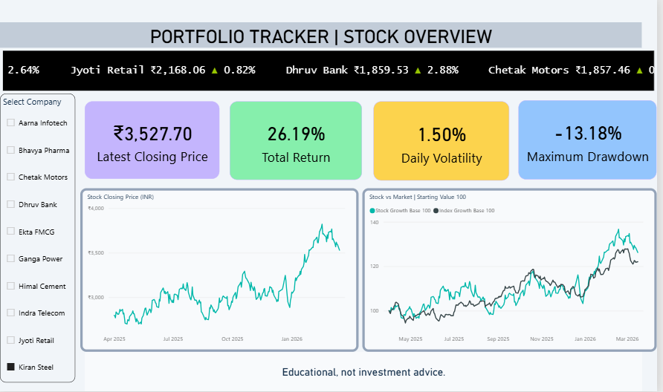
Figure 1 Stock Overview showing Kiran Steel and the all-company price scroller
The company slicer drives latest closing price, total price return, daily volatility and maximum drawdown. A price chart shows the selected stock over time. A second chart compares stock and index growth after setting both starting values to 100. The scroller remains independent of company selection so it can display all ten companies.
Figure 1 shows Kiran Steel at ₹3,527.70: total return 26.19%, daily volatility 1.50% and maximum drawdown −13.18%. Returns exclude dividends and fees. The notice states “Educational, not investment advice.”

4 Portfolio building and performance
The portfolio page lets users select any combination of the ten companies and an initial investment. It divides the initial investment equally among selected stocks and holds the resulting shares unchanged. Fractional shares are allowed. The model does not rebalance daily or include dividends, fees or further cash flows. If no single investment amount is selected, the default is ₹1,00,000.
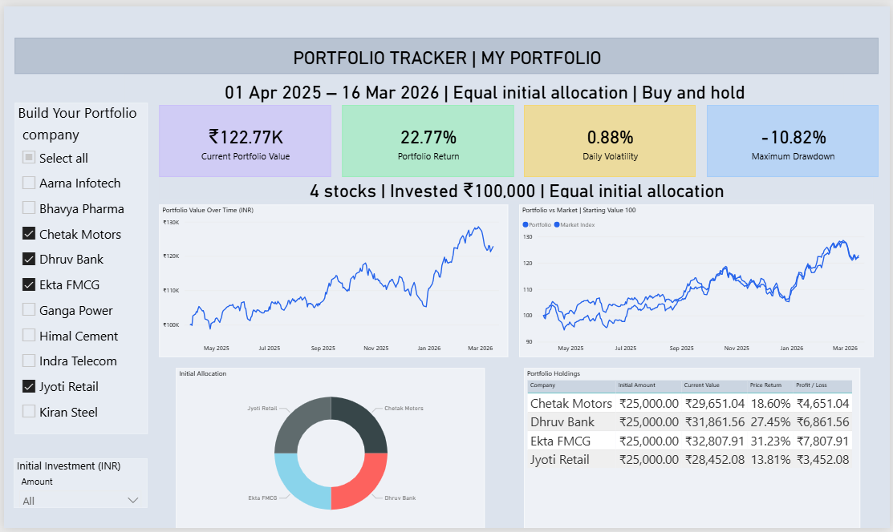
Figure 2 Four-stock portfolio containing Chetak Motors Dhruv Bank Ekta FMCG and Jyoti Retail

Portfolio valuation and risk
Each holding starts with investment divided by the number of selected stocks. Shares equal that allocation divided by the stock’s first closing price. On each trading date, portfolio value is the sum of shares multiplied by closing price. Equivalently, value equals the initial investment multiplied by the average selected-stock price relative. Initial weights are equal, but current weights can drift as prices change.
Measure | Calculation
Total return | Final value ÷ initial investment − 1
Daily return | Current value ÷ previous trading-day value − 1
Daily volatility | Sample standard deviation of portfolio daily returns
Drawdown | Portfolio value ÷ running peak − 1
Maximum drawdown | Most negative drawdown over the period

Each selected company begins with ₹25,000. Final value is ₹1,22,772.60 and profit is ₹22,772.60: return 22.77%, daily volatility 0.88% and maximum drawdown −10.82%. These independent results match Figure 2. The holdings table shows values and profit; the doughnut chart shows initial allocation. Volatility uses portfolio returns, not averaged stock volatilities.

5 AI commentary and verification
ChatGPT wrote 51 historical weekly commentaries for a fixed all-company reference portfolio with ₹1,00,000 invested. The week selector chooses a stored narrative and defaults to the latest observation. Separate company and investment controls drive a clearly labelled calculated summary; this is not a newly generated LLM response.
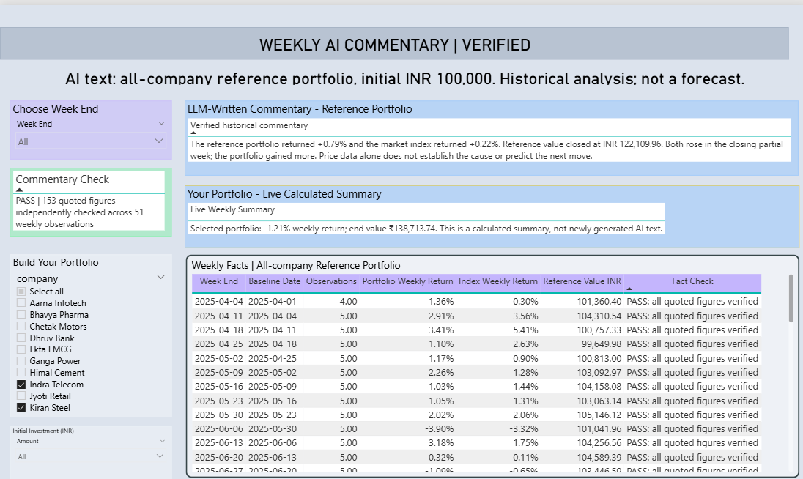
Figure 3 Weekly AI commentary with reference facts and a separate selected-portfolio summary

Numerical fact checking
Each narrative quotes three figures: reference portfolio weekly return, index weekly return and reference ending value. The verification process extracts those figures and compares them with independent calculations from raw workbook prices. That second method uses initial share counts and revalues holdings at the relevant closing prices. All 153 numerical checks pass within 0.005 of the stated unit, consistent with two-decimal rounding. The detailed evidence appears in the Commentary Fact Check workbook sheet and Fact_Check.csv.
Latest reference claim | Independent result | Quoted value | Check
Portfolio weekly return | 0.7942536% | 0.79% | Pass
Index weekly return | 0.2247878% | 0.22% | Pass
Reference value | ₹1,22,109.9618 | ₹1,22,109.96 | Pass

The latest claims cover the partial week ending 16 March 2026. Weekly baselines use the preceding observed week-end, except the first observation, which uses the opening date. Figure 3 separately selects Indra Telecom and Kiran Steel: −1.21% latest weekly return and ending value ₹1,38,713.74. This selected portfolio differs from the AI reference basket.
Commentary describes observed gains, losses and benchmark comparisons without inventing news, causes or forecasts.

6 Results and discussion
Measure | All ten stocks | Four-stock example
Initial investment | ₹1,00,000.00 | ₹1,00,000.00
Final portfolio value | ₹1,22,109.96 | ₹1,22,772.60
Total return | 22.11% | 22.77%
Daily volatility | 0.82% | 0.88%
Maximum drawdown | −9.21% | −10.82%

Recommendation
For this educational comparison, the four-stock portfolio earns around 0.66 percentage points more than the all-company reference but has higher daily volatility and a larger peak-to-trough loss. The market index returns 22.06% over the full period, only about 0.05 percentage points below the all-company portfolio. The small benchmark difference does not establish persistent outperformance. I would use the all-company basket as a comparison baseline and assess smaller selections using return, volatility and drawdown together, rather than choosing solely by final return.

7 AI use and improvement rounds
AI assisted with workbook interpretation, Power BI project generation, calculation design, commentary and verification. Iteration addressed three concrete issues: failing shared portfolio measures, dependency-sensitive helper columns, and report integration. The portfolio valuation was simplified; stock helper values and company/date tables were prepared before import; and the three report pages were merged while preserving their visual designs. The final screenshots provide evidence that the dashboards and selected-portfolio calculations display in Desktop.
The separate AI Use Log is to document at least 15 genuine prompts and checks and three improvement rounds, as required by the brief. It remains to be completed. ChatGPT Plus was used, although the brief requests free tools.

8 Reflection and limitations
AI-generated formulas required testing because model dependencies and field connections could prevent correct calculations from displaying. Independent valuation and screenshot comparisons confirmed the visible results. Clear separation of stored reference commentary and the selected-portfolio summary prevents misleading interpretation.
The fictional dataset covers one historical period. Fractional shares, equal initial allocation and exclusion of fees and dividends simplify the model. Commentary is stored rather than regenerated when holdings change. The tracker remains educational, not investment advice.

9 Conclusion
The project meets its analytical objective by combining stock comparison, interactive portfolio construction and historical AI commentary in three Power BI pages. Independent calculations match the displayed portfolio metrics, and all 153 quoted numerical claims pass verification. The results show a modest return advantage for the four-stock example with greater risk. AI adds readable interpretation, while calculation checks and explicit scope make that interpretation accountable.

Source and submission evidence
Source: supplied T13 workbook and its Task Brief, Prices, Market Index and Data Dictionary. Submission evidence comprises the three-page Power BI file, enhanced workbook, AI Use Log, 51 weekly narratives and 153 fact checks.

