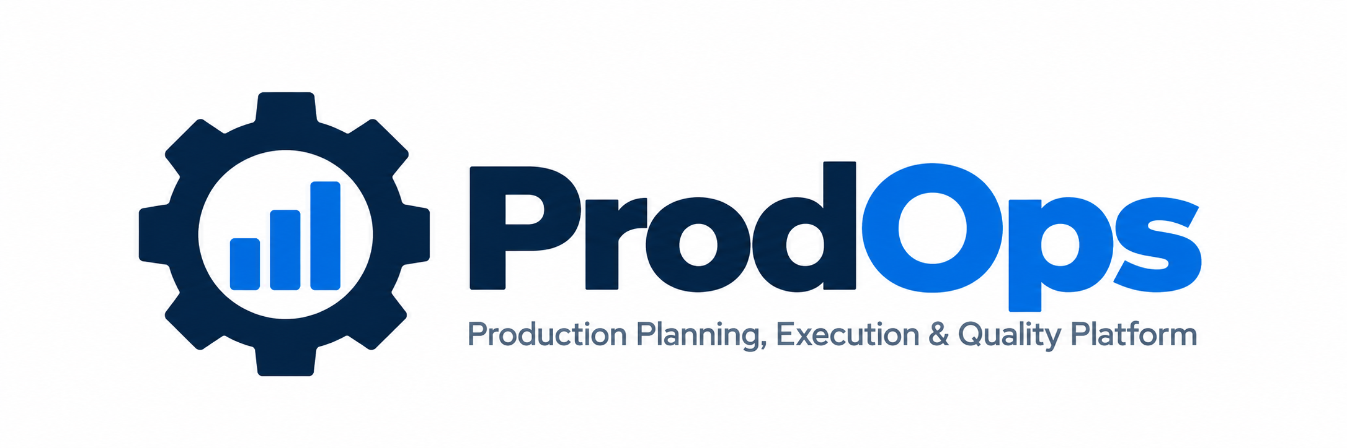

PRODOPS
Production Planning, Execution & Quality Platform
Complete Client-Facing Enterprise Documentation Suite comprising Product Overview, Business Process Guide, Practical User Guide, Role & Module Access Guide, and Visual Feature Guide.
Document Metadata | Specification & Value
Product Name | ProdOps Enterprise Platform
Tagline | Production Planning, Execution & Quality Platform
Developer & Publisher | Abhiyanta India Solutions Pvt. Ltd.
Product Domain | Discrete & Process Manufacturing Operations
Target System Alignment | Designed for SAP S/4HANA-Oriented Production Environments
Target Audience | Plant Leadership, Planners, Operators, Inspectors, Storekeepers
Document Release | Enterprise Edition 2026.1 (Consolidated Master Volume)
Confidentiality | Commercial Client-Facing Documentation

NOTE: Enterprise Synchronization Posture
ProdOps provides a unified operational workspace designed around SAP S/4HANA production processes. It keeps production orders, component availability, operation confirmations, goods movements, and quality inspection lots synchronized with central enterprise data.

Documentation Suite Index & Master Catalog
This consolidated volume gathers the entire official client documentation for ProdOps into an organized reference handbook.
Doc # | Document Title | Primary Audience | Key Focus Area
Doc 01 | Product Overview | Plant Managers, Executives, Decision Makers | Value proposition, manufacturing challenges, business benefits, end-to-end flow
Doc 02 | Business Process Guide | Planners, Process Engineers, Supervisors | Production order lifecycle (CRTD to CLSD), 3-D status architecture, movements, quality gates
Doc 03 | Practical User Guide | Machine Operators, Planners, Storekeepers | Screen-by-screen practical instructions, visual callouts, step-by-step procedures
Doc 04 | Role & Module Guide | Department Heads, System Admins, HR | 8 business personas, role-to-module matrix, cross-functional collaboration
Doc 05 | Feature & Workflow Guide | Operations Leads, CI Teams, Evaluators | Deep-dive visual analysis of 15 core manufacturing workflows with real screenshots

Platform Reader Guidelines
- Executive Briefing: For Executive Review: Read Document 01 (Product Overview) and Document 04 (Role Profiles).
- Process Alignment: For Standard Operating Procedures (SOP): Adopt Document 02 (Business Process Guide).
- Shop-Floor Operations: For Shift Training & Onboarding: Use Document 03 (User Guide) as the primary floor handbook.
- Functional Evaluation: For System Evaluation: Review Document 05 (Feature & Workflow Guide).

Document 01: ProdOps Product Overview

1. Executive Introduction
ProdOps is an enterprise-grade Production Planning, Execution & Quality Platform developed by Abhiyanta India Solutions Pvt. Ltd. Designed to work in concert with SAP S/4HANA production environments, ProdOps provides a unified, intuitive workspace that streamlines the entire production order lifecycle.
By integrating order scheduling, material availability checks, operation confirmations, goods movements, and quality inspections into an accessible operational cockpit, ProdOps empowers cross-functional teams to eliminate operational latency, reduce paperwork, and achieve complete shop-floor transparency.
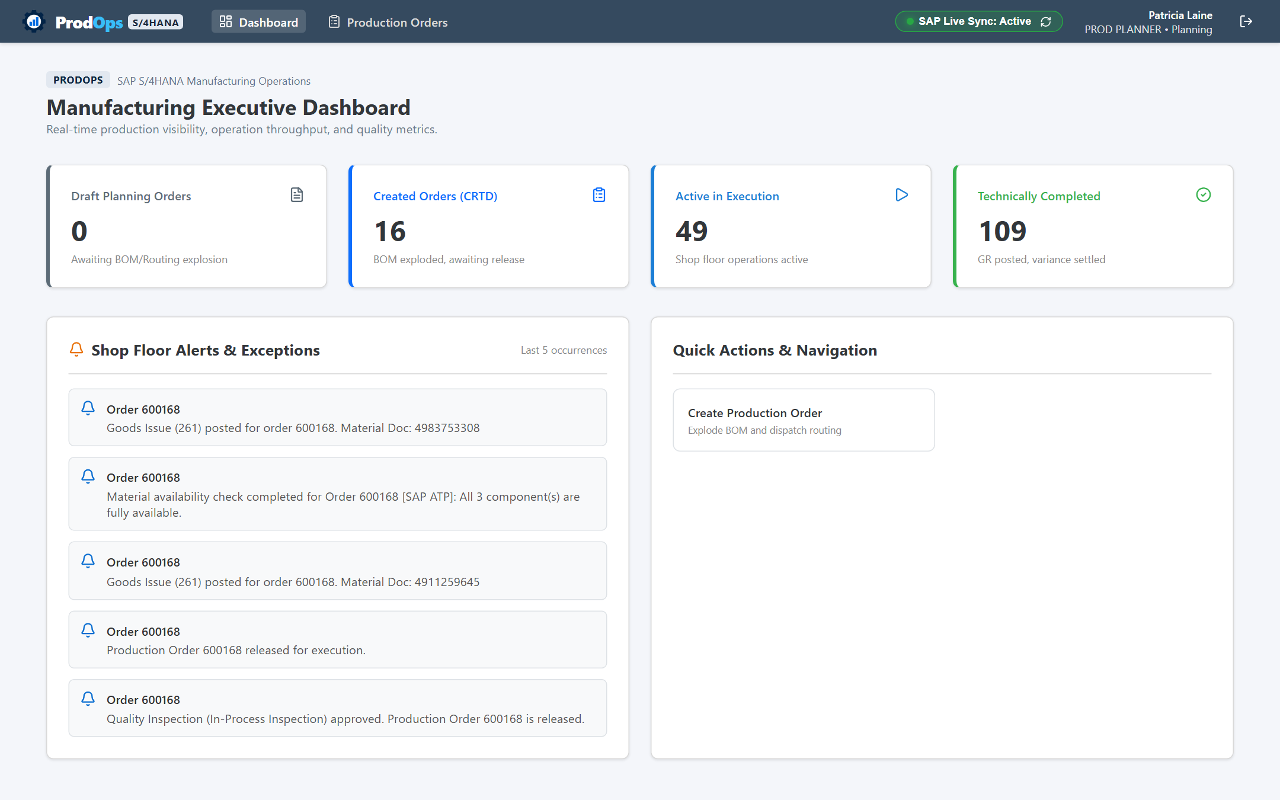
Figure 1.1: ProdOps Executive Operational Dashboard

2. Manufacturing Challenges Addressed
- Information Silos: Disparate Operational Information: Production schedules, component stock, and machine runtimes are scattered across disconnected screens.
- Operational Blind Spots: Limited Shop-Floor Visibility: Supervisors cannot immediately verify if an order is actively running, delayed by material shortages, or awaiting quality sign-off.
- Manual Overhead: Intensive Manual Follow-Up: Production controllers spend hours walking the shop floor, making phone calls, or generating manual shift reports.
- Inventory Disconnect: Material Movement Blind Spots: Delays in issuing components (261) or receiving finished goods (101) cause discrepancies between physical floor stock and recorded balances.
- Quality Latency: Fragmented Quality Gates: Inspection lot approvals operate outside the production flow, causing delays in clearing finished goods for shipment.

3. Key Platform Capabilities
- Order Cockpit: Production Order Monitoring & Search across plants, storage locations, and statuses.
- Order Detail Management: Structured Order Headers covering General, Assignment, Goods Receipt, and Master Data.
- Material Availability Engine: Component Reservations & Availability Checks to identify shortages prior to release.
- Shop-Floor Execution: Operation Confirmations capturing yield, scrap, and actual machine/labor runtimes.
- Inventory Movements: Standardized Goods Movements supporting Movement 261 (Goods Issue) and Movement 101 (Goods Receipt).
- Quality Assurance: Integrated Quality Control supporting In-Process (Type 03) and Post-Production (Type 04) inspections.
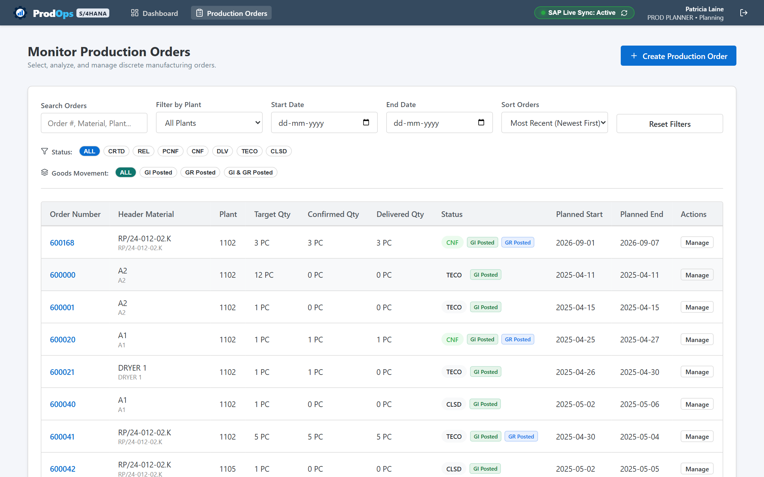
Figure 1.2: Central Production Order Monitor with multi-criteria filtering

4. Measurable Business Benefits
Operational Dimension | Traditional Legacy Operations | With ProdOps Platform
Operational Visibility | Fragmented paper travelers and isolated screens | Unified cockpit with live order, yield, and inventory status
Material Traceability | Delayed consumption postings causing floor stock errors | Immediate goods issue (261) and receipt (101) directly linked to orders
Decision Velocity | Planners rely on end-of-shift reports to catch delays | Immediate visibility into bottlenecks, scrap occurrences, and stalled jobs
Quality Compliance | Disconnected spreadsheets and paper sign-offs | Built-in inspection lots (Type 03/04) with formal usage decisions
User Productivity | Operators navigate complex multi-screen enterprise menus | Streamlined, role-tailored screens focused entirely on user tasks
Data Integrity | High potential for conflicting status overrides | Independent 3-dimension status architecture protecting milestones

Document 02: Business Process Guide

1. Production Order Lifecycle & System Statuses
In discrete manufacturing, a Production Order authorizes the conversion of raw materials into finished marketable goods. ProdOps guides every order through a disciplined chronological status lifecycle:
Status Code | Status Name | Operational Definition & Manufacturing Rules
CRTD | Created | Order is generated with basic dates and target quantity. BOM reservations and routing operations are planned, but floor execution is not yet permitted.
MACA | Material Availability Checked | A formal availability check has evaluated all required components with no shortages detected. Order is cleared for release.
MSPT | Material Shortage | An availability check revealed that one or more components lack stock. Planners must address shortages before line dispatch.
REL | Released | Order is officially released to the plant floor. Component reservations become active for withdrawal, and operations enter operator queues.
PCNF | Partially Confirmed | Shop-floor operators have confirmed partial yield or time against one or more operation steps. Production is underway.
CNF | Confirmed | All planned operations have received final confirmations. Total yield has been fully reported from the shop floor.
TECO | Technically Completed | Physical production is finished. Open reservations are closed, and the order enters financial variance settlement.
CLSD | Closed | The order is financially settled (Actual Costs - Credits = 0) and permanently locked against any further postings.

2. The 3-Dimension Independent Status Architecture
To ensure that physical material movements do not accidentally corrupt milestone progress, ProdOps tracks orders across three independent status dimensions:
- 1. System Operational Status: Tracks overall manufacturing progress: CRTD -> REL -> PCNF -> CNF -> TECO -> CLSD.
- 2. Goods Issue Status: Tracks component withdrawal (NOT_POSTED -> POSTED) via Movement 261 without altering the primary status.
- 3. Goods Receipt Status: Tracks finished product receipt (NOT_POSTED -> POSTED) via Movement 101 into warehouse stock.

3. Standardized Goods Movements & Reversals
Action Code | Transaction Description | Movement Type | Business Purpose & Impact
A07 | Goods Issue | 261 | Issues raw materials from warehouse to the production order. Debits order costs and reduces warehouse stock.
A01 | Goods Receipt | 101 | Receives finished goods into warehouse inventory. Credits order value and increments finished stock.
A03 | Goods Receipt Cancellation | 102 | Reverses an incorrect goods receipt posting. Reopens open order yield balance.
A03 | Goods Issue Cancellation | 262 | Returns unused materials from the shop floor back to warehouse stock. Credits material costs.
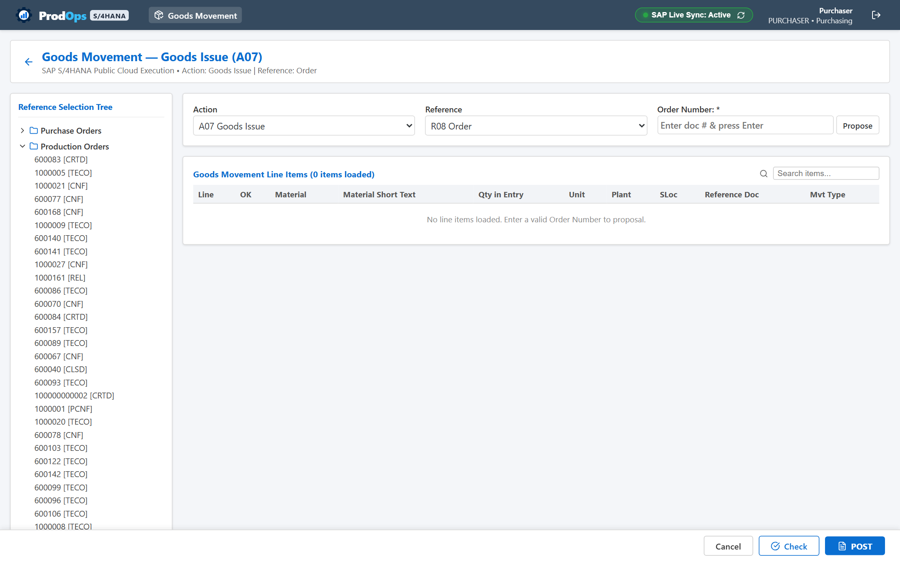
Figure 2.1: Standardized Goods Movement interface configured for Movement 261

Document 03: Practical User Guide
This practical operational handbook provides screen-by-screen instructions for performing daily tasks inside ProdOps.

Screen 1: Accessing ProdOps & User Authentication
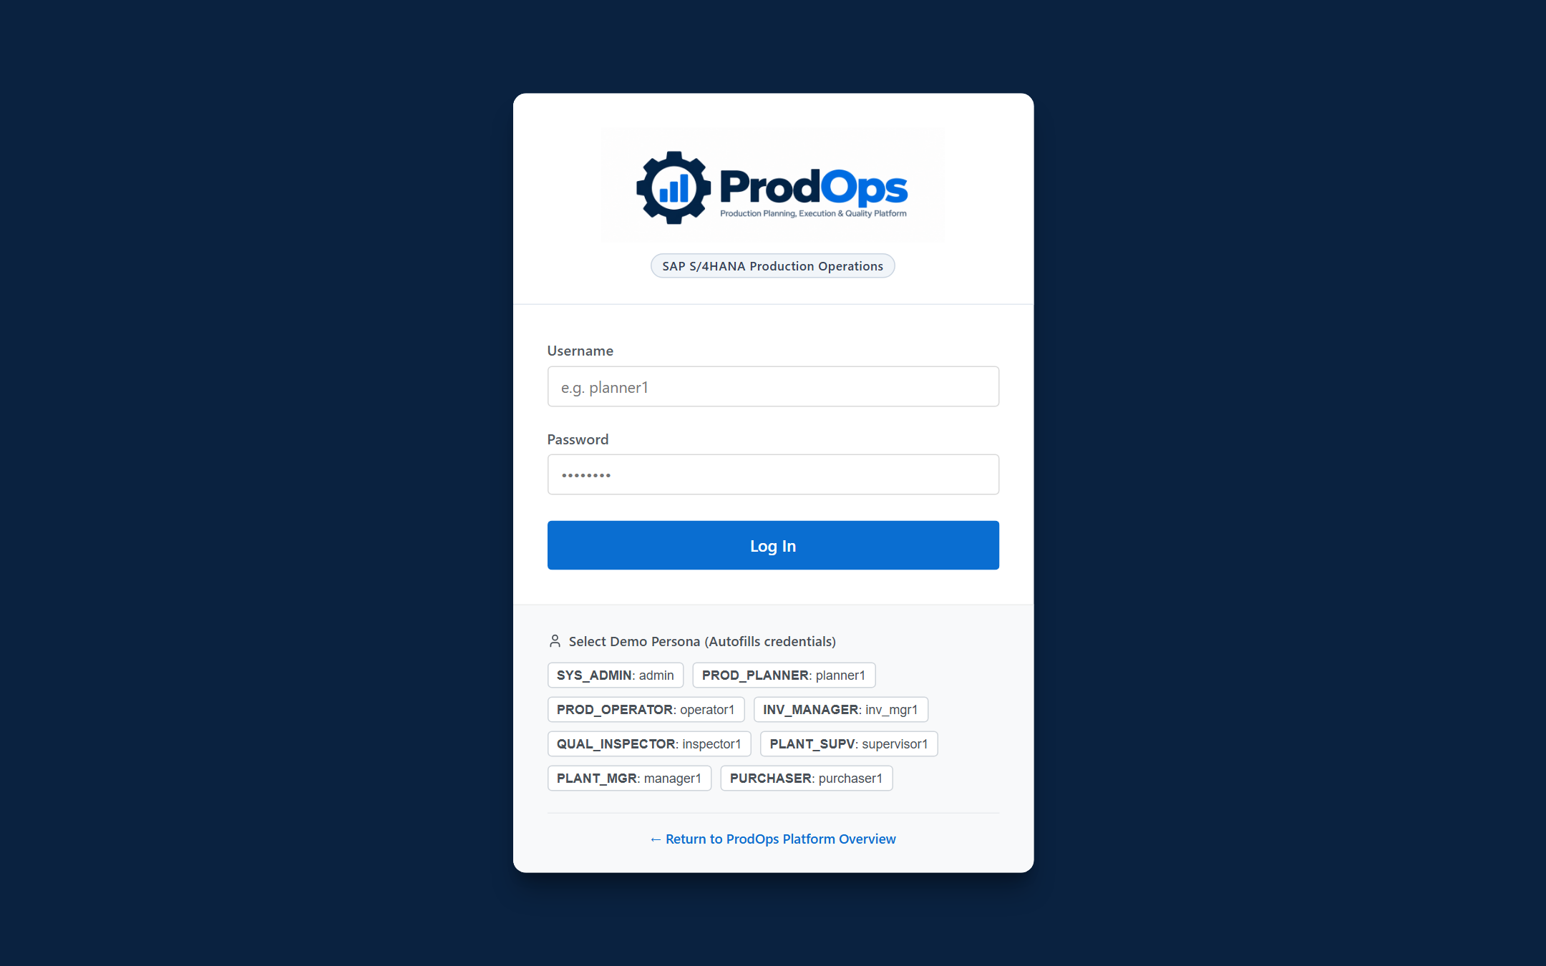
Figure 3.1: ProdOps Sign-In Screen with role-persona selector
What This Screen Does: Authenticates enterprise users and routes them to their personalized workspace.
When to Use It: At the start of every work shift or when switching operational roles.
- 1. Navigate to the ProdOps portal URL.
- 2. Enter your enterprise Username and Password, or click a quick-select persona during evaluation.
- 3. Click Sign In to open your role-tailored dashboard.
Expected Result: User is authenticated and loaded directly into their authorized modules.

Screen 2: Production Order Monitor
Figure 3.2: Production Order Monitor cockpit
What This Screen Does: Central cockpit for filtering, searching, and managing all plant production orders.
When to Use It: To evaluate order progress, inspect unissued materials, or locate orders for release.
- 1. Enter an order number or material name in the Search Bar.
- 2. Apply filters: Status (CRTD, REL, PCNF, CNF), Goods Movement, or Manufacturing Plant.
- 3. Click any Order Number link to open the full order details.
Expected Result: Instant filtering with live status pills and enterprise sync indicators.

Screen 3: Creating a Production Order
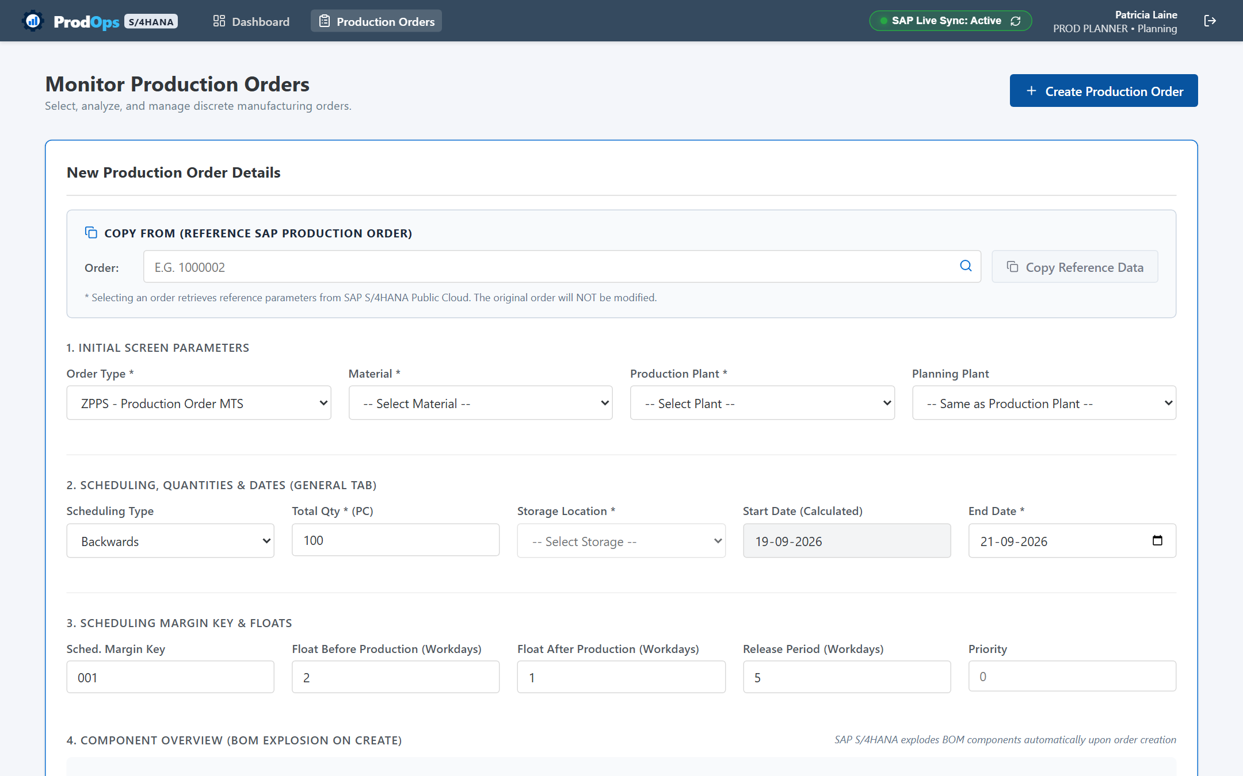
Figure 3.3: Production Order Creation modal
What This Screen Does: Generates a new manufacturing order with automated BOM explosion and routing calculation.
When to Use It: When demand requirements or stock replenishment triggers a new manufacturing batch.
- 1. Click Create Production Order on the monitor toolbar.
- 2. Select the Finished Material, Production Plant, and Target Storage Location.
- 3. Enter Planned Target Quantity and specify Planned Start/Finish dates.
- 4. Configure float margins (before/after production) and click Create Order.
Expected Result: A 10-digit order is generated in status CRTD with active component reservations.

Screen 4: Order Detail & SAP Action Toolbar
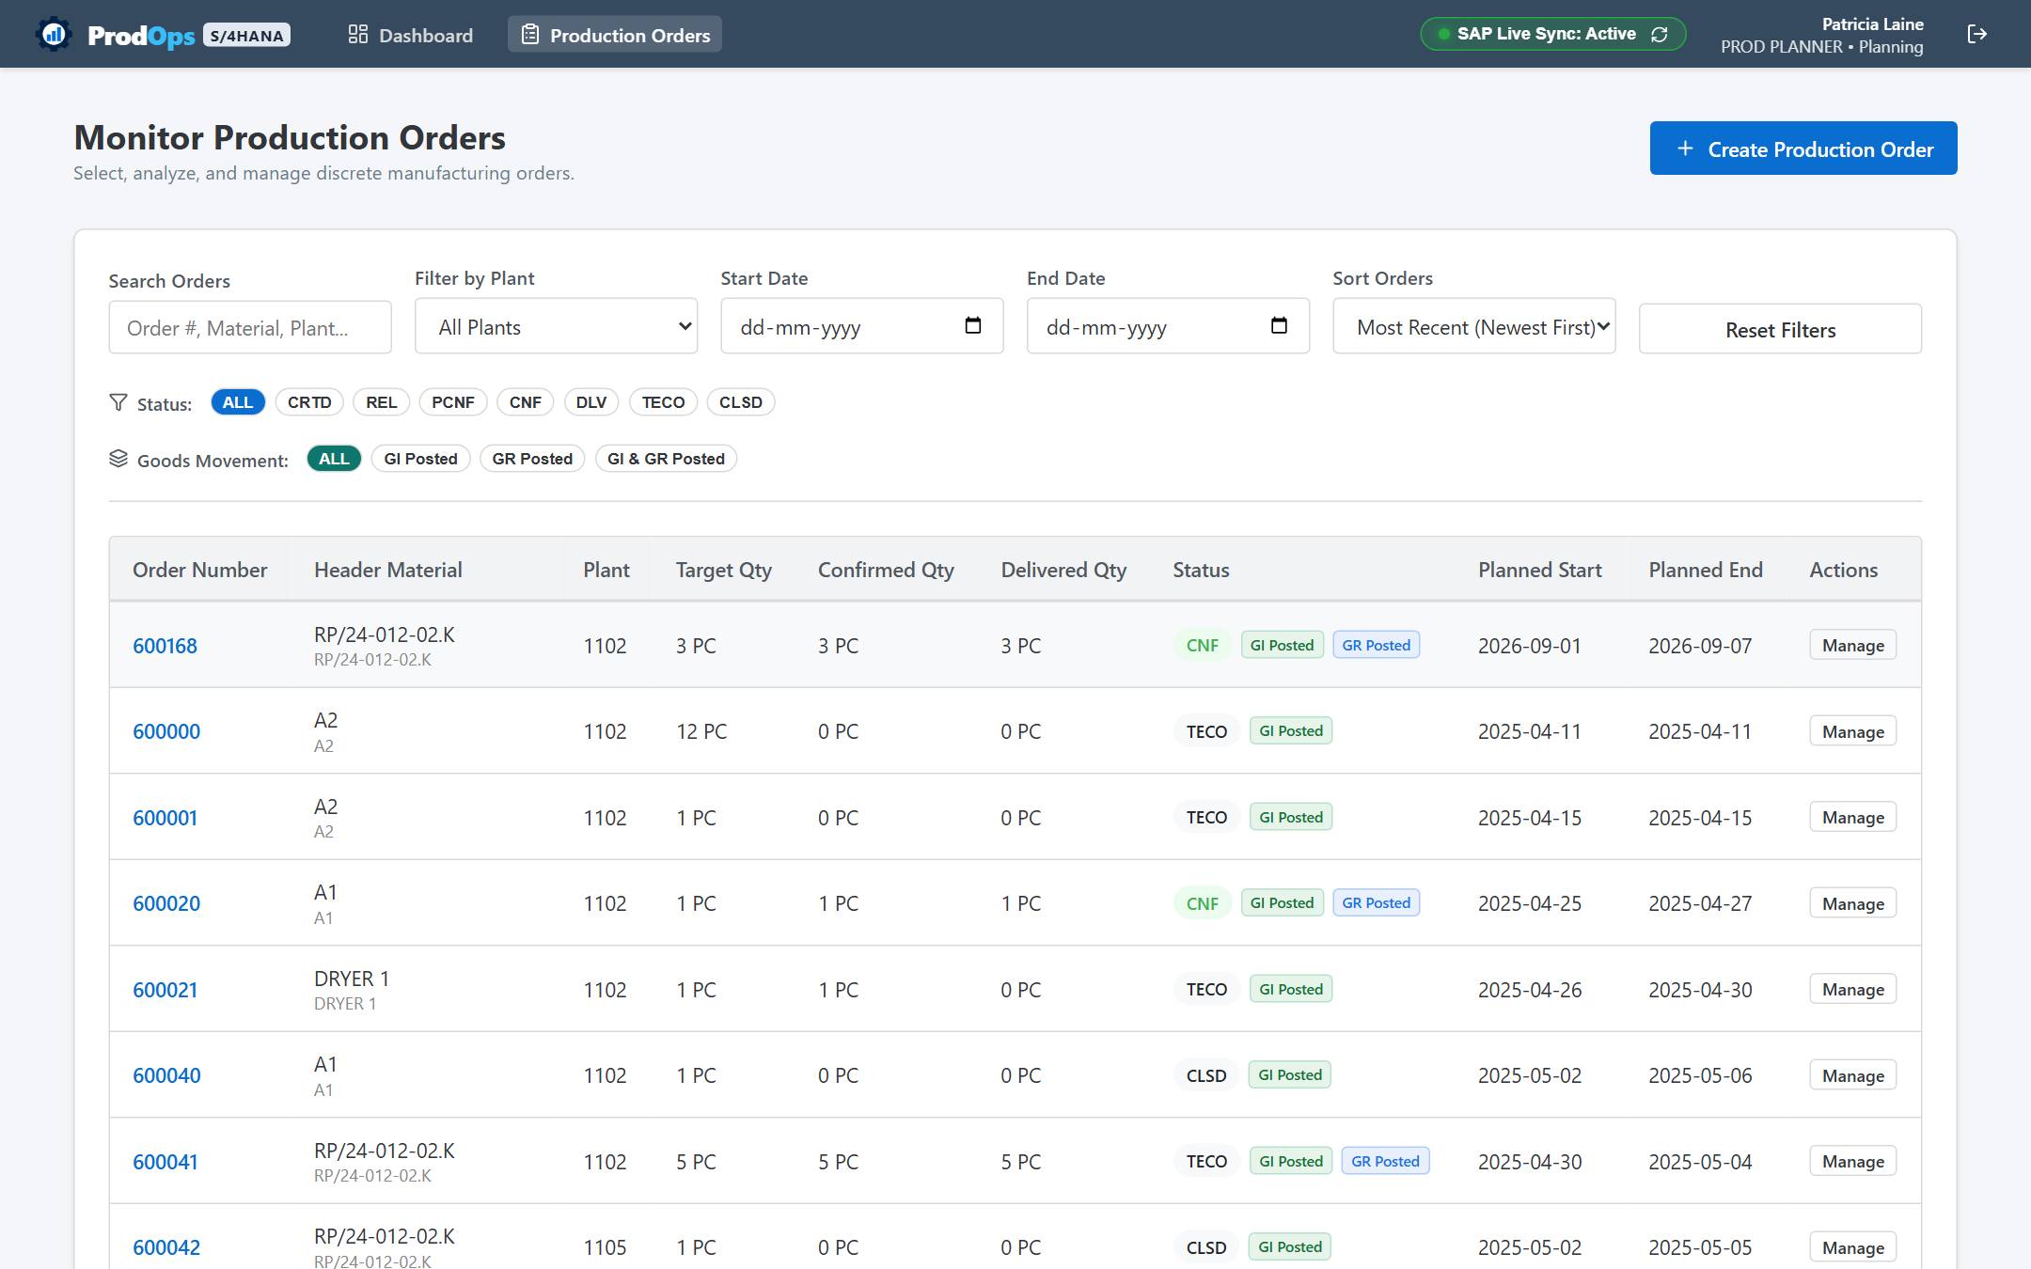
Figure 3.4: Order Detail Header and Action Toolbar
What This Screen Does: Provides 360-degree control of an individual order, including manual sync, release, and scheduling.
When to Use It: Whenever managing, releasing, or updating an existing production order.
- 1. Review order metrics across General, Assignment, Goods Receipt, and Master Data tabs.
- 2. Click "Check Availability" to evaluate component stock in the warehouse.
- 3. Click "Release Order" to authorize shop-floor execution (status advances to REL).
Expected Result: Order status updates with full audit history and active work center queues.

Screen 5: Routing & Work Center Operations
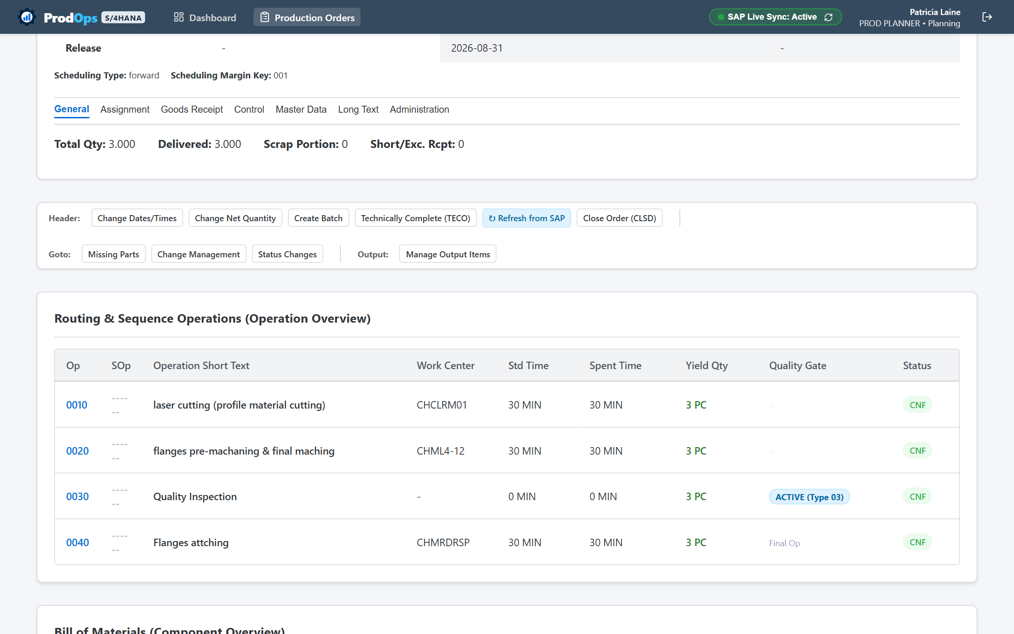
Figure 3.5: Operation routing sequence grid
What This Screen Does: Displays chronological operation steps, work center codes, and confirmed yield.
When to Use It: To verify which operations are finished, active, or pending on the shop floor.
- 1. Inspect operation sequence numbers (0010, 0020, 0030).
- 2. Review assigned work centers and planned setup/machine durations.
- 3. Monitor confirmed yield to detect machine bottlenecks.
Expected Result: Real-time visibility into line progress across all plant work centers.

Screen 6: Bill of Materials & Component Overview
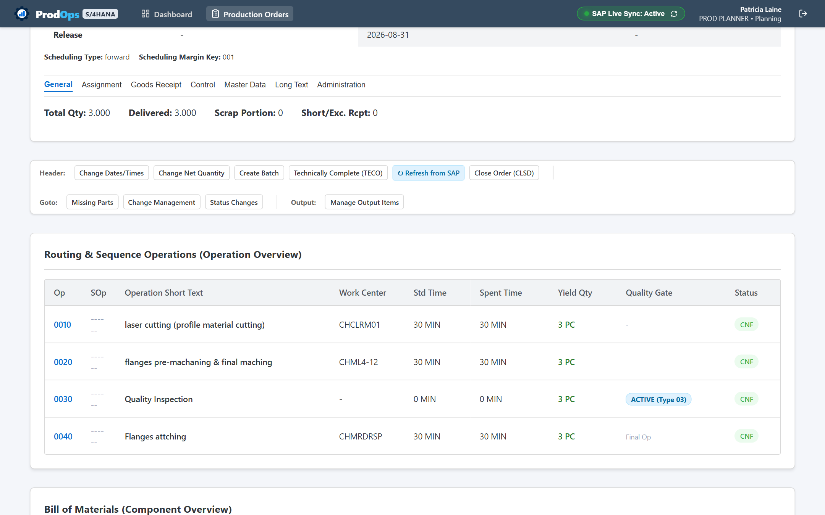
Figure 3.6: Component overview and withdrawal status
What This Screen Does: Tracks component reservations, comparing required vs. withdrawn quantities.
When to Use It: To verify component availability prior to release or ensure staging before machine setup.
- 1. Review required quantities calculated from order batch size.
- 2. Compare required against withdrawn quantities.
- 3. Verify issuing storage locations for staging.
Expected Result: Complete accountability for raw material consumption and floor stock.

Screen 7: Shop-Floor Operation Confirmations
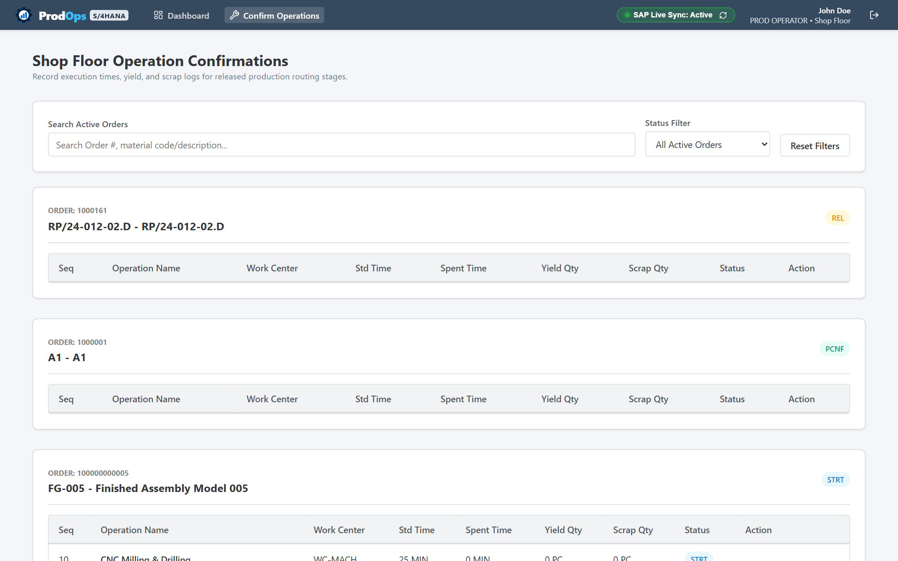
Figure 3.7: Operator confirmation modal
What This Screen Does: Captures shop-floor yield, scrap counts, and actual labor/machine runtimes.
When to Use It: At the completion of an operation run, at shift change, or after completing a discrete batch.
- 1. Navigate to Confirm Operations (/operations) and locate the target order.
- 2. Enter confirmed Yield Quantity and rejected Scrap Quantity.
- 3. Enter actual Time Spent in minutes and check Final Confirmation if the step is complete.
- 4. Click Confirm Operation to record the posting.
Expected Result: Operation status flips to CNF and order primary status updates immediately.

Screen 8: Standardized Goods Movements (MIGO Style)
Figure 3.8: Standardized Goods Movement interface
What This Screen Does: Issues raw materials (261), receives finished products (101), and handles reversals.
When to Use It: Whenever moving physical inventory between the warehouse and the production floor.
- 1. Select transaction Goods Issue (A07) with reference to Order (R08).
- 2. Enter Order Number to load reserved components.
- 3. Enter actual issued quantities and click Check followed by Post.
Expected Result: A formal Material Document is generated and warehouse inventory balances decrease.

Screen 9: Documented Goods Movements Log & Drill-Down
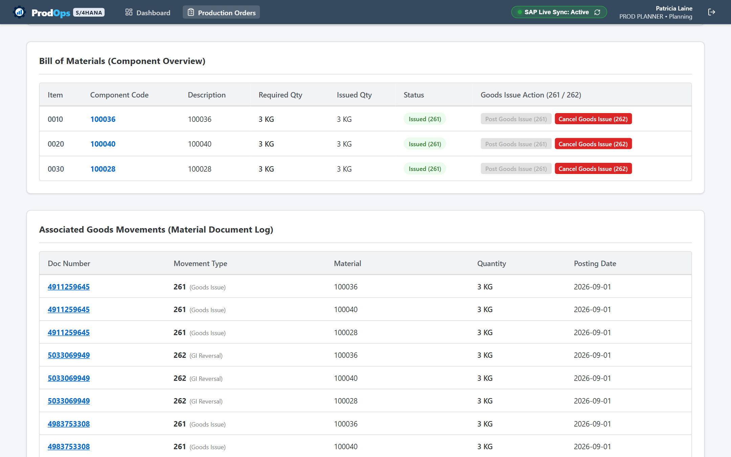
Figure 3.9: Associated goods movements log
What This Screen Does: Provides an immutable historical audit log of all inventory transactions on the order.
When to Use It: To verify component withdrawals, delivery quantities, or inspect cancellation linkages.
- 1. Scroll to Associated Goods Movements on the order detail page.
- 2. Click any clickable Material Document Number to open the Drill-Down modal.
- 3. Review document year, storage locations, and linked reversal documents.
Expected Result: Complete physical and financial traceability for audit compliance.

Screen 10: Quality Control & Usage Decisions
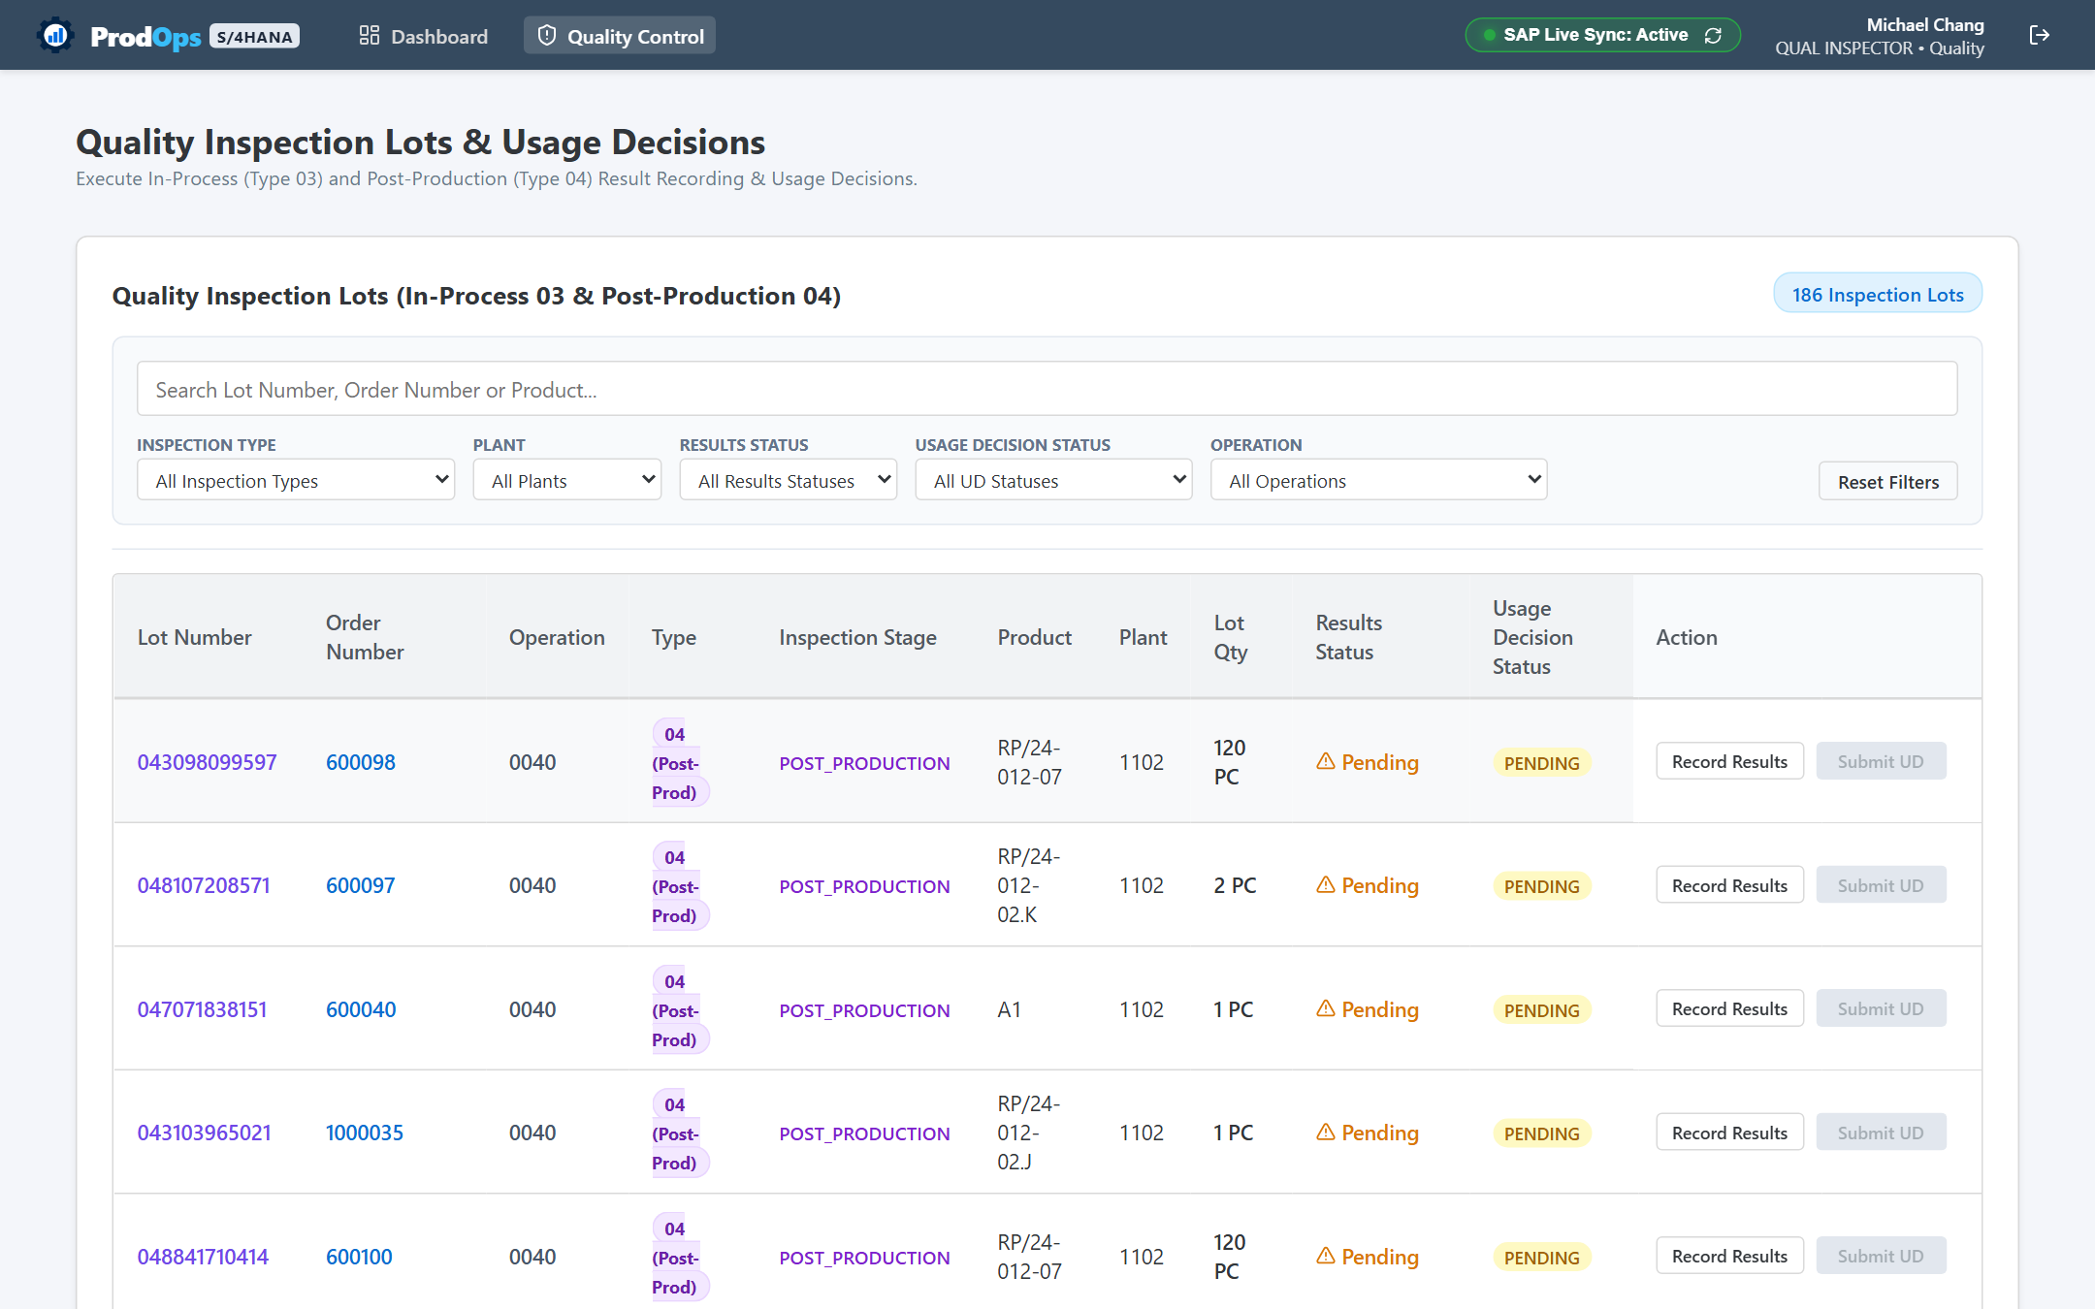
Figure 3.10: Quality inspection lot management
What This Screen Does: Allows quality inspectors to record test samples and grant formal usage decisions.
When to Use It: In-process (Type 03) during active machining, or post-production (Type 04) on finished batches.
- 1. Open Quality Control (/quality) and select the assigned inspection lot.
- 2. Click Record Results to log inspected samples and defect counts.
- 3. Click Usage Decision to grant Accepted (UDAC) or Rejected (UDRJ) disposition.
Expected Result: Approved finished goods are cleared for warehouse stocking.

Document 04: Role & Module Guide

1. Persona-Driven Design Philosophy
ProdOps tailors the operational workspace to the specific responsibilities of each employee. Buttons, navigation menus, and actions that do not pertain to a user role are hidden, preventing errors and speeding up training.

2. Master Role-to-Module Access Matrix
Business Role | Code | Dashboard | Orders | Detail | Operations | Quality | Movements | Inventory
Production Planner | PROD_PLANNER | YES | YES | YES | YES | YES | — | YES
Plant Supervisor | PLANT_SUPV | YES | YES | YES | YES | YES | — | YES
Production Operator | PROD_OPERATOR | YES | — | — | YES | — | — | —
Quality Inspector | QUAL_INSPECTOR | YES | — | — | — | YES | — | —
Inventory Manager | INV_MANAGER | YES | YES | YES | — | — | — | YES
Purchaser / Storekeeper | PURCHASER | YES | — | — | — | — | YES | —
Plant / Operations Manager | PLANT_MGR | YES | YES | YES | — | — | — | YES
System Administrator | SYS_ADMIN | YES | YES | YES | YES | YES | YES | YES

3. Key Role Profiles
- Production Planner: Responsible for creating orders, checking material availability, setting scheduling dates, and releasing orders to the plant floor.
- Plant Supervisor: Supervises shop-floor lines, handles operational exceptions, verifies yields, and authorizes Technical Completion (TECO).
- Production Operator: Operates machines and assembly lines, reporting confirmed yield, scrap, and actual runtimes against assigned operations.
- Quality Inspector: Inspects in-process samples (Type 03) and finished production (Type 04), recording test results and granting usage decisions.
- Storekeeper / Purchaser: Manages raw material staging, component withdrawals (Movement 261), finished goods intake (Movement 101), and reversals.

Document 05: Feature & Workflow Guide
This visual guide highlights the key functional workflows across the ProdOps platform.

Workflow 1: Material Availability Checking
The Material Availability Verification Engine compares required BOM component quantities against unrestricted warehouse inventory before order release. If sufficient stock exists, the order advances to MACA (Material Availability Checked). If shortages exist, status switches to MSPT (Material Shortage) and a Missing Parts List is generated.

Workflow 2: Shop-Floor Operation Confirmations
Shop floor operators report progress directly against assigned routing steps. Entering yield, scrap, and machine runtimes debits operational costs to the order and advances milestone progress from REL to PCNF and CNF.

Workflow 3: Integrated Quality Gates
Quality lots are generated automatically during execution. Type 03 lots evaluate intermediate machining quality, while Type 04 lots inspect finished goods prior to unrestricted warehouse stocking. Usage decisions (UDAC / UDRJ) enforce strict quality compliance.

Workflow 4: Technical Completion & Closure Safety
Before bringing an order to Technical Completion (TECO), ProdOps presents an interactive Pre-Check Safety Modal to verify status eligibility, open confirmations, and reservation clearance. Order Closure (CLSD) verifies that financial balances are settled.

NOTE: Document Governance & Sign-Off
This complete client documentation suite has been verified against the live ProdOps platform by Abhiyanta India Solutions Pvt. Ltd. It reflects all verified business rules, workflows, and operational capabilities.

