CYBER THREAT INTELLIGENCE

List of Figures

Fig 4.3.1 API keys importing……………………………………………………….25
Fig 4.3.2 IOC types detection……………………………………………………….25
Fig 4.3.3 Threat score……………………………………………………………….26
Fig 4.3.3 Final output report…..…………………………………………………….26
Fig 5.1 use case Diagram & activity Diagram……………………………………….28
Fig 6.1 Time Line………………………………………………………………………29

TABLE OF CONTENT
Chapter No. Title Page No.

List of Figures .......................................................................................................................... 6

Table of Contents ................................................................................................................... 7
Abstract ................................................................................................................................. 9
Objective................................................................................................................................ 10

Scope / Limitations of the Project ...............................................................…………………………11
Chapter 1 Introduction .................................................................................................................... 12
1.1 Introduction .................................................................................................................... 12
Chapter 2 Literature Survey / Research…………………………………………………………..14
2.1 overview of Splunk and machine data analytics...............................................................14
2.2 Splunk IT operation .........................................................................................................14
2.3 Splunk in security monitoring and analytics....................................................................15
2.4 Machine learning & advanced analytics in Splunk .........................................................15
2.5 Comparative studies ........................................................................................................16
2.6 Architecture, Scalability & validate deploy patterns……………………………………16
2.7 Summary………………………………………………………………………………...17

Chapter 3 Methodology .................................................................................................................. 18
3.1 Requirement Analysis ..................................................................................................... 18
3.2 System design .................................................................................................................. 18
3.3 Data collection and integration ........................................................................................ 19
3.4 Implementation and Configuration .................................................................................. 20
3.5 Testing and Validation...................................................................................................... 20
3.6 Evaluation and Optimization…………………………………………………………….21
3.7 Summary…………………………………………………………………………………22

Chapter 4 Proposed Work & Outcome ........................................................................................23
4.1 Proposed Work.................................................................................................................. 23
4.2 Expected Outcomes .......................................................................................................... 24
4.3 Output……………………………………………………………………………….……25
4.4 Summary............................................................................................................................27

Chapter 5 Diagram ......................................................................................................................28
5.1 UML ................................................................................................................................. 28
5.2 Process Diagram………………………………………………………………………….28

Chapter 6 Time line chart .......................................................................................................... 29
6.1 Time line ...................................................................................................................... 29

Chapter 7 Future Work .............................................................................................................. 30
7.1 Future work .................................................................................................................. 30

Chapter 8 Conclusion ................................................................................................................. 31
8.1 conclusion .................................................................................................................... 31
Chapter 9 References ........................................................................................................ 32

Abstract

This report presents the design and implementation of a Cyber Threat Intelligence (CTI) system developed to support the identification, analysis, and interpretation of cyber threat indicators in a practical and structured manner. The project focuses on collecting threat-related information from multiple intelligence sources and analyzing indicators such as IP addresses, domains, URLs, and file hashes to assist in cybersecurity investigation and decision-making.
The system aims to simplify the threat analysis process by centralizing intelligence data and providing meaningful insights about suspicious or malicious indicators. By integrating publicly available intelligence feeds and API-based data sources, the project helps reduce the manual effort required during threat investigation and improves the speed of identifying potential cyber risks. The solution is designed to support students, beginners, and security analysts by offering a more efficient approach to indicator-based analysis.
The developed CTI framework demonstrates how threat intelligence can be used to enhance cyber awareness, support investigation workflows, and strengthen defensive capabilities in a security environment. The project also provides a foundation for future improvements such as MITRE ATT&CK mapping, automated alert generation, dashboard visualization, and SIEM integration.

Objective
The main objective of this project is to develop a Cyber Threat Intelligence (CTI) system that can collect, process, and analyze cyber threat information from different intelligence sources. The system is designed to help in identifying suspicious or malicious indicators such as IP addresses, domains, URLs, and file hashes, which are commonly used during cybersecurity investigations and threat analysis.
Another important objective of this project is to simplify the threat investigation process by providing threat-related information in a more organized and accessible manner. Instead of manually checking multiple platforms, the project aims to reduce investigation time and make the analysis process easier for students, beginners, and security analysts working in a practical environment.
The project also aims to improve cybersecurity awareness and support better decision-making by presenting useful intelligence insights in a structured way. In addition, it creates a foundation for future enhancements such as automated alert generation, dashboard visualization, threat scoring, MITRE ATT&CK mapping, and integration with SIEM tools for more advanced security monitoring and analysis.

Scope/ Limitations of the project

Scope:
The project focuses on developing a Cyber Threat Intelligence (CTI) system for collecting, analyzing, and interpreting cyber threat-related data from multiple intelligence sources. It mainly deals with the investigation of indicators such as IP addresses, domains, URLs, and file hashes, which are commonly used to identify suspicious or malicious activity in a cybersecurity environment.
The system is designed to support threat analysis and basic investigation workflows by gathering intelligence data through APIs or publicly available threat intelligence platforms. It helps users understand the reputation and possible risk associated with a given indicator, making the investigation process faster and more organized.
The project can be used in a learning environment, basic SOC operations, or cybersecurity analysis practice. It also creates scope for future improvements such as dashboard development, automated alerting, threat classification, MITRE ATT&CK mapping, and SIEM integration.

Limitations:
One of the main limitations of the project is that it depends on third-party intelligence sources and APIs. If an API is unavailable, restricted, or returns incomplete data, the system may not provide full threat context for certain indicators.
Another limitation is that the project mainly supports indicator-based analysis and does not fully automate the entire threat detection or incident response process. It is useful for investigation and intelligence gathering, but it does not replace a complete enterprise-level SOC or SIEM solution.
The effectiveness of the system also depends on the quality, availability, and freshness of threat intelligence data. Some malicious indicators may not always be listed in public sources, and free intelligence services may have rate limits or usage restrictions, which can affect performance and depth of analysis.

Introduction
In today’s digital environment, cyber threats are growing rapidly in terms of volume, sophistication, and impact. Organizations across the world are increasingly facing attacks such as phishing, ransomware, malware infections, supply chain attacks, credential theft, and AI-driven cyber threats. Traditional security approaches that only react after an attack has occurred are no longer sufficient to defend against modern adversaries. As a result, there is a growing need for a more proactive, intelligence-driven approach to cybersecurity.
Cyber Threat Intelligence (CTI) is the process of collecting, analyzing, and interpreting threat-related information to support better cybersecurity decisions. Instead of only identifying technical indicators, CTI helps security teams understand the context, attacker behaviour, motivation, infrastructure, and possible impact of a threat. It transforms raw cyber data into actionable intelligence, which can be used by Security Operations Centers (SOCs), incident response teams, analysts, and decision-makers to improve threat detection, response, and risk management.
A CTI system typically works by gathering information from multiple intelligence sources, such as open-source intelligence (OSINT), internal security logs, threat feeds, trusted security communities, and known adversary frameworks. This collected data is then analyzed, enriched, and structured to identify suspicious or malicious indicators such as IP addresses, domains, URLs, file hashes, and attacker tactics, techniques, and procedures (TTPs). Frameworks such as MITRE ATT&CK, MITRE ATLAS, and collaborative platforms like MISP further improve the value of CTI by enabling better threat mapping, classification, and intelligence sharing.
The use of Cyber Threat Intelligence offers several important advantages. It helps organizations move from reactive security to proactive defense, improves incident response, supports risk-based decision-making, and strengthens the overall security posture. It also allows analysts to prioritize threats more effectively and respond with better context and confidence. In addition, CTI supports future enhancements such as dashboard-based visualization, automated report generation, real-time alerting, and integration with SIEM and security monitoring platforms.

This project focuses on the design and development of a Cyber Threat Intelligence framework that supports the collection, analysis, contextualization, and reporting of threat-related information. The aim of the project is to create a practical and structured CTI solution that can assist in identifying cyber threats, supporting investigation workflows, and improving intelligence-driven security operations in a meaningful and scalable way.

Literature Survey/Research
2.1 Overview of Cyber Threat Intelligence and Threat Data Analysis
Cyber Threat Intelligence (CTI) is the process of collecting, processing, analyzing, and interpreting threat-related data to generate actionable security insights. Unlike traditional security monitoring, which often focuses only on alerts or events, CTI helps organizations understand the context, intent, capability, and behaviour of threat actors. It transforms raw technical data such as IP addresses, domains, URLs, file hashes, malware indicators, and attack patterns into intelligence that can support detection, response, and strategic decision-making. Industry resources describe CTI as a shift from reactive security to proactive defense, enabling organizations to identify threats before they cause major damage.
2.2 Cyber Threat Intelligence in Security Operations and Incident Response
CTI plays an important role in Security Operations Centers (SOCs) and incident response teams by providing context around malicious indicators, adversary tactics, and known campaigns. Instead of analyzing alerts in isolation, security teams can use CTI to determine whether an observed event is part of a broader attack pattern or linked to known threat activity. This improves alert prioritization, reduces investigation time, and supports more informed incident handling. In practical environments, CTI is often used to enrich detections, validate suspicious activity, and support proactive threat hunting.

2.3 Threat Intelligence Platforms and Intelligence Sharing
Threat Intelligence Platforms (TIPs) are designed to centralize threat-related information and make it easier to collect, enrich, manage, and share intelligence across teams or organizations. One of the most widely recognized open-source platforms in this domain is MISP (Malware Information Sharing Platform), which supports structured sharing of indicators, events, taxonomies, confidence levels, and contextual metadata. Intelligence sharing platforms are important because cyber threats often affect multiple organizations, and collaboration helps defenders identify patterns faster. Literature and practical implementations emphasize that threat intelligence becomes significantly more useful when it is shared, classified, and contextualized properly.
2.4 Threat Frameworks and Adversary Mapping in CTI
Modern CTI practices are strongly supported by structured adversary knowledge frameworks such as MITRE ATT&CK and MITRE ATLAS. These frameworks help security teams map attacker behaviour into standardized tactics, techniques, and procedures (TTPs), making intelligence easier to interpret and operationalize. ATT&CK is widely used for enterprise adversary mapping, while ATLAS focuses more specifically on threats targeting AI-enabled systems and machine learning environments. The use of such frameworks improves reporting consistency, helps analysts correlate threat activity more effectively, and supports security teams in building stronger defensive strategies. Your PPT also correctly positions these frameworks as highly relevant to modern CTI workflows.

2.5 Structured Intelligence Reporting and CTI Blueprints
A major challenge in cyber threat intelligence is not only collecting data, but also converting it into clear, usable, and operationally relevant reports. The CTI Blueprints initiative by the Center for Threat-Informed Defense addresses this issue by providing templates and structured methods for creating intelligence reports aligned to defender needs. These blueprints help analysts produce consistent outputs that include contextualized indicators, ATT&CK references, and narrative threat summaries. This supports better communication between intelligence producers and consumers, and improves the usability of CTI in operational security environments.
2.6 Automation, AI, and Advanced Analysis in CTI
As the volume of cyber threats continues to increase, organizations are increasingly adopting automation and AI-assisted analysis to improve intelligence collection and processing. Automated CTI workflows can help in the ingestion of indicators, enrichment of threat data, pattern identification, and prioritization of suspicious activity. Recent industry discussions and research also highlight the growing importance of AI in both offensive and defensive cybersecurity, including its use in attacker infrastructure, phishing campaigns, malware development, and intelligent threat detection. This creates a need for CTI systems that can evolve to support automation, prediction, and contextual analysis more effectively.

2.7 Summary of Implications for this Project
The reviewed literature supports the development of a Cyber Threat Intelligence framework that focuses on multi-source intelligence collection, analysis, contextualization, structured reporting, and future automation support. Existing research and industry practices show that CTI is most effective when intelligence is not only collected, but also mapped, enriched, and shared in a usable format. Therefore, this project is designed to align with those practical needs by creating a structured CTI solution that can support cybersecurity investigation, improve threat understanding, and provide a strong base for future extensions such as dashboard visualization, automated alerting, threat scoring, and integration with security monitoring systems.

Methodology
The methodology outlines the systematic approach adopted for designing, developing, and implementing a Cyber Threat Intelligence (CTI) system. The process was divided into several important stages: requirement analysis, system design, threat data collection, implementation, testing, and evaluation. Each stage was focused on building a practical and structured CTI solution capable of collecting and analyzing cyber threat information from multiple sources in an efficient and meaningful way.

3.1 Requirement Analysis
The first stage involved identifying the functional and non-functional requirements of the Cyber Threat Intelligence system.
Functional Requirements:
- Collect threat-related data from multiple intelligence sources.
- Accept cyber threat indicators such as IP addresses, domains, URLs, and file hashes as input.
- Analyze the given indicators and retrieve related threat intelligence information.
- Present the results in a structured and understandable format.
- Support basic reporting and interpretation of collected intelligence.
Non-Functional Requirements:
- The system should be simple, reliable, and easy to use.
- It should provide fast response for indicator-based queries.
- It should support secure handling of API requests and collected data.
- The system should be flexible enough to support future integration with dashboards, alerts, and security platforms.
A practical analysis was carried out to understand which threat indicators and intelligence sources would be most relevant for a student-level CTI implementation. Based on this, the project was designed to focus on commonly used indicators and publicly accessible intelligence sources.

3.2 System Design
The Cyber Threat Intelligence system was designed using a modular and structured architecture so that each stage of the intelligence workflow could be handled clearly and efficiently. The system architecture consists of the following major components:
- User Input Module:
Accepts threat indicators such as IP addresses, domains, URLs, and file hashes from the command-line interface.
- Threat Intelligence Collection Module:
Connects with external intelligence sources or APIs to gather relevant information about the provided indicators.
- Analysis and Contextualization Module:
Processes the retrieved intelligence data and identifies whether the indicator is suspicious, malicious, or safe, while also extracting meaningful context.
- Structured Output Module:
Displays the analyzed intelligence results in a clear and readable CLI-based format.
- Future Integration Layer (Conceptual):
Provides scope for future enhancements such as dashboard visualization, MITRE ATT&CK mapping, report generation, and SIEM integration.
This modular design ensures that the system remains understandable, maintainable, and scalable for future development.

3.3 Threat Data Collection and Integration
Threat data was collected from publicly available intelligence sources and API-based services relevant to cyber threat investigation. The system was designed to support the analysis of indicators such as IP addresses, domains, URLs, and file hashes, which are commonly used in threat hunting, SOC workflows, and malware analysis.
The command-line interface accepts user-provided input and sends it to the connected intelligence modules for processing. Depending on the implementation, the system can retrieve threat-related details such as reputation, malicious classification, associated activity, or known threat context from the available sources.
Basic preprocessing and validation of input data were performed before sending requests to intelligence services. This helped ensure that only valid indicators were processed, improving system reliability and reducing unnecessary query failures. The collected intelligence was then organized into a structured output format for easier interpretation by the user.

3.4 Implementation and Configuration
1. Development Environment:
The CTI system was implemented in a Python-based command-line environment, selected for its simplicity, flexibility, and strong support for cybersecurity scripting and API integration.
2. Input Handling:
A CLI-based interface was developed to allow the user to enter threat indicators manually. The system was configured to handle multiple indicator types such as IP addresses, domains, URLs, and hashes.
3. Threat Intelligence Integration:
The core implementation involved integrating the system with relevant intelligence sources and APIs to fetch indicator-specific information. These integrations allowed the project to retrieve and process cyber threat data dynamically.
4. Output Formatting:
The retrieved threat intelligence was displayed in a readable command-line format, allowing the user to quickly understand the nature and severity of the indicator.
5. Security and Reliability Considerations:
Basic error handling, invalid input checks, and safe API interaction methods were included to ensure that the system could handle common operational issues gracefully.
This implementation approach made the project lightweight, practical, and aligned with the actual development scope of the system.

3.5 Testing and Validation
After implementation, the system was tested under controlled conditions to ensure that it performed correctly and consistently.
Functional Testing:
Verified that the system correctly accepted different types of indicators and returned the expected threat intelligence output.
Input Validation Testing:
Tested whether invalid or unsupported inputs were handled properly without causing system failure.

Response Verification:
Checked whether the intelligence output matched the expected reputation or threat context for known indicators.
Usability Testing:
Ensured that the CLI interface remained easy to use and that the displayed output was understandable and structured.
The project was tested using sample indicators representing both safe and suspicious inputs in order to evaluate the consistency and usefulness of the intelligence results.

3.6 Evaluation and Optimization
After testing, the system was evaluated based on its ability to provide useful, timely, and readable threat intelligence. The performance of the project was assessed using practical factors such as:
- Accuracy of returned threat-related information
- Reliability of indicator validation
- Simplicity of interaction through the command-line interface
- Clarity of output presentation
- Scope for future extensibility
Optimization efforts mainly focused on improving input handling, output formatting, and response reliability. Since the project is CLI-based, the main emphasis was on making the workflow efficient and user-friendly rather than overly complex.
The project also leaves room for future optimization through:
- Better automation of threat enrichment
- Confidence scoring
- MITRE ATT&CK mapping
- Dashboard integration
- Automated report generation
3.7 Summary
This methodology ensured a structured and practical implementation of the Cyber Threat Intelligence system. By following this approach, the project achieved its objective of creating a basic but effective CTI workflow for collecting, analyzing, and presenting cyber threat information in a simple and understandable manner.
The resulting system provides a useful foundation for threat investigation, cybersecurity learning, and future intelligence-driven security enhancements. It also demonstrates how a CLI-based CTI solution can support the transformation of raw threat indicators into meaningful and actionable intelligence.

Proposed Work & Outcomes
The proposed work aims to design and implement a Cyber Threat Intelligence (CTI) system that provides a structured approach for collecting, analyzing, and interpreting cyber threat-related data from multiple intelligence sources. The system is intended to support cybersecurity analysis by helping users investigate suspicious indicators and understand their potential threat context in a simple and efficient way.
The key aspects of the proposed work include:
1. Multi-Source Threat Intelligence Collection:
Develop a system capable of collecting cyber threat information from multiple intelligence sources such as threat feeds, APIs, open-source intelligence (OSINT), and structured security references.
2. Indicator-Based Threat Analysis:
Enable the system to analyze common cyber threat indicators such as IP addresses, domains, URLs, and file hashes to identify whether they are suspicious, malicious, or safe.
3. Structured Intelligence Processing:
Organize and process collected threat data into a more meaningful and understandable format so that the user can interpret threat information more effectively.
4. Command-Line Based User Interaction:
Implement a lightweight CLI-based interface through which users can input indicators and receive intelligence output in a simple and practical manner.
5. Threat Context and Investigation Support:
Provide useful context around indicators to support basic threat investigation, cyber awareness, and security decision-making.
6. Future Intelligence Expansion:
Design the project in a way that allows future enhancements such as MITRE ATT&CK mapping, dashboard visualization, automated reporting, real-time alerts, and SIEM integration.

4.2 Expected Outcomes
The implementation of the proposed system is expected to provide the following outcomes:
1. Improved Threat Visibility:
The system will help users gain a clearer understanding of suspicious indicators by presenting threat-related information in a structured manner.
2. Faster Threat Investigation:
By reducing the need for manual lookup across multiple platforms, the project will improve the speed and efficiency of basic cyber threat analysis.
3. Better Cybersecurity Awareness:
The project will assist students and analysts in understanding the behaviour and significance of cyber threat indicators more effectively.
4. Practical Intelligence Support:
The system will provide a useful foundation for threat hunting, basic SOC workflows, and security investigation practices.
5. Expandable Security Framework:
The project will serve as a base for future development into a more advanced CTI platform with automation, visualization, and intelligence sharing capabilities.
6. Improved Decision Support:
The structured intelligence output will support better understanding and decision-making in cybersecurity-related scenarios.

4.3 Output
4.3.1 API imparting
This output shows how the system import APIs for threat detection using IP address, domain, URL, or file hash through the command-line interface for threat analysis.
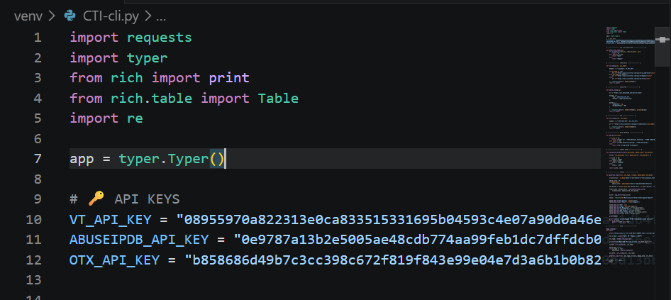
4.3.2 IOCs detection
This output displays the retrieved intelligence information related to the given indicator, such as reputation, threat status, and associated context.
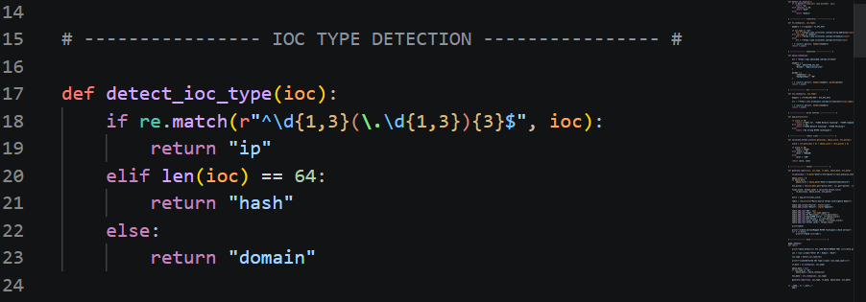

4.3.3 Threat score
This output demonstrates how the system handles Score of given IOC and displays an appropriate response to the user.
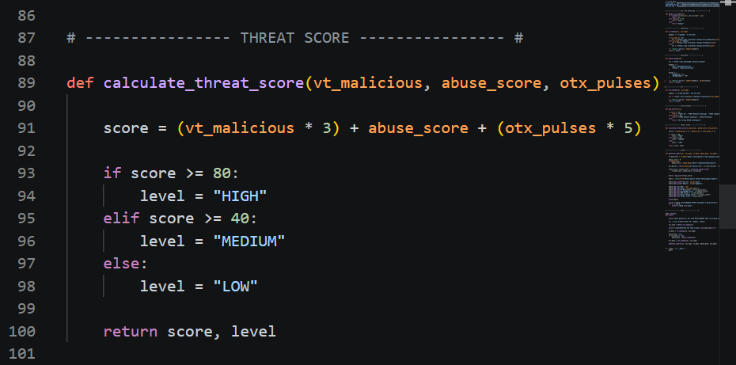
4.3.4 Final output / Report
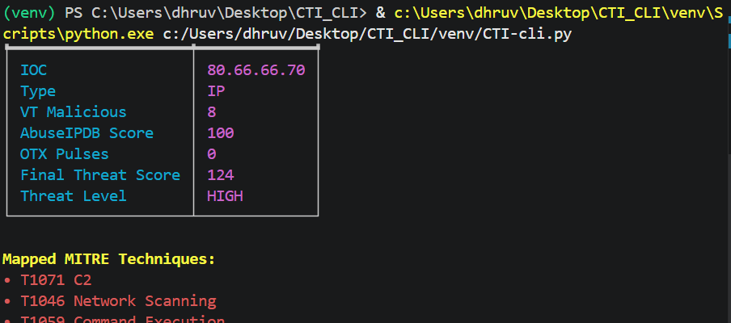

4.4 Summary
The proposed Cyber Threat Intelligence system is designed to transform raw threat indicators into meaningful and actionable intelligence. By supporting indicator-based analysis, multi-source intelligence collection, and structured output, the system improves the process of cyber threat investigation in a simple and practical way.
The expected outcomes of the project are aligned with its objective of enhancing threat visibility, investigation speed, cybersecurity awareness, and future scalability. This makes the project a useful foundation for intelligence-driven security analysis and future cybersecurity enhancements.

Diagram

5.1 Use case Diagram & Activity Diagram

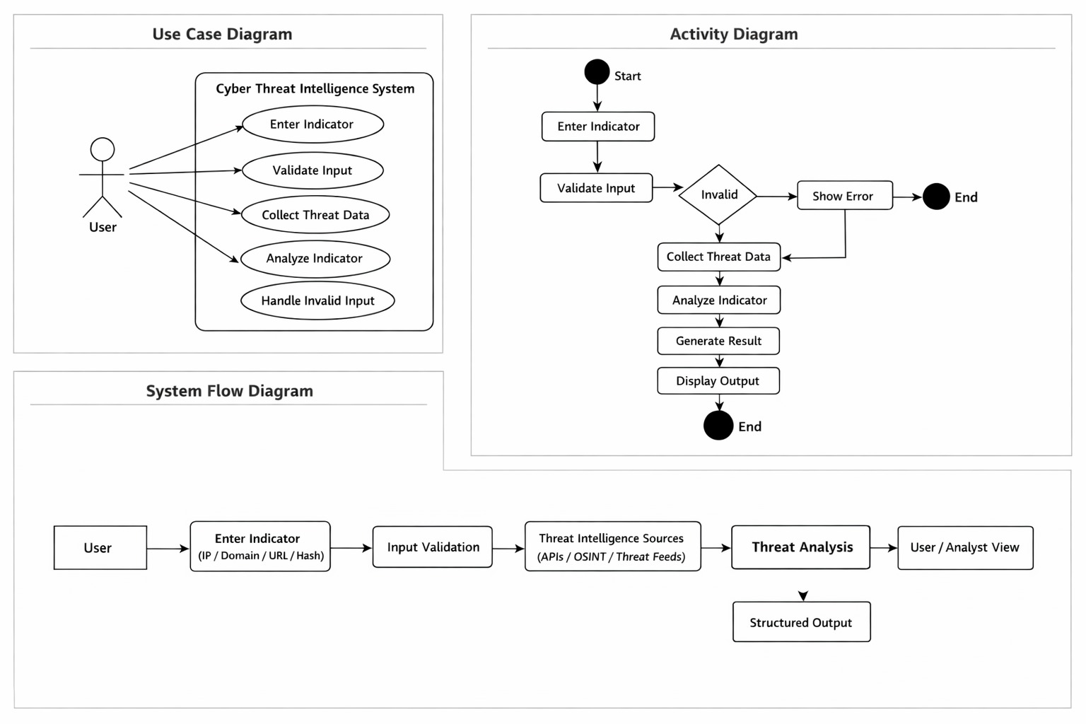

- Time line chart

6.1 Time line

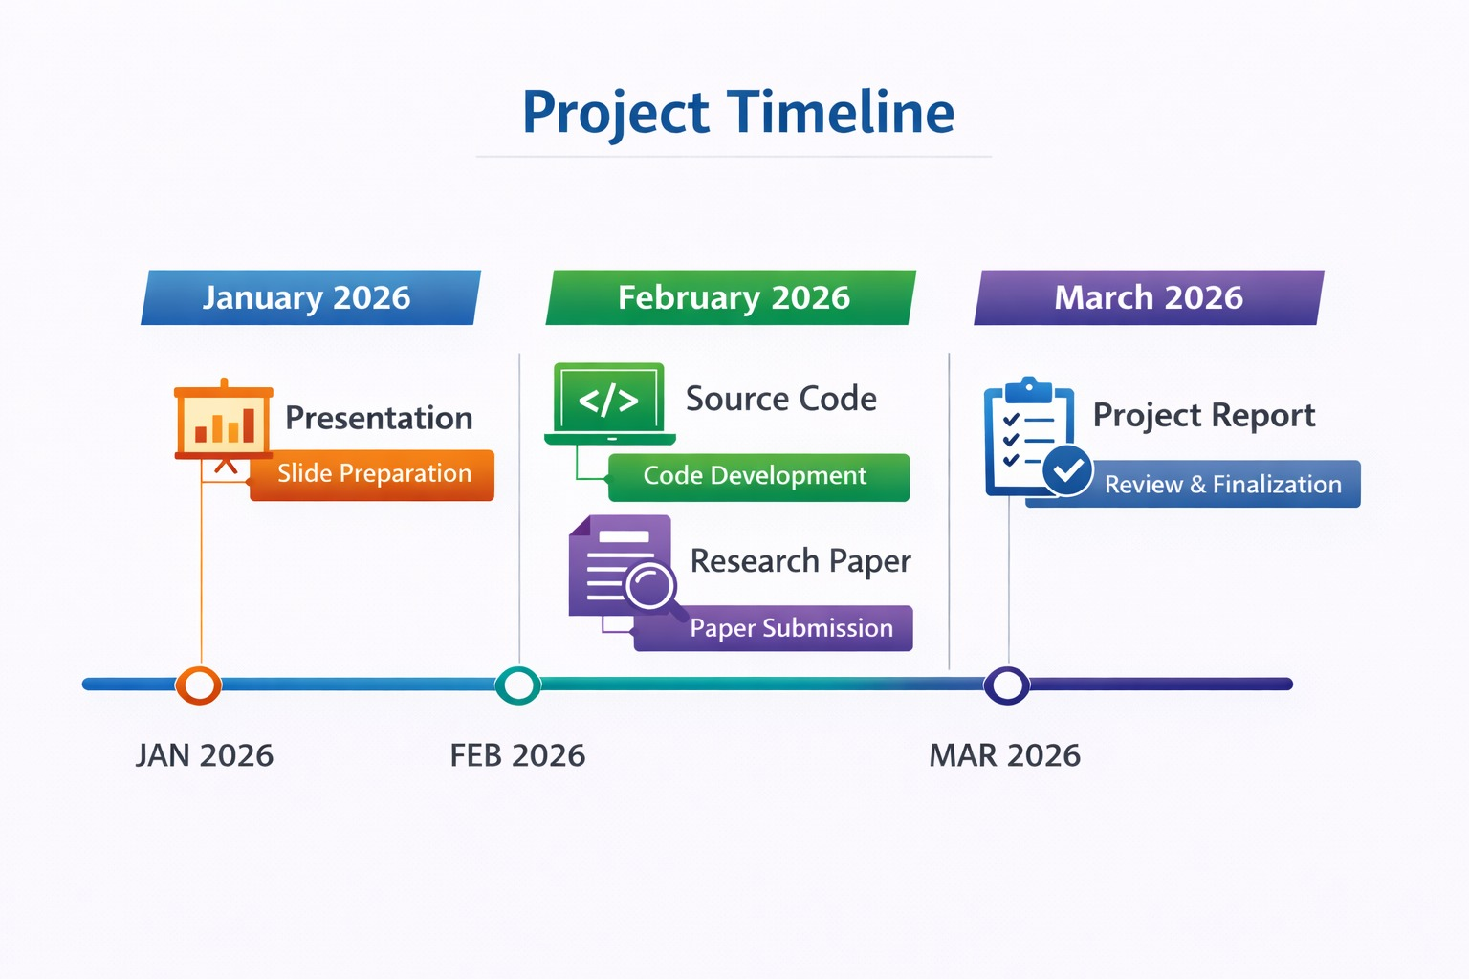

Future Work

- GUI-Based Platform Development:
Future work can focus on developing a user-friendly GUI-based interface for easier threat analysis, IOC lookup, report generation, and visualization.
- MITRE ATT&CK Framework Integration:
The system can be enhanced by integrating the MITRE ATT&CK framework to map threats, attacker techniques, and behaviours for better investigation and analysis.
- Automated Threat Intelligence Enrichment:
Future versions can automatically enrich suspicious IPs, domains, URLs, and file hashes using multiple threat intelligence sources.
- Real-Time Threat Detection and Alerting:
The project can be extended to generate real-time alerts for suspicious or malicious indicators detected in the system.
- SIEM and Security Tool Integration:
The system can be integrated with platforms like Splunk, Wazuh, or ELK Stack for better threat correlation and monitoring.
- AI-Based Threat Analysis:
Machine learning and AI models can be used to improve anomaly detection, threat prediction, and risk classification.
- Advanced Dashboards and Visualization:
Future work may include improved dashboards, charts, and MITRE ATT&CK matrix visualization for better threat understanding.
- Multi-User and Role-Based Access:
The platform can be enhanced with user authentication and role-based access control for secure and organized usage.

Conclusion
• The Cyber Threat Intelligence (CTI) System developed in this project demonstrates an effective approach to collecting, analyzing, and visualizing cyber threat data for modern security environments. Through the integration of multiple threat intelligence sources, the system provides a centralized platform for identifying suspicious indicators and supporting proactive cybersecurity operations.
• The project successfully achieved its objectives by designing and implementing a structured CTI framework capable of handling threat-related data such as IP addresses, domains, URLs, and file hashes. The system helps in gathering and organizing threat intelligence, enabling analysts to perform efficient investigation and better understand potential cyber threats.
• Moreover, the solution highlights the importance of automation and intelligence-driven analysis in cybersecurity. By supporting threat enrichment and analysis workflows, the system improves visibility into malicious activities and assists in faster detection, investigation, and response.
• While the current implementation provides a strong foundation for cyber threat intelligence operations, it also opens the path for future enhancements such as GUI development, MITRE ATT&CK integration, automated alerting, and AI-based threat analysis. These improvements can make the platform more practical, scalable, and effective for real-world use.
• In conclusion, the developed CTI system contributes significantly to improving threat visibility, security awareness, and incident investigation capabilities. It serves as a useful and scalable model for strengthening cybersecurity operations and supporting better threat-informed decision-making.

References

https://docs.virustotal.com/docs/api-overview

https://docs.virustotal.com/docs/searching

https://www.virustotal.com/gui/home/upload

https://any.run/

https://attack.mitre.org/

https://attack.mitre.org/matrices/enterprise/

https://gtidocs.virustotal.com/

https://otx.alienvault.com/

https://www.abuseipdb.com/

https://www.shodan.io/

