1.双击打开

\\192.168.0.2\Zdrive\TemcoSoftware\Release\T3000_Building_Automation_System

2.点击随机生成一个GUID



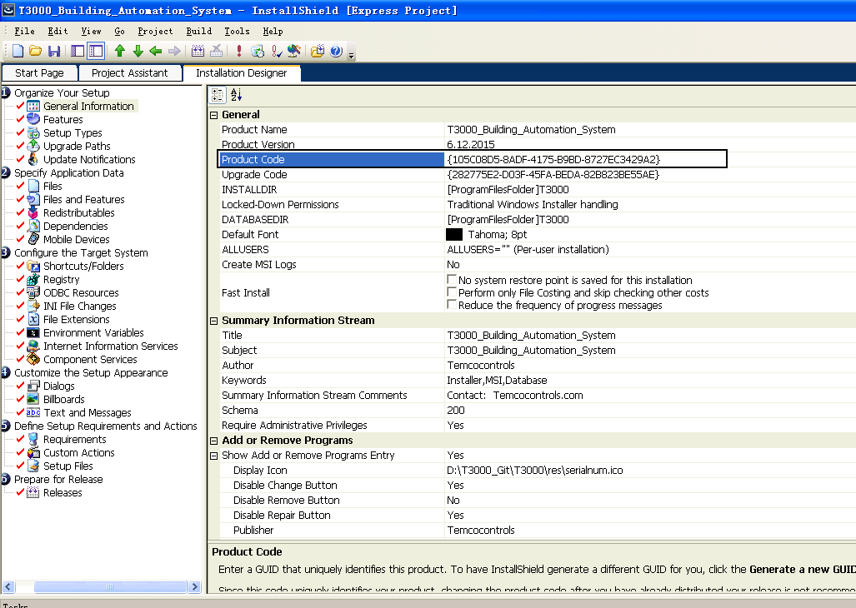

3. 点击随机生成一个GUID



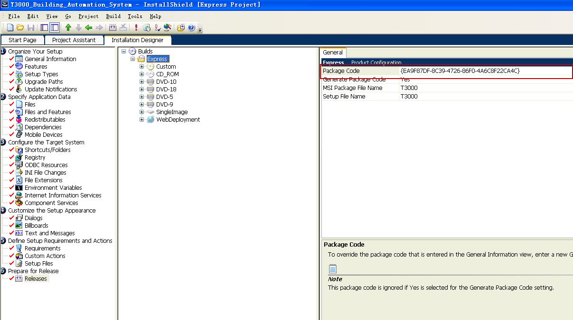

4.选择SingleImage

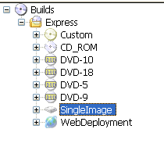

5.Build



6.



