Predictive Parser Generator
Compiler Design Review 2: Technical Project Report
Name:
Reg no.:
Team Members: Dhyey Dharmeshbhai Dumasia, Pamela Mukherjee, Mayukh Sarkar
Course Code: BCSE307P
Slot: L37+L38

Course / Subject | Compiler Design Lab
Project Title | Predictive Parser Generator
Document Type | Review 2 Project Report
Primary Stack | React 19, Vite 8, JavaScript (ES Modules)

1. Project Overview

1.1 Problem Statement
We learned about syntactic analysis in our compiler design class. The parser receives tokens from the lexical analyser and determines if those tokens are valid within the syntax of the programming language. LL(1) predictive parsing is a top-down parsing method that is typically the first such parser we learn about since it is a set in advance parser with no backtracking and is a one-token lookahead parser.
But from a practical perspective, learning of predictive parsing solely with lectures and paper exercises would entail an undue burden on the students:
- Manual Set Calculations: Determining FIRST and FOLLOW sets by hand involves repeatedly reviewing grammar rules until no additional symbols can be included. When a grammar contains multiple non-terminals, mutual dependencies, or epsilon productions, these calculations become laborious and it is easy to overlook a symbol.
- Table Construction Mistakes: LL(1) table construction is done by supplying all non-terminals as rows and each input terminal as a column. A single mistake in computing FIRST and FOLLOW sets often means a wrong table entry, leaving students confused about whether they made an error in their parser or an arithmetic mistake in previous steps.
- Conflicting Grammas and Transformations: Predictive parsers do not work on left- recursive grammars because unfolding a left-recursive rule over and over can go into an infinite regression. They also don't work on rules with shared prefixes because one lookahead token is not sufficient to determine, which rule to choose. It can be hard to detect these and refactor your rules correctly without ongoing input.
- Static Trace Tables: Tracing the pushdown parser on paper using trace tables (Stack Input Action) is slow and static. When students encounter an error partway down a trace, it needs a costly scratch-out and restart. Also, the construction of the parse tree node-by-node is not very clear.
That's why we created the Predictive Parser Generator! This interactive web-based program allows students to input any context-free grammar, automatically compute the FIRST and FOLLOW sets, create the LL(1) table with explicit conflict indications, and step through the stack-based parser execution with a real-time visual parse tree.

1.2 Project Objectives
Our goal was to develop a tool, which is: easy to use clean responsive, and automates all the mechanical parts of predictive parsing while being easy to understand what the theory is and how it works. We have these main goals with our project:
- Grammar Input and Checking: Enable users to input context free grammar rules using the conventional notation, to check the correctness of input grammar and specify automatically non-terminals, terminals, and the initial non-terminal.
- Automated Set Computation: Calculate the mathematical FIRST and FOLLOW sets in your program on-demand, with the same classic iterative algorithms covered in our approach.
- Full LL(1) parsing table - display the table, test if the grammar is really LL(1), mark conflicting cells in red, explain why the conflict is produced (for example direct left recursion or prefix of common prefix), fix the conflict.
- Grammar Transformations: Allow for one-click removal of left recursion and left factoring of common prefixes, while preserving the user's current grammar safely in the editor input box.
- On-Screen Simulation: Run a step-by-step simulation of the stack-based predictive parser for any test string with Next, Previous, Reset, and Auto-Play buttons to show stack, input, and actions at each step.
- Parse Tree: Render and show the parse tree of the result as interactive SVG drawing and as unstyled text.

1.3 Project Scope
We set clear scope to make sure we could stay focused on the project and not go out of scope, in particular in a semester timeline:
Aspect | What We Implemented (In-Scope) | What Is Not Supported (Out-of-Scope)
Grammar Types | Context-Free Grammars (CFGs) with a single non-terminal on the left-hand side and arbitrary symbols on the right-hand side. | Context-Sensitive Grammars, Type-0 Grammars, and raw Regular Expressions.
Parsing Technique | Top-down LL(1) predictive parsing using an explicit pushdown stack and parsing table. | Bottom-up parsing (LR(0), SLR(1), LALR(1), CLR(1)) and backtracking parsers.
Lookahead Depth | Strictly 1 token of lookahead (k = 1) with the $ symbol marking the end of input. | Multi-token lookahead parsing (LL(k) for k > 1).
Transformations | Automated immediate and indirect left-recursion elimination (Dragon Book Algorithm 4.19) and iterative left factoring. | Automated semantic analysis, type checking, or symbol table generation.
Input Processing | Maximal-munch tokenization that supports both spaced tokens (id + id) and unspaced tokens (id+id). | Full programming language lexical specifications (like Lex/Flex definitions).
Output and Display | Step-by-step trace table, SVG parse tree with color-coded nodes, and plain ASCII text trees. | Intermediate code generation (three-address code) or machine assembly code.

1.4 Proposed Technical Approach
While developing the app, we opted for a client-side architecture instead of the more common client/server combination with a Node/Express or Python back-end. Instead, every parsing algorithm, set calculation and tree laying out is handled by pure JavaScript ES modules running within the browser. There are three main advantages to this:
Zero Server Latency: since it is all executed in the browser's JavaScript engine, there is no network latency for parsing grammars or stepping through input strings. Computation completes in just a few milliseconds.
Easy to Deploy: no need for a backend database or server process. It just runs after it has loaded, even offline.
Automated Testing The code defining all the algorithms under /backend/ folder does not interact with the browser DOM. All algorithms can be tested directly from the terminal with Node.js without having to instantiate a browser.
React 19 was used to build the UI, while Vite 8 enabled fast local dev server and building bundle. The interface is designed with a clean pipeline of 5 tabs (Grammar Editor, FIRST & FOLLOW, Parsing Table, Parser Steps, Parse Tree) so the user seamlessly flows through the same order as the compiler classes!

2. System Architecture

2.1 Overall System Architecture
The application has two parts: the front-end presentation layer (in frontend/) and the compiler calculation engine (in backend/). While the computational engine is in a folder called backend/, it is not a remote web service. It is a collection of pure JavaScript modules directly imported by React components.
When the user enters a grammar or clicks an action button, React event handlers invoke the relevant calculation function from the backend module and the corresponding data structures: grammar objects, set maps, parsing table, and parse tree nodes are saved in React component state and displayed on the various tabs.

2.2 Frontend Architecture
The frontend is developed as a single page application, with React 19. It is responsible for:
App.jsx(Front End): frontend/App.jsx contains the main state variables and components. Data is being sent from here to the different tab components. It is also in charge of various user actions.
Pipeline Progress Bar: Pipeline.jsx is the first thing you see at the top of the page and is a visual pipeline progress bar of the 5 stages. It also indicates, which tab you are currently viewing and checkmarks completed stages.
Grammar Editor part: Grammar Editor.jsx has a textarea for the grammar. There are helper buttons for copying or inserting the unicode arrow (->) and epsilon, loading in sample grammars, and calling left recursion removal or left factoring.
Output Visualization: FirstFollowTable.jsx ParsingTableView.jsx ParserSteps.jsx ParseTreeView.jsx show the parsed output per stage of the compiler pipeline.

2.3 Backend / Compiler Engine Architecture
The backend includes nine custom-built JavaScript modules which perform all the compiler theory tasks:
- constants.js: Sets the global constants such as EPSILON = 'ε' and END_MARKER = '$'
- grammarParser.js: Reads the raw string input, makes sure that all symbols names comply with the restrictions, that each line contains an arrow, and finds non-terminals and terminals.
- transformations.js: Implements the left recursion elimination algorithms (direct and indirect) and left-factoring algorithm.
- first.js: Computes FIRST sets for individual symbols and for sequences of symbols via fixed point iterations.
- follow.js: Computes FOLLOW sets according to Dragon Book rules while new symbols may be found.
- parsingTable.js: Computes the M[A, a] parsing table, checks the grammar LL(1) properties and detects any conflicts.
- tokenizer.js: Tokenizes the user-inputted strings by terminal tokens and adds the $ end marker to them.
- predictiveParser.js: Implements a non-recursive pushdown automaton and takes trace snapshots during parsing.
- parseTree.js: Builds the parse tree node objects and calculates x, y coordinates for tree rendering in SVG.

2.4 System Architecture Diagram
Below is the diagram representing the architecture of the system and how the components interlink:
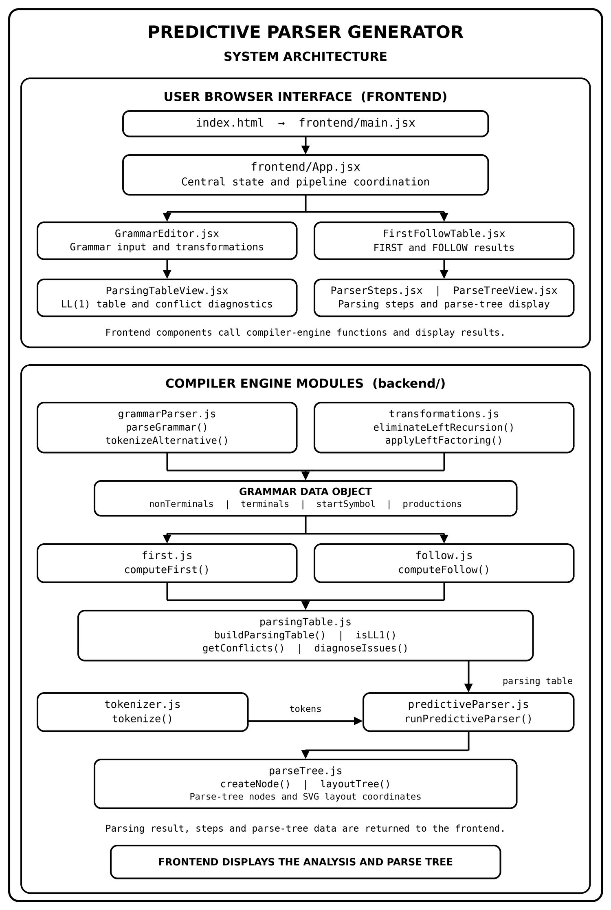
Figure 1: System architecture of the Predictive Parser Generator

2.5 Data Flow
Here is how the data flows into the program from the time the user inputs the grammar until the final output of the parse tree:
1. Grammar The student inputs or pastes a context-free grammar into the editor.
2. Input: (Grammar input page) grammarParser.js processes text input by loading lines, breaking text into lines, checking arrownames and arrowids, and finally assembling the Grammar object.
3. Transformation (Optional): Transformation.js can unroll the grammar if it has left recursion or common prefix. The original text remains in the editor while the transformed grammar is fed to the table builder.
4. Set Computation: first.js computes FIRST sets for all symbols. Follow.js uses those FIRST sets to compute FOLLOW sets.
5. Table Generation: parsingTable.js generates the M[A, a] cells for each production. It also checks whether any table cell has more than one rule to determine if the grammar is LL(1).
6. Tokenizer: as user types input string in Parser tab, it gets tokenized by adding $ by the tokenizer.js.
7. Pushdown Simulation: predictiveParser.js advances through the input with a stack starting at [$, startSymbol] it captures each step in a trace array and generates tree nodes.
8. Tree Visualizer: ParseTreeView.jsx uses layoutTree from parse tree.js to determine (x, y) coordinate and draws the SVG parse tree.

3. Module Descriptions
Here we will give an overview of all the source code modules used in this project, what they do, their important functions and their inputs and outputs.

3.1 Grammar Input and Grammar Parsing
Files: backend/constants.js and backend/grammarParser.js
Before we perform any calculations, we first need to verify and translate our raw user text into structured data. We store our two constants in constants.js. Constants.js contains only 2 main constants: EPSILON = '' END_MARKER = '$' using a single Greek character as the variable for EPSILON helps to prevent bugs and variations in the spelling of 'eps' or 'epsilon'.
grammarParser.js is responsible for reading the text. It uses a two-pass approach:
Pass 1: Declared Non-Terminals: Pass 1 traverses all the lines to identify all left side non-terminal names that are found before the arrow. These are checked to see if they conform to what comes next: /^[A-Za-z][A-Za-z0-9_']*$/ which means they must begin with a letter with only alphanumeric characters, primes, and underscores following.
Pass 2: Production Parsing and Checking: Pass 2 tokenizes every line. It supports the Unicode arrow () and gives a nice error on students who use ASCII arrows (->) or (::=). It breaks alternatives on | and calls subTokenizeChunk to break right-hand sides into individual symbols. It performs a BFS from the initial non-terminal and a fixed-point check to find non-generating symbols.
Inputs and Outputs: Input: Raw string. Output: { grammar errors warnings }.

3.2 Grammar Transformation
File: backend/transformations.js
A left recursive grammar cannot be parsed by an LL(1) parser. Transformations.js offers two algorithms for normalizing grammars:
Left Recursion Elimination: eliminateLeftRecursion(grammarText) follows Dragon Book Algorithm 4.19. It sorts the non-terminals, substitutes earlier rules into later rules to discover indirect left recursion, and then eliminates immediate left recursion by creating new prime non-terminals, e.g. E'.
Left Factoring: applyLeftFactoring(grammarText) factors out the common prefix of several alternatives to a non-terminal, because of this rewriting A-> 1 | 2 as A->A' and A'-> 1 | 2.
Friend / teammate's recent addition: when you run a transformation, it used to replace whatever you typed in the textarea. Our friend added this to the source in App.jsx, so that the original grammar is preserved in the input box, and the revised grammar in revisedGrammarText. The revised grammar is also available in its own card on the Parsing Table tab, with buttons to copy, load it into the editor, and return to the original.

3.3 FIRST Set Computation
File: backend/first.js
This module computes FIRST sets. ComputeFirst(grammar) sets all terminal FIRST sets to themselves, sets all non-terminals to the empty set, and iteratively adds items to the FIRST sets of non-terminals until no more can be added (until changed is false). This module also exports computeFirstOfSequence(symbols, FIRST sets) which computes the FIRST set of an entire sequence of symbols (like a production or the right-hand side of a production), including epsilon bleedthrough.

3.4 FOLLOW Set Computation
File: backend/follow.js
For example, computeFollow(grammar, FIRST sets) uses rules from Dragon Book and computes FOLLOW for each non-terminal. It inserts "$" into FOLLOW of the start symbol and repeatedly: for each A ->, for each non-terminal B inside, add FIRST of the rest of the string after B (excluding epsilon) to FOLLOW(B). If the rest of the string can produce epsilon or B is at the end of the production, then insert everything in FOLLOW(A) into FOLLOW(B).
Inputs and Outputs: Input: Grammar object, FIRST sets map. Output: Map >.

3.5 LL(1) Parsing Table Construction
File: backend/parsingTable.jsZ
buildParsingTable(grammar firstSets followSets) creates the two dimensional parsing table M[A, a] and for each production A -> a.
it computes FIRST () now, for each terminal an in FIRST (), (except epsilon), add A-> to M[A, a].
if epsilon is in FIRST() then check FOLLOW(A). For every terminal b in FOLLOW(A) (including $) add A -> to M[A, b].
isLL1(table) only returns true if all the cells of the table are filled with at most one rule. For those cells, which have more than one rule, those rules are set to be conflicting.

3.6 Conflict Detection and Grammar Validation
File: backend/parsingTable.js
If a student has an LL(1) table with conflicts, students want to know why. GetConflicts(table) displays all cells with more than one entry. DiagnoseGrammarIssues(grammar table FIRST sets, followSets) runs three automatic diagnoses:
1. Left Recursion Check: (A -> A) is a direct left recursion.
2. Common Prefix Test: Checks whether two alternative productions of the same non-terminal have common FIRST sets.
3. FIRST/FOLLOW Overlap Check: For non-terminals that can derive epsilon, does FIRST(A) intersect with FOLLOW(A)?
These diagnostic messages are shown on the Parsing Table tab with one-click fix buttons.
Now after solving the problem, the application also offers a way to fix the supported problem with the grammar. When the problem is left-recursion or common-prefix, the user clicks the appropriate one-click transformation Eliminate Left Recursion or Left Factor. The application outputs a new grammar, presents the original grammar, and also enables the new grammar for the parsing-table analysis. This is user-initiated and not an automatic fix that will solve all of the conflicts for the LL(1) parser. The FIRST/FOLLOW overlap is identified but it may mean the user has to manually fix the grammar.

3.7 Tokenization
File: backend/tokenizer.js
Before an input string can be parsed, it must be converted into a list of terminal tokens. Tokenize(input, grammarTerminals) handles both space-separated tokens ('id + id * id') and unspaced tokens ('id+id*id'). It sorts known terminals by length in descending order and applies maximal munch matching so that multi-character keywords like 'id' or 'num' are matched as single tokens rather than split into 'I' and 'd'. It also appends '$' at the end.

3.8 Predictive Parsing Algorithm
File: backend/predictiveParser.js
runPredictiveParser(grammar table tokens) executes the simulation of stack-based parser. It sets the stack to be ['$, startSymbol] and in a while loop tests for the top of the stack and current tokens.
If parse stack top is '$' and input is '$', parse succeeded (Accept).
If the top of stack is a terminal and matches the current input token, the parser pops the stack and consumes the next token from input. (Match)
If the stack top is a non-terminal, M[top, current token] is checked. If there is an entry, pop the top non-terminal and push the symbols of the right hand side of the rule, in reverse order onto the stack. If there isn't an entry, a syntax error is given.
It has a safety limit MAX_STEPS = 500 to avoid freezing your browser with a non-LL(1) grammar that gets into an infinite loop.

3.9 Parse Tree Construction and Visualization
Files: backend/parseTree.js and frontend/components/ParseTreeView.jsx
While predictiveParser.js runs, it leaves a nodeStack, as well as the parsing stack. Expanding a non-term leaves child tree nodes as children of the node. The render tree in ParseTreeView.jsx calls layoutTree in parseTree.js, which finds (x, y) coordinates: leaf nodes are evenly spaced for x, non-terminal parents are at the mid-point of their children for x, and a y-coord for each. The SVG output is a color-coded (Blue non-term, Green Term, Purple Epsilon) on-screen tree display, or the text version of the tree.

3.10 Frontend Components and User Interface
Directory: frontend/components/
Component | Tab | Role and Description
frontend/App.jsx | Root | Holds state variables, coordinates calculations between tabs, and passes props.
Pipeline.jsx | Top Bar | 5-step visual pipeline showing progress: Grammar -> Sets -> Table -> Parser -> Tree.
GrammarEditor.jsx | Tab 0 | Grammar textarea, symbol helper buttons (-> and ε), example selector, and transformation buttons.
FirstFollowTable.jsx | Tab 1 | Clean table showing FIRST and FOLLOW sets for each non-terminal in { ... } format.
ParsingTableView.jsx | Tab 2 | Renders M[A, a] table, shows LL(1) status, highlights conflicts in red, and displays the revised grammar card.
ParserSteps.jsx | Tab 3 | Interactive trace table with Next, Previous, Reset, and Auto-Play buttons, plus token stream preview.
ParseTreeView.jsx | Tab 4 | Renders derivation tree in SVG format or as a plain text hierarchy.
exampleGrammars.js | Catalog | Contains 5 pre-loaded grammars: Arithmetic (LL1), Simple Statement, Balanced Parentheses, Left Recursive, Ambiguous.

3.11 Application Integration and Main Workflow
Exports all backend functions to allow frontend components to import in a clean fashion. We test the entire calculation engine using backend/__tests__/grammarTests.js. In the base project, we run 15 test suites and 54 assertions that test our grammar parsing, epsilon handler, maximal munch tokenizer, removal of left recursion and predictive parser, with all 54 assertions passing.

4. Grammar Representation

4.1 Context-Free Grammar (CFG)
In formal language theory, a Context-Free Grammar G is mathematically defined as a 4-tuple:
G = (V_N, V_T, P, S)
Where:
- V_N: finite set of Non-Terminal symbols representing syntactic categories.
- V_T: finite set of terminal symbols that constitute the tokens of the language, disjoint from V N.
- P: a finite set of Production Rules of the form A -> alpha, where an is an element of V_N and alpha is a string of (V_N U V_T)*.
- S: The Start Symbol, a special non-terminal from V_N.

4.2 Grammar Components in the Application
Non-Terminals: Symbol on the left hand side of a production rule. Identifiers: identifier first character is a letter followed by letter digits prime or underscore (examples: E, E' Term Stmt)
Terminals: Any symbol that appears as the right side of an expression that is neither a non-terminal nor epsilon. Single-character terminals: (+ * ) multi-character keyword terminals: id num if then else.
Start Symbol: Pre-filled as the left-hand side of the first production rule.
Epsilon () Refers to the empty string, only used in production rules of an alternative: The application translates '', 'epsilon', 'eps', 'EPSILON', 'Epsilon', '^', or empty RHS into '', all with case insensitive handling. Epsilon cannot be used with other symbols for an alternative (like 'A -> a ' will error).
End Marker ($): end of input marker. The marker is automatically placed in the FOLLOW of the start symbol and appended at the end of input tokens returned by the input command. The symbol '$' cannot be used as a symbol in a grammar.

4.3 Grammar Input Format
You enter one production rule per line. The non-terminal on the left hand side is split from the right hand side by the Unicode arrow (->). Different options for the same non-terminal are split by the vertical bar (|). Here is the default arithmetic grammar:
E → T E'
E' → + T E' | ε
T → F T'
T' → * F T' | ε
F → ( E ) | id

Internally, parseGrammar transforms this text into a structured JavaScript object with nonTerminals (Set), terminals (Set), startSymbol ('E'), and an array of production objects like { lhs: 'E', rhs: ['T', "E'"] }.

4.4 Grammar Transformations
Top-down predictive parsers cannot parse grammars with left recursion or common prefixes:
Why Left Recursion need to be Eliminated: if a non-terminal can produce a sentential form beginning with itself, then the context-free grammar people say is left recursive (A =>+ A ). For an LL(1) parser when an is found on top of the stack and a look-ahead token is read, it will attempt to produce A , pushing a back on the stack without consuming input.
Why Left Factoring Is needed: When two alternatives of a non-terminal begin with the same symbol (A -> 1 | 2), the parser cannot distinguish, which alternative to select by inspecting a single token, leading to conflict in table cell M[A, first()].
Typical before and After Left Recursion Elimination:
Before (Left-Recursive):
E → E + T | T
T → T * F | F
F → ( E ) | id

After (Right-Recursive via Algorithm 4.19):
E → T E'
E' → + T E' | ε
T → F T'
T' → * F T' | ε
F → ( E ) | id

4.5 FIRST and FOLLOW Sets
FIRST and FOLLOW sets are the mathematical foundation of LL(1) parsing tables:
FIRST Set: FIRST(X) the set of terminals that begins any string derived from X. E.g. If X can derive epsilon, then epsilon can be in FIRST(X).
FOLLOW Set: FOLLOW(A) consists of all terminal symbols that can appear immediately after non-terminal an on some sentential form. When a may be the last non-terminal before the end marker of a valid sentence, the dollar sign is in FOLLOW(A).

5. Algorithms Used

5.1 Grammar Parsing and Validation Algorithm
Module: backend/grammarParser.js | Function: parseGrammar(text)
Objective: it transforms the raw text input provided by the user into a well-formed, semantically complete and validated Grammar data object.
Why needed: The remaining steps in the compiler pipeline need to know, which symbols, sets, and production lists exist. We parse first so you don't crash if you make a typo or screw up an arrow.
Step-by-Step Logic:
Given an input:
1. Split the input to lines; skip empty lines; skip lines starting with '//' or '#'.
2. Pass 1: Search for arrow -> (lower arrow). Use regex /^[A-Za-z][A-Za-z0-9_']*$/ to check LHS name and store declared non-terminals.
3. Pass 2: Run each line. If student write other forms of arrows (->, =>,::=), mark an error, say that using only '->' is allowed.
4. Split RHS on '|' to produce alternatives. Tokenize symbols in each alternative using subTokenizeChunk, trying to match the longer ones first, so "id" doesn't turn into "I" and "d".
5. Terminals are any RHS symbol, which is neither a non-terminal and epsilon. C. Add '$' to the set of terminals.
6. Run BFS from start symbol to find unreachable symbols, fixed-point generating check to find non-generating ones.
Pseudocode:
function parseGrammar(text):
lines = splitLines(text)
declaredNTs = findLHSNonTerminals(lines)
for each line in lines:
if '→' not in line: reportError("Missing arrow")
lhs = getLHS(line)
for each alt in splitByPipe(getRHS(line)):
symbols = subTokenize(alt, declaredNTs)
addProduction(lhs, symbols)
extractTerminalsAndAddDollar()
checkReachabilityAndGenerating()
return GrammarObject

5.2 Immediate and Indirect Left-Recursion Elimination Algorithm
Module: backend/transformations.js | Function: eliminateLeftRecursion(grammarText)
Motivation: Removes immediate (A -> A ) and indirect (A -> B.-> A...) left recursion by applying Dragon Book Algorithm 4.19.
Why needed: Top-down predictive parsers spin in an infinite loop when expanding left-recursive rules.
Step-by-Step Logic:
1. Line up the non-terminals as: A1, A2,... An.
2.
For I = 1 to n, replace any production of Ai that involves a previous non-terminal Aj (j Ai' and Ai' -> Ai' |epsilon
Pseudocode:
for i = 1 to n:
for j = 1 to i - 1:
replace each Ai -> Aj gamma with Ai -> delta_1 gamma | delta_2 gamma ...
where Aj -> delta_1 | delta_2 ... are Aj productions
eliminate_immediate_left_recursion(Ai):
Ai -> beta_1 Ai' | beta_2 Ai' ...
Ai' -> alpha_1 Ai' | alpha_2 Ai' ... | ε

5.3 Left Factoring Algorithm
Module: backend/transformations.js | Function: applyLeftFactoring(grammarText)
Purpose: Extracts left common prefixes from different alternative productions of the same non-terminal.
Need to: LL(1) parser decides, which alternative it has to pick by the 1 lookahead token.
Step-by-Step Logic:
1. For each non-term A, find the longest common prefix (!=) among pairs of alternatives.
2. Alternatives matching group: A -> 1 | 2 |... | .
3. From the initial non-terminals create a separate prime non-terminal A'.
4. Rewrite productions: A -> A' | and A' -> 1 | 2 |... (empty remainders become epsilon).
5. Continue this process until every non-terminal's alternatives no longer share a common prefix.
Pseudocode:
repeat until no common prefixes exist:
for each non-terminal A:
alpha = findLongestCommonPrefix(A.alternatives)
if alpha is not empty:
create unique non-terminal A'
A.productions = [ alpha + A', nonMatchingAlternatives ]
A'.productions = [ remainders (empty becomes ε) ]

5.4 FIRST Set Computation Algorithm
Module: backend/first.js | Function: computeFirst(grammar)
Goals: Computes the set of terminals that are first symbol of some string derived from each symbol of the grammar.
Why needed: Instructs the parser, which rule can be expanded to relate to the lookahead token as it is read.
Step-by-Step Logic (Iterative Fixed-Point):
1. For each terminal t, FIRST(t) = {t}. FIRST() = { }.
2. Set FIRST(A) = empty set for all non-terminals A.
3. Traverse over every productions A -> Y1Y2... Yk in a while(changed) loop.
4. FIRST(Y1) - {} to FIRST(A) + if () FIRST(Y1) then FIRST(Y2) - {} and so on.
5. If FIRST(Yi) for all 1 <= i <= k, then add to FIRST(A).
6. Repeat until all productions have been processed once without any symbol being added to any set.
Pseudocode:
while changed:
changed = false
for each production A -> Y_1 Y_2 ... Y_k:
sizeBefore = FIRST(A).size
addFirstOfSequence(Y_1...Y_k, FIRST, FIRST(A))
if FIRST(A).size > sizeBefore:
changed = true

5.5 FOLLOW Set Computation Algorithm
Module: backend/follow.js | Function: computeFollow(grammar, firstSets)
Application: Computes the set of terminals that can follow each non-terminal in some valid sentence.
Reasons needed: When a non-terminal produces epsilon, so the parser can determine when to apply the rule epsilon it must consult FOLLOW.
Step-by-Step Logic (Iterative Fixed-Point):
1. For all non-terminals let FOLLOW(A) = empty set add '$' to FOLLOW(startSymbol).
2. Repeat through each of the productions A -> in a while(changed) loop.
3. If B is a non-terminal at position I in , then = what follows B.
4. If is not the empty string, find FIRST(). Add all of FIRST() - {} to FOLLOW(B). If is in FIRST(), add FOLLOW(A) to FOLLOW(B).
5. If is empty (B is last in ), add FOLLOW(A) to FOLLOW(B).
6. Repeat until a full pass has occurred with zero set modifications.
Pseudocode:
FOLLOW(startSymbol).add('$')
while changed:
changed = false
for each production A -> alpha:
for each non-terminal B at index i in alpha:
beta = alpha[i+1 ...]
if beta is empty:
FOLLOW(B).addAll(FOLLOW(A))
else:
firstBeta = computeFirstOfSequence(beta)
FOLLOW(B).addAll(firstBeta - { ε })
if ε in firstBeta:
FOLLOW(B).addAll(FOLLOW(A))

5.6 LL(1) Parsing Table Construction Algorithm
Module: backend/parsingTable.js | Function: buildParsingTable(grammar firstSets followSets)
Purpose: creates the 2-dimensional table M[A, a] for set in advance lookups in the process of parsing.
Why needed: Lets the parser determine, which production rule to choose for a given table entry.
Step-by-Step Logic:
1. Generate (empty) rows in table M for each non-terminal.
2. For the production A, determine FIRST().
3. For each an in FIRST() (a!= ), set M[A, a] to A -> .
4. If is in FIRST(), for every terminal b in FOLLOW(A) (including '$'), add A -> to M[A, b].
5. If any one of the cells M[A, a] gets more than one rule, then label the cell as "conflict".
Pseudocode:
for each production A -> alpha:
firstAlpha = computeFirstOfSequence(alpha, firstSets)
for each terminal a in firstAlpha (a != ε):
M[A, a].add(A -> alpha)
if ε in firstAlpha:
for each terminal b in FOLLOW(A):
M[A, b].add(A -> alpha)

5.7 LL(1) Conflict Detection and Diagnosis Algorithm
Module: backend/parsingTable.js | Function: diagnoseGrammarIssues(grammar table firstSets, followSets)
Purpose: points out the conflicting cells in the table and states why the given grammar is not LL(1).
Why needed: Enables students to understand why the conflict occurs instead of experiencing an error.
Step-by-Step Logic:
1. IsLL1 looks for cells with more than one entry (any with empty cells are ignored, assuming other selectors will catch those. Conflicts are reported by getConflicts.
2. Check 1 (Left recursion): detects productions where the LHS symbol (A -> A ) appears as the first symbol in the rule (A) and advises the use of left-recursion removal.
3. Check 2. (Common Prefixes): considers alternative productions of each non-terminal. If there is a common terminal in the FIRST() and FIRST(), it suggests left factoring.
4. Check 3 (FIRST/ FOLLOW Overlap): For non-terminals producing epsilon, tests for common terminal symbols between FIRST(A) and FOLLOW(A).
What happens after diagnosis: The tool reports the problem it has found and its description. If the problem is a left-recursion or common-prefix situation, then the user can click on the proposed transformation button to produce a new grammar; the user can view and/or load that grammar and rebuild the parsing table to see if the problem is eliminated. The tool does not assume it can automatically fix all sorts of conflicts; some cases (like FIRST/FOLLOW overlap) may require manual grammar modifications.

5.8 Stack-Based Predictive Parsing Simulation Algorithm
Module: backend/predictiveParser.js | Function: runPredictiveParser(grammar table tokens)
Purpose: Performs the push down parser in a stepwise manner on a string entered by the user.
Why needed: it is used to emulate the running of a top-down syntax analyzer without using recursion.
Step-by-Step Logic:
1. Push ['$', startSymbol] on the stack; the input pointer is set as ip = 0; put safety limit MAX_STEPS=500.
2. Examine top of stack, lookahead token a = tokens[ip]. Remember current state of stack, input, and action.
3. If top ='$' and a ='$' then stop and accept (Accept).
4. If top is a terminal with value a, pop the stack, consume input (ip++) and record 'Match top'.
5. If top is non-terminal, find M[top, a]. If empty, syntax error. If exist, pop, and push right hand side (reverse order, but ignore ).
Pseudocode:
Stack = [ '$', startSymbol ]
ip = 0
while Stack not empty and step < 500:
top = Stack.top(); a = tokens[ip]
if top == '$':
if a == '$': return ACCEPT
else: return ERROR("Expected $")
else if isTerminal(top):
if top == a:
Stack.pop(); ip++
recordStep("Match " + top)
else: return ERROR("Terminal mismatch")
else if isNonTerminal(top):
prod = M[top, a]
if not prod: return ERROR("No rule in table")
Stack.pop()
if prod.rhs != [ε]:
pushReverse(Stack, prod.rhs)
recordStep(format(prod))

5.9 Parse Tree Construction and Spatial Layout Algorithm
Files: backend/parseTree.js and frontend/components/ParseTreeView.jsx
goal: Constructs the nodes of the derivation tree as it is being parsed. Also performs the calculation of coordinates for drawing in SVG.
Why needed: shows the expansion of rules into a tree with top-down parsing.
Step-by-Step Logic:
1. Keep nodeStack next to parsing stack. Create the root node for the start symbol.
2. Expansion of non-terminal a to X1Xk. Create child nodes, add them to A's children list, and push them onto nodeStack in reverse order.
3. When a terminal is matched, the terminal node has matched = true set.
4. LayoutTree to use a top-down, DFS search to layout leaves at 64px apart horizontally, and place parent nodes horizontally centered over their children: x_parent = (x_first_child + x_last_child)/2 y_parent = depth*72px.

6. Complete Project Workflow
Here is the complete step-by-step workflow of the application from grammar entry to parse tree rendering:
Step # | Workflow Phase | Component / Module | What Happens at This Step
Step 1 | Grammar Entry | GrammarEditor.jsx | User types a grammar or picks a preset. Helper buttons insert arrow (->) and epsilon (ε).
Step 2 | Syntax Validation | grammarParser.js | User clicks 'Parse Grammar'. parseGrammar() scans lines, enforces arrow syntax, and identifies non-terminals, terminals, and start symbol.
Step 3 | Transformations | transformations.js | If conflicts exist, user clicks 'Eliminate Left Recursion' or 'Left Factor'. Original grammar is kept in the editor, and revised grammar is stored for the table.
Step 4 | FIRST Computation | first.js | computeFirst() runs fixed-point iteration to compute FIRST sets for all symbols and sequences, handling epsilon derivations.
Step 5 | FOLLOW Computation | follow.js | computeFollow() places '$' in FOLLOW(startSymbol) and iteratively evaluates Dragon Book rules 1, 2, and 3.
Step 6 | Table Construction | parsingTable.js | buildParsingTable() populates M[A, a] for FIRST(RHS) and FOLLOW(LHS) when RHS derives epsilon.
Step 7 | Conflict Detection | parsingTable.js | isLL1() verifies determinism. Conflicts are highlighted in red in ParsingTableView.jsx with root-cause diagnostic explanations.
Step 8 | Input String Entry | ParserSteps.jsx | User enters an input test string (e.g., 'id + id * id') in the Parser tab.
Step 9 | Tokenization | tokenizer.js | tokenize() splits input using maximal munch against grammar terminals and automatically appends '$'.
Step 10 | Predictive Parsing | predictiveParser.js | runPredictiveParser() executes pushdown parsing using stack [$, S] up to 500 steps, recording full trace snapshots.
Step 11 | Trace Display | ParserSteps.jsx | Trace table displays each step's stack snapshot, remaining input, and action with manual controls (Prev, Next, Auto-Play).
Step 12 | Parse Tree Display | ParseTreeView.jsx | Derivation tree is displayed in SVG format with color-coded nodes and in formatted ASCII text format.

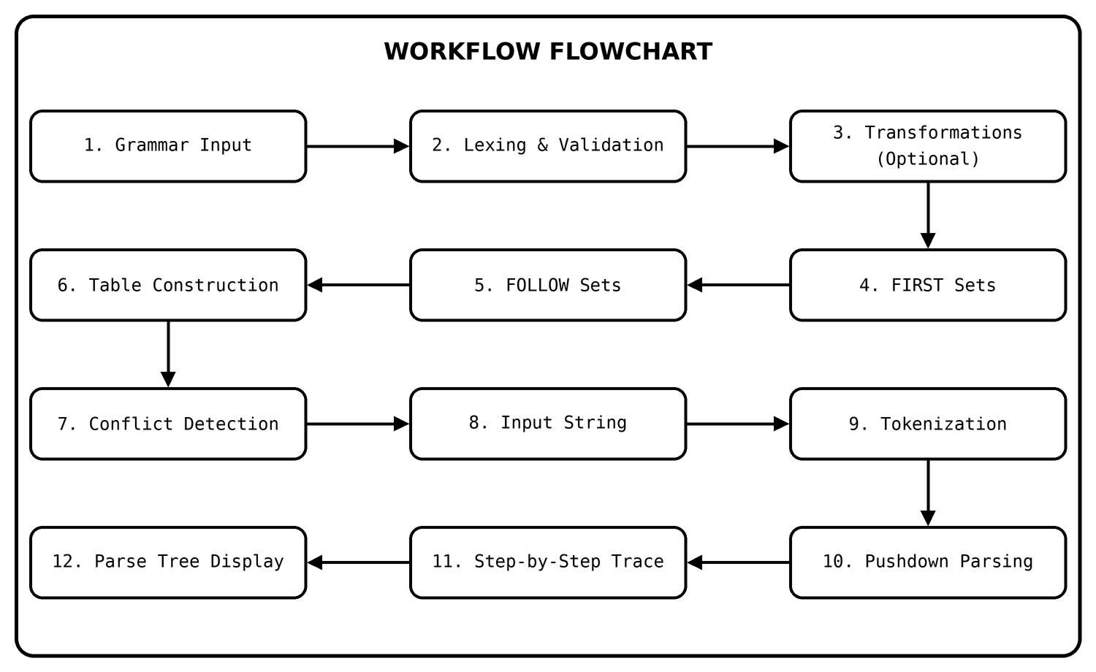
Figure 2: End-to-end workflow of the application

