PREDICTIVE PARSER GENERATOR
Interactive LL(1) Compiler Design System — Review 3 Project Report
Project Title | Predictive Parser Generator (Interactive LL(1) Web Platform)
Course / Subject | Compiler Design Lab (BCSE307P / BCSE303L) — Slot: L37+L38
Student & Reg. No.
Team Members | Dhyey Dharmeshbhai Dumasia, Pamela Mukherjee, Mayukh Sarkar
Project Links | GitHub Repository: github.com/dhyeydumasia24022006/Predictive-Parser-Generator  Live Deployed Page: dhyeydumasia24022006.github.io/Predictive-Parser-Generator/

1. Project Overview

1.1 Problem Statement
Syntactic analysis (parsing) begins with the lexical tokens in a linear stream by a scanner, and transforms them into a tree structure satisfying the desires of a CFG. An LL(1) predictive parser is a sound and complete top-down set in advance parser, which makes all its decisions using just one token of look-ahead and a pushdown stack. While conceptually straightforward, learning, and developing predictive parsers by hand gives students formidable practical challenges:
- Calculating FIRST and FOLLOW sets manually can be cumbersome and error-prone: the iterative fixed point calculations often propagate among linked non-terminals. For a grammar with multiple alternations, epsilon transitions and cycles in derivations, the calculations are a pain.
- Errors in Building Table: M[A, a] an easy mistake to make when constructing the table is to give non-terminals as rows and terminals as columns. With an arithmetic mistake in FIRST or FOLLOW, a rule can be mis-placed or not placed at all and, which can confuse the students as to which rule to use with manual traces.
- Various Grammars and Transformations: Top-down parsers are unable to parse grammars that are Left-Recursive (as they cause an infinite recursion while expanding) or having common prefixes (which cannot be distinguished by one lookahead token). As students change their grammars by building grammars out of their grammars (via Left Recursion elimination and Left Factoring), they lose the original grammars.
- Static Slow Paper Traces Tracing a pushdown automaton on paper is a slow process. When there is a mismatch or syntax error, students cannot easily step back, examine stack states, or see how a derivation tree is forming.
These problems are tackled in an interactive, zero-latency, online educational environment through automated validation of grammars, set calculations, construction of LL(1) tables, non-destructive grammars transformations, interactive step-by-step simulation of the pushdown automaton, and a dynamic SVG parse tree visualization.

1.2 Project Objectives
The primary objectives of the Predictive Parser Generator project are:
1. -Grammar Input and Syntax Check: Enable your users to input arbitrary CFGs with basic BNF notation with terminals, non-terminals, ''/'eps'/'epsilon' (epsilon), and start symbols automatically detected.
2. Automated Fixed-Point Set Generation: on request, generate mathematically correct FIRST and FOLLOW sets, by applying standard iterative closure algorithms.
3. Automate LL(1) Table Generation for your LL(1) grammar, fill in the matrix M[A, a], check for LL(1) compliance, mark conflicts in red, diagnose the reasons for conflicts (direct left recursion, common prefix or FIRST/FOLLOW conflict).
4. Non-Destructive Grammar Transformations: Enable one-click algorithms for removing immediate left recursion, left factoring, and others, without changing the student's original input text in the editor and documenting the resulting new grammar in a separate card.
5. Interactive Stack Simulator - execute the pushdown automaton (Play/Pause, Step Next/Previous, Reset) while observing the stack, input, and rules (expanded).
6. Dynamic Derivation Tree Rendering: show an interactive SVG derivation tree with differently colored nodes and formatted text hierarchy.

1.3 Project Scope
To maintain focus on deterministic top-down syntax analysis within the academic semester timeline, the project boundary was defined according to the following explicit scope matrix:
Technical Dimension | In-Scope (Implemented) | Out-of-Scope (Excluded)
Grammar Types | Context-Free Grammars (CFGs) with single non-terminal LHS and arbitrary RHS symbols. | Context-sensitive, Type-0 grammars, or raw regular expressions.
Parsing Method | Top-down deterministic LL(1) parsing using pushdown stack and table M[A, a]. | Bottom-up parsing (LR(0), SLR(1), LALR(1), CLR(1)) and backtracking.
Lookahead Depth | Strictly 1 lookahead token (k = 1) with '$' marking end of input. | Multi-token lookahead parsers (LL(k) for k > 1).
Transformations | Automated immediate left recursion elimination and iterative left factoring. | Automated semantic analysis, type checking, or symbol tables.
Input Processing | Greedy maximal-munch tokenizer supporting spaced ('id + id') and unspaced ('id+id'). | Full lexical analyzer generators (such as Lex or Flex specifications).
Output Display | Step-by-step trace table, color-coded interactive SVG tree, and ASCII tree. | Intermediate code generation (three-address code) or assembly emission.

1.4 Proposed Technical Approach
Instead of designing a typical client-server app architecture with highly reliant server side setups (e.g. Python Flask/Django, Node/Express etc.) we settled to building a solely client-side computing approach. All parsing engines, set calculations, tree coordinate layout engines are run directly from the user browser runtime environment in pure modern JavaScript ES Module (ESM) standards. This technical decision has some major upside benefits:
- Zero Server Latency: Grammars are parsed, tables are synthesized, and sentences are simulated in under a millisecond without network delay.
- Offline Functionality and Dependability - Once loaded, the web app is completely online independent and does not rely on calls to an API or database outages.
- Headless Testing Convergence: with all back-end modules having absolutely zero DOM dependencies, identical mathematical calculations can be headlessly performed in Node. js for robust automated unit test validation.

2. System Architecture & Implemented Modules

2.1 Overall System Architecture
The project workspace is clearly separated into two tiers: frontend/ (the presentation/visualization layer, written with React 19 + Vite 8) & backend/ (algorithmic compiler engine, written with regular ES Modules). Components connect using single directional reactive data flow, and App. Jsx orchestrates the data flow.2.2 System Architecture Diagram
These diagram depicts the entire structure of the Predictive Parser Generator, illustrating how the interface of the user browser connects the backend components of the compiler engine calculation:
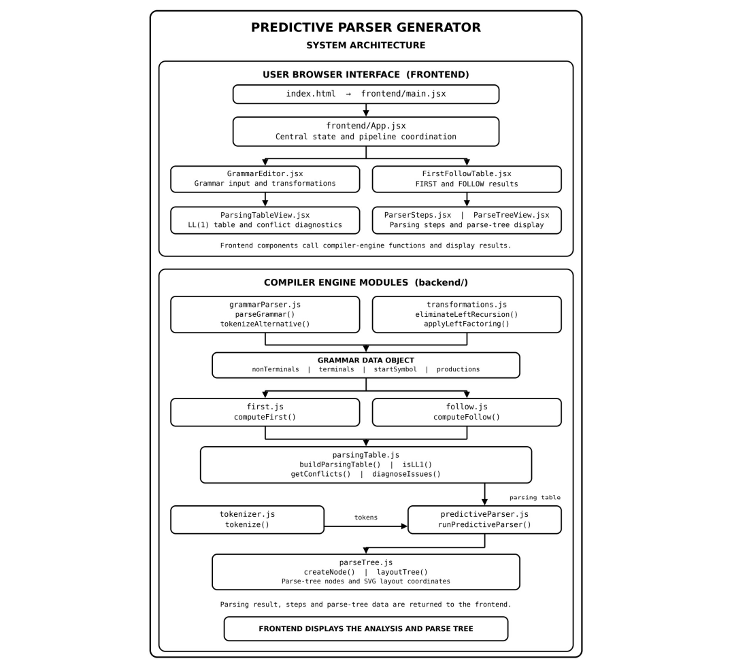
Figure 1: System architecture of the Predictive Parser Generator

2.3 Frontend Modules & Component Specifications
The frontend is implemented as a high-performance Single Page Application (SPA). The components and their roles include:
Component Name | Tab / Location | Operational Responsibilities
frontend/App.jsx | Root Pipeline | Main state manager; coordinates calculations across tabs; passes reactive props and transformation callbacks.
Pipeline.jsx | Top Navigation Bar | 5-stage progress indicator (Grammar → FIRST & FOLLOW → LL(1) Table → Parser → Parse Tree) displaying active and completed steps.
GrammarEditor.jsx | Tab 0: Grammar | Textarea for grammar input; symbol insertion buttons ('→', 'ε'); sample grammar loader; error alerts; transformation controls.
FirstFollowTable.jsx | Tab 1: Sets | Side-by-side mathematical table displaying calculated FIRST and FOLLOW sets formatted in clean { ... } notation.
ParsingTableView.jsx | Tab 2: Table | Renders matrix M[A, a]; highlights multi-rule collisions in red; shows diagnostic alerts; renders the new Revised Grammar Card.
ParserSteps.jsx | Tab 3: Parser | Execution controls (Next, Prev, AutoPlay, Reset); token stream preview; formatted chronological stack trace table.
ParseTreeView.jsx | Tab 4: Tree | Visual derivation tree rendered via SVG with color-coded nodes (Blue=NT, Green=Terminal, Purple=Epsilon) and ASCII view.

2.4 Backend Compiler Engine Modules
The compiler core comprises nine specialized, decoupled JavaScript modules located in backend:
1. Constants.js: Accepted compiler constants (EPSILON = '', END_MARKER = '$'). The single Greek letter removes spelling differences between 'eps' and 'epsilon'.
2. GrammarParser.js: Reads raw text using a two-pass algorithm. Pass 1 checks LHS identifiers; Pass 2 enforces strict arrow syntax, splits alternatives, normalizes epsilon, and extracts terminals and non-terminals.
3. Transformations.js: Uses Algorithm 4.19 from the Dragon Book for immediate left recursion elimination and greedy left factoring.
4. First.js: Computes FIRST sets for single symbols and arbitrary strings of symbols iteratively with fixed-point closure.
5. Follow.js: calculates FOLLOW set using all three Dragon Book rules with end-marker '$' on start symbol.
6. ParsingTable.js: builds table M[A, a], tests for LL(1) correctness and runs automated root-cause analysis on conflicting cells.
7. Tokenizer.js: maximal-munch greedy tokenizer, which translates strings into known grammar terminals with trailing '$'.
8. PredictiveParser.js: performs a simulation of the set in advance pushdown automaton, with a safeguard of 500 steps, and logs state snapshots.
9. Concurrently builds tree nodes during parsing and computes spatial (X, Y) coordinates for visual SVG drawing.

2.5 Recent Architectural Enhancement: Non-Destructive Transformations
A key new addition to the workspace is the non-destructive transformation workflow. In previous revisions, pressing 'Eliminate Left Recursion' or 'Left Factor' would actually replace the Grammar Editor textarea text with the transformed version, eliminating the original form of the grammar the students typed in. In the new workflow:
- Original Text Maintained: App. Jsx saves the original grammar input text provided by the user to grammar text.
- Revised grammar pipeline: The printFiltered revised grammar is written to revisedGrammarText and then parsed in the downstream pipeline (sets table parser).
- Grammar Editor Notification banner: a warning banner found within Grammar Editor. Jsx informs the user that an active grammar has been transformed.
- Interactive Revised Grammar Card: ParsingTableView. Jsx displays a prominent card for the revised rules with syntax highlighting, transformation badge labels (e.g. ' Left Recursion Eliminated (created E', T')'), and 3 inline action buttons (Copy Revised Grammar, Load into Editor, Revert to original).

2.6 Integrated Data Flow Pipeline
The end-to-end data flow operates in six coordinated phases:
1. Raw string is taken in and processed by grammarParser.js into a validated Grammar data object.
2. Optional Transformation: transformations.js, when invoked, outputs optimized grammar text, everything else remains as input.
3. Fixed-Point Sets: first.js computes FIRST sets FOLLOW.js then uses to create FOLLOW sets.
4. Table synthesis: parsingTable. js assigns M[A, a] and checks isLL1. Conflicts result in diagnostic workup.
5. Tokenization & Pushdown Execution The string is tokenized by tokenizer. js and then the predictionStep function in predictiveParser. js emulates the step-by-step execution of the parser.
6. Visualization: ParserSteps. Jsx Draws the step trace. ParseTreeView. Jsx Draws the SVG derivation tree.

3. Formal Grammar Representation & Compiler Algorithms

3.1 Context-Free Grammar (CFG) Mathematical Definition
The formal definition of a Context-Free Grammar G as a 4-tuple: G = (V_N V_T P, S), where:
- V_N = a finite set of the Non-Terminal symbols indicating the syntactic categories.
- V T is a finite set of Terminal symbols, i.e. tokens of the language, such that V T and V N are disjoint.
- where P is a finite set of Production Rules of the form A , with A V_N and (V_N V_T)*.
- S V_N is the Start Symbol.

3.2 Grammar Input Format & Normalization Rules
- Unicodes_ARROW: Productions should prefer Unicode arrow "". ASCII arrows ("->", "=>", "::=") are rejected with line number diagnostics.
- Symbol Naming: each non-terminal starts with a letter and continues with a letter digit underscore or prime (E, E', Term).
- Terminals: Any token in the RHS other than a V_N The special cases are tokens like 'id' or 'num' which are left as an atomic token.
- Epsilon Forms: Forcing of any variants of '', 'eps', 'epsilon', 'EPSILON' or empty rhs on to the binding constant ''. Any other term beginning with epsilon name cannot be glued with other tokens.

3.3 Grammar Transformations (Before & After)
Common prefix (A 1 | 2) and immediate left recursion (A) rewrite rules are not possible for top-down parsers to parse. The application automates transforms for these two cases:
--- BEFORE TRANSFORMATION (Left-Recursive Expression Grammar) ---
E → E + T | T
T → T * F | F
F → ( E ) | id
--- AFTER IMMEDIATE LEFT RECURSION ELIMINATION (Dragon Book Algorithm 4.19) ---
E → T E'
E' → + T E' | ε
T → F T'
T' → * F T' | ε
F → ( E ) | id
--- COMMON PREFIX LEFT FACTORING EXAMPLE ---
Before: S → abA | abB | c
After: S → ab S' | c
S' → A | B

3.4 Compiler Algorithms: Logic and Pseudocode
Below are the step-by-step logic descriptions and pseudocode for all core algorithms implemented in backend/:

Algorithm 1: Grammar Parsing and Lexical Validation (grammarParser.js)
function parseGrammar(text):
lines = splitLines(text)
Pass 1: declaredNTs = scanLHSNonTerminals(lines)
Pass 2: for each line in lines:
if '→' not in line: reportError('Missing arrow on line ' + lineNo)
lhs = extractLHS(line)
for alt in splitByPipe(getRHS(line)):
symbols = greedySubTokenize(alt, declaredNTs)
productions.add({ lhs, rhs: symbols })
terminals = extractTerminals(productions) - declaredNTs
terminals.add('$')
return Grammar({ nonTerminals, terminals, startSymbol, productions })

Algorithm 2: Immediate Left Recursion Elimination (transformations.js)
function eliminateLeftRecursion(grammarText):
for each non-terminal A:
alphas = []; betas = []
for each alternative A → α of A:
if α begins with A: alphas.add(α[1:]) // recursive
else: betas.add(α) // non-recursive
if alphas is not empty:
create unique prime symbol A'
rewrite A productions to: [ β + A' for β in betas ]
rewrite A' productions to: [ α + A' for α in alphas ] + ['ε']
return { transformed: true, text: reconstructedGrammarText }

Algorithm 3: Left Factoring Common Prefixes (transformations.js)
function applyLeftFactoring(grammarText):
repeat until no non-terminal has alternatives sharing common prefixes:
for each non-terminal A:
prefix = findLongestCommonPrefix(A.alternatives)
if prefix is not empty:
create unique prime symbol A'
matching = alternatives starting with prefix
remainders = [ alt.slice(prefix.length) or 'ε' for alt in matching ]
A.productions = [ prefix + A', nonMatchingAlternatives ]
A'.productions = remainders
return { transformed: true, text: factoredGrammarText }

Algorithm 4: Iterative Fixed-Point FIRST Set Computation (first.js)
function computeFirst(grammar):
for terminal t in grammar.terminals: FIRST[t] = { t }; FIRST['ε'] = { 'ε' }
for non-terminal A in grammar.nonTerminals: FIRST[A] = {}
changed = true
while changed:
changed = false
for each production A → Y_1 Y_2 ... Y_k:
for i = 1 to k:
FIRST[A].addAll(FIRST[Y_i] - { 'ε' })
if 'ε' not in FIRST[Y_i]: break
if i == k: FIRST[A].add('ε')
return FIRST

Algorithm 5: Iterative Fixed-Point FOLLOW Set Computation (follow.js)
function computeFollow(grammar, firstSets):
for A in grammar.nonTerminals: FOLLOW[A] = {}
FOLLOW[grammar.startSymbol].add('$')
changed = true
while changed:
changed = false
for each production A → α B β:
FOLLOW[B].addAll(FIRST(β) - { 'ε' })
if 'ε' in FIRST(β) or β is empty:
FOLLOW[B].addAll(FOLLOW[A])
return FOLLOW

Algorithm 6: LL(1) Predictive Parsing Table Construction (parsingTable.js)
function buildParsingTable(grammar, firstSets, followSets):
for each production A → α:
firstAlpha = computeFirstOfSequence(α, firstSets)
for each terminal a in (firstAlpha - { 'ε' }):
M[A, a].add(A → α)
if 'ε' in firstAlpha:
for each terminal b in followSets[A]:
M[A, b].add(A → α)
isLL1 = all cells in M contain at most 1 production
return { table: M, isLL1 }

Algorithm 7: Non-LL(1) Conflict Detection and Diagnosis (parsingTable.js)
function diagnoseGrammarIssues(grammar, table, firstSets, followSets):
conflicts = getCellsWithMultipleProductions(table)
for each conflict at cell (A, a):
if any production of A has direct left recursion (A → A α):
report('Left Recursion Conflict on ' + A + ': apply Left Recursion Elimination')
if two alternatives share common FIRST terminal:
report('Common Prefix Conflict on ' + A + ': apply Left Factoring')
if 'ε' in FIRST[A] and (FIRST[A] ∩ FOLLOW[A]) is not empty:
report('FIRST/FOLLOW Overlap Conflict on ' + A)
return diagnosticList

Algorithm 8: Stack-Based Predictive Pushdown Automaton (predictiveParser.js)
function runPredictiveParser(grammar, table, tokens):
stack = ['$', grammar.startSymbol]; ip = 0; step = 0
while stack is not empty and step < 500:
top = stack.top(); a = tokens[ip]
if top == '$' and a == '$': recordStep('Accept'); return SUCCESS
if isTerminal(top):
if top == a: stack.pop(); ip++; recordStep('Match ' + a)
else: return ERROR('Mismatched terminal: expected ' + top)
else if isNonTerminal(top):
prod = table[top, a]
if not prod: return ERROR('Syntax error: no rule for ' + top + ' on ' + a)
stack.pop()
if prod.rhs != ['ε']: pushReverse(stack, prod.rhs)
recordStep('Apply ' + format(prod))
return traceHistory

Algorithm 9: Parse Tree Construction & Spatial Layout (parseTree.js)
function layoutTree(rootNode):
leafX = 0
function assignCoordinates(node, depth):
node.y = depth * 72px
if node.children is empty: node.x = (leafX++) * 64px
else:
for child in node.children: assignCoordinates(child, depth + 1)
node.x = (node.children[0].x + node.children[last].x) / 2
assignCoordinates(rootNode, 0)
return rootNodeWithCoordinates

4. Complete Input-to-Output Demonstration
To verify all compiler stages end-to-end, we demonstrate the standard LL(1) arithmetic expression grammar parsing the input token sequence: id + id * id.

4.1 Grammar Specification & Vocabulary
E → T E'
E' → + T E' | ε
T → F T'
T' → * F T' | ε
F → ( E ) | id
Vocabulary: Terminals = { +, *, (, ), id }; Non-Terminals = { E, E', T, T', F }; Start Symbol = E.

4.2 Grammar Editor Interface (Website Verification)
The screenshot below illustrates the Grammar Editor interface in the deployed web application. It displays the syntax helper buttons ('Insert Arrow (→)', 'Insert ε'), the preset loader, and the grammar rules entered:
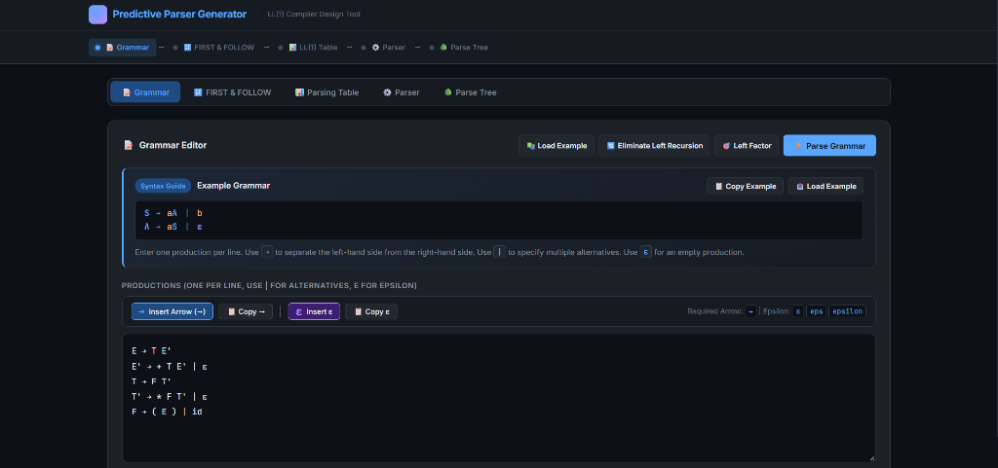
Figure 2: Grammar Editor interface with syntax guide and arithmetic expression grammar.

4.3 Computed FIRST and FOLLOW Sets
The table below shows the mathematically computed FIRST and FOLLOW sets for the five non-terminals, followed by the corresponding live screenshot from the application's FIRST & FOLLOW Sets tab:
Non-Terminal | FIRST Set | FOLLOW Set
E | { (, id } | { ), $ }
E' | { +, ε } | { ), $ }
T | { (, id } | { +, ), $ }
T' | { *, ε } | { +, ), $ }
F | { (, id } | { *, +, ), $ }
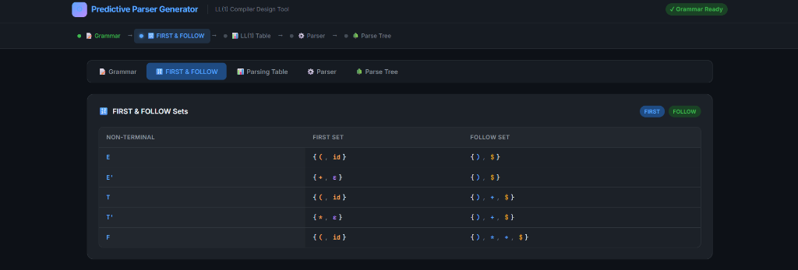
Figure 3: Computed FIRST and FOLLOW Sets rendered in Tab 1 of the web platform.

4.4 LL(1) Predictive Parsing Table Construction
Using the FIRST and FOLLOW sets, the 2D predictive parsing table M[A, a] is populated. Every cell contains at most one production rule, proving that the grammar is deterministic LL(1) with 0 conflicts:
NT \ INPUT | ( | ) | * | + | id | $
E | E → T E' | — | — | — | E → T E' | —
E' | — | E' → ε | — | E' → + T E' | — | E' → ε
T | T → F T' | — | — | — | T → F T' | —
T' | — | T' → ε | T' → * F T' | T' → ε | — | T' → ε
F | F → ( E ) | — | — | — | F → id | —
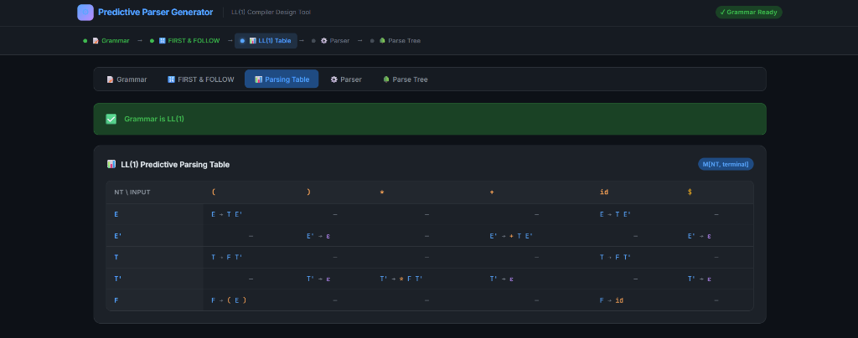
Figure 4: LL(1) Predictive Parsing Table with green 'Grammar is LL(1)' verification banner.

4.5 Stack-Based Predictive Parsing Simulation
The user inputs 'id + id * id' in the Parser tab. The maximal-munch tokenizer converts it to [id, +, id, *, id, $]. The pushdown automaton begins with stack [$ E] and advances deterministically through 18 execution steps, terminating in the 'Accept' state. The screenshot and complete trace table below detail the entire process:
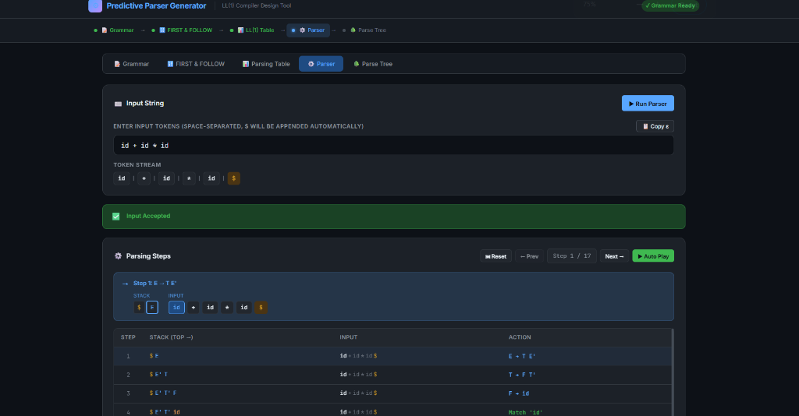
Figure 5: Stack-Based Predictive Parser in action, showing 'Input Accepted' and live step trace.
Step | Stack (Top on Right) | Remaining Input | Action Taken
1 | $ E | id + id * id $ | Apply: E → T E'
2 | $ E' T | id + id * id $ | Apply: T → F T'
3 | $ E' T' F | id + id * id $ | Apply: F → id
4 | $ E' T' id | id + id * id $ | Match terminal: 'id'
5 | $ E' T' | + id * id $ | Apply: T' → ε
6 | $ E' | + id * id $ | Apply: E' → + T E'
7 | $ E' T + | + id * id $ | Match terminal: '+'
8 | $ E' T | id * id $ | Apply: T → F T'
9 | $ E' T' F | id * id $ | Apply: F → id
10 | $ E' T' id | id * id $ | Match terminal: 'id'
11 | $ E' T' | * id $ | Apply: T' → * F T'
12 | $ E' T' F * | * id $ | Match terminal: '*'
13 | $ E' T' F | id $ | Apply: F → id
14 | $ E' T' id | id $ | Match terminal: 'id'
15 | $ E' T' | $ | Apply: T' → ε
16 | $ E' | $ | Apply: E' → ε
17 | $ | $ | Accept (Stack empty & Input consumed)
18 | $ | $ | Parsing successfully completed

4.6 Parse Tree Visualization (Website Verification)
Concurrently with the pushdown automaton trace, parseTree.js constructs the derivation tree nodes. The screenshot below presents the interactive SVG-rendered parse tree from the application's Parse Tree tab. Nodes are color-coded: Non-terminals in Blue, Terminals in Green, and Epsilon transitions in Purple. The hierarchy clearly confirms that multiplication binds more tightly than addition:
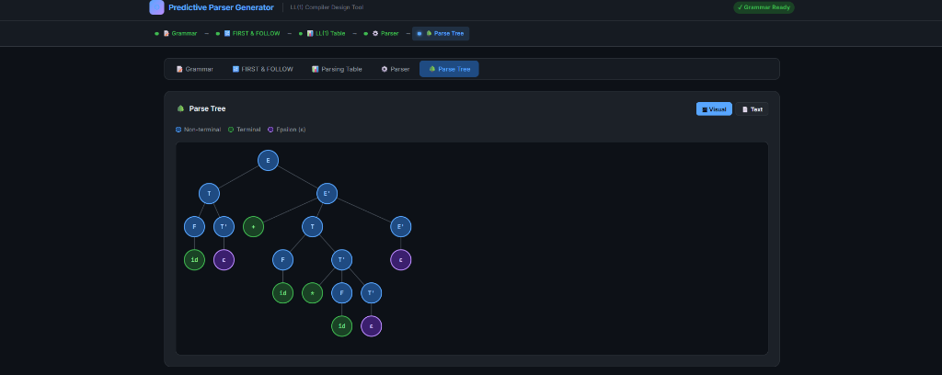
Figure 6: Final Parse Tree visualization rendered via SVG on the web platform.

5. Testing, Error Handling, and Known Limitations

5.1 Automated Unit Testing Architecture
To guarantee mathematical correctness and algorithmic robustness, the backend compiler engine is paired with a headless automated test runner (backend/__tests__/grammarTests.js) executed via Node.js. It exercises 16 test suites encompassing 59 assertions without requiring browser DOM instantiation. All 59 assertions pass with 100% success rate.
Suite | Test Target & Scope | Assertions | Status
Test 1 | Simple Grammars: Non-terminal/terminal detection, FIRST/FOLLOW correctness, LL(1) valid. | 6 | Passed
Test 2 | Epsilon Productions: Multi-level nullability propagation, FIRST set bleedthrough, FOLLOW rules. | 7 | Passed
Test 3 | Left-Recursive Grammars: Detection of direct left recursion; correctly marked as NOT LL(1). | 3 | Passed
Test 4 | Right-Recursive Grammars: Deterministic top-down right-recursive grammar confirmed as LL(1). | 2 | Passed
Test 5 | Multiple Alternatives: Branching alternatives per non-terminal with disjoint FIRST sets. | 2 | Passed
Test 6 | Common Prefixes: Common prefix grammars (S → abA | abB) flagged as NOT LL(1). | 2 | Passed
Test 7 | Multi-Character Terminals: Preserving multi-character keywords ('id') without character splitting. | 2 | Passed
Test 8 | Multi-Character Non-Terminals: Validating identifiers with primes and words ('ExprPrime'). | 3 | Passed
Test 9 | Arrow Enforcement: Strict Unicode '→' accepted; ASCII '->', '=>', '::=' rejected with errors. | 4 | Passed
Test 10 | Epsilon Representations: Normalizing 'ε', 'eps', 'epsilon', 'EPSILON', and empty RHS. | 6 | Passed
Test 11 | Malformed Grammar Diagnostics: Missing arrows, empty LHS, invalid epsilon placement with line numbers. | 3 | Passed
Test 12 | Tokenizer Precision: Space-separated, contiguous ('aab'), and arithmetic expressions with '$'. | 3 | Passed
Test 13 | Pushdown Simulation: Trace generation, parse tree construction, acceptance of valid inputs, error on invalid. | 5 | Passed
Test 14 | Immediate Left Recursion Elimination: Replaces A → Aα | β with A → βA', A' → αA' | ε. | 3 | Passed
Test 15 | Left Factoring Algorithm: Extracts common prefixes into prime non-terminals with remainder alternatives. | 3 | Passed
Test 16 | Non-Destructive Transformation: Verifies original grammar retains 6 rules while revised has transformed rules. | 5 | Passed

5.2 Multi-Tier Error Handling
- Grammar syntax errors: each line in the input is read by grammarParser.js. Missing arrows, multiple arrows, invalid non-terminal identifiers, or invalid epsilon pairings immediately generate descriptive error cards indicating exact line numbers.
- Collision Detection for Non-LL(1): parsingTable.js finds collisions in M[A, a]. Cells in the table with conflicts are drawn red borders and the collision type (FIRST/FIRST or FIRST/FOLLOW) is listed in the diagnostics panel.
- Lexical Tokenizer Errors: tokenizer.js throws an error banner for all characters not matched to a known grammar terminal (before starting the parser).
- Pushdown automaton runtime errors: predictiveParser.js cleanly aborts with descriptive messages for empty table cells, terminal mismatch on top of stack, or remaining unprocessed tokens at '$'. Safety cap of 500 steps stops the browser from hanging on cyclic non-LL(1) grammars.

5.3 Known Technical Limitations
- Scope confines to LL(1): grammars that are inherently ambiguous or require k> 1 lookaheads will lead to table conflicts that may not be parseable top-down deterministically.
- Automated rule substitution Only: The auto-transformation automates immediate left recursion (A A). Indirect left recursion (A B A) is best solved by separate rule substitution before parsing.
- Epsilon Constraint: Epsilon is the empty transition. That symbol cannot be concatenated with other symbols in the same RHS alternative.

6. Installation and Complete Workflow Guide

6.1 Prerequisites and Local Setup
Prerequisites: Node.js 18.0+ and npm 9.0+ installed on Windows, macOS, or Linux. Git for repository cloning. Modern web browser.
# 1. Clone the repository from GitHub
git clone https://github.com/dhyeydumasia24022006/Predictive-Parser-Generator.git
cd Predictive-Parser-Generator
# 2. Install dependencies (React 19, Vite 8, Oxlint)
npm install
# 3. Available npm scripts
npm run dev # Starts Vite development server at http://localhost:5173
npm test # Runs automated compiler engine tests (16 test suites, 59 assertions)
npm run lint # Runs Oxlint code quality verification across all files
npm run build # Builds production bundle into dist/ directory
npm run preview # Locally previews the production build

6.2 Complete 12-Step Project Workflow Table
The table below details the complete user and algorithmic workflow from grammar ingestion to parse tree rendering:
Step # | Workflow Phase & Module | Operational Behavior & Outcome
Step 1 | Grammar Entry  (GrammarEditor.jsx) | User inputs grammar productions or selects a preset. Helper buttons insert '→' and 'ε'.
Step 2 | Syntax Validation  (grammarParser.js) | User clicks 'Parse Grammar'. System scans lines, enforces arrow syntax, and identifies V_N and V_T.
Step 3 | Transformations  (transformations.js) | If conflicts exist, user triggers 'Eliminate Left Recursion' or 'Left Factor'. Original grammar is preserved in editor.
Step 4 | FIRST Computation  (first.js) | computeFirst() executes iterative fixed-point closure for all symbols and sequences, handling nullability.
Step 5 | FOLLOW Computation  (follow.js) | computeFollow() places '$' in FOLLOW(startSymbol) and iteratively evaluates Dragon Book rules 1, 2, and 3.
Step 6 | Table Construction  (parsingTable.js) | buildParsingTable() populates M[A, a] for FIRST(RHS) and FOLLOW(LHS) when RHS derives epsilon.
Step 7 | Conflict Detection  (parsingTable.js) | isLL1() verifies determinism. Conflicting cells highlighted in red with root-cause diagnostic explanations.
Step 8 | Input String Entry  (ParserSteps.jsx) | User enters an input test string (e.g., 'id + id * id') in the Parser tab.
Step 9 | Tokenization  (tokenizer.js) | tokenize() splits input using maximal-munch matching against grammar terminals and appends '$'.
Step 10 | Predictive Parsing  (predictiveParser.js) | runPredictiveParser() executes pushdown automaton using stack [$, S] up to 500 steps, recording trace snapshots.
Step 11 | Trace Display  (ParserSteps.jsx) | Trace table displays each step's stack snapshot, remaining input, and action with manual and auto controls.
Step 12 | Parse Tree Display  (ParseTreeView.jsx) | Derivation tree is displayed in interactive SVG format with color-coded nodes and in formatted ASCII text.

6.3 End-to-End Workflow Flowchart
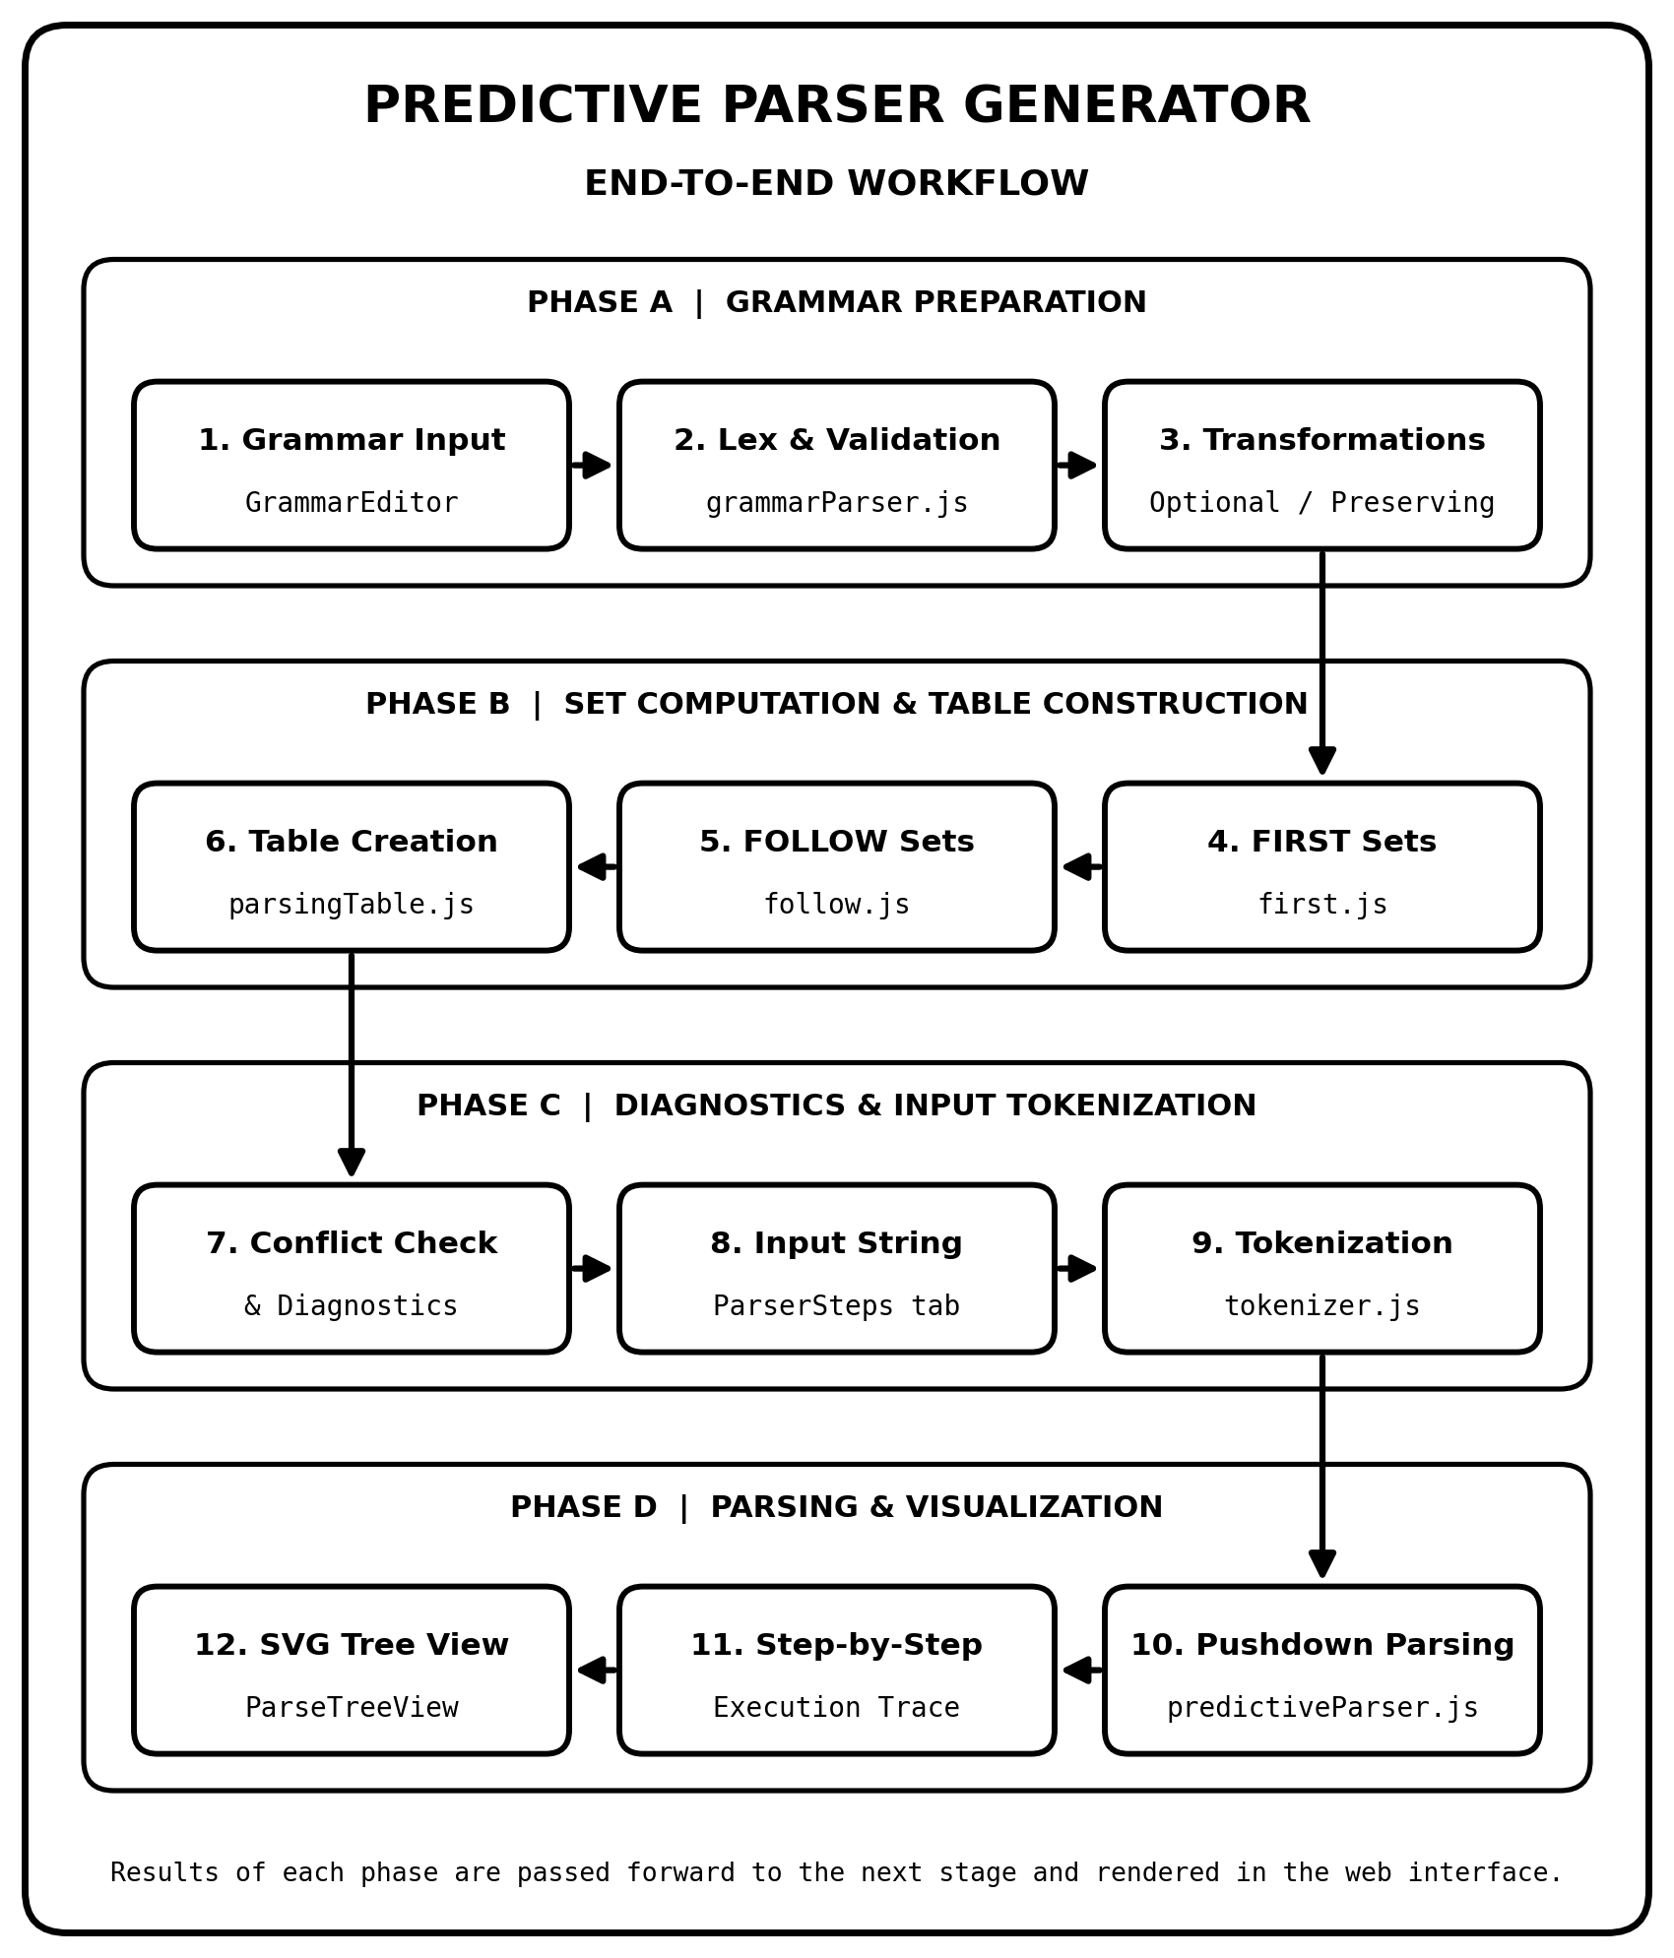

7. GitHub Repository and Live Website
The project is open source and hosted publicly on GitHub with automated Continuous Deployment (CI/CD) via GitHub Actions to GitHub Pages. Both resources are verified and directly accessible via the clickable links below:
Resource | Clickable URL | Deployment & Verification Details
GitHub Repository  (Source Code) | https://github.com/dhyeydumasia24022006/Predictive-Parser-Generator | Public GitHub repository containing complete modular codebase (frontend/ & backend/), automated test suite, Vite configuration, and CI/CD workflow.
Live Deployed Website  (GitHub Pages) | https://dhyeydumasia24022006.github.io/Predictive-Parser-Generator/ | HTTP 200 Verified. Deployed via GitHub Actions (.github/workflows/deploy.yml) on push to main branch. Verified active with latest assets and non-destructive transformations.

8. Conclusion and Future Improvements

8.1 Conclusion and Project Retrospective
The Predictive Parser Generator fulfills all the requirements of an interactive powerful pedagogic compiler engineering environment. Basically, it removes the abstraction of the design concepts of iterative fixed-point set closure, fixed LL(1) table generation, and pushdown stack operation and presents it in form of visual calculation, which can be performed interactively.
Key Accomplishments Achieved:
Pure Client-Side Architecture Decoupled backend calculative engine in pure ES modules with zero DOM dependencies, providing sub-millisecond responsiveness with no server latency or hosting overhead.
Non-Destructive Workflow: The added changes preserve the initial input text in the Grammar Editor, and show the resulting altered LL(1) grammars in a second interactive card on the Parsing Table page.
Full testing: 16 automated test suites with 59 assertions all pass at 100%, code verified with 0 Oxlint warnings, automated continuous deployment to Github pages.

8.2 Future Improvements and Roadmap
To improve the class and practical use of PPG in future milestones, the general plan has been suggested.
1. Indirect Left Recursion Elimination: extend the transformation engine so it will eliminate cyclic derivations made of multiple steps (e.g. A B, B A) automatically by following production rules until the candidate is put into immediate left recursion form.
2. Bottom-Up Parser Extensions (LR family): for each of the below types, provide code that generates action/goto tables, defines sets of common items, and the code needed to run them. LR(0)/SLR(1)/LR(1)/LALR(1).
3. Semantic Actions and Attribute Grammars: show students how to include SDD semantic actions (e.g. the calculations needed to evaluate an expression) into the rules of the grammar, and view the result of computed synthesized attributes on the parse tree.
4. One-Click Multi-Format Export: an export feature that allows students and instructors to export parsing tables and step traces as LaTeX tabular code, CSV spreadsheets, and publication-quality SVG or high-res PNG parse trees.

