Alpha Group

Bordwell

Hadi

Morales

Songcuan

Bacchus Winery

Business Rules

One employee has many clock ins

One supplier has many supplier_orders

One distributor has many distributor_orders

Assumptions

Distributors order by the case, not individual bottles

Case contains 12 bottles

Each bottle uses one cork, one label

if an employee clocks in, they work 8 hours that day

On time delivery of supplier order = delivered w/i 2 wks, late if > 2 wks

Use 2 vat, 8 tubing per month

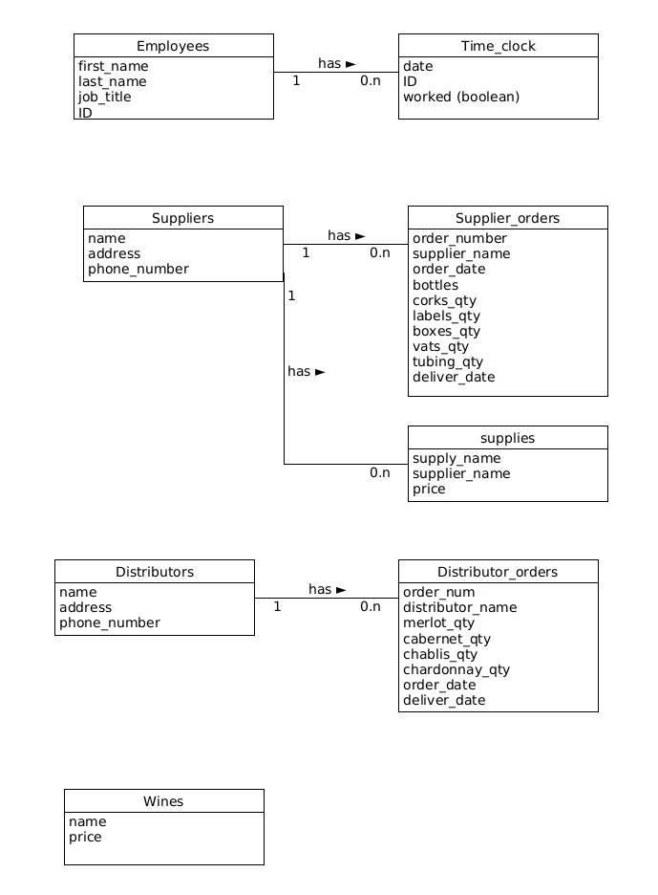

Github link

https://github.com/DHadi-5722/csd-310.git