Grazioso Salvare Animal Rescue Dashboard

Dhandeaka Harris-Kearse
Southern New Hampshire University
CS-340 Client/Server Development
Prof. Helen Gebre-Amlak

October 18, 2026

Project Overview
This project provides a Python dashboard for Grazioso Salvare to explore Austin Animal Center Outcomes records and identify dogs whose recorded characteristics match search-and-rescue training profiles. The dashboard connects to MongoDB through the reusable AnimalShelter class in CRUD_Python_Module.py from Project One.
The application combines rescue-category controls, an interactive data table, a breed-distribution pie chart, and a geolocation map. The Grazioso Salvare logo and the developer's name identify the dashboard.

Functionality
The initial view retrieves all records through db.read({}). Users can select Water Rescue, Mountain or Wilderness Rescue, Disaster or Individual Tracking, or Reset. Each selection runs a MongoDB query through the CRUD module and updates the table. Reset retrieves the complete dataset, including animals other than dogs.
The table displays ten records per page and supports pagination, sorting by multiple columns, column filtering, column highlighting, and single-row selection. The pie chart summarizes breed counts from the table's current filtered data. Selecting a row updates the map marker and displays the animal's breed and name through a tooltip and popup.

Implemented rescue queries
Category | Breeds matched, including breed mixes containing these names | Sex upon outcome | Age in weeks, inclusive
Water Rescue | Labrador Retriever, Chesapeake Bay Retriever, Newfoundland | Intact Female | 26–156
Mountain or Wilderness Rescue | German Shepherd, Alaskan Malamute, Old English Sheepdog, Siberian Husky, Rottweiler | Intact Male | 26–156
Disaster or Individual Tracking | Doberman Pinscher, German Shepherd, Golden Retriever, Bloodhound, Rottweiler | Intact Male | 20–300
Reset | All records | All | All
The three rescue queries also require animal_type to equal Dog. Breed matching uses case-insensitive regular expressions. These values describe the implemented code; compare them with the course Dashboard Specifications Document before submission.

Tools and Design Rationale
Tool | Role and rationale | Reference
MongoDB | Model and document storage. Its flexible documents represent shelter records, and its query operators support breed matching and numeric age ranges. PyMongo exposes documents as Python dictionaries. | https://www.mongodb.com/docs/
PyMongo | Connects the Python CRUD module to MongoDB and supports authenticated database operations. | https://www.mongodb.com/docs/languages/python/pymongo-driver/current/
Python | Implements the reusable database interface and dashboard logic in one language. | https://www.python.org/
Dash | Supplies layout components, the interactive table, and callbacks that connect user input to updated outputs. | https://dash.plotly.com/
JupyterDash | Runs the supplied Dash application from the course notebook environment. | https://github.com/plotly/jupyter-dash
pandas | Converts query results into DataFrames, removes MongoDB identifiers, and calculates breed counts. | https://pandas.pydata.org/docs/
Plotly Express | Creates the breed-distribution pie chart from the filtered table records. | https://plotly.com/python/plotly-express/
Dash Leaflet | Provides the interactive map, marker, tooltip, popup, and tile layer. | https://www.dash-leaflet.com/
JupyterLab and Codio | Provide the course development environment and notebook execution. | https://jupyterlab.readthedocs.io/ and https://www.codio.com/
GitHub | Hosts source code and documentation for reuse by other organizations. | https://github.com/

MVC organization
Model: MongoDB stores shelter records. CRUD_Python_Module.py provides the reusable interface to this data.
View: Dash renders the logo, developer identifier, rescue controls, data table, pie chart, and map.
Controller: Dash callbacks handle rescue selections, run CRUD read queries, and update the table and charts. Keeping database access in the CRUD module separates storage operations from presentation code.

Project Files
- ProjectTwoDashboard.ipynb: Dashboard layout, filtering logic, callbacks, and server startup.
- CRUD_Python_Module.py: Project One CRUD module containing the AnimalShelter class.
- code_files/Grazioso Salvare Logo.png: Client logo; adjust the notebook path to its actual location.
The Austin Animal Center CSV is supplied separately in the course environment. Use the exact provided filename when importing it.

Setup and Reproduction
- Open the course Codio workspace and confirm that MongoDB is running. Place the notebook and CRUD_Python_Module.py where Python can import the module.
- Use the Austin Animal Center Outcomes dataset and MongoDB setup from Project One. The CRUD module should connect to the aac database and animals collection. If recreating the database, import the provided CSV, replacing the placeholder path below:
mongoimport --db aac --collection animals --type csv --headerline --file /actual/path/to/aac_shelter_outcomes.csv
Import only once into the intended collection to avoid duplicate records. Supply the authentication options required by your MongoDB configuration.
- Configure the aacuser account as established in Project One. Ensure that its password matches the notebook and that the CRUD module uses the database where the account was created as its authentication source. The assignment requires credentials in the class instantiation; use only course-local credentials in this educational project.
- Confirm that the environment includes jupyter-dash, dash, dash-leaflet, plotly, pandas, pymongo, numpy, and matplotlib. The notebook uses the course's older JupyterDash and app.run_server() APIs, so preserve the working course package versions. For reproduction outside Codio, record the working environment with python -m pip freeze > requirements.txt and use compatible Python and MongoDB versions.
- Confirm that the import is from CRUD_Python_Module import AnimalShelter and that the class accepts the username and password. Its read method must accept a query dictionary and return records usable by pandas.
- Set image_filename to the actual logo path. A relative path is resolved from the notebook kernel's current working directory; an absolute path avoids this ambiguity.
- Run the notebook cells in order. The notebook reads all records, removes _id, creates the layout, registers callbacks, and starts the Dash server with app.run_server().
- Open the Codio preview for port 8050. If that port is occupied by a previous run, stop the earlier server or use another available port and its matching preview URL.
- Test every rescue category, row selection, sorting, pagination, and Reset. Save the screenshots listed below.
Note: The preview depends on the Codio workspace and running server; it is not a permanent public deployment.

Development Process
The dashboard builds on the MongoDB database and reusable CRUD module from Project One. The first step was retrieving all records into a DataFrame and removing _id so MongoDB ObjectId values would not interfere with table serialization. Next, the layout was assembled with branding, identification, rescue controls, and a paginated table.
The rescue categories were mapped to MongoDB query dictionaries. A callback passes the selected category's query to db.read() and returns the results to the table. A separate callback counts breeds from the table's derived data and builds a pie chart. The map callback uses the selected table row to display the animal's recorded location.
Challenges and Troubleshooting
Indentation: An IndentationError occurred in the chart callback. Replacing the callback with consistently indented code addressed the mismatched indentation. Function bodies use four spaces, and decorators and function definitions start at the left margin.
Logo path: A FileNotFoundError occurred when opening the logo. The relative path was interpreted from the notebook's working directory. The correction is to set image_filename to the verified location of the logo, using the full path when necessary.
Map edge cases: The supplied map callback assumes that a selected row exists and reads fields by column position. An empty selection or empty results can cause an error, and changed column order can select incorrect fields. Verify these cases during testing; a future improvement is to validate row selection and use named latitude, longitude, breed, and name fields.

Testing Evidence
Figure 1 — Initial dashboard
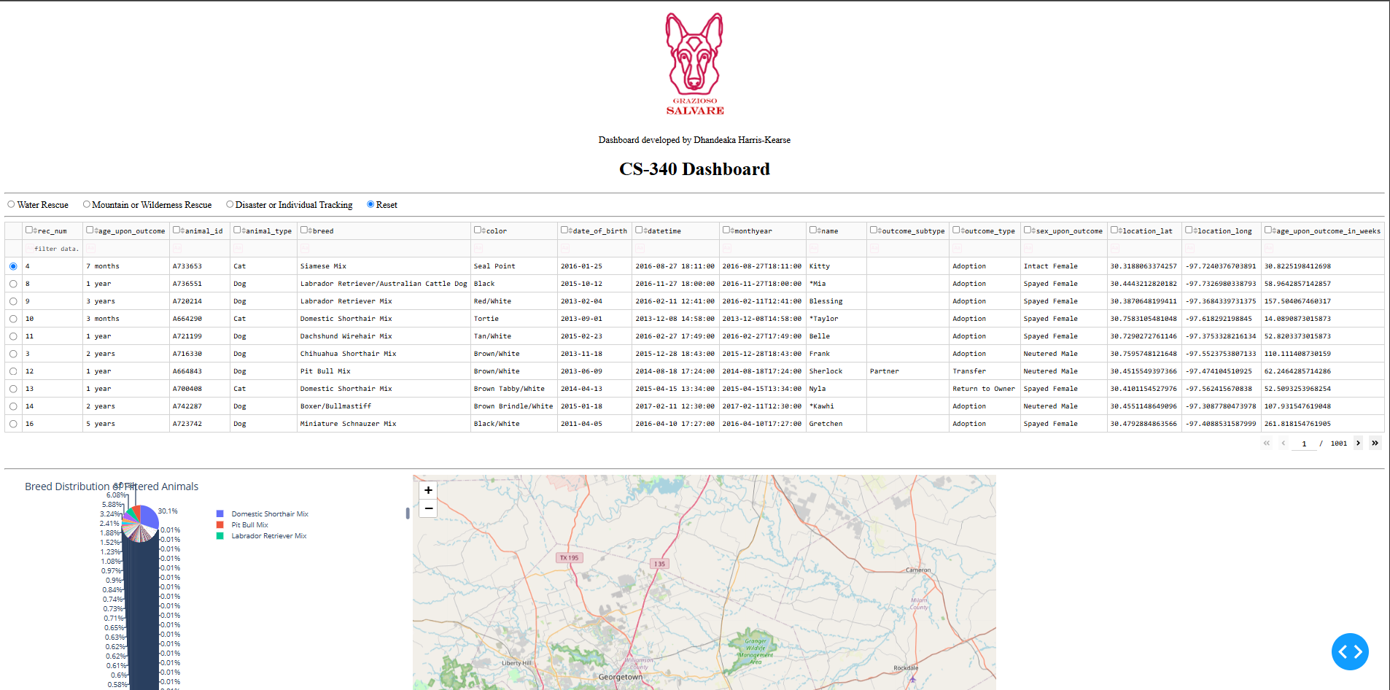
The initial dashboard displays the unfiltered shelter records, rescue-category controls, paginated data table, breed-distribution pie chart, and geolocation map. The Grazioso Salvare logo and developer identifier appear above the controls.
Figure 2 — Water Rescue
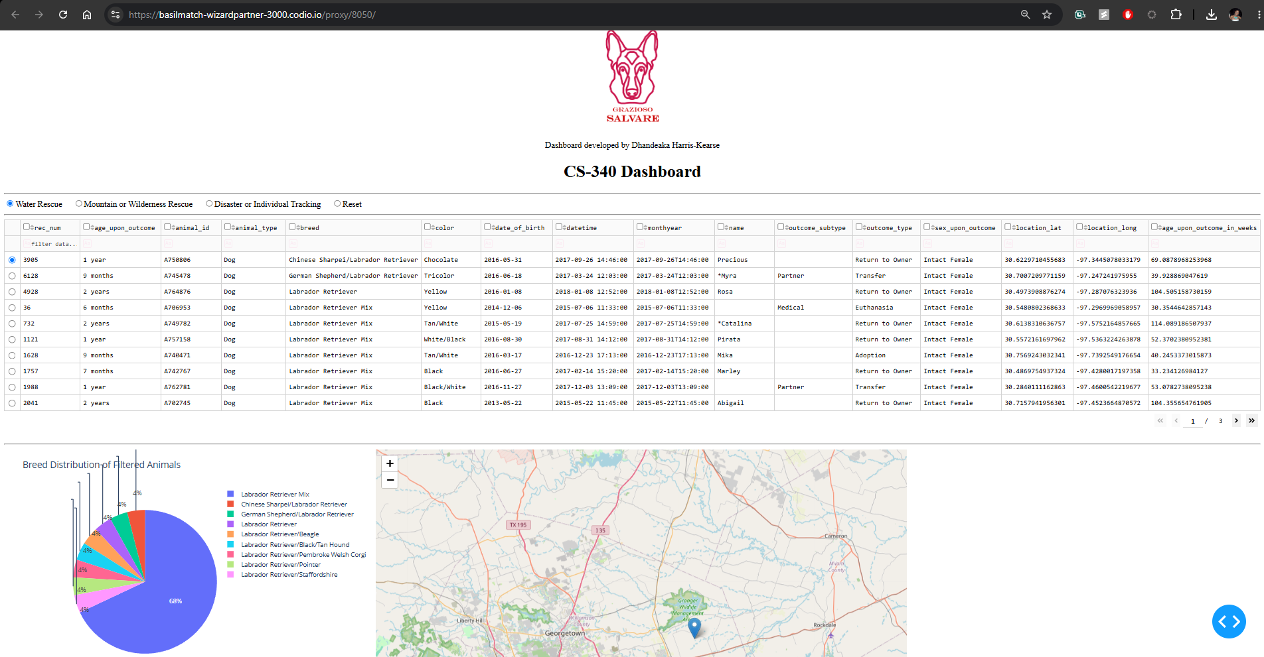
Selecting Water Rescue updates the table to display dogs matching the configured breed, sex, and age criteria. The pie chart summarizes the matching breeds, and the map displays a location marker for the selected record.
Figure 3 — Mountain or Wilderness Rescue
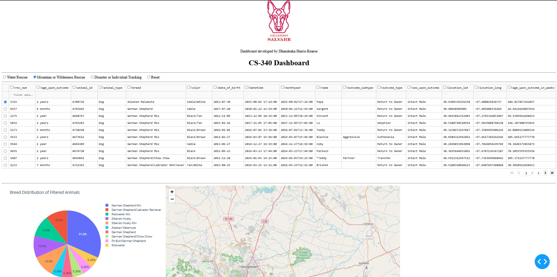
The Mountain or Wilderness Rescue option displays records matching its configured training profile. The chart summarizes those breeds, and the map displays the selected animal's location.
Figure 4 — Disaster or Individual Tracking
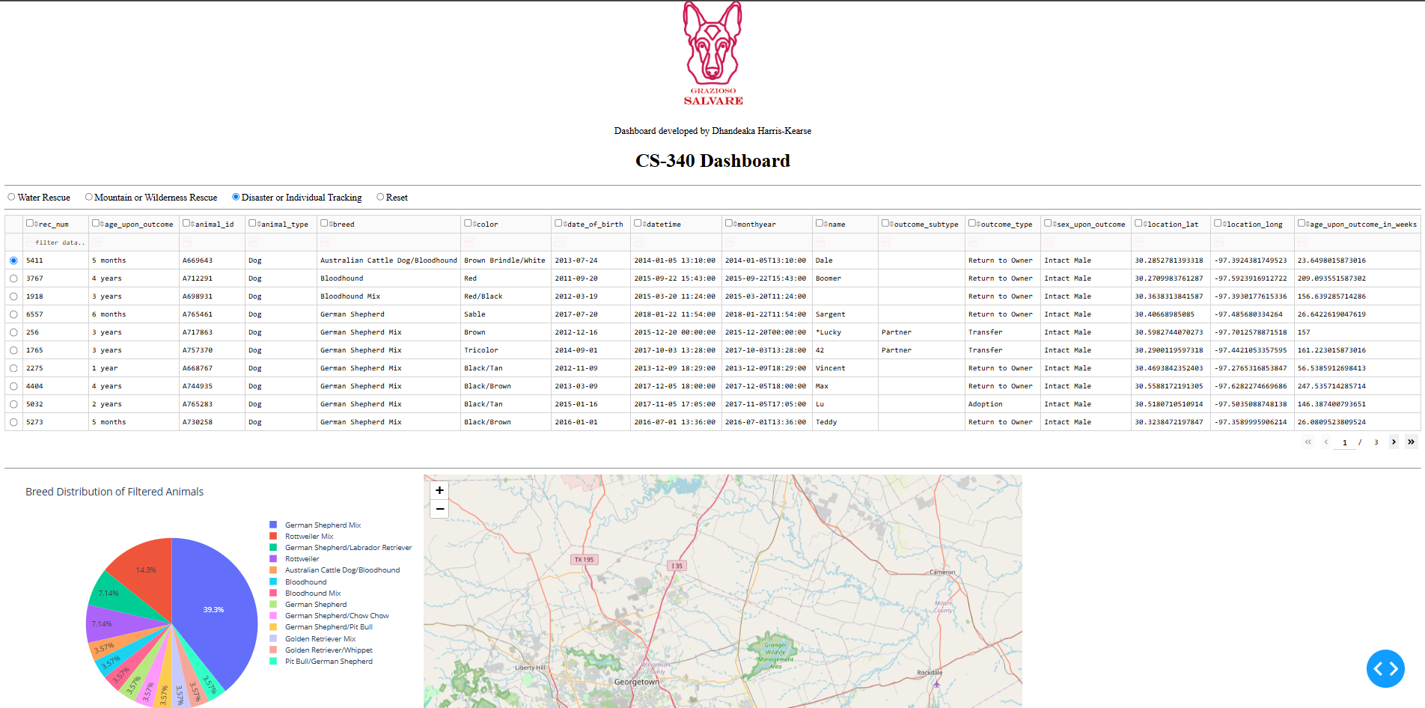
Selecting Disaster or Individual Tracking displays dogs matching this rescue profile, including Bloodhounds and German Shepherds. The updated pie chart summarizes the breeds represented in the filtered results.
Figure 5 — Reset
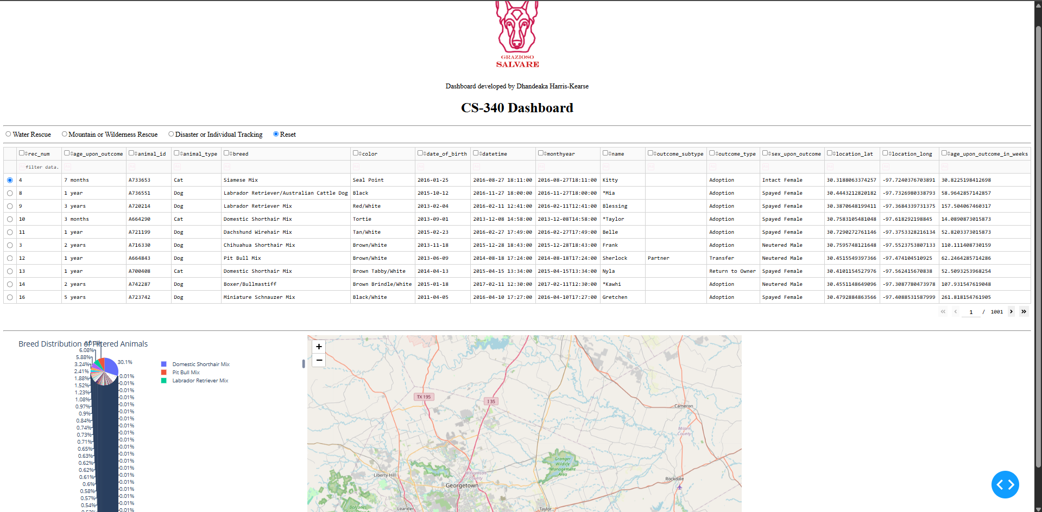
Selecting Reset restores the unfiltered shelter records, including both cats and dogs. The table returns to 1,001 pages, matching the initial view, and the pie chart returns to the full dataset’s breed distribution.

Acknowledgments
This educational project uses the SNHU CS 340 starter notebook, course-provided Austin Animal Center Outcomes dataset, and Grazioso Salvare logo. Review course and asset permissions before redistributing supplied materials.

