**Introduction-**

Perfect pets in an UK based e-commerce company. They are manufacture high-quality pet products. Their growth strategy is increased day by day and they sell their 75% products via an e-commerce site. Now Perfect pets company are using LAN to control their domain which is hosted by ISP where company stored all their business data, processing and marketing system, but they are hesitate to marketing their products because ISP doesn’t provide any e-commerce facilities. Company have a security question for maintaining e-commerce via ISP. They can face any kind of online attack in future, that’s why Company MD decided to get consultant help to protect their e-commerce network system. Consultant identifies company online threats and provided better possible solution.

**Task-1**

1. Below show the five (5) most important electronically held information assets in the company-
2. Customer Personal Data.
3. Marketing Information.
4. Payment Details.
5. Financial Details.
6. Company Personal Data.
7. Production Data.

**Justification for the five point-** For the Security purpose reduced the risk assessment, I listed down this, five information assets which is valuable and prioritized for this company. Which can help to protect from the hacker, for example- a hacker can entered your network and copied your entire customer data and damaged your database information.

So that kind of information is critical for this “Perfects Pets” Company. This information assets confidentiality, integrity and availability is of utmost importance.

**Reasonable Assumptions-** This Information asset has risks associated with “Perfects Pets” Company, which is the risk of losses the assets, information will fall into the wrong hands, getting corrupted or any number of other issues. By considering these risks, we will able mitigate against risk measures and plans.

**Below shows the b, c, d question answer in a table based on Selected assets-**

|  |  |  |  |  |  |
| --- | --- | --- | --- | --- | --- |
| **Assets(a)** | **Threat(b)** | **CIA(b)** | **Likelihood(c)** | **Impact(c)** | **Risk (d)** |
| Customer Personal Data | Server Failure | A | Low | Medium | Low |
| Information leakage | C | Low | High | Medium |
| Phishing Data | C | High | High | Medium |
| Viruses | A | Low | Medium | Low |
| Fire | I | Low | High | Very High |
| Software Errors | C | Medium | Low | Very Low |
| Marketing Information. | Server Failure | A | Low | Medium | Medium Low |
| Loss of Support Services | C | Low | Low | Medium Low |
| Information Leakage | C | Medium | High | High |
| Ransom Ware Attack | A | Low | High | High |
| Payment Details | SQL Injection | I | Medium | High | Very High |
| Phishing | C | High | High | Very High |
| Software Errors | A | Medium | Low | Medium |
| Spyware | A | Medium | High | High |
| Financial Details | SQL Injection | I | Medium | High | Very High |
| Software Errors | A | Low | Low | Medium |
| Ransom Ware Attack | A | Low | High | High Medium |
| Malware | A | Low | Low | Medium |
| Information Leakage | C | High | High | Very High |
| Company Personal Data | Server Failure | A | Low | low | very low |
| Information leakage | C | Medium | high | Very High |
| Viruses | A | Low | Medium | High |
| Fire | I | Low | High | Very High |
| Software Errors | A | Low | low | low |
| Unauthorized use of software | C | Medium | high | High |
| Production Data | Software Errors | A | Low | low | low |
| Unauthorized use of software | C | Medium | high | High |
| Fire | I | Low | high | Very High |
| Information leakage | C | Low | high | Very High |

**Task-2**

1. **Security Threats**

After analysis the scenario for Perfect Pets company I have identified threats and highest risks and also plan the possible solutions to reduce the risk.

Below show the explanation and the plane-

1. **Fire Threats-** In the scenario we can see that Perfect Pets company using LAN included Domain Controller based on windows server 2012R2 which hosts financial systems, order processing, customer record data, email and human resources data. Now we can understand the company store all activity in the local server which is in the highest vulnerabilities, because in future if the server internal and external physical attack can be happen, for that reason they can lose all their business data. For this we have planned a proper step to safe their server data.

**Solutions -**

1. First of all, the Perfect Pets company need to set up their own server to store all the data. Because hosted server can’t provide all the security installation.
2. Setup fire detection devices and system and maintained them regularly and server room temperature must be under control.
3. Train Server staff/employees to know what measures to take when the alarm is activated.
4. Important data have a backup file needed in cloud server or another server. (lucionservices, 2019)
5. **Information leakage-** The company Store all the marketing information, financial details, company, personal data, production details which is private and Important information for the company. So if any employee betrays to the company and leaked that data into another company then the company will be faced with a big loss. To reduce that kind of internal security problems we have a plan- (sans.org, 2019)

**Solutions -**

1. To hire an employee, we must Inquiry employee background very carefully.
2. For security reason, apply lock policy for each and every employee account.
3. Fixed employee access level to set password and each other employee can’t access file and documentation.
4. Network and share devices configure securely.
5. **SQL Injection**- In the scenario company have a domain and domain hosted into the local ISP. Which is under risk because we don’t know about the server security and the network security, we can't ensure that which security standard they follow to protect the server. So today or tomorrow, the Server may face SQL Injection attacked, which may damage the company physical or logical important data like- Payment Details, company Financial Details etc. We also have a plane to reduce the SQL injection attack risk- (malwarebytes, 2019)

**Solutions –**

1. Setup won server to reduced one stage risk.
2. User validation to filter All user input data and then store them.
3. Setup Demilitarize zone which will provide additional security layer for internal and external LAN attack. (searchsecurity.techtarget., 2019)
4. **Phishing Data-** In the scenario we can see that company run e-commerce website where customer directly can buy products from their site and pay through online. They also host their domain into the other local server where they are not prepared for any kind of online attack, so we clearly say company can have faced phishing attack from online. The company and user both will be in trouble. Below shows the plan how to reduce this problem. (compuquip, 2019)

**Solutions –**

1. Provide **Two-way** authentication when buy product.
2. Transmitted website data must be encrypted.
3. Use VPN to pass Confidential data.
4. To manage system used “Secure Sockets Layer” which will secure data transmission process
5. **Spyware, Virus-** Company has no e-commerce marketing facilities to promote their products just because of they are hosted by local ISP. Company marketing staff manually access via site portal to update products information. Company can be easily effected by spyware and virus because staff can access web portal from their pc or laptop, where they are not following any kind of internet access rules and are not controlled staff internet access. Staff can browse many sites and download files from untrusted or infected or malicious websites.Which is harmful for the company for that reason we have a plane to reduce that kind of risk. (kaspersky, 2019)

**Solutions –**

1. Blocked all the unexpected mails and links etc.
2. Control staff or employee Internet access.
3. Install all security patches and set password to access user pc or laptop.
4. All the staff PC or Laptop necessary software must be authorized software and up to date.
5. Regularly check security system to reduce vulnerabilities.
6. Obviously company needs an encryption method because company run e-commerce business and store the customer information and company financial and business information on the server, which is the most important data for the company and to protect from the hacker we must use encryption method to transmit data.

To protect perfect pet company data and authentication we can use AES, IPsec protocol, RSA algorithm and to set a more secure password we used hashing algorithm. For remote access and transmit data, we used VPN with AES algorithm where we set IP security, PPTP (point to point tunneling protocol), L2PT (Layer 2 tunneling protocol), SSTP and IKEv2.

For the data security in the storage 3DES algorithm will be used and also will be used symmetric and asymmetric encryption to store all the files and folder data.

**Task-3**

1. 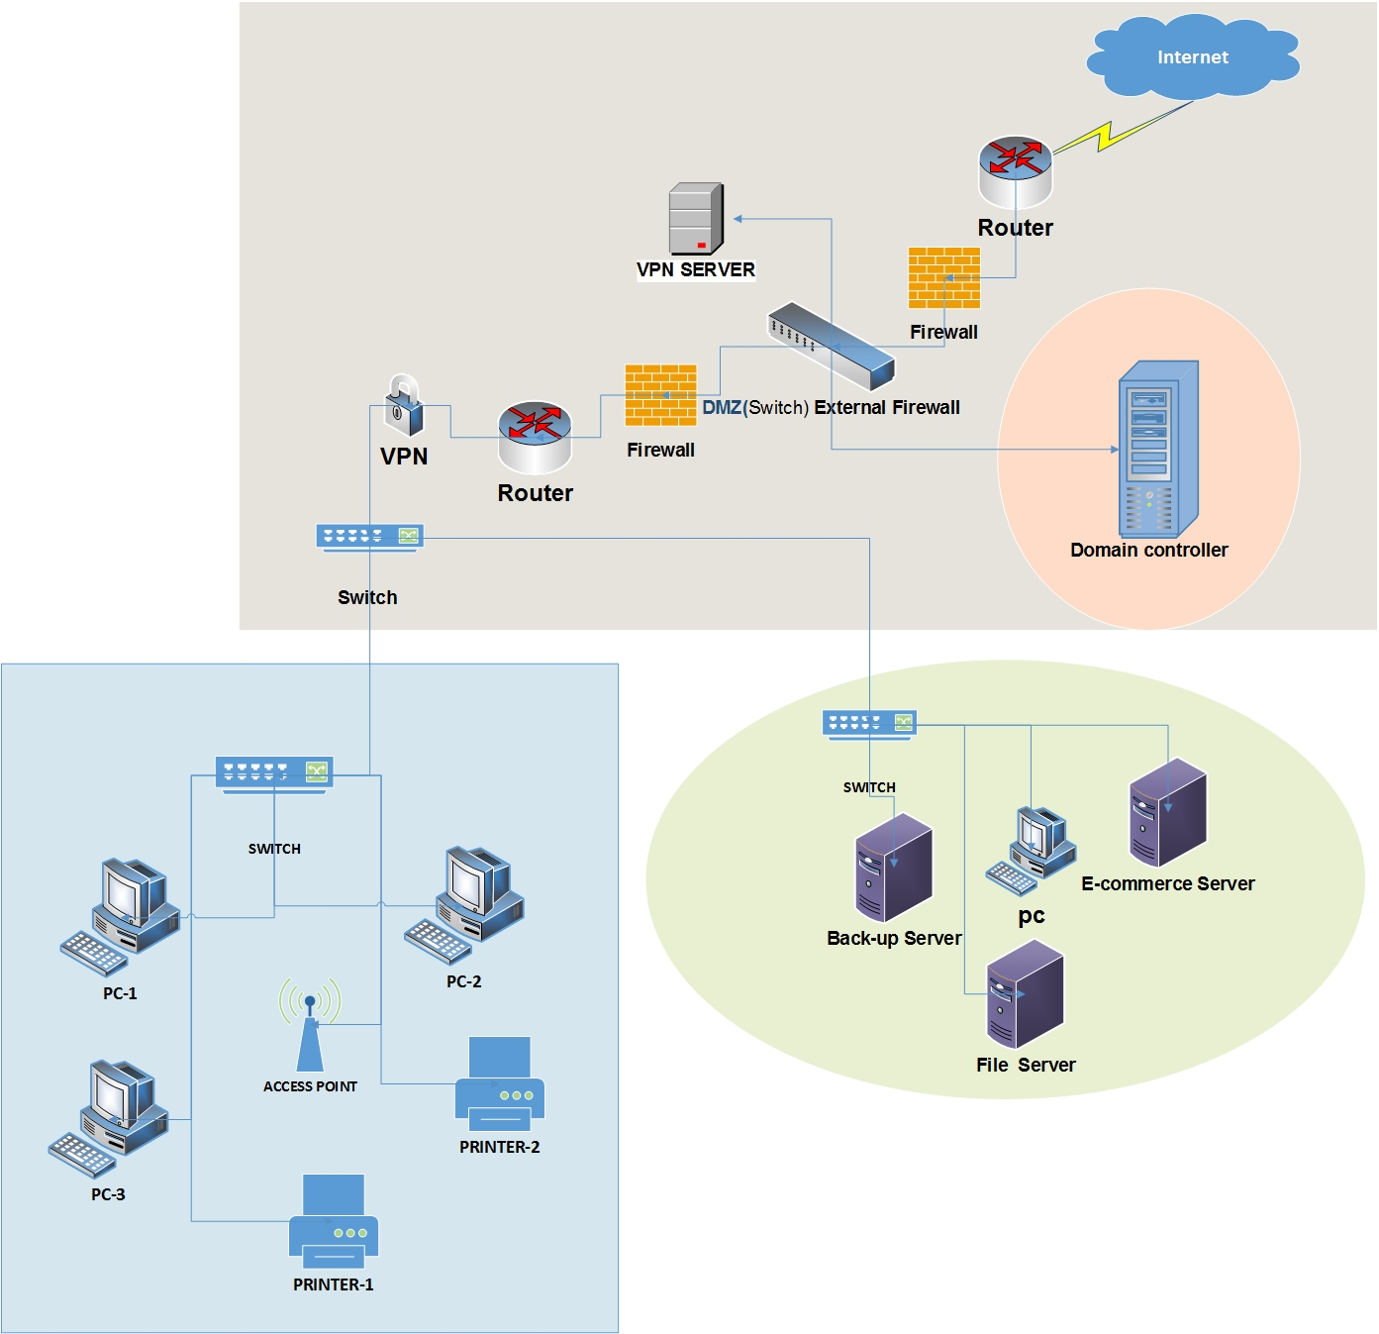Below show a Network Diagram for ‘perfect pet’s’ company without IP Address-

**Figure-(1)-**Network Diagram without IP address

1. 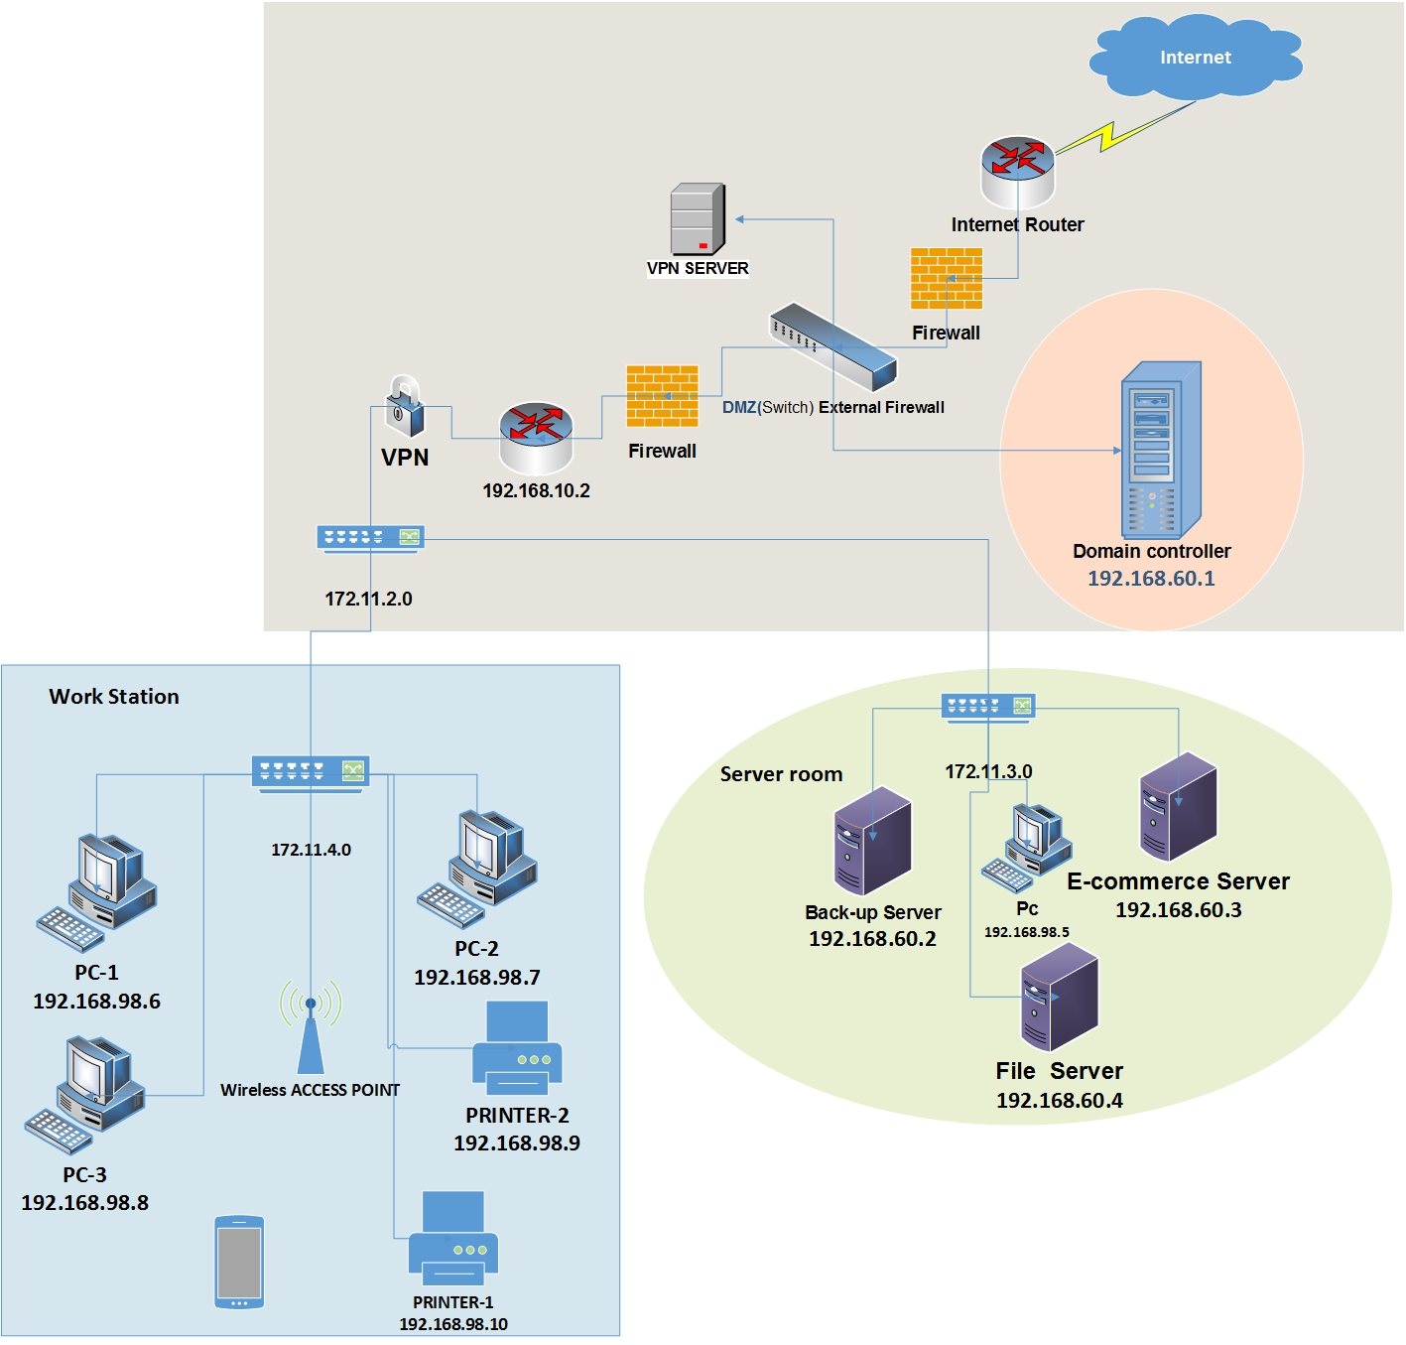Below show a Network Diagram for ‘perfect pet’s’ company with IP Address-

**Figure-(2)-**Network Diagram with IP address