**HANOI UNIVERSITY**

**FACULTY OF INFORMATION TECHNOLOGY**

**Name: Đỗ Hoàng Nam**

**Student ID: 2001040141**

**Class: 5C-20**

**IWS Tutorial Class: IWS-02**

**FINAL PROJECT PERSONAL REPORT**

**INTERNET AND WEB SERVICES – SPRING 2024**

**I. Overview**

As being required by lecturer and tutor, for the final project, I had done 2 parts:

First, the weather web which can update the real-time data.

Second, APIs for the topic movie library management.

**II. Detail of the Part 1 – Weather Website**

**1. Technologies and Weather API Provider**

In this part, to create the weather website, I had used HTML, CSS and Bootstrap to create the main interface, then used JavaScript to fetch API, handle the data and transfer it to be displayed on the interface.

About the third-party API to get weather data, I used the services from OpenWeatherMap.

**2. Code Captures of Main Code Files**

**a) index.html**

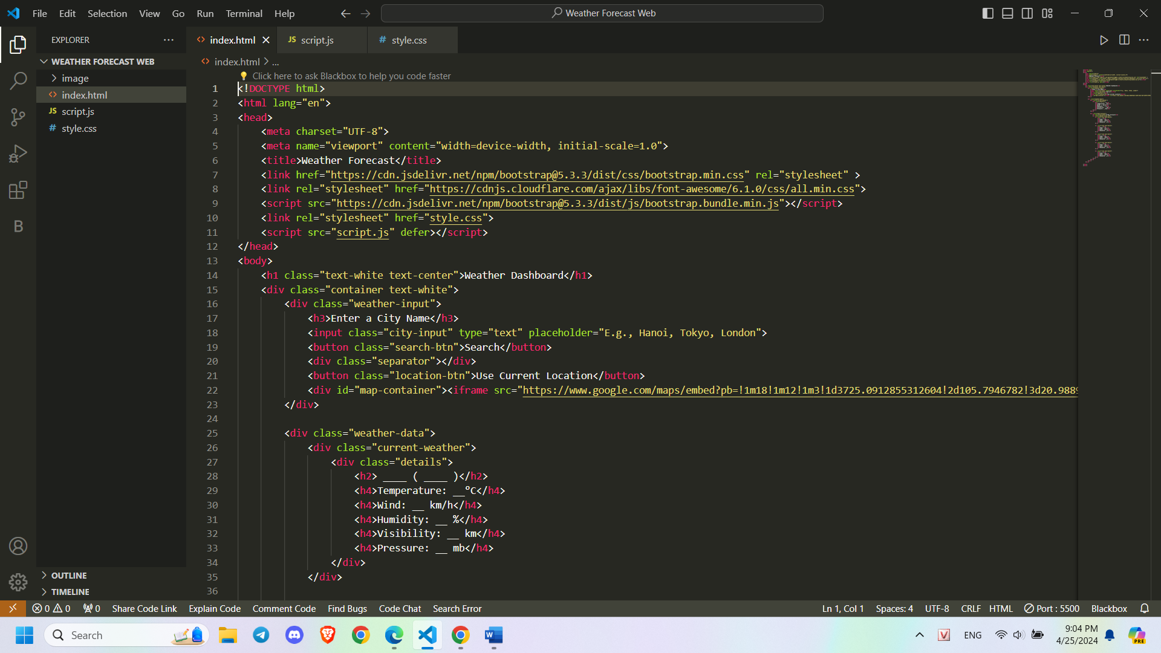

**b) styles.css**

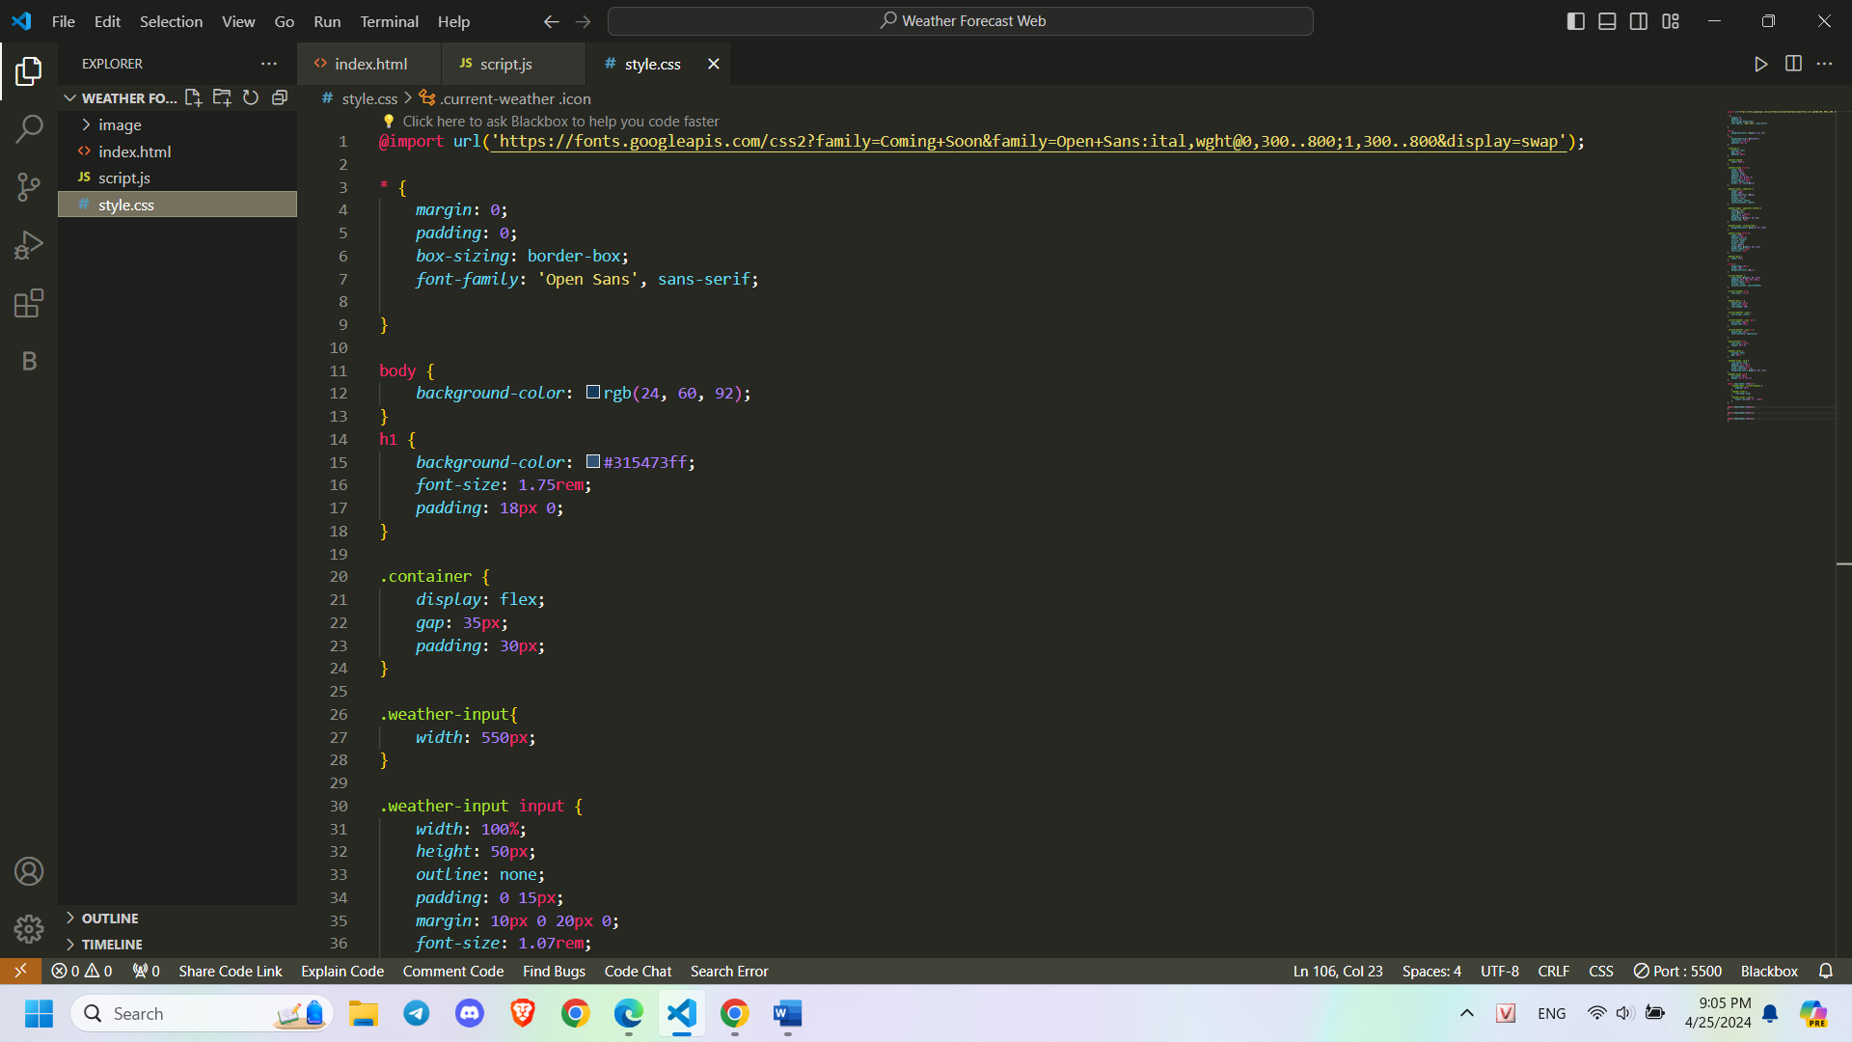

**c) script.js**

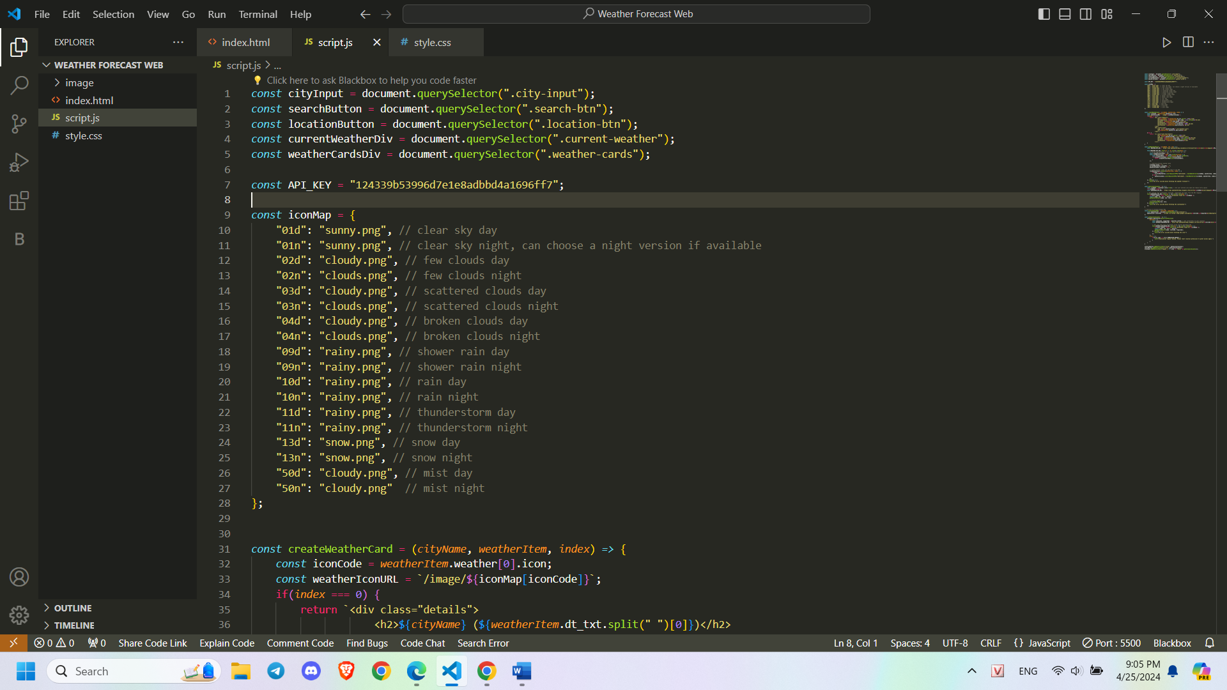

**3. Captures of Website**

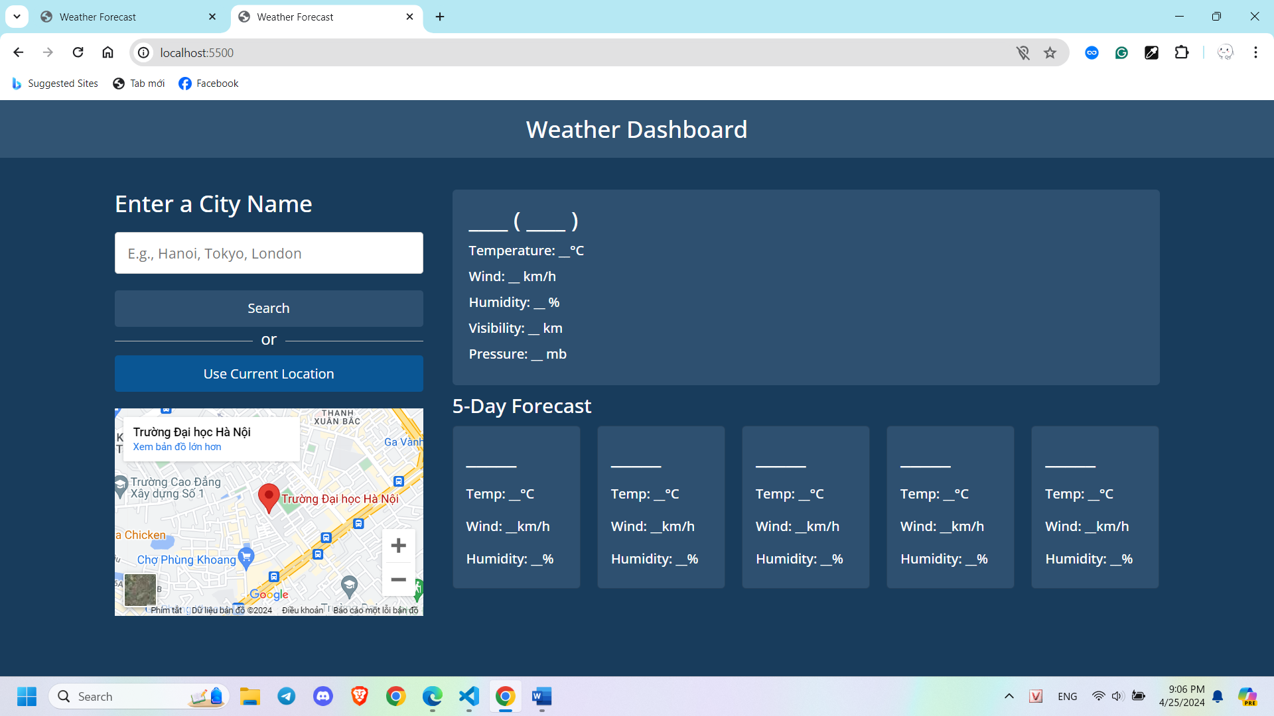

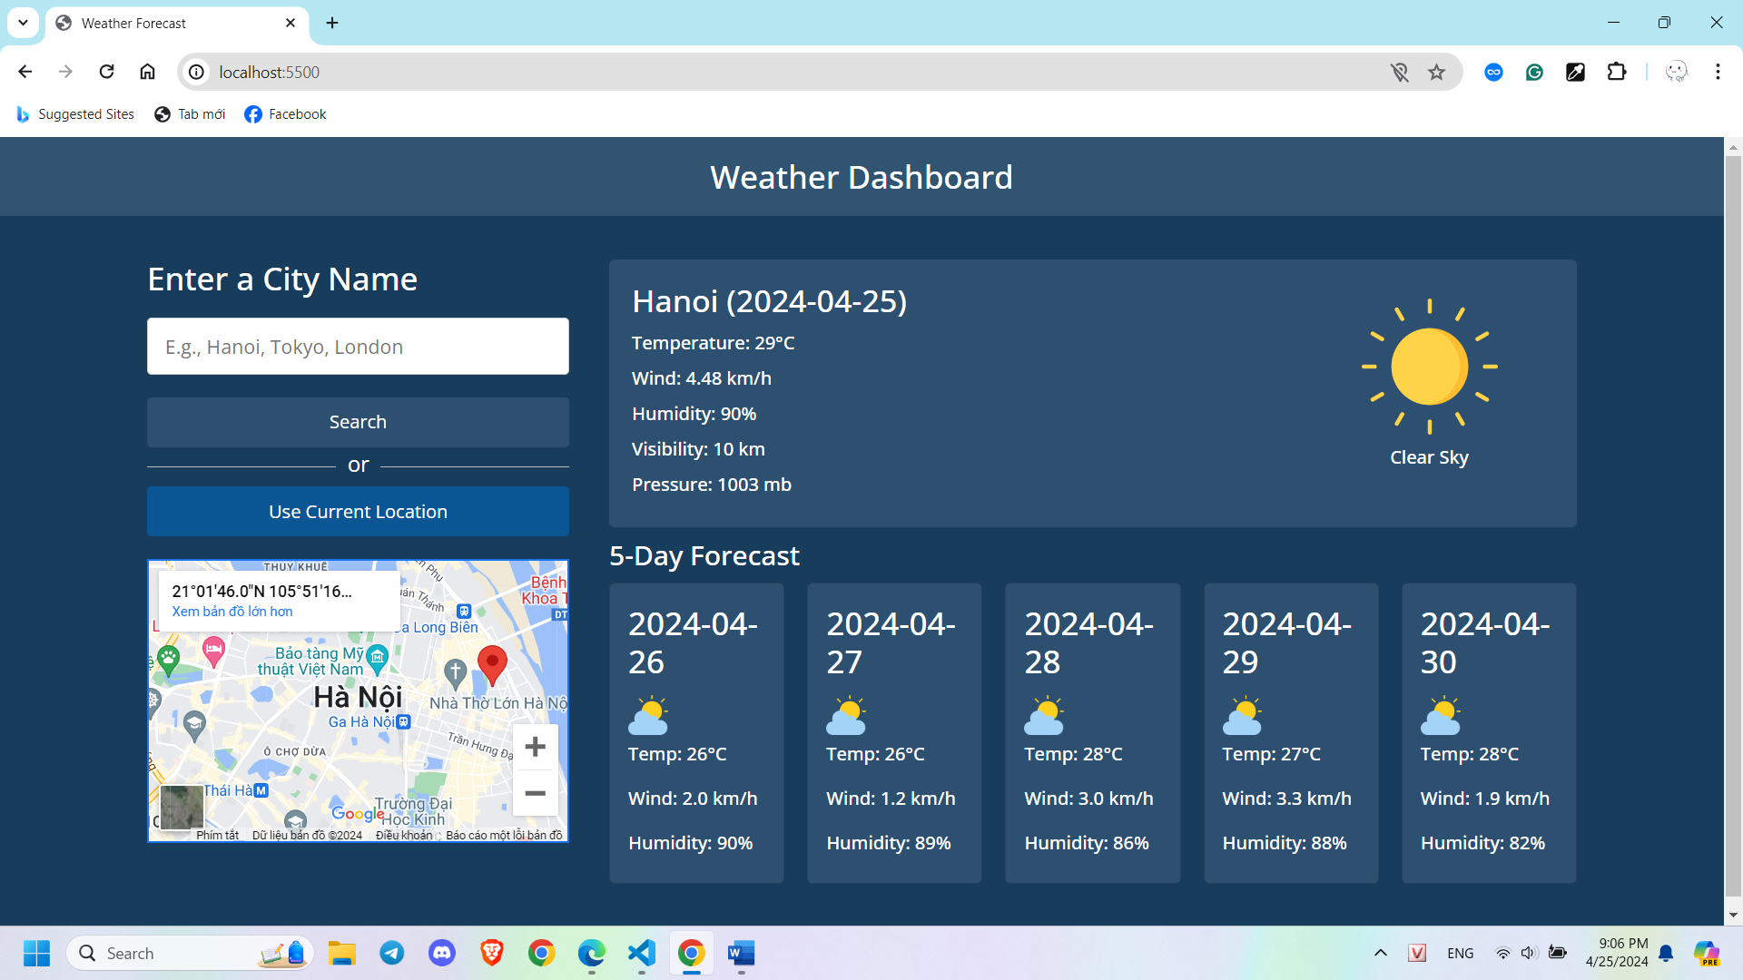

**III. Detail of the Part 2 – Create My Own APIs**

**1. Technologies**

In this part, to create my own APIs for the topic movie library, I had used NodeJS and ExpressJS to create routes and middlewares along with MongoDB Atlas for the database. To make the implementation more comfortable, I also used Mongoose to work with MongoDB and Nodemon to handle the server restart after changed the code.

For API result testing, I choose Postman as it is the most comfortable application for API testing.

**2. Code Captures of Main Code Files**

**index.js: the entry point of the project, where everything starts**

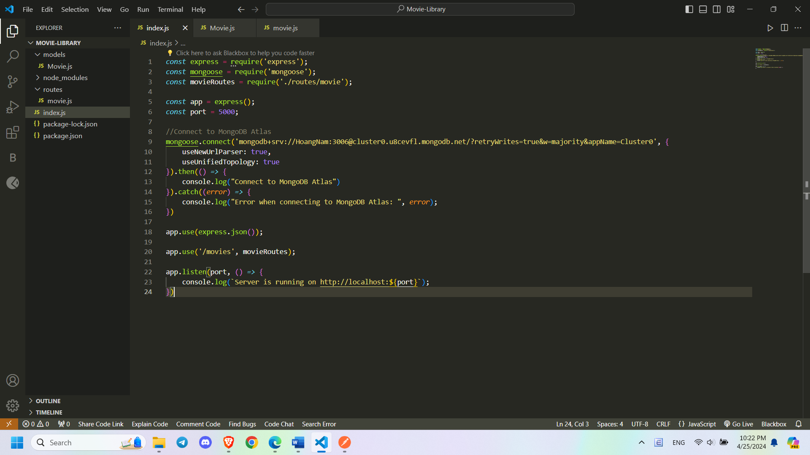

**Movie.js: the model of movie library item, contains details/characteristics of each movie item**

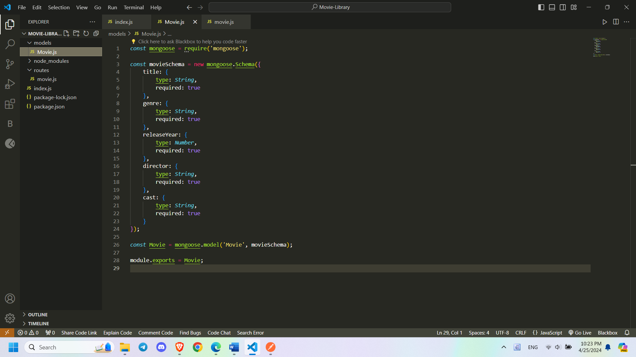

**movie.js: the routes of functions relating to movie item and API endpoints as required inside the project requirement**

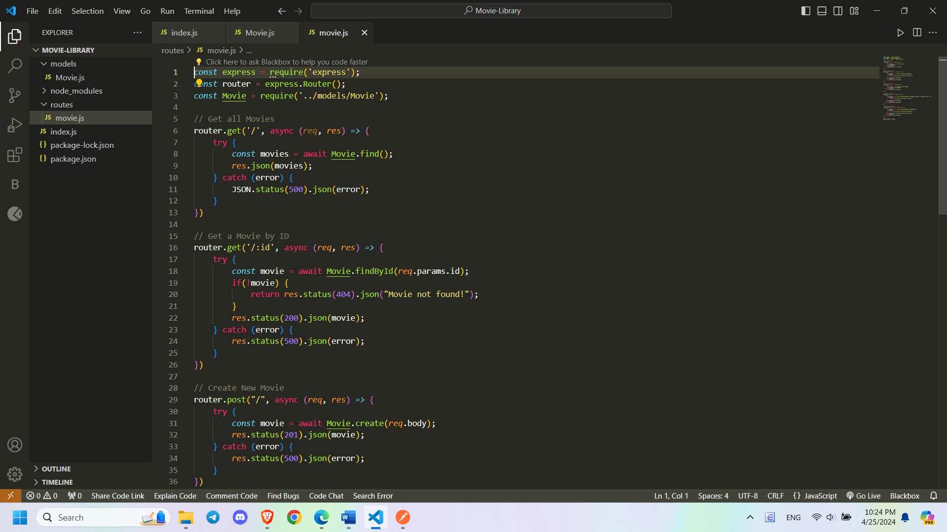

**package.json: contains information related to project and libraries used**

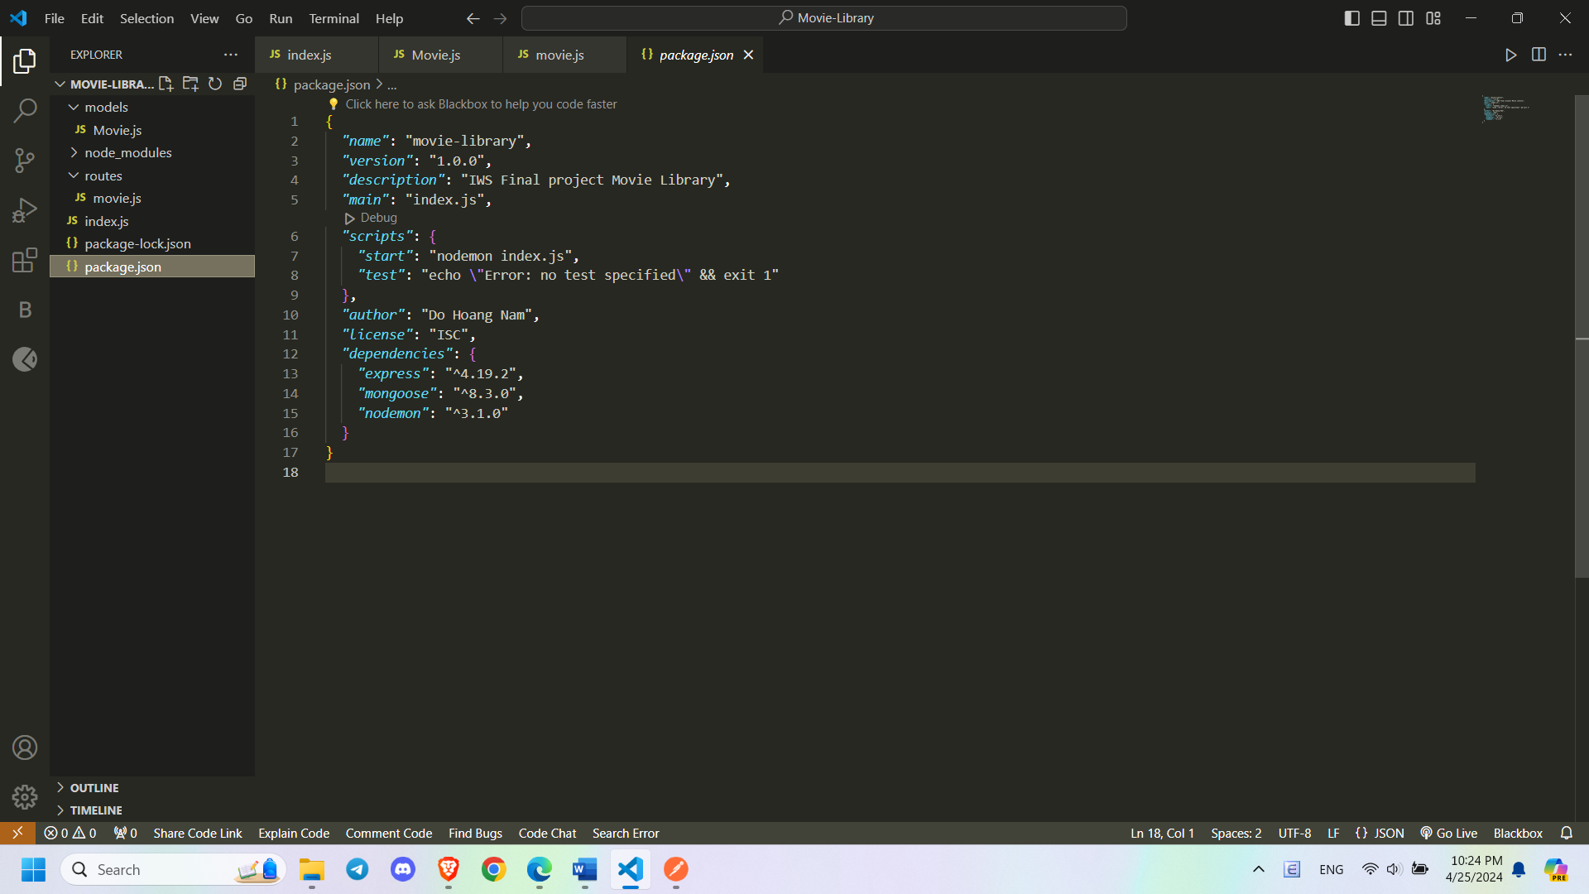

**3. Code Captures of API Testing Results**

**a) Get All Movies Items**

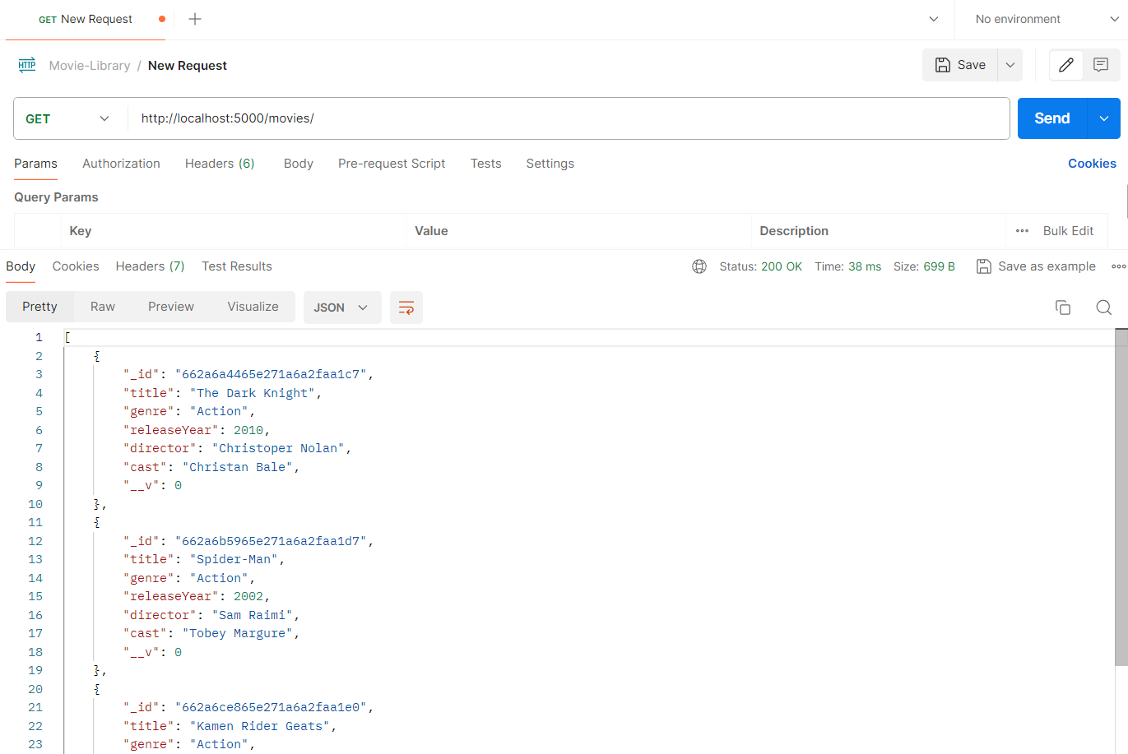

**b) Get a Movies Item by ID**

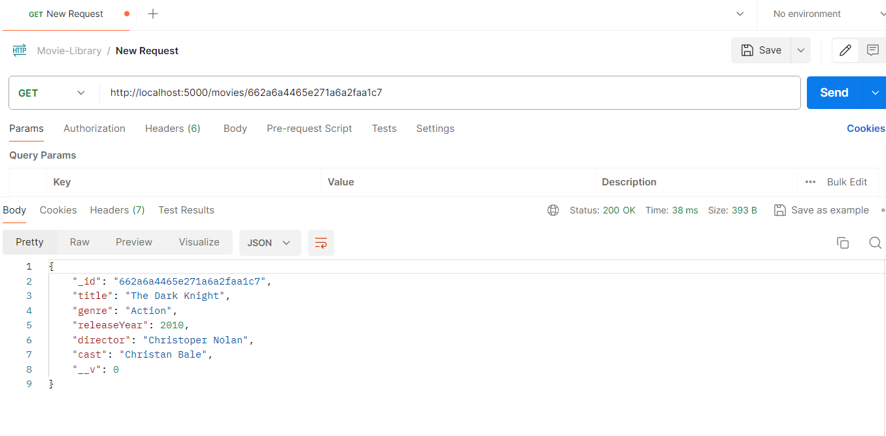

**c) Create New Movie Item**

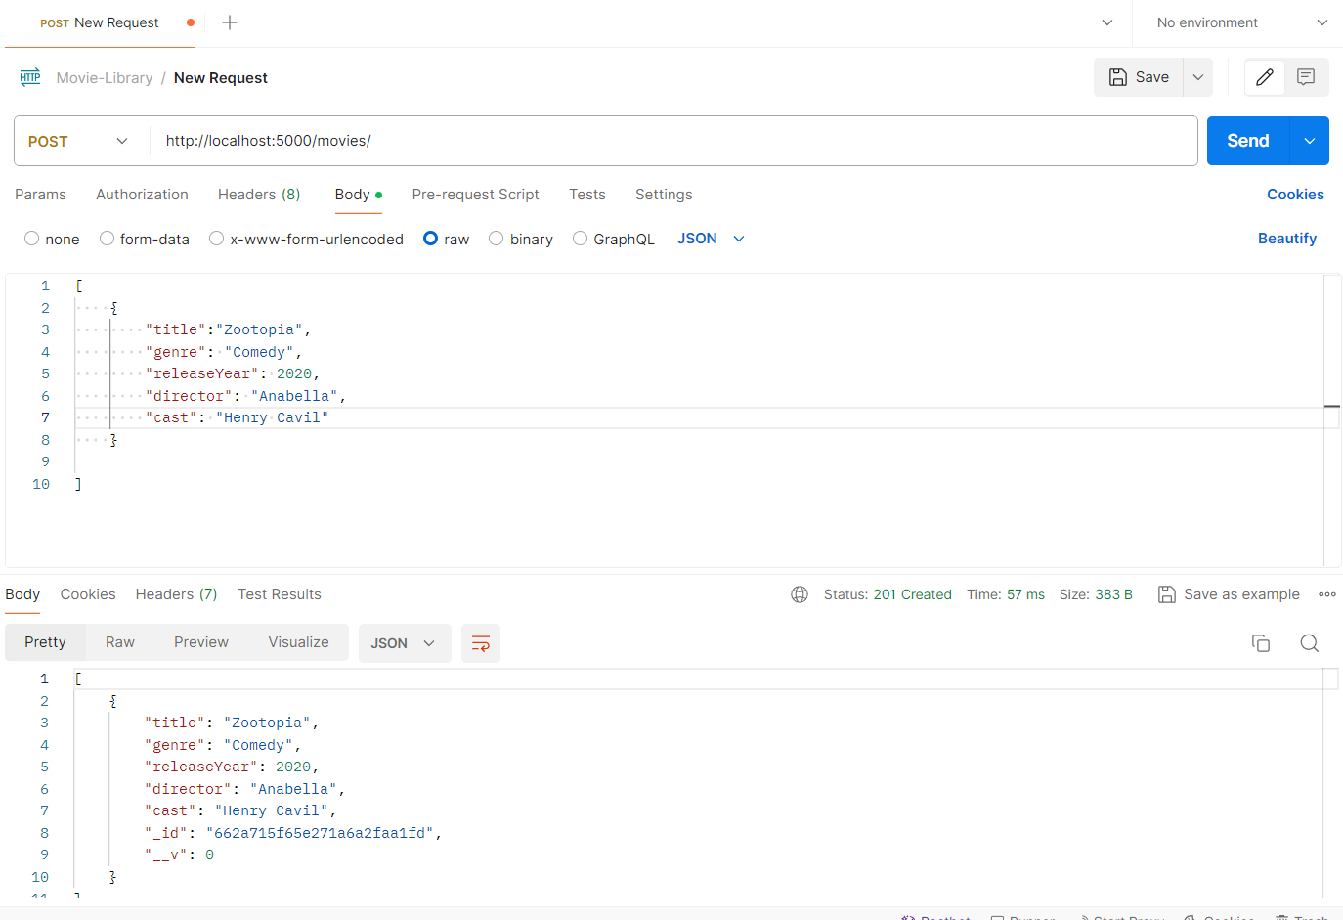

**d) Update a Movie Item by ID**

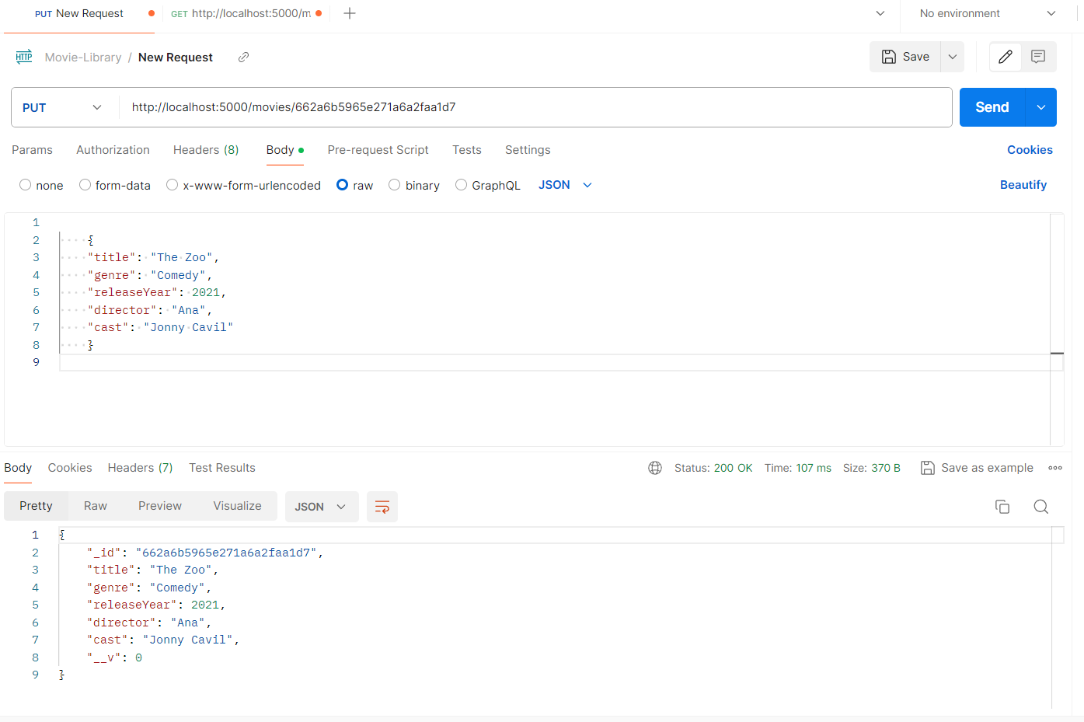

**e) Delete a Movie Item by ID**

