Eclipse Installation Confirmation:
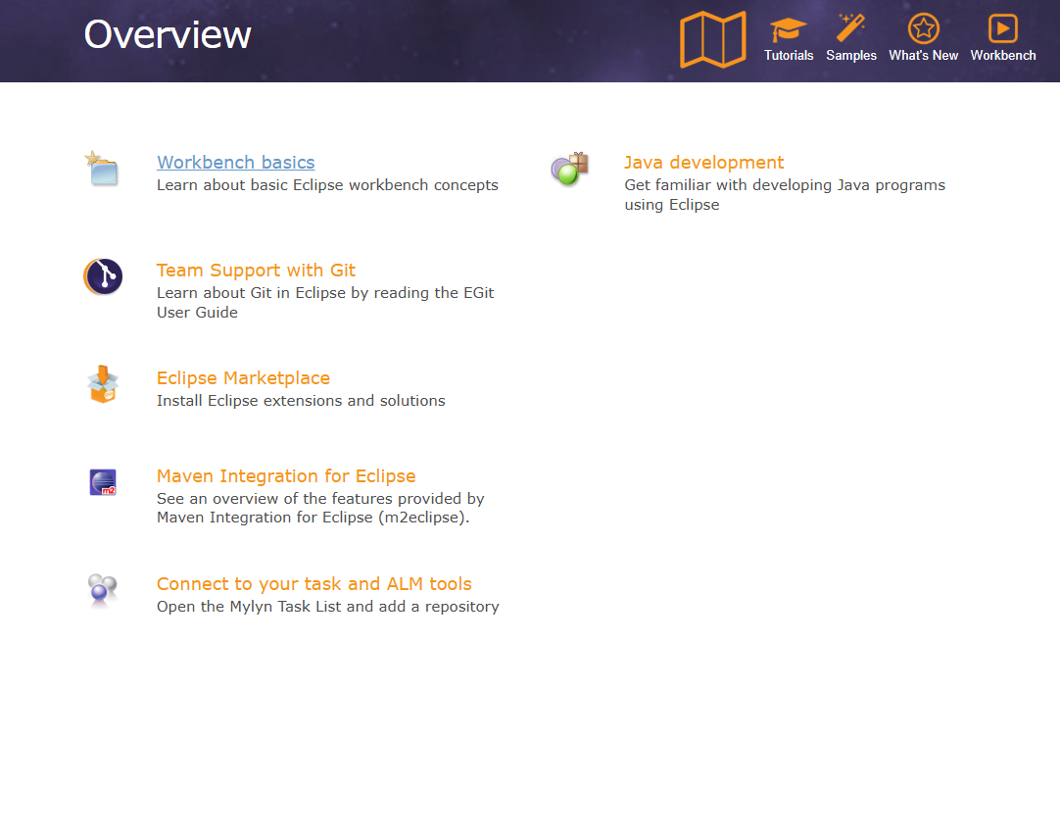

Output

