Vocabulary:
- Lower camel case - A naming convention to eliminate spaces in a name, but to ease readability with capitalization.
- Switch Workspace - To change the different physical location onto which you will store and save your files.
- Package - Stored inside a project, a mechanism for organizing Java classes into namespaces, or containers.
- Main Method - The method inside a class that runs when the class is compiled and ran.
- Class - A construct that is used as a blueprint to create objects. Also a construct in which objects are created.
- Perspective - An option to choose a combination of views and editors.
- Views - Areas within the Eclipse IDE that provide a way to navigate a hierarchy of information and allow modifications to elements.

Question 2 Output:
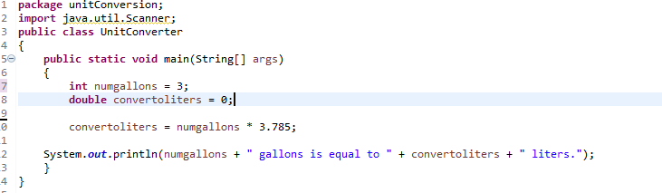

Question 3 Output:
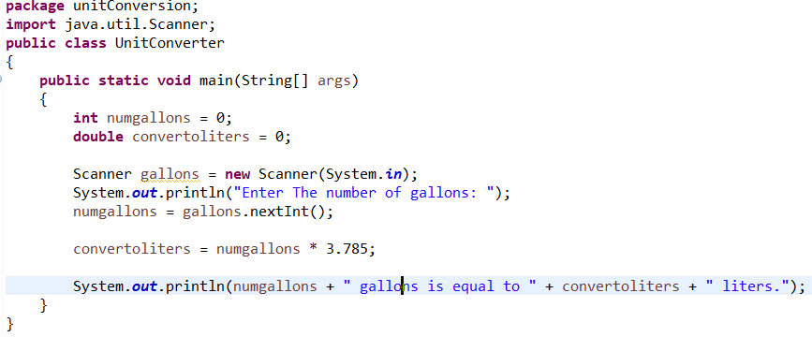
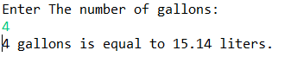

Question 4: 3 ways to test my program
- Does the program compile?
- Are the results what you expected?
- Using multiple input, do they produce the correct mathematical calculations?

