BIO - DATA

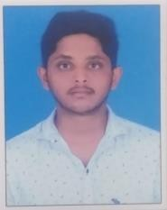

Name : Jenil Mukeshbhai Patel Father’s Name : Mukeshbhai Balubhai Patel Mobile : 8866203021

Email id : [jenil.patel4502@gmail.com](mailto:jenil.patel4502@gmail.com)

Gender : Male

Date of Birth : 04 / 05 /2002

Marital Status : Unmarried

Religion : Hindu

Nationality : Indian Languages Known : Gujrati , Hindi Education : 10th complated

Name of Institute : Central institute of petrochemicals

engineering & technology (CIPET)

Training : Re-skilling training programme on "Basic programming & operation on CNC lathe"

Address : Dhakwada Mali Faliya , Ta -gandevi ,

Di - Navsari , pincode - 396321

Place:

Date: Signature.