TERADATA SQL HANDS_ON

Project description:

This series of tasks help the participant understand how to create table, insert records, update records and efficiently write basic queries in Teradata.

1. Create tables are per the below specification.

CREATE TABLE DEPT (

DEPTNO NUMERIC(2) NOT NULL,

DNAME CHAR(14),

LOC CHAR(13),

CONSTRAINT DEPT_PRIMARY_KEY PRIMARY KEY (DEPTNO));

INSERT INTO DEPT VALUES (10,'ACCOUNTING','NEW YORK');

INSERT INTO DEPT VALUES (20,'RESEARCH','DALLAS');

INSERT INTO DEPT VALUES (30,'SALES','CHICAGO');

INSERT INTO DEPT VALUES (40,'OPERATIONS','BOSTON');

CREATE TABLE EMP (

EMPNO NUMERIC(4) NOT NULL,

ENAME CHAR(10),

JOB CHAR(9),

MGR NUMERIC(4) CONSTRAINT EMP_SELF_KEY REFERENCES EMP (EMPNO),

HIREDATE DATE,

SAL NUMERIC(7,2),

COMM NUMERIC(7,2),

DEPTNO NUMERIC(2) NOT NULL,

CONSTRAINT EMP_FOREIGN_KEY FOREIGN KEY (DEPTNO) REFERENCES DEPT (DEPTNO),

CONSTRAINT EMP_PRIMARY_KEY PRIMARY KEY (EMPNO));

INSERT INTO EMP VALUES (7839,'KING','PRESIDENT',NULL,'17-NOV-81',5000,NULL,10);

INSERT INTO EMP VALUES (7698,'BLAKE','MANAGER',7839,'1-MAY-81',2850,NULL,30);

INSERT INTO EMP VALUES (7782,'CLARK','MANAGER',7839,'9-JUN-81',2450,NULL,10);

INSERT INTO EMP VALUES (7566,'JONES','MANAGER',7839,'2-APR-81',2975,NULL,20);

INSERT INTO EMP VALUES (7654,'MARTIN','SALESMAN',7698,'28-SEP-81',1250,1400,30);

INSERT INTO EMP VALUES (7499,'ALLEN','SALESMAN',7698,'20-FEB-81',1600,300,30);

INSERT INTO EMP VALUES (7844,'TURNER','SALESMAN',7698,'8-SEP-81',1500,0,30);

INSERT INTO EMP VALUES (7900,'JAMES','CLERK',7698,'3-DEC-81',950,NULL,30);

INSERT INTO EMP VALUES (7521,'WARD','SALESMAN',7698,'22-FEB-81',1250,500,30);

INSERT INTO EMP VALUES (7902,'FORD','ANALYST',7566,'3-DEC-81',3000,NULL,20);

INSERT INTO EMP VALUES (7369,'SMITH','CLERK',7902,'17-DEC-80',800,NULL,20);

INSERT INTO EMP VALUES (7788,'SCOTT','ANALYST',7566,'09-DEC-82',3000,NULL,20);

INSERT INTO EMP VALUES (7876,'ADAMS','CLERK',7788,'12-JAN-83',1100,NULL,20);

INSERT INTO EMP VALUES (7934,'MILLER','CLERK',7782,'23-JAN-82',1300,NULL,10);

CREATE TABLE BONUS (

ENAME CHAR(10),

JOB CHAR(9),

SAL NUMERIC,

COMM NUMERIC);

CREATE TABLE SALGRADE (

GRADE NUMERIC,

LOSAL NUMERIC,

HISAL NUMERIC);

INSERT INTO SALGRADE VALUES (1,700,1200);

INSERT INTO SALGRADE VALUES (2,1201,1400);

INSERT INTO SALGRADE VALUES (3,1401,2000);

INSERT INTO SALGRADE VALUES (4,2001,3000);

INSERT INTO SALGRADE VALUES (5,3001,9999);

Execute the below queries

1. List all columns and all rows of employee table

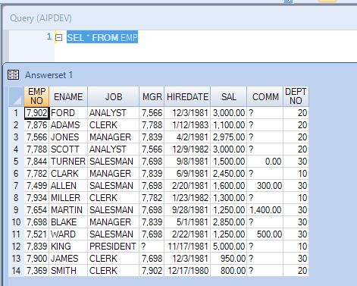

1. List employee number, name and salary from employee table

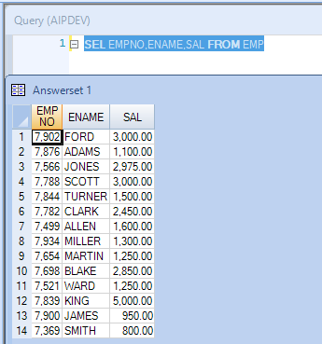

1. List employee number, name and salary from employee table where salary is > 3000

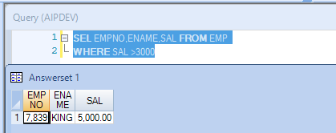

1. List employees joined after 1981

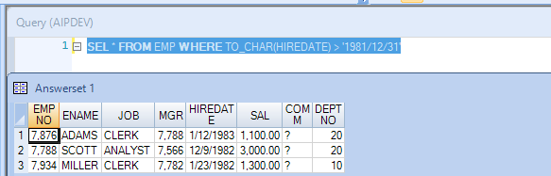

1. List all clerks

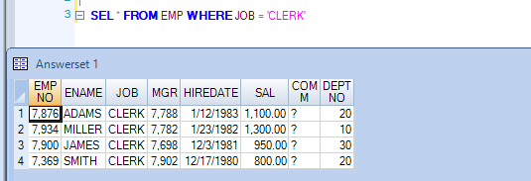

1. List employees in the ascending order of salary

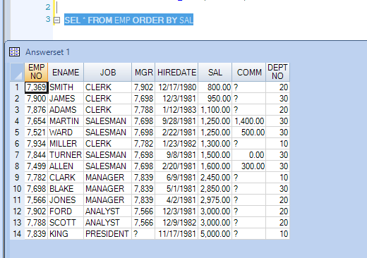

1. List employees in ascending order of job within descending order deptno

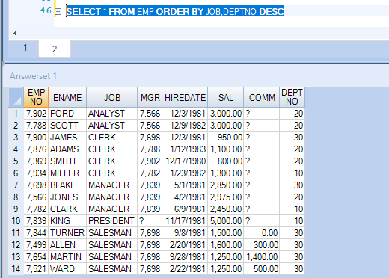

1. List distinct department

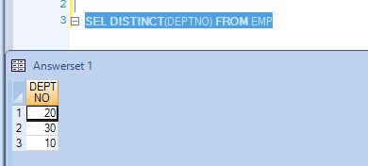

1. List distinct jobs in each department

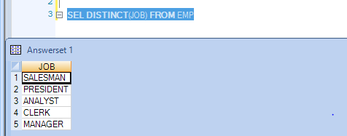

1. List name, salary and annual salary in the descending order of annual salary

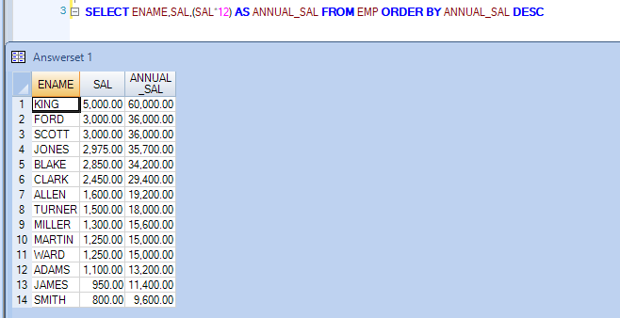

1. List your session number, default database and user name of the current session

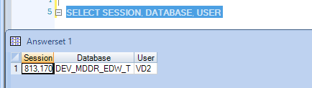

1. List all objects in your database

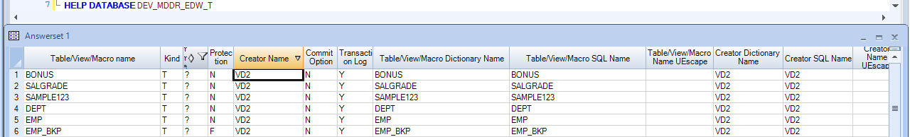

1. List the structure of EMP table

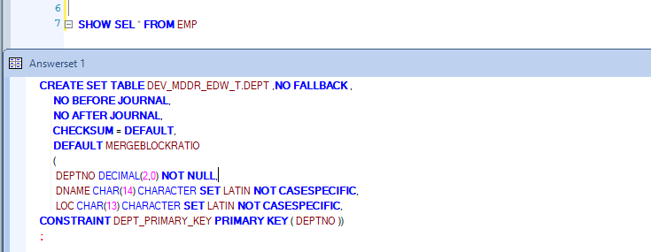

1. Get the syntax SQL SELECT statement

*Select column1, column2*

*From table_name ;*

*Select * from table_name;*

1. Get the current source code of EMP table

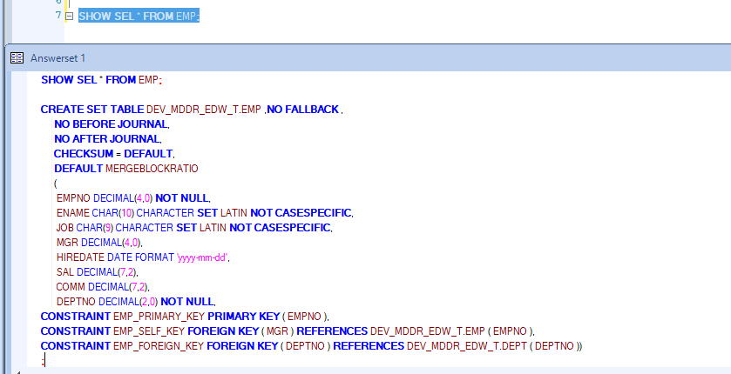

1. Produce the execution plan of your SQL statement

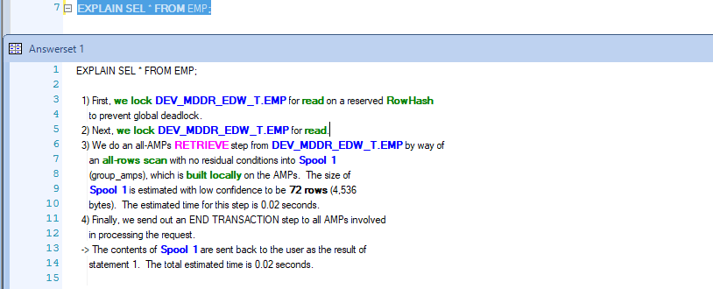

1. List employees whose salary is not in the range of 2000 and 3000

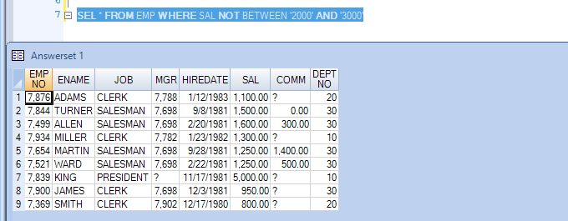

1. List name and the department for all employees who are NOT members of departments 10 and 20

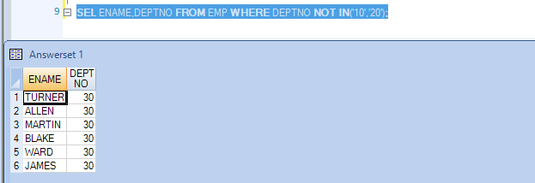

1. List employees for whom COMM is not applicable

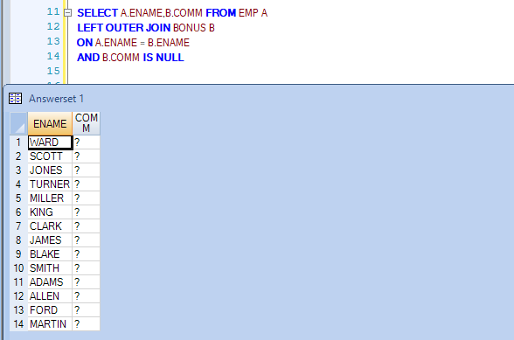

1. List employees for whom COMM is applicable

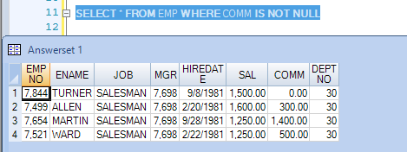

1. List employees in ascending order of COMM and note who NULLs are sorted

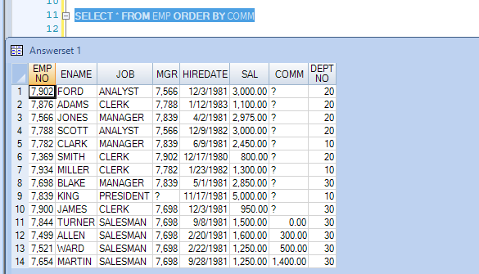

1. List employees whose names start with ‘K’

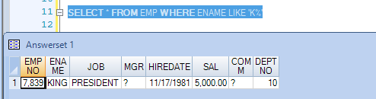

1. List employees whose names contain ‘K’

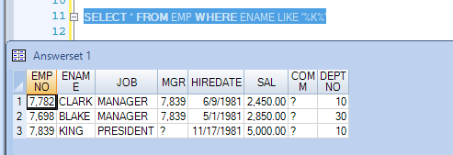

1. List employees whose name start with an _ char.

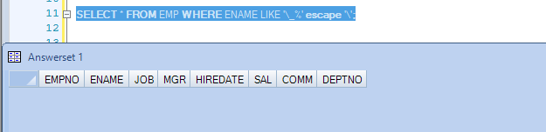

1. List total, maximum, minimum , average of salary from employee table

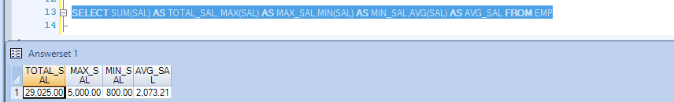

1. List average and count of commission of all employees in department 10

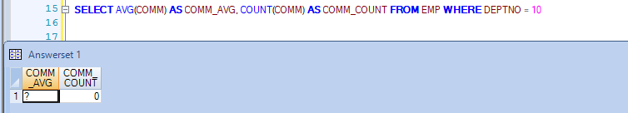

1. List department wise no of employees and total salary

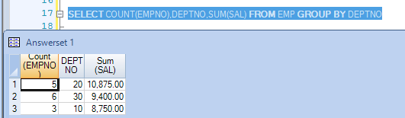

1. List total salary Job wise within each department

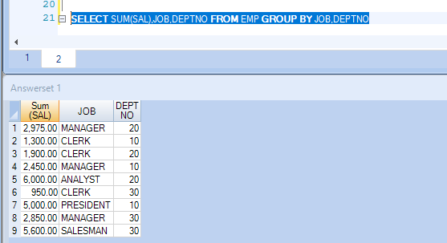

1. List department wise total salary for deptno 10 and 20 only

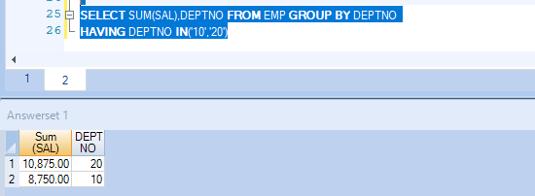

1. List department wise total salary where total salary is > 6000

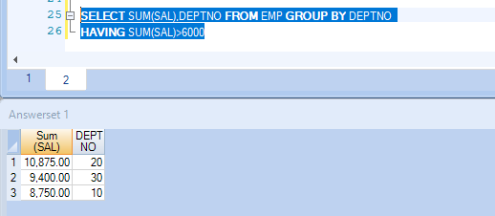

1. SELECT COUNT(*), COUNT(COMM) FROM EMP; - explain why the two counts are different

*Count doesn’t include NULL values.*

*As there are 10 NULL’s in COMM , the counts are different*

1. Update the Employees table and increase the salary by 15%

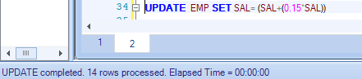

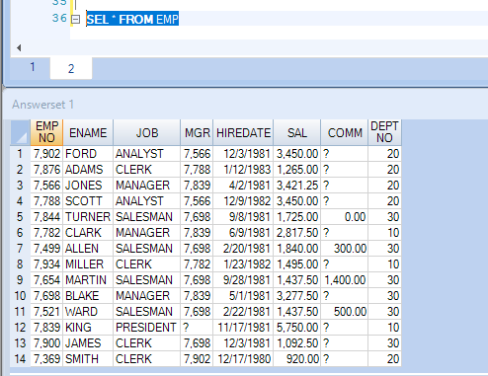

1. Update the commission column value to 1000 for all the employees who are not getting any commission

**UPDATE** EMP **SET** COMM = 1000 **WHERE** COMM **IS** **NULL**

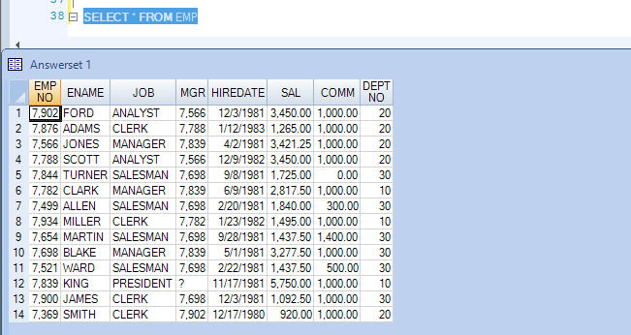

1. Delete all the records where salary is less than 3000

**DELETE** **FROM** EMP **WHERE** SAL < 3000

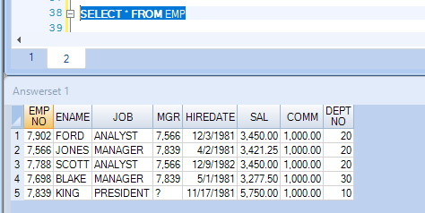

1. Delete all the records where commission is null

