APM PROJECT

Bus-Maintenance Keyword Extraction

Abstract
The system is a fully local NLP pipeline that converts free-text Italian bus-maintenance reports into eight structured columns. Its distinguishing is that the classification categories are not authored by a human in advance. Instead, the system induces and grows its category inventory directly from the incoming data, online, one record at a time. There is no manually curated label set to classify into; the taxonomy is a by-product of processing the corpus.
Operating constraints. The entire pipeline runs offline on a single machine via Ollama. The reasoning/generation model is qwen3:8b; embeddings are produced by nomic-embed-text.

1. Quick start
Prerequisites
- Ollama installed and running locally, with both models pulled:
- ollama pull qwen3:8b
- ollama pull nomic-embed-text
- Python dependencies: pip install -r requirements.txt
Run a batch
# place exactly ONE .xlsx/.csv of maintenance records in input/
python3 main.py
The pipeline reads every row of the input file, processes it, and writes output/processed_<inputname>.xlsx — the original columns plus the eight new ones. At startup the persisted taxonomies are loaded and their current sizes reported, e.g.:
[Regime C] sistema: 16 categories
[Regime C] sintomo: 17 categories
[Regime C] azione: 9 categories
[Regime C] componente: 41 categories
...
[CONFIDENCE] Distribution: {'HIGH': 15, 'MEDIUM': 6, 'LOW': 8}
Because the taxonomies are persisted to disk (taxonomy_free/*_online.json), they carry over between runs: a second batch continues to grow the same category inventory rather than starting from scratch.
Periodic taxonomy maintenance (optional)
python3 taxonomy_cleanup.py --dry-run # report proposed changes, write nothing
python3 taxonomy_cleanup.py # apply changes (writes .bak backups first)

2. The eight output columns and how each is produced
The eight columns fall into three mechanistically distinct groups.

Group A — Self-growing online taxonomies
Four fields are not classified against a fixed list. Each holds an online taxonomy: a set of clusters that grows as records arrive. When a new value is encountered, the system either attaches it to an existing cluster or opens a new one (see section 4 for the exact mechanism). None of these fields ever emits ALTRO/"other" — every value is placed somewhere, either in an existing category or in a freshly created one.
Column | Semantics | How the taxonomy grows, and how a new category is named
sistema | The vehicle system involved (e.g. TRAZIONE, IMPIANTO_FRENANTE, CENTRALINE_ELETTRONICHE). | Online, self-growing. A new cluster's label is drawn from a reference vocabulary of standard system terms (reference_vocabulary.json). The vocabulary is a naming aid only; it never restricts which clusters may exist.
sintomo | The reported symptom / failure mode (e.g. MANCATO_AVVIAMENTO, PERDITA_OLIO). | Same mechanism as sistema, using the symptom reference vocabulary (reference_vocabulary_sintomo.json) for naming.
azione | The maintenance action(s) taken. Multi-valued. | Online, self-growing — NOT a closed list. A new action cluster is named from a short standard action list of ~12 canonical verbs in keyword_taxonomy.json; an action matching none of them is still admitted with an invented label. Common actions collapse onto the standard verbs, while genuinely novel actions expand the inventory.
componente | The physical part(s) involved. Multi-valued. | Online, self-growing, with NO naming dictionary: a new cluster's canonical label is the normalized part phrase itself (e.g. pompa dell'acqua -> POMPA_ACQUA). A tighter join threshold (0.88 vs 0.72) is used because part names are short and lexically dense.
Why azione and componente are online rather than fixed: the space of maintenance actions is small and fairly stable, but the space of parts is large and open-ended. Making all four fields share the same online mechanism also keeps the architecture uniform — one code path, one maintenance routine, one failure model — rather than special-casing two of them. For azione specifically the online machinery rarely needs to create a new category (most actions map to the ~12 standard verbs), so the cost of treating it as online is negligible while the benefit — catching a genuinely new action type instead of forcing it into ALTRO — is retained.

Group B — Free text (no taxonomy)
Column | Semantics | How produced
luogo | The location/place named in the report, if any. | Extracted verbatim by the LLM in Stage 2; lightly cleaned. No clustering, no fixed list.

Group C — Closed enumerations (fixed lists)
Column | Semantics | How produced
tipo_intervento | The intervention type. | Snapped to a small hand-written fixed list in keyword_taxonomy.json. This one is a human-authored enum, because the set of intervention types is administratively defined and stable.
esito | The outcome/result. | Same — a small fixed enum.

Auxiliary output
Column | Semantics
AI_Confidence | HIGH / MEDIUM / LOW. A self-estimate of extraction reliability for that row, used to triage human review. Produced by validator.py.

3. Worked example (one record, end to end)
Input
note: "BUS NON PARTE. RISCONTRATA CENTRALINA MOTORE GUASTA. SOSTITUZIONE."
material: STEROWNIK SILNIKA (a foreign-language spare-part label — here Polish)
Processing Trace
- Text cleaning (text_cleaner.py) — normalize whitespace, casing, and punctuation; uppercase for consistency.
- Cache lookup (learned_mappings.json) — has this exact note been processed before? If yes, the stored result is returned and the expensive stages are skipped. Here: no → continue.
- Stage 1 · free understanding (LLM). The model reads the note without being shown any category list and emits free-form interpretive fields — deliberately not the final columns yet: sistema_libero = "centralina motore", sintomo_libero = "non parte", an action "sostituito", and it registers the foreign material token STEROWNIK SILNIKA. The purpose of Stage 1 is comprehension, decoupled from the constraint of any label set.
- Online assignment of the Group-A fields. Each free phrase from Stage 1 is routed through its field's online taxonomy (online_taxonomy.py, assign()):
  - Embed the phrase and find the nearest existing cluster. If cosine similarity ≥ the field's threshold → join that cluster (adopt its canonical label).
  - Otherwise consult the LLM gate: present the top-few nearest existing clusters and ask "does this phrase correspond to one of these, or is it genuinely new?" If the LLM says it matches one → join (this catches near-duplicates that the embedding similarity narrowly missed). If the LLM says new → create a new cluster and name it (via the reference vocabulary / standard list, or by invention).
  - Result here: sistema = CENTRALINE_ELETTRONICHE, sintomo = MANCATO_AVVIAMENTO.
- Stage 2 · structured completion (LLM). With comprehension established, the model fills the remaining fields: tipo_intervento and esito are constrained to their fixed lists; azione, componente, and luogo are written freely. The foreign material STEROWNIK SILNIKA is translated into a clean Italian part name (CENTRALINA_MOTORE).
- Validation and normalization (validator.py). Closed fields are snapped to a legal list value; free/part fields are normalized (POMPA DELL'ACQUA → POMPA_ACQUA). The azione and componente outputs — being multi-valued — are split on commas and each value is passed through its own online taxonomy (as in step 4), then de-duplicated.
- Confidence scoring. Agreement between stages, embedding margins, and list-match quality yield an overall label — HIGH for this record.
Output
luogo N/A
tipo_intervento SOCCORSO_STRADALE
sintomo MANCATO_AVVIAMENTO
sistema CENTRALINE_ELETTRONICHE
azione SOSTITUZIONE, DIAGNOSI
componente CENTRALINA_MOTORE material label (translated from the Polish)
esito NON_SPECIFICATO
AI_Confidence HIGH
Note that CENTRALINE_ELETTRONICHE is a category the original human schema did not contain — it emerged because the data demanded it.

4. Architecture
The system has three logical parts. The first two run per-record inside main.py/ router.py; the third is an occasional offline maintenance pass.
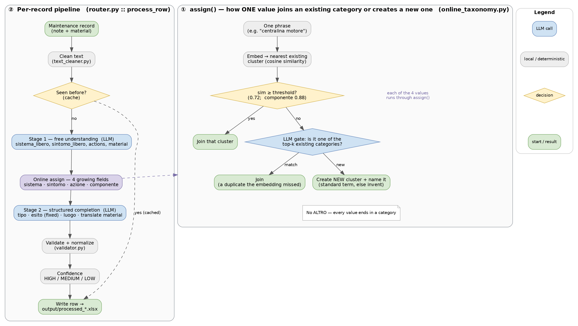

① Online taxonomy growth (embedded within per-record processing)
There is no separate "build the taxonomy" phase. The taxonomy is constructed incrementally as a side effect of classifying records. The core operation is OnlineTaxonomy.assign(phrase) in online_taxonomy.py, which implements a centroid/leader-style online clustering with an LLM safeguard:
assign(phrase):
v = embed(phrase)
(best, sim) = nearest existing cluster by cosine(v, centroid)
if sim >= self.sim: # confident match
join(best); return best.label
if gate enabled: # embedding was unsure
m = LLM_match_existing(phrase, top-k nearest clusters)
if m is not NONE:
join(m); return m.label # duplicate the embedding missed
label = name(phrase) # reference vocab -> match or invent
create_cluster(v, label); return label
Two thresholds govern granularity: the join threshold sim (0.72 for sistema/sintomo/ azione; 0.88 for componente) decides when a phrase is close enough to merge without asking the LLM, and the LLM gate covers the uncertain region below that bar so the system does not open a redundant category for something it already knows under a slightly different surface form. The reference vocabularies (reference_vocabulary*.json, the azione standard list) are consulted only inside name(), i.e. only when a brand-new cluster is being labelled. They influence names, never membership, and never cap the number of categories.

② Per-record classification (runtime)
router.py::process_row orchestrates the full path for one record:
clean → cache lookup → Stage 1 (free understanding)
→ online assign (sistema, sintomo, azione, componente)
→ Stage 2 (fixed lists + free fields)
→ validate/normalize → confidence → write row
Every Group-A value is placed in a real category; nothing is deferred to ALTRO.

③ Periodic taxonomy maintenance (taxonomy_cleanup.py)
Online clustering created incrementally is inevitably slightly order-dependent and can accumulate two kinds of imperfection: near-duplicate clusters (two centroids that drifted close) and one-off noise clusters (a typo or hapax that spawned its own category). The maintenance pass — a redesign of what was previously a "discover/promote" loop — addresses both, per field, using only the stored cluster centroids (no LLM, no embedding recompute, fully offline and deterministic):
- Merge pass — merge two clusters when the cosine similarity of their centroids exceeds MERGE_SIM for that field.
- Prune pass — a support-1 (single-record) cluster is absorbed into its nearest neighbour if that neighbour is within PRUNE_SIM; otherwise it is kept (a genuinely distinct rare category is not force-merged).
PRUNE_SIM is deliberately kept high (≈0.82) after an observed failure where a low threshold wrongly absorbed a distinct singleton into an unrelated cluster. --dry-run reports every proposed change without touching state; the real run writes .bak backups first.

5. File map

Path | Role
main.py | Entry point: reads input/, iterates rows, writes output/.
router.py | Per-record orchestrator (clean -> cache -> Stage 1 -> online assign -> Stage 2 -> validate -> confidence). Instantiates and persists the four OnlineTaxonomy objects.
text_cleaner.py | Raw-text normalization.
keyword_extractor.py | The two LLM calls — Stage 1 (free understanding) and Stage 2 (structured completion). Holds the prompts.
online_taxonomy.py | The self-growing taxonomy class: assign() = embedding nearest -> LLM gate -> join / create+name. Ships with --self-test.
validator.py | Snaps closed fields to legal values, normalizes free fields, builds the material hint (validate_material + material_map.json), and computes the confidence label.
name_normalizer.py | Naming helper: shortlists the nearest reference-vocabulary terms for a new category's name.
taxonomy_bootstrap.py | Naming-prompt library (match-standard / invent) reused by online_taxonomy, plus a standalone batch clustering tool.
taxonomy_cleanup.py | Offline, deterministic maintenance pass (merge duplicates + prune noise). --dry-run, --field, --self-test.
config.py | Central configuration: file paths, Ollama model names, embedding threshold, batch settings.
keyword_taxonomy.json | Fixed enums for tipo_intervento / esito, plus the ~12-verb standard azione naming list.
reference_vocabulary.json | Naming dictionary for sistema (standard system terms).
reference_vocabulary_sintomo.json | Naming dictionary for sintomo.
material_map.json | Material->hint dictionary; validate_material passes a hint into Stage 1.
learned_mappings.json | Per-row result cache; reset with: echo '{}' > learned_mappings.json.
requirements.txt | Python dependencies.
input/ | The maintenance-record file(s) to process. main.py reads exactly one .xlsx/.csv per run.
output/ | Results, one processed_<inputname>.xlsx per input (original columns + the 8 new ones).
taxonomy_free/*_online.json | The LIVE induced taxonomies (sistema, sintomo, azione, componente) — the system's primary output. Grows across runs.
eval/ | Measurement suite (NOT runtime): evaluator.py, gold_standard.xlsx, name_gold.xlsx, name_eval.py, cluster_compare.py. All gold assets now live here.
_archive/ | Backups / archived material; not used at runtime. Includes a removed_<date>/ folder of retired files (e.g. the dead azione_extractor.py).

6. Key design decisions (and their rationale)
- The data constructs the taxonomy; a human only standardizes names. The category inventory is induced from the corpus. Reference vocabularies contribute canonical spellings for new categories, nothing more — they cannot add, remove, or cap categories. This separation is what lets the thesis claim a genuinely data-induced taxonomy.
- Online, with no cold-start build phase, and no ALTRO. Categories materialize as records arrive, so there is no chicken-and-egg preparation step, and every value is placed in a concrete category rather than a catch-all bucket.
- A two-tier "is this new?" decision. Embedding similarity is the fast first filter; the LLM gate adjudicates only the uncertain band. This specifically prevents the creation of a duplicate category for a value that already exists under a slightly different surface form — a failure the embedding alone would occasionally cause.
- Uniform mechanism across all four growing fields. sistema, sintomo, azione, and componente share one code path, one persistence format, and one maintenance routine. The only per-field differences are the join threshold and the naming source. Avoiding special-cases keeps behaviour predictable and reviewable.
- No overfitting, no whack-a-mole. Vocabulary descriptions are not reactively hand-tuned to fix individual misclassifications (doing so perturbs every cluster's ranking), and no hard-coded "don't confuse X with Y" rules are inserted. Errors are addressed structurally (thresholds, gate, cleanup), not by patching symptoms.
- Measure, do not eyeball. Structural choices — e.g. average- vs single-linkage in the offline validation experiments — were decided against a labelled gold set, not by inspection.

7. Extending and debugging
- Adjust category granularity. The join threshold is sim in online_taxonomy.py (default 0.72; componente 0.88). A higher value yields more, tighter categories; a lower value yields fewer, broader ones.
- Tune the maintenance pass. MERGE_SIM / PRUNE_SIM per field in taxonomy_cleanup.py. Keep PRUNE_SIM high (~0.82) so weakly-related singletons are not force-merged.
- Disable the LLM gate for a field (e.g. to speed up componente): pass gate=False when that field's OnlineTaxonomy is constructed in router.py. The field then relies on embedding similarity alone.
- Inspect the induced taxonomies. Read taxonomy_free/*_online.json. Each cluster shows its canonical label, support count, and the phrases it has absorbed — this is the primary artifact for evaluating what the system learned.
- Offline logic tests. Every core module carries a --self-test that runs without Ollama: python3 online_taxonomy.py --self-test, python3 taxonomy_cleanup.py --self-test.
- Reset a run cleanly. Clear the row cache before a fresh full run so no stale result is served: echo '{}' > learned_mappings.json. (A common pitfall: copying a populated cache from a previous configuration causes cache hits that bypass Stage 2 and the online assignment, reproducing the old configuration's output.)

