Predictive Maintenance Dashboard

1. What the system is
This dashboard turns the fleet's free-text maintenance notes into an interactive management view. Its input is the processed Excel produced by the keyword-extraction pipeline — the one where each Italian note has already been turned into 8 structured columns (system, symptom, action, component, result, place, type, confidence). The dashboard reads and analyses that history; it does not predict the future and it is not a machine-learning model. Everything runs locally, so the data never leaves the computer.

How the data flows
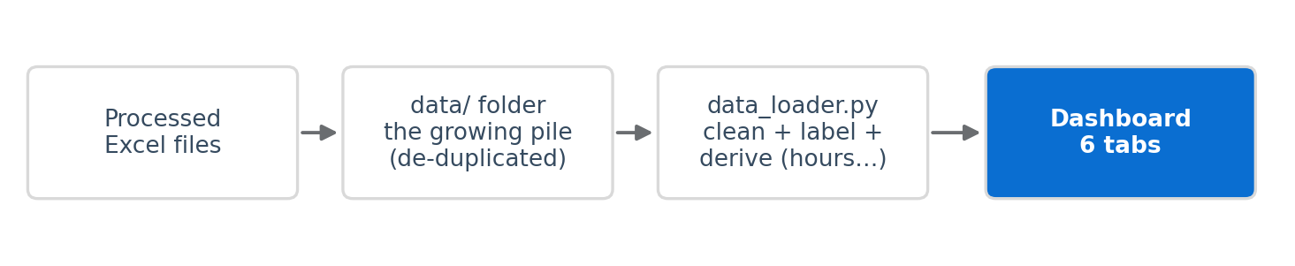
Drop a new processed Excel into the data/ folder (or the sidebar uploader) and press Reload data — the pile grows. Duplicate work orders (same Claim number) are counted only once. Italian codes such as PNEUMATICI are shown in plain English (Tyres).

2. The tabs at a glance
Overview — The big picture: KPIs, which systems fail most, planned vs unplanned, and the trend over time.
Work orders — Every record as a work order. Click one on the left to read its full detail and original note.
Buses — Worst-bus ranking, repeat-failure warnings, and one bus's full service history.
Faults — Most common systems and symptoms, where faults happen, actions, and which faults cost the most work.
Parts — Most used parts, parts per bus, and monthly parts demand for stock planning.
Suggest — Add a new category the system missed; it is saved as a suggestion for the pipeline to review.

3. What each chart answers

Overview
KPI cards — total jobs, buses involved, jobs per bus, avg hours/job, % unplanned, % road breakdowns, total work hours, % needing review.
Which systems fail most (donut) — the share of each fault system.
Planned vs unplanned (donut) — how much is scheduled upkeep vs firefighting.
Trend over time (area) — jobs by day / week / month / year (switchable).

Work orders
A searchable list on the left; clicking an item opens the full record on the right — priority, date, place, bus, mileage, work hours, result, symptom, action, components, parts, and the original Italian note. Used to inspect a single job and to check whether the pipeline classified it correctly.

Buses
Worst-bus ranking (table) — buses sorted by number of jobs. Click a row to open that bus below.
Early-maintenance candidates (table) — buses that had the same fault 2+ times. Click a row to open it.
One bus in detail — a summary card plus a service-history card for every job of that bus.

Faults (linked / clickable)
Most common systems — click a bar to see that system's symptoms.
Most common symptoms — click a bar to see which systems it appears in.
Where faults happen — workshop vs road (donut).
What technicians did — click an action to see which systems it was performed on.
Which faults take the most work — typical labor hours per system.

Parts
Most used parts — click a part to see which buses used it.
Parts used per bus and parts demand month by month — for stock and ordering.

4. Quick user guide
Filters (left sidebar) — Year, Month, Date range, Planned/unplanned, Fault system, Symptom, Where, Bus. A selection narrows every tab at once.
Add data — sidebar → “Add data” → drop the processed Excel → it joins the pile.
Remove data — sidebar → “Files in the pile / remove” → select a file → Delete.
Reload data — after adding files to the data/ folder manually, press this to refresh.
Linked charts — in Buses, Faults and Parts, clicking a row or bar reveals related detail below.

5. How to open it on the computer
The app runs locally in a web browser. It needs to be started once from a terminal; after that it opens automatically in the browser. Below are the steps for macOS and Windows.
Prerequisite: Python 3.10 or newer.

macOS
Put the cotral_dashboard folder somewhere easy (e.g. the Desktop). It must contain app.py, data_loader.py, requirements.txt and the data/ folder.
Open Terminal (Applications → Utilities → Terminal).
Go into the folder, then install and run with the commands below.
cd ~/Desktop/cotral_dashboard
python3 -m pip install -r requirements.txt
python3 -m streamlit run app.py
The browser opens at http://localhost:8501.

Windows
Put the cotral_dashboard folder on the Desktop (same files as above).
Open Command Prompt (Start → type cmd → Enter).
Go into the folder, then install and run with the commands below.
cd %USERPROFILE%\Desktop\cotral_dashboard
python -m pip install -r requirements.txt
python -m streamlit run app.py
The browser opens at http://localhost:8501.
Files: app.py (interface), data_loader.py (data layer), data/ (Excel pile), requirements.txt, Dockerfile + DEPLOY.md (optional server hosting).

